41. EC2 Instance Creation
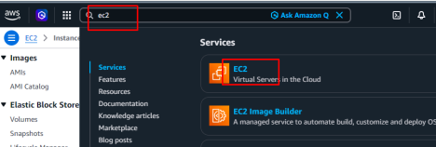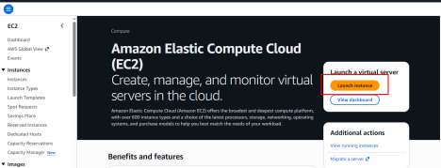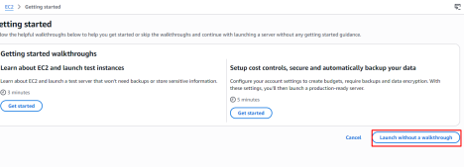DVS Technologies | Website: www.dvstechnologies.in | Mobile: 8892499499
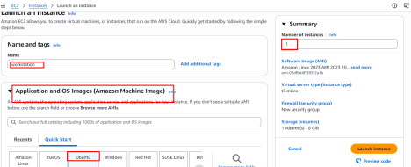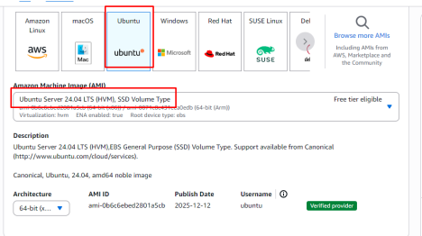
DVS Technologies | Website: www.dvstechnologies.in | Mobile: 8892499499
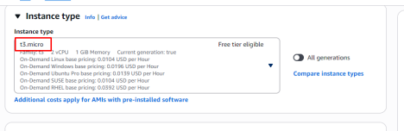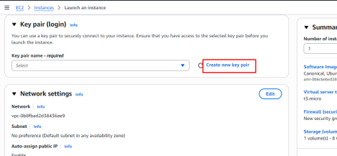Note: DON’T CREATE KEY PAIR DAILY, IT IS ONLY ONE TIME
DVS Technologies | Website: www.dvstechnologies.in | Mobile: 8892499499
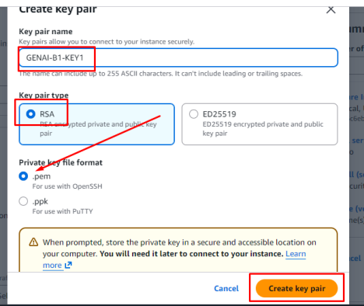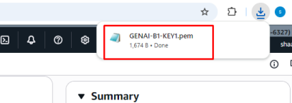Make sure that you are saving this keypair for future purpose
DVS Technologies | Website: www.dvstechnologies.in | Mobile: 8892499499
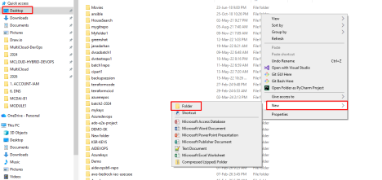
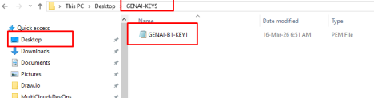Save the key for future purpose
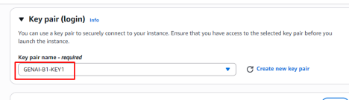DVS Technologies | Website: www.dvstechnologies.in | Mobile: 8892499499
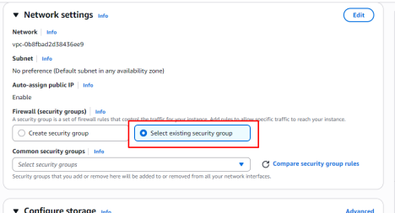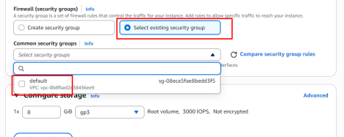
DVS Technologies | Website: www.dvstechnologies.in | Mobile: 8892499499
Verify the instance creation clicking on view all instances
2.Allow ports in the security group to access server
DVS Technologies | Website: www.dvstechnologies.in | Mobile: 8892499499
DVS Technologies | Website: www.dvstechnologies.in | Mobile: 8892499499
Note: Delete all the entries before you create below
DVS Technologies | Website: www.dvstechnologies.in | Mobile: 8892499499
DVS Technologies | Website: www.dvstechnologies.in | Mobile: 8892499499
3.How do we login to EC2 Server
DVS Technologies | Website: www.dvstechnologies.in | Mobile: 8892499499
4.Switching to ROOT /Administrator user
After you create the server make sure that you are terminating server when not required
DVS Technologies | Website: www.dvstechnologies.in | Mobile: 8892499499
We have two options 1. Stop instance 2. Terminating
1. Stopping instance will just bring down your server but it will not delete the data 2. Terminating server will delete the data
DVS Technologies | Website: www.dvstechnologies.in | Mobile: 8892499499

