1.Create Ec2 instance
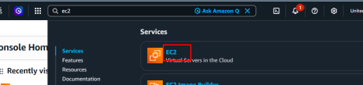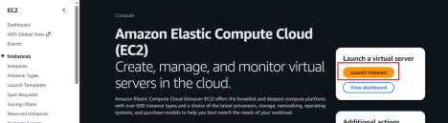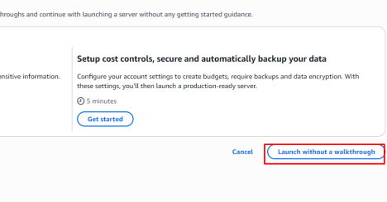
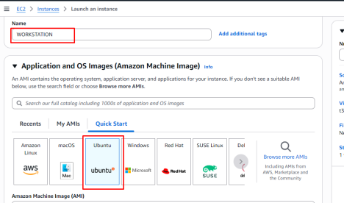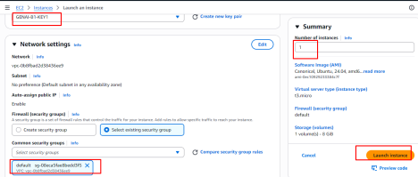
2.Login to the server then execute below
Install and configure your ec2 with below
sudo apt update -y
sudo apt install python3 python3-pip -y
sudo apt install python3.12-venv -y
mkdir /root/app
cd /root/app
python3 -m venv .venv
source .venv/bin/activate
cat <<EOF > requirements.txt
flask
EOF
cat <<EOF >app.py
from flask import Flask, jsonify
app = Flask(__name__)
@app.route("/")
def home():
return jsonify({"message": "Hello All Welcome to Dvs GenAI Sessions!"})
@app.route("/health")
def health():
return jsonify({"status": "OK"})
if __name__ == "__main__":
app.run(host="0.0.0.0", port=5000)
EOF
3.Running the application:
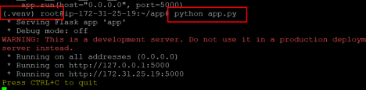Verifying our application
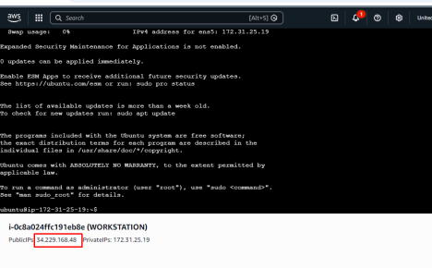http://34.229.168.48:5000/health
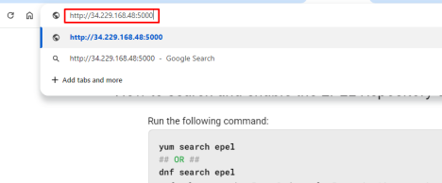
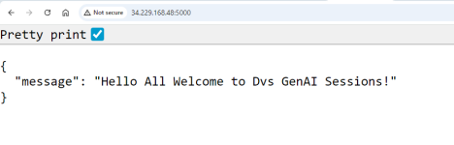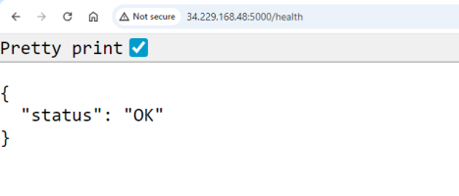
Troubleshooting
Make sure you are allowing ports in the security group
