Pre-Requisites:
1. EC2 Instance – Ubuntu
2. Install Docker
3. Install aws-cli
4. Create one IAM user and provide user with ECR full access & Generate key pairs 5. Configure aws credentials in the server
6. Create one ECR repository and do the ecr login in the EC2
1.Create Ec2 instance
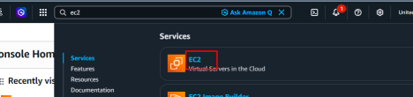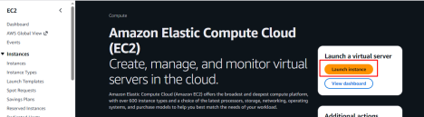
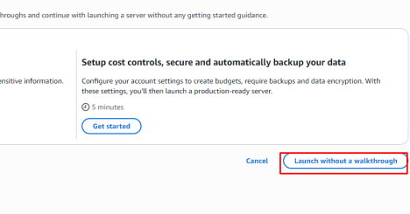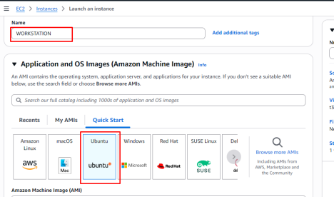
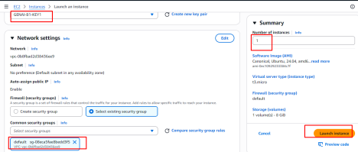
Make sure you are allowing ports in the security group
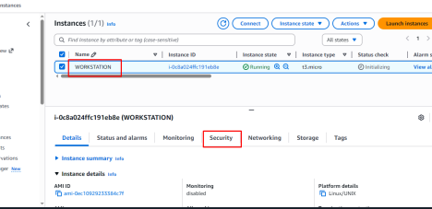
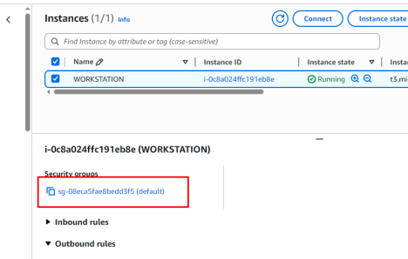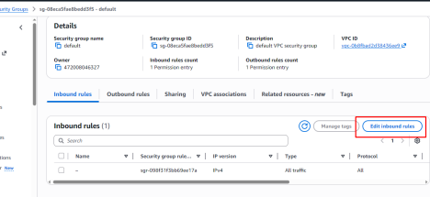
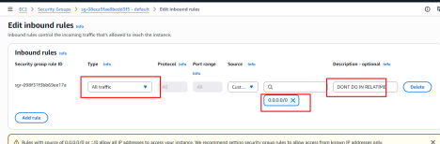
2.Docker Installation
Login to the server and execute the below
sudo apt update
sudo apt upgrade -y
sudo apt install -y ca-certificates curl gnupg lsb-release
sudo mkdir -p /etc/apt/keyrings
curl -fsSL https://download.docker.com/linux/ubuntu/gpg | \
sudo gpg --dearmor -o /etc/apt/keyrings/docker.gpg
echo \
"deb [arch=$(dpkg --print-architecture) \
signed-by=/etc/apt/keyrings/docker.gpg] \
https://download.docker.com/linux/ubuntu \
$(lsb_release -cs) stable" | \
sudo tee /etc/apt/sources.list.d/docker.list > /dev/null
sudo apt update
sudo apt install -y docker-ce docker-ce-cli containerd.io docker-buildx-plugin docker compose-plugin
sudo docker --version
sudo docker run hello-world
3.Working with Registry
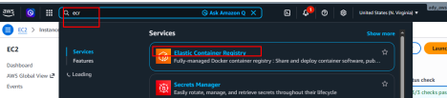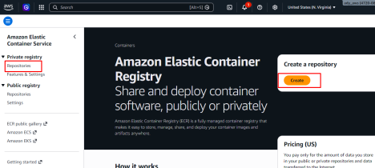
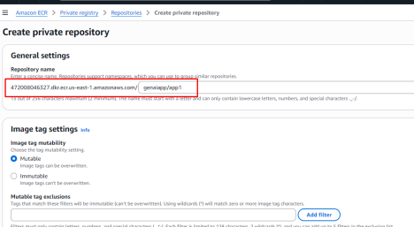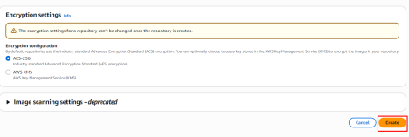
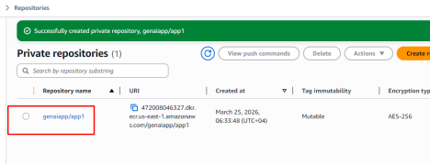4.Pushing images to the repository
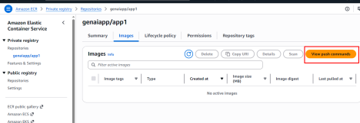
5. Generate credentials to push images to ECR
IAM
Create a service account and generate the credentials
6.Generate access keys
7.Configure the keys in the server/laptop
Installing aws-cli software
snap install aws-cli --classic
aws configure
8.Creating lambda with Container Image
Now we have all the components required for us to start building our own image
mkdir /root/lambda-image
cd /root/lambda-image/
Application code
cat <<EOF >lambda_function.py
import json
def handler(event, context):
# Sample name variable
print(event)
body_str = event.get("body",{})
body = json.loads(body_str)
print(body)
# You can also get name dynamically from event (optional)
name = body.get('name',"DVS-TECHNOLOGIES")
message = f"Hi {name} welcome to Dvs GenAI Cloud Sessions"
# Response
return {
"statusCode": 200,
"body": message
}
EOF
cat <<EOF >requirements.txt
boto3
EOF
Note: whatever the name mentioned in the CMD you application file name and handler function name should match each other.
cat <<EOF > Dockerfile
FROM public.ecr.aws/lambda/python:3.12
# Copy requirements.txt
COPY requirements.txt \${LAMBDA_TASK_ROOT}
# Install the specified packages
RUN pip install -r requirements.txt
# Copy function code
COPY lambda_function.py \${LAMBDA_TASK_ROOT}
# Set the CMD to your handler (could also be done as a parameter override outside of the Dockerfile)
CMD [ "lambda_function.handler" ]
EOF
Building docker image:
docker buildx build --platform linux/amd64 --provenance=false -t docker-image:test .
Now ensure you are changing the docker image name as per your ECR repository naming standards
In my case it is
472008046327.dkr.ecr.us-east-1.amazonaws.com/genaiapp/app1
Make sure you are adding your url
docker buildx build --platform linux/amd64 --provenance=false -t 472008046327.dkr.ecr.us-east-1.amazonaws.com/genaiapp/app1:lambda .
https://docs.aws.amazon.com/lambda/latest/dg/configuration
envvars.html#configuration-envvars-runtime
Pushing image to registry
Login to the registry
aws ecr get-login-password --region us-east-1 | docker login --username AWS -- password-stdin 472008046327.dkr.ecr.us-east-1.amazonaws.com
docker push 472008046327.dkr.ecr.us-east-1.amazonaws.com/genaiapp/app1:lambda
Let’s start creating our lambda function with docker image
Let’s expose our lambda function with url
Final testing
Login to postman and then test the application using below https://www.postman.com/
Finally we can see that our application is running with our image in the lambda platform

