API GATEWAY --> LAMBDA --> DYNAMODB
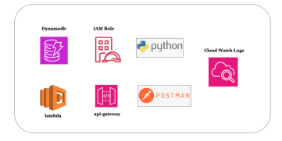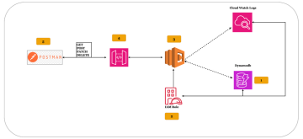
1.Creating dynamodb:
Table Name: employee-details
BUSINESS DOCUMENT This document is intended for business use and should be distributed to intended recipients only.
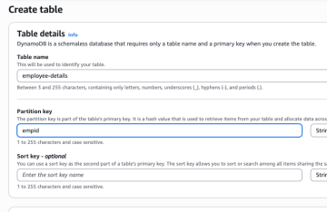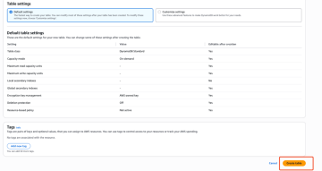
2.IAM Role - LAMBDA
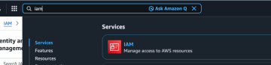Select the below option role
BUSINESS DOCUMENT This document is intended for business use and should be distributed to intended recipients only.
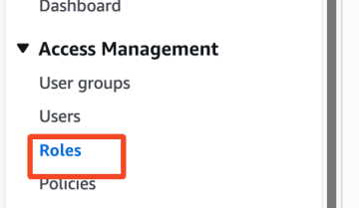
Click on create role
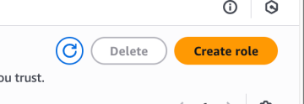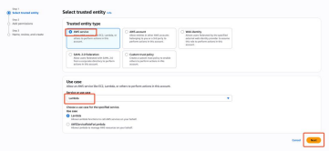
BUSINESS DOCUMENT This document is intended for business use and should be distributed to intended recipients only.
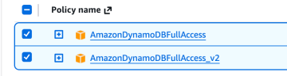
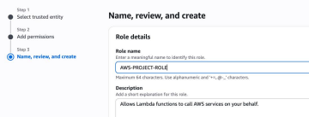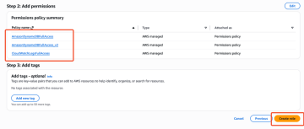
3.Creating LAMBDA
Create a lambda with role created above
BUSINESS DOCUMENT This document is intended for business use and should be distributed to intended recipients only.
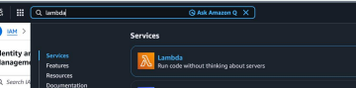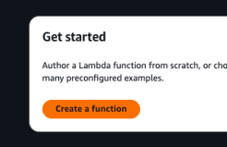
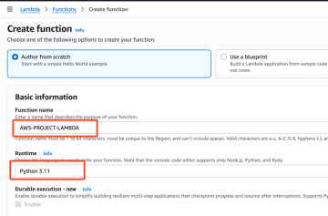
BUSINESS DOCUMENT This document is intended for business use and should be distributed to intended recipients only.
Python Code:
import json
import boto3
import logging
from botocore.exceptions import ClientError
# ---------------------------
# Logging Configuration
# ---------------------------
logger = logging.getLogger()
logger.setLevel(logging.INFO)
# ---------------------------
# DynamoDB Setup
# ---------------------------
dynamodb = boto3.resource("dynamodb")
TABLE_NAME = "employe-details"
table = dynamodb.Table(TABLE_NAME)
# ---------------------------
# Common Response Formatter
# ---------------------------
def process_response(status_code, body):
logger.info(f"Returning response | status={status_code} | body={body}")
return {
"statusCode": status_code,
"headers": {
"Content-Type": "application/json"
},
"body": json.dumps(body, default=str)
}
# ---------------------------
# READ Item
# ---------------------------
def read_item(empid):
logger.info(f"Reading employee | empid={empid}")
try:
result = table.get_item(Key={"empid": empid})
logger.debug(f"DynamoDB raw response: {result}")
if "Item" in result:
logger.info(f"Employee found | empid={empid}")
return process_response(200, result["Item"])
else:
logger.warning(f"Employee NOT found | empid={empid}") return process_response(404, f"No employee found with empid {empid}")
except ClientError as e:
logger.error(f"DynamoDB read failed | empid={empid} | error={str(e)}")
BUSINESS DOCUMENT This document is intended for business use and should be distributed to intended recipients only.
return process_response(500, str(e))
# ---------------------------
# CREATE Item
# ---------------------------
def create_item(payload):
logger.info(f"Creating employee | payload={payload}")
try:
table.put_item(Item=payload)
return process_response(201, "Employee created successfully")
except ClientError as e:
logger.error(f"DynamoDB create failed | error={str(e)}")
return process_response(500, str(e))
# ---------------------------
# UPDATE Item
# ---------------------------
def update_item(empid, update_data):
logger.info(f"Updating employee | empid={empid} | update_data={update_data}")
try:
update_expression = "SET " + ", ".join(
[f"{k} = :{k}" for k in update_data.keys()]
)
expression_values = {f":{k}": v for k, v in update_data.items()}
response = table.update_item(
Key={"empid": empid},
UpdateExpression=update_expression,
ExpressionAttributeValues=expression_values,
ReturnValues="UPDATED_NEW"
)
logger.info(f"Update successful | response={response}")
return process_response(200, "Employee updated successfully")
except ClientError as e:
logger.error(f"DynamoDB update failed | empid={empid} | error={str(e)}") return process_response(500, str(e))
# ---------------------------
# DELETE Item
# ---------------------------
def delete_item(empid):
logger.info(f"Deleting employee | empid={empid}")
try:
table.delete_item(Key={"empid": empid})
BUSINESS DOCUMENT This document is intended for business use and should be distributed to intended recipients only.
return process_response(200, f"Employee {empid} deleted successfully")
except ClientError as e:
logger.error(f"DynamoDB delete failed | empid={empid} | error={str(e)}") return process_response(500, str(e))
# ---------------------------
# Lambda Entry Point
# ---------------------------
def lambda_handler(event, context):
request_id = context.aws_request_id
logger.info(f"Lambda invoked | request_id={request_id}") logger.info(f"Incoming event: {json.dumps(event)}")
try:
path = event.get("path")
method = event.get("httpMethod")
body = json.loads(event["body"]) if event.get("body") else {} query_params = event.get("queryStringParameters") or {} empid = query_params.get("empid")
logger.info(f"Routing request | path={path} | method={method}")
# -------- READ --------
if path == "/read" and method == "GET":
if not empid:
logger.warning("Missing empid in query params")
return process_response(400, "empid query parameter is required") return read_item(empid)
# -------- CREATE --------
elif path == "/create" and method == "POST":
if "empid" not in body:
logger.warning("empid missing in request body")
return process_response(400, "empid is required in request body") return create_item(body)
# -------- UPDATE --------
elif path == "/update" and method == "PUT":
if not empid:
logger.warning("Missing empid for update")
return process_response(400, "empid query parameter is required") return update_item(empid, body)
# -------- DELETE --------
elif path == "/delete" and method == "DELETE":
if not empid:
logger.warning("Missing empid for delete")
BUSINESS DOCUMENT This document is intended for business use and should be distributed to intended recipients only.
return process_response(400, "empid query parameter is required") return delete_item(empid)
else:
logger.warning(f"Invalid route | path={path} | method={method}") return process_response(404, "Route not found")
except Exception as e:
logger.exception("Unhandled Lambda exception")
return process_response(500, str(e))
4.API Gateway
Let's create the API gateway with below - CRUD
/read --> GET
/create --> POST
/update --> PUT
/delete --> DELETE
BUSINESS DOCUMENT This document is intended for business use and should be distributed to intended recipients only.
Creating API Gateway
BUSINESS DOCUMENT This document is intended for business use and should be distributed to intended recipients only.
Creating resources:
Read, Create, Update, Delete
BUSINESS DOCUMENT This document is intended for business use and should be distributed to intended recipients only.
Let's create methods for the each resource
/read --> GET
/create --> POST
/update --> PUT
/delete --> DELETE
BUSINESS DOCUMENT This document is intended for business use and should be distributed to intended recipients only.
Read:
CREATE - POST:
BUSINESS DOCUMENT This document is intended for business use and should be distributed to intended recipients only.
UPDATE - PUT
BUSINESS DOCUMENT This document is intended for business use and should be distributed to intended recipients only.
DELETE - DELETE
BUSINESS DOCUMENT This document is intended for business use and should be distributed to intended recipients only.
Deploy API
BUSINESS DOCUMENT This document is intended for business use and should be distributed to intended recipients only.
BUSINESS DOCUMENT This document is intended for business use and should be distributed to intended recipients only.
Now we got the invoke url
https://pl4pfeimz1.execute-api.us-east-1.amazonaws.com/dev
5.Final Testing
Open Postman and start doing the below
1. Creating the employee records
Method: POST
Resource: create
Body:
{
"empid": "12345",
"age": 40,
"city": "blr"
}
Before:
BUSINESS DOCUMENT This document is intended for business use and should be distributed to intended recipients only.
Postman:
After:
2. Get employee records
3. Put employee records
BUSINESS DOCUMENT This document is intended for business use and should be distributed to intended recipients only.
4. Delete employee records
6.Logging & Troubleshooting:
BUSINESS DOCUMENT This document is intended for business use and should be distributed to intended recipients only.
BUSINESS DOCUMENT This document is intended for business use and should be distributed to intended recipients only.
BUSINESS DOCUMENT This document is intended for business use and should be distributed to intended recipients only.

