GENAI-TEXT2SQL-CHATBOT

1.Configuring Workstation

Note: Take instance type big higher than t3.micro if possible

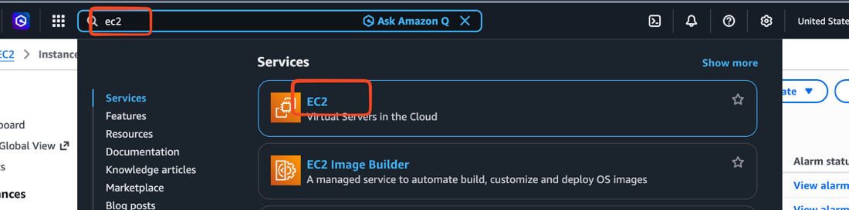

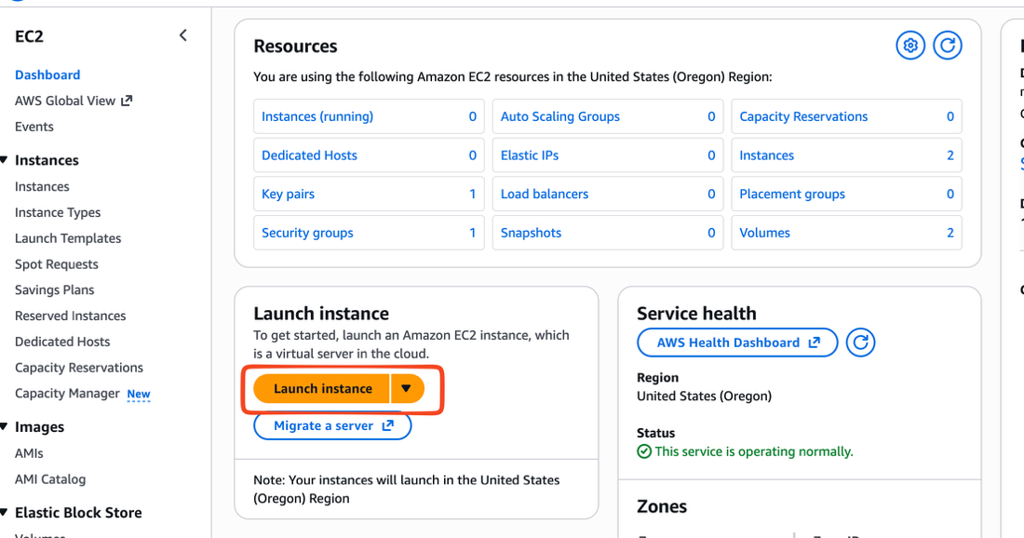

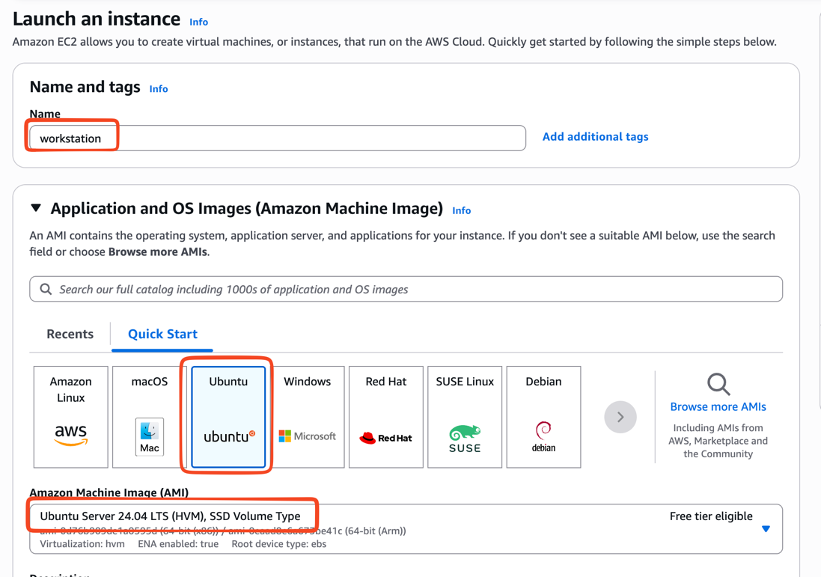

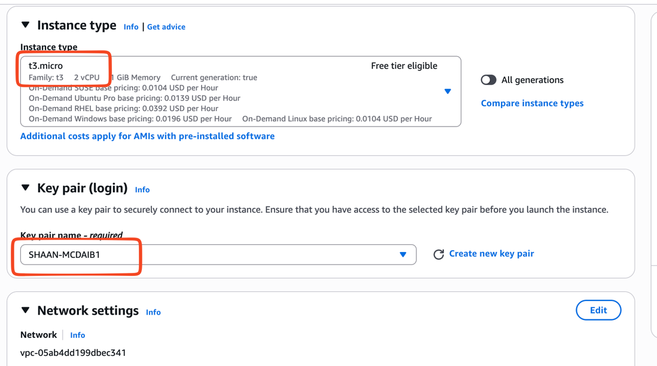

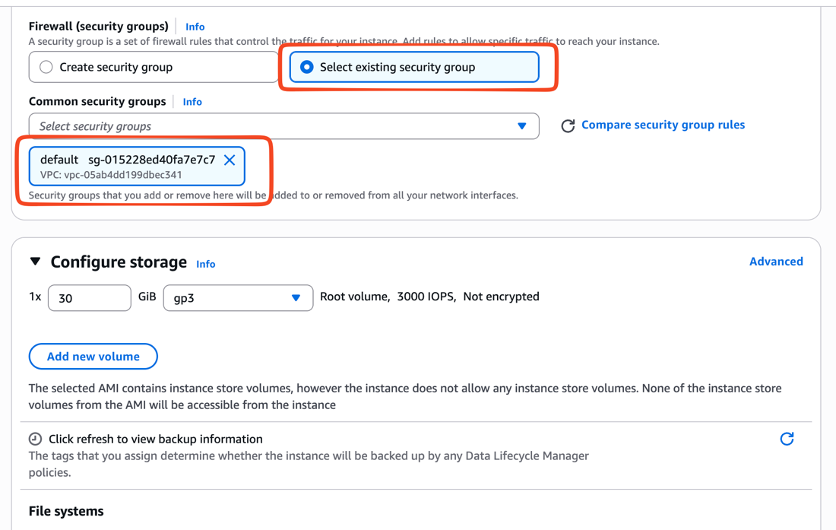

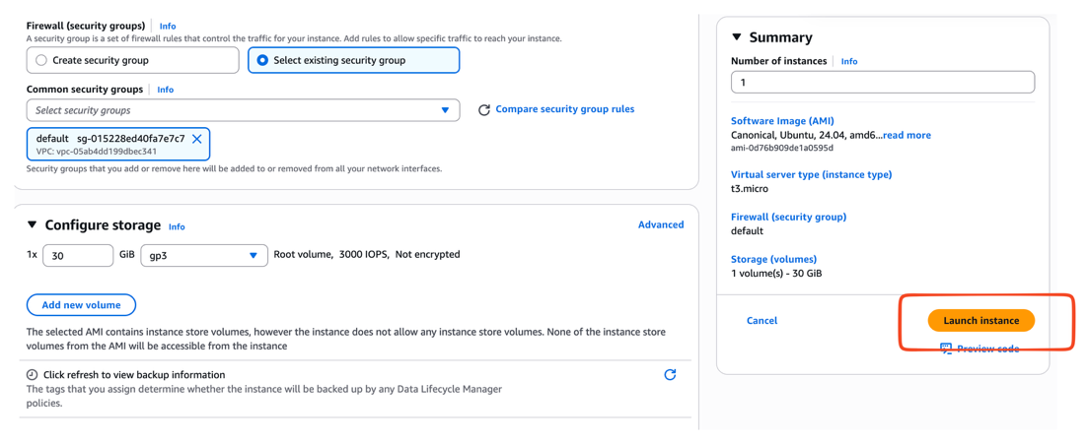

2.Configuring workstation with required softwares

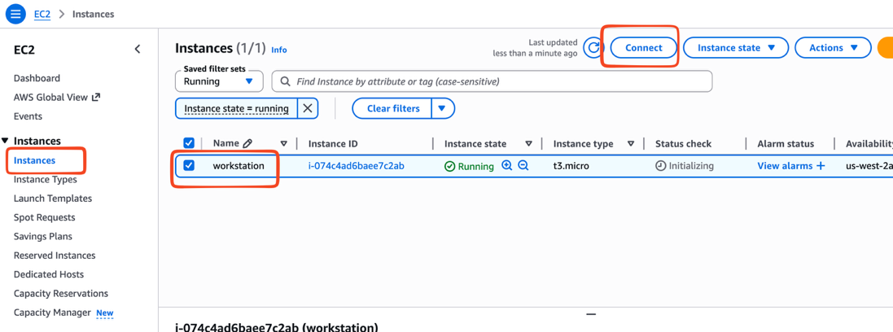

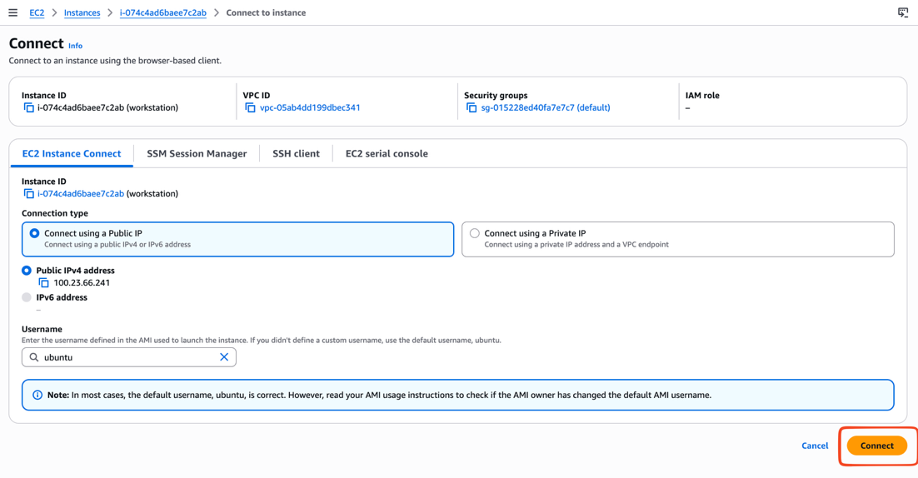

sudo su -

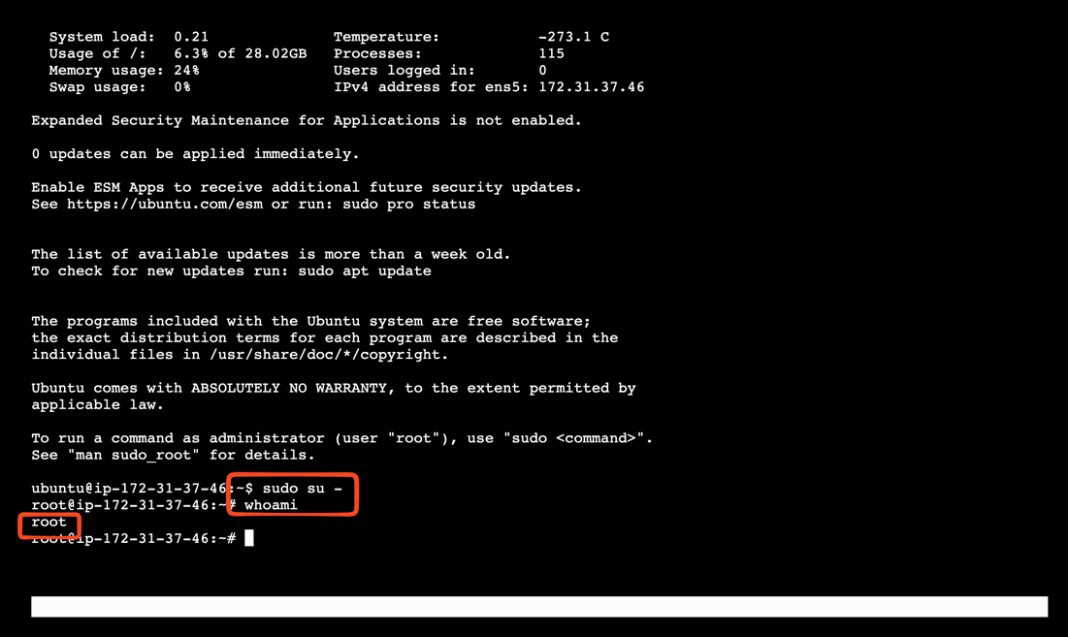

Installing docker and aws cli

# Add Docker's official GPG key:
sudo apt update
sudo apt install ca-certificates curl
sudo install -m 0755 -d /etc/apt/keyrings
sudo curl -fsSL https://download.docker.com/linux/ubuntu/gpg -o /etc/apt/keyrings/docker.asc
sudo chmod a+r /etc/apt/keyrings/docker.asc

# Add the repository to Apt sources:
URIs: https://download.docker.com/linux/ubuntu
Suites: $(. /etc/os-release && echo "${UBUNTU_CODENAME:-$VERSION_CODENAME}")
Components: stable
Signed-By: /etc/apt/keyrings/docker.asc
sudo tee /etc/apt/sources.list.d/docker.sources <<EOF
Types: deb
EOF

sudo apt update
sudo apt install docker-ce docker-ce-cli containerd.io docker-buildx-plugin docker-compose-plugin
sudo systemctl status docker
sudo systemctl start docker
sudo docker run hello-world

Note: Here give ctrl + c for ending the prompt if incase its not allowing you to go further

Aws cli

snap install aws-cli --classic

3.Create IAM User GENAI-TEXT2SQL-USER with "administrator" access

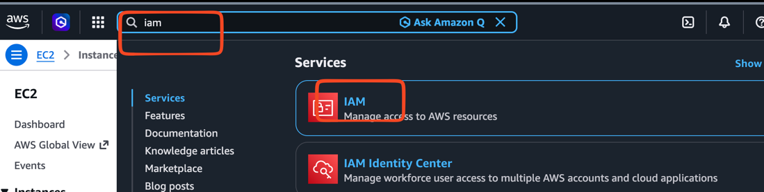

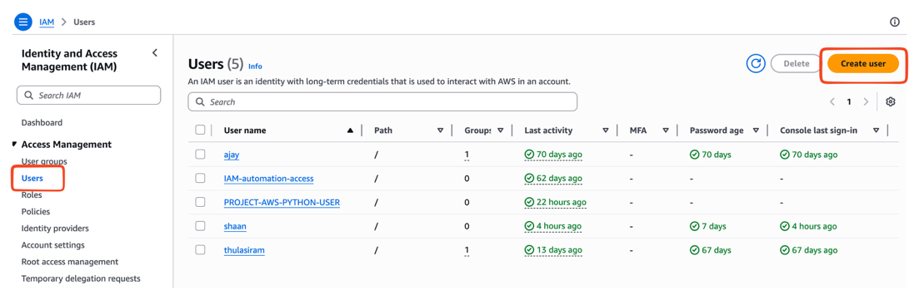

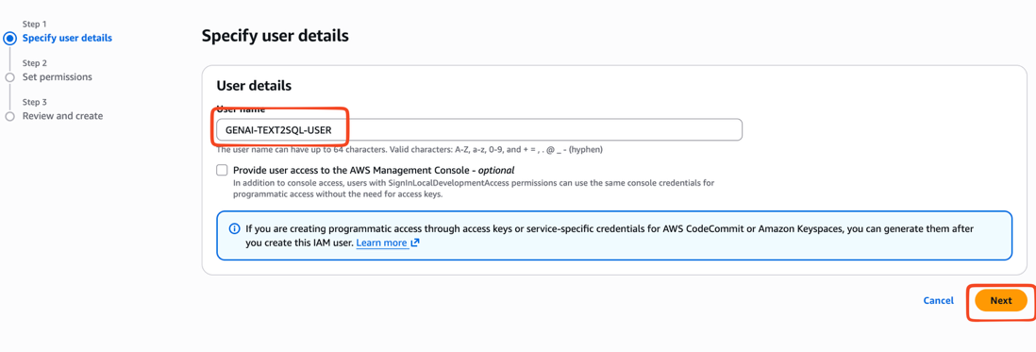

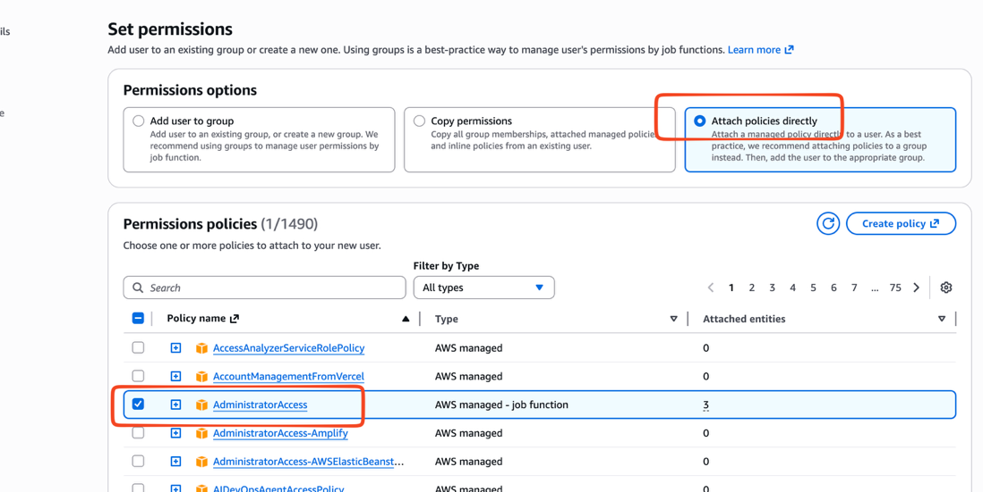

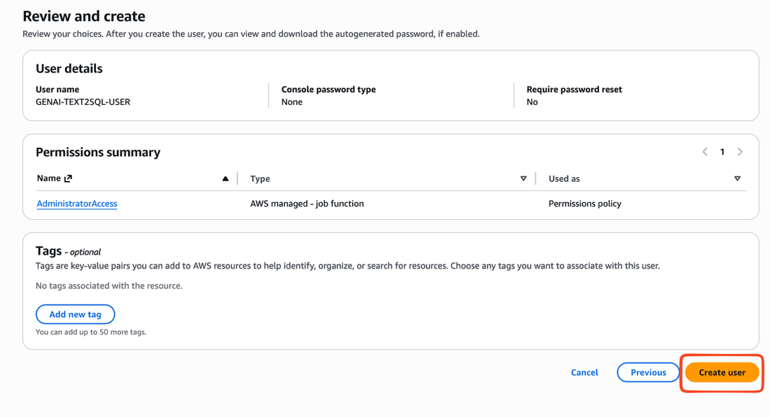

Generating access key & secret key

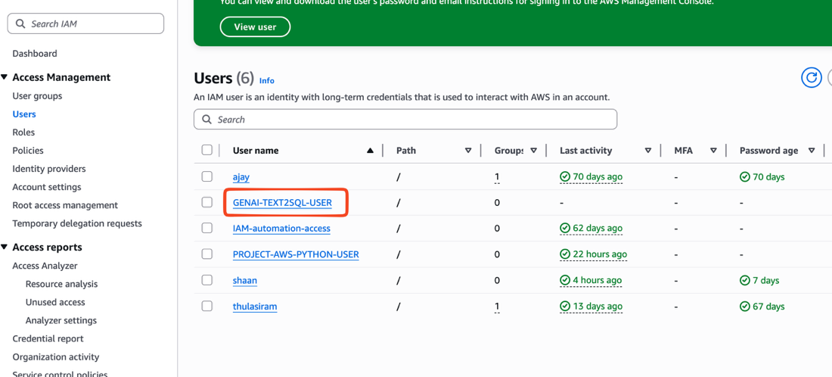

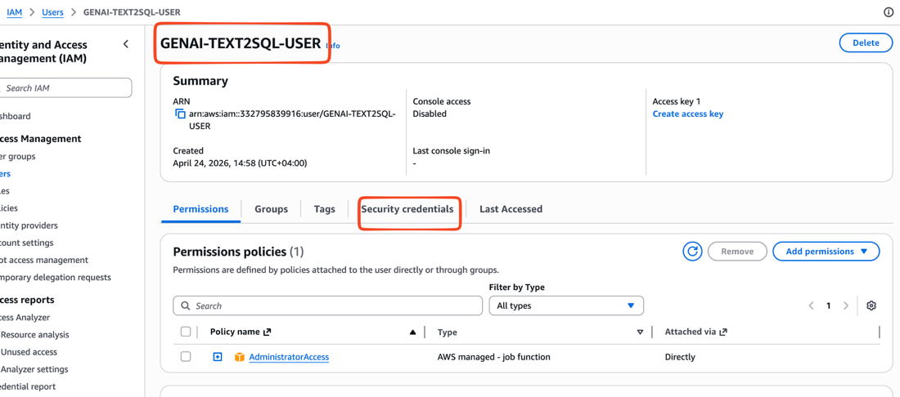

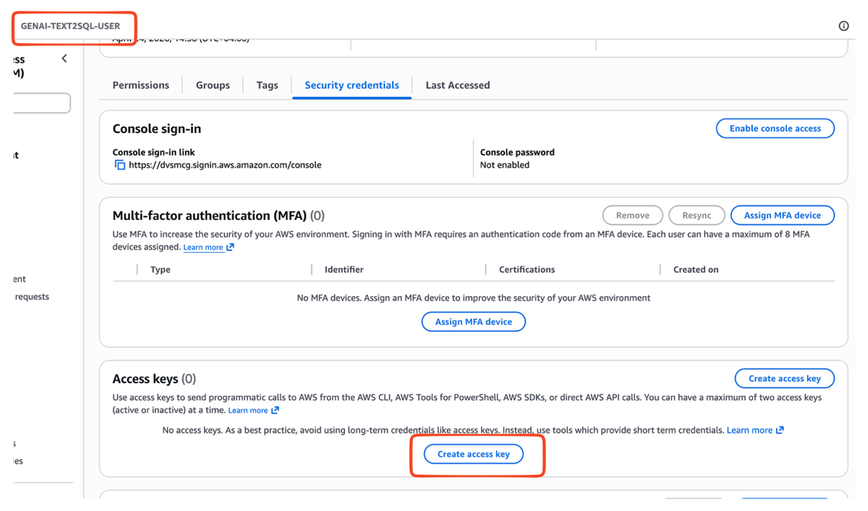

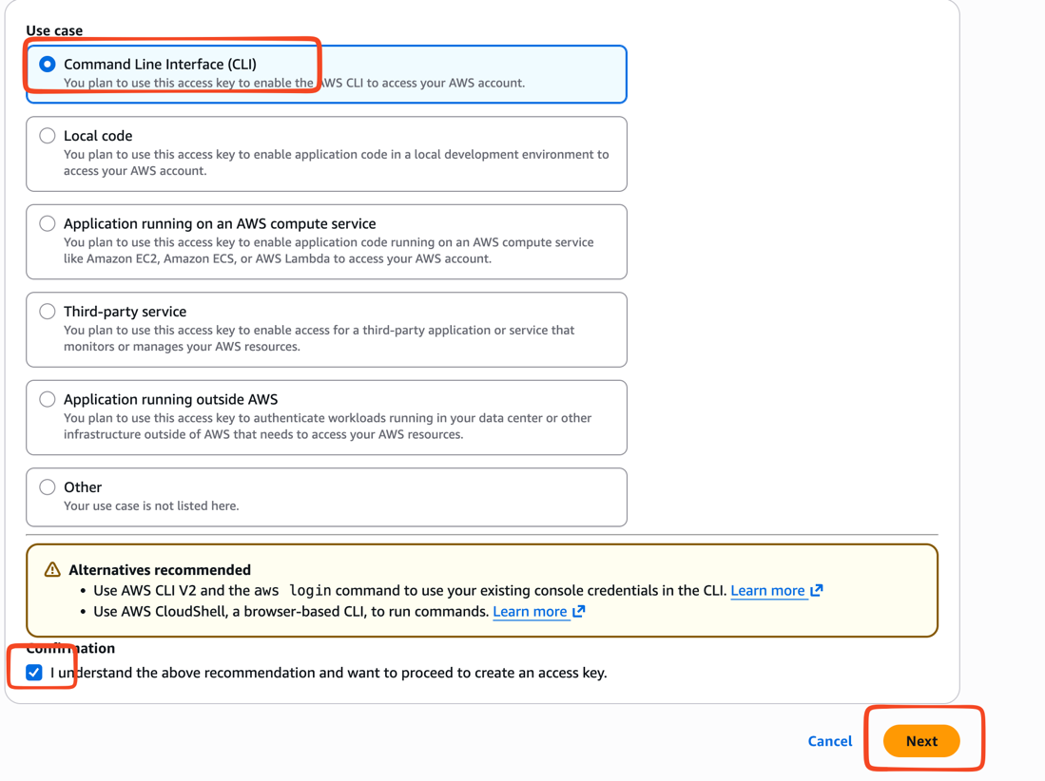

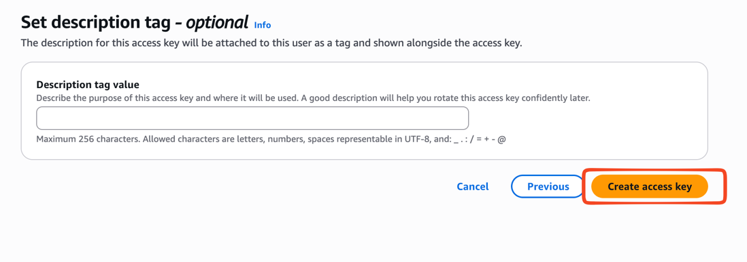

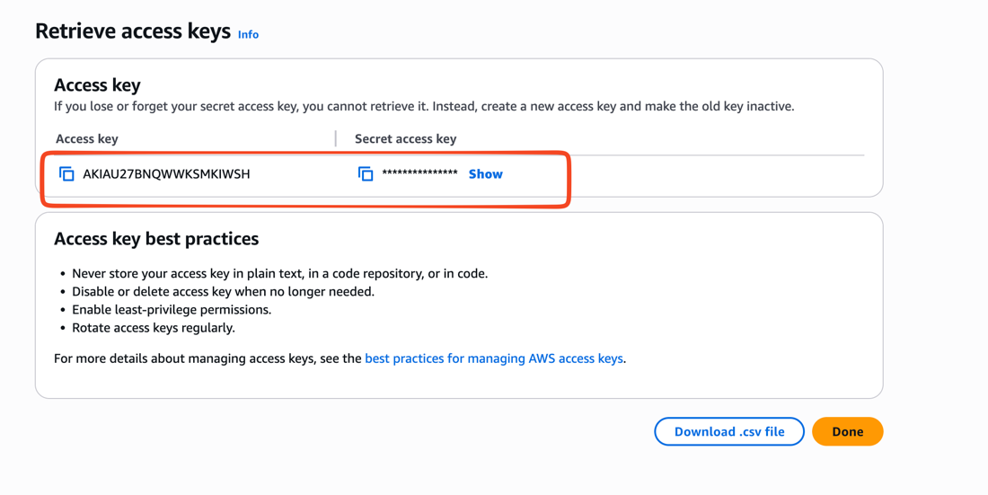

Note: Copy paste the Access key && Secret key

AKIAU27BNQWWKS
cd8EY31tMSnbLWauXexnbDmAjKxQQxG

Configure credentials

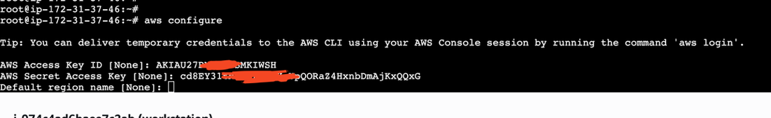

Region: take the region from the browser

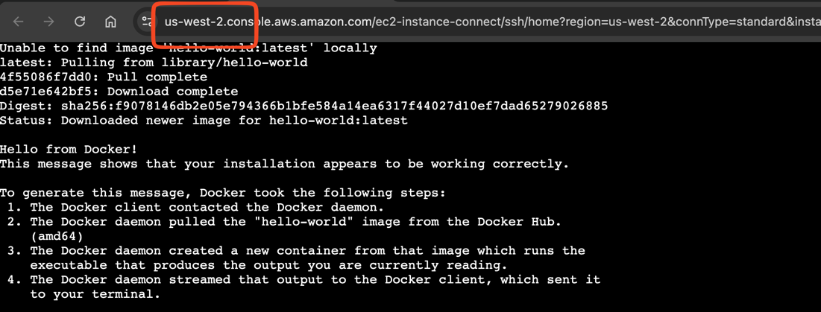

root@ip-172-31-37-46:~# aws configure

Tip: You can deliver temporary credentials to the AWS CLI using your AWS Console session by running the command 'aws login'.

AWS Access Key ID [None]: AKIAU27BIWSH
AWS Secret Access Key [None]: cd8EY31tMSnbLWxnbDmAjKxQQxG
Default region name [None]: us-west-2
Default output format [None]: json

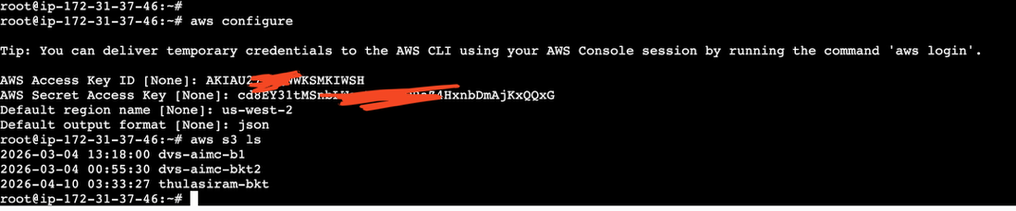

4.Creating ECR Repositories

generic-query-executor

llm-text-sql-agent

chat-assistant

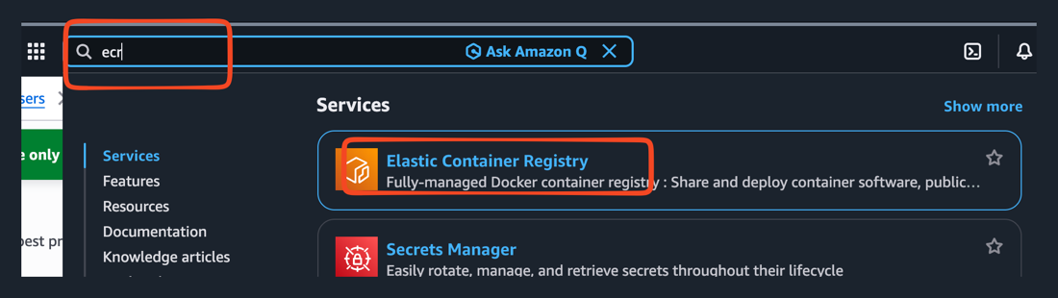

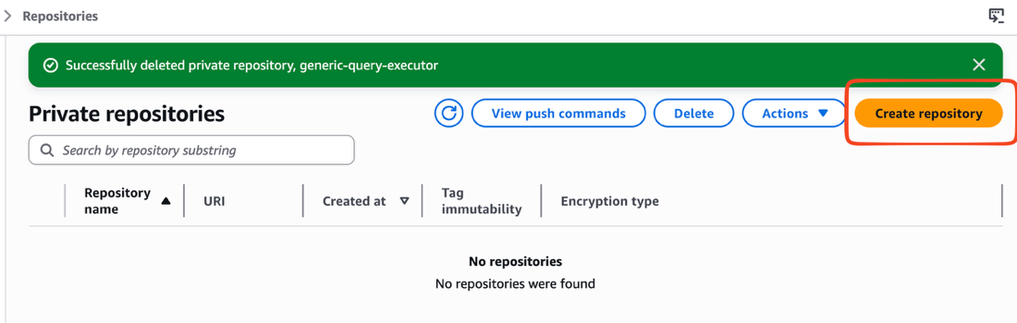

generic-query-executor

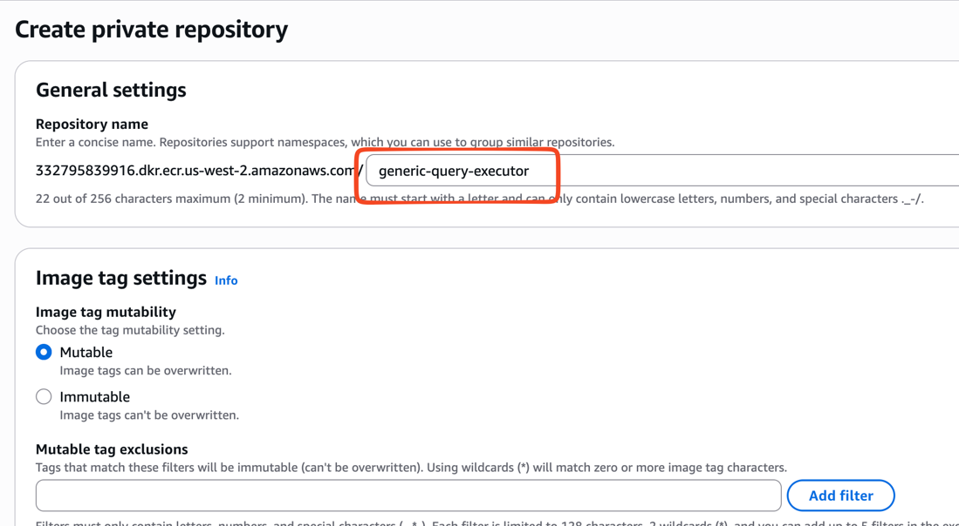

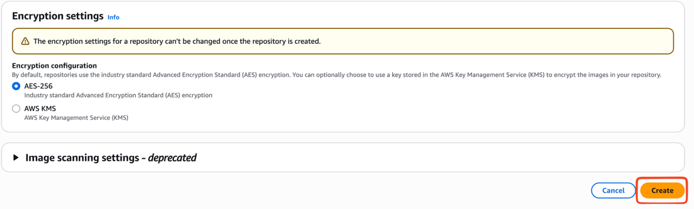

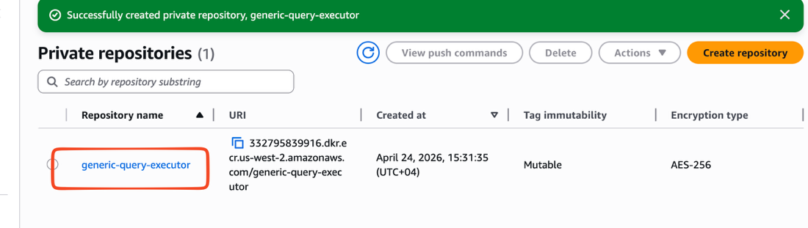

llm-text-sql-agent

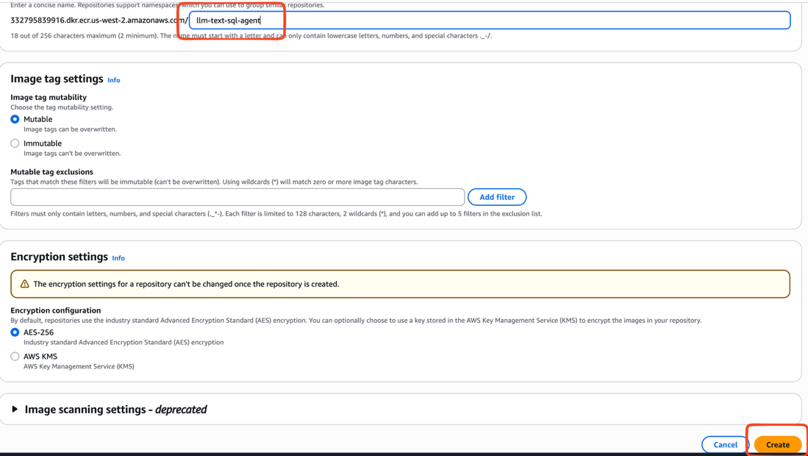

chat-assistant

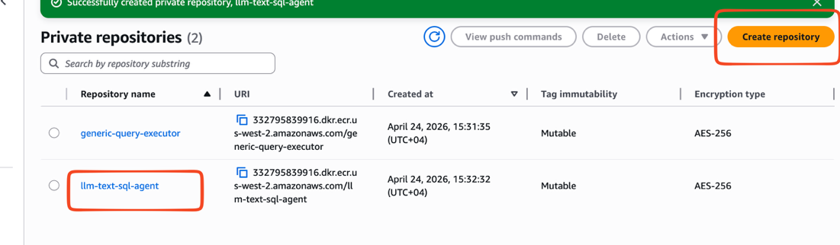

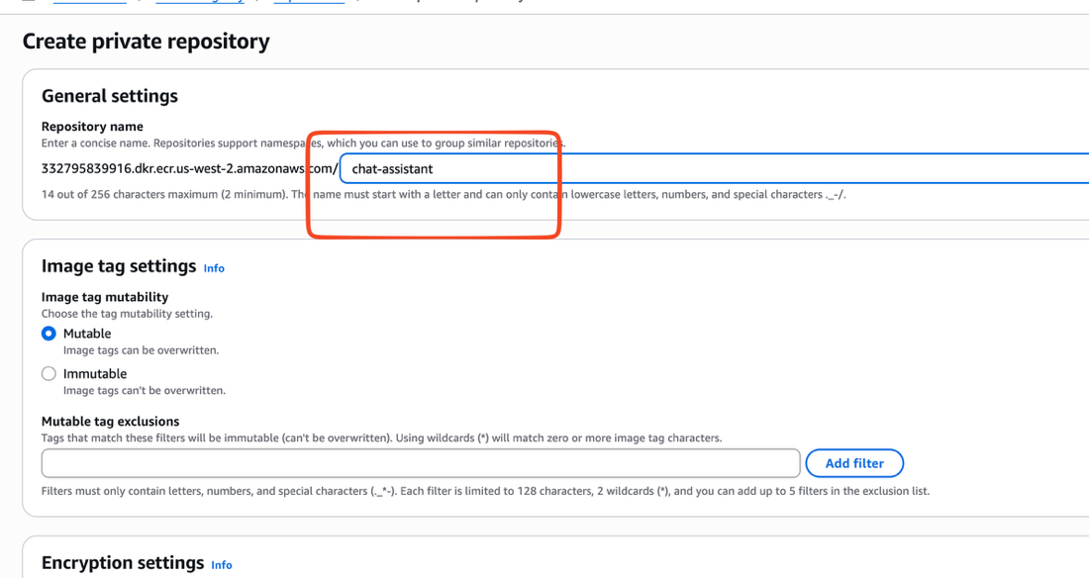

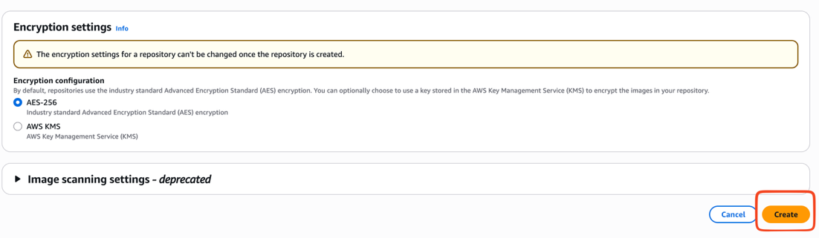

Finally

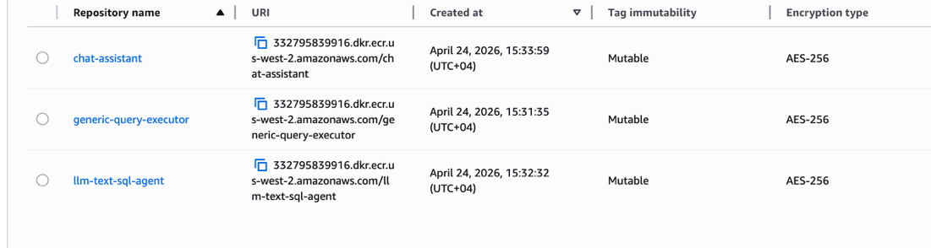

5.Building and Pushing application images

NOTE:

- My region is us-west-2, please double check what is your region and configure it accordingly
- Always remember that you should export AWS_REGION & AWS_ACCOUNT_ID before you push image to ECR

Cloning application repository

git clone https://github.com/shan5a6/GENAI-MATERIAL.git

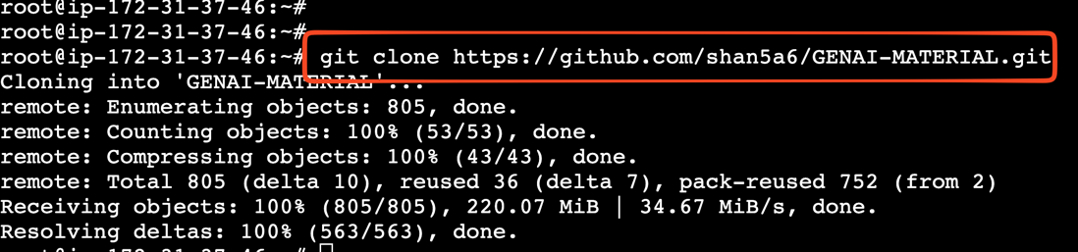

cd GENAI-MATERIAL/PROJECT3-PROMPT-ENGG-TEXT-TO-SQL/

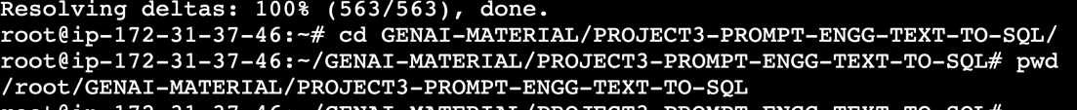

ls -l

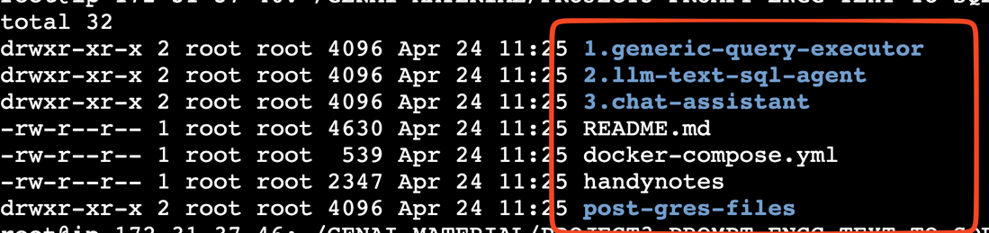

cd 1.generic-query-executor/

export AWS_REGION="eu-west-2"

export AWS_ACCOUNT_ID=$(aws sts get-caller-identity --query Account --output text)

aws ecr get-login-password --region $AWS_REGION | \
docker login --username AWS --password-stdin $AWS_ACCOUNT_ID.dkr.ecr.$AWS_REGION.amazonaws.com

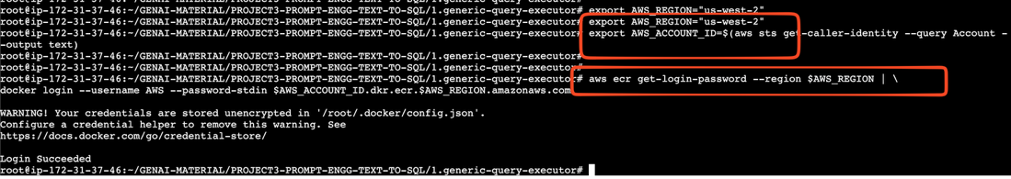

# Build Docker image
docker buildx build --platform linux/amd64 --output type=docker --provenance=false -t generic-query-executor:latest --no-cache .

# Tag image for ECR
docker tag generic-query-executor:latest \
$AWS_ACC
OUNT_ID.dkr.ecr.$AWS_REGION.amazonaws.com/generic-query-executor:latest
# Push to ECR
docker push $AWS_ACCOUNT_ID.dkr.ecr.$AWS_REGION.amazonaws.com/generic-query-executor:latest

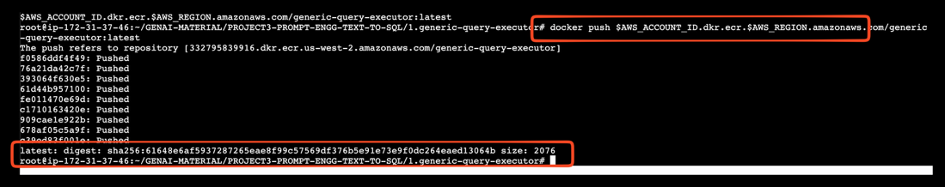

cd ~/GENAI-MATERIAL/PROJECT3-PROMPT-ENGG-TEXT-TO-SQL/2.llm-text-sql-agent/

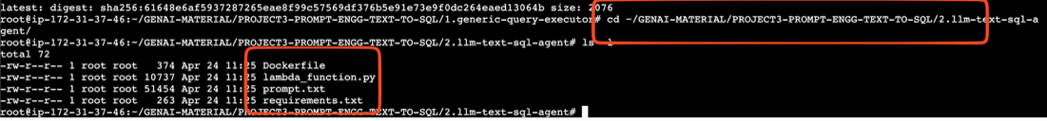

# Build Docker image
docker buildx build --platform linux/amd64 --output type=docker --provenance=false -t llm-text-sql-agent:latest --no-cache .

# Tag image for ECR
docker tag llm-text-sql-agent:latest \
$AWS_ACCOUNT_ID.dkr.ecr.$AWS_REGION.amazonaws.com/llm-text-sql-agent:latest

# Push to ECR
docker push $AWS_ACCOUNT_ID.dkr.ecr.$AWS_REGION.amazonaws.com/llm-text-sql-agent:latest

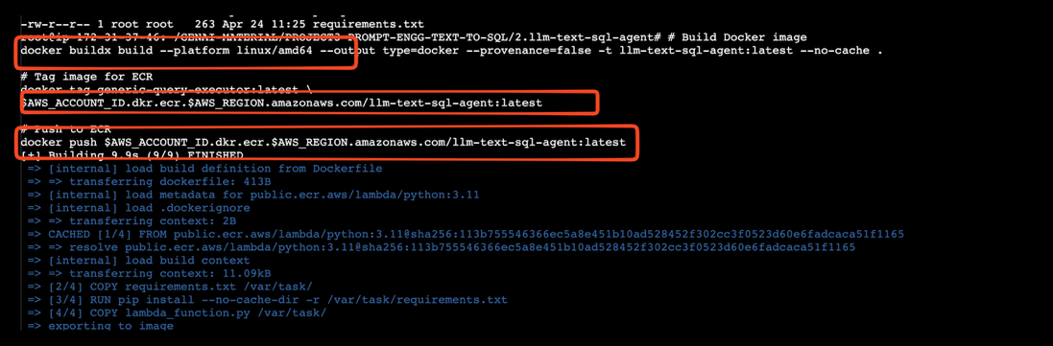

cd ~/GENAI-MATERIAL/PROJECT3-PROMPT-ENGG-TEXT-TO-SQL/3.chat-assistant/

# Build Docker image
docker buildx build --platform linux/amd64 --output type=docker --provenance=false -t chat-assistant:latest --no-cache .

# Tag image for ECR
docker tag chat-assistant:latest \
$AWS_ACCOUNT_ID.dkr.ecr.$AWS_REGION.amazonaws.com/chat-assistant:latest

# Push to ECR
docker push $AWS_ACCOUNT_ID.dkr.ecr.$AWS_REGION.amazonaws.com/chat-assistant:latest

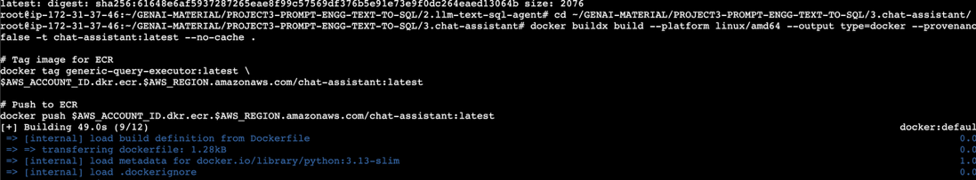

Note: Verify all the images pushed to the ECR

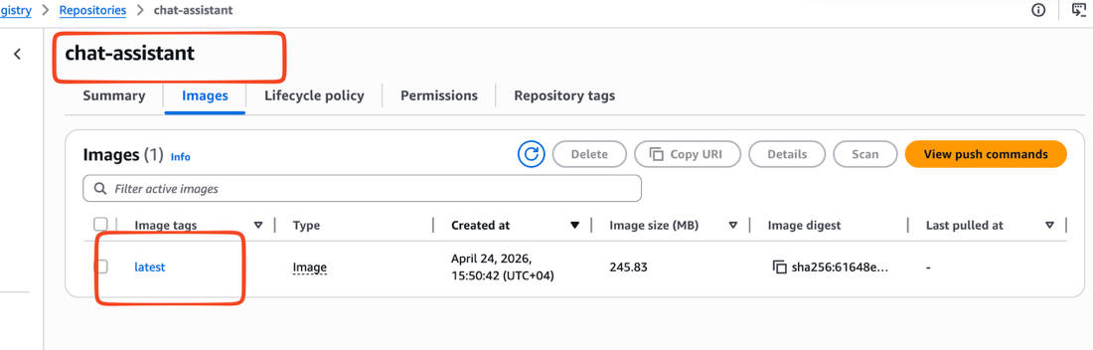

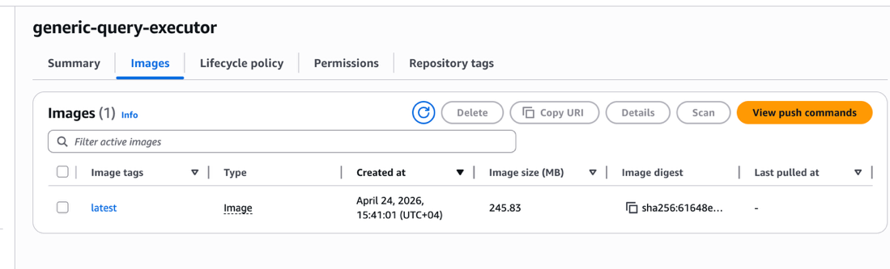

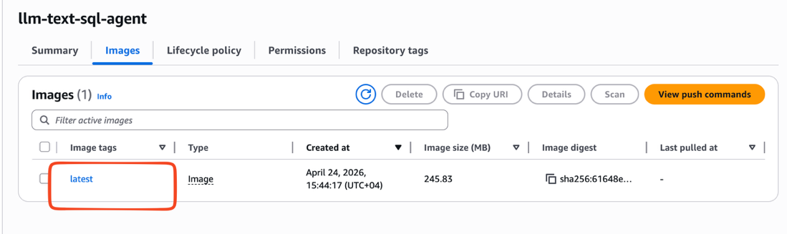

6.Create lambda IAM role with all services like below with a policy and role

lambda, rds, cloudwatch logs, api-gateway, api-gatewayv2, secret manager

RoleName and policy as GENAI-TEXT2SQL-ROLE & GENAI-TEXT2SQL-POLICY

Creating Policy :

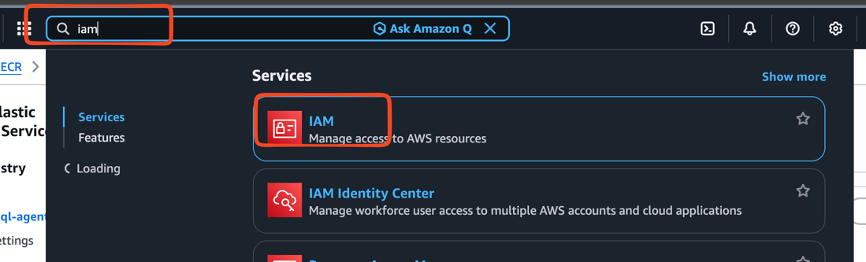

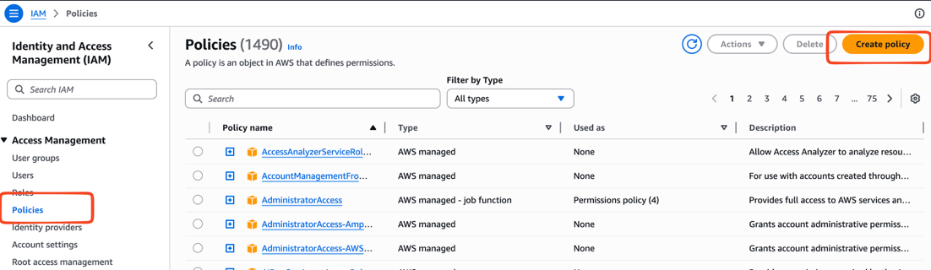

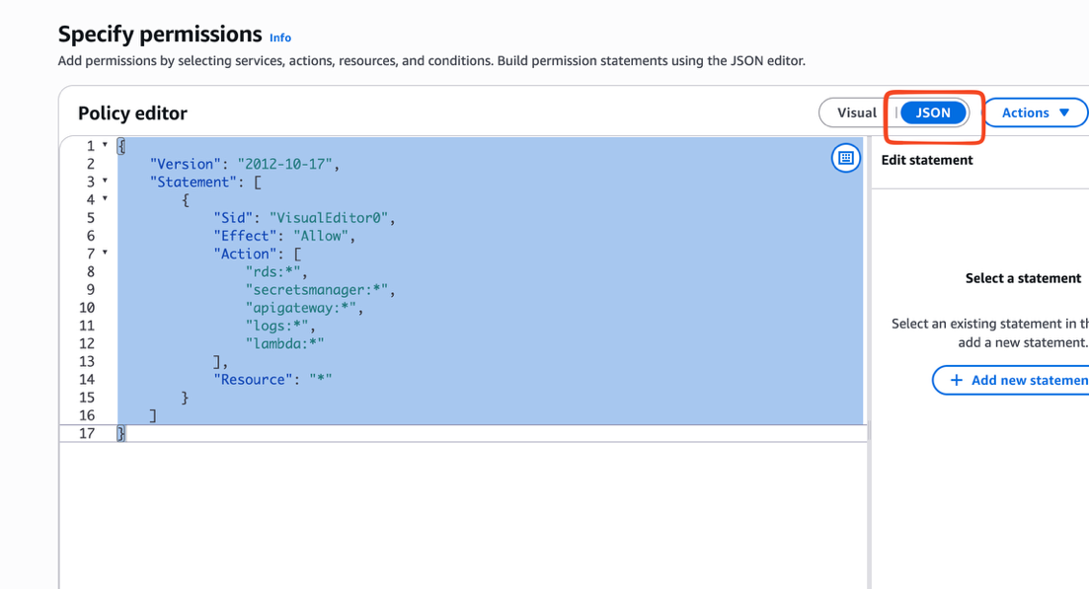

{
"Version": "2012-10-17",
"Statement": [
{
"Sid": "VisualEditor0",
"Effect": "Allow",
"Action": [
"rds:*",
"secretsmanager:*",
"apigateway:*",
"logs:*",
"lambda:*"
],
"Resource": "*"
}
]
}

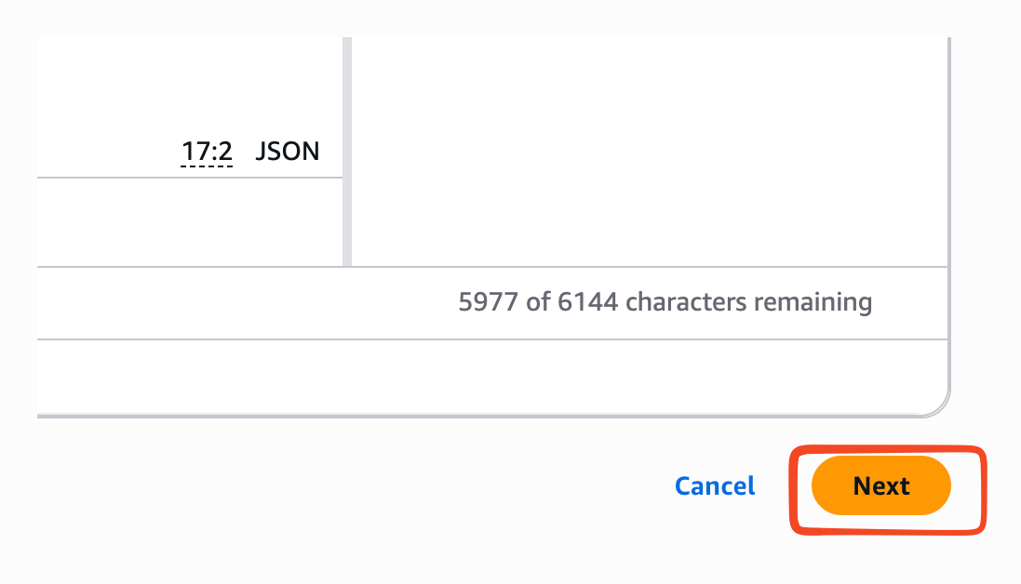

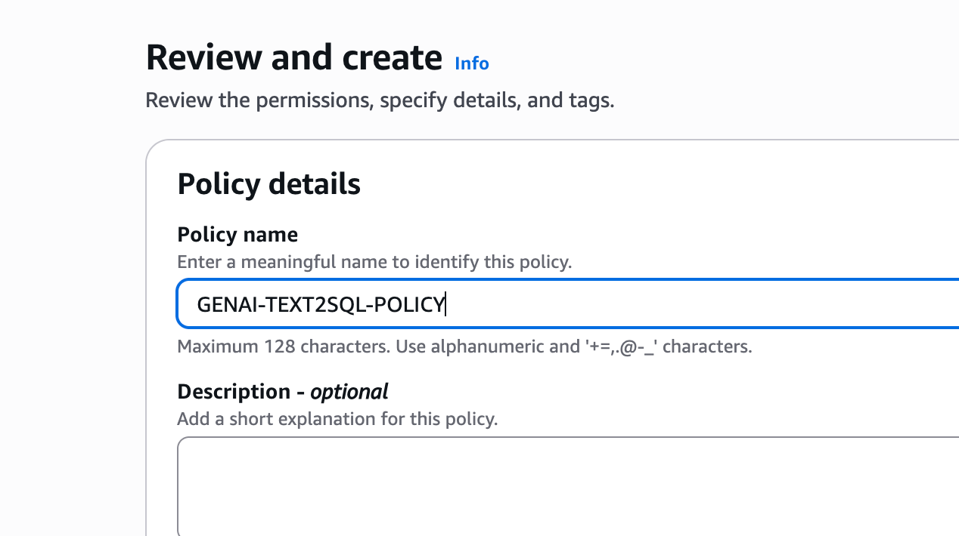

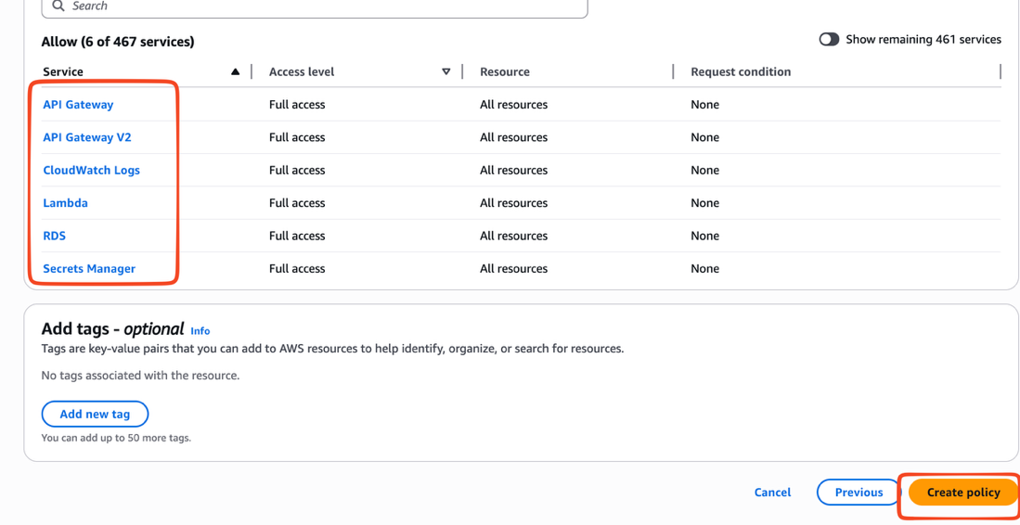

Creating Role:

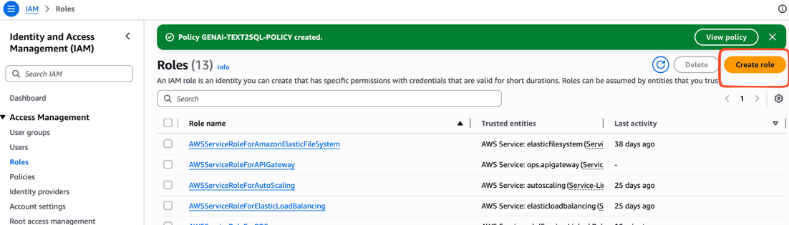

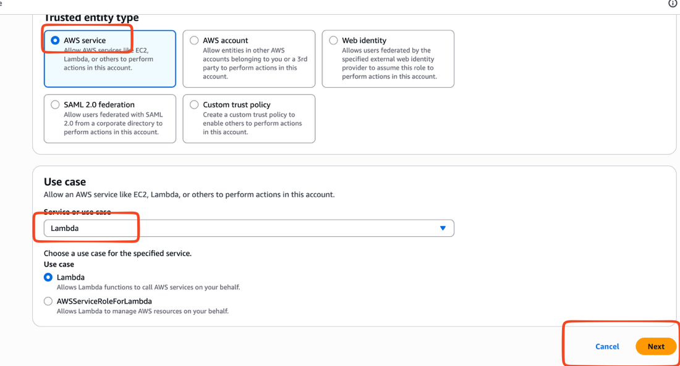

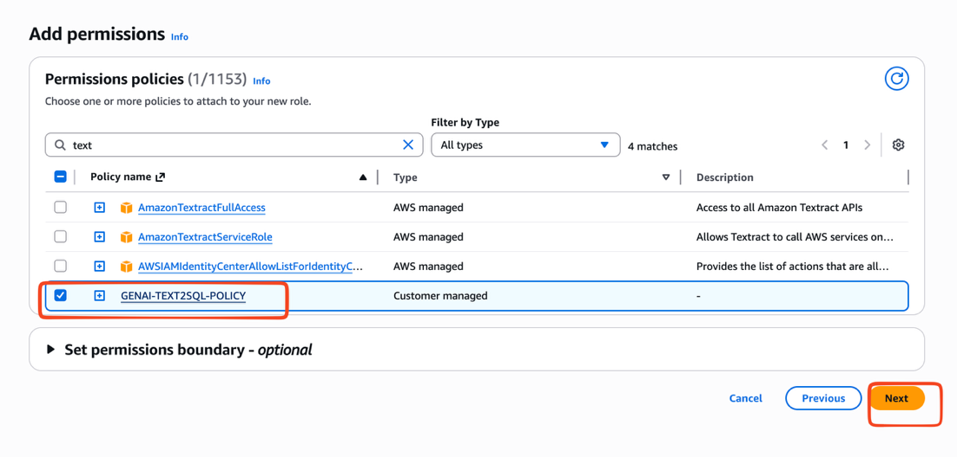

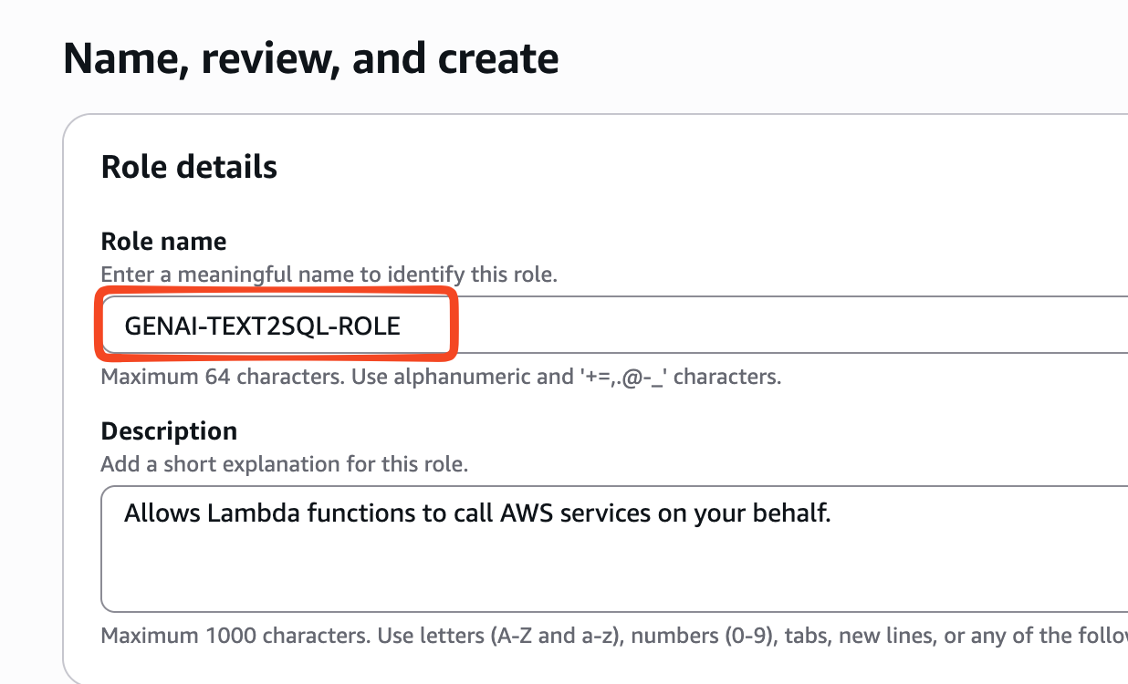

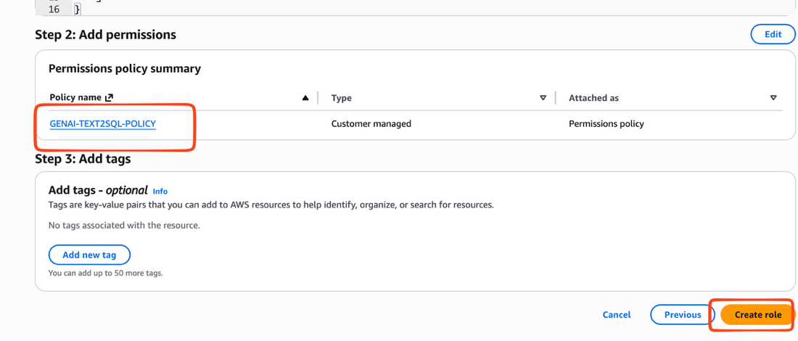

7.Creating Lambda Functions for generic-query-executor & llm-text-sql-agent

1. generic-query-executor

Configure the below as environment variables:

DB_HOST - <YOU HAVE TO UPDATE THIS WITH YOUR RDS ENDPOINT - ONCE CREATED>
DB_NAME - postgres
DB_PASSWORD - postgres1234
DB_PORT - 5432
DB_SECRET_NAME - postgres
DB_USER - postgres

Note:
1. IAM ROLE is important
2. Change execution time to 15 mins
3. We will create RDS at the last and ensure you are creating the DB secret DB_SECRET_NAME - postgres secret manager once you have the database

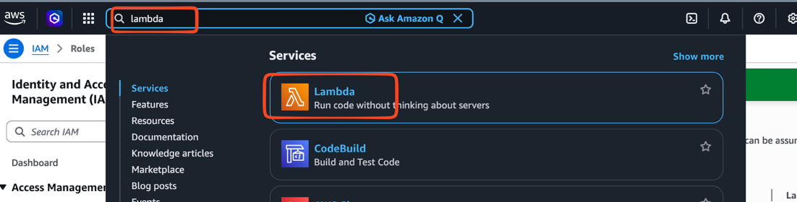

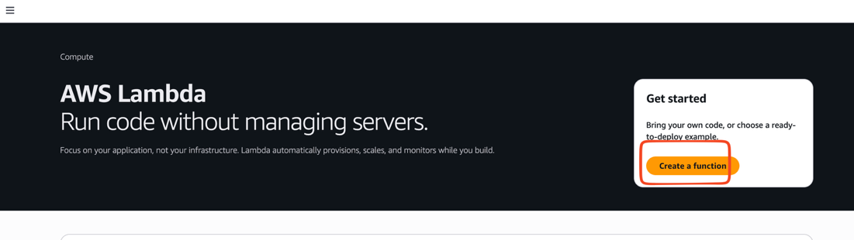

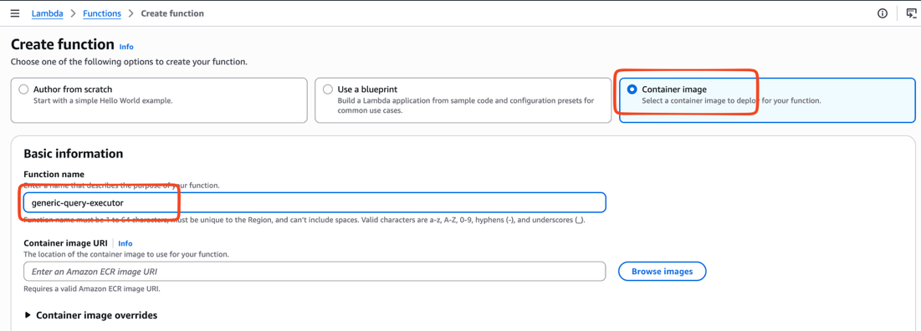

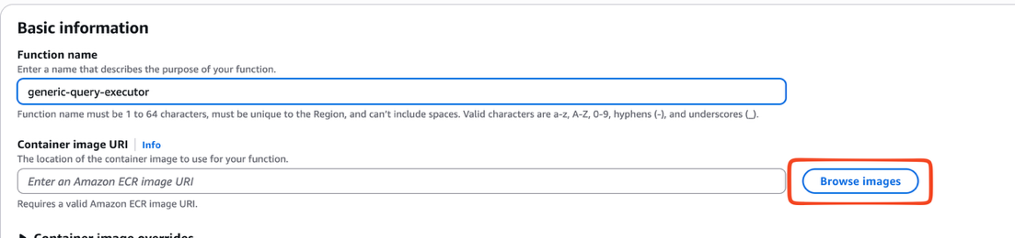

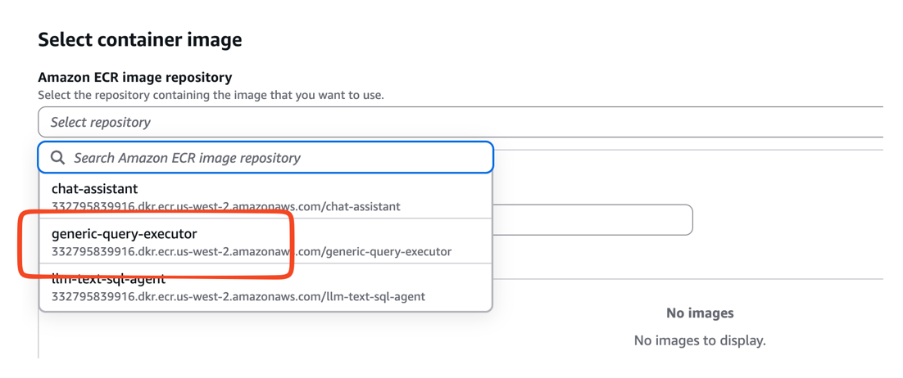

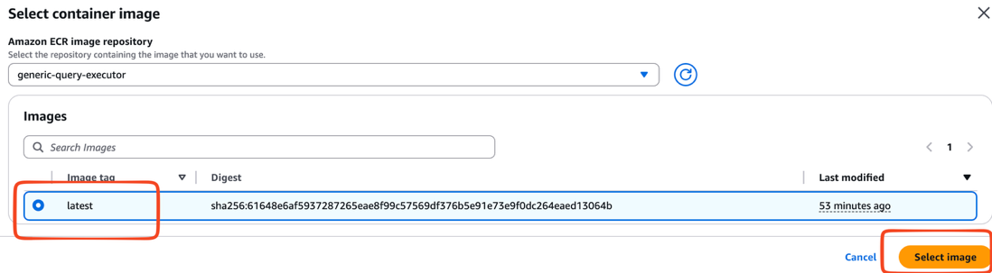

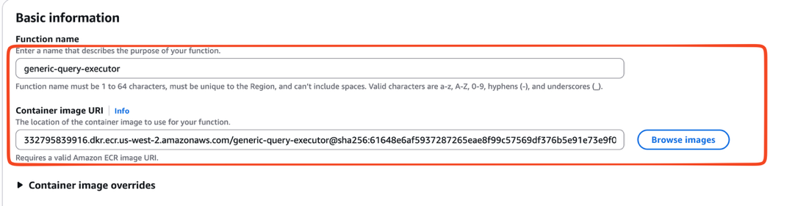

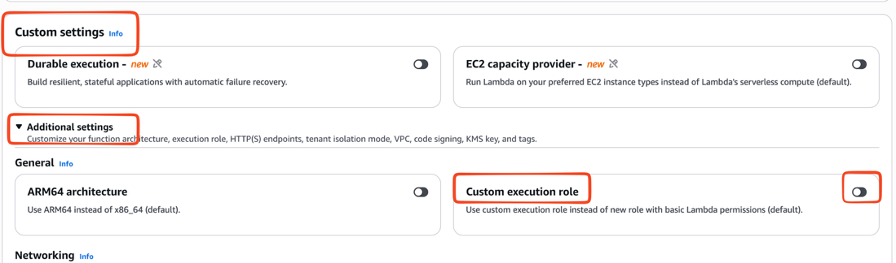

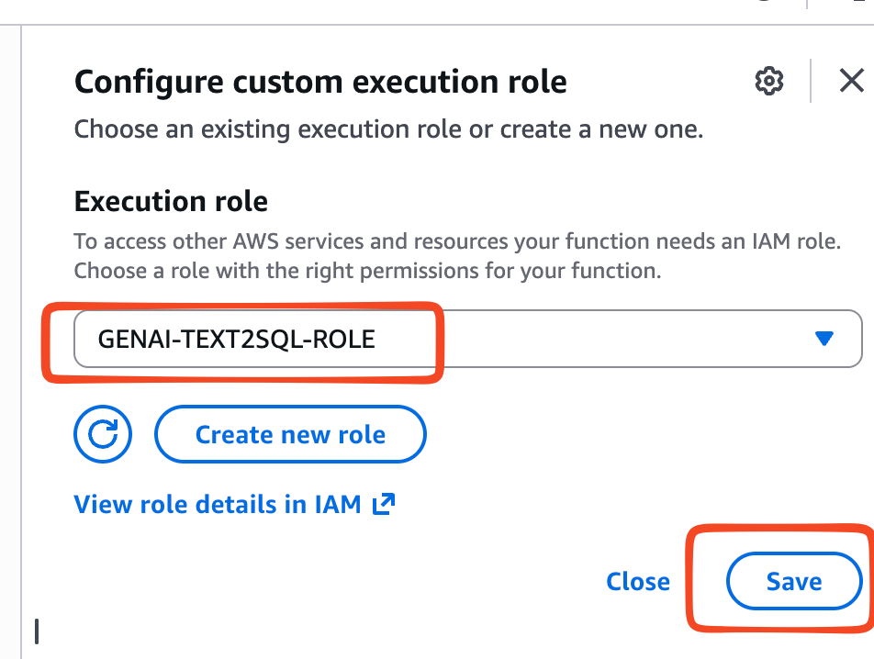

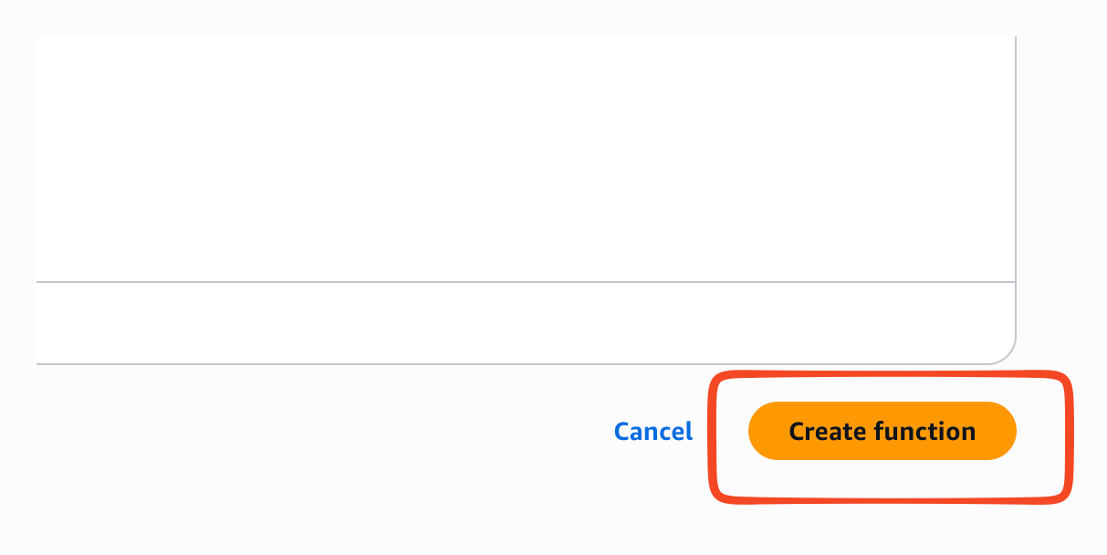

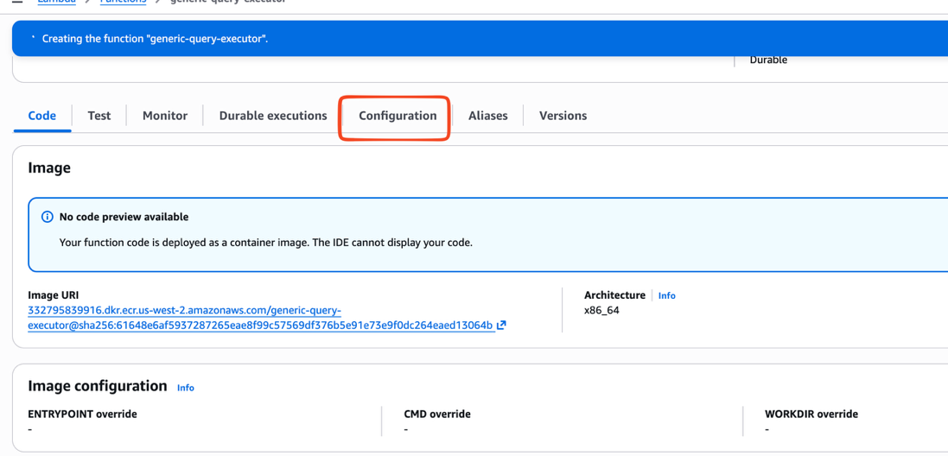

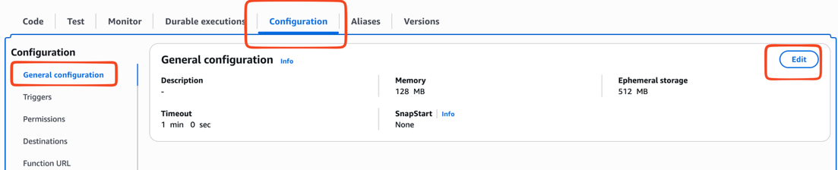

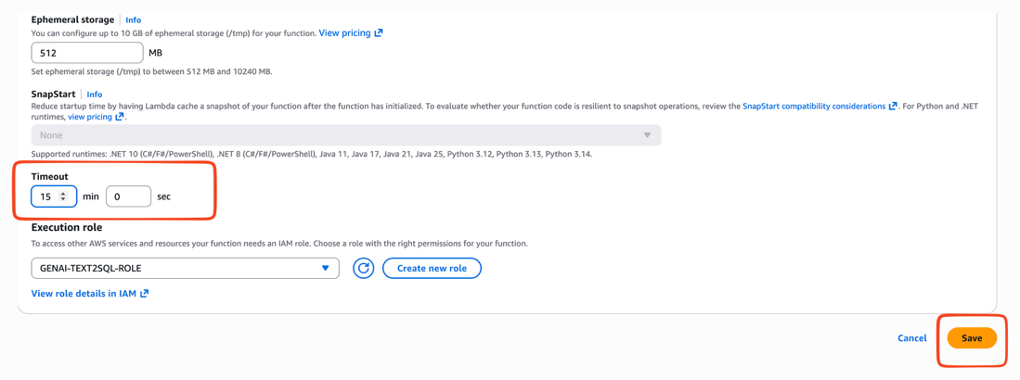

Setting up environment variables

DB_HOST - <YOU HAVE TO UPDATE THIS WITH YOUR RDS ENDPOINT - ONCE CREATED>
DB_NAME - postgres
DB_PASSWORD - postgres1234
DB_PORT - 5432
DB_SECRET_NAME - postgres
DB_USER - postgres

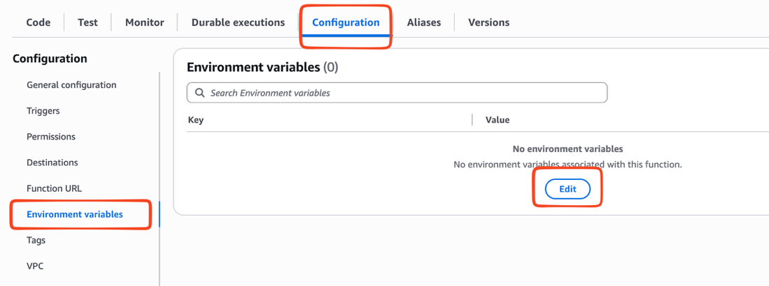

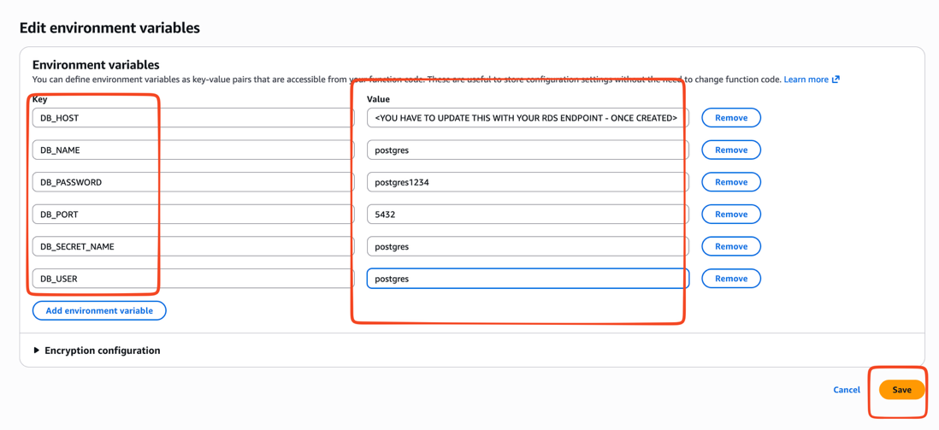

<<<< WILL COME AGAIN AFTER RDS Creation >>>>>>

2. llm-text-sql-agent

Environment variables:

AWS_REGION_NAME: eu-west-2

SECRET_NAME: llm-text-sql-agent-secrets

Secret should be created with below information as others
{
"OPENAI_API_KEY": "",
"OPENAI_MODEL": "gpt-4o-mini",
"QUERY_EXECUTOR_FUNCTION": "generic-query-executor"
}
Note:
- Expose this with function url
- Change execution time to 15 mins
- IAM ROLE is important

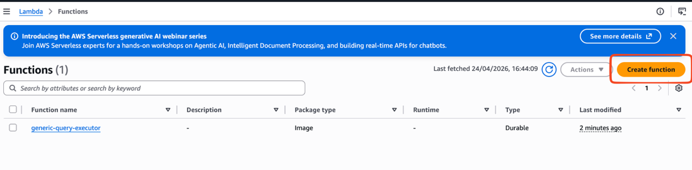

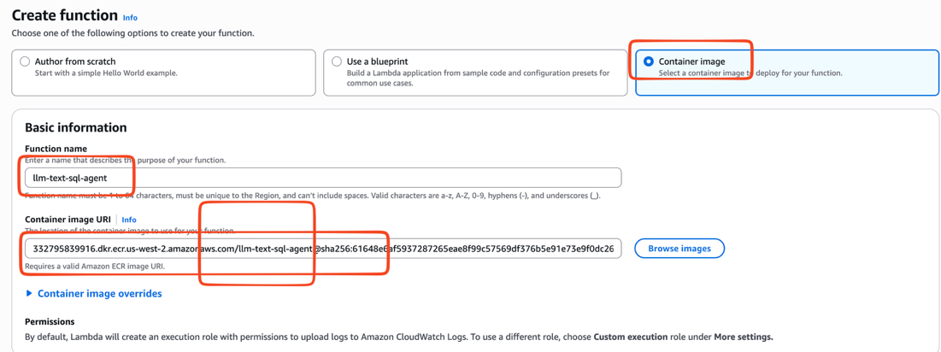

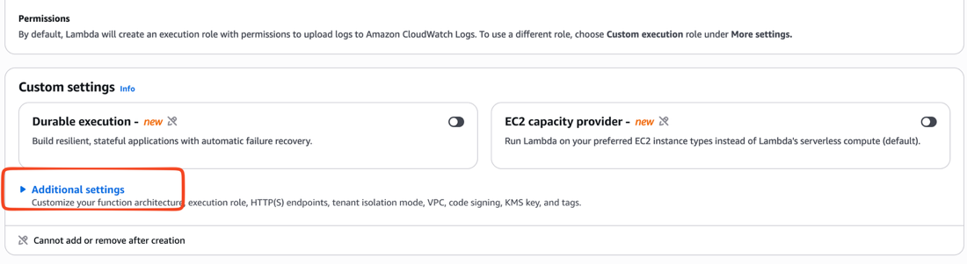

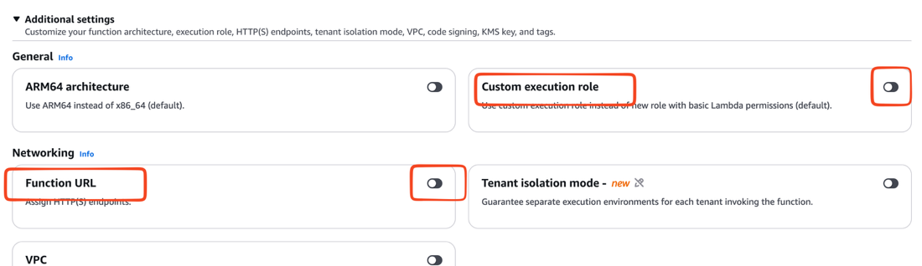

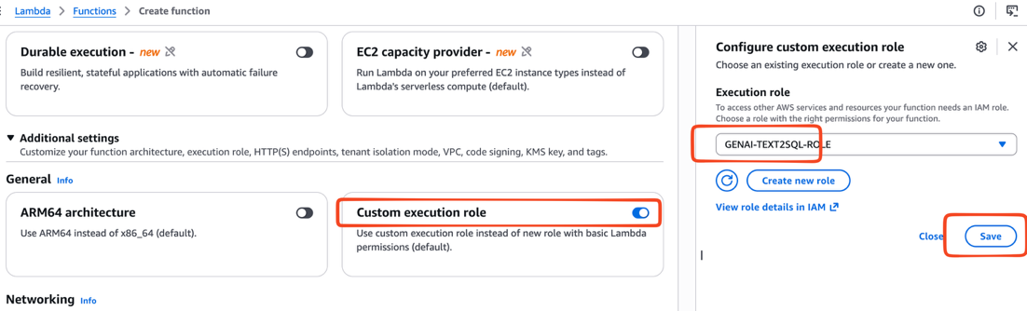

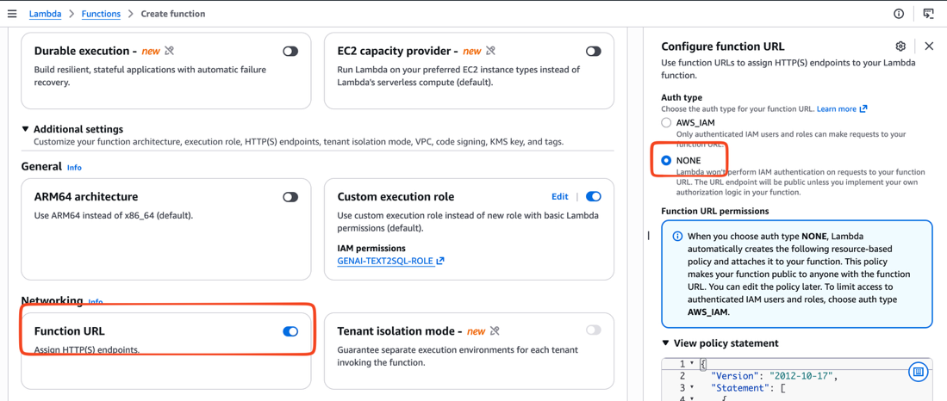

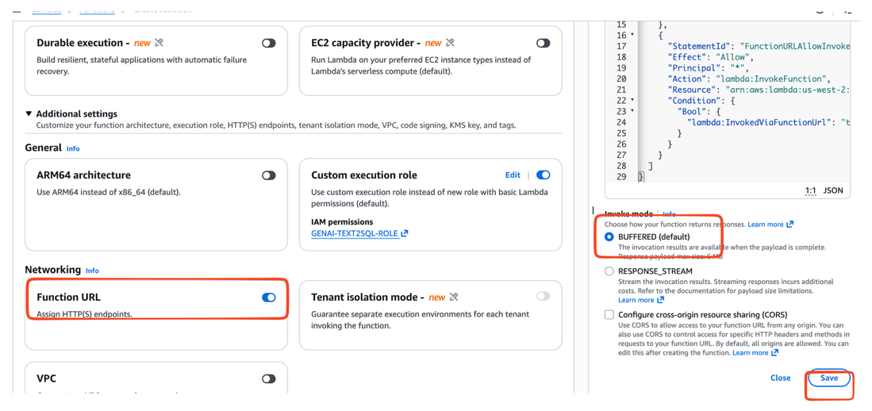

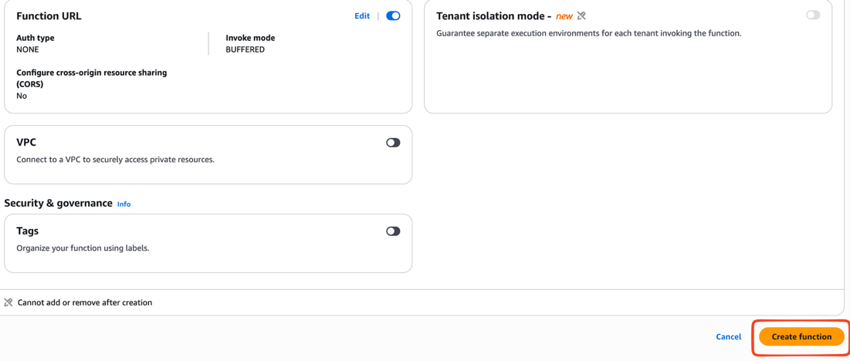

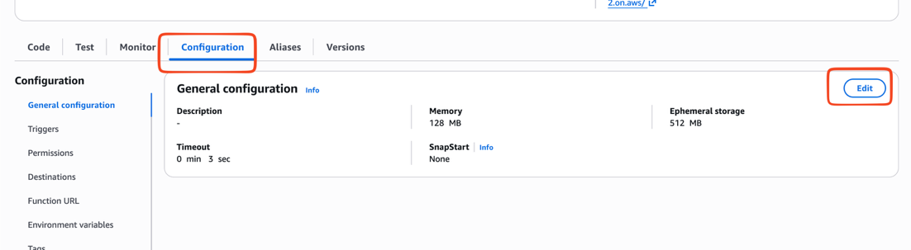

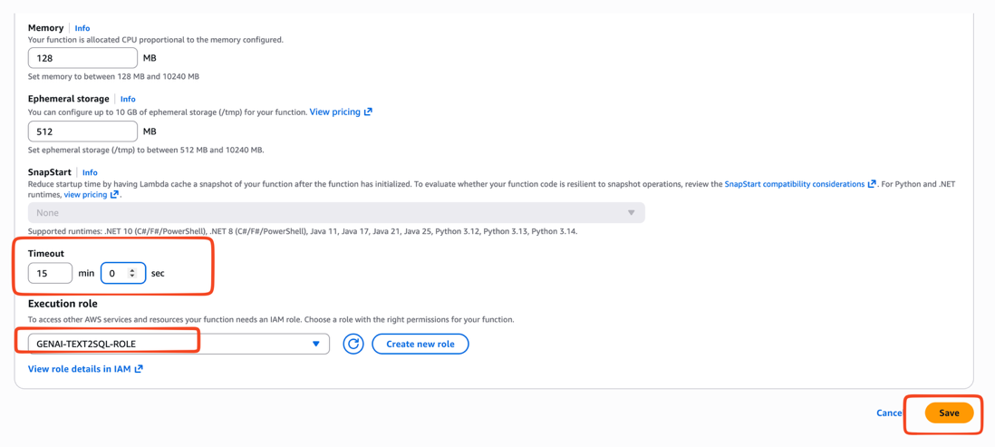

Setting up environment variables

Environment variables:
AWS_REGION_NAME: us-west-2

SECRET_NAME: llm-text-sql-agent-secrets
Secret should be created with below information as others
{
"OPENAI_API_KEY": "",
"OPENAI_MODEL": "gpt-4o-mini",
"QUERY_EXECUTOR_FUNCTION": "generic-query-executor"
}

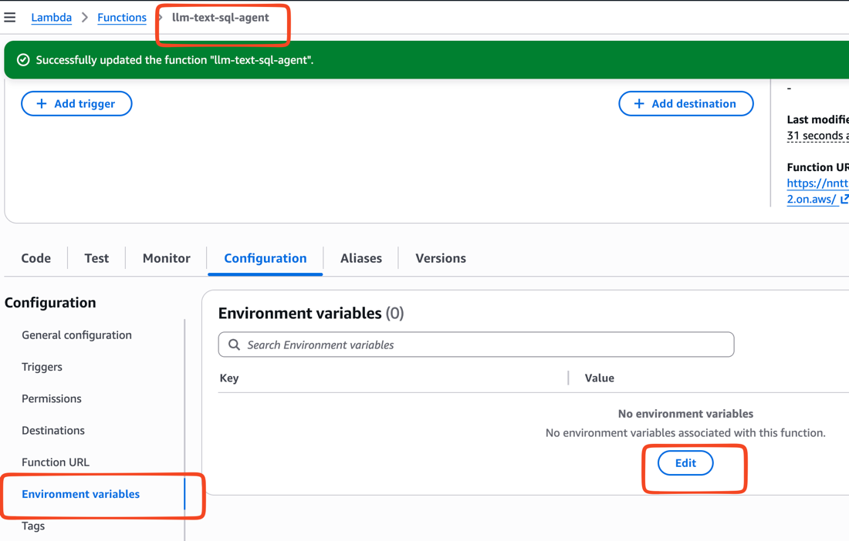

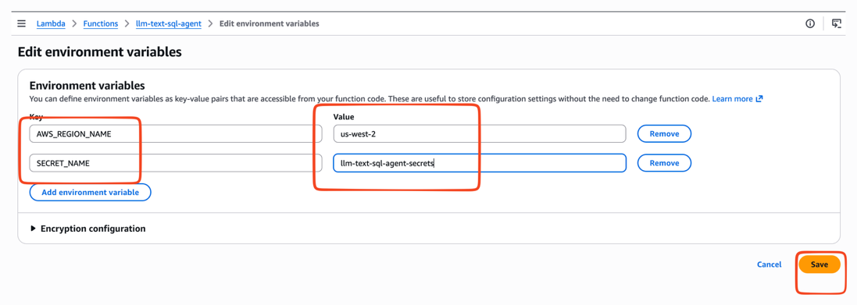

Creating Secrets

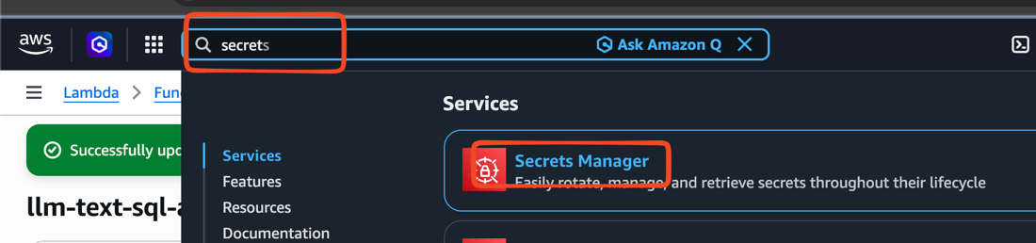

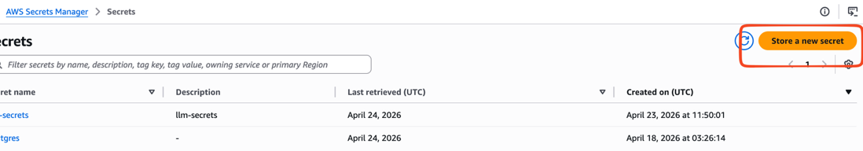

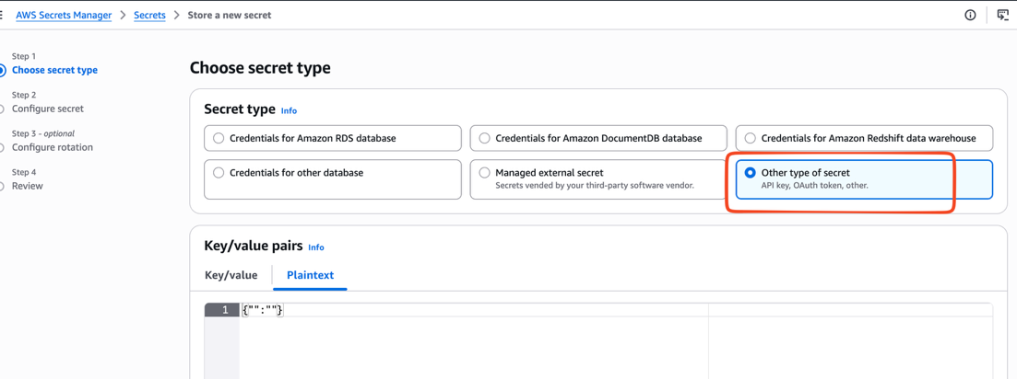

{
"OPENAI_API_KEY": "sk-proj-ZnRNCAoYrBuPh8mPjDgIiqZf99UYDMdcGdJ6Cqjh2vBf1QxPYtpYSsGkPl5m5XGjU6TriXIsOXT3BlbkF”
"OPENAI_MODEL": "gpt-4o-mini",
"QUERY_EXECUTOR_FUNCTION": "generic-query-executor"
}

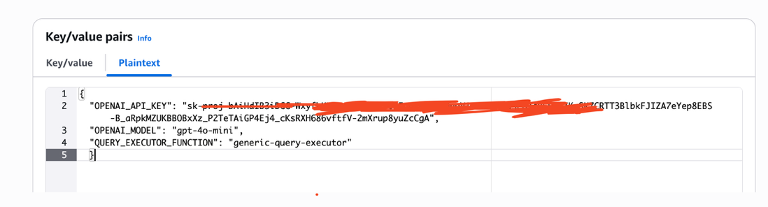

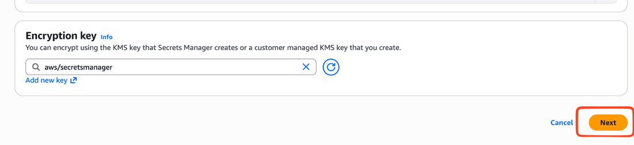

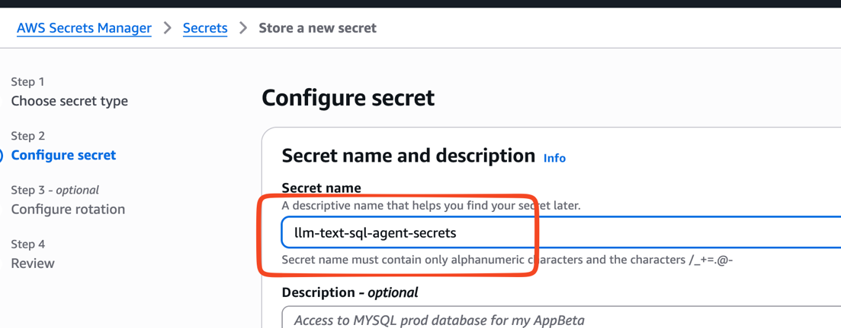

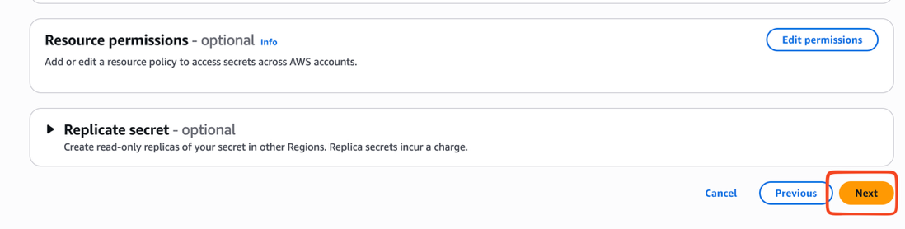

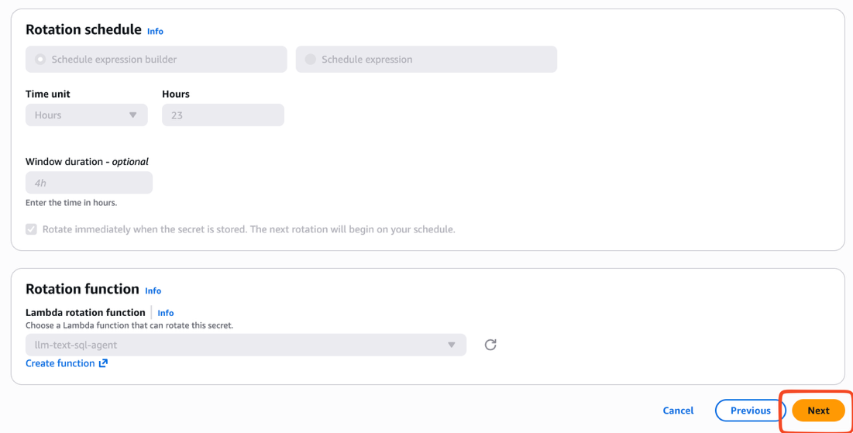

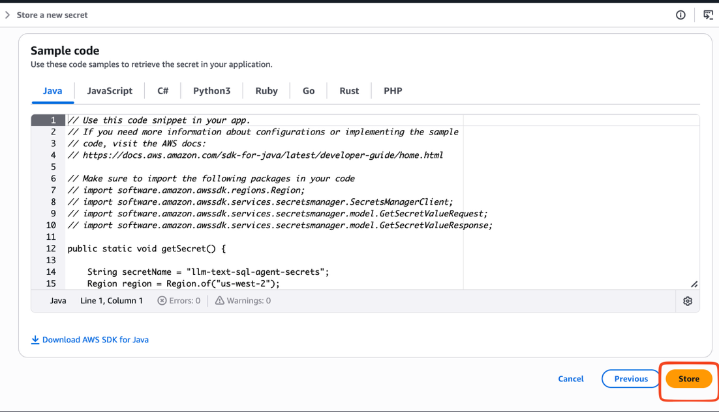

8.Configuring RDS-POSTGRES

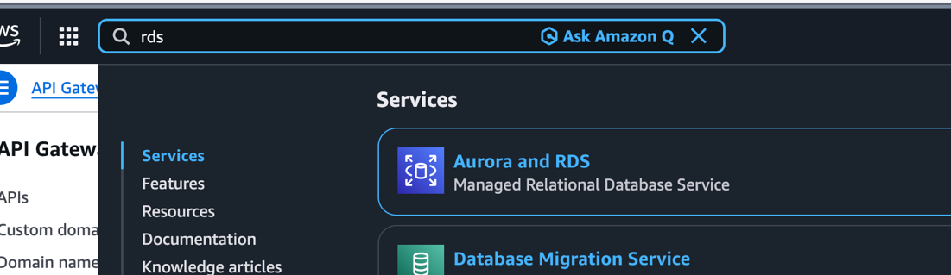

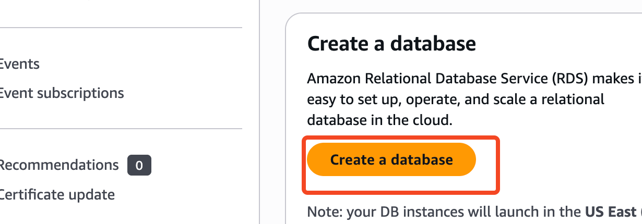

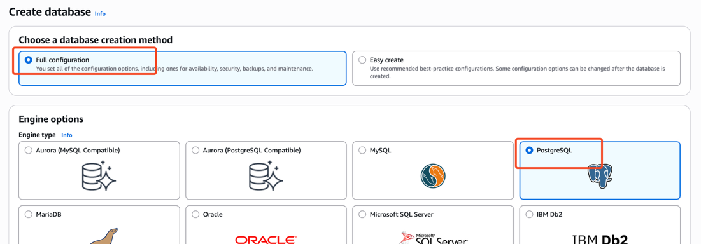

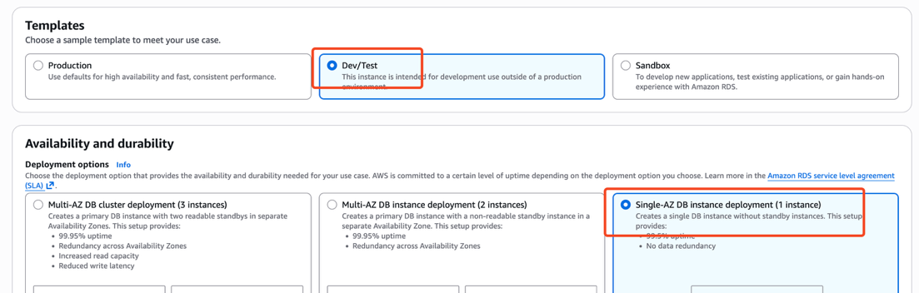

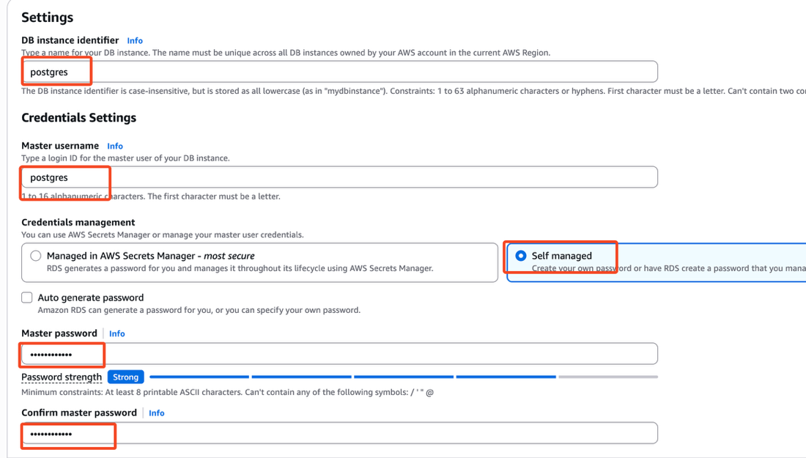

In this case we gave dbname, username and password as postgres,postgres,postgres1234

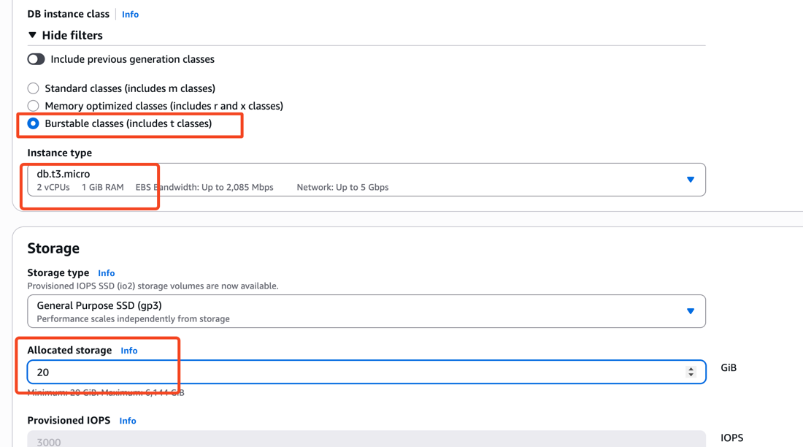

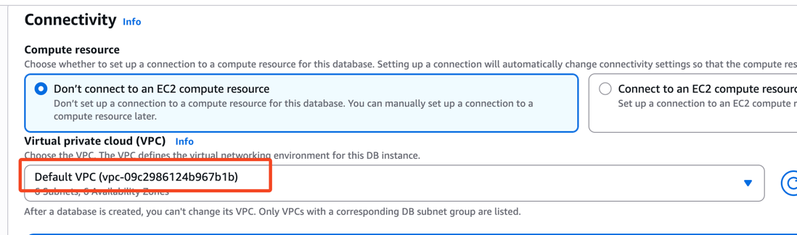

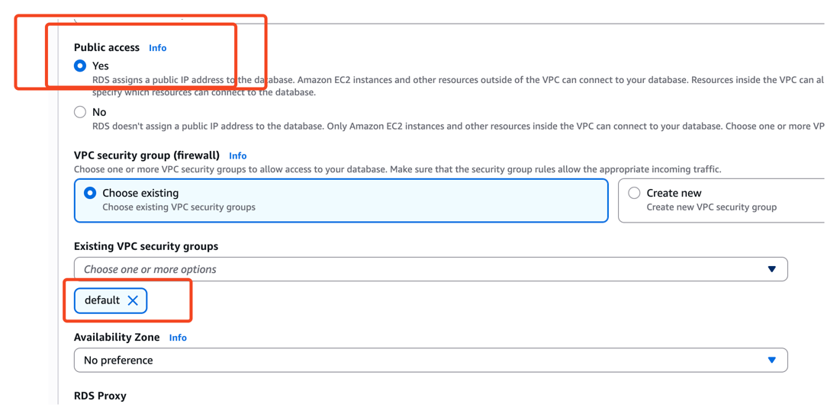

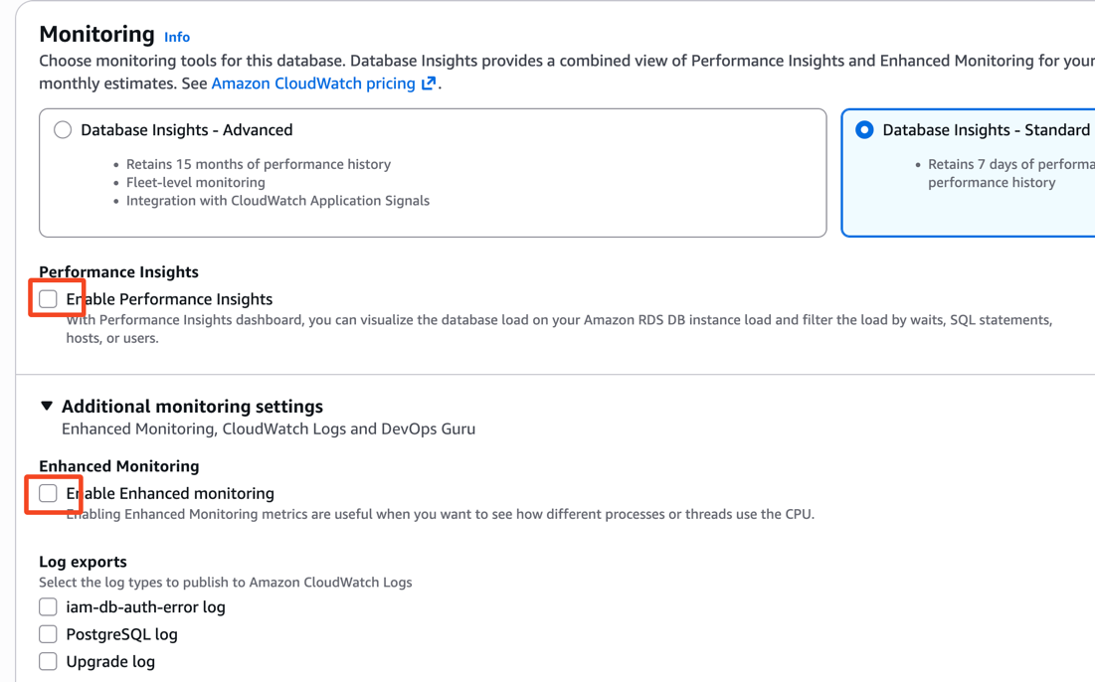

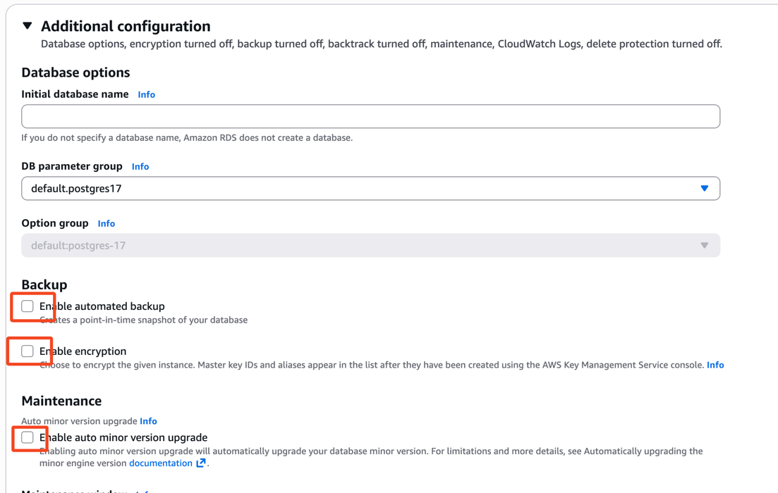

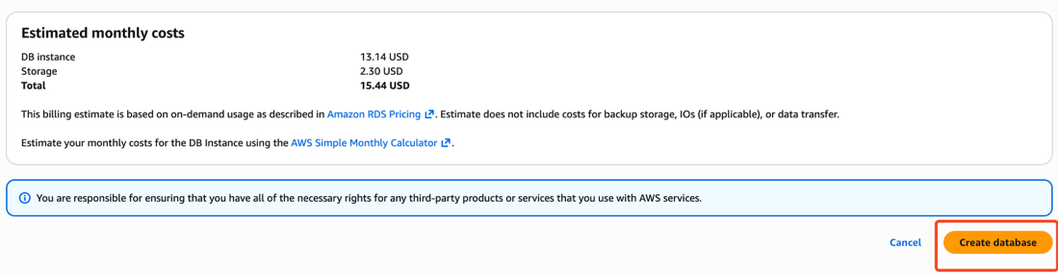

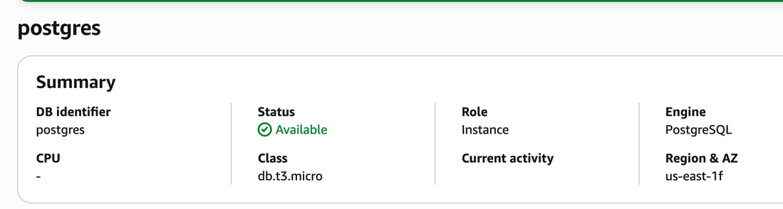

RDS endpoint:

postgres.csp4i2q8g62l.us-east-1.rds.amazonaws.com

Now we are done by creating the rds with postgres

9.Create the secret in the secret manager with below

We need to perform below

postgres as secret name, postgres username, postgres1234 password

1.Create secret in the secret manager

2.Update the generic-query-executor with RDS endpoint in the environment variables

3.Make sure that the security group port 5432 is allowed

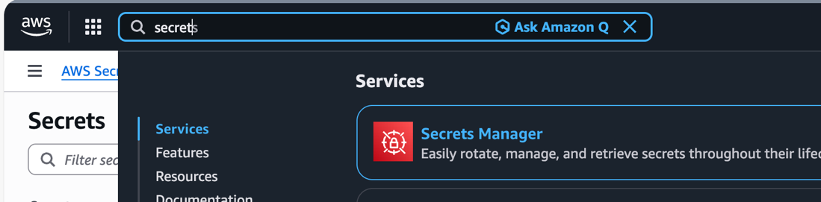

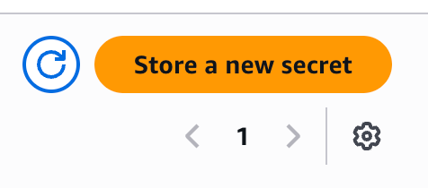

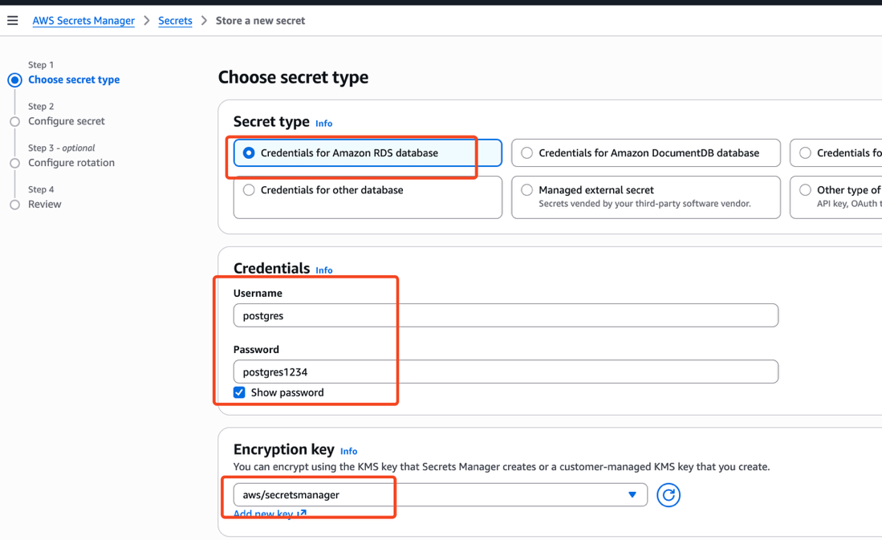

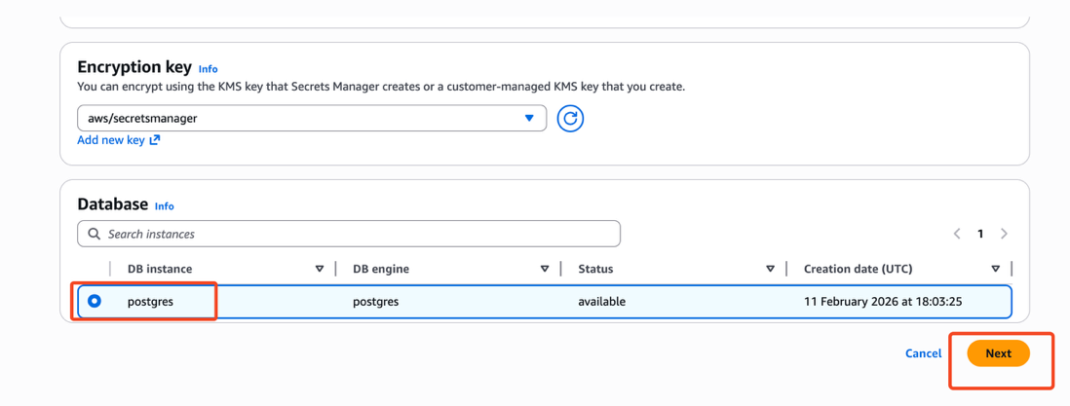

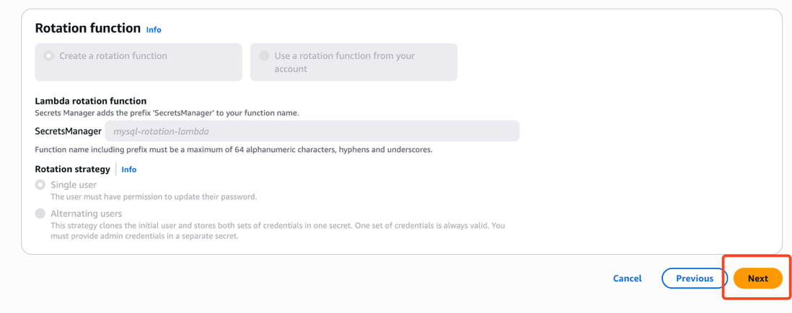

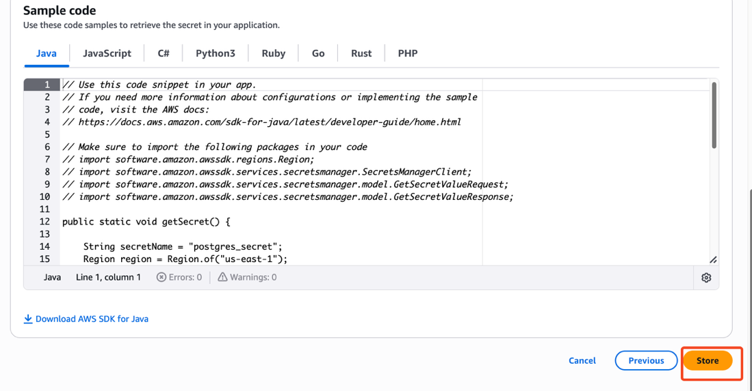

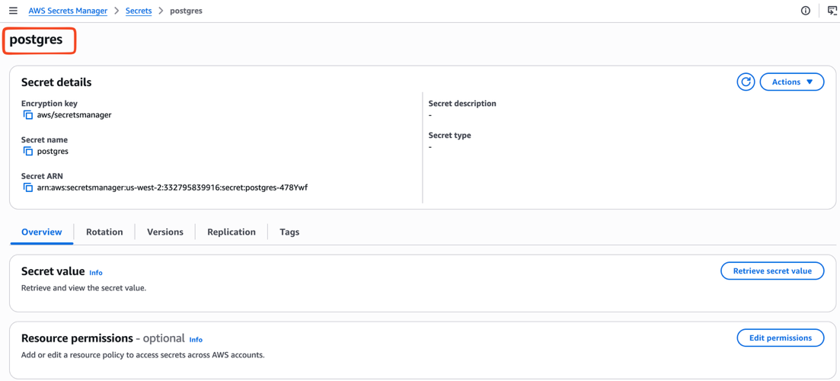

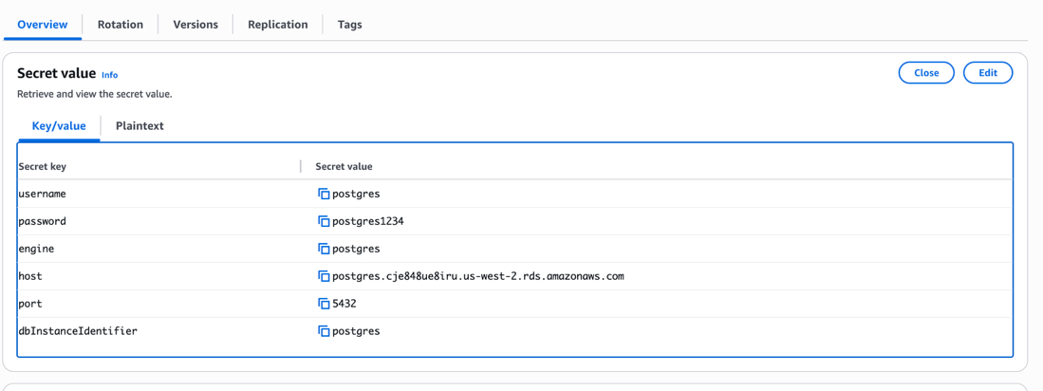

Note: Here postgres we should pass as the DB_SECRET_NAME in the generic-query-executor lambda

Let's update the generic-query-executor lambda

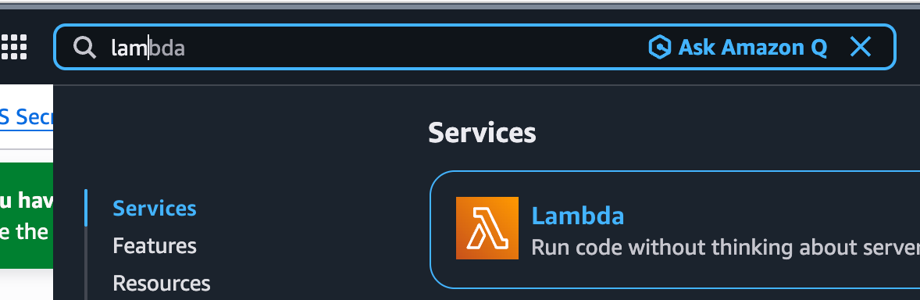

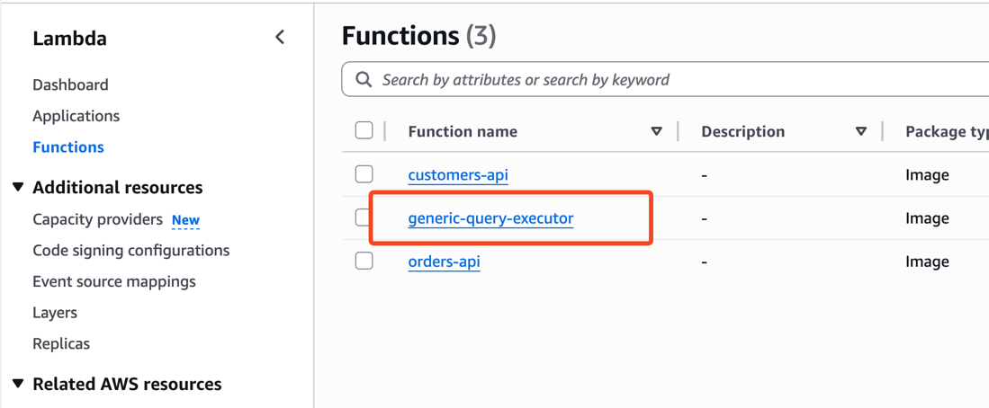

Getting DB hostname details

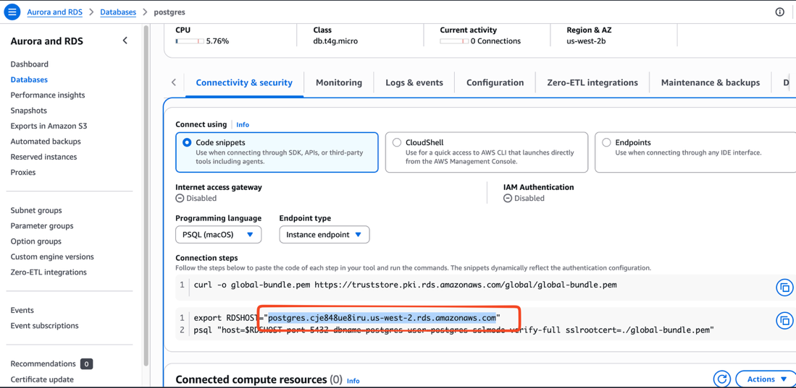

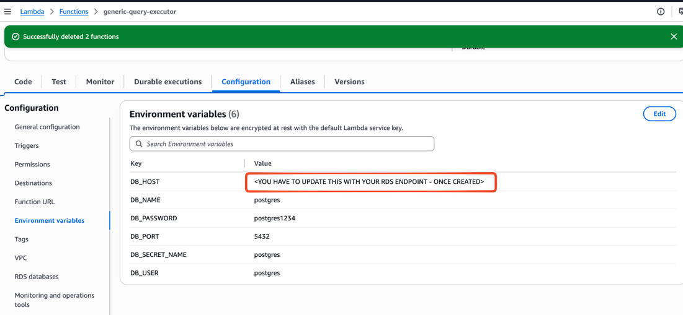

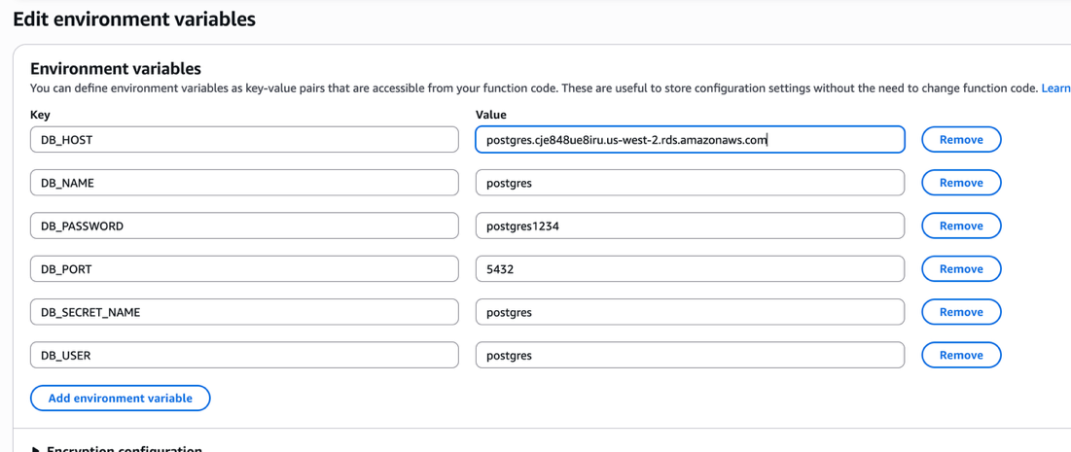

10.Let's load the datasets to the rds-postgres

Login to the workstation and do the below

cd ~/GENAI-MATERIAL/PROJECT3-PROMPT-ENGG-TEXT-TO-SQL/

docker compose up -d

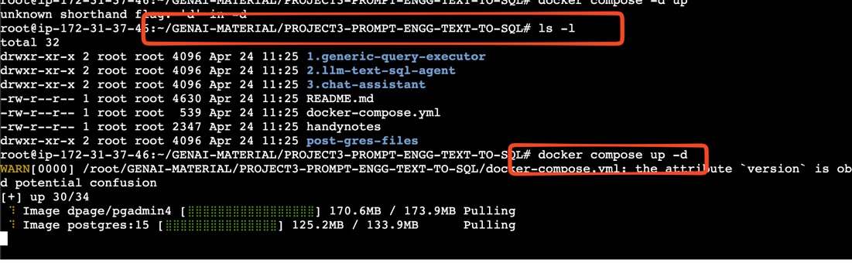

docker ps

Here we are trying to bring up an instance called "PGADMIN" this tool help us to manage the postgres

Note: This tool is going to run on port 5050

Username to login: admin@admin.com
Password: admin123

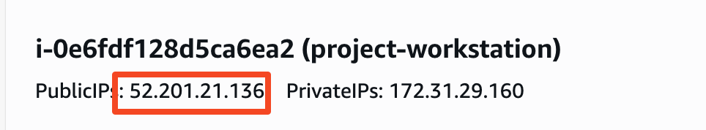

http://52.201.21.136:5050/

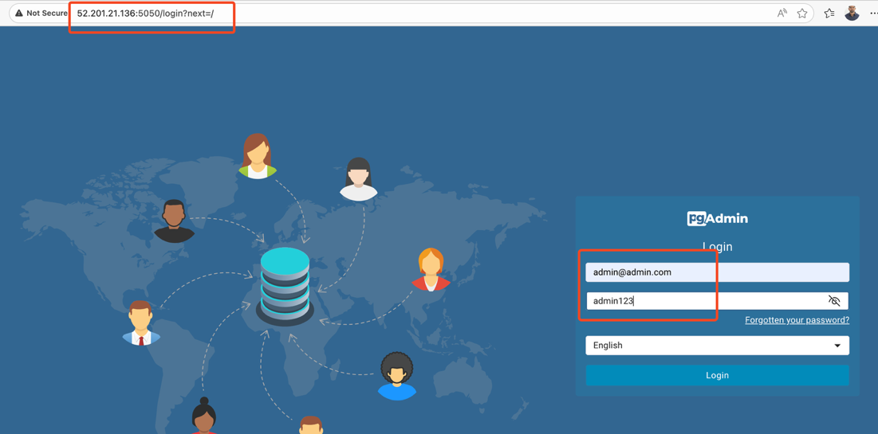

Let's connect to our RDS Postgres

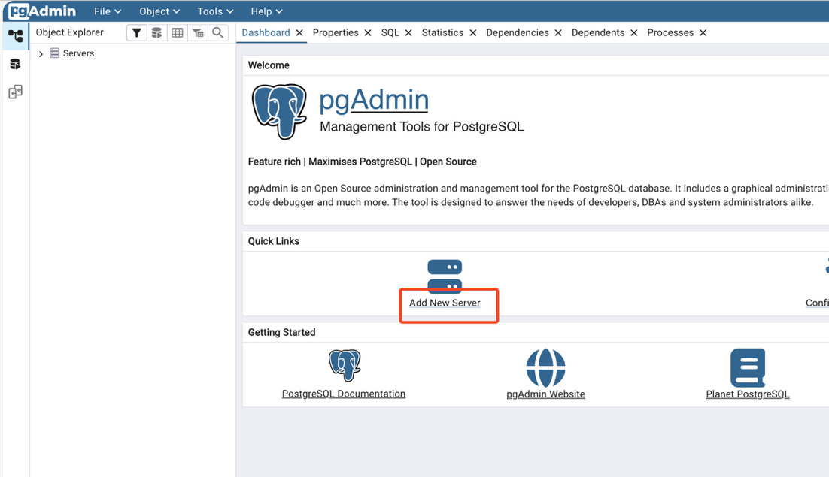

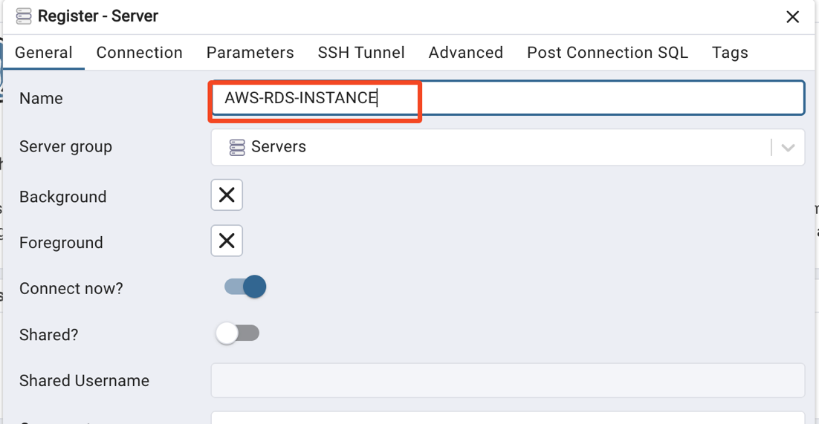

postgres.csp4i2q8g62l.us-east-1.rds.amazonaws.com

postgres

postgres

postgres1234

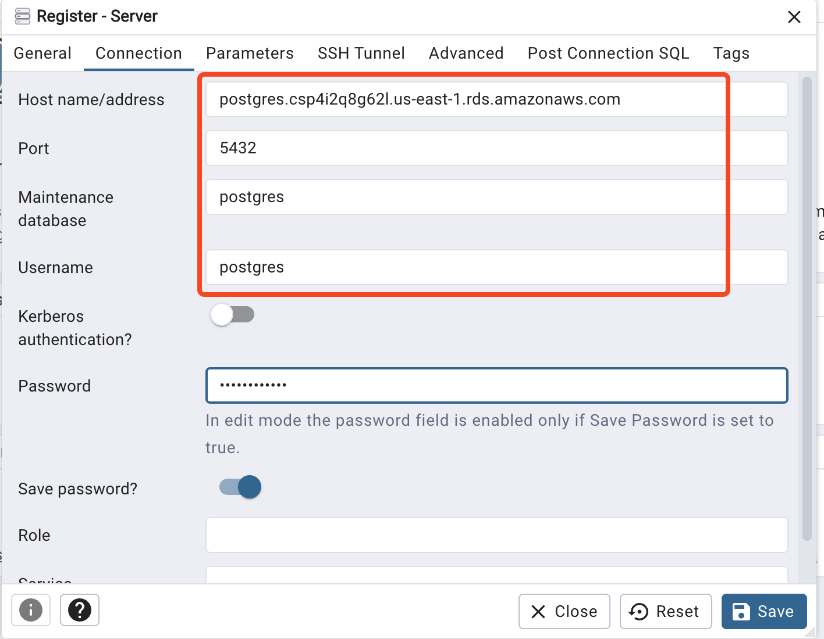

Finally click on save

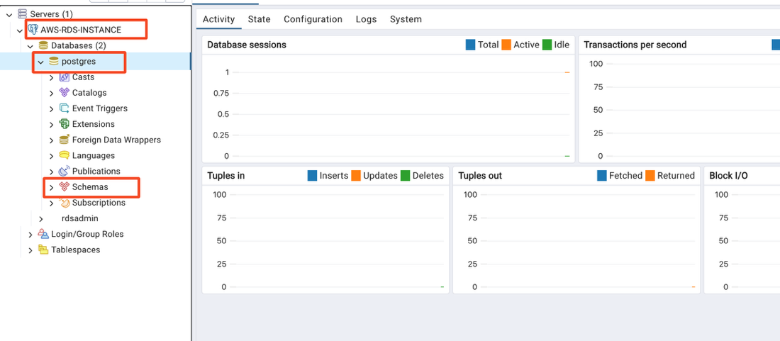

Let's try to create our schema, in our case our schema is "demo". Note don't change the name "demo"

Just right click and do the below

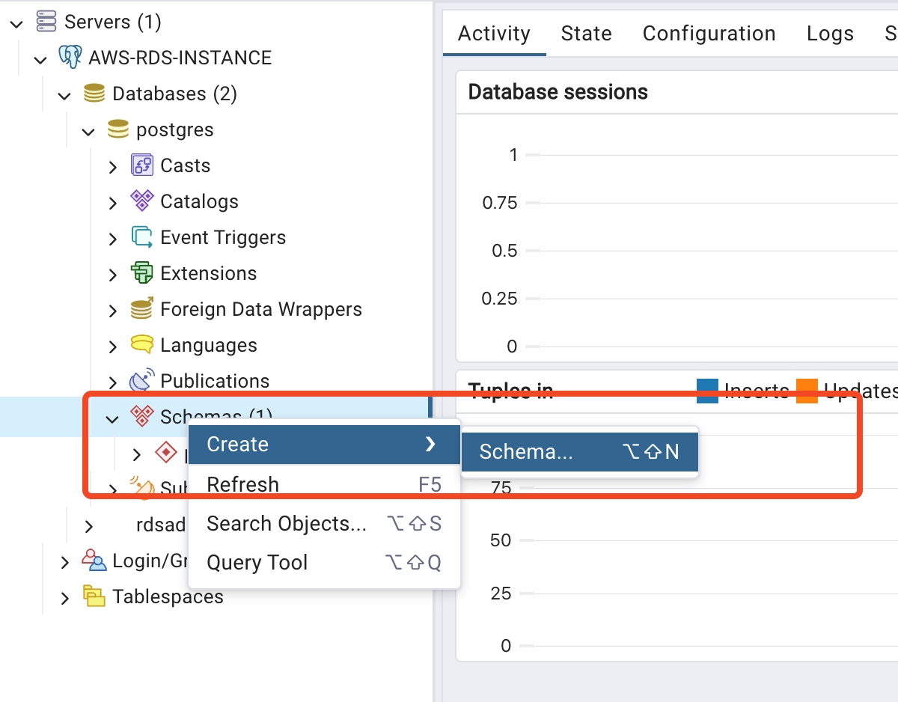

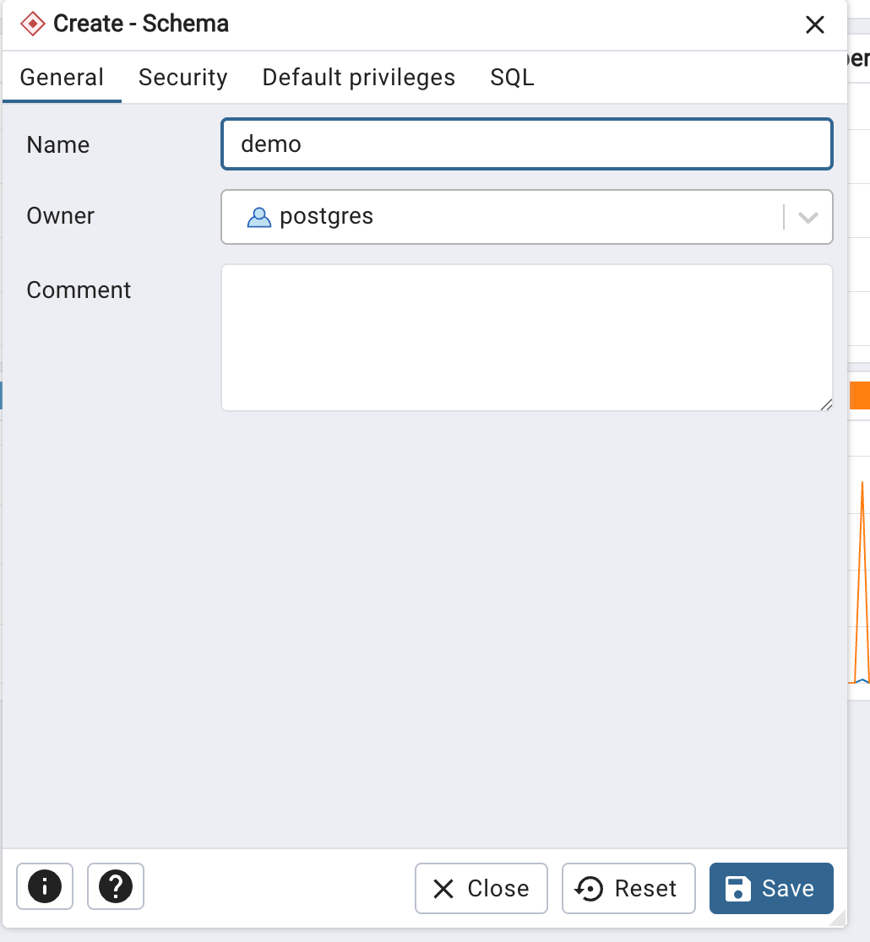

Click on save.

Let's create the tables "customers & orders"

CREATE TABLE demo.customers (
customer_id VARCHAR(20) PRIMARY KEY,
customer_name VARCHAR(100),
email VARCHAR(150),
city VARCHAR(50),
state VARCHAR(10),
created_at TIMESTAMP
);

CREATE TABLE demo.orders (
order_id VARCHAR(20) PRIMARY KEY,
customer_id VARCHAR(20),
order_date TIMESTAMP,
status VARCHAR(50),
total_amount NUMERIC(10,2),
FOREIGN KEY (customer_id) REFERENCES demo.customers(customer_id)
);

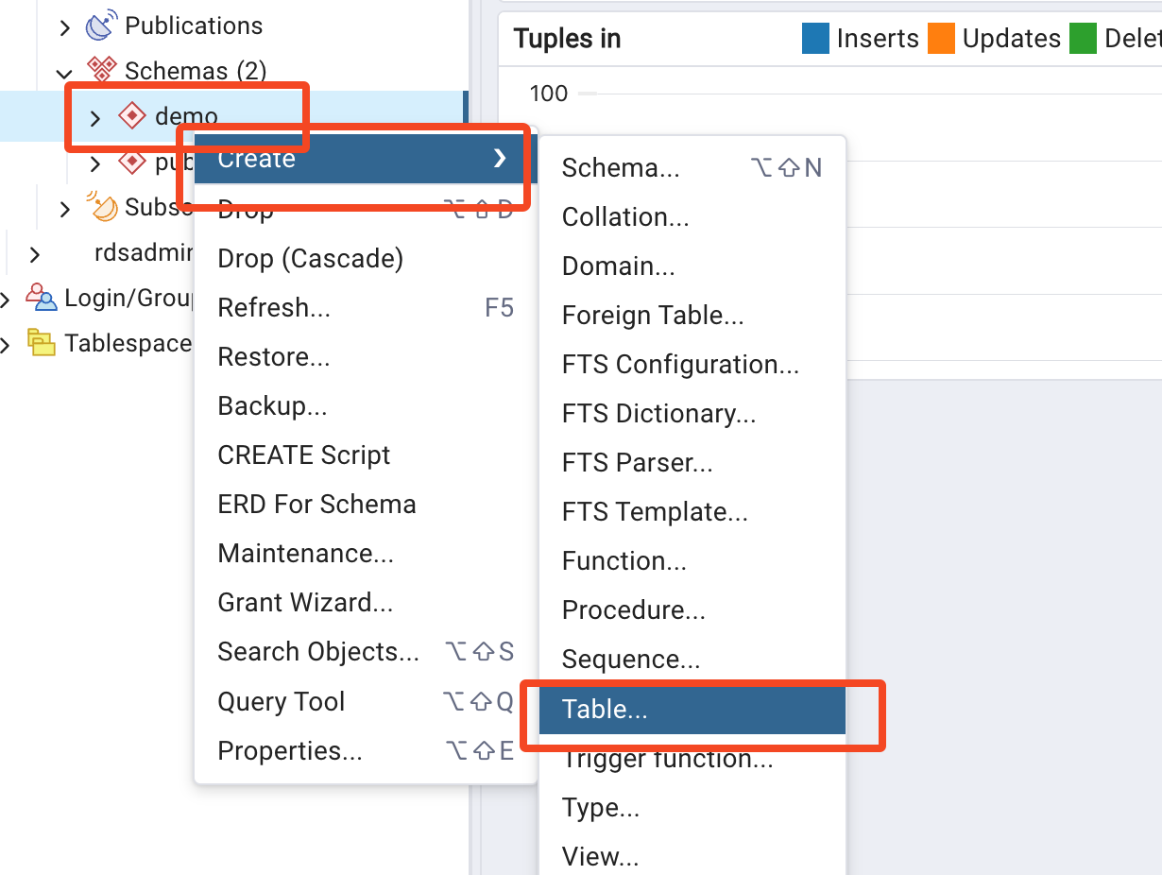

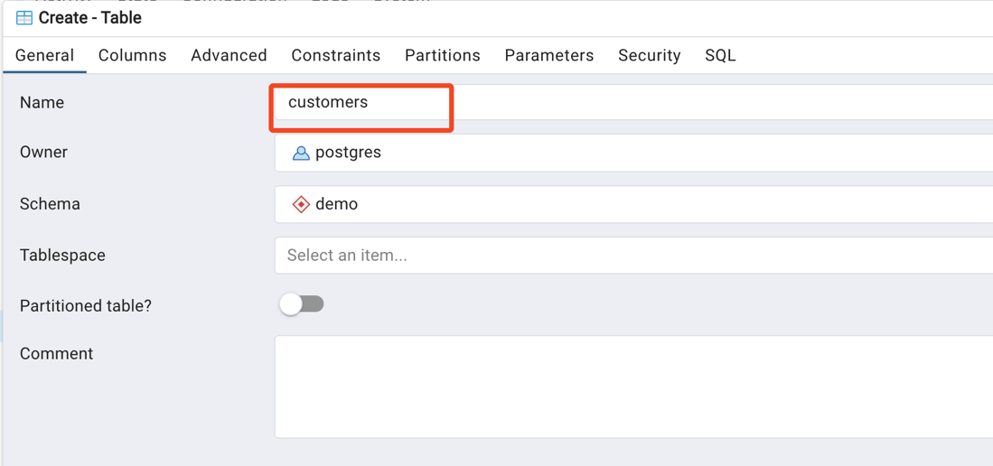

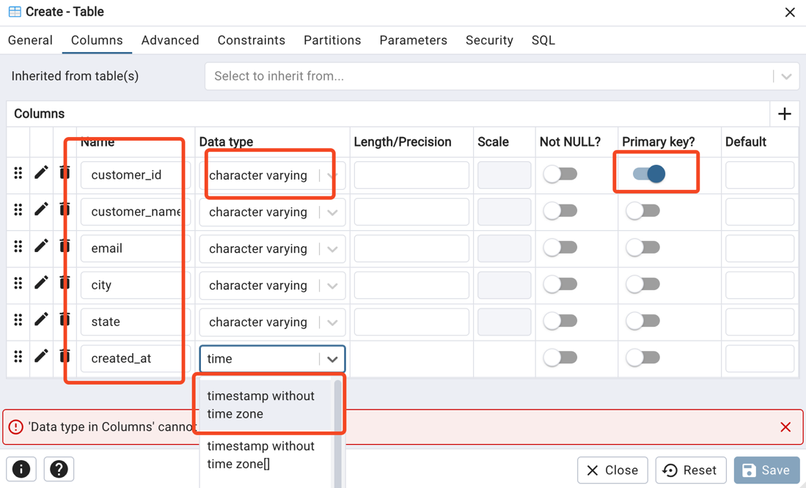

Pls click on save.

Like wise let's create the orders table too

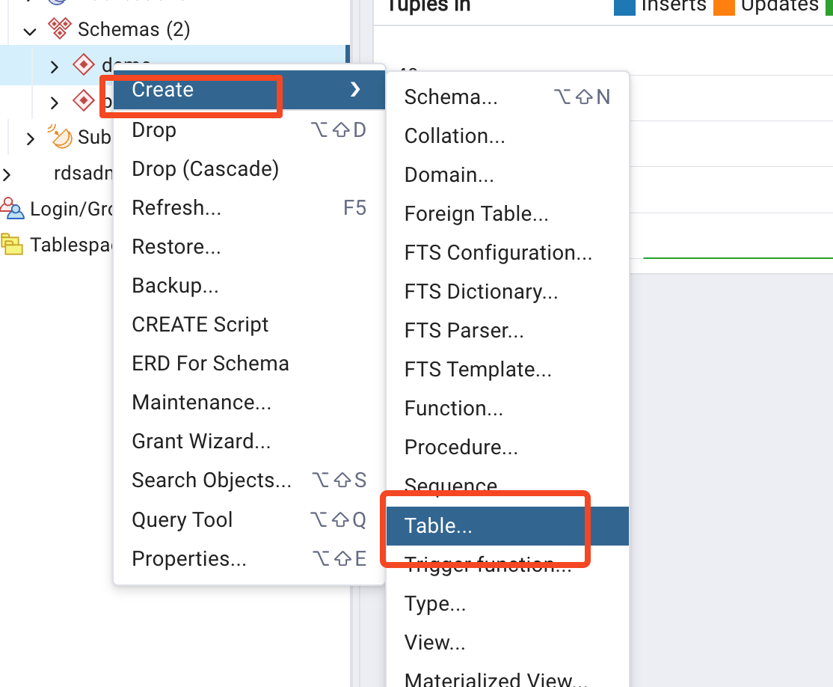

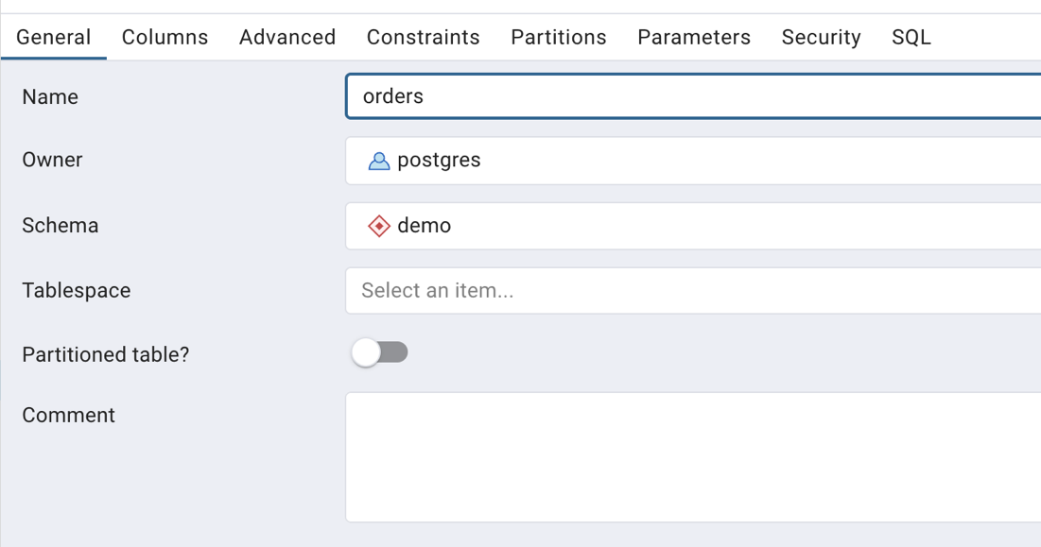

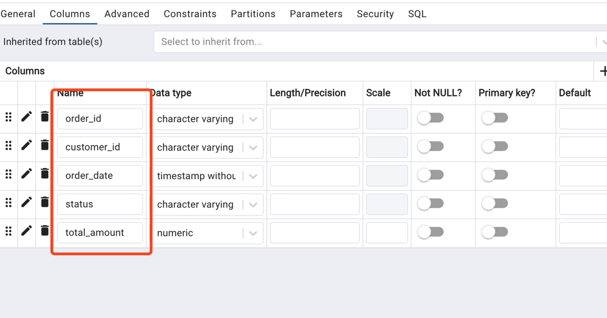

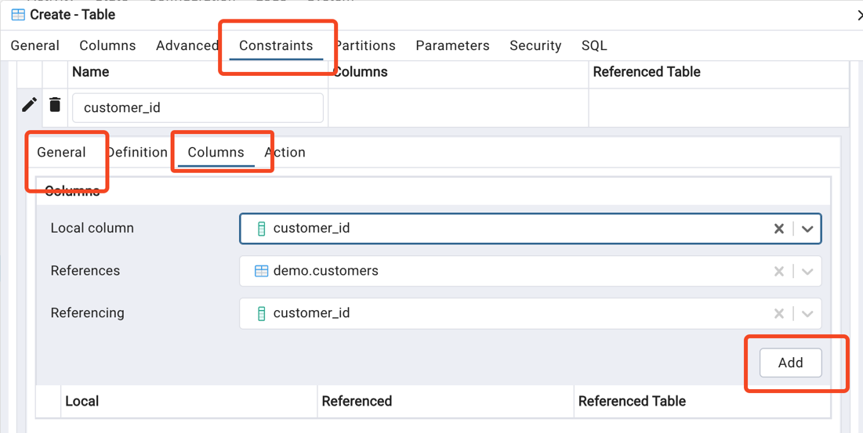

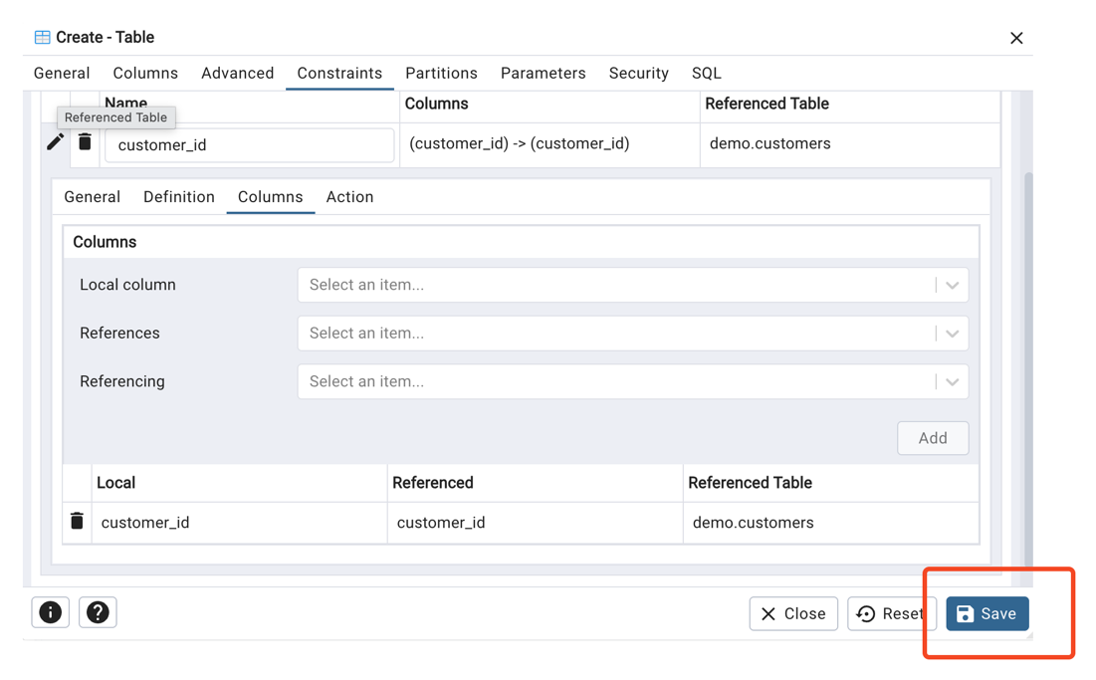

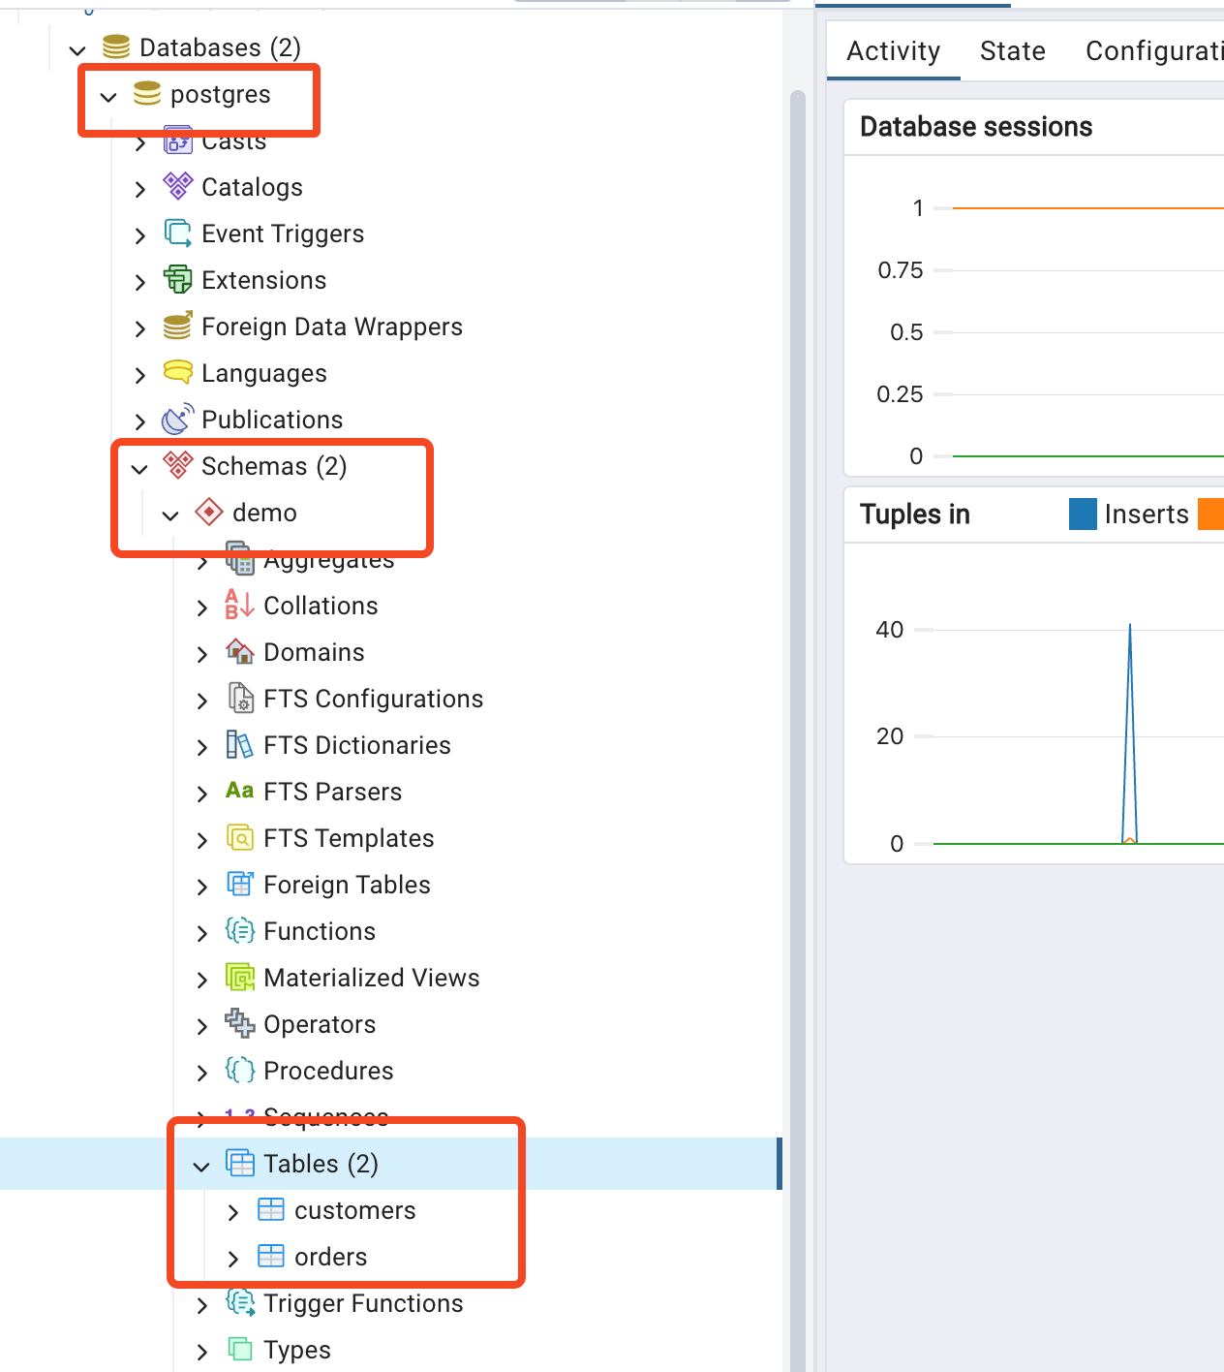

We can able to see that we have two tables "customers, orders"

Let's try to download and upload our datasets

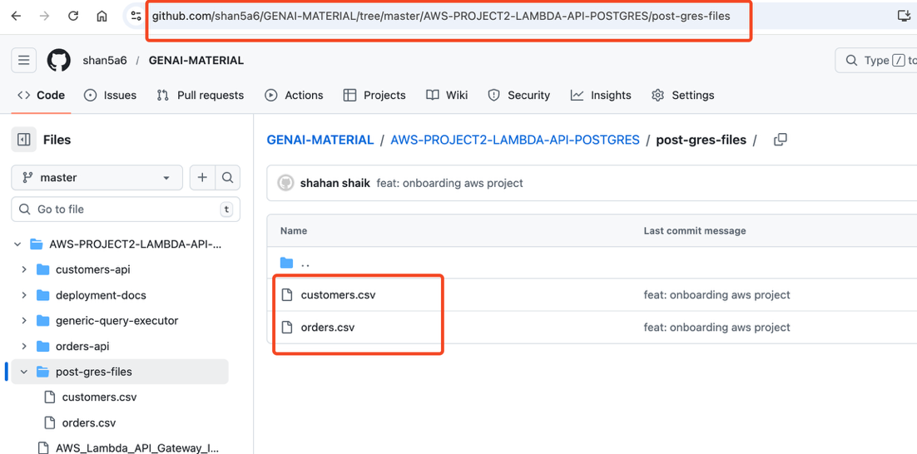

https://github.com/shan5a6/GENAI-MATERIAL/tree/master/AWS-PROJECT2-LAMBDA-API-POSTGRES/post-gres-files

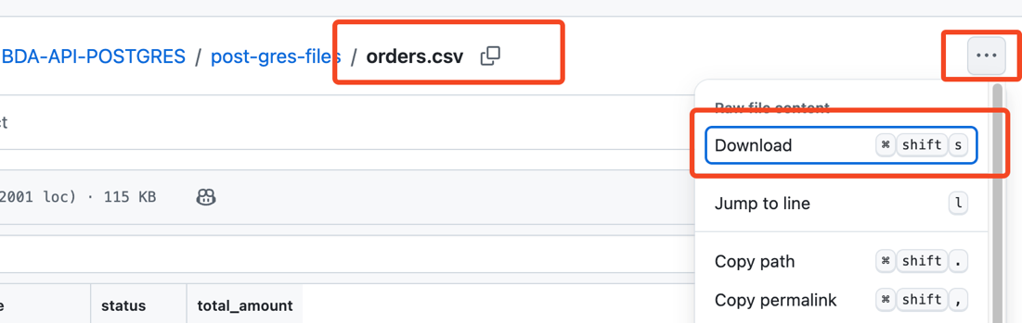

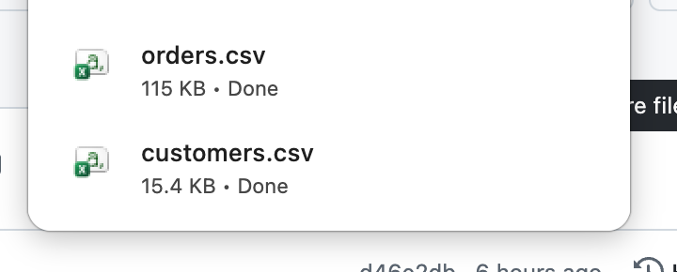

Upload files to tables customers, orders

Rightclick on the table

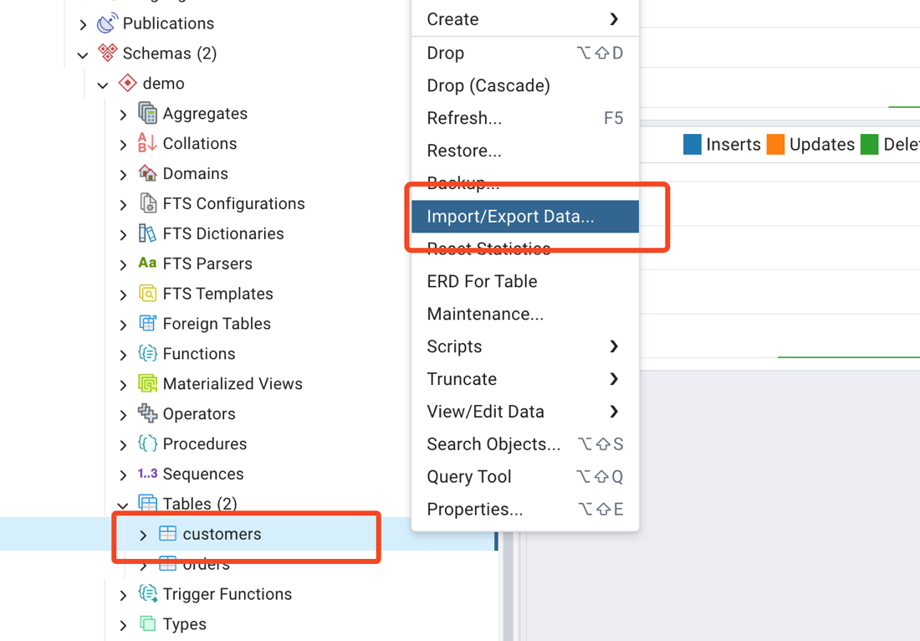

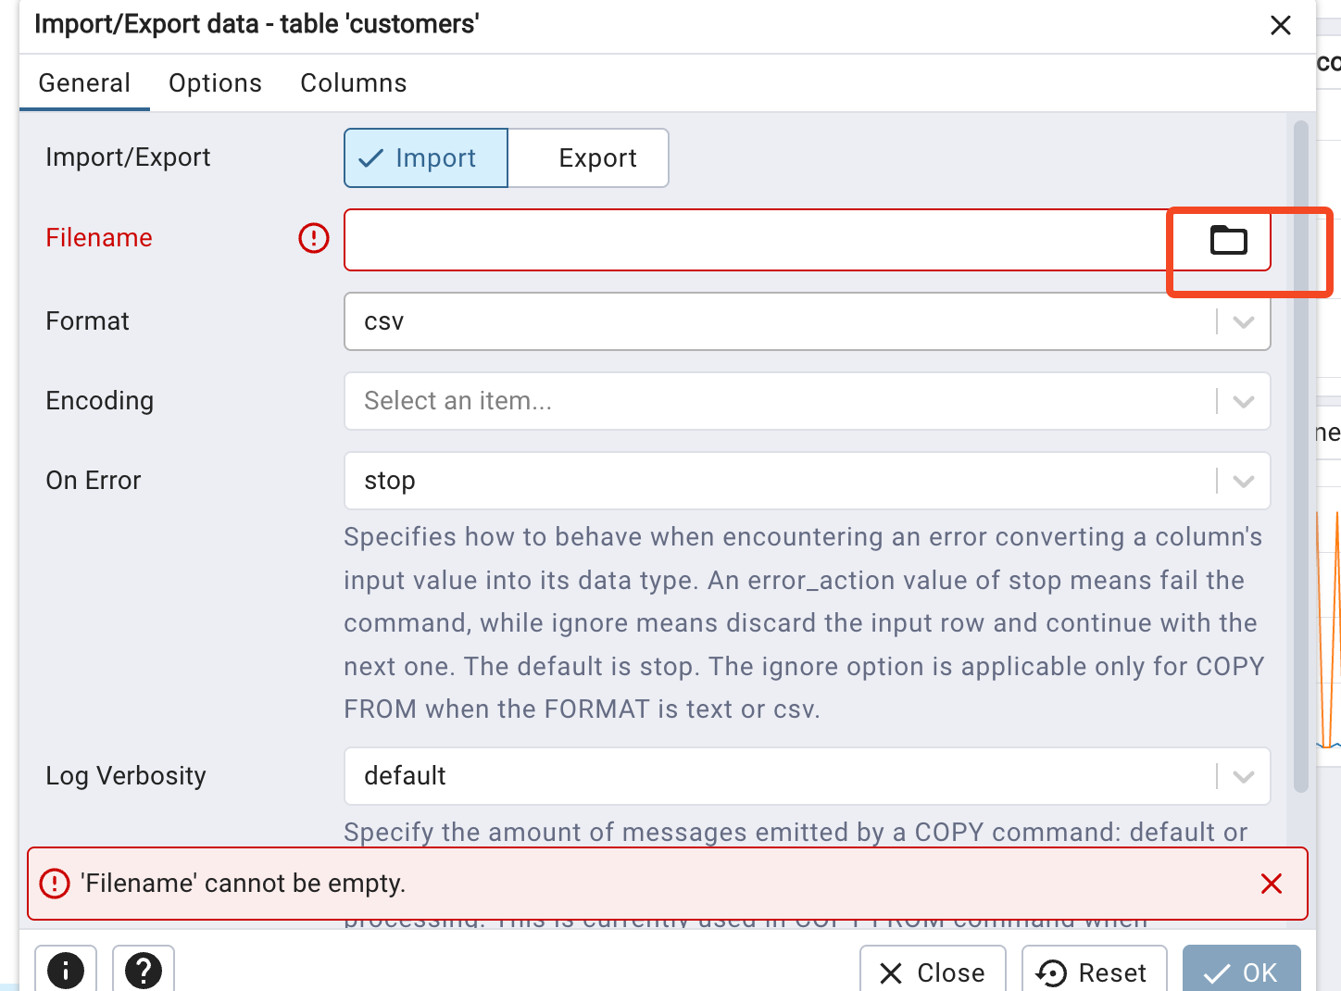

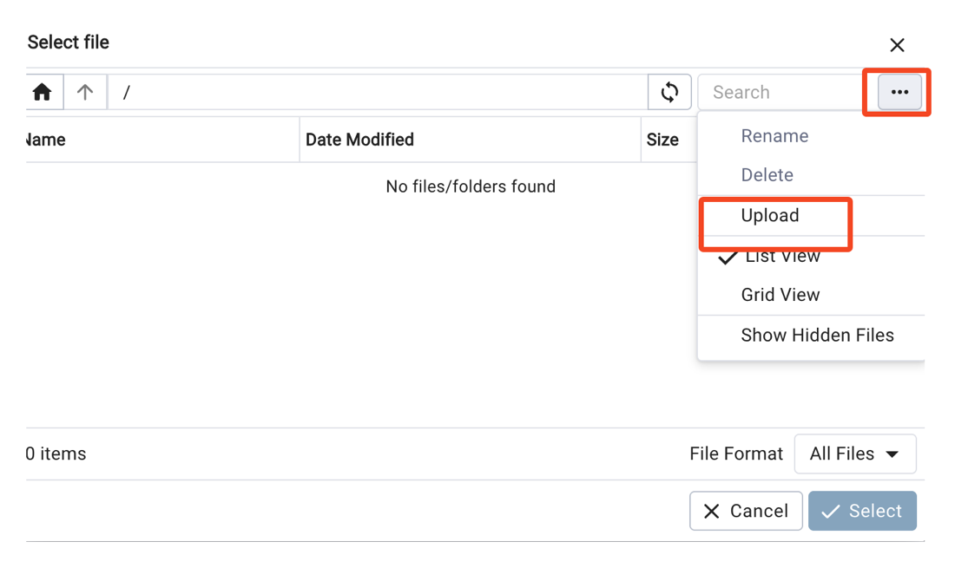

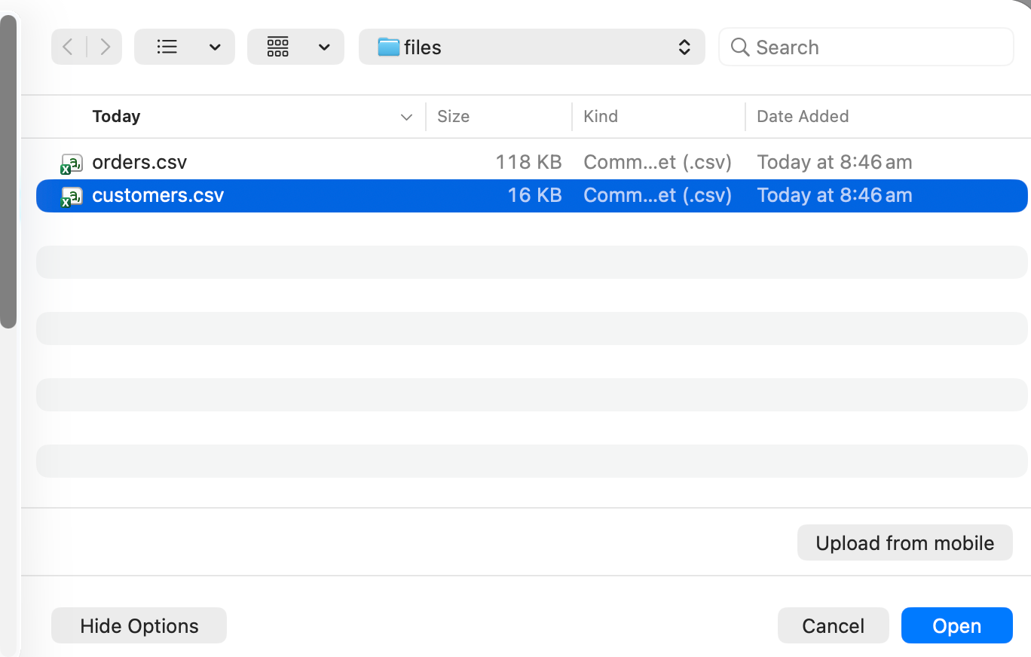

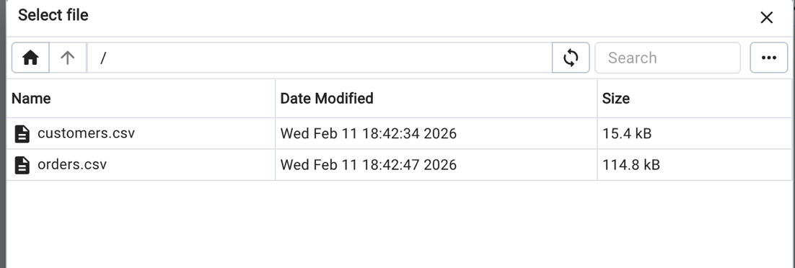

So finally we upload both files

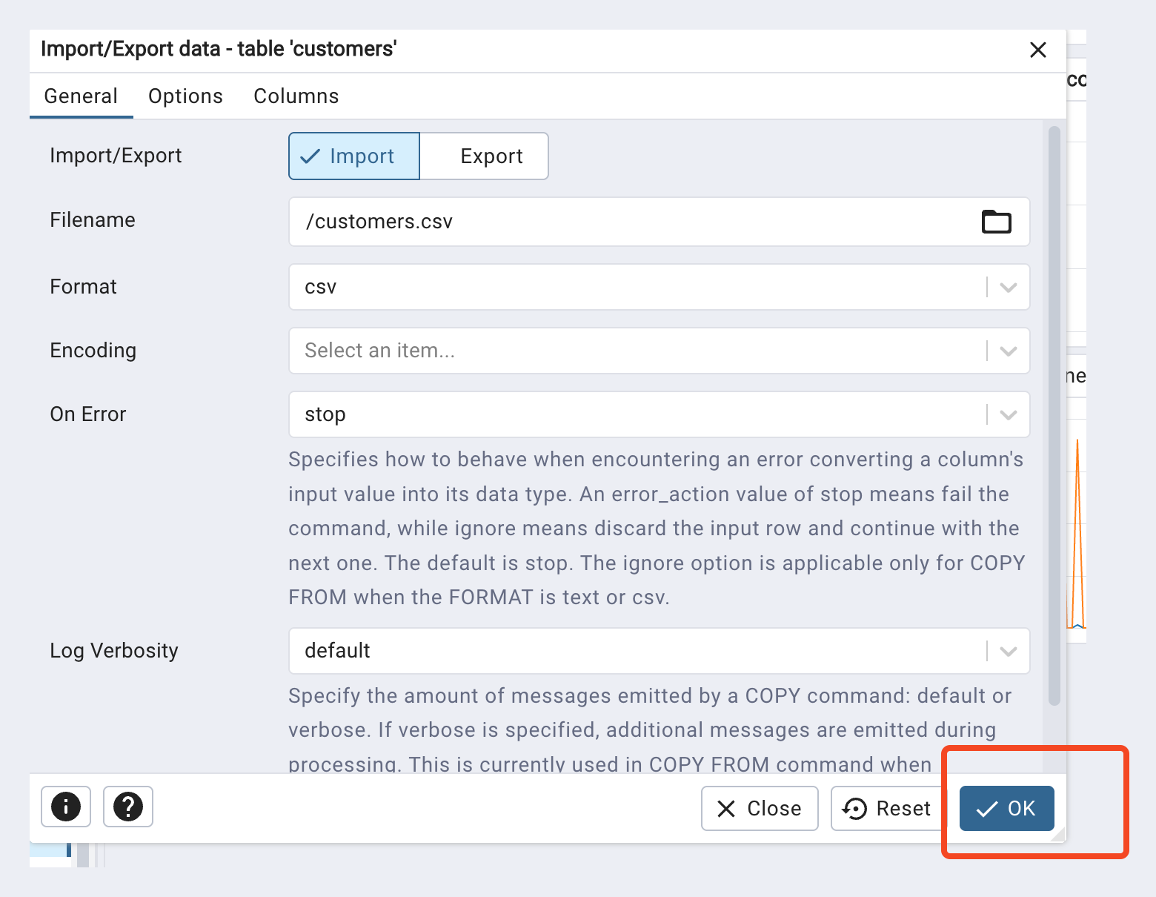

Issue in uploading the data:

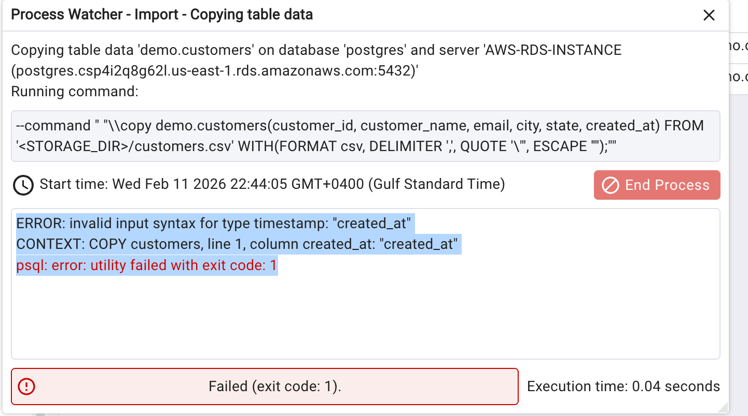

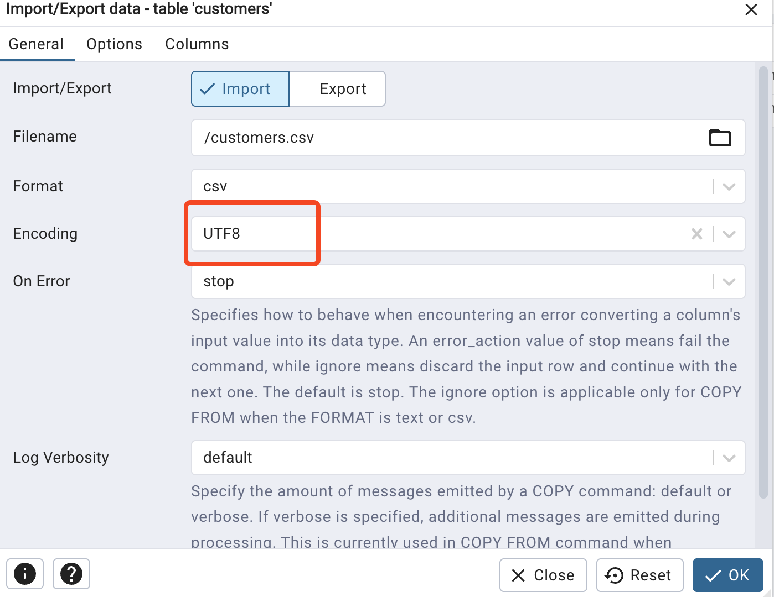

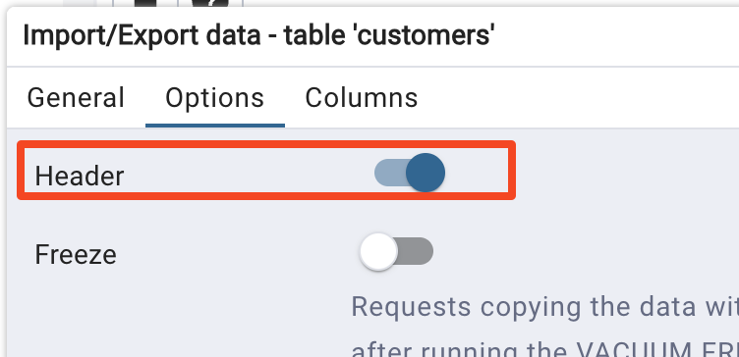

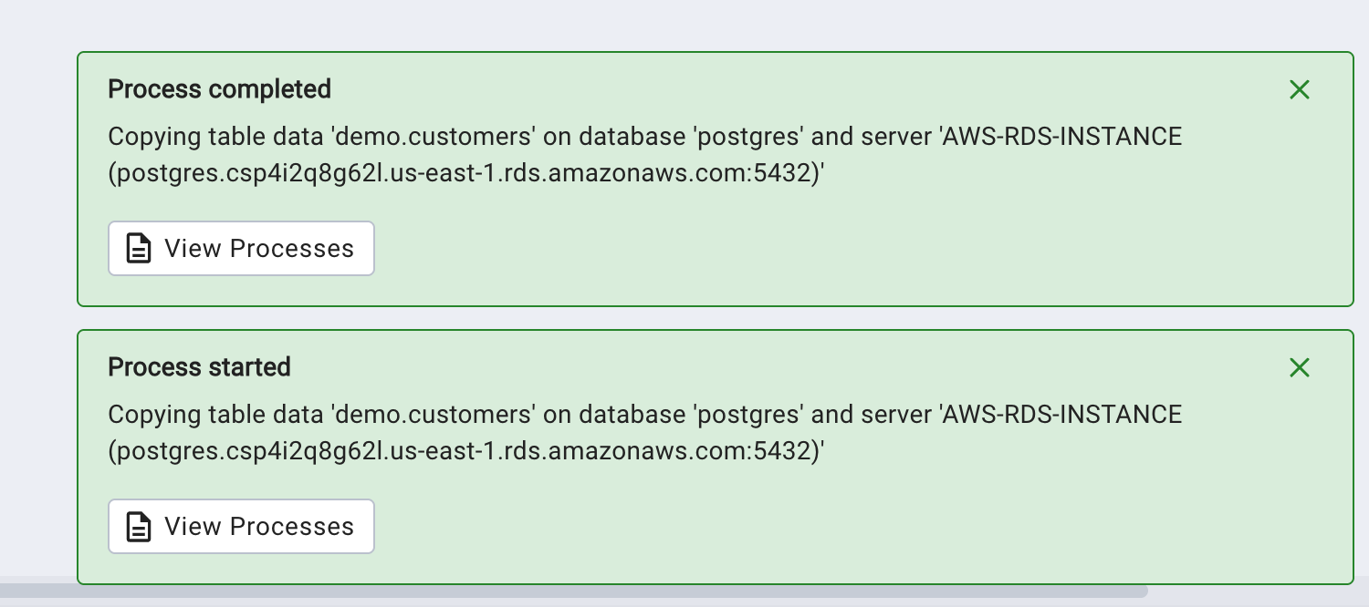

Now do the same for the orders table too

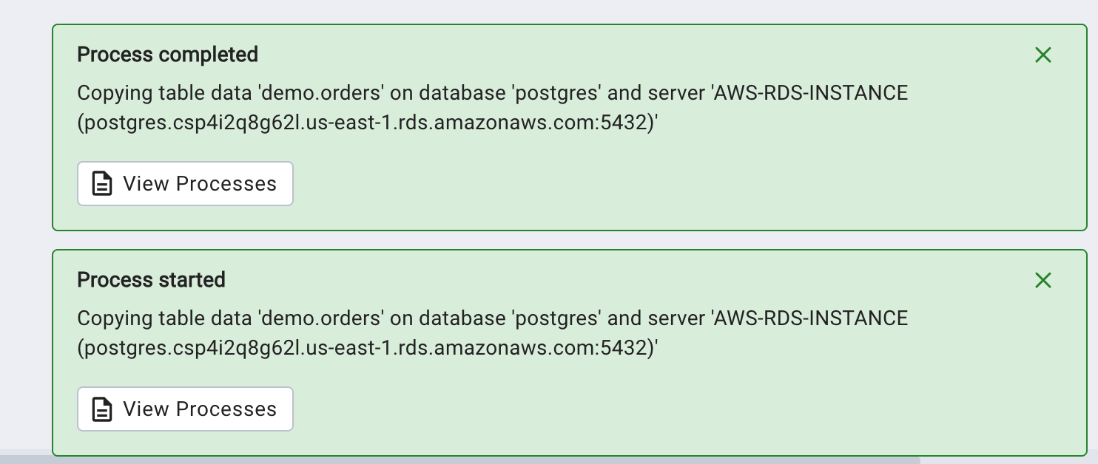

Final validation

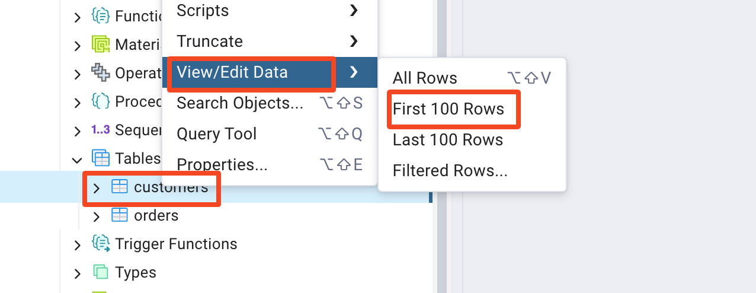

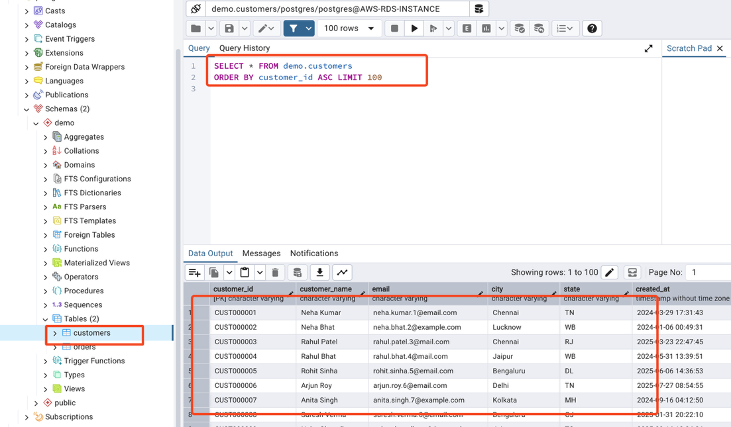

Now we can say that our platform is ready. Let's test the setup …

11.Let's test if llm-text-sql-agent

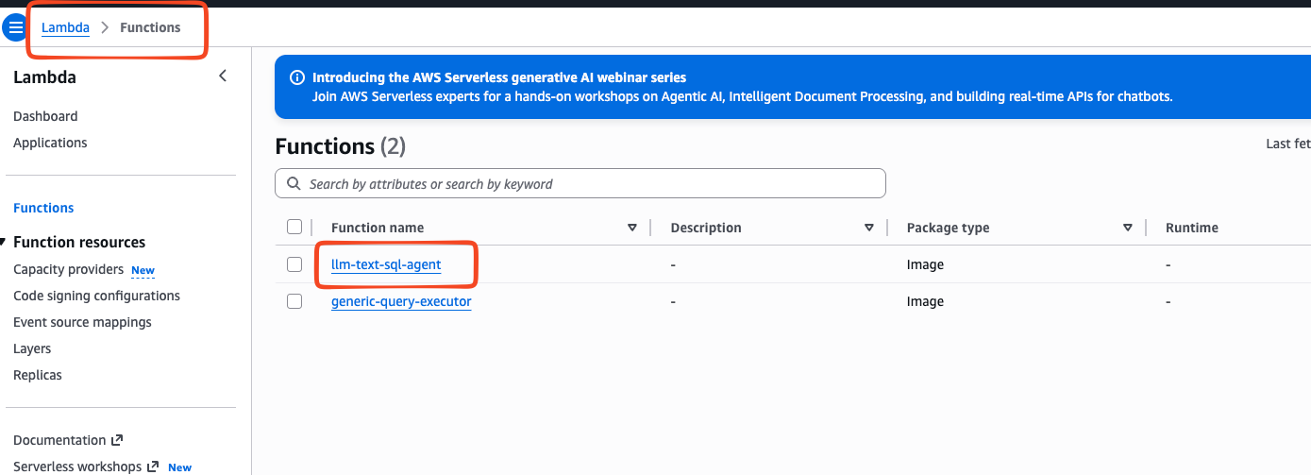

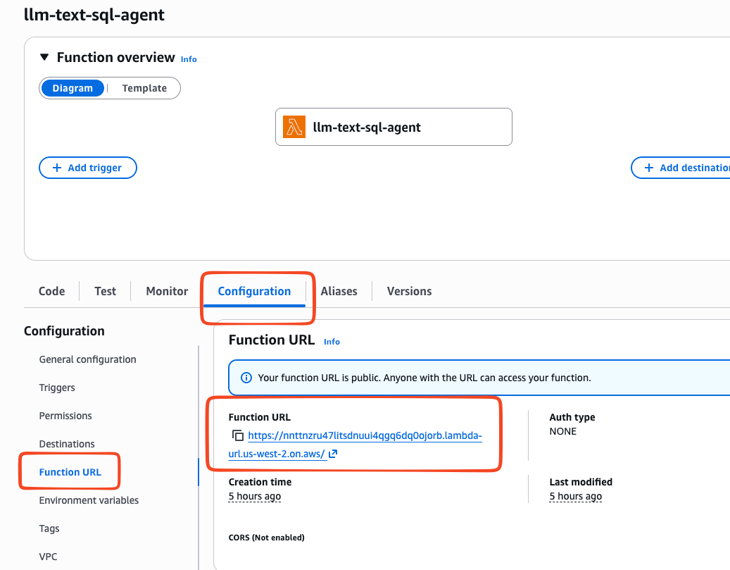

https://nnttnzru47litsdnuui4qgq6dq0ojorb.lambda-url.us-west-2.on.aws/

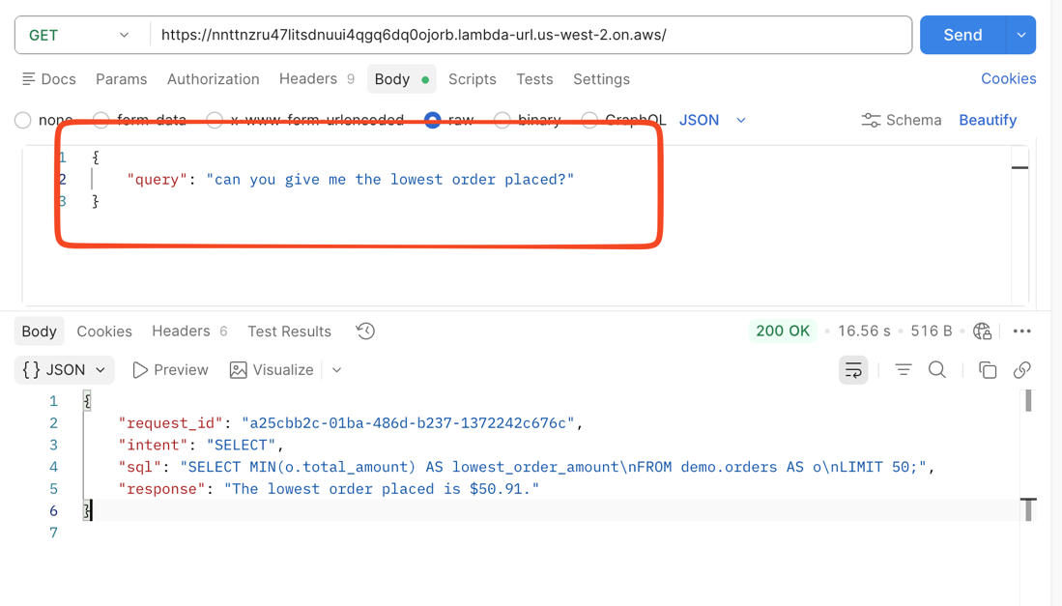

{
"query": "can you give me the lowest order placed?"
}

Note: No need to worry which method if its GET/POST/UPDATE and so on .. It just expect you to pass query that's it

12.Let's start Building our chatbot

This time we are going to deploy chatbot with ECS - Elastic Container Service

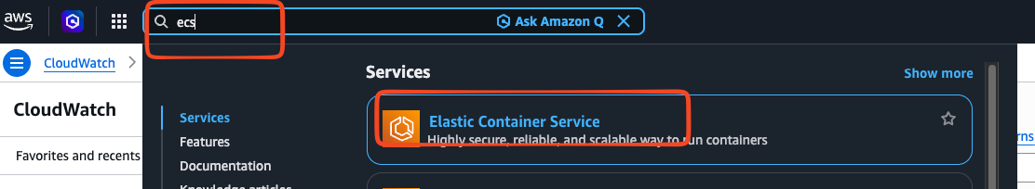

Use the below during role creation time

{
"Version": "2012-10-17",
"Statement": [
{
"Sid": "VisualEditor0",
"Effect": "Allow",
"Action": [
"rds:*",
"secretsmanager:*",
"apigateway:*",
"logs:*",
"lambda:*",
"ecs:*",
"ecr:*"
],
"Resource": "*"
}
]
}

Working with ECS Service:

Creating a task definition:
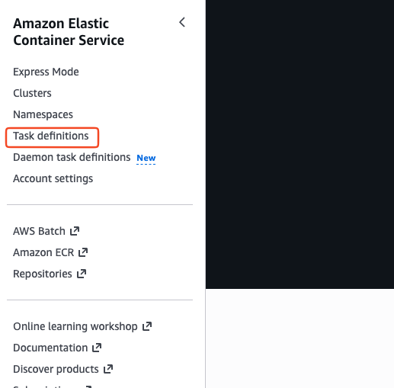

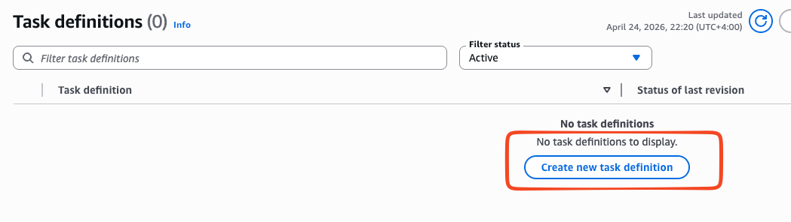

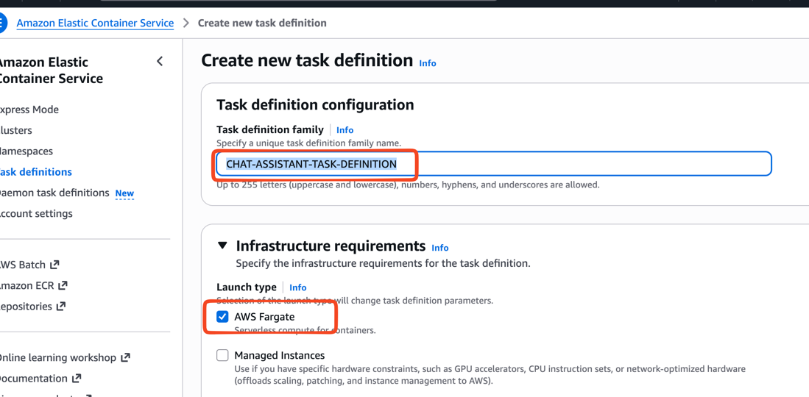

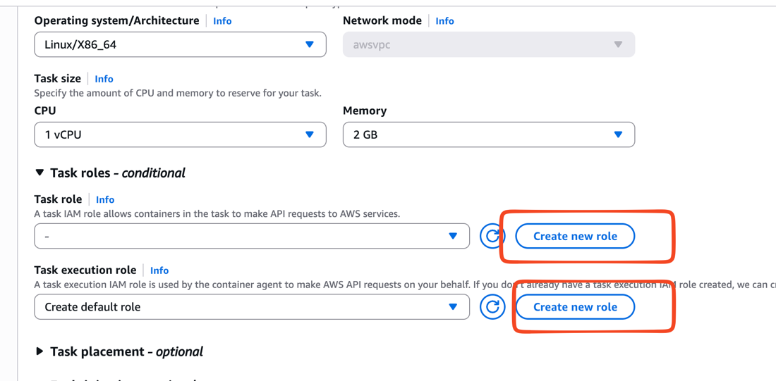

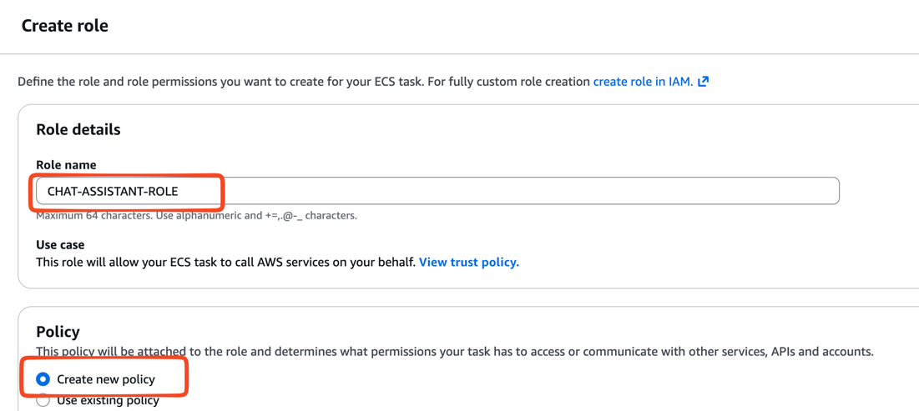

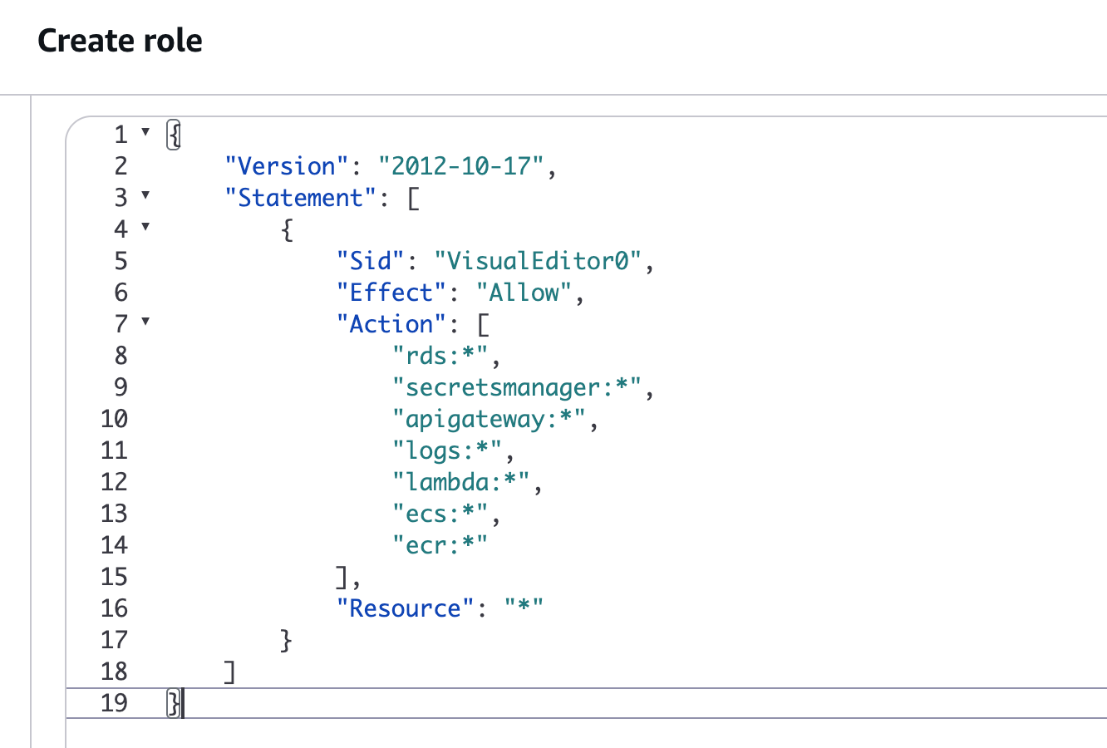

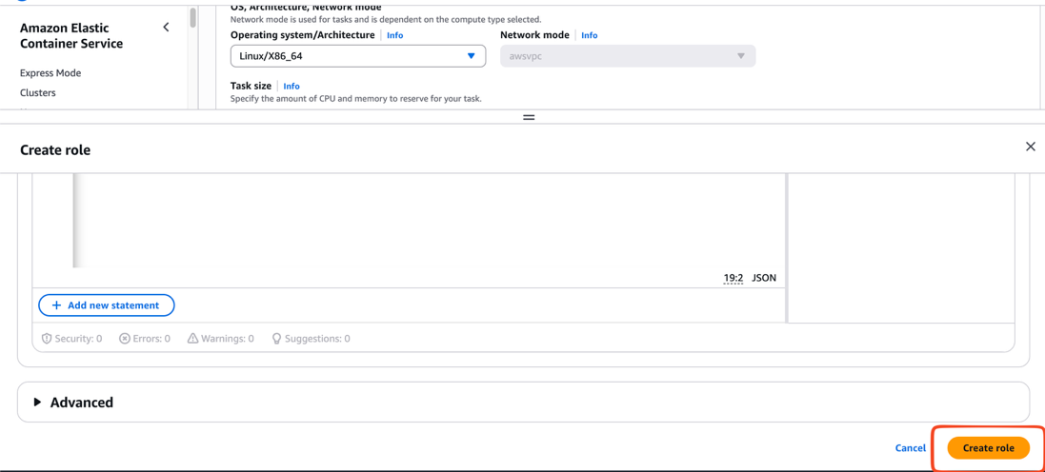

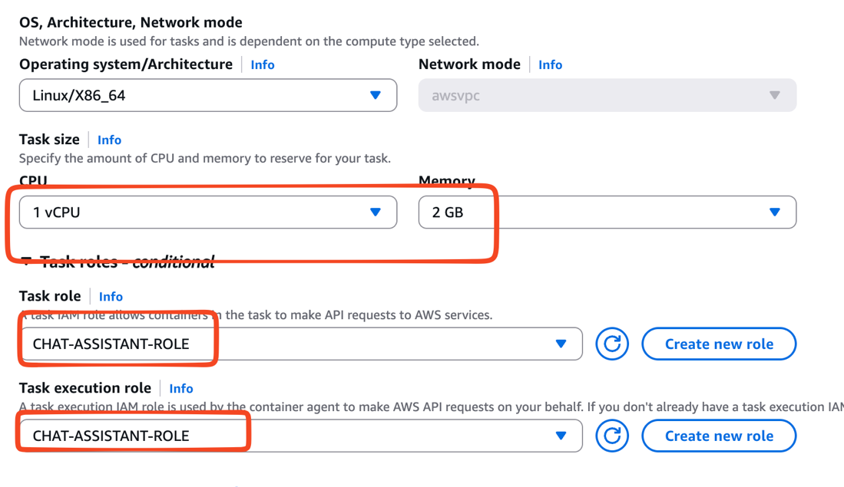

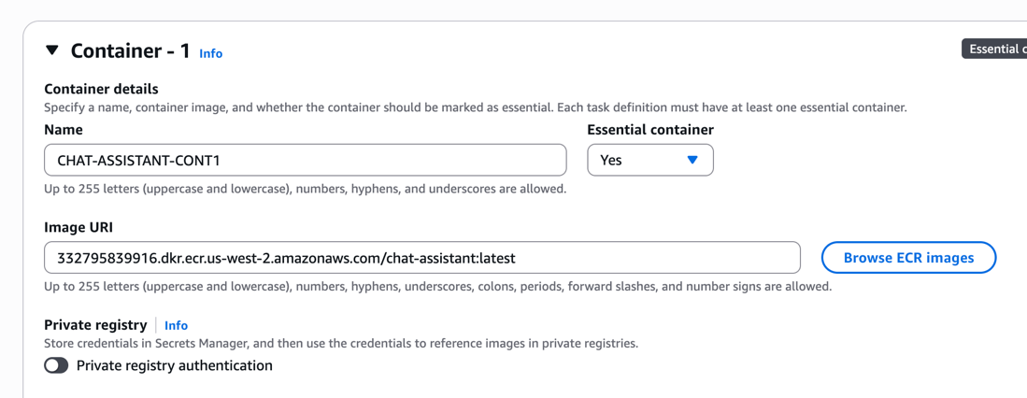

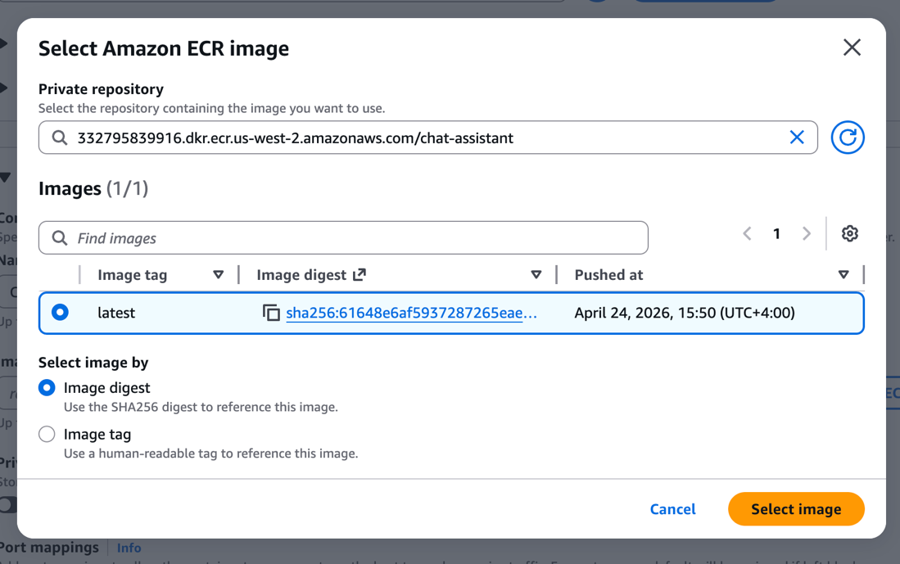

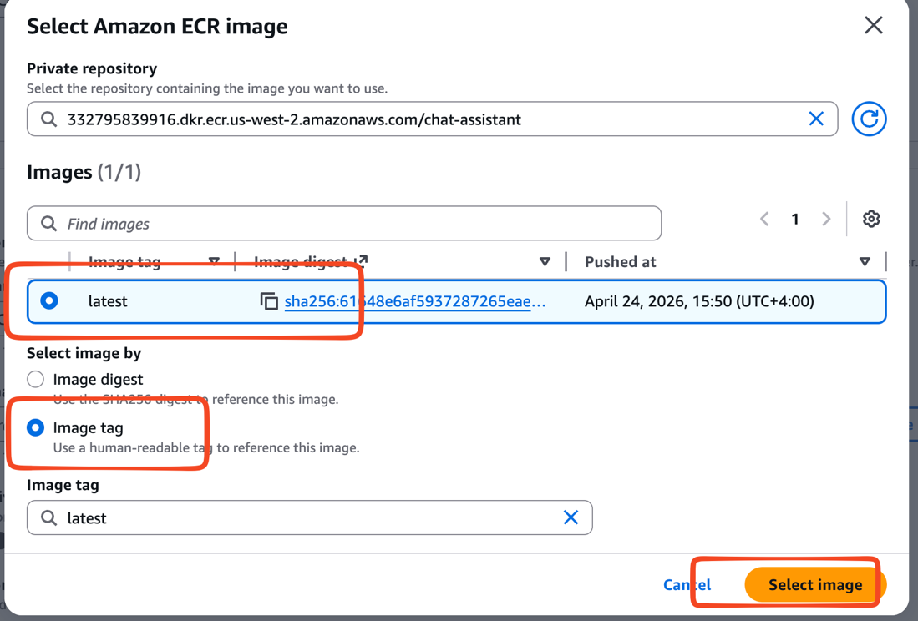

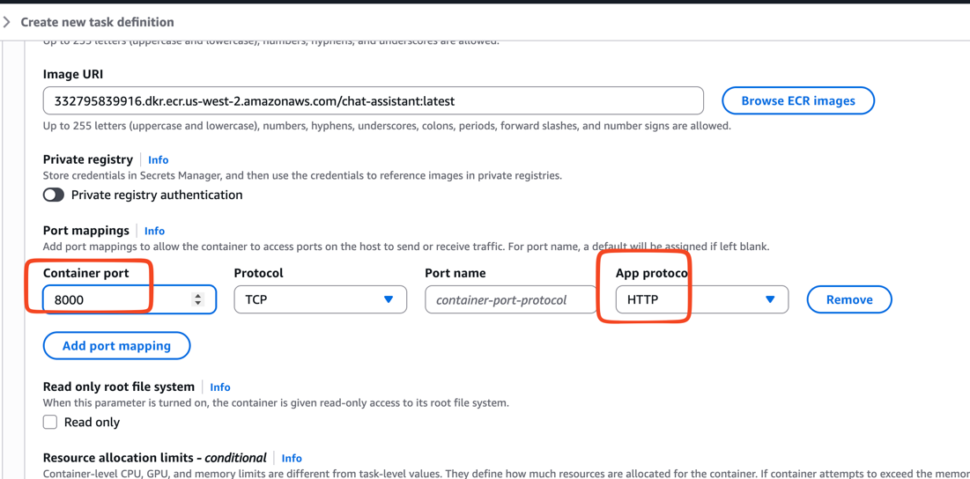

Make sure you are creating a variable called "LLM_AGENT_URL" where value of this variable our llm-text-sql-agent lambda url

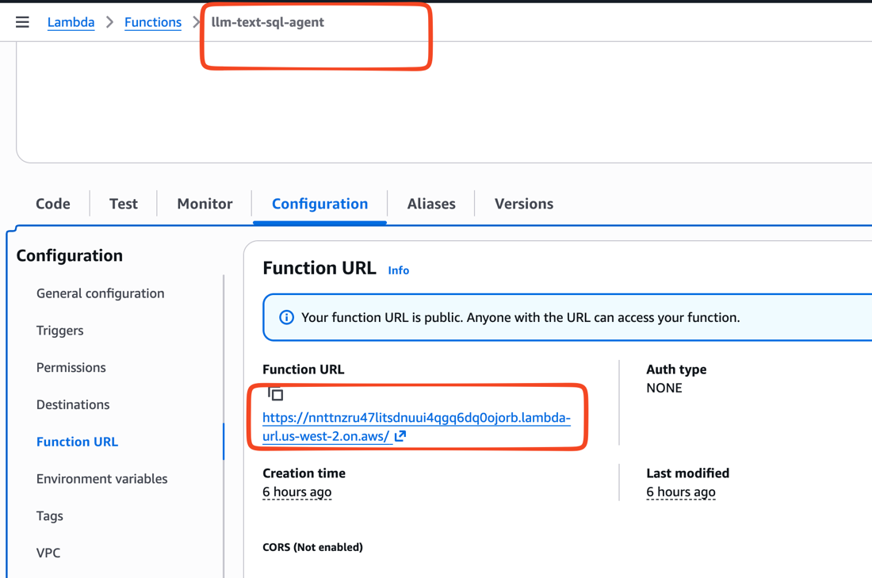

https://nnttnzru47litsdnuui4qgq6dq0ojorb.lambda-url.us-west-2.on.aws/

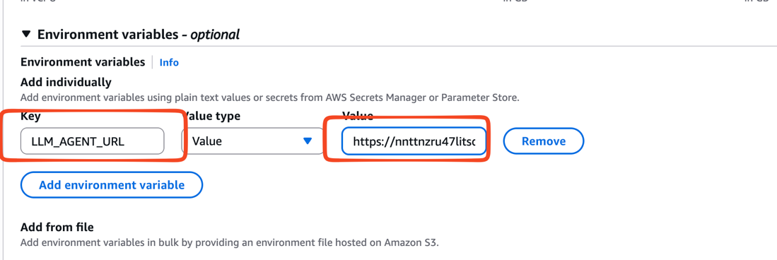

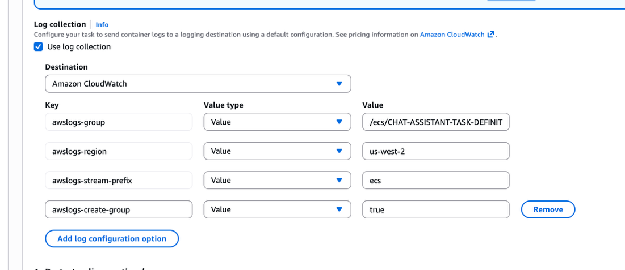

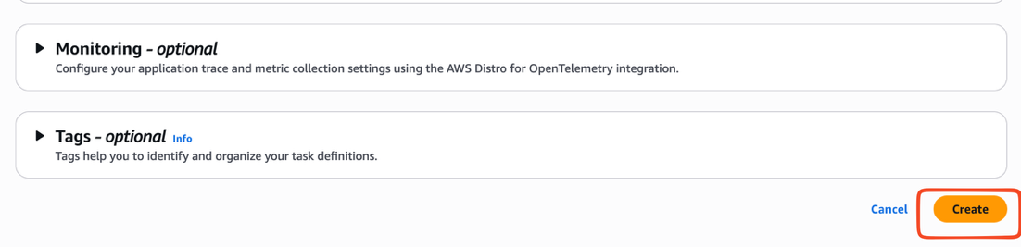

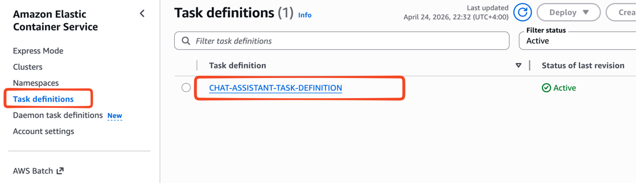

Let's Create the Cluster

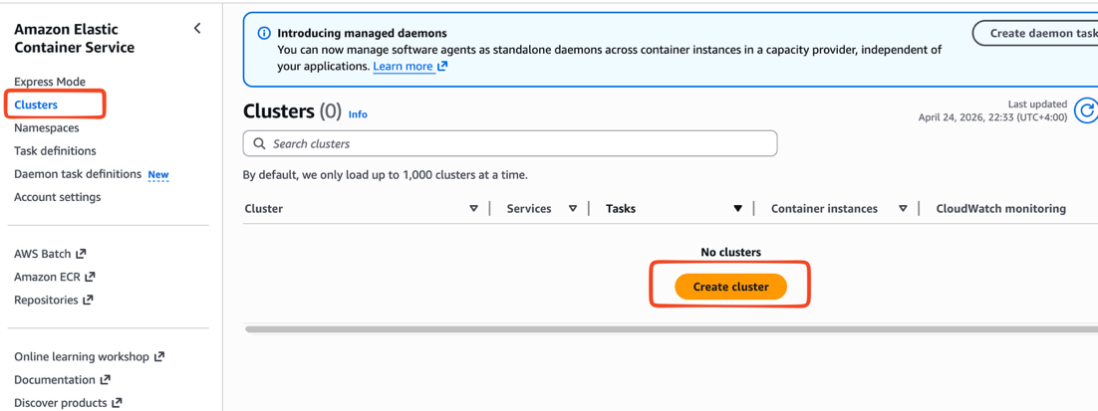

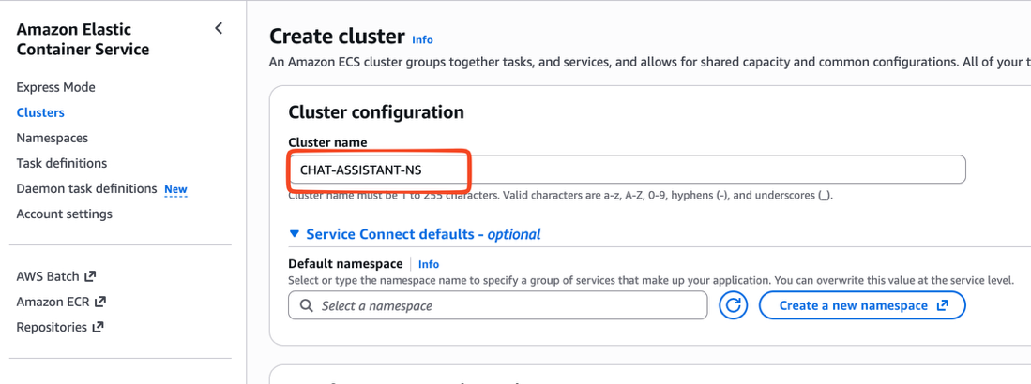

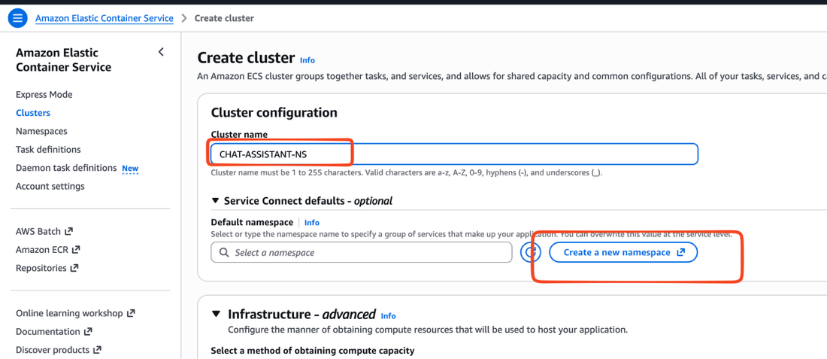

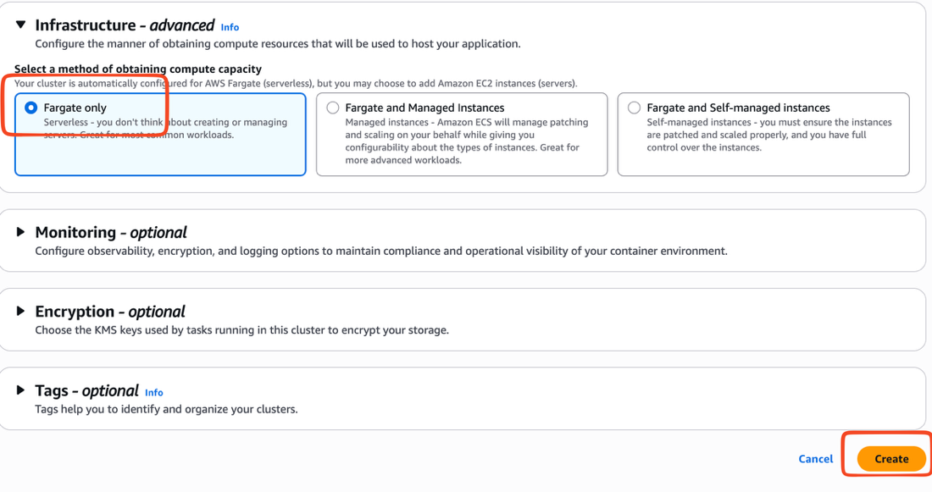
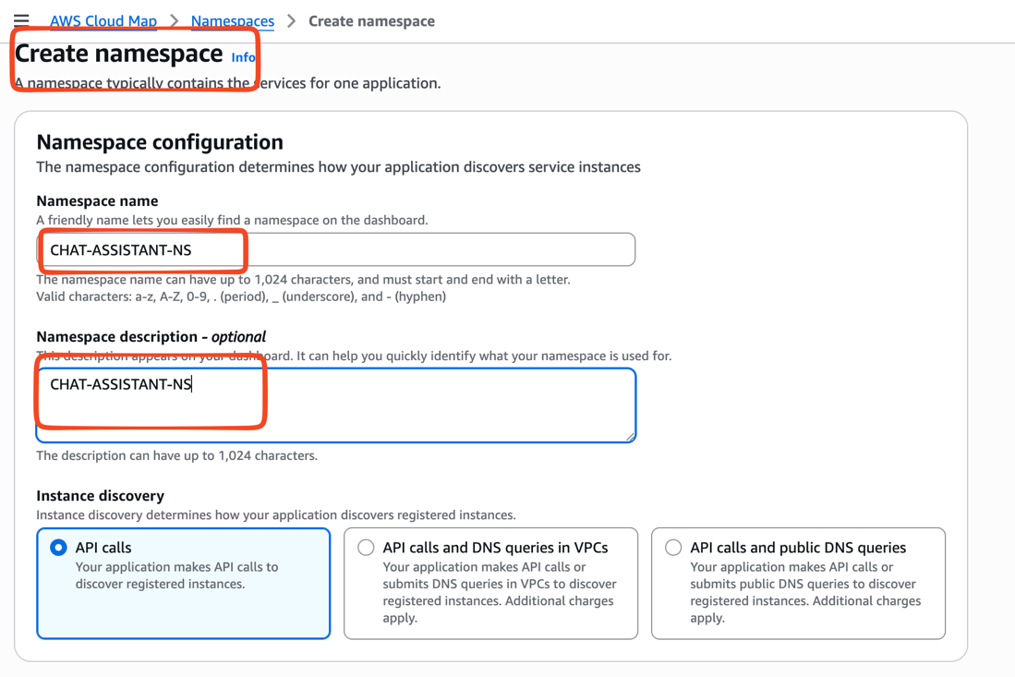

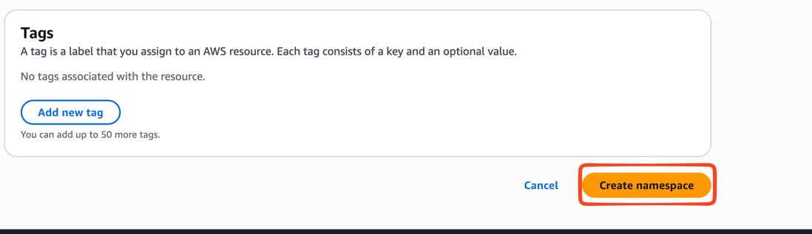

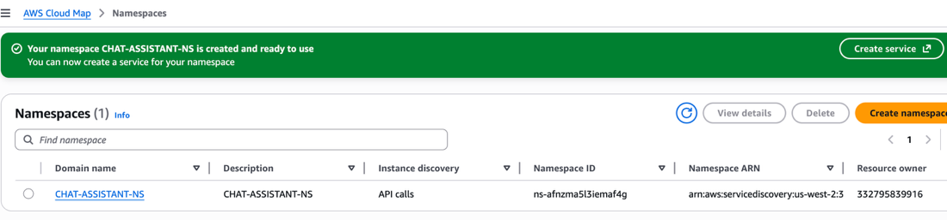

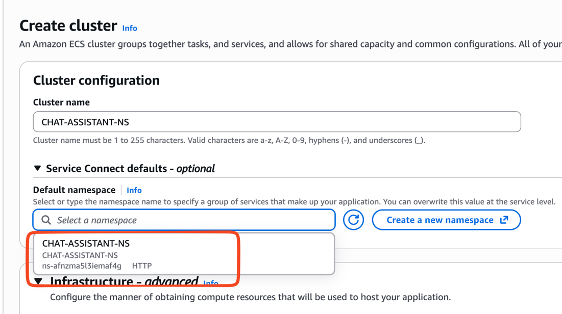

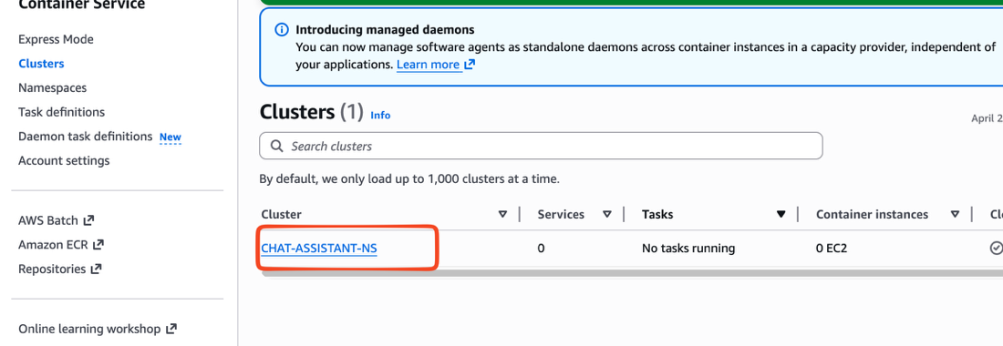

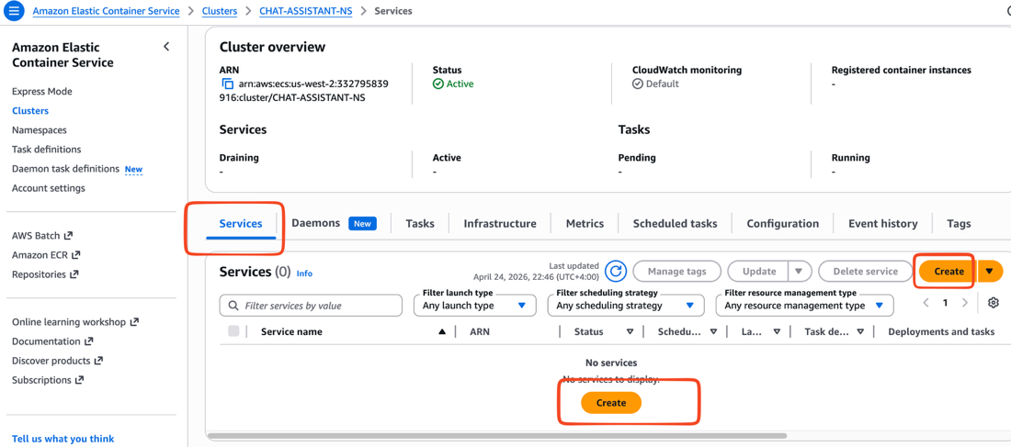

Let's create the service:
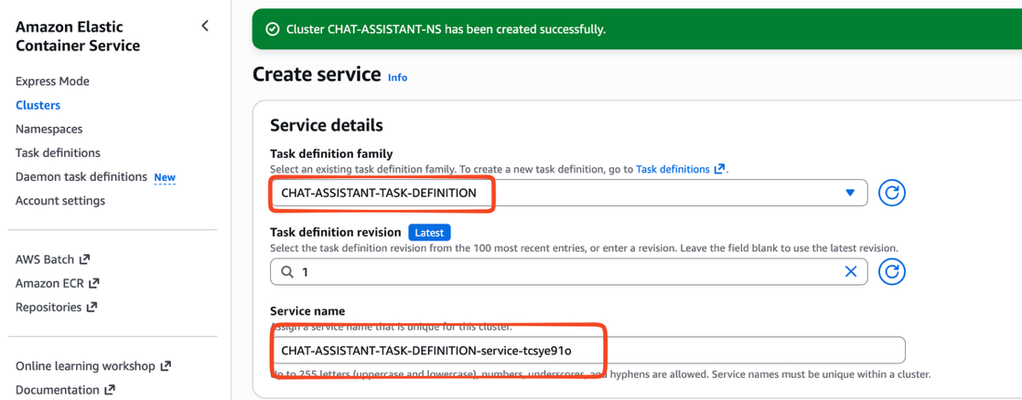

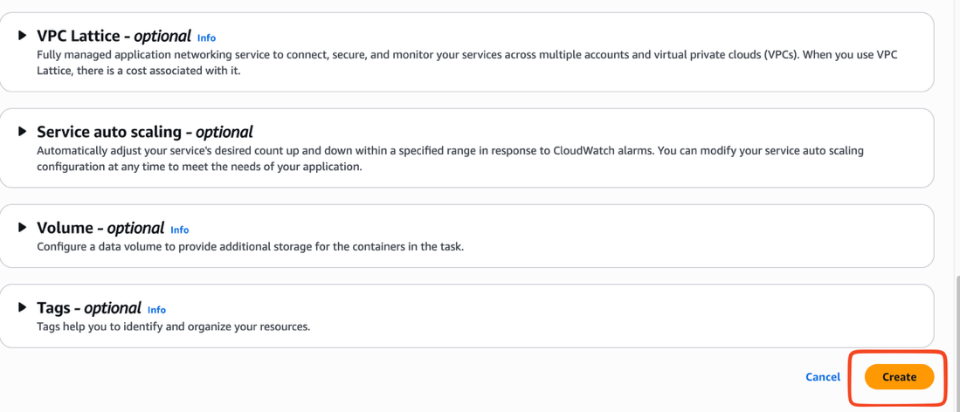

Note our chat bot runs on port 8000

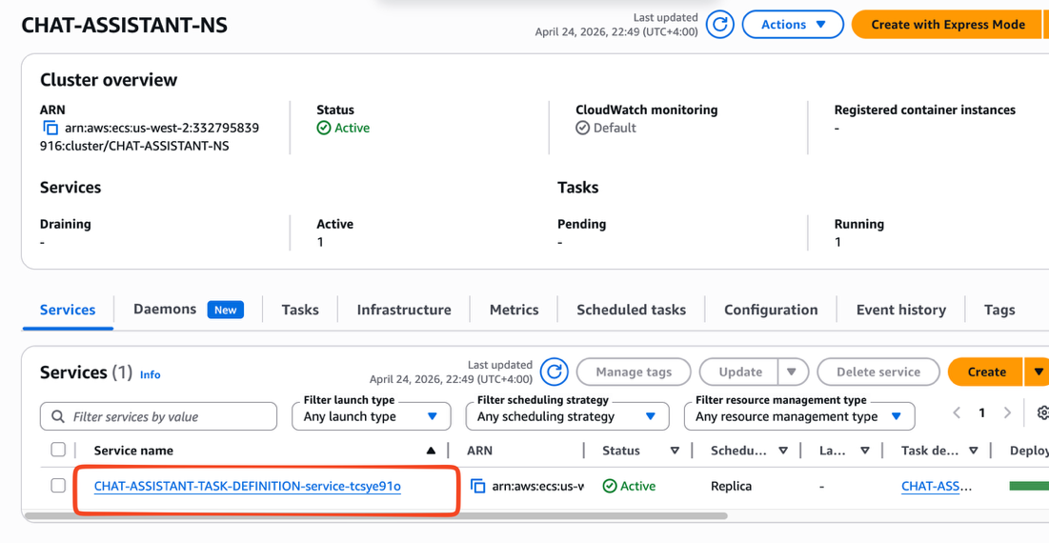

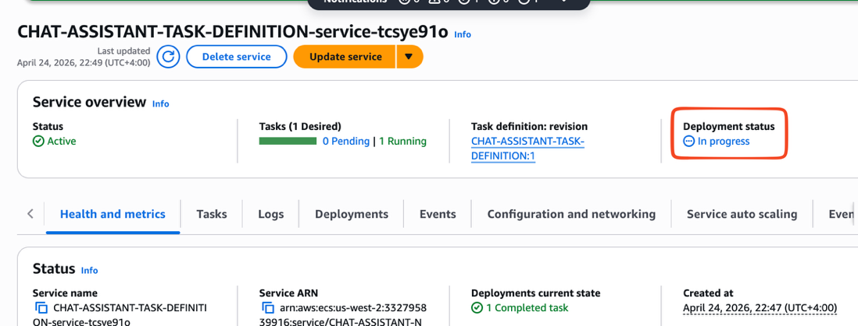

Pls wait till it complete the creation

Let's get the final ip address for the service

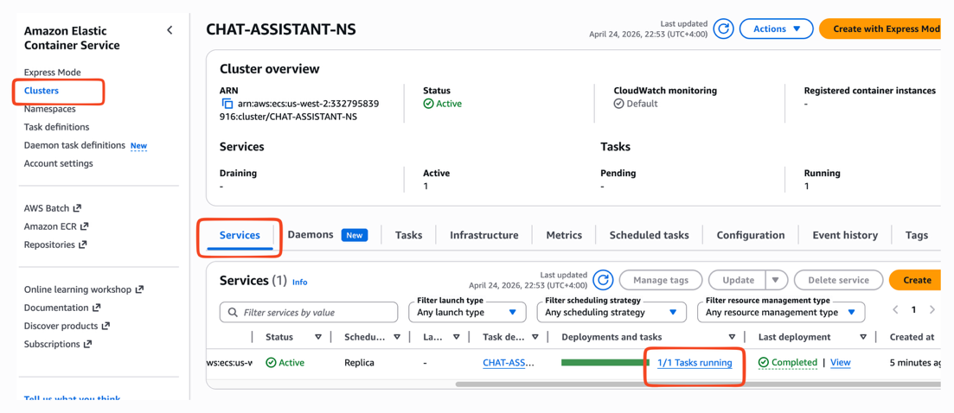

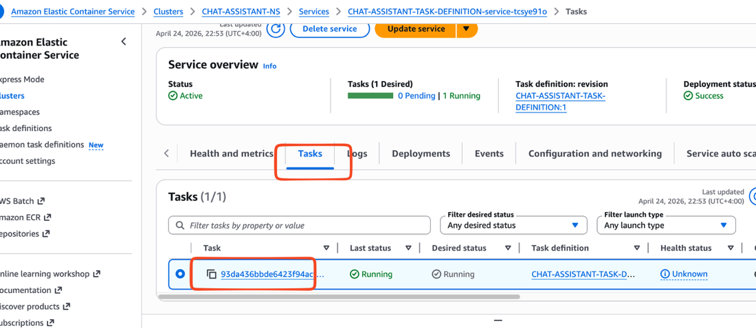

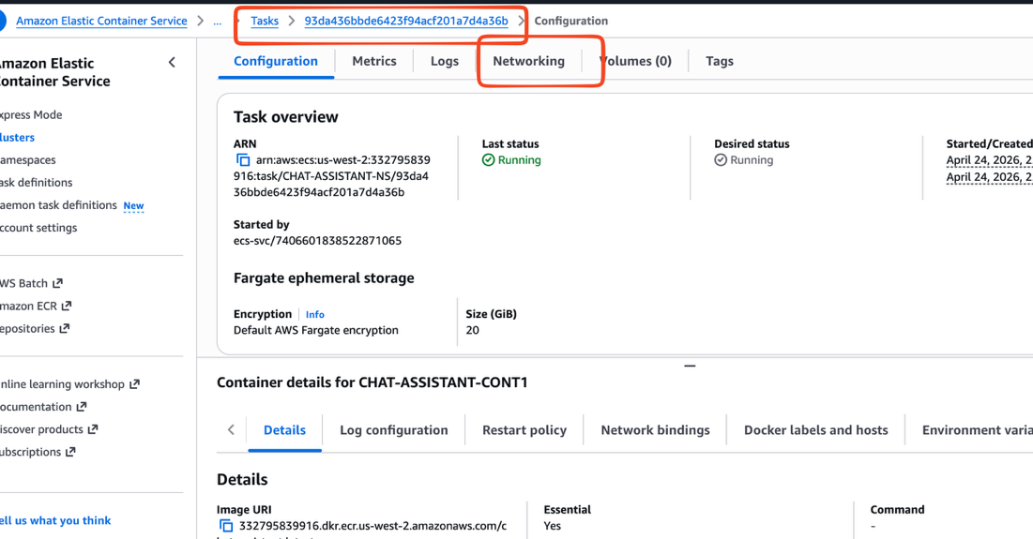

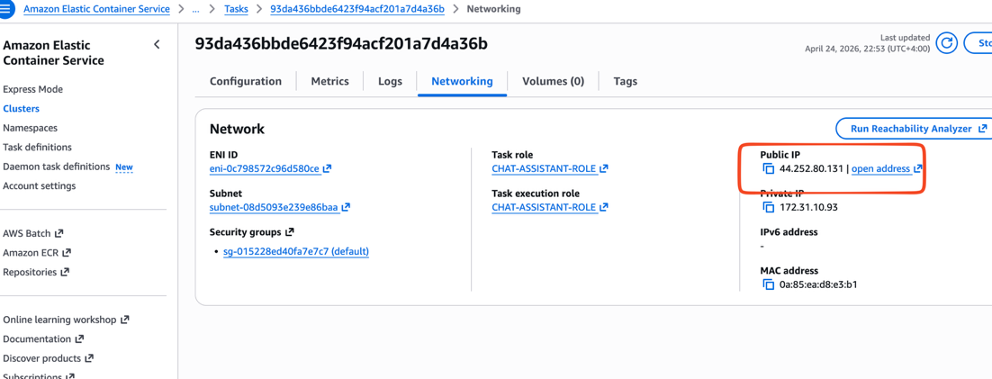

44.252.80.131

Let's hit this ip on port 8000

http://44.252.80.131:8000

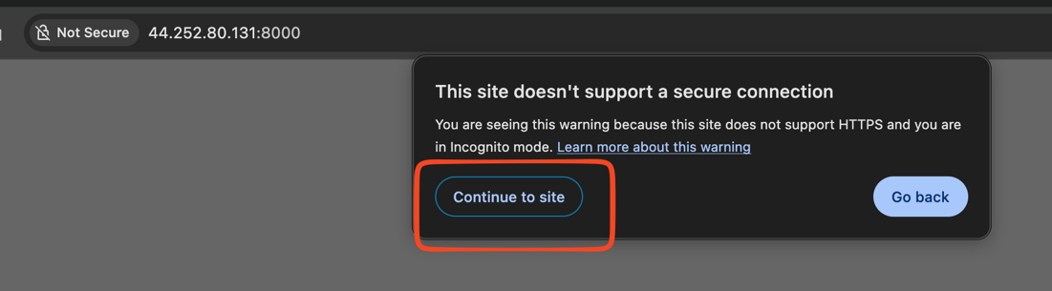

Hi can you give me the highest order placed?

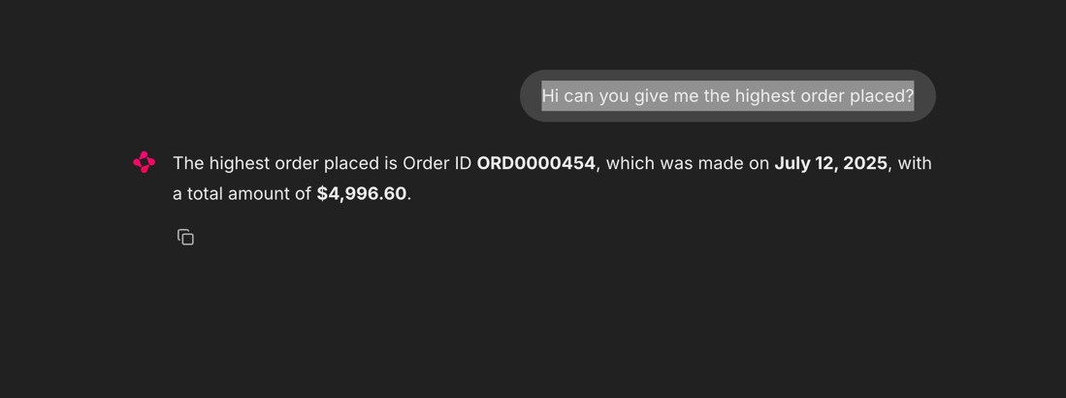

which customer placed this order?

can you get the complete details of this customer ?

