1.Creating Sandbox DB

https://sandbox.neo4j.com/

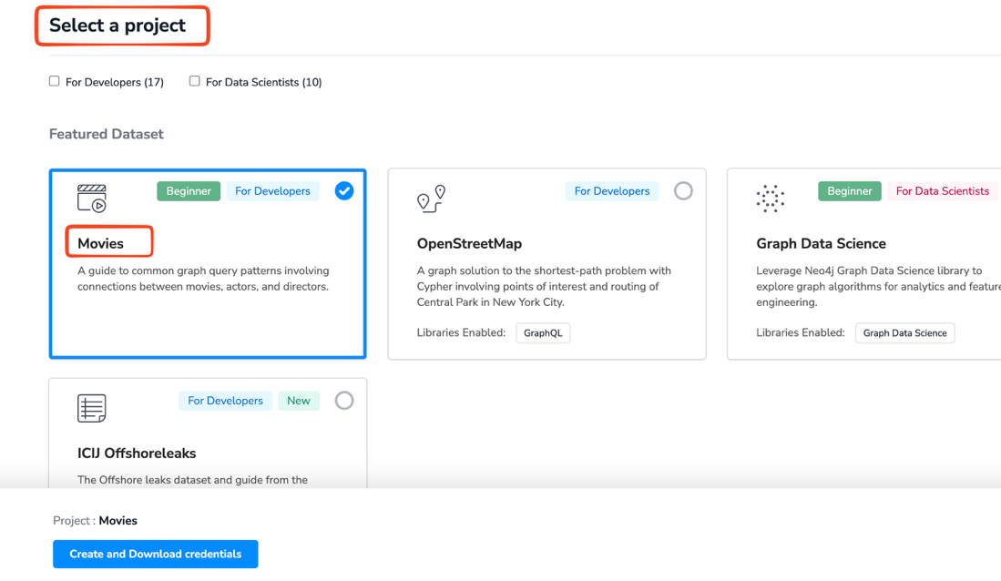

Click on create and download credentials

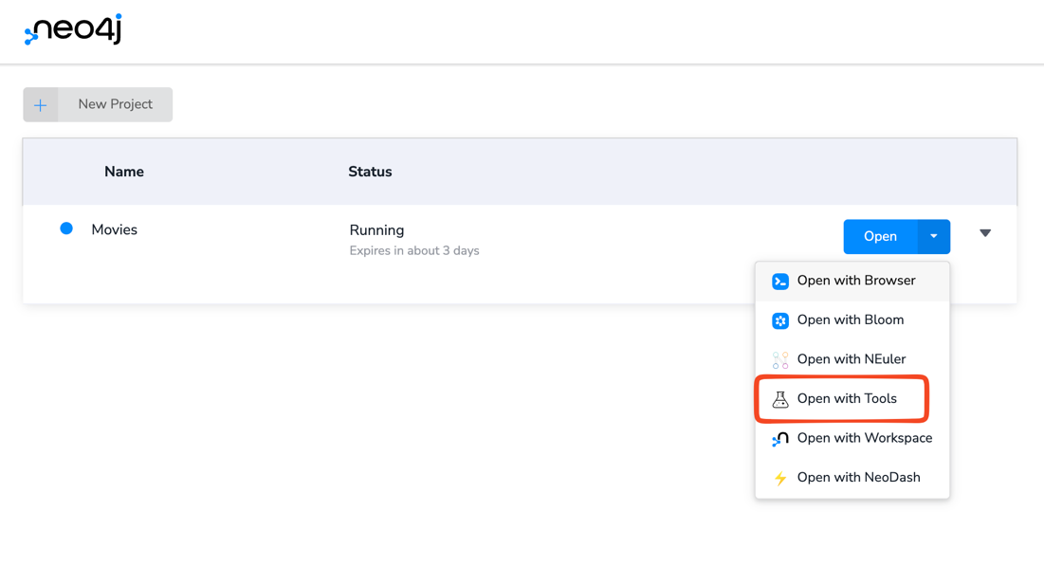

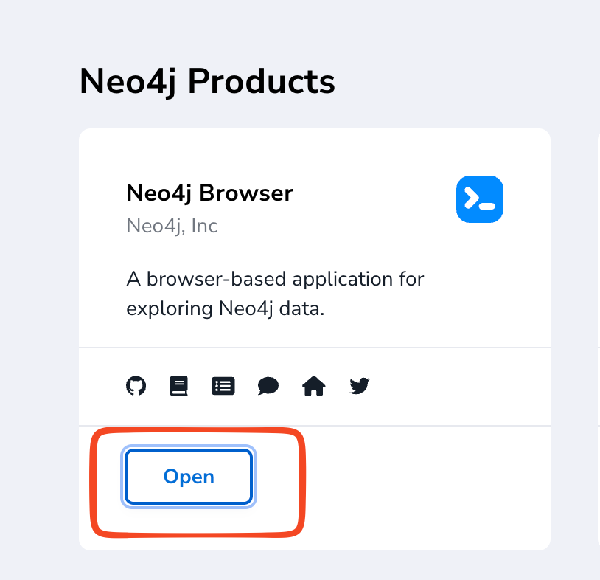

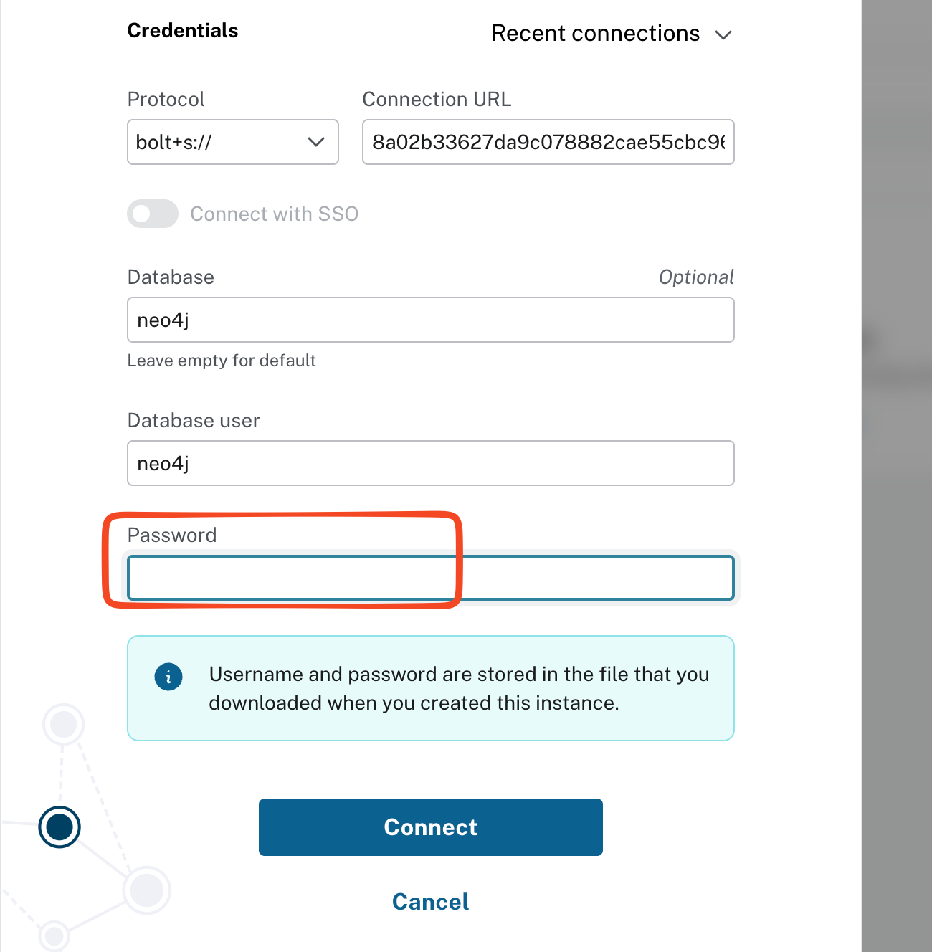

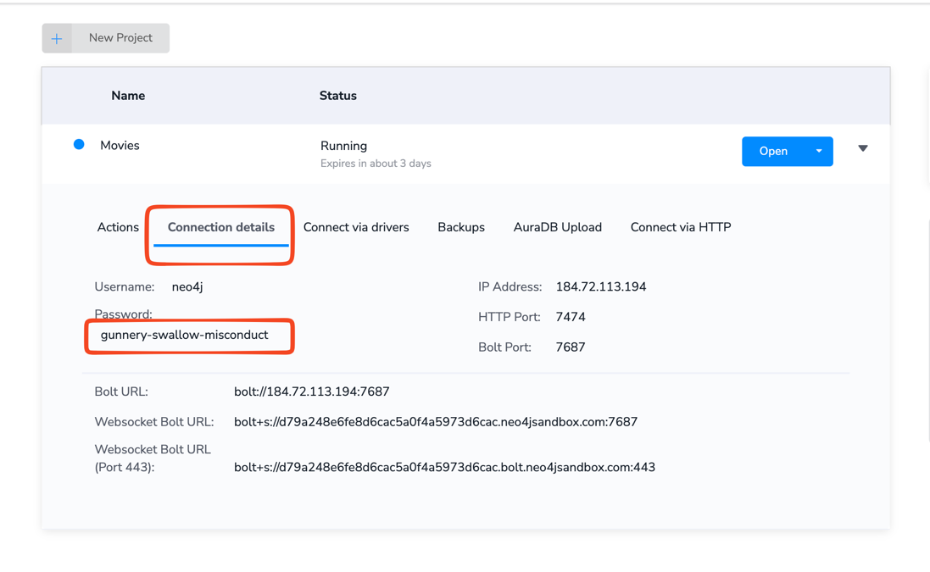

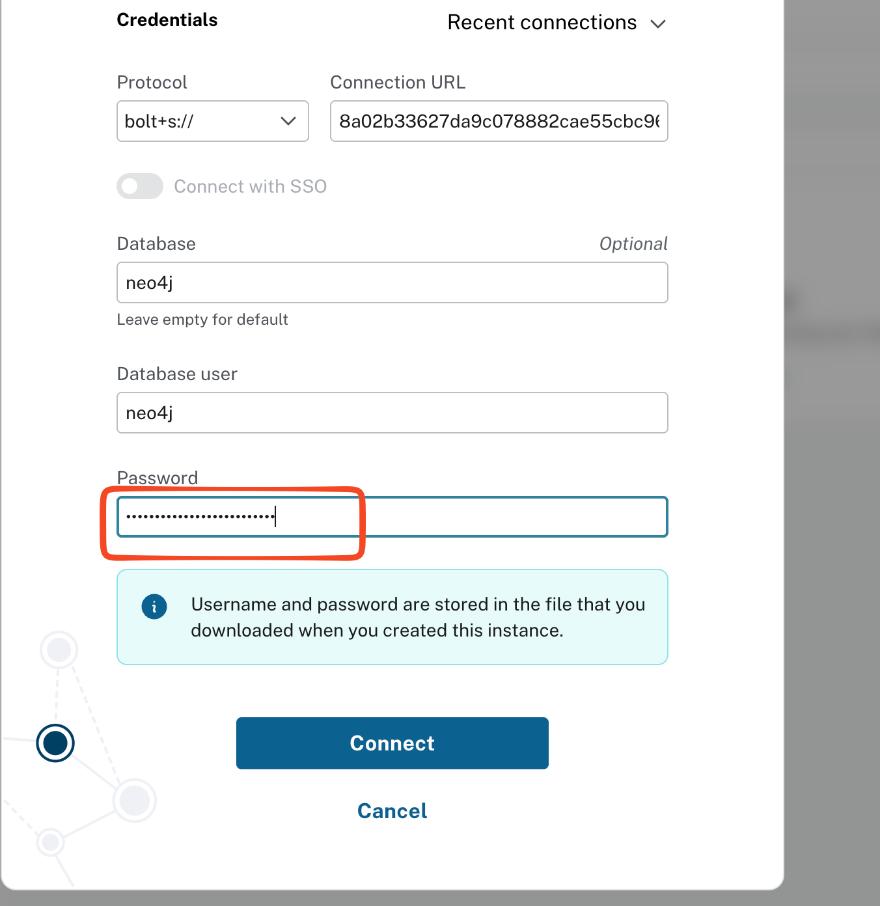

Click on Connect

We need to have a database to connect and inject the data hence we are going to use this one. But we are going to inject our own data as we don't want movies data.

Let's delete the entire data

MATCH (m)
DETACH DELETE m

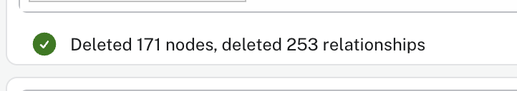

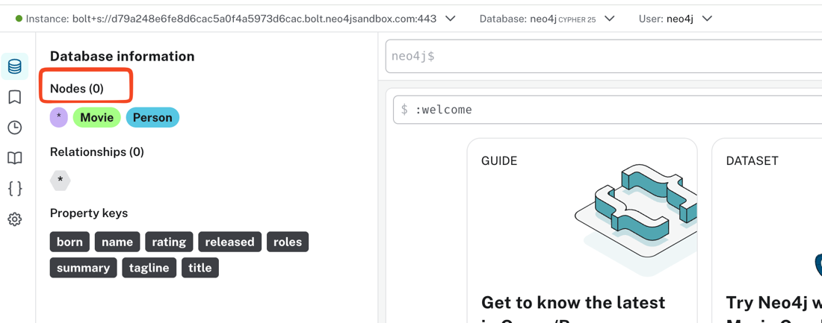

2.Injecting data to graphdb

Let's connect to the google colab or you can use your local vscode to perform the below

In my case I will go with google colab

#### Installing required package

!pip install faker neo4j

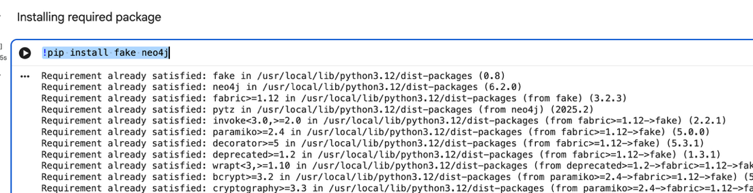

#### Generating fake data and injecting data to the graphdb
**Make sure you are updating the database credentials, otherwise you can't inject the data to the DB**

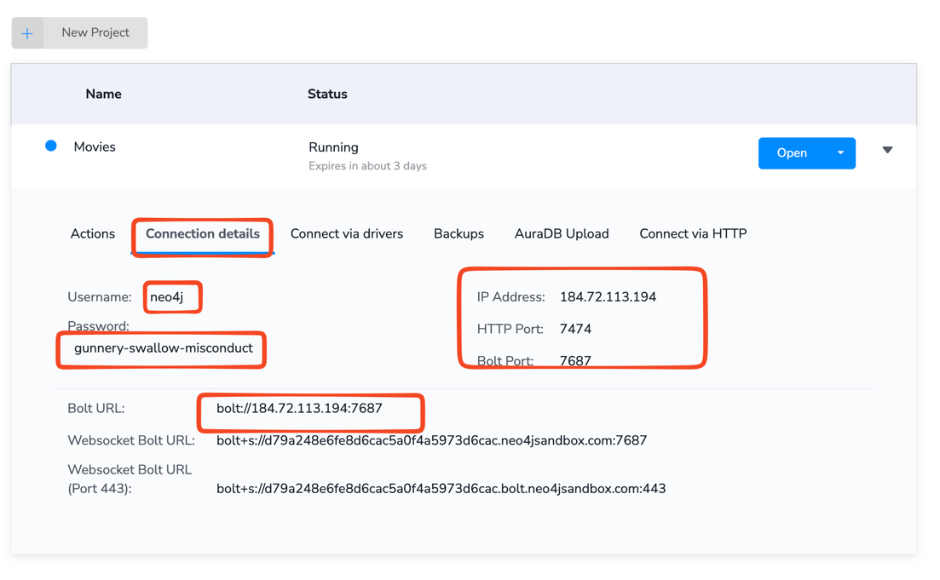

NEO4J_URI= "bolt://184.72.113.194:7687"
NEO4J_USER = "neo4j"
NEO4J_PASSWORD = "gunnery-swallow-misconduct"

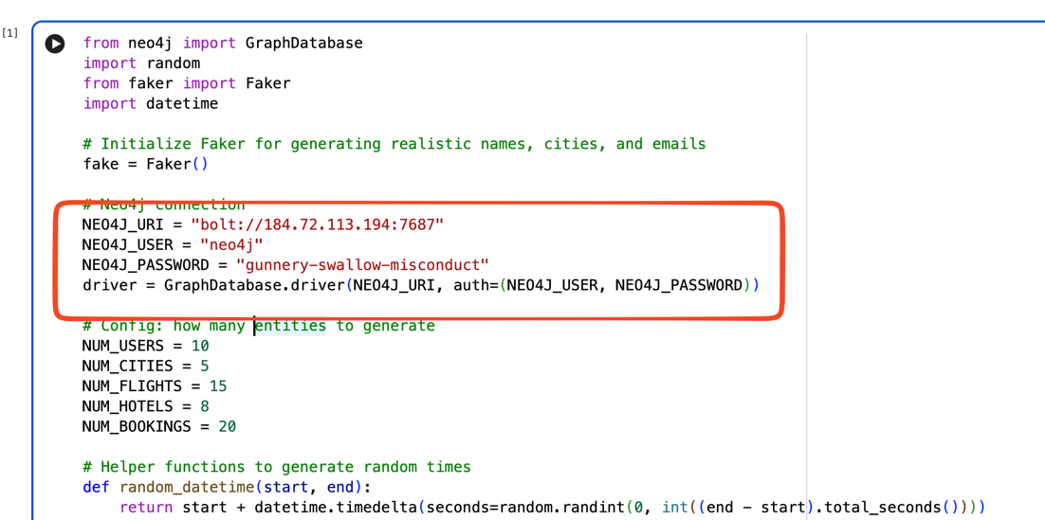

Copy paste the below code to the colab

from neo4j import GraphDatabase
import random
from faker import Faker
import datetime

# Initialize Faker for generating realistic names, cities, and emails
fake = Faker()

# Neo4j connection
NEO4J_URI = "bolt://184.72.113.194:7687"
NEO4J_USER = "neo4j"
NEO4J_PASSWORD = "gunnery-swallow-misconduct"
driver = GraphDatabase.driver(NEO4J_URI, auth=(NEO4J_USER, NEO4J_PASSWORD))

# Config: how many entities to generate
NUM_USERS = 10
NUM_CITIES = 5
NUM_FLIGHTS = 15
NUM_HOTELS = 8
NUM_BOOKINGS = 20

# Helper functions to generate random times
def random_datetime(start, end):
return start + datetime.timedelta(seconds=random.randint(0, int((end - start).total_seconds())))

# Step 1: Create Cities
cities = [fake.city() for _ in range(NUM_CITIES)]
with driver.session() as session:
for city in cities:
session.run("MERGE (c:City {name:$name})", name=city)

# Step 2: Create Airlines
real_airlines = ["Emirates", "IndiGo", "Flydubai", "Lufthansa", "Qatar Airways", "Etihad", "Singapore Airlines", "Air India"]
with driver.session() as session:
for airline in real_airlines:
session.run("MERGE (a:Airline {name:$name})", name=airline)

# Step 3: Create Users
users = [{"userId": f"U{i}", "name": fake.name(), "email": fake.email()} for i in range(NUM_USERS)]
with driver.session() as session:
for u in users:
session.run("MERGE (u:User {userId:$userId, name:$name, email:$email})", **u)

# Step 4: Create Flights
# Step 4: Create Flights
flights = []
start_date = datetime.datetime.now()
end_date = start_date + datetime.timedelta(days=30)

with driver.session() as session:
for i in range(NUM_FLIGHTS):
from_city = random.choice(cities)
to_city = random.choice([c for c in cities if c != from_city])
airline = random.choice(real_airlines) # pick from real airline names
dep_time = random_datetime(start_date, end_date)
arr_time = dep_time + datetime.timedelta(hours=random.randint(2, 12))
flight_id = f"F{i}"
flights.append(flight_id)
session.run(
"""
MERGE (f:Flight {flightId:$flightId, airline:$airline, fromCity:$fromCity, toCity:$toCity, departureTime:$depTime, arrivalTime:$arrTime})
""",
flightId=flight_id, airline=airline, fromCity=from_city, toCity=to_city,
depTime=dep_time.isoformat(), arrTime=arr_time.isoformat()
)

# Step 5: Create Hotels
hotels = []
with driver.session() as session:
for i in range(NUM_HOTELS):
city = random.choice(cities)
hotel_id = f"H{i}"
hotels.append(hotel_id)
session.run(
"MERGE (h:Hotel {hotelId:$hotelId, name:$name, city:$city, stars:$stars})",
hotelId=hotel_id, name=f"{city} Grand Hotel", city=city, stars=random.randint(3, 5)
)

# Step 6: Create Bookings (link Users -> Flights -> Hotels)
with driver.session() as session:
for i in range(NUM_BOOKINGS):
user = random.choice(users)["userId"]
flight = random.choice(flights)
hotel = random.choice(hotels)
booking_id = f"B{i}"
booking_date = (start_date - datetime.timedelta(days=random.randint(1, 10))).date().isoformat()
status = random.choice(["Confirmed", "Pending", "Cancelled"])
session.run(
"""
MERGE (b:Booking {bookingId:$bookingId, bookingDate:$bookingDate, status:$status})
WITH b
MATCH (u:User {userId:$user}), (f:Flight {flightId:$flight}), (h:Hotel {hotelId:$hotel})
MERGE (u)-[:HAS_BOOKING]->(b)
MERGE (b)-[:INCLUDES_FLIGHT]->(f)
MERGE (b)-[:INCLUDES_HOTEL]->(h)
MERGE (u)-[:BOOKED_FLIGHT]->(f)
MERGE (u)-[:BOOKED_HOTEL]->(h)
""",
bookingId=booking_id, bookingDate=booking_date, status=status,
user=user, flight=flight, hotel=hotel
)

print("Dynamic travel data generated successfully!")
driver.close()

Just run the cell

Before running the code:

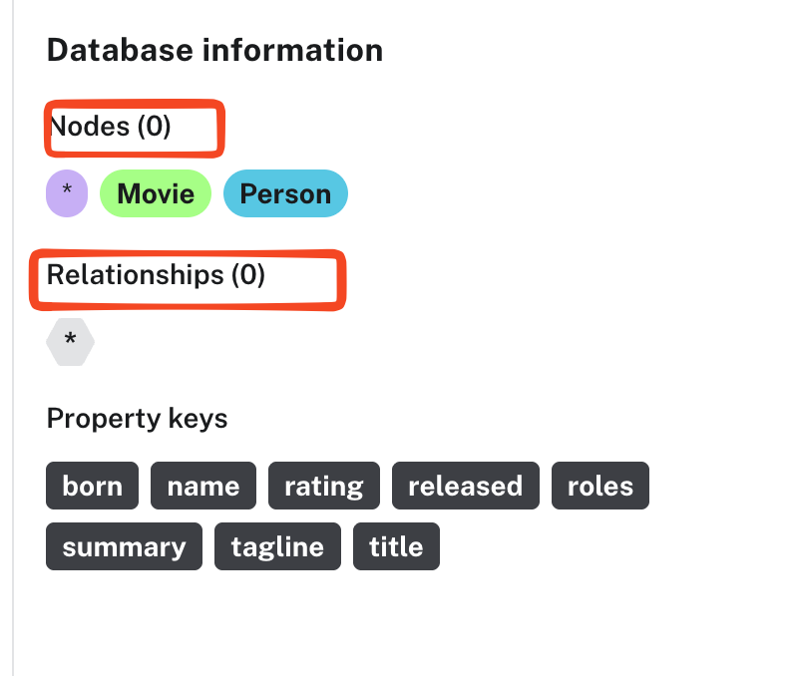

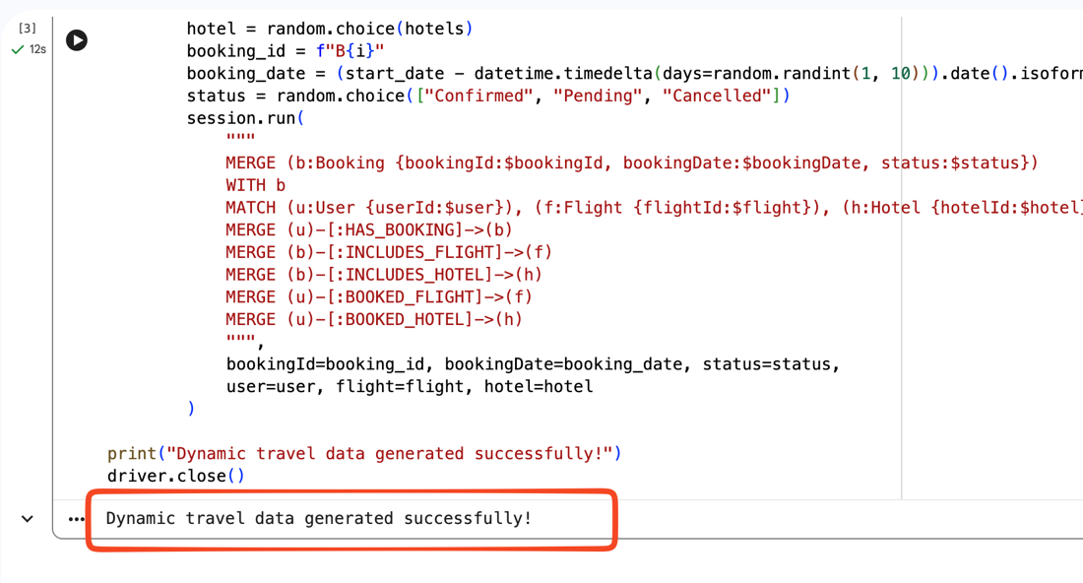

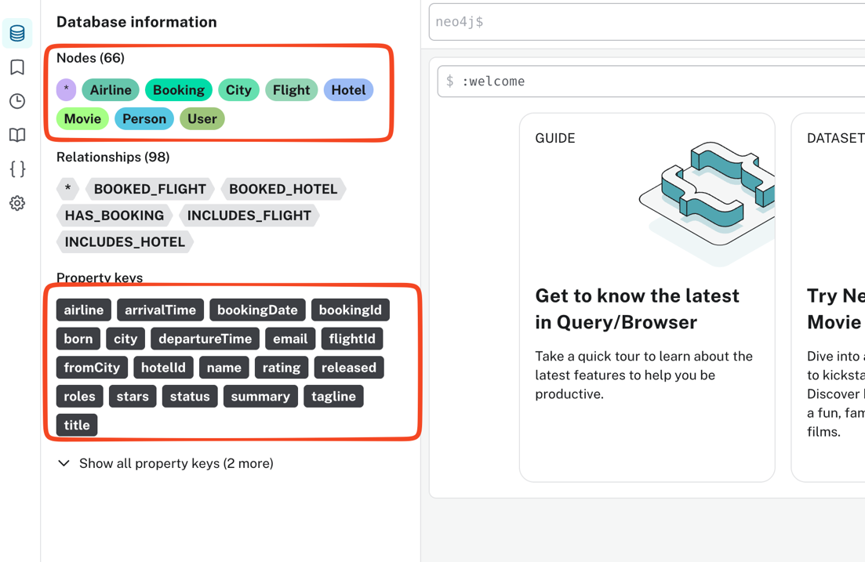

Finally we can say that we have inserted data to the database

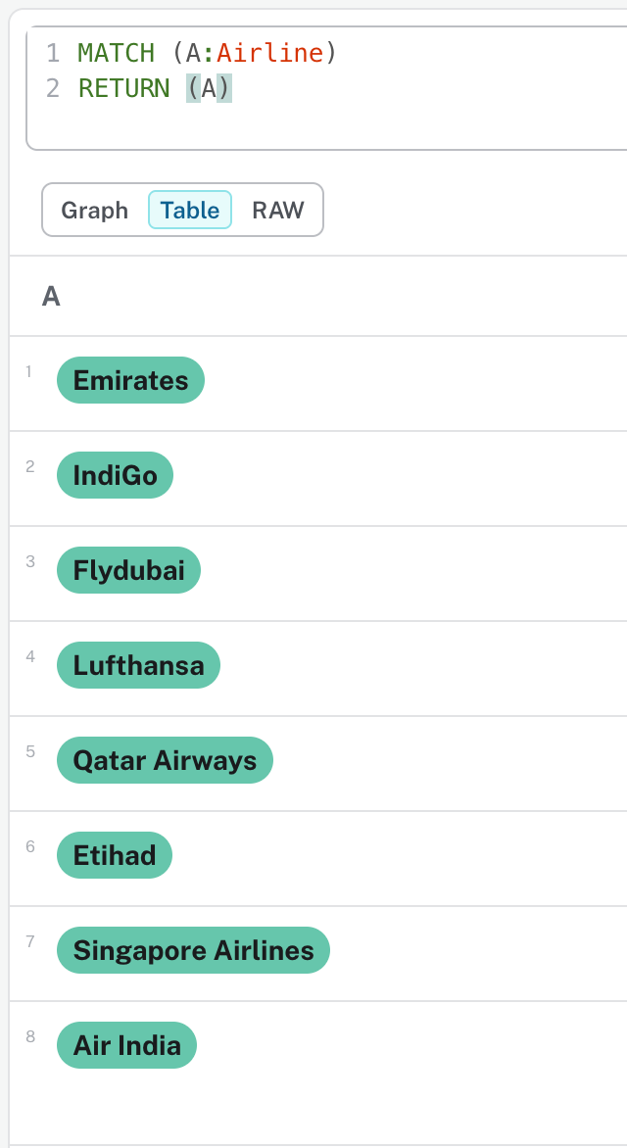

3.Implementing Langchain+Graphdb

#### Installing required packages
- https://docs.langchain.com/oss/python/integrations/vectorstores/neo4jvector
- https://docs.langchain.com/oss/python/integrations/providers/neo4j
- https://docs.langchain.com/oss/python/integrations/graphs/neo4j_cypher

!pip install neo4j langchain-neo4j langchain-openai

#### Connecting to graph db
- https://docs.langchain.com/oss/python/integrations/graphs/neo4j_cypher

#### Run the below iff if any issue with google colab runtime otherwise not required

print('Attempting to fix google-cloud-aiplatform issue by reinstalling...')
!pip install --upgrade --force-reinstall google-cloud-aiplatform
print('Reinstallation complete. Please re-run the import cell (9hO5vGAzcrfB) and subsequent cells.')

from langchain_neo4j import GraphCypherQAChain, Neo4jGraph
from langchain_openai import ChatOpenAI
graph = Neo4jGraph(url="bolt://184.72.113.194:7687", username="neo4j", password="gunnery-swallow-misconduct")
from google.colab import userdata
import os
os.environ["OPENAI_API_KEY"] = userdata.get('OPENAI_API_KEY')
print(graph.get_schema)

#### Exploring more options with graphdb

**#### Enhanced Graph**

enhanced_graph = Neo4jGraph(
url="bolt://184.72.113.194:7687",
username="neo4j",
password="gunnery-swallow-misconduct",
enhanced_schema=True,
)
print(enhanced_graph.schema)

**#### Limiting results, direct output, integrating with llms**

graph = Neo4jGraph(
url="bolt://184.72.113.194:7687",
username="neo4j",
password="gunnery-swallow-misconduct",
enhanced_schema=True
)

chain = GraphCypherQAChain.from_llm(
ChatOpenAI(temperature=0),
graph=graph,
verbose=True,
return_direct=True,
allow_dangerous_requests=True,
)

**#### Invoking chain**

result = chain.invoke({"query": "list down all airlines"})
print(f"Final answer: {result['result']}")

#### Enhancing the LLM with prompts and chains

from langchain_core.prompts.prompt import PromptTemplate

CYPHER_GENERATION_TEMPLATE = """Task:Generate Cypher statement to query a graph database.
Instructions:
Use only the provided relationship types and properties in the schema.
Do not use any other relationship types or properties that are not provided.
Schema:
{schema}
Note: Do not include any explanations or apologies in your responses.
Do not respond to any questions that might ask anything else than for you to construct a Cypher statement.
Do not include any text except the generated Cypher statement.
Examples: Here are a few examples of generated Cypher statements for particular questions:
# How many users booked flights ?
MATCH (u:User)-[:BOOKED]->(f:Flight)
RETURN count(u.name)

The question is:
{question}"""

CYPHER_GENERATION_PROMPT = PromptTemplate(
input_variables=["schema", "question"], template=CYPHER_GENERATION_TEMPLATE
)

chain = GraphCypherQAChain.from_llm(
ChatOpenAI(temperature=0),
graph=graph,
verbose=True,
validate_cypher=True,
cypher_prompt=CYPHER_GENERATION_PROMPT,
allow_dangerous_requests=True,
)

#### Invoking chain
f

4.Creating and configuring workstation

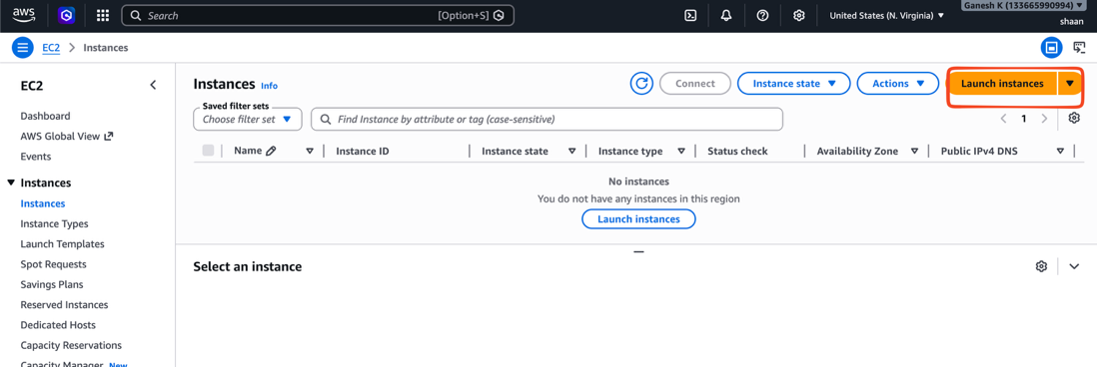

Make sure you are taking 2Core Cpu with 4GB RAM

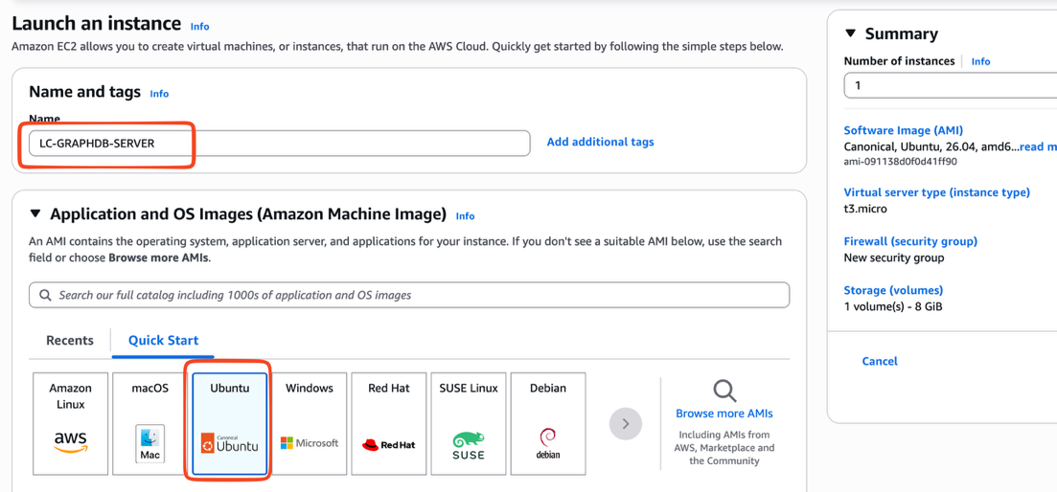

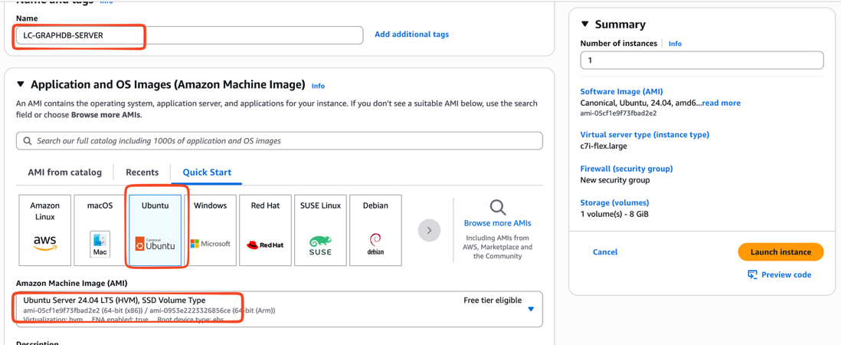

NOTE: Make sure you are taking Ubuntu 24.04 ONLY. Don't go with Ubuntu 26

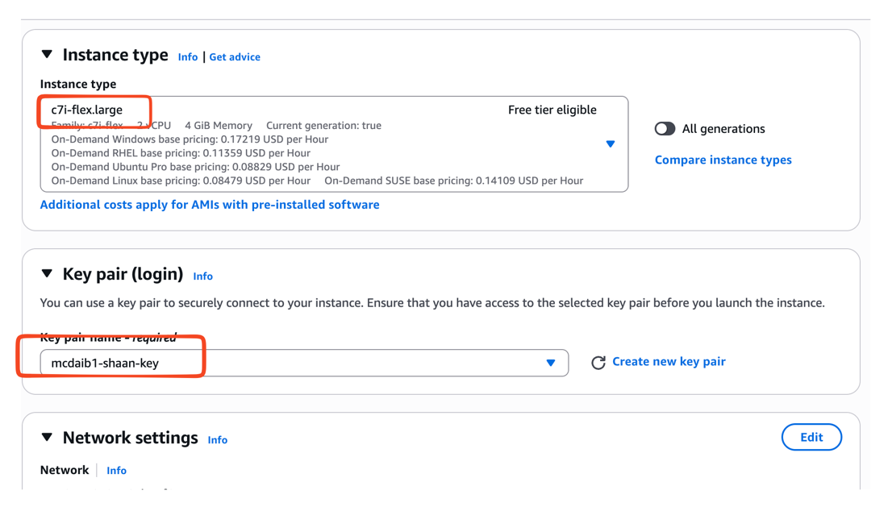

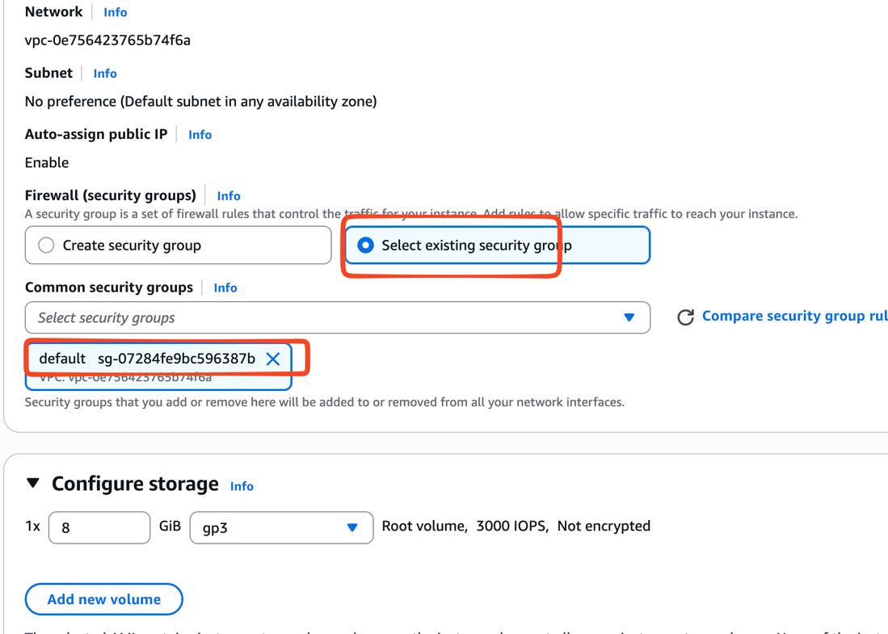

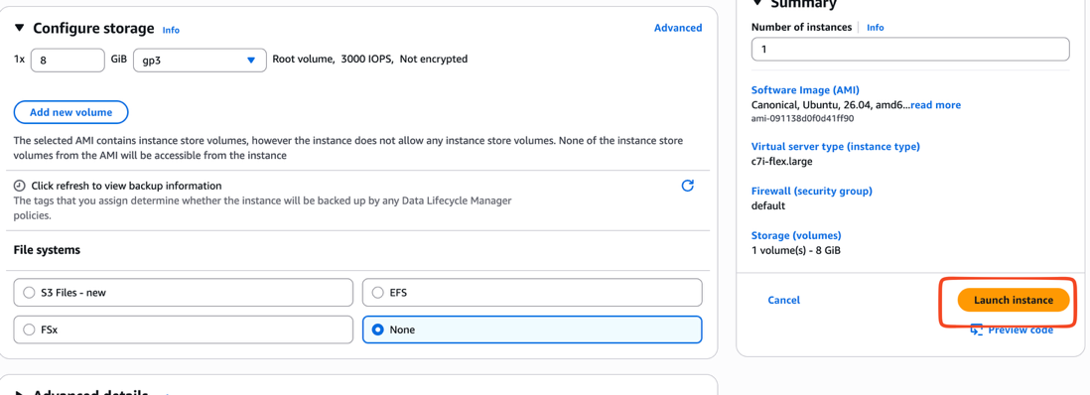

Configuring workstation with below

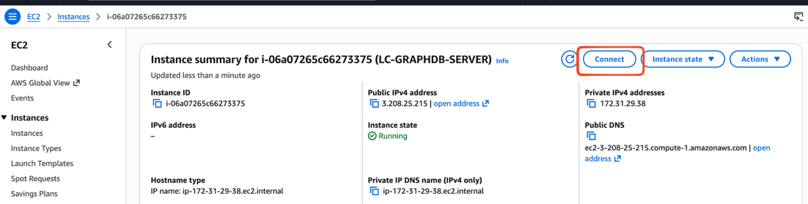

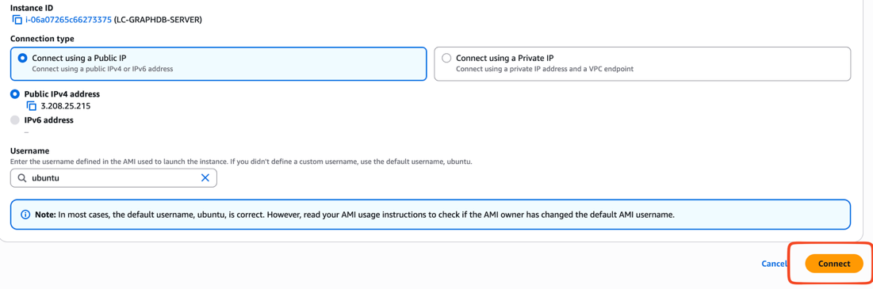

sudo su -

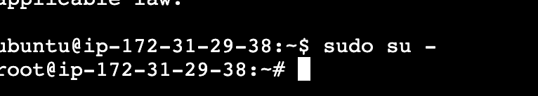

apt update -y
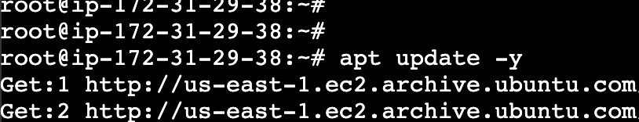

apt install python3-pip

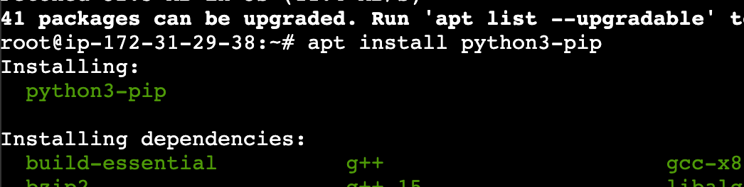

apt install python3-venv

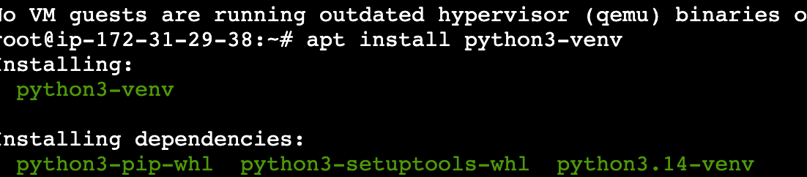

mkdir /opt/app

cd /opt/app

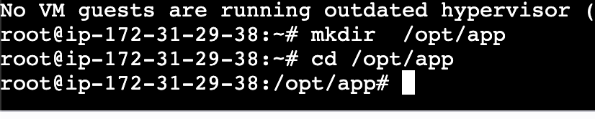

python3 -m venv .venv

source .venv/bin/activate

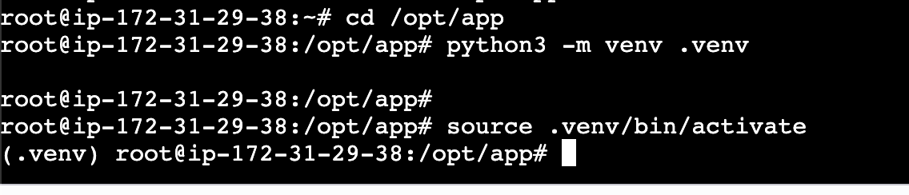

Copy the application code

Note: Ensure that you are replacing below variables as per your values

os.environ["OPENAI_API_KEY"] = 'sk-proj-bAiHdIB3iDGG-WxyfhKLkncWZ684qLbO0Ioa7w8LVXV-2mXrup8yuZcCgA'
NEO4J_URI = "bolt://52.91.25.198:7687"
NEO4J_USER = "neo4j"
NEO4J_PASSWORD = "effort-boys-events"

app.py

cat << EOF > app.py
# pip install neo4j langchain-neo4j langchain-openai fastapi
from langchain_neo4j import GraphCypherQAChain, Neo4jGraph
import chainlit as cl
from langchain_openai import ChatOpenAI
from pydantic import BaseModel
import os
os.environ["OPENAI_API_KEY"] = 'sk-proj-bAiHdIB3iDGG-WxyfhKLkncWZ684qLbO0Ioa7w8LVXQXH686vftfV-2mXrup8yuZcCgA'
NEO4J_URI = "bolt://184.72.113.194:7687"
NEO4J_USER = "neo4j"
NEO4J_PASSWORD = "gunnery-swallow-misconduct"
graph = Neo4jGraph(url=NEO4J_URI, username=NEO4J_USER, password=NEO4J_PASSWORD,enhanced_schema=True,)
from langchain_core.prompts.prompt import PromptTemplate
CYPHER_GENERATION_TEMPLATE = """Task:Generate Cypher statement to query a graph database.
Instructions:
Use only the provided relationship types and properties in the schema.
Do not use any other relationship types or properties that are not provided.
Schema:
{schema}
Note: Do not include any explanations or apologies in your responses.
Do not respond to any questions that might ask anything else than for you to construct a Cypher statement.
Do not include any text except the generated Cypher statement.
Examples: Here are a few examples of generated Cypher statements for particular questions:
# Total no of bookings per airline?
MATCH (u:User)-[:BOOKED_FLIGHT]->(f:Flight)
RETURN f.airline, count(*) as totalbooking
The question is:
{question}
Can you generate human generated format so that everyone understand naturally
"""
CYPHER_GENERATION_PROMPT = PromptTemplate(
input_variables=["schema", "question"], template=CYPHER_GENERATION_TEMPLATE
)
chain = GraphCypherQAChain.from_llm(
ChatOpenAI(temperature=0),
graph=graph,
verbose=True,
cypher_prompt=CYPHER_GENERATION_PROMPT,
return_direct=True,
validate_cypher=True,
use_function_response=True,
allow_dangerous_requests=True,
)
# from fastapi import FastAPI
# # API app
# app = FastAPI()
# # Request schema
# class QueryRequest(BaseModel):
# query: str
# # API endpoint
# @app.post("/ask")
# def ask_graph(request: QueryRequest):
# result = chain.invoke({"query": request.query})
# return {
# "query": request.query,
# "result": result
# }
from langchain_core.prompts import PromptTemplate
from langchain_openai import OpenAI
llm = OpenAI()
outputprompt = PromptTemplate.from_template("""
You are a response formatter.
Your job is to convert database results into a clean and human-readable format.
Rules:
- Never return raw JSON or dictionaries.
- Present the result in a pretty readable format.
- If the result contains a count, write it as a sentence.
- If the result contains multiple items, present them as a numbered list.
- If the result is empty, say "No results found".
- Only return the formatted answer.
Examples:
Input:
{{'totalAirlines': 8}}
Output:
Total airlines are 8.
Input:
{{'totalUsers': 10}}
Output:
Total users are 10.
Input:
[{{'h.name': 'Jackton Grand Hotel'}}, {{'h.name': 'North Johnhaven Grand Hotel'}}]
Output:
Hotels found:
1. Jackton Grand Hotel
2. North Johnhaven Grand Hotel
Input:
[{{'name': 'Emirates'}}, {{'name': 'Qatar Airways'}}, {{'name': 'Lufthansa'}}]
Output:
Airlines found:
1. Emirates
2. Qatar Airways
3. Lufthansa
Now format the following result in a clean and pretty way:
{input}
""")
outputchain = outputprompt | llm
# Chat handler
@cl.on_message
async def main(message: cl.Message):
query = message.content
result = chain.invoke({"query": query})
finalresult = outputchain.invoke({"input": result})
print(finalresult)
await cl.Message(
content=str(finalresult)
).send()

EOF

requirements.txt

cat <<EOF >requirements.txt
neo4j
langchain-neo4j
langchain-openai
fastapi
uvicorn
chainlit
EOF

4.Copy the code to the server as app.py , requirement.txt

Then copy the content to the server as below

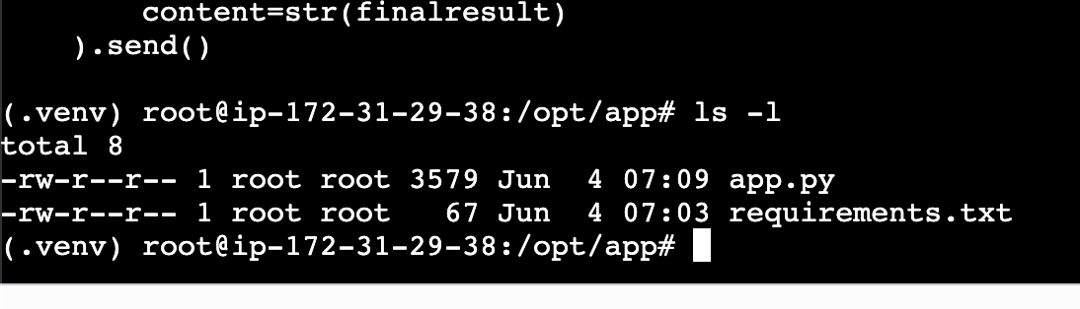

5.Running application

Install all dependencies before you run

pip install -r requirements.txt

chainlit run app.py --host 0.0.0.0 --port 8080

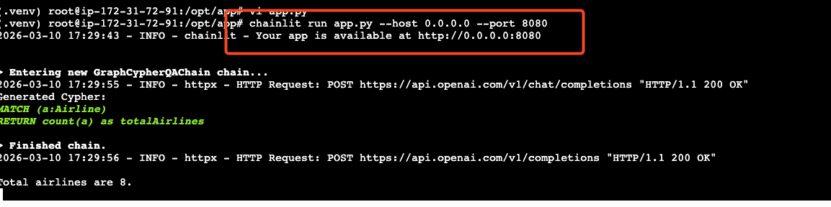

Final result

