Compiled and Scrutinized by
Mr. Shaan Shaik
(Senior DevOps Lead)

Words To The Students

Though we have taken utmost efforts to present you this book error free, but still it may contain some errors or mistakes. Students are encouraged to bring, if there are any mistakes or errors in this document to our notice. So that it may be rectified in the next edition of this document.

“Suppressing your doubts is Hindering your growth”.

We urge you to work hard and make use of the facilities we are providing to you, because there is no substitute for hard work. We wish you all the best for your future.

“The grass isn’t greener on the other side; the grass is greener where you water it.”

You and your suggestions are valuable to us; Help us to serve you better. In case of any suggestions, grievance, or complaints, please feel free to write us your suggestions, grievance and feedback on the following

Dvs.training@gmail.com

1. Introduction to Kubernetes

What is Kubernetes:

Commonly referred to by its internal designation during the development as Google(k8s),Kubernetes is an open source container cluster manage.

When it was released in july 2015, Google donated it as "seed technology" to the newly formed Cloud native computing foundation established in a partenership with the linux foundation

Kubernetes primary goal is to provide a platform for automating deployment,scaling and operations of application containers across a cluster of hosts.

Design Overview:

kubernetes is built through the definition of a set of components (building blocks or "primitives") which,when used collectively,provide a method for the deployment, maintenance and scalability of container based application clusters.

These "primitives" are designed to be loosely coupled(i.e. where little to no knowledge of the other component definitions is needed to use) as well as easily extensible through an API. Both the internal components of kubernetes as well as the extensions and containers make use of this API.

Although kubernetes was designed and used internally at google to deploy and utilize "billion of containers", since it was open sourced under the Apache common license, it has since been adopted formally as a service available from each of the major cloud providers.

Components:

Building Block of Kubernetes:

Node(matser & workers)
Pods
Labels
Selectors
Controllers/Deployments
Services
Control Pane
API

Understanding Kubernetes Architecture :

Explain in detail about the architecture of K8s how it works.

Please check "HighLevel Architecture" figure for more information ...

From the above architecture we can conclude that we will have a "master controller" which will control all the other nodes. Here in k8s we called these nodes as "worker nodes", which means that each and every server (worker nodes) should have docker package installed. Along with this we are going to create our containers in seperate environment which we called it as "Pods". Hence you are not allowed to create as seperate entity. You should create the containers as part of the pods. If you want to increase the containers
you can increase the containers as part of that pods. And finally all the worker nodes will be managed by our master controller.

Components of Kubernetes in detail over view :

worker nodes (Nodes):

You can think of these as "container clients". These are the individual hosts(physical or virtual) that docker is installed on and hosts the various containers within your managed cluster. So Finally "worker nodes" are nothing but our physical or virtula server where we have our container package installed and it acts like a slave to the master controller.

Pods:

A pod consists of one or more containers. Those containers are guaranteed (by the cluster
controller) to be located on the same host machine in order to facilitate sharing of
resources. Pods are assigned unique ips with in each cluster. These allow an application to use ports
without having to worry about conflicting port utilization.

Pods can contain definitions of disk volumes or share, and then provide access from those to
all the members(containers) with in the pod.

Finally, pod management is done through the API or delegated to a controller.

Labels:
Clients can attach "key-value pairs" to any object in the system (like pods or worker nodes).
These become the labels that identify them in the configuration and management of them.

Selectors:

Label selectors represent queries that are made against those labels. They resolve to the
corresponding matching objects.
These two item are the primary way that grouping is done in kubernetes and determine which
components that a given operation applies to when indicated.

Controllers:

These are used in the management of your cluster. Controllers are the mechanism by which
your desired configuration state is enforced.Controllers manage a set of pods and depending on the desire configuration state, may enagage other controllers to handle replication and scaling (Replication ontroller)
of XX number of containers and pods across the clsuter. It is also responsible for replacing any container in a pod that fails (based on the desired state of the cluster). Other controllers that cna be engaged include a DaemonSet Controller (enforces a 1 to 1 ratio of pods to worker nodes) and job Controller(that runs pods to "completion", such as in batch jobs).

Each set of pods any controller manages, is determined by the label selectors that are part of its definition.

Services:

A pod consists of one or more containers. Those containers are guranteed (by the cluster controller) to be located on the same host machine in order to facilitate sharing of resources. This is so that pods can work together, like in a multi-tier application configuration. Each set of pods that define and implement a service (like Mysql or Apache) are defined by the label selector.

Kubernetes can then provide service discovery and handle routing with the static ip for each pod as well as load balancing (round robin based) connections to that service among the pods that match the label selector indicated. By default although a service is only exposed inside a cluster, it can also be exposed
outside a cluster as needed

On the Master Node following components will be installed :

API Server – It provides kubernetes API using Json / Yaml over http, states of
API objects are stored in etcd

Scheduler – It is a program on master node which performs the scheduling tasks like
launching containers in worker nodes based on resource availability

Controller Manager – Main Job of Controller manager is to monitor replication controllers
and create pods to maintain desired state.

etcd – It is a Key value pair data base. It stores configuration data of cluster and cluster state.

Kubectl utility – It is a command line utility which connects to API Server on port 6443. It is used by administrators to create pods, services etc.

On Worker Nodes following components will be installed ::

Kubelet – It is an agent which runs on every worker node, it connects to docker and takes care of creating, starting, deleting containers.

Kube-Proxy – It routes the traffic to appropriate containers based on ip address and port number of the incoming request. In other words we can say it is used for port translation.

Pod – Pod can be defined as a multi-tier or group of containers that are deployed on a single worker node or docker host.

2 Preparing workstation

Read the below before you start (mandatory):

1 Since it’s a workstation we can go ahead and create workstation with t2.micro
2 Make sure that you are configuring worker node groups with t2.medium configuration
3 Note that all the servers are getting created in the same network(vpc)
for example in future jenkins (t2.medium) etc ..
4 Make sure you are creating the infrastructure in OHIO (us-east-2)

- Creating workstation:

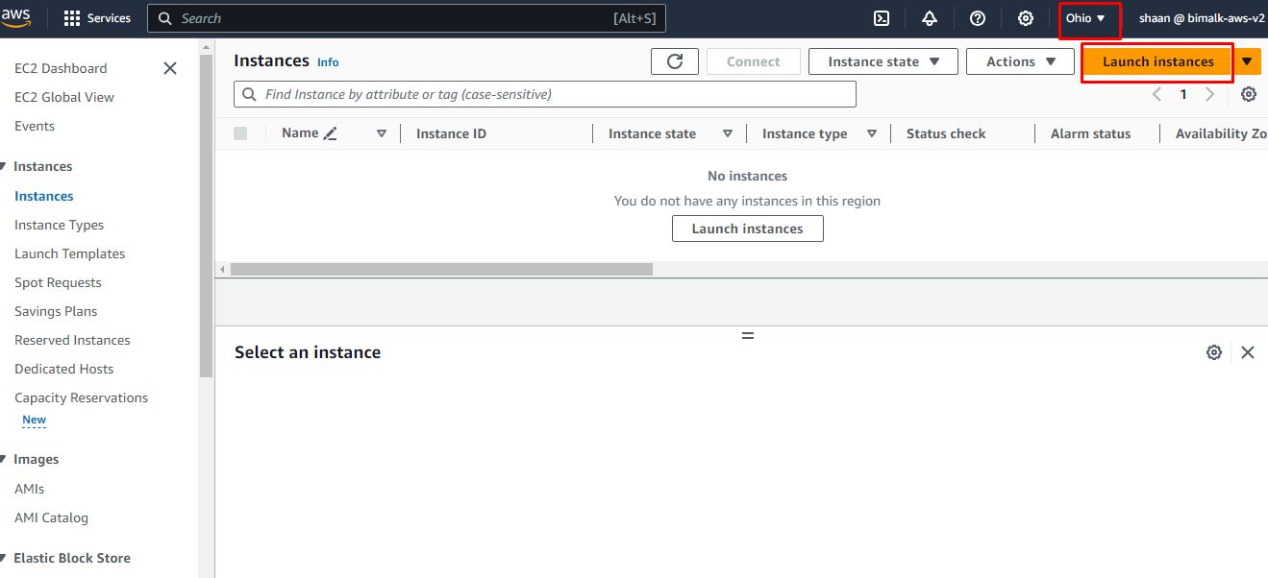

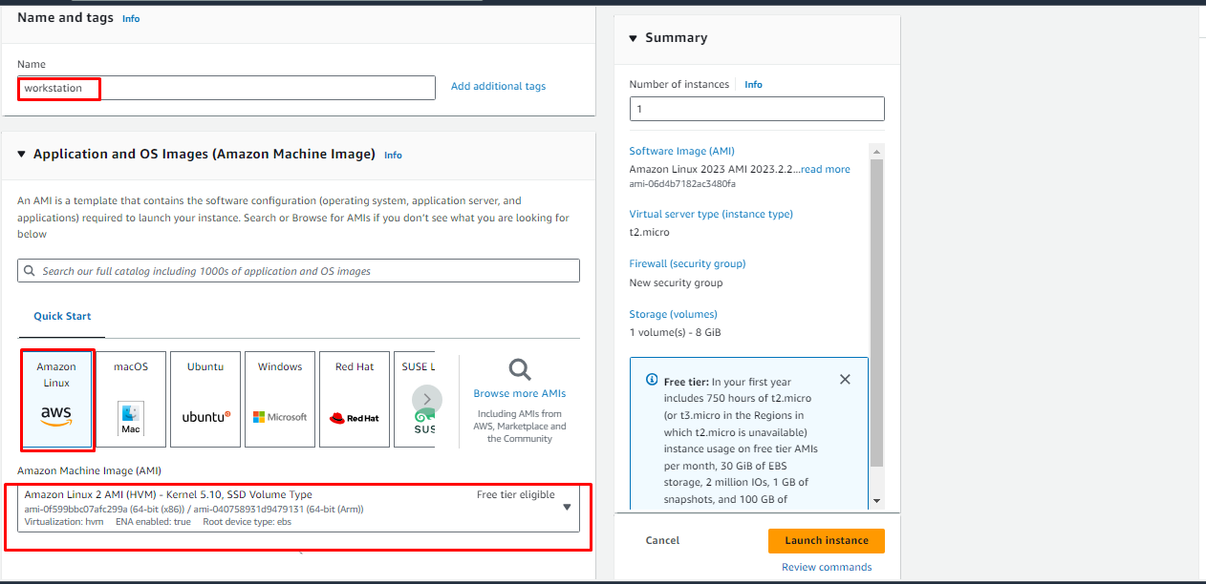

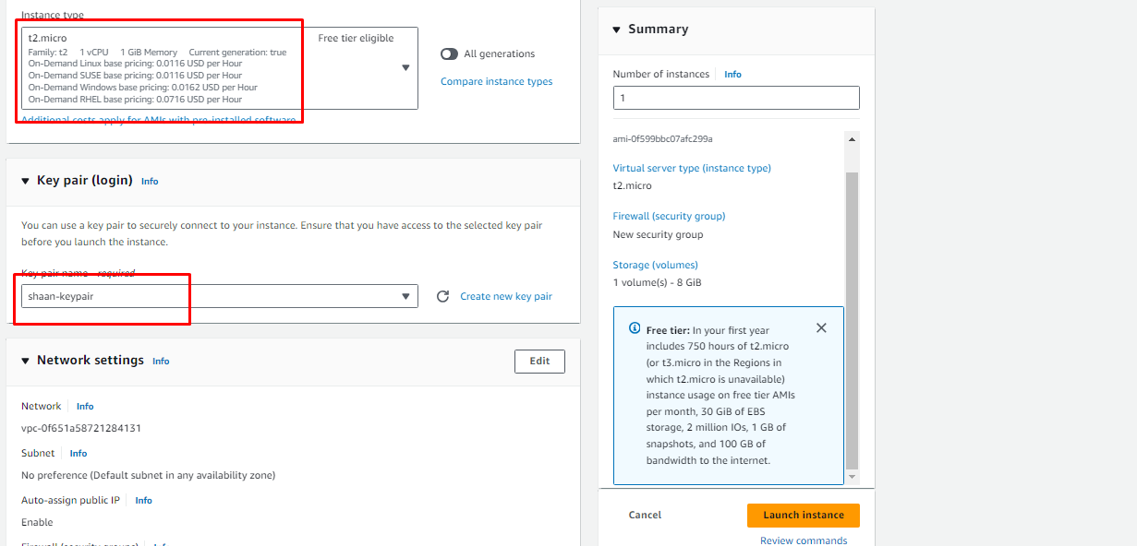

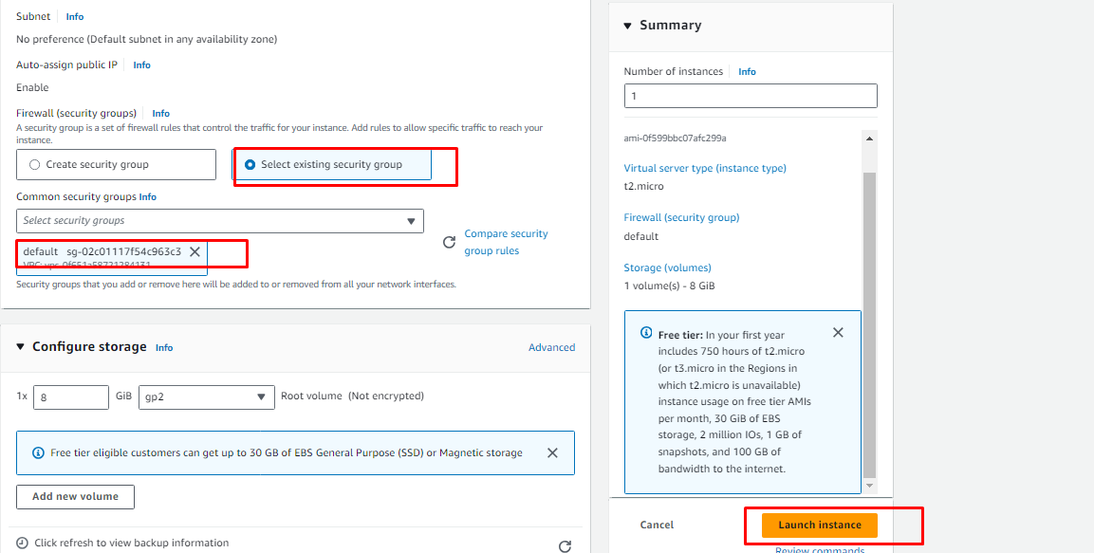

- Login to the server and do the below

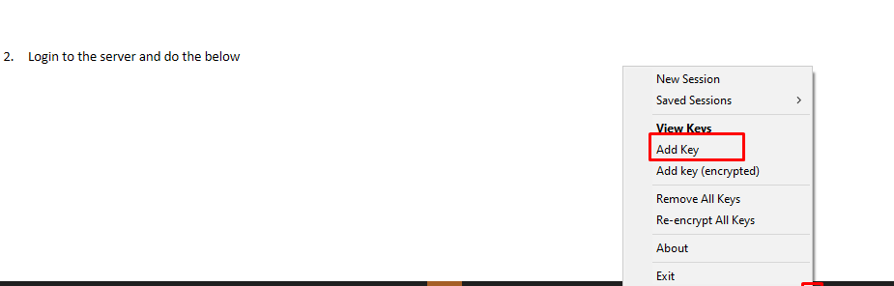

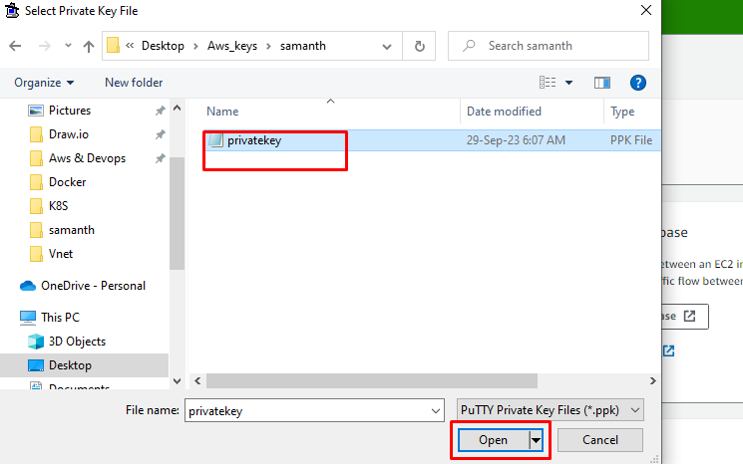

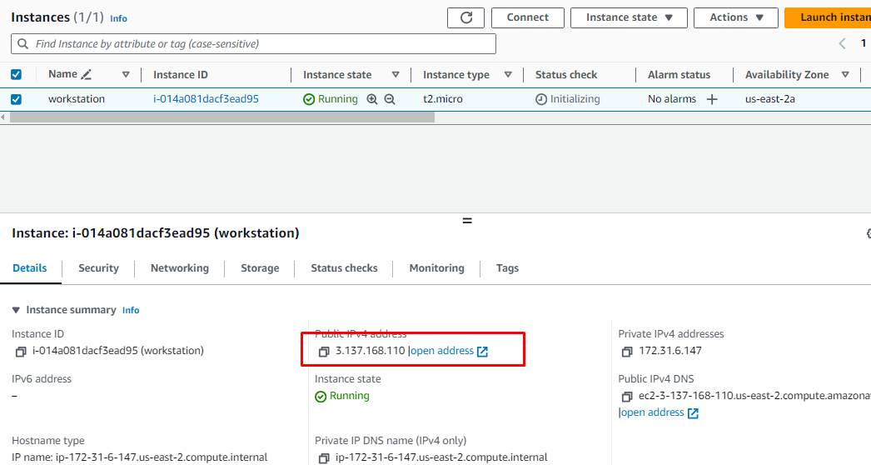

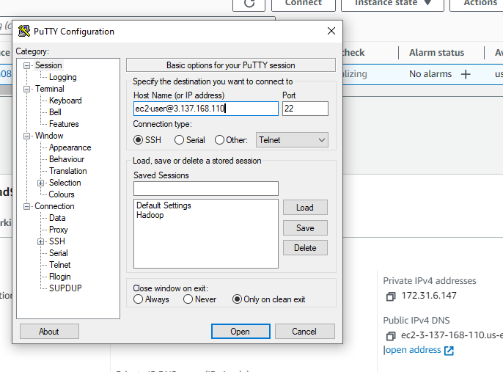

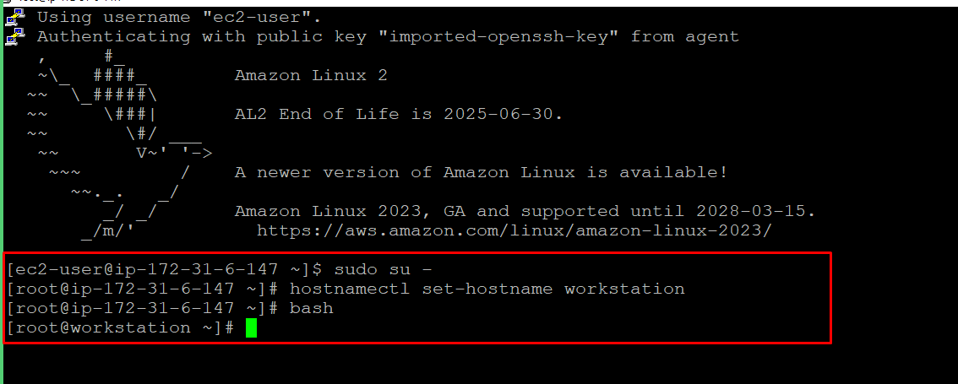

- Installing all the required softwares to proceed with installation

- Aws cli installation:

curl "https://awscli.amazonaws.com/awscli-exe-linux-x86_64.zip" -o "awscliv2.zip"
unzip awscliv2.zip
sudo ./aws/install

2. Install eksctl latest binary
https://eksctl.io/installation/
# for ARM systems, set ARCH to: `arm64`, `armv6` or `armv7`
ARCH=amd64
PLATFORM=$(uname -s)_$ARCH
curl -sLO "https://github.com/eksctl-io/eksctl/releases/latest/download/eksctl_$PLATFORM.tar.gz"
# (Optional) Verify checksum
curl -sL "https://github.com/eksctl-io/eksctl/releases/latest/download/eksctl_checksums.txt" | grep $PLATFORM | sha256sum --check
tar -xzf eksctl_$PLATFORM.tar.gz -C /tmp && /usr/bin/rm -f eksctl_$PLATFORM.tar.gz
sudo mv /tmp/eksctl /usr/local/bin
echo 'export PATH=$HOME/bin:$PATH' >> ~/.bashrc

3. Install latest of needed version of kubectl command
https://docs.aws.amazon.com/eks/latest/userguide/install-kubectl.html
curl -O https://s3.us-west-2.amazonaws.com/amazon-eks/1.28.3/2023-11-14/bin/linux/amd64/kubectl
chmod +x ./kubectl
mkdir -p $HOME/bin && cp ./kubectl $HOME/bin/kubectl && export PATH=$HOME/bin:$PATH
echo 'export PATH=$HOME/bin:$PATH' >> ~/.bashrc
kubectl version --client

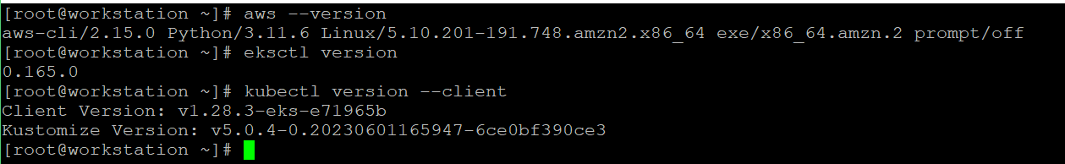

4. Configuring aws cli

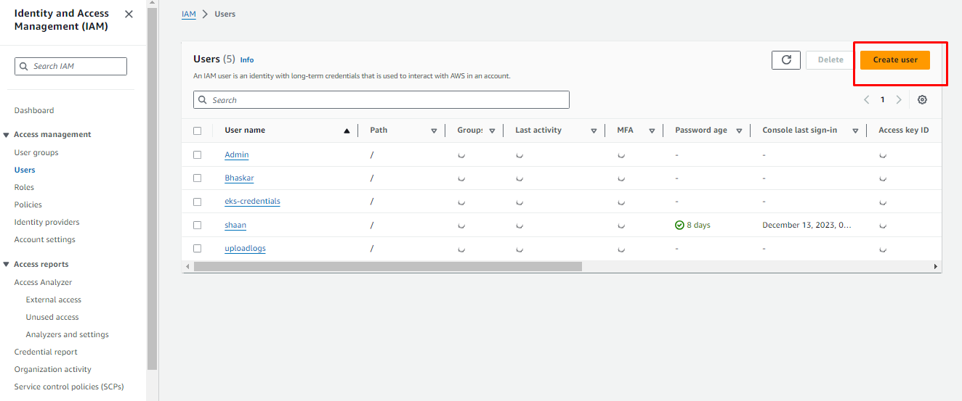

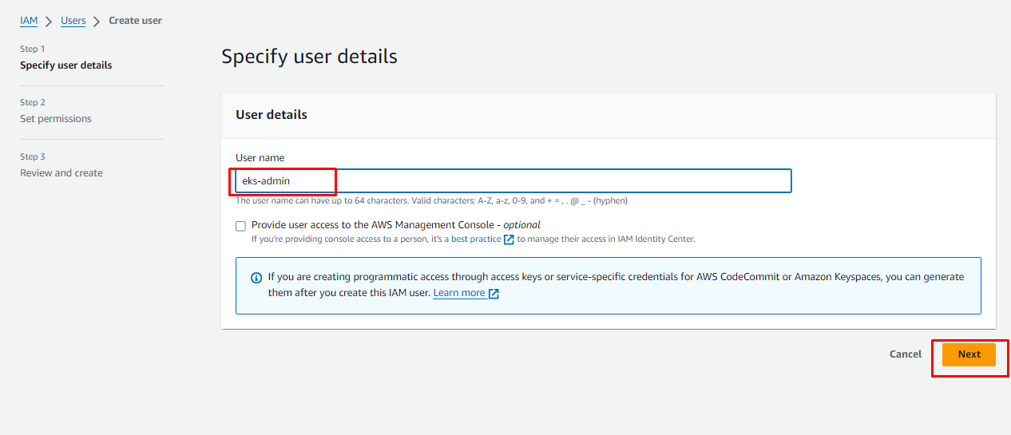

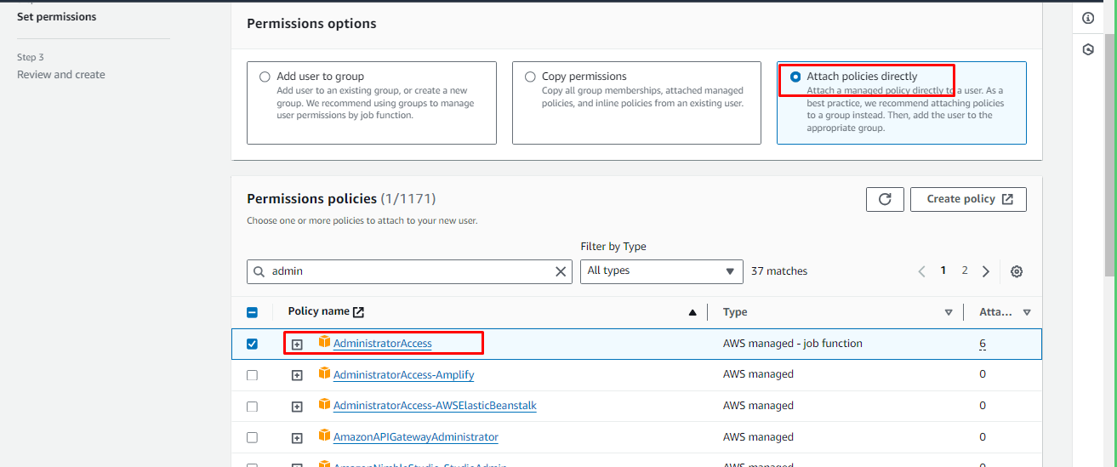

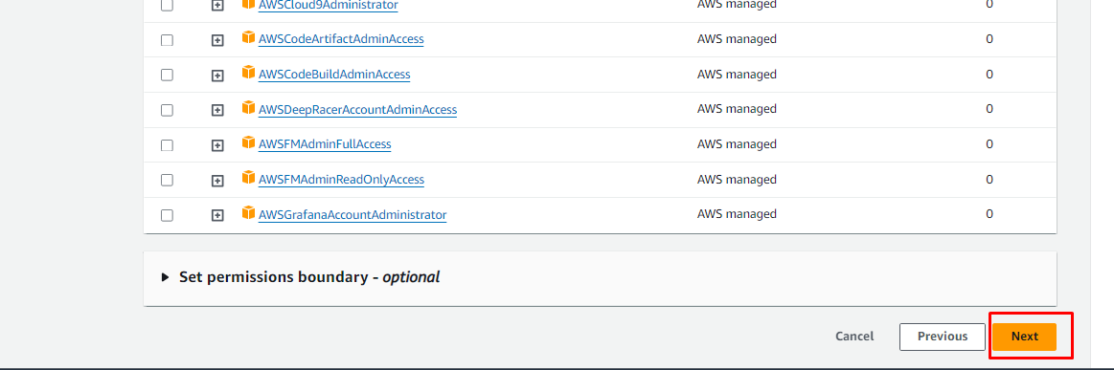

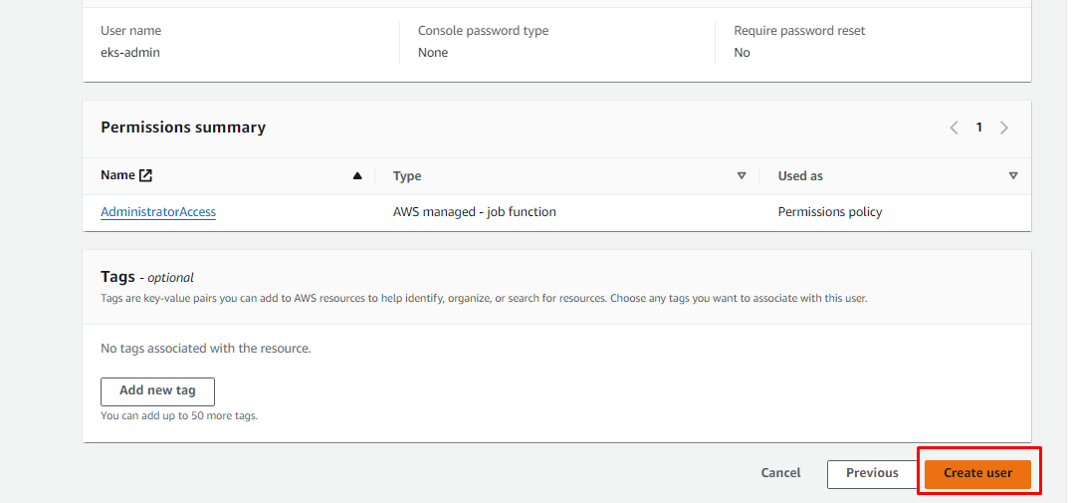

Now let's generate the credentials (access key,token)

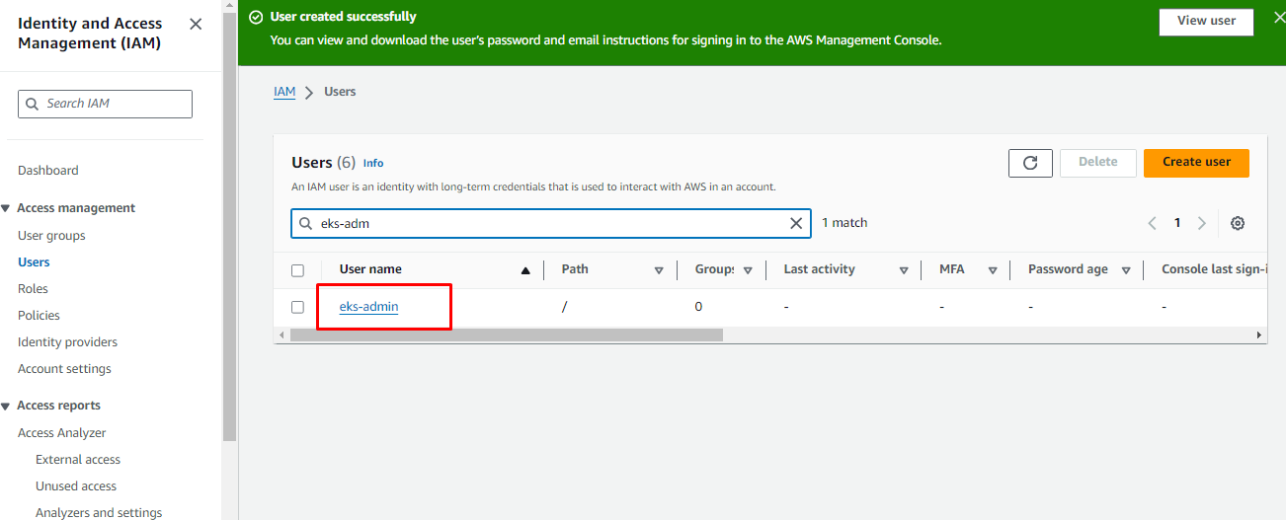

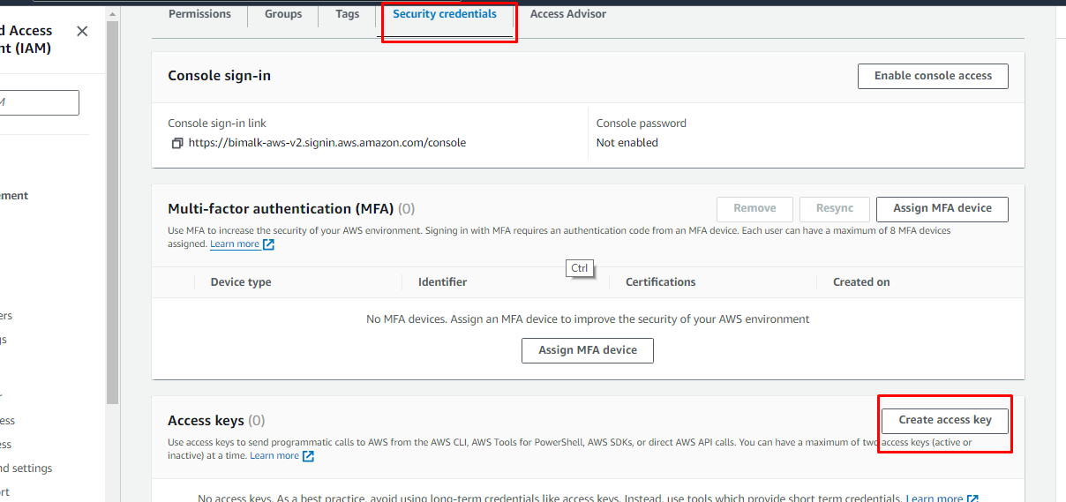

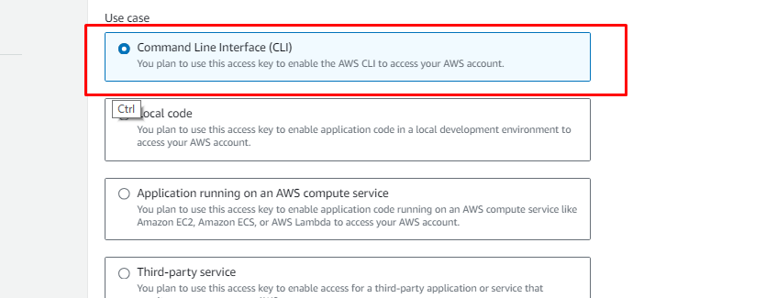

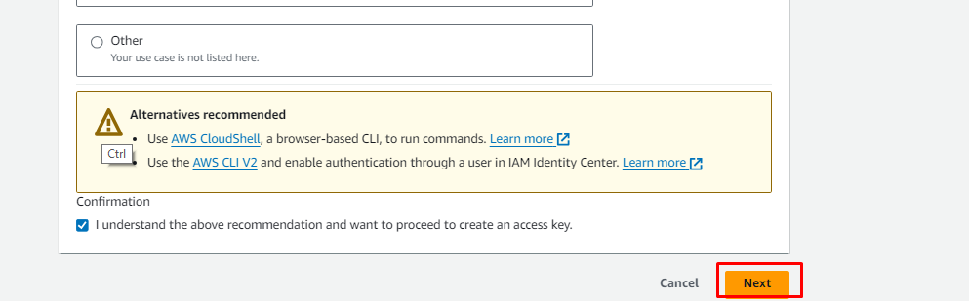

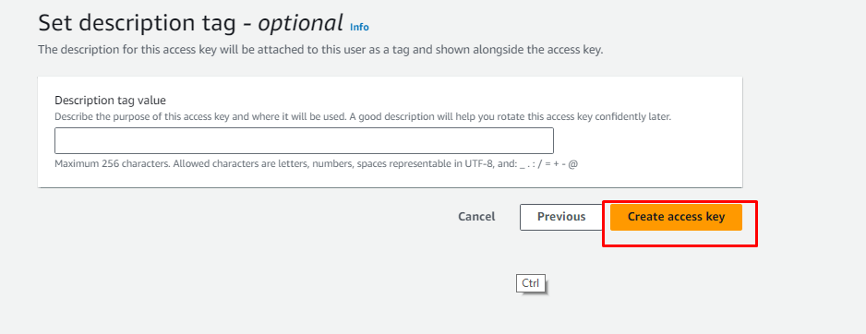

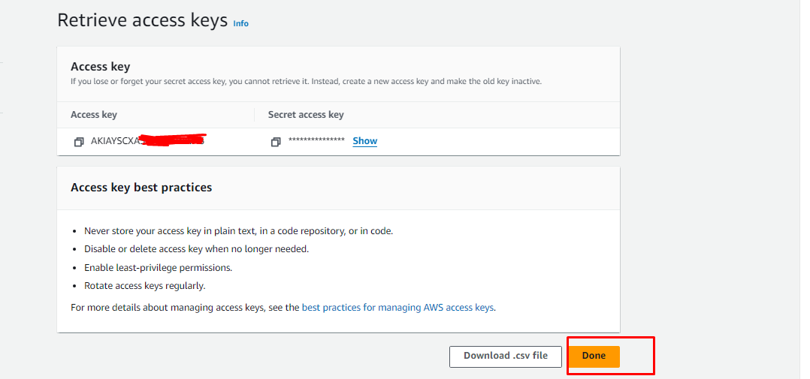

Now you can go to workstation & do the aws configure as mentioned below

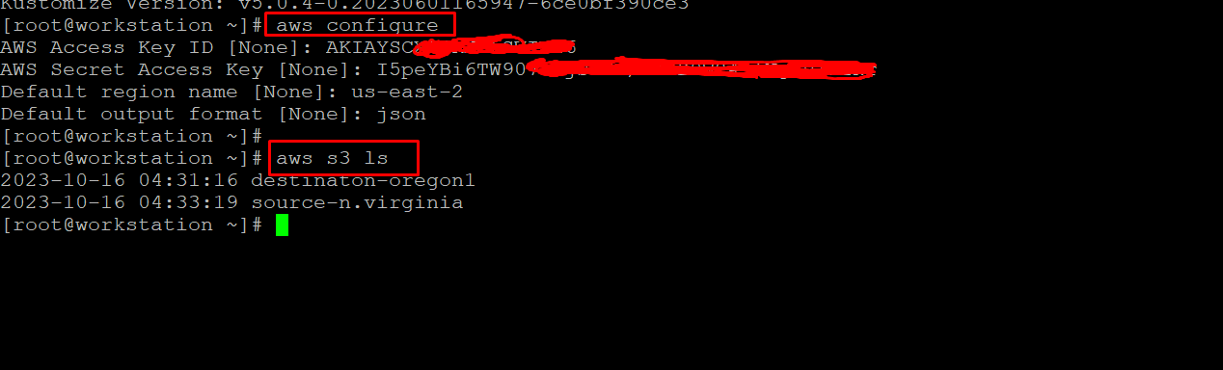

Finally we can see that we have successfully prepare our workstation with all necessary software's required.

3. Creating Cluster with terraform
1. Ensure you are creating one ec2 instance and do the below in that server. Let's call this server as workstation
2. Install below softwares

Installing kubectl:
export VERSION=1.29.3
curl -o kubectl https://s3.us-west-2.amazonaws.com/amazon-eks/${VERSION}/2024-04-19/bin/linux/amd64/kubectl
curl -o kubectl.sha256 https://s3.us-west-2.amazonaws.com/amazon-eks/${VERSION}/2024-04-19/bin/linux/amd64/kubectl.sha256
openssl sha1 -sha256 kubectl
chmod +x ./kubectl
mkdir -p $HOME/bin && cp ./kubectl $HOME/bin/kubectl && export PATH=$PATH:$HOME/bin
echo 'export PATH=$PATH:$HOME/bin' >> ~/.bashrc

Installing git:
yum install git -y

Installing awscli2:
Update awscli to 2:
curl "https://awscli.amazonaws.com/awscli-exe-linux-x86_64.zip" -o "awscliv2.zip"
unzip awscliv2.zip
sudo ./aws/install --update

Terraform install:
wget https://releases.hashicorp.com/terraform/1.2.7/terraform_1.2.7_linux_amd64.zip
unzip terraform_1.2.7_linux_amd64.zip
mv terraform /usr/local/bin/

OR

sudo yum install -y yum-utils
sudo yum-config-manager --add-repo https://rpm.releases.hashicorp.com/AmazonLinux/hashicorp.repo
sudo yum -y install terraform

Configuring access:

[root@myworkstation ~]# aws configure
AWS Access Key ID [****************MTFS]: AKIAWHS4WUKU
AWS Secret Access Key [****************DE8X]: crHNTiUye0Vvnafi41VA7pxjcvWf
Default region name [us-east-1]:
Default output format [json]:

Installing EKS Cluster
git clone https://github.com/shan5a6/eks-infra-terraform.git
cd eks-infra-terraform
terraform init
terraform apply -auto-approve

Note: make sure you are updating the variable ec2_ssh_key with your public key for your server access

4. Working With Cluster

Namespace Creation:

vi ns.yaml

apiVersion: v1
kind: Namespace
metadata:
creationTimestamp: null
name: myapplication
spec: {}
status: {}

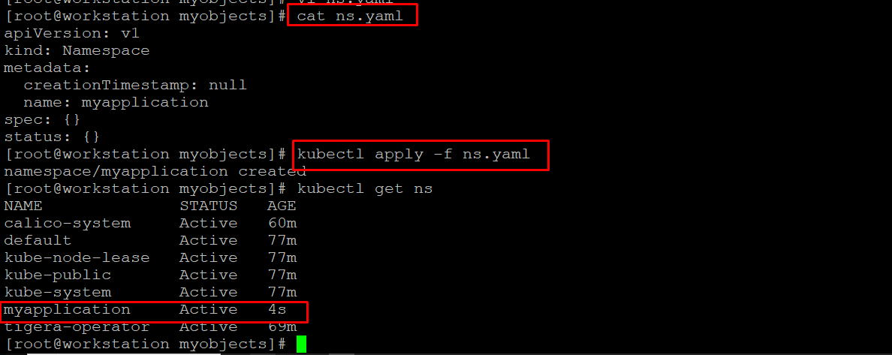

Pod Creation:

vi pod.yaml

apiVersion: v1
kind: Pod
metadata:
creationTimestamp: null
labels:
run: mypod
name: mypod
namespace: myapplication
spec:
containers:
- image: nginx
name: mypod
resources: {}
dnsPolicy: ClusterFirst
restartPolicy: Always
status: {}

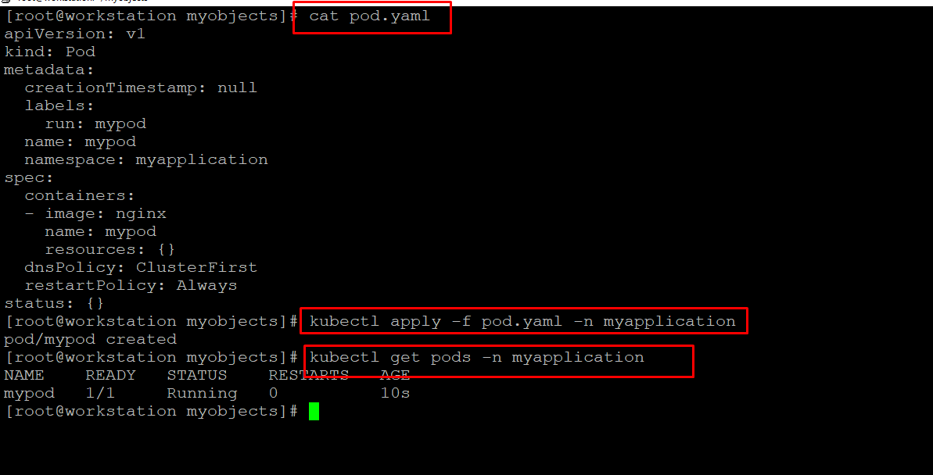

Deployment creation:

vi deploy.yaml

apiVersion: apps/v1
kind: Deployment
metadata:
creationTimestamp: null
labels:
app: mydeployment
name: mydeployment
namespace: myapplication
spec:
replicas: 1
selector:
matchLabels:
app: mydeployment
strategy: {}
template:
metadata:
creationTimestamp: null
labels:
app: mydeployment
spec:
containers:
- image: nginx
name: nginx
resources: {}
status: {}

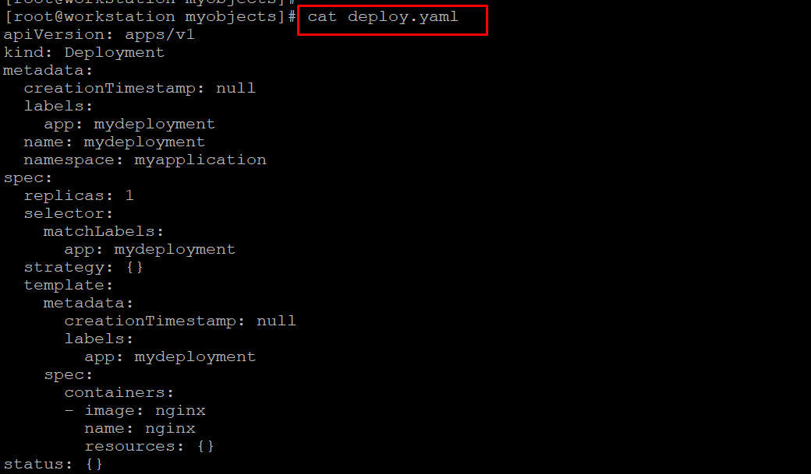

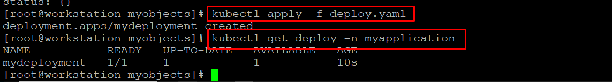

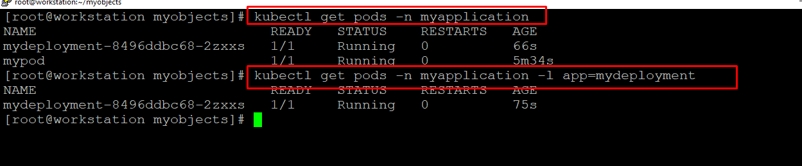

Service creation:

vi svc.yaml

apiVersion: v1
kind: Service
metadata:
creationTimestamp: null
labels:
app: mydeployment
name: mydeployment
namespace: myapplication
spec:
ports:
- port: 80
protocol: TCP
targetPort: 80
selector:
app: mydeployment
type: LoadBalancer
status:
loadBalancer: {}

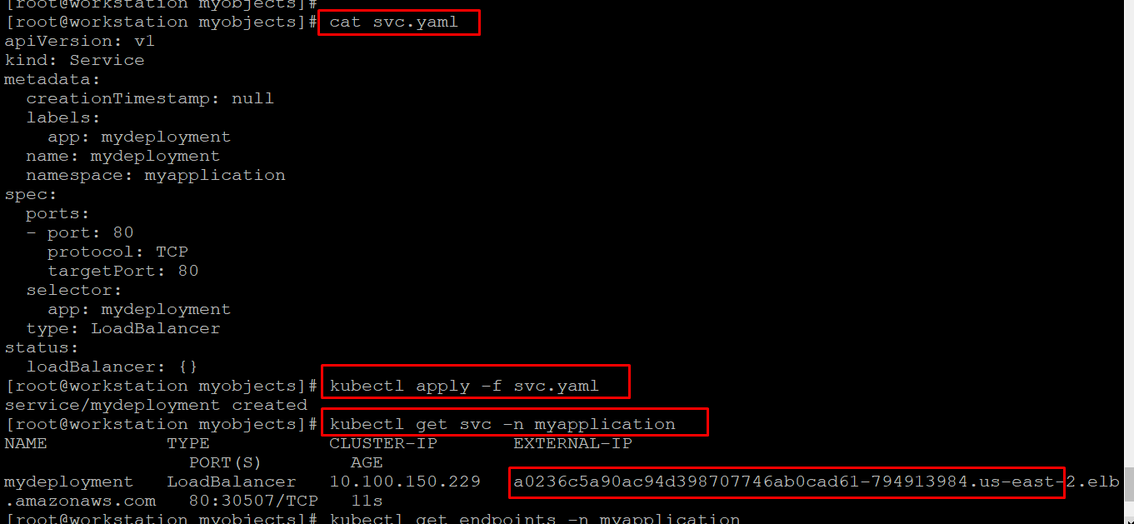

We can able to see that our deployment got exposed as service of type loadbalancer. We got out LB url which we can use it for accessing our application from browser.

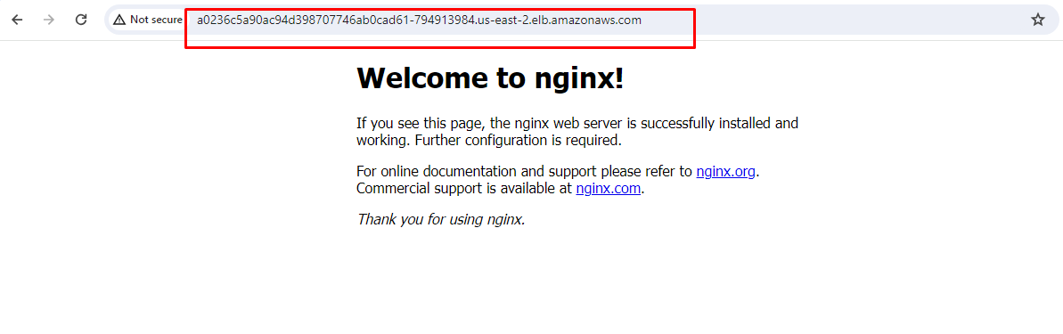

If you want to see the pods behind this service then you can execute the below command

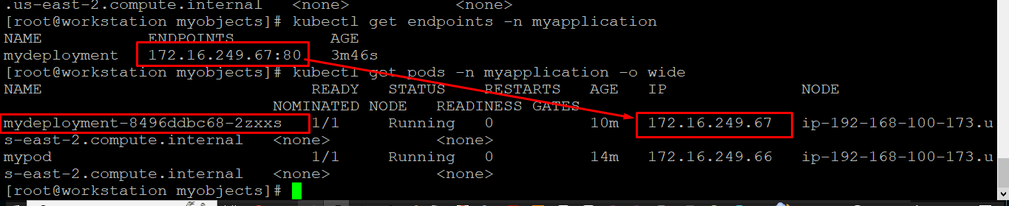

Increasing Replica Count:

If you want to run more than one pod then you can increase the replica count in the below yaml

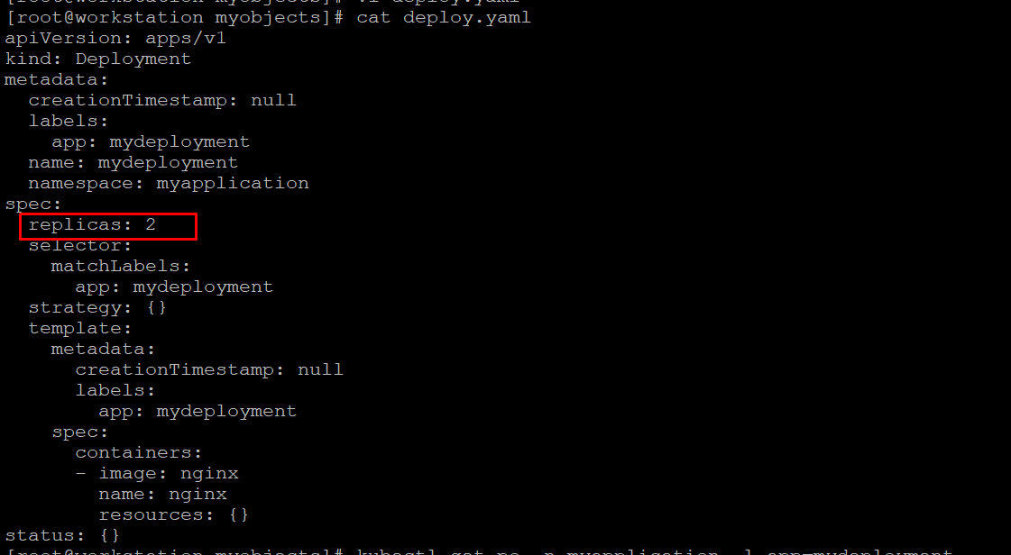

Before changes:

We can see before we apply the yaml no.of pods for this deployment is 2.

Post changes:

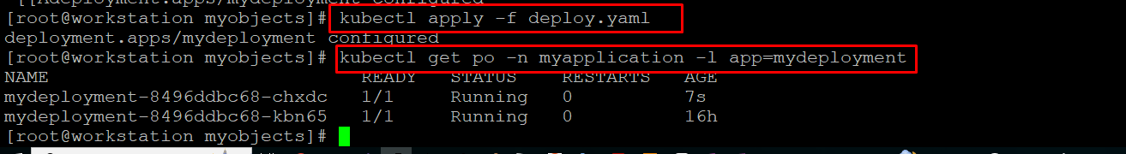

Overall Commands:

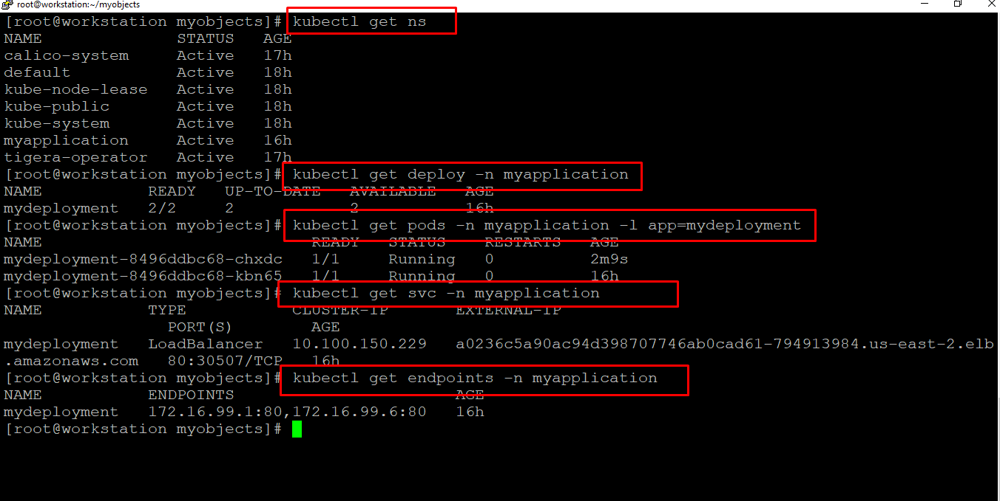

5. Working with Service

Service acts like as a loadbalancer on top of all the pods of an expose deployment. We have three types of services in kubernetes. They are clusterip,nodeport & loadbalancer

- ClusterIP: (This is a default service type, which helps communication between microservices internal to the cluster)

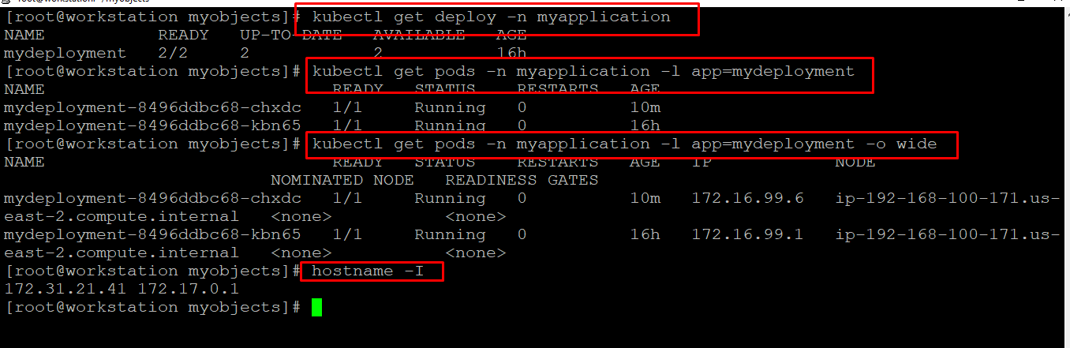

Above screenshot give us an overview of no of pods running for a deployment and their ipaddresses. If you observer properly our host ipaddress(workstation) is not in the range of the cluster ipaddress hence we need an intermediate container which help us to test the application. Hence we are going to use busbox container.

vi busybox.yaml
apiVersion: v1
kind: Pod
metadata:
name: busybox1
labels:
app: busybox1
namespace: myapplication
spec:
containers:
- image: radial/busyboxplus:curl
command:
- sleep
- "3600"
imagePullPolicy: IfNotPresent
name: busybox
restartPolicy: Always

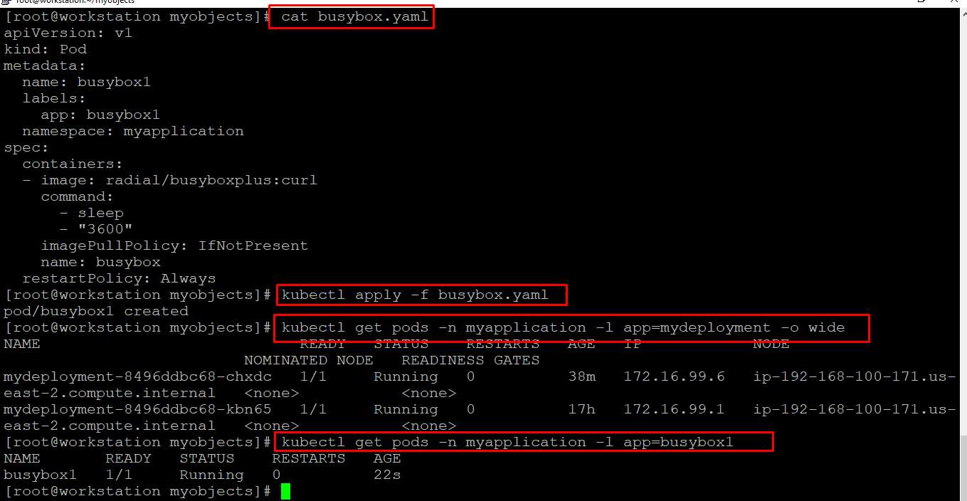

Let's login to the busybox pod and check the application status of our deployment pod

kubectl exec -it busybox1 -n myapplication /bin/sh

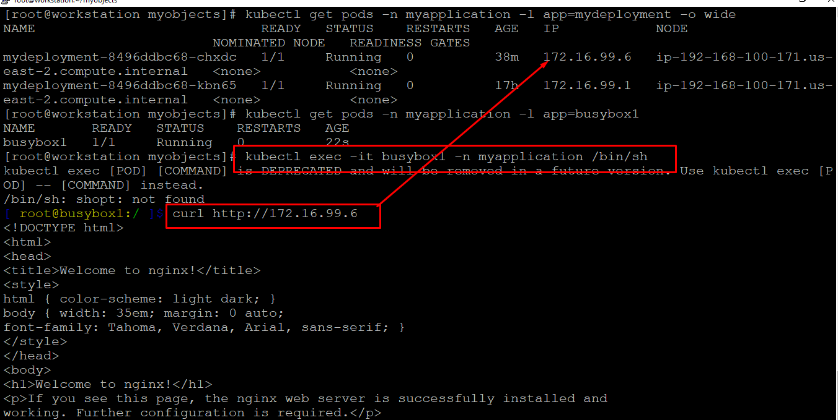

Let's test the application with the service of type clusterip using below.

vi svc-cip.yaml
apiVersion: v1
kind: Service
metadata:
creationTimestamp: null
labels:
app: mydeployment
name: svc-clusterip
namespace: myapplication
spec:
ports:
- port: 80
protocol: TCP
targetPort: 80
selector:
app: mydeployment
type: ClusterIP

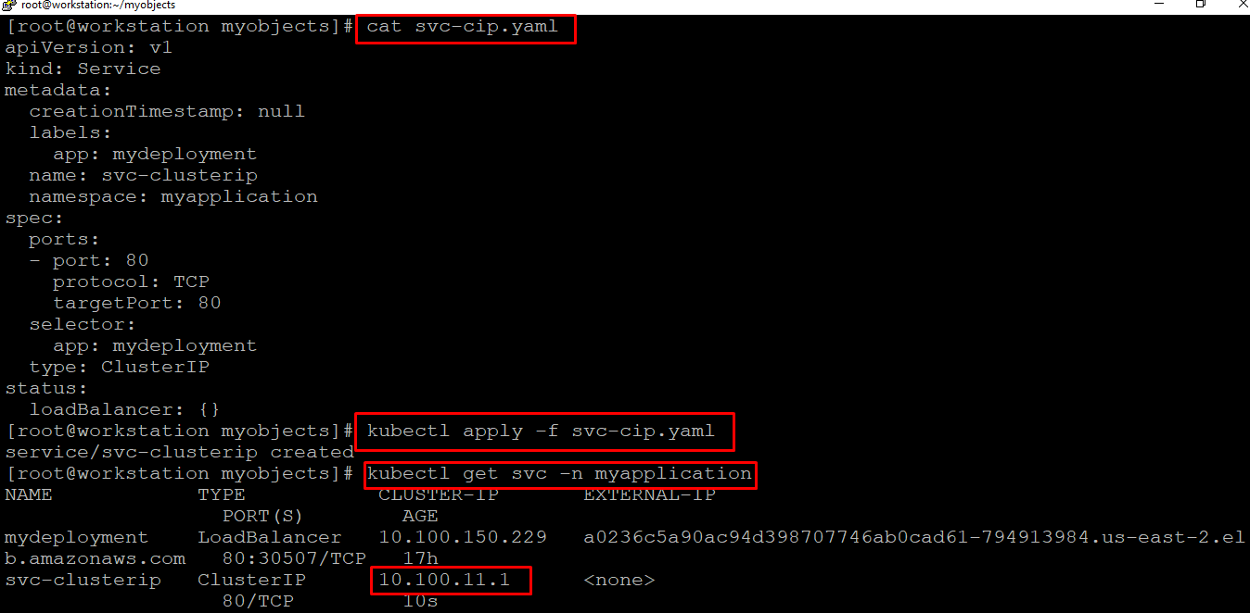

Verification:

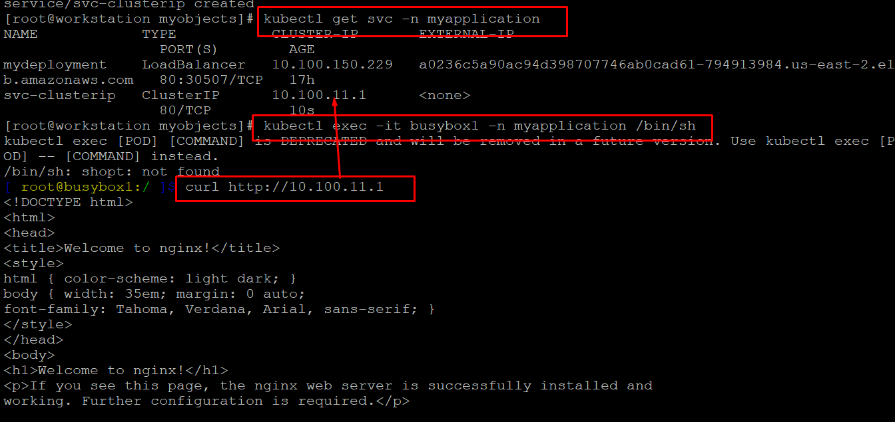

From the above we can conclude that we can able to hit the application via service of type clusterip

- Configuring Load balancer type:

vi svc-lb.yaml
apiVersion: v1
kind: Service
metadata:
creationTimestamp: null
labels:
app: mydeployment
name: svc-nodeport
namespace: myapplication
spec:
ports:
- port: 80
protocol: TCP
targetPort: 80
selector:
app: mydeployment
type: LoadBalancer
status:
loadBalancer: {}

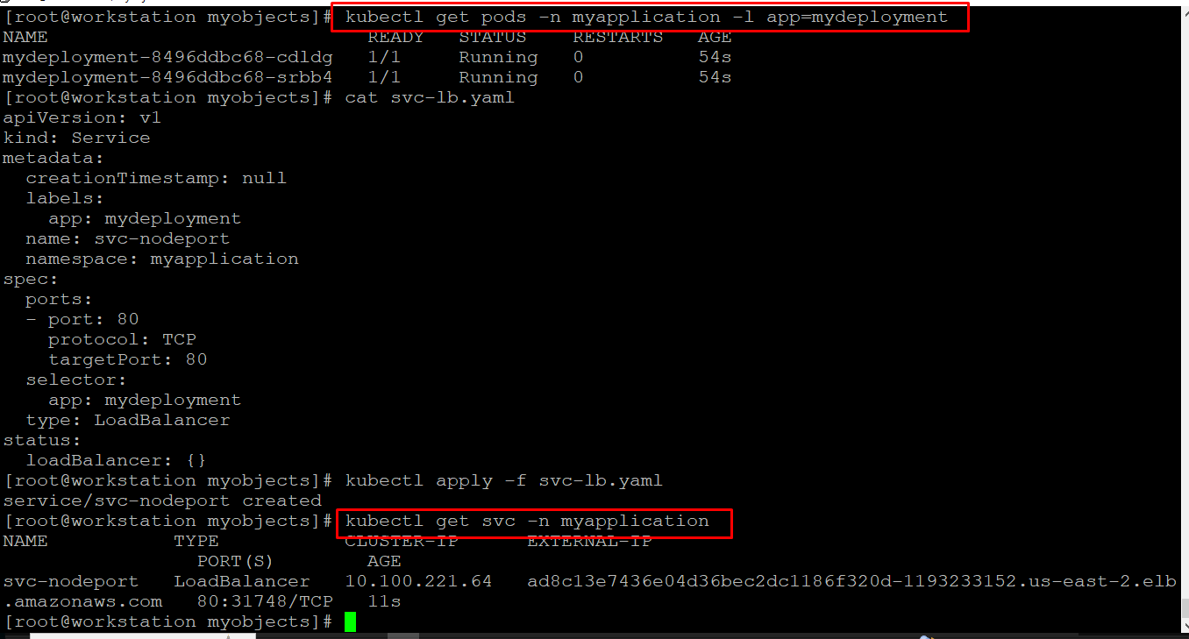

From the above we got our loadbalancer url, just hit above url in the browser

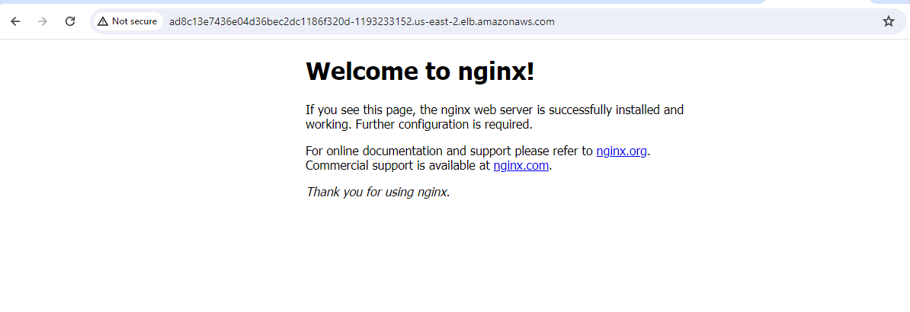

Finally we got our application url and its up & running.

6. Resource Management:

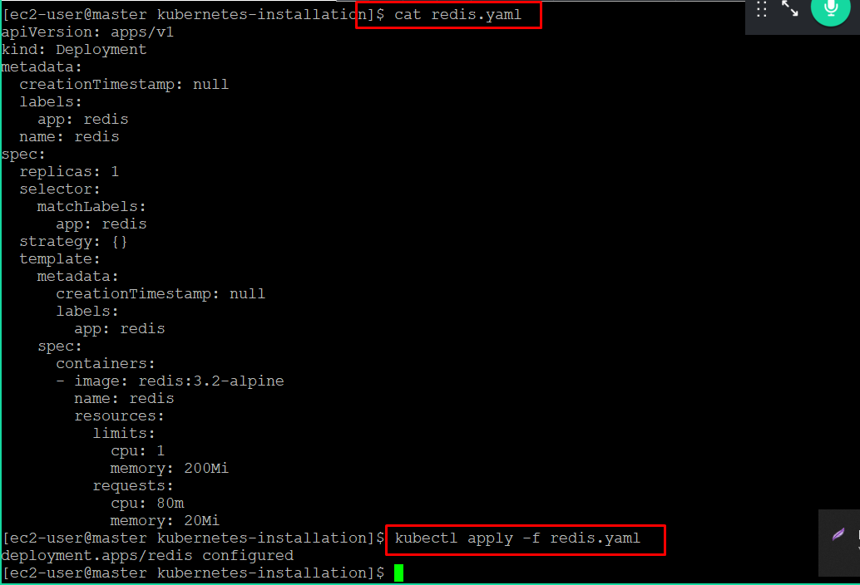

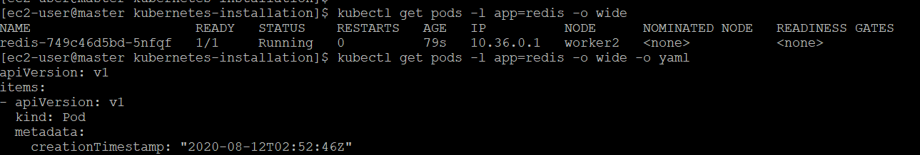

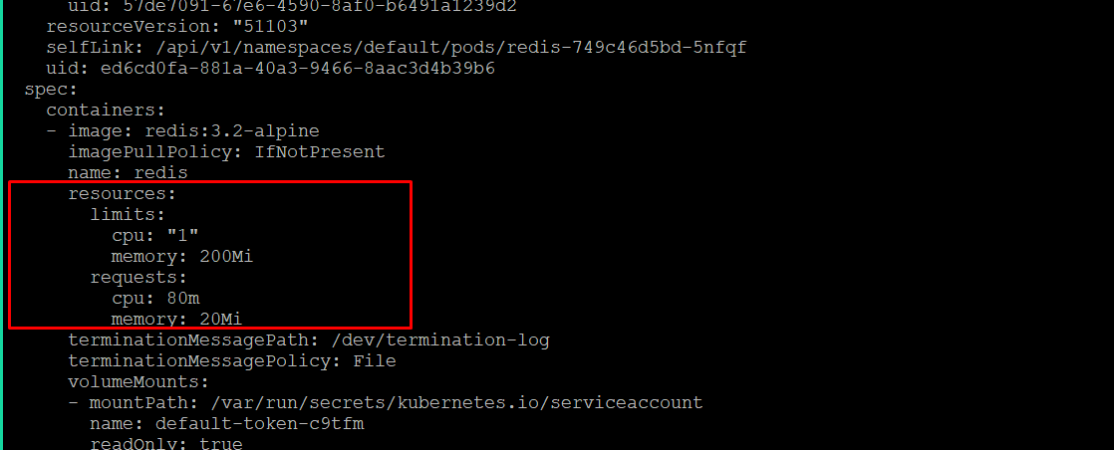

DaemonSets and Manually Scheduled Pods :

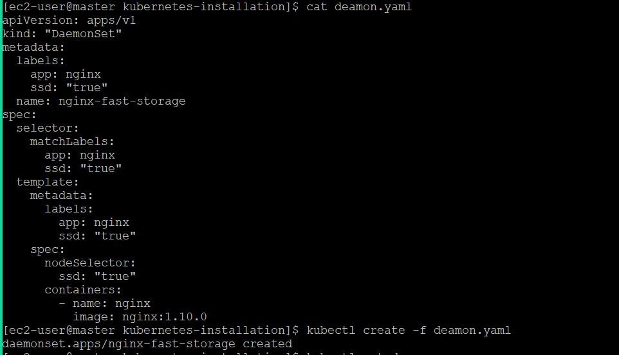

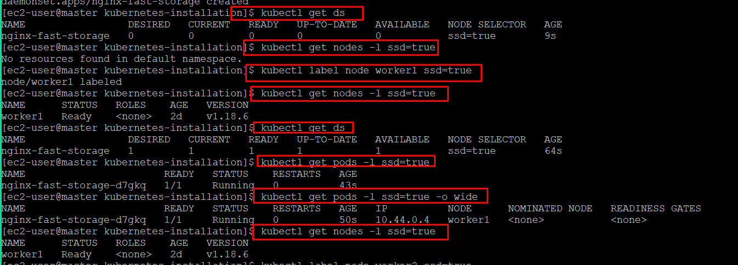

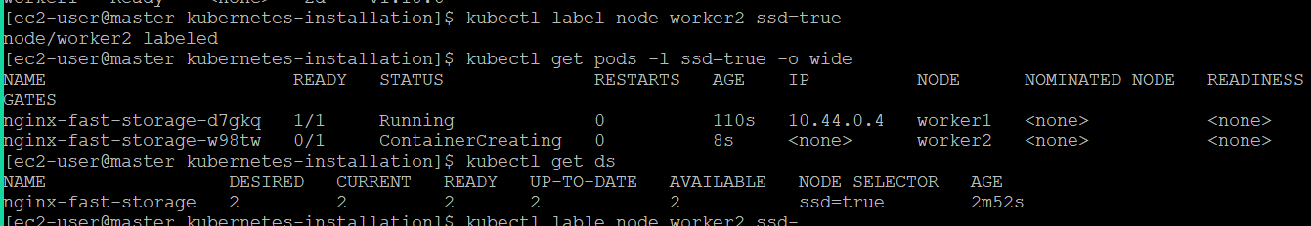

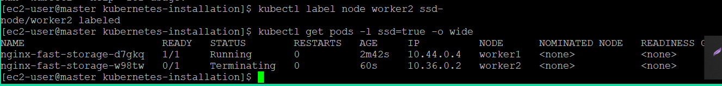

Displaying Scheduler Events:

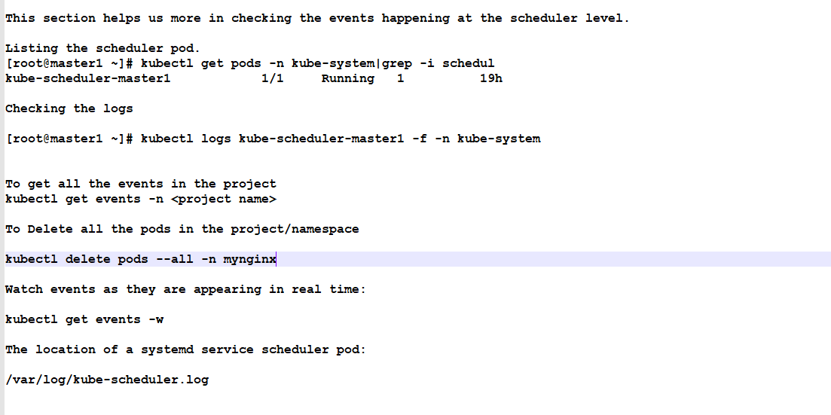

7. Configuring an Application for High Availability and Scale

1. Configmaps :

Creating configmap:

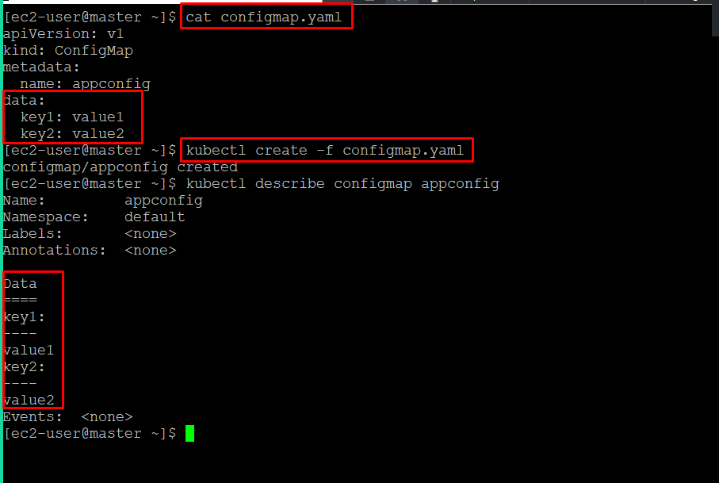

Creating pod with configmap

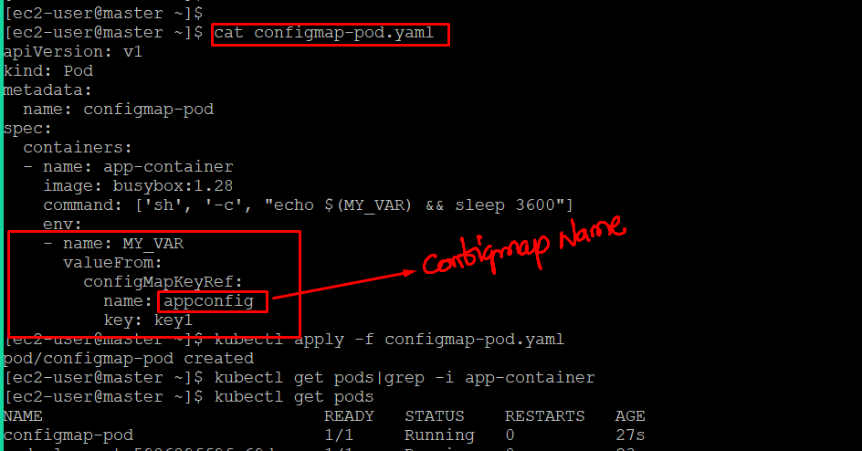

Verifying details inside the pod:

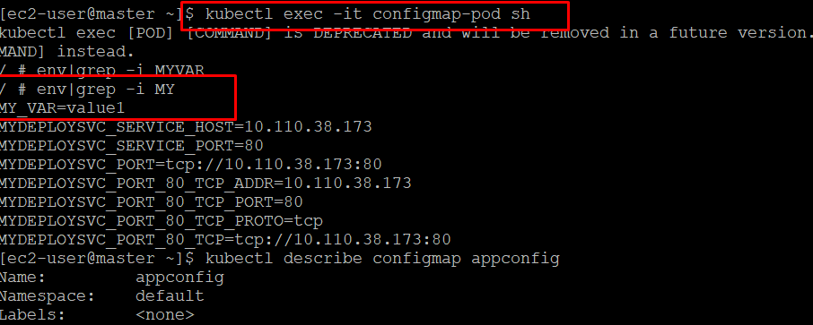

2. Creating a secret

Let's create the secret

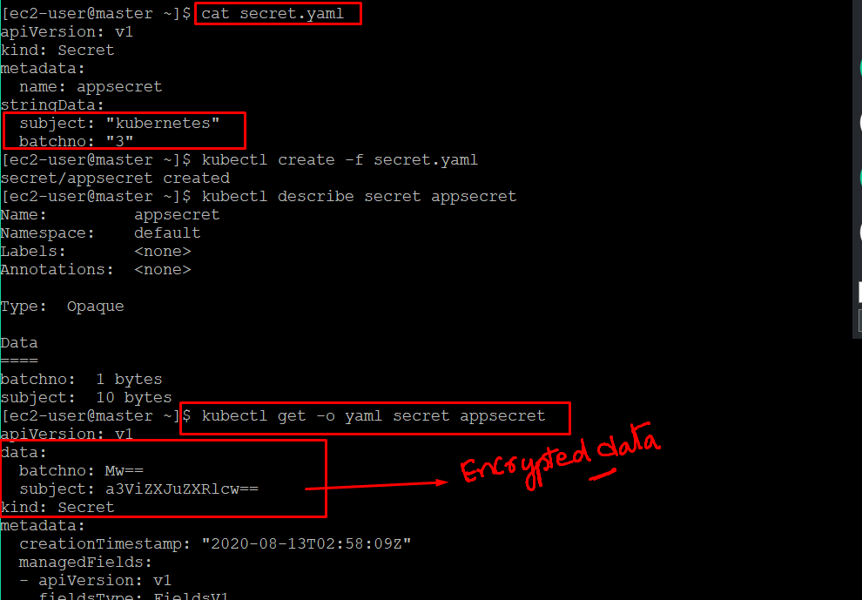

Creating a pod:

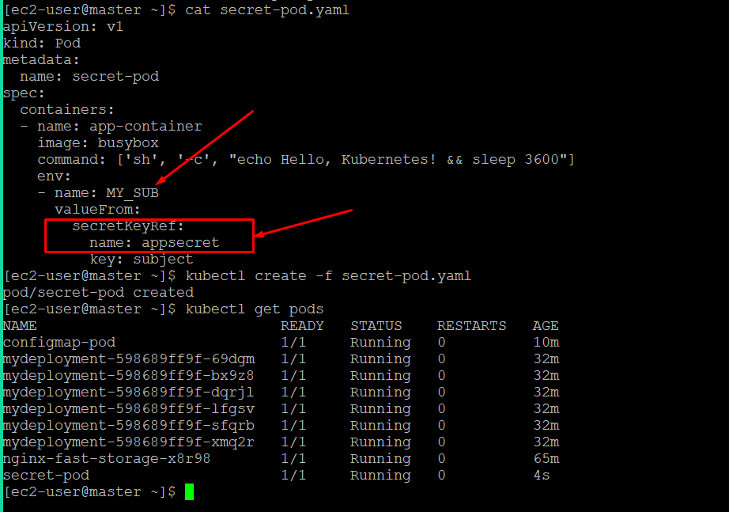

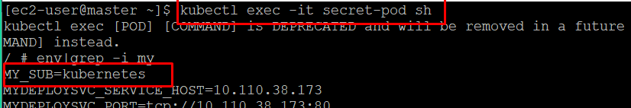

Encrypting & decrypting the secrets:

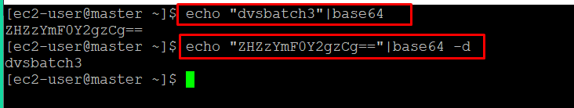

8. Ingress

https://kubernetes.github.io/ingress-nginx/deploy/#azure

Installing Ingress: (Manually)

kubectl apply -f https://raw.githubusercontent.com/kubernetes/ingress-nginx/controller-v1.1.2/deploy/static/provider/cloud/deploy.yaml

kubectl apply -f https://raw.githubusercontent.com/kubernetes/ingress-nginx/controller-v1.1.3/deploy/static/provider/cloud/deploy.yaml

Make sure that you have below softwares in the workstation

Installing helm:

curl https://raw.githubusercontent.com/helm/helm/main/scripts/get-helm-3 | bash

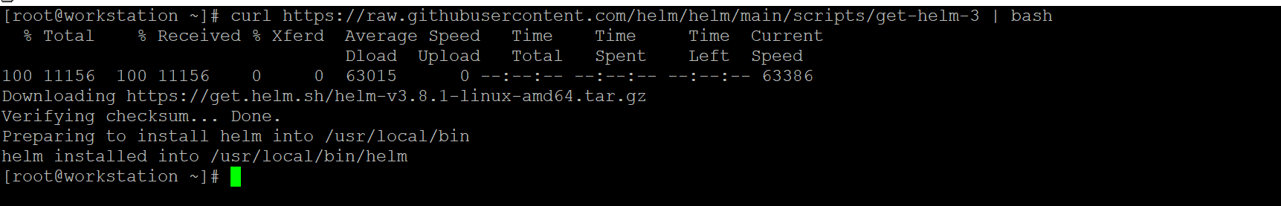

Installing Ingress using helm:

https://docs.microsoft.com/en-us/azure/aks/ingress-basic?tabs=azure-cli

NAMESPACE=ingress-basic

helm repo add ingress-nginx https://kubernetes.github.io/ingress-nginx
helm repo update

helm install ingress-nginx ingress-nginx/ingress-nginx --create-namespace --namespace $NAMESPACE

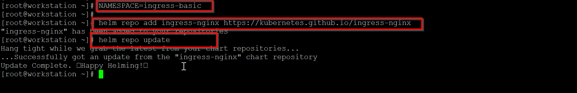

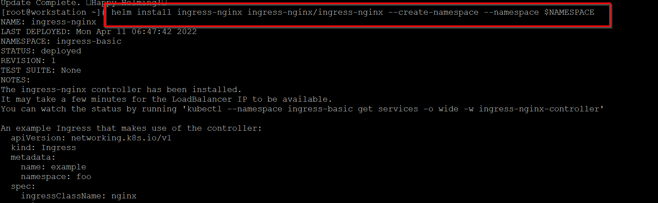

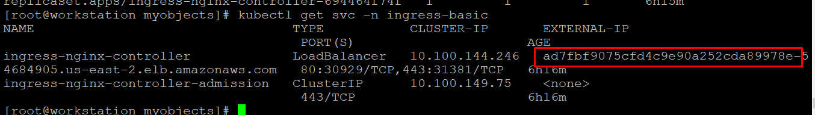

In the aws console:

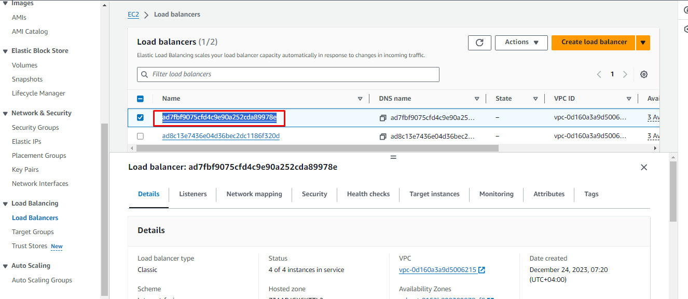

Let's configure the application with ingress and test the routing:

Create two deployments:

Create two images & push to dokcerhub:

App1:

Dockerfile

FROM httpd
RUN echo "<h1>Hi Team welcome to deployment1-app1</h1>" > /usr/local/apache2/htdocs/index.html

docker build -t "shan5a6/deployment1-app1:v1.0" .

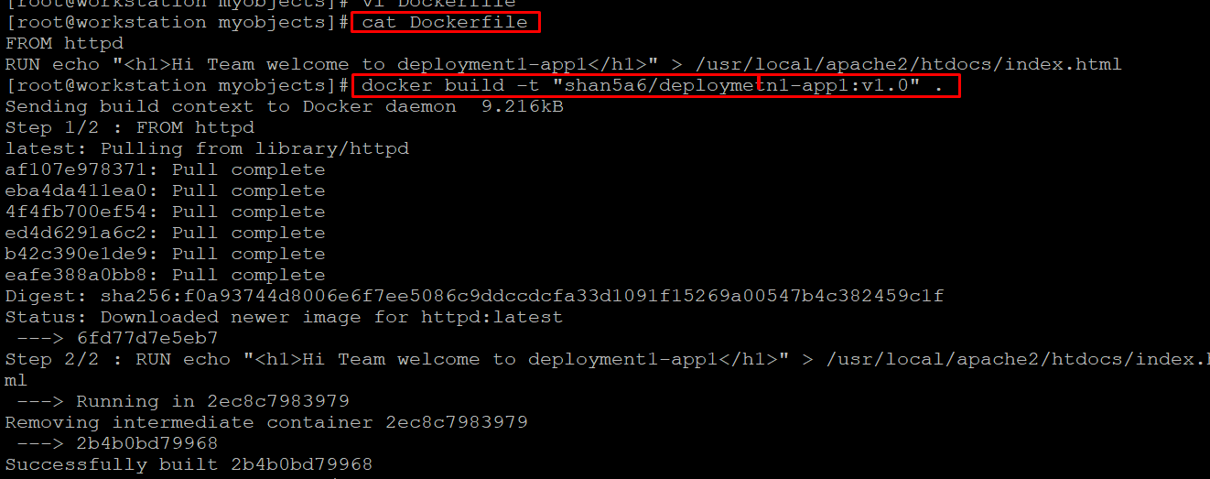

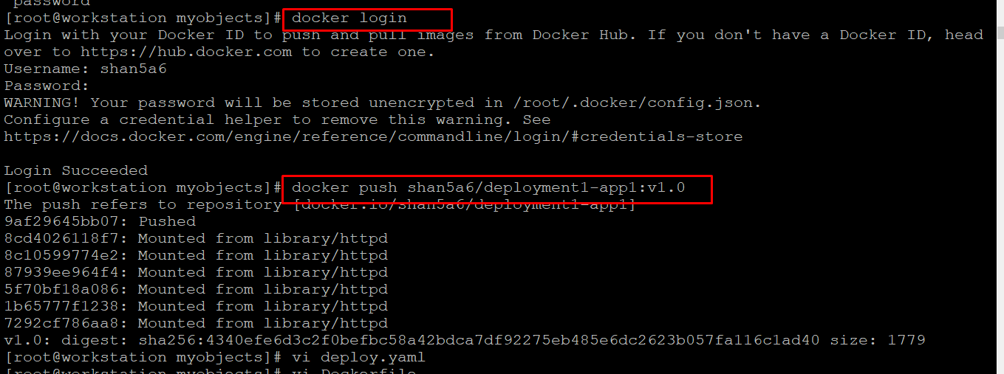

Do the same for App2:

App2:

Dockerfile:

FROM httpd
RUN echo "<h1>Hi Team welcome to deployment2-app2</h1>" > /usr/local/apache2/htdocs/index.html

docker build -t "shan5a6/deployment2-app2:v1.0" .

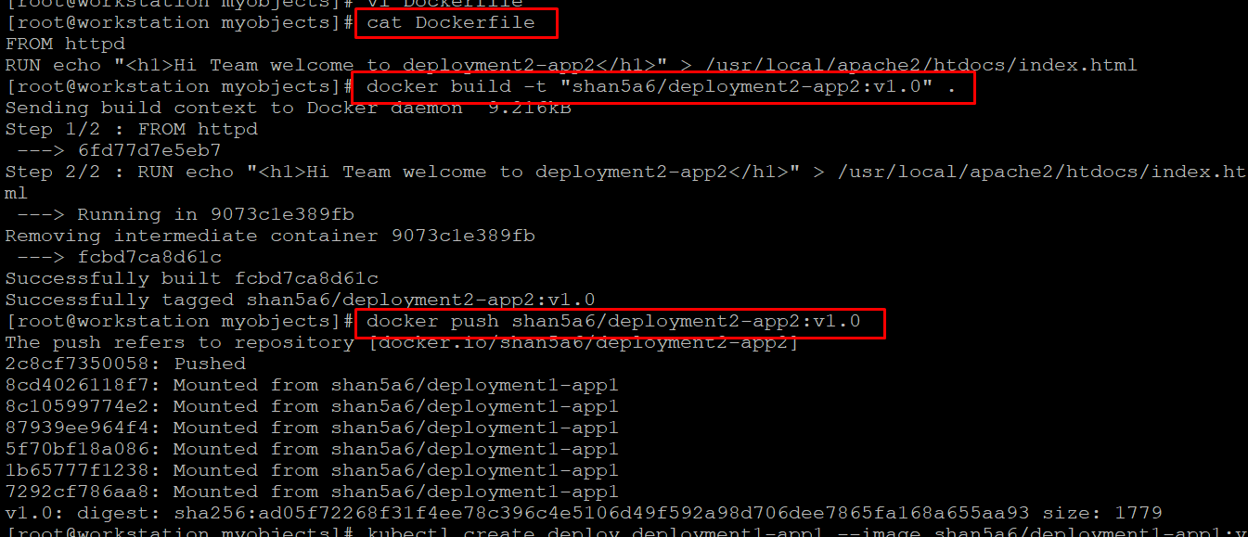

Create the deployments along with services in javaapp namespace:

kubectl create ns javaapp

App2:

Deployment:

apiVersion: apps/v1
kind: Deployment
metadata:
creationTimestamp: null
labels:
app: app2-deploy
name: app2-deploy
namespace: javaapp
spec:
replicas: 1
selector:
matchLabels:
app: app2-deploy
strategy: {}
template:
metadata:
creationTimestamp: null
labels:
app: app2-deploy
spec:
containers:
- image: shan5a6/deployment2-app2:v1.0
name: app2
resources: {}
status: {}

Service:

apiVersion: v1
kind: Service
metadata:
creationTimestamp: null
labels:
app: app2-deploy
name: app2-deploy
namespace: javaapp
spec:
ports:
- port: 80
protocol: TCP
targetPort: 80
selector:
app: app2-deploy
status:
loadBalancer: {}

Same goes with APP1:

Deployment:

apiVersion: apps/v1
kind: Deployment
metadata:
creationTimestamp: null
labels:
app: app1-deploy
name: app1-deploy
namespace: javaapp
spec:
replicas: 1
selector:
matchLabels:
app: app1-deploy
strategy: {}
template:
metadata:
creationTimestamp: null
labels:
app: app1-deploy
spec:
containers:
- image: shan5a6/deployment1-app1:v1.01
name: app1
resources: {}
status: {}

Service:

apiVersion: v1
kind: Service
metadata:
creationTimestamp: null
labels:
app: app1-deploy
name: app1-deploy
namespace: javaapp
spec:
ports:
- port: 80
protocol: TCP
targetPort: 80
selector:
app: app1-deploy
status:
loadBalancer: {}

Let's configure the ingress rules:

[root@workstation ~]# cat app-ingress.yaml
apiVersion: networking.k8s.io/v1
kind: Ingress
metadata:
name: application-access
annotations:
nginx.ingress.kubernetes.io/rewrite-target: /
nginx.ingress.kubernetes.io/use-regex: "true"
spec:
ingressClassName: nginx
rules:
- http:
paths:
- path: /app1
pathType: Prefix
backend:
service:
name: app1-deploy
port:
number: 80
- path: /app2
pathType: Prefix
backend:
service:
name: app2-deploy
port:
number: 80
- path: /
pathType: Prefix
backend:
service:
name: app1-deploy
port:
number: 80

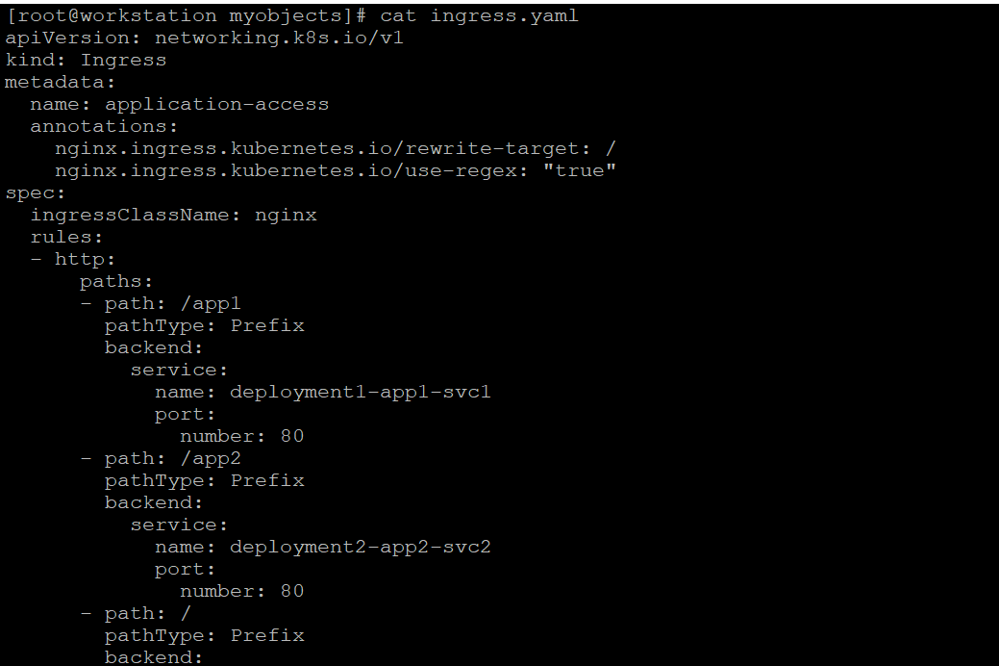

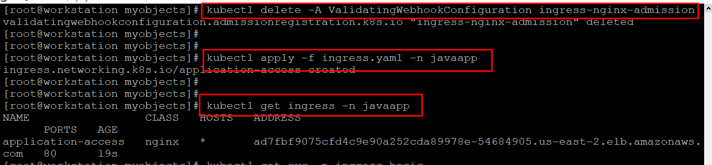

Execute the below if you are facing any issues during ingress definition creation.

kubectl delete -A ValidatingWebhookConfiguration ingress-nginx-admission

Final verification:

