8.Write a JSP program to demonstrate the declaration, scriplets and expressions.

8.jsp:

<%@ **page** language=*"java"* contentType=*"text/html; charset=UTF-8"*

pageEncoding=*"UTF-8"*%>

<!**DOCTYPE** html>

<**html**>

<**head**>

<**meta** charset=*"UTF-8"*>

<**title**>JSP Example</**title**>

</**head**>

<**body**>

<!-- Declaration -->

<%!

String message = "Hello, World!";

%>

<!-- Scriptlet -->

<%

int x = 5;

int y = 10;

int sum = x + y;

%>

<!-- Expression -->

<**h1**><%= message %></**h1**>

<**p**>Sum of <%= x %> and <%= y %> is <%= sum %>.</**p**>

</**body**>

</**html**>

Output:

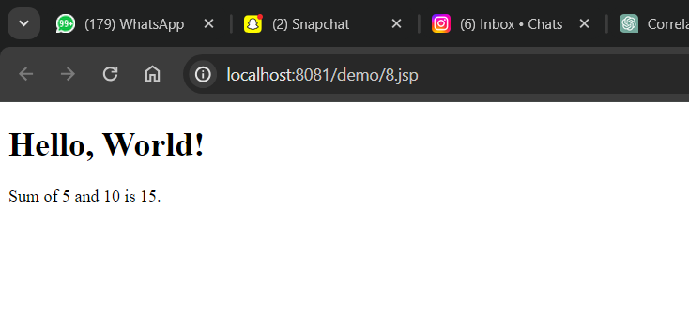

9.Write a JSP program to demonstrate the setAttribute and getAttribute method.

9.jsp:

<%@ **page** language=*"java"* contentType=*"text/html; charset=UTF-8"*

pageEncoding=*"UTF-8"*%>

<!**DOCTYPE** html>

<**html**>

<**head**>

<**meta** charset=*"UTF-8"*>

<**title**>JSP Attribute Example</**title**>

</**head**>

<**body**>

<%

// Set an attribute

String message = "Hello, World!";

request.setAttribute("message", message);

// Get the attribute

String retrievedMessage = (String) request.getAttribute("message");

%>

<**h1**>Message set using setAttribute:</**h1**>

<**p**><%= retrievedMessage %></**p**>

</**body**>

</**html**>

Output:  
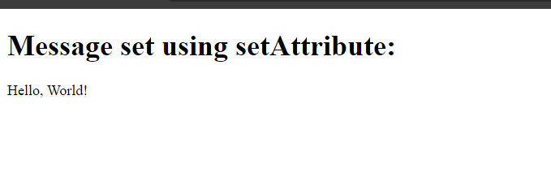

10.Write a JSP program to demonstrate the use of JSP Page directives

10.jsp:  
<%@ **page** language=*"java"* contentType=*"text/html; charset=UTF-8"*

pageEncoding=*"UTF-8"*%>

<!**DOCTYPE** html>

<**html**>

<**head**>

<**meta** charset=*"UTF-8"*>

<**title**>JSP Page Directive Example</**title**>

</**head**>

<**body**>

<**h1**>JSP Page Directive Example</**h1**>

<**p**>This is an example of using JSP page directives.</**p**>

<%-- This is a comment in JSP --%>

<%-- Including another JSP page --%>

<%@ **include** file=*"included.jsp"* %>

<%-- Setting a session attribute --%>

<% session.setAttribute("username", "JohnDoe"); %>

<%-- Forwarding the request to another resource --%>

<%@ **include** file=*"forwarded.jsp"* %>

</**body**>

</**html**>

Included.jsp:

<**p**>This is the included JSP file.</**p**>

Forwarded.jsp:

<**p**>This is the forwarded JSP file.</**p**>

<**p**>The username attribute set in the main JSP is: <%= session.getAttribute("username") %></**p**>

Output:

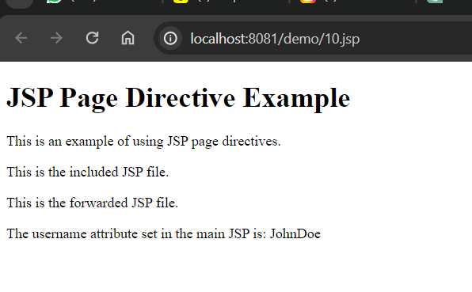

11.Write a JSP program to pass a parameter from one jsp file to another and display the values.

Index.jsp:

<!**DOCTYPE** html>

<**html**>

<**head**>

<**title**>Pass Parameter Example</**title**>

</**head**>

<**body**>

<**form** action=*"second.jsp"* method=*"get"*>

<**label** for=*"param"*>Enter Parameter:</**label**>

<**input** type=*"text"* id=*"param"* name=*"param"*>

<**input** type=*"submit"* value=*"Submit"*>

</**form**>

</**body**>

</**html**>

Second.jsp:

<!**DOCTYPE** html>

<**html**>

<**head**>

<**title**>Second JSP</**title**>

</**head**>

<**body**>

<**h1**>Received Parameter</**h1**>

<**p**>Parameter value: <%= request.getParameter("param") %></**p**>

</**body**>

</**html**>

Output:

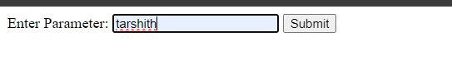

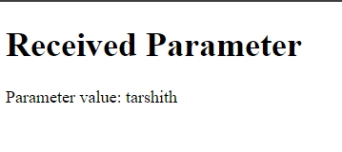

12.Create an HTML form to accept the login name and password, check the authorized login name and password through JSP at the server side and display appropriate message.

Login.html:

<!**DOCTYPE** html>

<**html**>

<**head**>

<**title**>Login Form</**title**>

</**head**>

<**body**>

<**h2**>Login Form</**h2**>

<**form** action=*"login.jsp"* method=*"post"*>

<**label** for=*"username"*>Username:</**label**>

<**input** type=*"text"* id=*"username"* name=*"username"* required><**br**><**br**>

<**label** for=*"password"*>Password:</**label**>

<**input** type=*"password"* id=*"password"* name=*"password"* required><**br**><**br**>

<**input** type=*"submit"* value=*"Login"*>

</**form**>

</**body**>

</**html**>

Login.jsp:

<%@ **page** language=*"java"* contentType=*"text/html; charset=UTF-8"*

pageEncoding=*"UTF-8"*%>

<!**DOCTYPE** html>

<**html**>

<**head**>

<**title**>Login Status</**title**>

</**head**>

<**body**>

<**h2**>Login Status</**h2**>

<%-- Define authorized username and password --%>

<%

String authorizedUsername = "admin";

String authorizedPassword = "password";

// Retrieve username and password from the request

String username = request.getParameter("username");

String password = request.getParameter("password");

// Check if the credentials are correct

if(authorizedUsername.equals(username) && authorizedPassword.equals(password)) {

out.println("<p>Login successful!</p>");

} else {

out.println("<p>Invalid username or password. Please try again.</p>");

}

%>

</**body**>

</**html**>

Output:

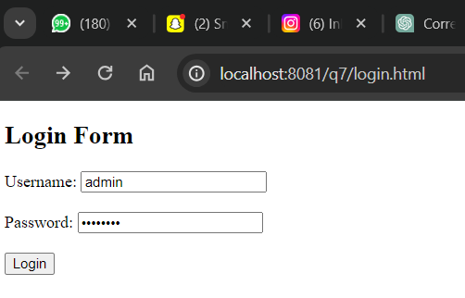

Only admin , password ivandi inka emi ichina fail avtadhi code lo by default declare chesam username, password

