1. 1. Write a program to create a servlet that displays the welcome message.

**WelcomeServlet.java**

import java.io.IOException;

import java.io.PrintWriter;

import javax.servlet.ServletException;

import javax.servlet.annotation.WebServlet;

import javax.servlet.http.HttpServlet;

import javax.servlet.http.HttpServletRequest;

import javax.servlet.http.HttpServletResponse;

@WebServlet("/WelcomeServlet")

public class WelcomeServlet extends HttpServlet {

private static final long serialVersionUID = 1L;

protected void doGet(HttpServletRequest request, HttpServletResponse response) throws ServletException, IOException {

response.setContentType("text/html");

PrintWriter out = response.getWriter();

out.println("<html>");

out.println("<head>");

out.println("<title>Welcome Servlet</title>");

out.println("</head>");

out.println("<body>");

out.println("<h1>Welcome to our website!</h1>");

out.println("<p>This is a simple servlet example.</p>");

out.println("</body>");

out.println("</html>");

}

}

Ouput:

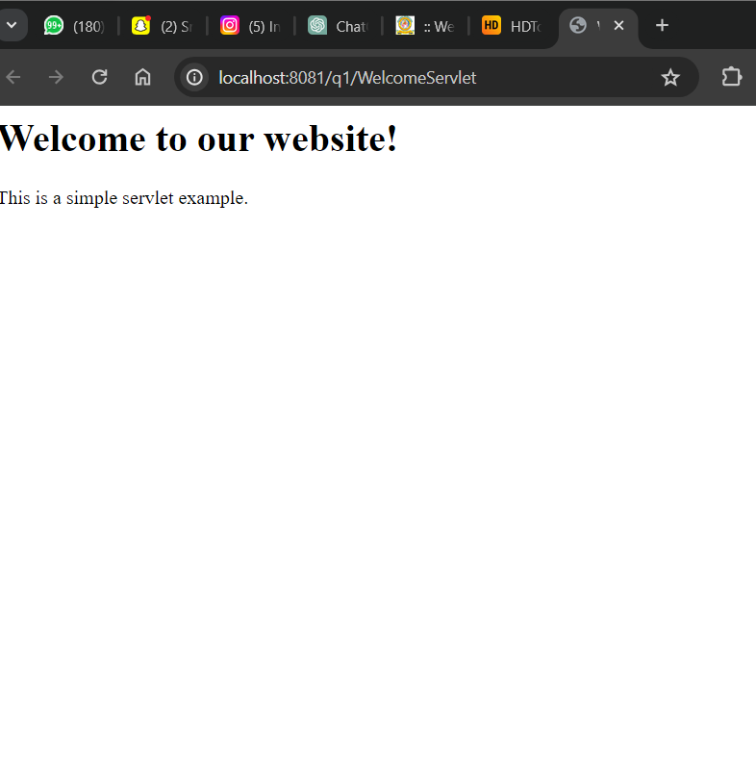

2. Create a simple interest calculator web page using a servlet.

**Index.html:**

<!**DOCTYPE** html>

<**html**>

<**head**>

<**title**>Simple Interest Calculator</**title**>

</**head**>

<**body**>

<**h1**>Simple Interest Calculator</**h1**>

<**form** action=*"SimpleInterestServlet"* method=*"get"*>

<**label** for=*"principal"*>Principal Amount:</**label**>

<**input** type=*"text"* id=*"principal"* name=*"principal"*><**br**><**br**>

<**label** for=*"rate"*>Rate of Interest:</**label**>

<**input** type=*"text"* id=*"rate"* name=*"rate"*><**br**><**br**>

<**label** for=*"time"*>Time Period (in years):</**label**>

<**input** type=*"text"* id=*"time"* name=*"time"*><**br**><**br**>

<**input** type=*"submit"* value=*"Calculate"*>

</**form**>

</**body**>

</**html**>

**SimpleInterestServlet.java:**

package q2;

import java.io.IOException;

import java.io.PrintWriter;

import javax.servlet.ServletException;

import javax.servlet.annotation.WebServlet;

import javax.servlet.http.HttpServlet;

import javax.servlet.http.HttpServletRequest;

import javax.servlet.http.HttpServletResponse;

*@WebServlet*("/SimpleInterestServlet")

public class SimpleInterestServlet extends HttpServlet {

private static final long ***serialVersionUID*** = 1L;

protected void doGet(HttpServletRequest request, HttpServletResponse response) throws ServletException, IOException {

response.setContentType("text/html");

PrintWriter out = response.getWriter();

// Getting parameters from the request

double principal = Double.*parseDouble*(request.getParameter("principal"));

double rate = Double.*parseDouble*(request.getParameter("rate"));

double time = Double.*parseDouble*(request.getParameter("time"));

// Calculating simple interest

double simpleInterest = (principal * rate * time) / 100;

// Displaying the result

out.println("<html>");

out.println("<head>");

out.println("<title>Simple Interest Calculator</title>");

out.println("</head>");

out.println("<body>");

out.println("<h1>Simple Interest Calculator</h1>");

out.println("<p>Principal Amount: " + principal + "</p>");

out.println("<p>Rate of Interest: " + rate + "</p>");

out.println("<p>Time Period (in years): " + time + "</p>");

out.println("<p>Simple Interest: " + simpleInterest + "</p>");

out.println("</body>");

out.println("</html>");

}

}

**Output:**

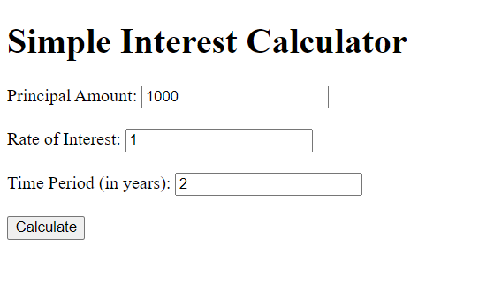

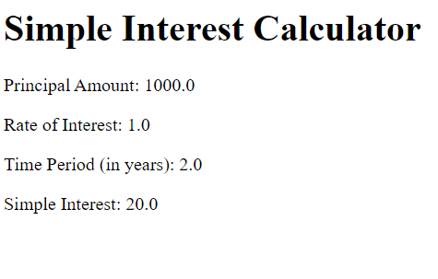

**3.** Develop a dynamic web application using servlets to create and display cookies.

CookieServlet.java:

package q3;

import java.io.IOException;

import java.io.PrintWriter;

import javax.servlet.ServletException;

import javax.servlet.annotation.WebServlet;

import javax.servlet.http.Cookie;

import javax.servlet.http.HttpServlet;

import javax.servlet.http.HttpServletRequest;

import javax.servlet.http.HttpServletResponse;

*@WebServlet*("/CookieServlet")

public class CookieServlet extends HttpServlet {

private static final long ***serialVersionUID*** = 1L;

protected void doGet(HttpServletRequest request, HttpServletResponse response) throws ServletException, IOException {

response.setContentType("text/html");

PrintWriter out = response.getWriter();

// Creating a cookie

Cookie cookie = new Cookie("username", "JohnDoe");

// Adding the cookie to the response

response.addCookie(cookie);

out.println("<html>");

out.println("<head>");

out.println("<title>Cookie Example</title>");

out.println("</head>");

out.println("<body>");

out.println("<h1>Cookie Created</h1>");

out.println("<p>A cookie named 'username' with value 'JohnDoe' has been created.</p>");

out.println("<a href='DisplayCookieServlet'>Display Cookie</a>");

out.println("</body>");

out.println("</html>");

}

}

**DisplayCookieServlet.java:**

package q3;

import java.io.IOException;

import java.io.PrintWriter;

import javax.servlet.ServletException;

import javax.servlet.annotation.WebServlet;

import javax.servlet.http.Cookie;

import javax.servlet.http.HttpServlet;

import javax.servlet.http.HttpServletRequest;

import javax.servlet.http.HttpServletResponse;

*@WebServlet*("/DisplayCookieServlet")

public class DisplayCookieServlet extends HttpServlet {

private static final long ***serialVersionUID*** = 1L;

protected void doGet(HttpServletRequest request, HttpServletResponse response) throws ServletException, IOException {

response.setContentType("text/html");

PrintWriter out = response.getWriter();

// Getting cookies from the request

Cookie[] cookies = request.getCookies();

out.println("<html>");

out.println("<head>");

out.println("<title>Display Cookie</title>");

out.println("</head>");

out.println("<body>");

out.println("<h1>Displaying Cookie</h1>");

if (cookies != null) {

for (Cookie cookie : cookies) {

out.println("<p>Name: " + cookie.getName() + ", Value: " + cookie.getValue() + "</p>");

}

} else {

out.println("<p>No cookies found.</p>");

}

out.println("</body>");

out.println("</html>");

}

}

**Output:**

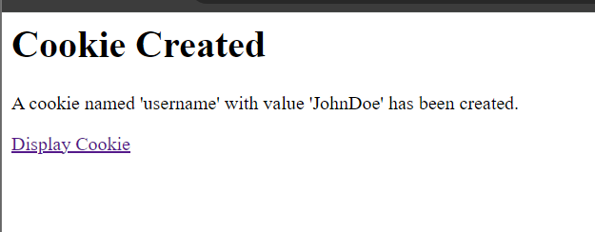

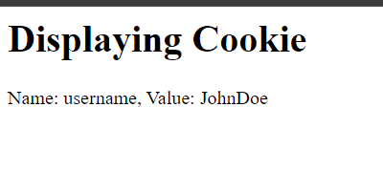

**4.** Create a registration form and display the values entered by the user in another page using servlets.

**Registration_form.html:**

<!**DOCTYPE** html>

<**html**>

<**head**>

<**title**>Registration Form</**title**>

</**head**>

<**body**>

<**h1**>Registration Form</**h1**>

<**form** action=*"RegistrationServlet"* method=*"post"*>

<**label** for=*"username"*>Username:</**label**>

<**input** type=*"text"* id=*"username"* name=*"username"*><**br**><**br**>

<**label** for=*"email"*>Email:</**label**>

<**input** type=*"email"* id=*"email"* name=*"email"*><**br**><**br**>

<**label** for=*"password"*>Password:</**label**>

<**input** type=*"password"* id=*"password"* name=*"password"*><**br**><**br**>

<**input** type=*"submit"* value=*"Register"*>

</**form**>

</**body**>

</**html**>

**RegistrationServlet.java:**

package q4;

import java.io.IOException;

import java.io.PrintWriter;

import javax.servlet.ServletException;

import javax.servlet.annotation.WebServlet;

import javax.servlet.http.HttpServlet;

import javax.servlet.http.HttpServletRequest;

import javax.servlet.http.HttpServletResponse;

*@WebServlet*("/RegistrationServlet")

public class RegistrationServlet extends HttpServlet {

private static final long ***serialVersionUID*** = 1L;

protected void doPost(HttpServletRequest request, HttpServletResponse response) throws ServletException, IOException {

response.setContentType("text/html");

PrintWriter out = response.getWriter();

// Retrieving values from the form submission

String username = request.getParameter("username");

String email = request.getParameter("email");

String password = request.getParameter("password");

// Displaying the entered values on another page

out.println("<html>");

out.println("<head>");

out.println("<title>Registration Details</title>");

out.println("</head>");

out.println("<body>");

out.println("<h1>Registration Details</h1>");

out.println("<p>Username: " + username + "</p>");

out.println("<p>Email: " + email + "</p>");

out.println("<p>Password: " + password + "</p>");

out.println("</body>");

out.println("</html>");

}

}

**Output:**

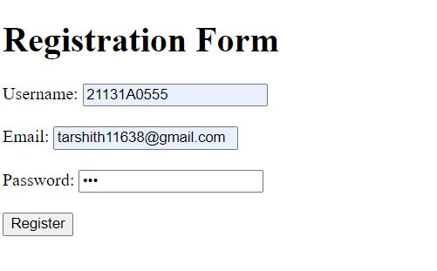

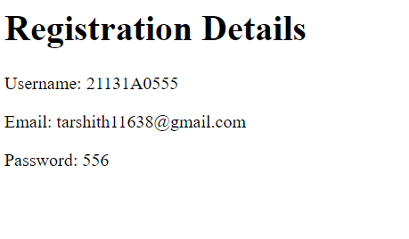

**5** Write a program using servlets to display data from a database table

**DisplayDataServlet.java**

package q5;

import java.io.IOException;

import java.io.PrintWriter;

import java.sql.Connection;

import java.sql.DriverManager;

import java.sql.PreparedStatement;

import java.sql.ResultSet;

import java.sql.SQLException;

import javax.servlet.ServletException;

import javax.servlet.annotation.WebServlet;

import javax.servlet.http.HttpServlet;

import javax.servlet.http.HttpServletRequest;

import javax.servlet.http.HttpServletResponse;

*@WebServlet*("/DisplayDataServlet")

public class DisplayDataServlet extends HttpServlet {

private static final long ***serialVersionUID*** = 1L;

// JDBC URL, username, and password

private static final String ***JDBC_URL*** = "jdbc:oracle:thin:@localhost:1521/xe";

private static final String ***USERNAME*** = "system";

private static final String ***PASSWORD*** = "system";

protected void doGet(HttpServletRequest request, HttpServletResponse response) throws ServletException, IOException {

response.setContentType("text/html");

PrintWriter out = response.getWriter();

Connection conn = null;

PreparedStatement pstmt = null;

ResultSet rs = null;

try {

// Establishing database connection

Class.*forName*("oracle.jdbc.driver.OracleDriver");

conn = DriverManager.*getConnection*("jdbc:oracle:thin:@localhost:1521/xe", "system", "system");

// SQL query to retrieve data from the table

String query = "SELECT * FROM data";

pstmt = conn.prepareStatement(query);

// Executing the query

rs = pstmt.executeQuery();

// Displaying the data

out.println("<html>");

out.println("<head>");

out.println("<title>Data from Database</title>");

out.println("</head>");

out.println("<body>");

out.println("<h1>Data from Database Table</h1>");

out.println("<table border='1'>");

out.println("<tr>");

out.println("<th>ID</th>");

out.println("<th>Name</th>");

out.println("<th>Email</th>");

out.println("</tr>");

// Iterating over the result set

while (rs.next()) {

out.println("<tr>");

out.println("<td>" + rs.getInt("id") + "</td>");

out.println("<td>" + rs.getString("name") + "</td>");

out.println("<td>" + rs.getString("email") + "</td>");

out.println("</tr>");

}

out.println("</table>");

out.println("</body>");

out.println("</html>");

} catch (ClassNotFoundException | SQLException e) {

e.printStackTrace();

} finally {

// Closing resources

try {

if (rs != null) rs.close();

if (pstmt != null) pstmt.close();

if (conn != null) conn.close();

} catch (SQLException e) {

e.printStackTrace();

}

}

}

}