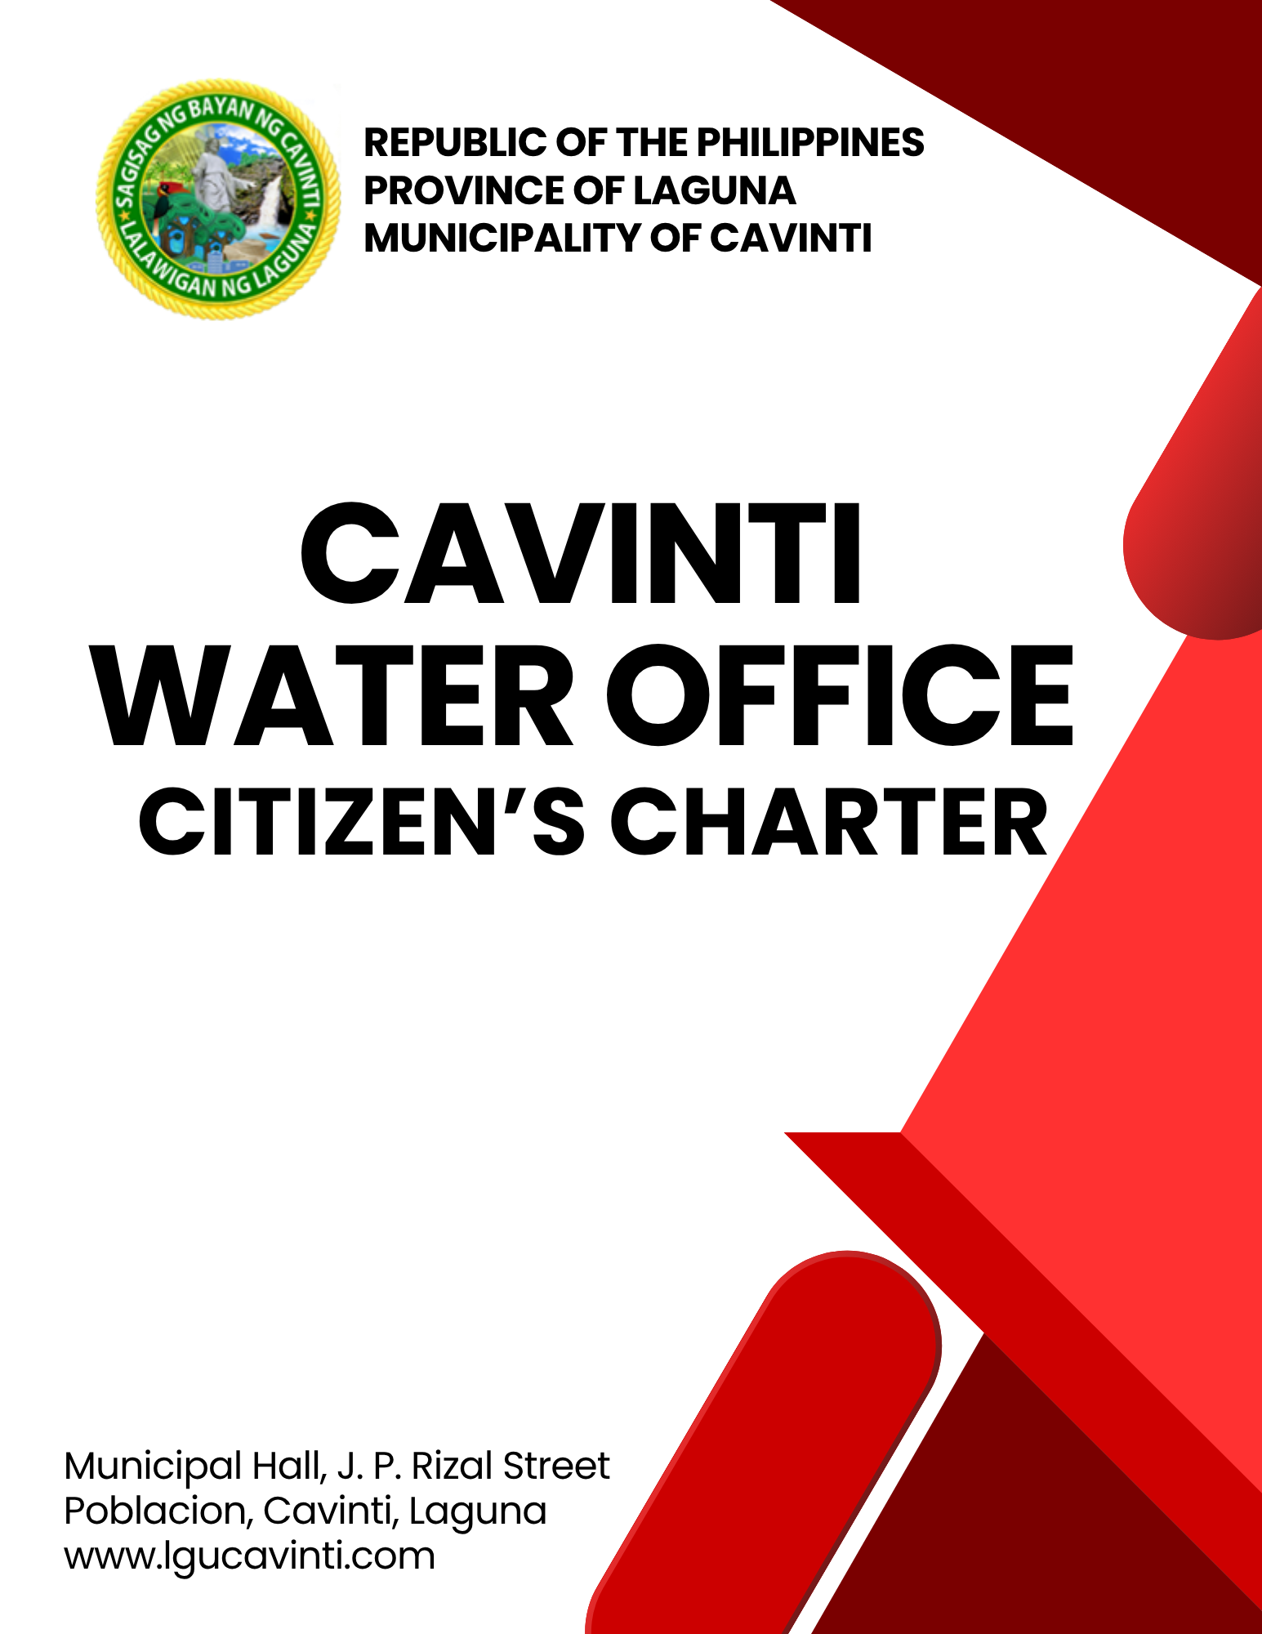

Cavinti Water Office

External Services

- Application for Water Connection (New)

This process enables residents or organizations to apply for a new water connection to their premises. The application is reviewed by the relevant water supply authority to ensure compliance with technical, legal, and environmental standards. Upon approval, necessary installation procedures are initiated. This service ensures proper documentation, tracking, and management of new water connections in accordance with established regulations and service policies.

Office or Division: | Cavinti Water Office
Classification: | Simple
Type of Transaction: | G2C - Government to Citizen  G2B - Government to Business  G2G - Government to Government
Who may avail: | All Individuals
CHECKLIST OF REQUIREMENTS |  | WHERE TO SECURE
- Community Tax Certificate  (1 photocopy) |  | Barangay or Municipal Treasurer Office
- Application Form (2 original copies) |  | Cavinti Water Office
CLIENT STEPS | AGENCY ACTIONS | FEES TO BE PAID | PROCESSING TIME | PERSON RESPONSIBLE
- Coordinate with Cavinti Water Office. | - Inspect the location. | None | 30 minutes | Process Server  Cavinti Water Office
- Submit the requirements. | - Issue the application form to the client. | None | 5 minutes | Process Server  Cavinti Water Office
- Fill out the application form. | - Prepare a recommendation for the Local Chief Executive’s approval. | None | 1 day | Process Server  Cavinti Water Office
- Pay the materials and Water Permit in Window 1 of the Office of the Municipal Treasurer. | - Receive the payment and advise the client to claim the official receipt in Window 2. | Please see Table 14. | 10 minutes | Cashier  Office of the Municipal Treasurer
- Submit the order of payment and claim the official receipt in Window 2 of the Office of the Municipal Treasurer. | - Print and issue the official receipt of payment. | None | 5 minutes | Process Server  Office of the Municipal Treasurer
- Present the official receipt to the Cavinti Water Office. | - Install the new water connection. | None | 1 hour | Maintenance Team  Cavinti Water Office
TOTAL: |  | Please see Table 14. | 1 day, 1 hour &  50 minutes
END OF TRANSACTION

- Request for Water Billing Statement (in case of loss or personal use)

This service allows consumers to request and obtain an official copy of their water billing statement for purposes such as payment verification, personal records, reimbursement, or official transactions. The request may be made by the account holder or an authorized representative.

Office or Division: | Cavinti Water Office
Classification: | Simple
Type of Transaction: | G2C - Government to Citizen  G2B - Government to Business  G2G - Government to Government
Who may avail: | All Individuals
CHECKLIST OF REQUIREMENTS |  | WHERE TO SECURE
None |  | Cavinti Water Office
CLIENT STEPS | AGENCY ACTIONS | FEES TO BE PAID | PROCESSINGTIME | PERSON RESPONSIBLE
- Report and request for a water billing statement at the office. | - Verify the records in the Cavinti Water system. | None | 5 minutes | Process Server  Cavinti Water Office
 | - Process and print the requested billing statement. | None | 5 minutes | Process Server  Cavinti Water Office
- Claim the requested water billing statement. | - Release the billing statement to the client. | None | 5 minutes | Process Server  Cavinti Water Office
TOTAL: |  | None | 15 minutes
END OF TRANSACTION

- Reconnection of Pipeline

This process applies when a previously disconnected water supply needs to be restored due to either voluntary disconnection or administrative action (e.g., non-payment). After verifying that all reconnection conditions are met, including fee payment or resolution of pending issues, the supply is reinstated by authorized personnel. This service ensures responsible restoration of water access in accordance with applicable guidelines.

Office or Division: | Cavinti Water Office
Classification: | Simple
Type of Transaction: | G2C - Government to Citizen  G2B - Government to Business  G2G - Government to Government
Who may avail: | All Individuals
CHECKLIST OF REQUIREMENTS |  | WHERE TO SECURE
- Official Receipt (1 photocopy) |  | Office of the Municipal Treasurer
CLIENT STEPS | AGENCY ACTIONS | FEES TO BE PAID | PROCESSING TIME | PERSON  RESPONSIBLE
- Report at the Cavinti Water Office regarding the reconnection of the pipeline. | - Verify the records and issue an order of payment. | None | 5 minutes | Process Server  Cavinti Water Office
 | - Advise the client to pay the outstanding balance and the reconnection fee at the Cashier | None | 5 minutes | Process Server  Cavinti Water Office
- Pay the corresponding fees in Window 1 of the Office of the Municipal Treasurer. | - Receive the payment and advise the client to claim the official receipt in Window 2. | Outstanding Balance + Php 300.00 | 5 minutes | Cashier  Office of the Municipal Treasurer
- Submit the order of payment and claim the official receipt in Window 2 of the Office of the Municipal Treasurer. | - Print and issue the official receipt of payment. | None | 5 minutes | Process Server  Office of the Municipal Treasurer
- Present the official receipt to the Cavinti Water Office. | - Advise the client to wait for the maintenance in their residence to reconnect the pipeline. | None | 5 minutes | Process Server  Cavinti Water Office
- Present the official receipt to the Cavinti Water Office. | - Issue the Job Order to the maintenance team. | None | 5 minutes | Process Server  Cavinti Water Office  Supervisor  Cavinti Water Office
- Present the official receipt to the Cavinti Water Office. | - Reconnect the water meter of the client. | None | 30 minutes | Maintenance Team  Cavinti Water Office
TOTAL: |  | Outstanding Balance + Php 300.00 | 1 hour
END OF TRANSACTION

- Repair of Supply Pipeline

This process allows residents or organizations to report issues related to damaged or leaking water pipelines. Upon receiving a complaint, the concerned authority assesses the situation and dispatches a technical team for necessary repairs. This service ensures minimal disruption to the water supply and supports the maintenance of a safe and efficient water distribution network.

Office or Division: | Cavinti Water Office
Classification: | Simple
Type of Transaction: | G2C - Government to Citizen  G2B - Government to Business  G2G - Government to Government
Who may avail: | All Individuals
CHECKLIST OF REQUIREMENTS |  | WHERE TO SECURE
- Application for Repair Form  (1 original copy) |  | Cavinti Water Office
CLIENT STEPS | AGENCY ACTIONS | FEES TO BE PAID | PROCESSING TIME | PERSON RESPONSIBLE
- Coordinate and report the leaking pipes and other concerns to the office. | - Verify the client’s record and advise them to fill out the Application Repair Form. | None | 5 minutes | Process Server  Cavinti Water Office
- Fill out and submit the Application Repair Form to the office. | - Collect the Consumer's Data and issue the job order. | None | 5 minutes | Process Server  Cavinti Water Office
 | - Submit the job order form for Supervisor’s Approval. | None | 5 minutes | Process Server  Cavinti Water Office
 | - Approve the job order form. | None | 5 minutes | Cavinti Water Supervisor  Cavinti Water Office
 | - Estimate materials needed and fix the reported leakage. | None | 10 minutes | Repair Team  Cavinti Water Office
 | - Deploy the maintenance team and conduct repairs in the reported area. | None | 2 hours | Repair Team  Cavinti Water Office
- Pay the corresponding fees in Window 1 of the Office of the Municipal Treasurer. | - Receive the payment and advise the client to claim the official receipt in Window 2. | Please see Table 14. | 5 minutes | Cashier  Office of the Municipal Treasurer
- Submit the order of payment and claim the official receipt in Window 2 of the Office of the Municipal Treasurer. | - Print and issue the official receipt of payment. | None | 5 minutes | Process Server  Office of the Municipal Treasurer
- Present the official receipt to the Cavinti Water Office. | - Advise the client the record is updated. | None | 5 minutes | Process Server  Cavinti Water Office
TOTAL: |  | Please see Table 14. | 2 hours, 45 minutes
END OF TRANSACTION

Table 14. Schedule of Other Fees (Cavinti Water Office)

Based on Revised Revenue Code of 2022 of the Municipality of Cavinti, Laguna, Article F – Water Fees, Section 5F.01 Imposition of Fees

- OTHER FEES

- Water Connection Fee (New Application)
- Registration Fee 100.00
- Mayor’s Permit 200.00

- Materials
- Water meter ½ 1,600.00
- Ball valve ½ 400.00
- Teflon 10m x ¾ 45.00
- Elbow ½ 55.00
- St. elbow ½ 55.00
- Union Patente ½ in dia. 110.00
- Saddle Clamp 2 in x ½ 450.00
- Saddle Clamp 4 in x ½ 600.00
- Saddle Clamp 3 in x ½ 550.00
- Nipple 2 x ½ 65.00
- G.I pipe 1 m x ½ dia. 250.00

*Prices of materials are subject to change depending on current market price

- Transfer/ Relocation of Connection 300.00

- Reconnection Fees 300.00

- Replacement of Defective Water Meter
- Due to natural cause free
- Due to an intentional cause 300.00
Plus, cost of water meter 1,600.00

*Prices of materials are subject to change depending on current market price

- Repair of Supply Pipe labor is free of charge/
materials charge to consumer

- Excavation, Demolition, Restoration, 1,800.00
Cutting and Tapping

LIST OF OFFICES

OFFICE | ADDRESS | CONTACT INFORMATION
Office of the Mayor (OM) | 2nd Floor, Municipal Hall,  J. P. Rizal Street, Poblacion, Cavinti, Laguna | email: omcavinti@gmail.com  telephone no.: (049) 523-0012
Office of the Sangguniang Bayan (SB) | 2nd Floor, SB Hall, M. H. Del Pilar Street, Poblacion, Cavinti, Laguna | email: sbcavinti@gmail.com  telephone no.: (049) 523-4357
Office of the Municipal Administrator (OMAD) | 2nd Floor, Municipal Hall,  J. P. Rizal Street, Poblacion, Cavinti, Laguna | email: omadrecordslgucavinti@gmail.com  telephone no.: (049) 521-0147
Human Resource Management Office (HRMO) | 2nd Floor, Municipal Hall,  J. P. Rizal Street, Poblacion, Cavinti, Laguna | email: hrmocavintilaguna@gmail.com  telephone no.: (049) 523-1761
Municipal Budget Office (MBO) | 2nd Floor, Municipal Hall,  J. P. Rizal Street, Poblacion, Cavinti, Laguna | email: mbocavinti1071@gmail.com  telephone no.: (049) 523-1765
Office of the Municipal Accountant (OMACC) | 2nd Floor, Municipal Hall,  J. P. Rizal Street, Poblacion, Cavinti, Laguna | email: cavinti.omacc@gmail.com  telephone no.: (049) 503-7580
Municipal Civil Registrar Office (MCRO) | Municipal Hall, J. P. Rizal Street, Poblacion, Cavinti, Laguna | email: lcro_cavinti@gmail.com  telephone no.: (049) 523-1034
Office of the Municipal Treasurer | Municipal Hall, J. P. Rizal Street, Poblacion, Cavinti, Laguna | email: mtocavinti4013@gmail.com  telephone no.: (049) 502-4201
Municipal Planning and Development Office (MPDO) | 2nd Floor, Municipal Hall,  J. P. Rizal Street, Poblacion, Cavinti, Laguna | email: cavintimpdo@gmail.com  telephone no.: (049) 523-0366
Office of the Municipal Engineer (OME) | 2nd Floor, Municipal Hall,  J. P. Rizal Street, Poblacion, Cavinti, Laguna | email: ome.cavinti@gmail.com  telephone no.: (049) 521-8936
Municipal Disaster Risks Reduction and Management Office (MDRRMO) | National Highway, Barangay Poblacion, Cavinti, Laguna | email: mdrrmocavinti2022@gmail.com  Hotline Number: 0962-843-0781  Radio Frequency: 146.260
Office of the Municipal Social Welfare and Development (MSWDO) | Municipal Hall, J. P. Rizal Street, Poblacion, Cavinti, Laguna | email: omswdocavinti@yahoo.ocm  cavintisocialwelfare@gmail.com  telephone no.: (049) 523-0990
Municipal Environment and Natural Resources Office (MENRO) | Municipal Hall, J. P. Rizal Street, Poblacion, Cavinti, Laguna | email: menrocavinti@gmail.com  telephone no.: (049) 523-0967
Office of the Municipal Assessor (OMASS) | Municipal Hall, J. P. Rizal Street, Poblacion, Cavinti, Laguna | email: cavintiassessor@gmail.com  telephone no.: (049) 523-1023
Office of the Municipal Agriculture (OMAG) | SB Hall, M. H. Del Pilar Street, Poblacion, Cavinti, Laguna | email: maocavinti@gmail.com  telephone no.: (049) 544-2618
Cavinti Water Office (CWO) | 2nd Floor, Municipal Hall,  J. P. Rizal Street, Poblacion, Cavinti, Laguna | email: cavintiwater@gmail.com  telephone no.: (049) 523-0859
Cavinti Culture, History, Arts, Trade and Tourism Office (CCHATTO) | Ecopark, Barangay Tibatib, Cavinti, Laguna | email: tourismcavintilaguna@gmail.com  telephone no.: (049) 540-3924
Office of the Municipal Health Officer (OMHE) | Barangay Anglas, Cavinti, Laguna | email: cavintirhu@yahoo.com  telephone no.: (049) 523-0148
General Service Office (GSO) | Municipal Hall, J. P. Rizal Street, Poblacion, Cavinti, Laguna | email: gso.lgucavinti@gmail.com  telephone no.: (049) 523-1042
Public Employment Service Office (PESO) | Municipal Hall, J. P. Rizal Street, Poblacion, Cavinti, Laguna | email: @gmail.com  telephone no.: (049) 523-
Municipality of Cavinti | Municipal Hall, J. P. Rizal Street, Poblacion, Cavinti, Laguna | cavintimunicipalgovernment@gmail.com

FEEDBACK AND COMPLAINTS MECHANISMS
How to send feedback? | Answer the client feedback form and drop it at the designated drop boxes across the vicinity of the Municipal Building or you may contact us through the following to send in any suggestions, compliments and/or complaints.  cavintimunicipalgovernment@gmail.com Telephone No. 523-0129 local 100
How feedback is processed? | Every last working day of the week, the assigned personnel will open the drop box and compiles and records all the feedback submitted.  Feedbacks requiring answers will be forwarded to the relevant offices and they will be required to provide an answer within three (3) days upon receipt of the feedback.  The response will then be forwarded/relayed to the citizen if applicable.
How to file a complaint? | Answer the client complaint form and drop it at the designated drop boxes across the vicinity of the Municipal Building.  Make sure to provide the following information:  - Name of person being complained  - Incident  - Evidence
How complaints are processed? | The responsible/assigned personnel will open the complaint drop box on a daily basis and evaluate each complaint.  After thorough review of the complaint, an investigation will commence and require the personnel concerned for their explanation.  A report containing all the details of the incident and the findings shall be submitted to the head of agency for appropriate action.  Afterwards, feedback will be given to the client (complainant).
Contact Information of ARTA | email address: info@arta.gov.ph  contact nos.  PLDT - 1-ARTA (12782)  Smart  0920-925-3078  0998-856-8338

