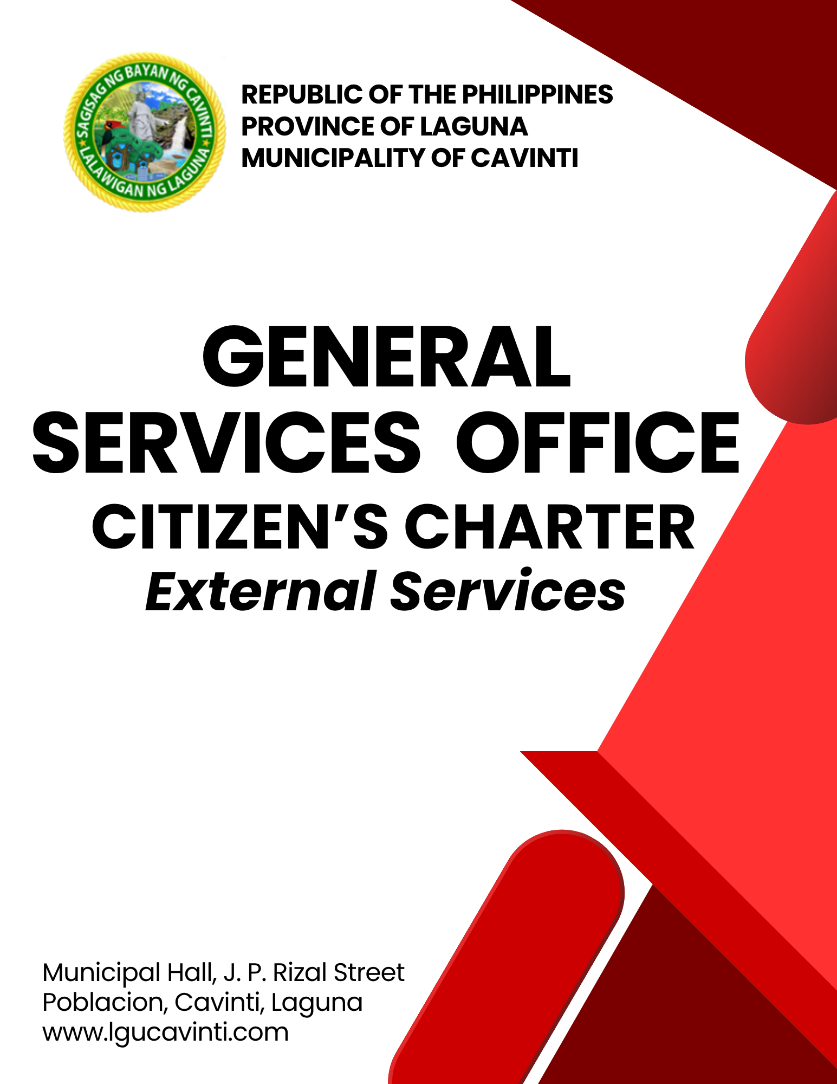

General Services Office (GSO)

External Services

- Issuance of Acknowledgement Receipt for Equipment and Property Acknowledgement Receipt for Newly Acquired Properties and Including Insurance

This division manages all municipal property records, handling their classification, storage, retrieval, security, tracking, and archiving. They also oversee inventory, including record keeping, physical counts, tagging, and issuing receipts for equipment and property.

Office or Division: | General Services Office
Classification: | Simple
Type of Transaction: | G2G – Government to Government
Who may avail: | Municipality of Cavinti
CHECKLIST OF REQUIREMENTS |  | WHERE TO SECURE
- Purchase Order papers with attached Inspected Official Receipt (6 copies) |  | Municipal Treasury Office/Office of the Municipal Accountant
CLIENT STEPS | AGENCY ACTIONS | FEES TO BE PAID | PROCESSING TIME | PERSON  RESPONSIBLE
- Bring the Purchase Order and Acknowledgement Receipt for Equipment and Property Acknowledgement Receipt. | - Receive and review all documents. | None | 10 minutes | Engineer III/  GSO-Designate  General Services Office
 | - Prepare a triplicate copy of the Acknowledgement Receipt for Equipment and Property Acknowledgement Receipt. | None | 10 minutes | Staff  General Services Office
 | - Return the papers for the signatory (in-charge of equipment). | None | 10 minutes | Staff  General Services Office
- Sign the accomplished Acknowledgement Receipt for Equipment and Property Acknowledgement Receipt. | - Receive and check completely. | None | 5 minutes | Engineer III/  GSO-Designate  General Services Office  or  Staff  General Services Office
 | - Record and place inventory tags. | None | 10 minutes | Engineer III/  GSO-Designate  General Services Office  or  Staff  General Services Office
 | - Submit to the department head for signature. | None | 10 minutes | Engineer III/  GSO-Designate  General Services Office  or  Staff  General Services Office
- Have a copy of the Acknowledgement Receipt for Equipment and Property Acknowledgement Receipt for file. | - Give copies of the Acknowledgement Receipt for Equipment and Property Acknowledgement Receipt to the client and the Office of the Municipal Accountant. | None | 10 minutes | Staff  General Services Office
- Securing Government Insurances on all Property, Plant and Equipment | - Process the application for insurance to the Government Service Insurance System (GSIS). | None | 1 day | Staff  General Services Office
 | TOTAL: | None | 1 day, 1 hour, 5 minutes
END OF TRANSACTION

- Municipal Vehicle Management (Repair and Maintenance)

The objective of these services is to ensure all municipal vehicles are regularly inspected, serviced, and repaired to remain safe, operational, and extend their lifespan, often involving scheduled preventive maintenance and responsive repairs

Office or Division: | General Services Office
Classification: | Complex
Type of Transaction: | G2G – Government to Government
Who may avail: | Drivers of Various Vehicles owned by the Municipality of Cavinti
CHECKLIST OF REQUIREMENTS |  | WHERE TO SECURE
- Requisition Slip with approval from the Municipal Mayor and Budget Officer if there is fund available (4 copies) |  | Office of the Mayor and Municipal Budget Office
CLIENT STEPS | AGENCY ACTIONS | FEES TO BE PAID | PROCESSING TIME | PERSON  RESPONSIBLE
- Bring the approved Requisition Slip to the General Services Office. | - Receive the request and discuss the possible action to be taken | None | 10 minutes | Staff  General Services Office
- Bring the vehicle to the site where the vehicle is to be diagnosed. | - Take action by inspecting the vehicle with the help of the mechanic. | None | 2 hours | Mechanic  General Services Office
 | - Canvass to different Auto Supply or Accredited Repair Center. | None | 2 days | Mechanic  General Services Office
 | - If the amount is above Php 200,000.00 and less than Php 400,000.00 it should be posted for PhilGEPS portal and a quotation should be acquired from qualified Repair Center or Auto Supply | None | 4 days | Staff  General Services Office
 | TOTAL: | None | 6 days, 2 hours, 20 minutes
END OF TRANSACTION

- Municipal Owned Vehicles Management (Registration and Insurance)

The objective of these services is to ensure all municipal vehicles are legally registered and covered by appropriate insurance for compliant and protected operation.

Office or Division: | General Services Office
Classification: | Highly Technical
Type of Transaction: | G2G – Government to Government
Who may avail: | Drivers of Various Vehicle owned by the Municipality of Cavinti
CHECKLIST OF REQUIREMENTS |  | WHERE TO SECURE
For New Vehicles:
- Official Receipt/Certificate of Registration (OR/CR) (1 copy) |  | Land Transportation Office (LTO)
- Sales Invoice (1 original, 1 photocopy) |  | Land Transportation Office (LTO)
For renewals:
- Latest Official Receipt/Certificate of Registration (OR/CR) (1 copy) |  | Land Transportation Office (LTO)
- Emission Test Result (1 copy) |  | Testing Center
- Valid Insurance Policy (1 copy) |  | Government Service Insurance System (GSIS)
CLIENT STEPS | AGENCY ACTIONS | FEES TO BE PAID | PROCESSING TIME | PERSON  RESPONSIBLE
- Submit vehicle documents for registration or renewal. | - Receive and review submitted vehicle documents for completeness and accuracy. | None | 1 hour | Staff  General Services Office
- Submit vehicle documents for registration or renewal. | - Check for any outstanding issues (e.g., Land Transportation Office (LTO) alarms, previous violations). | None | 1 day | Staff  General Services Office
- Wait for the insurance acquisition or renewal. | - Process the acquisition or renewal of vehicle insurance (Compulsory Third Party Liability (CTPL) and/or comprehensive, as per policy). | None | 5 days | Staff  General Services Office
- Wait for the insurance acquisition or renewal. | - Coordinate with accredited insurance providers. | None | 1 day | Staff  General Services Office
- Wait for the Land Transportation Office (LTO) Registration/Renewal Processing | - Prepare all necessary documents for submission. | None | 1 day | Driver  General Services Office
 | - Process the vehicle registration or renewal. | None | 2 days | Driver  General Services Office
 | - Secure official receipts (OR) and certificate of registration (CR). | None | 1 day | Driver  General Services Office
- Receive the updated documents (OR/CR, Insurance Policy, Car Plate Sticker) | - Release the updated Original Receipt (OR), Certificate of Registration (CR), new plate sticker, and copy of the insurance policy to the requesting department. | None | 30 minutes | Staff  General Services Office
 | - Secure acknowledgment receipt from the client department. | None | 30 minutes | Staff  General Services Office
- Report damaged or lost documents (if applicable) | - Guide the requesting department on procedures for reporting damaged or lost documents. | None | 1 day | Staff  General Services Office
- Report damaged or lost documents (if applicable) | - Assist in preparing necessary affidavits and requests for duplicate copies. | None | 1 day | Staff  General Services Office
 | TOTAL: | None | 13 days, 2 hours
END OF TRANSACTION

- Procurement of Supply and Management

This division manages getting all supplies, materials, and equipment for the municipality. They do this through public bidding or by personally canvassing for items. Before buying anything, they ensure it's the right quality, reasonably priced, in the correct quantity, from a reliable source, and delivered on time. They also handle all the paperwork, including procurement documents, purchase orders, purchase requests, and keep track of in-stock supplies.

Office or Division: | General Services Office
Classification: | Complex
Type of Transaction: | G2G – Government to Government
Who may avail: | Various Department of Municipal Government of Cavinti
CHECKLIST OF REQUIREMENTS |  | WHERE TO SECURE
- Purchase Request documents (4copies) |  | General Services Office – Procurement Division/End-User
CLIENT STEPS | AGENCY ACTIONS | FEES TO BE PAID | PROCESSING TIME | PERSON  RESPONSIBLE
- Provide the purchase request paper with the approval of the Municipal Mayor and the Budget Officer for verification. | - Receive and record the documents. | None | 10 minutes | Staff  General Services Offices
 | - Schedule a meeting with the BAC (Bids and Awards Committee) to determine what procurement process should be used. | None | 10 minutes | BAC Secretariat  General Services Offices
 | - Make a canvass if the cost is below Php 200,000.00 | None | 1 days | BAC Secretariat  General Services Offices  or  Staff  General Services Offices
 | - If the amount is above Php 200,000.00 and less than Php 400,000.0, it should be posted at PhilGEPSS, and a quotation should be acquired from a qualified supplier. | None | 2 days | BAC Secretariat  General Services Offices  or  Staff  General Services Offices
- Follow-up | - Update the client about the request (Verify with the Bids and Awards Committee the status of the canvass) | None | 5 minutes | BAC Secretariat  General Services Offices  or  Staff  General Services Offices
- Follow-up | - Advise the winning supplier to deliver the supply. | None | 5 minutes | BAC Secretariat  General Services Offices  or  Staff  General Services Offices
- Follow-up | - Witness the delivery and acceptance of the supply together with the representative from the accounting office and the end-user. | None | 10 minutes | Staff  General Services Offices
 | TOTAL: | None | 3 days, 40 minutes
END OF TRANSACTION

- Provision of Inventory Services on Government Property

This service is primarily used to inspect the condition of various government-owned properties.

Office or Division: | General Services Office
Classification: | Simple
Type of Transaction: | G2G – Government to Government
Who may avail: | Various Departments of the Municipal Government of Cavinti
CHECKLIST OF REQUIREMENTS |  | WHERE TO SECURE
- Purchase Order with delivery receipt and charge invoice (6 copies) |  | Municipal Treasurer’s Office / Office of the Municipal Accountant
CLIENT STEPS | AGENCY ACTIONS | FEES TO BE PAID | PROCESSING TIME | PERSON  RESPONSIBLE
- Give out Purchase Order papers with Official Receipt to the in-charge and request an inspection report. | - Receive and check the complete documents. | None | 30 minutes | Staff  General Services Office
 | - Inspect the official receipt of the items. | None | 30 minutes | Staff  General Services Office
- Take note of the inspector to be assigned by the GSO head to conduct the inspection. | - Check and review all the documents. | None | 30 minutes | Staff  (Assigned Inspector)  General Services Office
 | - Review the items in the official receipt and mark it inspected. | None | 30 minutes | Staff  (Assigned Inspector)  General Services Office
- Wait to give out the Inspection and Acceptance Report. | - Accomplish the Inspection and Acceptance Report. | None | 1 hour | Staff  General Services Office
 | TOTAL: | None | 3 hours
END OF TRANSACTION

- Scheduling and Management of Various Activities (Civil Works)

This service is generally to provide repair and maintenance activities on all government-owned properties in terms of civil works.

Office or Division: | General Services Office
Classification: | Highly Technical
Type of Transaction: | G2G – Government to Government
Who may avail: | Various Departments of the Municipal Government of Cavinti
CHECKLIST OF REQUIREMENTS |  | WHERE TO SECURE
- Letter request signed and approved by the Municipal Mayor (1 received copy) |  | Office of the Mayor
CLIENT STEPS | AGENCY ACTIONS | FEES TO BE PAID | PROCESSING TIME | PERSON  RESPONSIBLE
- Submit Request or Inquiry. | - Receive and log the request or inquiry. | None | 10 minutes | Staff  General Services Office
- Submit Request or Inquiry. | - Conduct an initial assessment of the nature and urgency of the civil works activity. | None | 30 minutes | Staff  General Services Office
- Provide necessary information. | - Advise the client on required information (e.g., project details, proposed schedule if applicable). | None | 10 minutes | Engineer III/  GSO-Designate  General Services Office
- Provide necessary information. | - Verify the completeness of submitted information. | None | 10 minutes | Engineer III/  GSO-Designate  General Services Office
- Wait for coordination and scheduling. | - Coordinate with relevant stakeholders (e.g., barangay officials, other municipal offices, public schools). | None | 1 day | Engineer III/  GSO-Designate  General Services Office  or  Foreman  General Services Office
- Wait for coordination and scheduling. | - Conduct site inspection (if necessary) to assess feasibility and potential impact. | None | 5 days | Engineer III/  GSO-Designate  General Services Office  or  Foreman  General Services Office
- Wait for coordination and scheduling. | - Secure necessary internal approvals for the schedule. | None | 2 days | Engineer III/  GSO-Designate  General Services Office  or  Foreman  General Services Office
 | TOTAL: | None | 8 days, 1 hour
END OF TRANSACTION

- Scheduling and Management of Various Activities (Electrical Works)

This service is generally to provide repair and maintenance activities on all government-owned properties in terms of electrical works.

Office or Division: | General Services Office
Classification: | Complex
Type of Transaction: | G2G – Government to Government
Who may avail: | Various Departments of the Municipal Government of Cavinti
CHECKLIST OF REQUIREMENTS |  | WHERE TO SECURE
- Letter request signed and approved by the Municipal Mayor (1 received copy) |  | Office of the Mayor
CLIENT STEPS | AGENCY ACTIONS | FEES TO BE PAID | PROCESSING TIME | PERSON  RESPONSIBLE
- Submit the request or report (e.g., streetlight outage, request for new connection to municipal facility, general electrical concern). | - Receive and log request or inquiry. | None | 10 minutes | Staff  General Services Office
 | - Conduct initial assessment of the nature and urgency of the electrical works activity. | None | 30 minutes | Staff  General Services Office
- Provide necessary information or details. | - Advise the client on required information (e.g., exact location, detailed description of concern, photos if applicable). | None | 10 minutes | Engineer III/  GSO-Designate  General Services Office
- Provide necessary information or details. | - Verify the completeness of submitted information. | None | 10 minutes | Engineer III/  GSO-Designate  General Services Office
- Wait for inspection, coordination, and scheduling. | - Conduct on-site inspection or assessment of the electrical issue or request. | None | 5 days | Engineer III/  GSO-Designate  General Services Office  or  General Services Office
- Wait for inspection, coordination, and scheduling. | - Coordinate with relevant stakeholders (e.g., barangay officials, other municipal offices). | None | 1 day | Engineer III/  GSO-Designate  General Services  or  Electrician  General Services Office
- Wait for inspection, coordination, and scheduling. | - Secure necessary internal approvals for the schedule. | None | 1 day | Engineer III/  GSO-Designate  General Services Office  or  Electrician  General Services Office
 | TOTAL: | None | 7 days, 1 hour
END OF TRANSACTION

- Scheduling and Management of Various Activities (Utility Section)

This service facilitates the proper scheduling, coordination, and management of various utility works activities within the municipality. The aim is to ensure efficient execution of utility works, minimize public inconvenience, and maintain essential services.

Office or Division: | General Services Office
Classification: | Complex
Type of Transaction: | G2G – Government to Government
Who may avail: | Various Department of Municipal Government of Cavinti
CHECKLIST OF REQUIREMENTS |  | WHERE TO SECURE
- Letter request signed and approved by the Municipal Mayor (1 received copy) |  | Office of the Mayor
CLIENT STEPS | AGENCY ACTIONS | FEES TO BE PAID | PROCESSING TIME | PERSON  RESPONSIBLE
- Submit the request or report | - Receive and log the request or inquiry. | None | 10 minutes | Staff  General Services Office
- Submit the request or report | - Conduct an initial assessment of the nature and urgency of the work/activity. | None | 30 minutes | Staff  General Services Office
- Provide necessary information or details. | - Advise the client on required information (e.g., exact location, detailed description of concern, photos if applicable). | None | 10 minutes | Engineer III/  GSO-Designate  General Services Office
- Provide necessary information or details. | - Verify the completeness of submitted information. | None | 10 minutes | Engineer III/  GSO-Designate  General Services Office
- Wait for inspection, coordination, and scheduling. | - Conduct on-site inspection/ or assessment of the issue/request. | None | 2 days | Engineer III/  GSO-Designate  General Services Office  Staff  General Services Office
- Wait for inspection, coordination, and scheduling. | - Coordinate with relevant stakeholders (e.g., barangay officials, other municipal offices). | None | 1 day | Engineer III/  GSO-Designate  GSO-Designate  General Services Office  or  Staff  General Services Office
- Wait for inspection, coordination, and scheduling. | - Secure necessary internal approvals for the schedule. | None | 2 days | Engineer III/  GSO-Designate  General Services Office  or  Staff  General Services Office
 | TOTAL: | None | 5 days, 1 hour
END OF TRANSACTION

LIST OF OFFICES

OFFICE | ADDRESS | CONTACT INFORMATION
Office of the Mayor (OM) | 2nd Floor, Municipal Hall,  J. P. Rizal Street, Poblacion, Cavinti, Laguna | email: omcavinti@gmail.com  telephone no.: (049) 523-0012
Office of the Sangguniang Bayan (SB) | 2nd Floor, SB Hall, M. H. Del Pilar Street, Poblacion, Cavinti, Laguna | email: sbcavinti@gmail.com  telephone no.: (049) 523-4357
Office of the Municipal Administrator (OMAD) | 2nd Floor, Municipal Hall,  J. P. Rizal Street, Poblacion, Cavinti, Laguna | email: omadrecordslgucavinti@gmail.com  telephone no.: (049) 521-0147
Human Resource Management Office (HRMO) | 2nd Floor, Municipal Hall,  J. P. Rizal Street, Poblacion, Cavinti, Laguna | email: hrmocavintilaguna@gmail.com  telephone no.: (049) 523-1761
Municipal Budget Office (MBO) | 2nd Floor, Municipal Hall,  J. P. Rizal Street, Poblacion, Cavinti, Laguna | email: mbocavinti1071@gmail.com  telephone no.: (049) 523-1765
Office of the Municipal Accountant (OMACC) | 2nd Floor, Municipal Hall,  J. P. Rizal Street, Poblacion, Cavinti, Laguna | email: cavinti.omacc@gmail.com  telephone no.: (049) 503-7580
Municipal Civil Registrar Office (MCRO) | Municipal Hall, J. P. Rizal Street, Poblacion, Cavinti, Laguna | email: lcro_cavinti@gmail.com  telephone no.: (049) 523-1034
Office of the Municipal Treasurer | Municipal Hall, J. P. Rizal Street, Poblacion, Cavinti, Laguna | email: mtocavinti4013@gmail.com  telephone no.: (049) 502-4201
Municipal Planning and Development Office (MPDO) | 2nd Floor, Municipal Hall,  J. P. Rizal Street, Poblacion, Cavinti, Laguna | email: cavintimpdo@gmail.com  telephone no.: (049) 523-0366
Office of the Municipal Engineer (OME) | 2nd Floor, Municipal Hall,  J. P. Rizal Street, Poblacion, Cavinti, Laguna | email: ome.cavinti@gmail.com  telephone no.: (049) 521-8936
Municipal Disaster Risks Reduction and Management Office (MDRRMO) | National Highway, Barangay Poblacion, Cavinti, Laguna | email: mdrrmocavinti2022@gmail.com  Hotline Number: 0962-843-0781  Radio Frequency: 146.260
Office of the Municipal Social Welfare and Development (MSWDO) | Municipal Hall, J. P. Rizal Street, Poblacion, Cavinti, Laguna | email: omswdocavinti@yahoo.ocm  cavintisocialwelfare@gmail.com  telephone no.: (049) 523-0990
Municipal Environment and Natural Resources Office (MENRO) | Municipal Hall, J. P. Rizal Street, Poblacion, Cavinti, Laguna | email: menrocavinti@gmail.com  telephone no.: (049) 523-0967
Office of the Municipal Assessor (OMASS) | Municipal Hall, J. P. Rizal Street, Poblacion, Cavinti, Laguna | email: cavintiassessor@gmail.com  telephone no.: (049) 523-1023
Office of the Municipal Agriculture (OMAG) | SB Hall, M. H. Del Pilar Street, Poblacion, Cavinti, Laguna | email: maocavinti@gmail.com  telephone no.: (049) 544-2618
Cavinti Water Office (CWO) | 2nd Floor, Municipal Hall,  J. P. Rizal Street, Poblacion, Cavinti, Laguna | email: cavintiwater@gmail.com  telephone no.: (049) 523-0859
Cavinti Culture, History, Arts, Trade and Tourism Office (CCHATTO) | Ecopark, Barangay Tibatib, Cavinti, Laguna | email: tourismcavintilaguna@gmail.com  telephone no.: (049) 540-3924
Office of the Municipal Health Officer (OMHE) | Barangay Anglas, Cavinti, Laguna | email: cavintirhu@yahoo.com  telephone no.: (049) 523-0148
General Service Office (GSO) | Municipal Hall, J. P. Rizal Street, Poblacion, Cavinti, Laguna | email: gso.lgucavinti@gmail.com  telephone no.: (049) 523-1042
Public Employment Service Office (PESO) | Municipal Hall, J. P. Rizal Street, Poblacion, Cavinti, Laguna | email: @gmail.com  telephone no.: (049) 523-
Municipality of Cavinti | Municipal Hall, J. P. Rizal Street, Poblacion, Cavinti, Laguna | cavintimunicipalgovernment@gmail.com

FEEDBACK AND COMPLAINTS MECHANISMS
How to send feedback? | Answer the client feedback form and drop it at the designated drop boxes across the vicinity of the Municipal Building or you may contact us through the following to send in any suggestions, compliments and/or complaints.  cavintimunicipalgovernment@gmail.com Telephone No. 523-0129 local 100
How feedback is processed? | Every last working day of the week, the assigned personnel will open the drop box and compiles and records all the feedback submitted.  Feedbacks requiring answers will be forwarded to the relevant offices and they will be required to provide an answer within three (3) days upon receipt of the feedback.  The response will then be forwarded/relayed to the citizen if applicable.
How to file a complaint? | Answer the client complaint form and drop it at the designated drop boxes across the vicinity of the Municipal Building.  Make sure to provide the following information:  - Name of person being complained  - Incident  - Evidence
How complaints are processed? | The responsible/assigned personnel will open the complaint drop box on a daily basis and evaluate each complaint.  After thorough review of the complaint, an investigation will commence and require the personnel concerned for their explanation.  A report containing all the details of the incident and the findings shall be submitted to the head of agency for appropriate action.  Afterwards, feedback will be given to the client (complainant).
Contact Information of ARTA | email address: info@arta.gov.ph  contact nos.  PLDT - 1-ARTA (12782)  Smart  0920-925-3078  0998-856-8338

