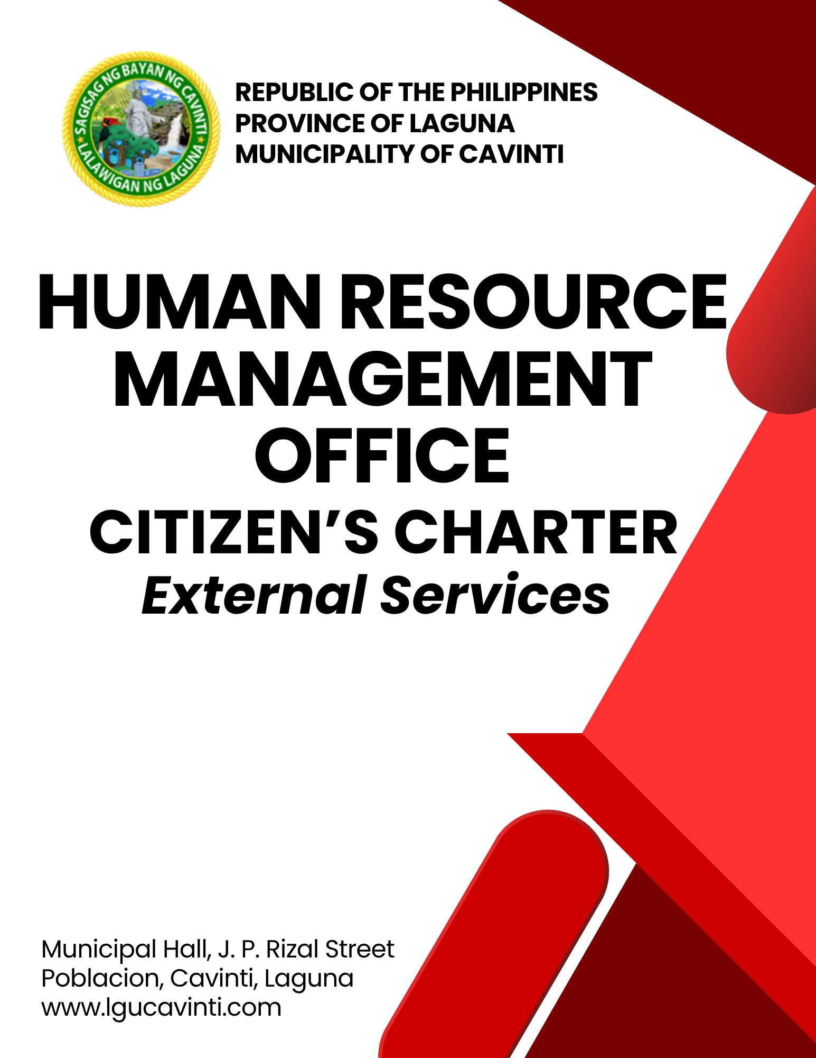

HUMAN RESOURCE MANAGEMENT OFFICE

EXTERNAL SERVICES

- Program for Employment of Student Trainees

This service provides qualified students with the opportunity to gain hands-on experience in local government operations through temporary employment or on-the-job training. The program aims to develop the skills, work ethic, and public service orientation of student trainees.

Office or Division: | Human Resource Management Office (HRMO)
Classification: | Simple
Type of Transaction: | G2C – Government to Citizen
Who may avail: | College students undergoing their On-the-Job Training (OJT)
CHECKLIST OF REQUIREMENTS |  | WHERE TO SECURE
- Official school request letter endorsed through the Human Resource Management Officer to the Municipal Mayor (2 original copies) |  | Client
- Resume detailing full personal and academic information, accompanied by a recent photo (1 original copy) |  | Client
- Memorandum of Agreement (MOA) entered into by the School and the Local Government Unit (LGU)  (1 original copy) |  | Client
CLIENT STEPS | AGENCY ACTIONS | FEES TO BE PAID | PROCESSING TIME | PERSON RESPONSIBLE
- Submit the requirements to the Human Resource Management Office. | - Review the submitted requirements to ensure they are complete and accurate. | None | 2 minutes | Administrative Officer II  Human Resource Management Office
 | - Conduct individual interviews and formally inform the on-the-job trainee of the official start date of the training. | None | 30 minutes | Administrative Officer II  Human Resource Management Office
- Attend the scheduled orientation covering essential information on job requirements, policies, procedures, work hours, disciplinary rules, and related regulations. | - Facilitate the session, ensuring all topics are clearly explained and that there is an opportunity for questions and clarifications. | None | 1 hour | Administrative Officer II  Human Resource Management Office
 | - Officially endorse the student to their designated department assignment. | None | 5 minutes | Administrative Officer II/Information Technology Clerk  Human Resource Management Office
TOTAL: |  | None | 1 hour, 42 minutes
END OF TRANSACTION

- Issuance of Certificate of Training Completion of Student Trainee

This service involves the preparation and issuance of a Certificate of Training Completion to student trainees who have successfully completed their On-the-Job Training (OJT) or internship program with the Local Government Unit (LGU). The certificate serves as official documentation of the duration and nature of the training rendered within the LGU offices.

Office or Division: | Human Resource Management Office (HRMO)
Classification: | Simple
Type of Transaction: | G2C – Government to Citizen
Who may avail: | College students who completed their On-the-Job Training.
CHECKLIST OF REQUIREMENTS |  | WHERE TO SECURE
- Accomplishment Report/Journal of Activities (1 photocopy) |  | Client
- Graded Evaluation Sheet signed by the Department Head of the office the student was assigned (1 photocopy) |  | Client
CLIENT STEPS | AGENCY ACTIONS | FEES TO BE PAID | PROCESSING TIME | PERSON RESPONSIBLE
- Accomplish the Customer Action Sheet and submit the requirements. | - Receive the submitted documents and review their authenticity and accuracy. | None | 10 minutes | Information Technology Clerk  Human Resource Management Office
 | - Prepare the requested certification and submit it to the Human Resource Head for signature. | None | 3 minutes | Information Technology Clerk  Human Resource Management Office
 | - Sign the certification. | None | 2 minutes | MGDH I (HRMO)  Human Resource Management Office
- Receive the requested documents. | - Release the certificate and ask the client to sign the logbook before releasing, serving as proof of receipt. | None | 1 minute | Information Technology Clerk  Human Resource Management Office
TOTAL: |  | None | 16 minutes
END OF TRANSACTION

- Applying for a Job in the Municipal Government

This service caters to individuals who wish to apply for available plantilla or contract-of-service positions in the Municipal Government. The Human Resource Management Office (HRMO) facilitates the recruitment, selection, and placement process in accordance with the Civil Service Commission (CSC) rules and hiring guidelines of the Local Government Unit, ensuring merit-based and competency-based hiring.

Office or Division: | Human Resource Management Office (HRMO)
Classification: | Highly Technical
Type of Transaction: | G2G – Government to Government  G2C – Government to Citizen
Who may avail: | All qualified applicants who meet the minimum qualification standards for the position.
CHECKLIST OF REQUIREMENTS |  | WHERE TO SECURE
- Application Letter (1 original copy) |  | Applicant
- Fully accomplished Personal Data Sheet (PDS) with recent passport-sized picture (1 original copy) |  | Civil Service Commission (CSC) website
- Photocopy of Transcript of Records and/or Diploma (1 photocopy) |  | School/University attended
- Photocopy of Certificate of Eligibility/PRC License (1 photocopy/printed copy |  | Civil Service Commission (CSC)/Professional Regulation Commission (PRC)
CLIENT STEPS | AGENCY ACTIONS | FEES TO BE PAID | PROCESSING TIME | PERSON RESPONSIBLE
- Submit application and complete requirements. | - Receive and record the application. | None | 15 minutes | HRMPSB Secretariat/  Human Resource Management Office
- Submit application and complete requirements. | - Conduct initial evaluation of documents against Qualification Standards (QS). | None | 2 hours | HRMPSB Secretariat/  Human Resource Management Office
- Submit application and complete requirements. | - Administer written examination. | None | 1 day | HRMPSB Secretariat/  Human Resource Management Office
- Submit application and complete requirements. | - Check the qualifying tests of applicants. | None | 1 day | HRMPSB Secretariat/  Human Resource Management Office
- Submit application and complete requirements. | - Submit qualified applicants to the Human Resource Merit, Promotion and Selection Board (HRMPSB) for interview scheduling. | None | 1 day | HRMPSB Secretariat/  Human Resource Management Office
- Submit application and complete requirements. | - Conduct interviews by the Human Resource Merit Promotion and Selection Board (HRMPSB) | None | 3 days | HRMPSB Secretariat/  Human Resource Management Office
- Submit application and complete requirements. | - Rank the applicants based on the examination result and HRMPSB interview. | None | 2 days | HRMPSB Secretariat/  Human Resource Management Office
- Submit application and complete requirements. | - Endorse the top-ranked applicants to the appointing authority. | None | 3 days | HRMPSB Secretariat/  Human Resource Management Office
- Submit application and complete requirements. | 1.9. Conduct background investigations of the chosen appointee. | None | 2 days
- Submit application and complete requirements. | - Prepare and issue the appointment papers. | None | 5 days | HRMPSB Secretariat/  Human Resource Management Office
- Submit application and complete requirements. | - Submit the appointment to the Civil Service Commission (CSC) Field Office for attestation. | None | 1 day | HRMPSB Secretariat/  Human Resource Management Office
TOTAL: |  | None | 19 days,2 hours, 15 minutes
END OF TRANSACTION

- Issuance of Service Record and Certifications

Provision of official records and certifications such as Service Records, Certificate of Employment, Certificate of No Pending Administrative Case, or other Human Resource-related documents upon request of current or former employees.

Office or Division: | Human Resource Management Office (HRMO)
Classification: | Simple
Type of Transaction: | G2G – Government to Government  G2C – Government to Citizen
Who may avail: | Municipal Employees and Retired/Resigned Employees
CHECKLIST OF REQUIREMENTS |  | WHERE TO SECURE
1. Customer Action Sheet (1 copy) |  | Human Resource Management Office
CLIENT STEPS | AGENCY ACTIONS | FEES TO BE PAID | PROCESSING TIME | PERSON RESPONSIBLE
- Accomplish the Customer Action Sheet and present it to the receiving clerk. | - Receive and process the request. | None | 1 minute | Information Technology Clerk  Human Resource Management Office
 | - Prepare the certificates or service record for the approval and signature of the Human Resource Head. | None | 3 minutes | Information Technology Clerk  Human Resource Management Office
 | - Approve and sign the requested documents. | None | 2 minutes | MGDH I (HRMO)  Human Resource Management Office
 | - Issue the requested documents. | None | 1 minute | Information Technology Clerk  Human Resource Management Office
TOTAL: |  | None | 7 minutes
END OF TRANSACTION

- Request for Access to Public HR Information / Documents (FOI)

This service facilitates public requests for official, non-confidential administrative information, plantilla statistics, and general policies under the custody of the Human Resource Management Office (HRMO) in compliance with Municipal Ordinance No. 028-2026.

NOTE: STRICT DATA PRIVACY & CONFIDENTIALITY NOTICE

Pursuant to the Data Privacy Act of 2012 (RA 10173) and Section 7 of Municipal Ordinance No. 028-2026, all personal files, individual Service Records, Personal Data Sheets (PDS), medical records, leave balances, performance ratings (IPCR), and disciplinary files are strictly confidential. This service is strictly limited to non-sensitive administrative data (e.g., Plantilla of Personnel, vacant positions, general staffing statistics, published HR guidelines).

DESIGNATED HRMO DEPUTY FOI PUBLIC INFORMATION OFFICER

Name of Designated Officers:
- Marlon I. Esguerra
Deputy FOI Public Information Officer

- Sharrielyn S. Flores
Alternate Deputy FOI PIO (In the absence of the HRMO Head)

Office Location: 2nd Floor, Municipal Hall, J. P. Rizal Street, Poblacion,
Cavinti, Laguna

Contact Number: (049) 523-1761

Official Email: hrmocavintilaguna@gmail.com

Office or Division: | Human Resource Management Office (HRMO)
Classification: | Simple
Type of Transaction: | G2C – Government to Citizen/G2G – Government to Government
Who may avail: | All citizens, researchers, and government agencies requesting public HR data.
CHECKLIST OF REQUIREMENTS |  | WHERE TO SECURE
- Duly accomplished Municipal FOI Request Form (2 original copies) |  | Human Resource Management Office (HRMO)
- Valid Government-Issued ID with photo and signature (1 photocopy) |  | Client
CLIENT STEPS | AGENCY ACTIONS | FEES TO BE PAID | PROCESSING TIME | PERSON RESPONSIBLE
- Submit the completed FOI Request Form and required IDs to the HRMO. | - Receive Request: Check completeness of form/IDs, verify if the requested information is public or confidential, and log in the FOI Registry. | None | 10 minutes | Deputy FOI PIO/Alternate  Human Resource Management Office
 | - Privacy Evaluation: Assess request against RA 10173 (Data Privacy Act).  If Confidential: Issue formal Notice of Denial to the client.  If Public Record: Proceed to retrieval | None | 30 minutes | Deputy FOI PIO/Alternate  Human Resource Management Office
 | - Record Processing: Retrieve and prepare certified copies of approved public HR documents. | None | 1 day | Deputy FOI PIO/Alternate  Human Resource Management Office
- Pay the required reproduction fees at the Municipal Treasurer's Office. (If hardcopies/certifications are requested) | - Issue Official Receipt (OR): Receive payment and issue OR to the requesting client. | See Schedule below | 10 minutes | Treasury Clerk  Human Resource Management Office
3. Present Official Receipt and receive requested documents. | 3.1 Release Documents: Record OR details, release certified public documents, and require client signature in logbook. | None | 5 minutes | Deputy FOI PIO/Alternate  Human Resource Management Office
TOTAL: |  | Variable (Fee schedule) | 1 day, 55 minutes
END OF TRANSACTION

OFFICIAL FOI REPRODUCTION & CERTIFICATION FEE SCHEDULE
(Pursuant to Section 15 of Municipal Ordinance No. 028-2026)

Service Output | Applicable Fee
Digital Copies via Email / USB / PDF | FREE
Certification of Official Public HR Records | ₱100.00 (1st page) | ₱5.00 per succeeding page
Hardcopy Printing | ₱5.00 per page
Photocopying | ₱3.00 per page (Long) | ₱2.00 per page (Short)

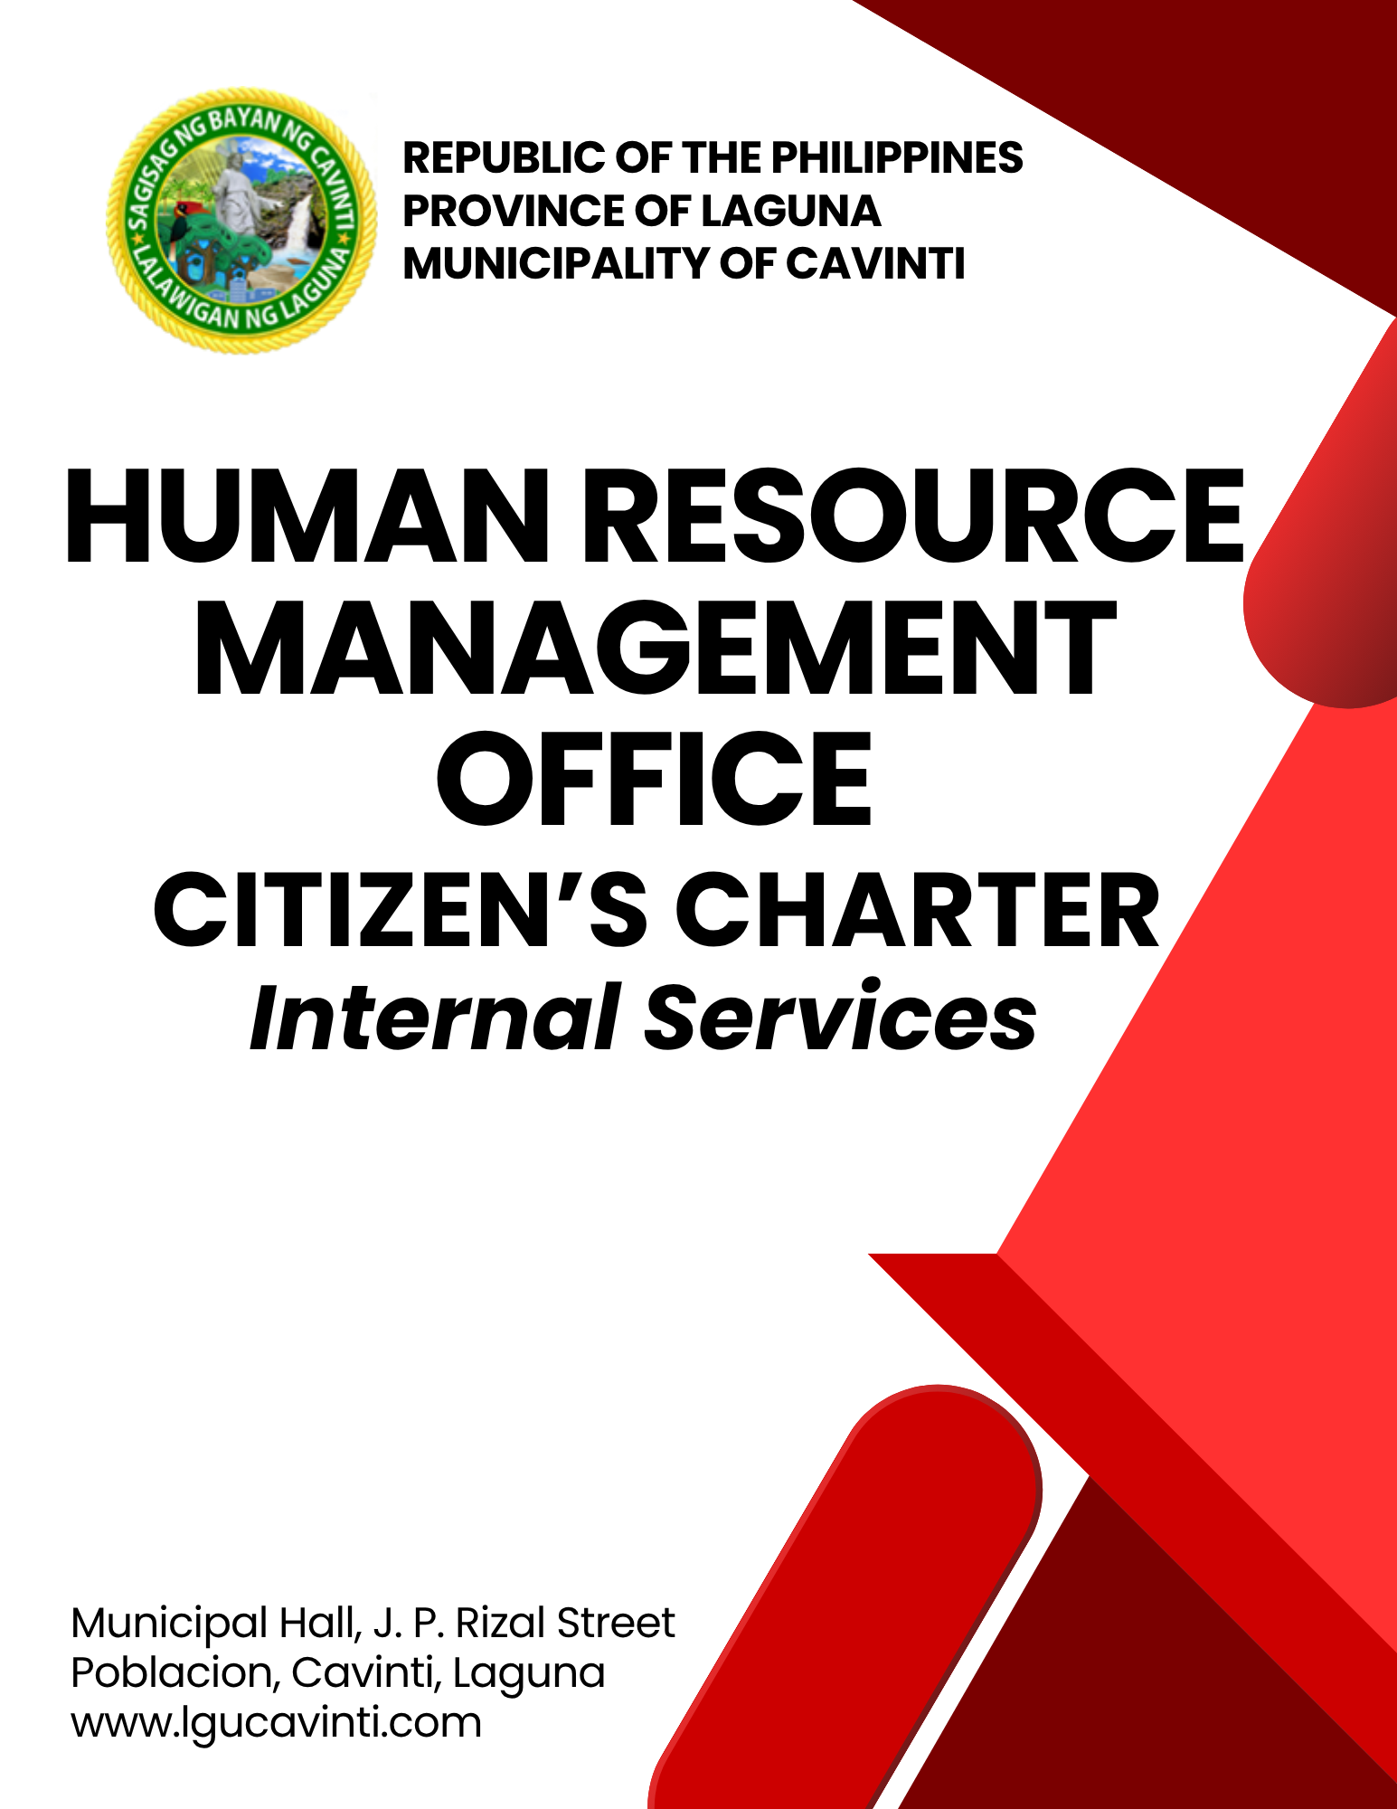

HUMAN RESOURCE MANAGEMENT OFFICE

INTERNAL SERVICES

- Issuance Of Certification of Net Take-Home Pay (NTHP)

This service provides permanent employees of the Municipal Government with a Certification of Net Take-Home Pay, usually required for loan applications, financial assistance, or other official transactions. The certification reflects the employee’s monthly basic salary, deductions, and the remaining net amount.

Office or Division: | Human Resource Management Office (HRMO)
Classification: | Simple
Type of Transaction: | G2G – Government to Government
Who may avail: | Municipal Permanent Employees/Officials
CHECKLIST OF REQUIREMENTS |  | WHERE TO SECURE
- Duly Accomplished Customer Action Sheet (1 original copy) |  | Human Resource Management Office (HRMO)
- Originally signed Authorization Letter (if a representative is requesting) (1 original copy) |  | Client
- Photocopy of valid government-issued ID of the employee and the representative (1 photocopy) |  | Client
CLIENT STEPS | AGENCY ACTIONS | FEES TO BE PAID | PROCESSING TIME | PERSON RESPONSIBLE
- Submit the Accomplish Customer Action Sheet, Authorization Letter and IDs (if a representative is requesting). | - Receive and process the request. | None | 1 minute | HR staff/clerk  Human Resource Management Office
 | - Review the employee records and retrieve the latest payroll data. | None | 3 minutes | Bookbinder II  Human Resource Management Office
 | - Compute Net Take-Home Pay (NTHP) based on the salary and the mandatory deductions. | None | 2 minutes | Bookbinder II  Human Resource Management Office
 | - Prepare and print certification of Net Take-Home Pay (NTHP) for the signature of the Human Resource Head. | None | 1 minute | Bookbinder II  Human Resource Management Office
- Receive the requested documents. | - Release the signed Certification to the employee or authorized representative. | None | 1 minute | Bookbinder II  Human Resource Management Office
TOTAL: |  | None | 8 minutes
END OF TRANSACTION

- Application for Leave

Processing of leave applications of government employees in accordance with Civil Service Commission (CSC) rules and regulations.

Office or Division: | Human Resource Management Office (HRMO)
Classification: | Simple
Type of Transaction: | G2G – Government to Government
Who may avail: | Municipal Officials and Employees
CHECKLIST OF REQUIREMENTS |  | WHERE TO SECURE
- CSC Form No. 6, revised 2020 (2 original copies) |  | Client
- Medical Certificate (for sick leave exceeding 5 days) (1 original copy) |  | Client
- Clearance from money and/or property responsibilities (if leave will last for 30 calendar days or more) (3 original copies) |  | Client
- MOA (Sec. 68, Rule XVI, Omnibus Rules Implementing E.O. No. 292) for Study Leave (1 original copy) |  | Client
- Memorandum or any proof that the employee is required to report to work outside of his/her official duty. (in case of compensatory leave). |  | Client
CLIENT STEPS | AGENCY ACTIONS | FEES TO BE PAID | PROCESSING TIME | PERSON RESPONSIBLE
- Submit the accomplished CSC Form No. 6, duly approved by the Department Head. | - Acknowledge the receipt of the leave application (stamp) and record it in the logbook. | None | 4 minutes | Information Technology Clerk  Human Resource Management Office
 | - Check if the supporting documents are in order, compute accrued leave credits, process application for leave form, and encode and update the leave records of the employees. | None | 3 minutes | Information Technology Clerk  Human Resource Management Office
 | - Validate the leave computation. | None | 2 minutes | MGDH I (HRMO)  Human Resource Management Office
 | - Forward the leave application form to the Local Chief Executive (LCE) and/or Vice Mayor in the case of Sangguniang Bayan members and employees for their approval | None | 2 minutes | Municipal Mayor or Vice Mayor  Municipal Government of Cavinti
TOTAL: |  | None | 11 minutes
END OF TRANSACTION

- Monetization/Terminal Leave Benefits

This service facilitates the processing and release of leave monetization and terminal leave benefits for qualified government employees. Leave monetization allows employees to convert a portion of their earned leave credits to cash. While terminal leave benefits are granted to employees who are retiring, resigning, or otherwise separating from government service.

Office or Division: | Human Resource Management Office (HRMO)
Classification: | Simple
Type of Transaction: | G2G – Government to Government
Who may avail: | Municipal Officials and Qualified Employees
CHECKLIST OF REQUIREMENTS |  | WHERE TO SECURE
- CSC Form No. 7 revised 2018  (3 original copies) |  | Client
- CSC Form No. 6 revised 2020  (3 original copies) |  | Human Resource Management Office (HRMO)
- Letter of Intent for Monetization, duly approved by the Municipal Mayor and certified for fund availability by the Municipal Budget Officer  (2 original copies) |  | Client
Requirements for Terminal Benefits:
A. CSC Form No. 7 revised 2018  (3 original copies) |  | Client
B. CSC Form No. 6 revised 2020  (3 original copies) |  | Human Resource Management Office (HRMO)
C. Certified True Copy of Employees Leave Card at the last date of service duty. (2 original copies) |  | Human Resource Management Office (HRMO)
- Service Record (1 original copy) |  | Human Resource Management Office (HRMO)
C. Statement of Assets Liabilities and Networth (SALN) (4 original copies)
D. Certified True Copy of Appointment (1 certified copy) |  | Human Resource Management Office (HRMO)
- Certified True Copy of NOSA of the last salary increase (1 copy) |  | Human Resource Management Office (HRMO)
- Terminal Leave Benefits certified by the Mun. Accountant (2 original copies) |  | Office of the Municipal Accountant (OMAcc)
- Applicant Authorization (in affidavit form) to deduct all financial obligations with the agency. (2 original copies) |  | Client
- Affidavit of no pending criminal investigation or prosecution against him/her (2 original copies) |  | Client
- In case of resignation, a duly accepted resignation letter (2 original copies) |  | Client
CLIENT STEPS | AGENCY ACTIONS | FEES TO BE PAID | PROCESSING TIME | PERSON RESPONSIBLE
1. Submit all the requirements. | - Compute and update the accrued leave credits: process the application for monetization or terminal pay. | None | 4 minutes | Information Technology Clerk  Human Resource Management Office
1. Submit all the requirements. | - Validate the Monetization/Terminal Pay benefits. | None | 1 minute | MGDH I (HRMO)  Human Resource Management Office
1. Submit all the requirements. | - Forward the documents to the Office of the Mayor for approval of Monetization Terminal Leave with the computation. | None | 3 days | Municipal Mayor  Municipal Government of Cavinti
1. Submit all the requirements. | - Ensure that the voucher includes all computations, then forward the documents to the appropriate office for processing. | None | 3 minutes | Bookbinder II  Human Resource Management Office
TOTAL: |  | None | 3 days, 8 minutes
END OF TRANSACTION

- Travel Order Monitoring and Documentation

This service involves the monitoring, processing, recording, and safekeeping of travel orders issued to Local Government Unit (LGU) personnel for official travel. It ensures that all travel activities are properly documented, compliant with existing rules and regulations, and are supported by the required documents for auditing and administrative purposes.

Office or Division: | Human Resource Management Office (HRMO)
Classification: | Simple
Type of Transaction: | G2G – Government to Government
Who may avail: | Municipal Officials and Employees (Permanent, Casual, Co-terminous, ELective, Job Order, and COS)
CHECKLIST OF REQUIREMENTS |  | WHERE TO SECURE
- Duly accomplished Travel Order Form (3 original copies) |  | Client
- Invitation letter for the activity, duly approved by the Municipal Mayor (applicable for seminars, conventions, conferences, or meetings) (1 printed copy) |  | Client
- For rank-and-file employees, a travel advice letter duly approved by the Department Head (1 original copy) |  | Client
- In the case of Department Heads, a travel advisory letter must be duly approved by the Municipal Mayor or Vice Mayor (1 original copy) |  | Client
Additional Requirements for Postponed/Rescheduled Travel:
1. New Travel Order Form referencing the original cancelled TO number |  | Client
2. Written Justification (Simple Memorandum) form the immediate supervisor explaining the postponement. |  | Immediate Supervisor/Client
CLIENT STEPS | AGENCY ACTIONS | FEES TO BE PAID | PROCESSING TIME | PERSON RESPONSIBLE
- Submit the complete Travel Order and all requirements to the receiving clerk for processing. | - Logging & Numbering: HRMO Receiving Clerk checks, logs the submission, assigns a unique Travel Order Number, and verifies endorsements. . | None | 3 minutes | Information Technology Clerk  Human Resource Management Office
 | - Forward the documents to the Office of the Municipal Administrator or the Office for signature and further transmission to the Office of the Mayor for final approval. | None | 1 day | Information Technology Clerk  Human Resource Management Office
TOTAL: |  | None | 1 day, 3 minutes
END OF TRANSACTION

- Personnel Locator Slip (Pass Slip) Monitoring and Documentation

This service involves the systematic issuance, monitoring, and documentation of Personnel Locator Slips (Pass Slips) for all Local Government Unit (LGU) employees. It ensures that all official time-offs, fieldwork, and temporary absences from the workplace are properly recorded, authorized, and accounted for in accordance with Human Resource Office policies and Civil Service Commission rules.

Office or Division: | Human Resource Management Office (HRMO)
Classification: | Simple
Type of Transaction: | G2G – Government to Government
Who may avail: | Local Government Unit (LGU) Employees
CHECKLIST OF REQUIREMENTS |  | WHERE TO SECURE
- Accomplished Personnel Locator Slip (pass slip) signed by the concerned employee and duly approved by the Department Head (2 original copies) |  | Client
CLIENT STEPS | AGENCY ACTIONS | FEES TO BE PAID | PROCESSING TIME | PERSON RESPONSIBLE
- Submit the accomplished Personnel Locator Slip (Pass Slip) to the Human Resource Management Office. | - Receive the submitted Personnel Locator Slip (Pass Slip) for documentation purposes. | None | 3 minutes | Information Technology Clerk  Human Resource Management Office
 | - Once recorded, a copy shall be issued to the employee | None | 2 minutes | Information Technology Clerk  Human Resource Management Office
TOTAL: |  | None | 5 minutes
END OF TRANSACTION

- Payroll Preparation for Job Order and Casual Employees

This service involves the preparation and processing of payroll for Job Order (JO) and Casual employees of the Local Government Unit. It ensures that salaries, wages, and other related compensation are computed accurately and disbursed on time in accordance with existing government rules and regulations.

Office or Division: | Human Resource Management Office (HRMO)
Classification: | Simple
Type of Transaction: | G2G – Government to Government
Who may avail: | Municipal Job Order (JO) and Casual Employees
CHECKLIST OF REQUIREMENTS |  |  | WHERE TO SECURE
- Verified Employee Daily Time Record (DTR) (2 original copies) |  |  | Employees
- Accomplishment Report for the cut-off period, prepared and signed by the employee, certified by the Department Head, and acknowledged by the Municipal Administrator (2 original copies) |  |  | Employees
CLIENT STEPS | AGENCY ACTIONS | FEES TO BE PAID |  | PROCESSING TIME |  | PERSON RESPONSIBLE
- Submit the validated requirements for the cut-off period (11th and 26th) 2 days before the payday. | - Receive the submitted documents and ensure the completeness of attachments (e.g., memorandum for overtime work). | None |  | 1 minutes |  | Bookbinder II/Clerk  Human Resource Management Office
 | - Verify and validate the number of days worked by the employee based on available records (e.g., notices of schedule changes, overtime authorizations). | None |  | 1 day |  | MGDH I (HRMO)  Human Resource Management Office
 | - Prepare the salary computation in accordance with the verified number of days and hours worked. | None |  | 1 hour |  | Bookbinder II/Clerk  Human Resource Management Office
 | - Encode the employee’s salary for the cut-off period into the Land Bank of the Philippines Payroll Facility – Financial Data Entry System (FINDES) after verifying that the total computed amount matches the records of the Municipal Treasurer’s Office. | None |  | 2 hours |  | Bookbinder II/Clerk  Human Resource Management Office
 | - Print the generated payroll summary from the Payroll Facility – Financial Data Entry System (FINDES) for submission to the Land Bank of the Philippines and send the same via email. | None |  | 2 hours |  | Bookbinder II/Clerk  Human Resource Management Office
TOTAL: |  |  | None |  | 6 hours, 1 minute
END OF TRANSACTION

- Payroll Preparation for Permanent Employees

This service involves the preparation, verification, and processing of payroll for permanent employees and elective officials of the Local Government Unit (LGU). The Human Resource Management Office ensures that all salaries, allowances, and applicable deductions are accurately computed and submitted for timely release in accordance with existing government rules and regulations.

Office or Division: | Human Resource Management Office (HRMO)
Classification: | Simple
Type of Transaction: | G2G – Government to Government
Who may avail: | Municipal Permanent Employees and Elective Officials
CHECKLIST OF REQUIREMENTS |  | WHERE TO SECURE
- Updated list of loan deductions.
- Government Service Insurance System (GSIS) (1 original copy) |  | Weekly Notice to Deduct Government Service Insurance System Electronic Billing and Collection System (GSIS eBCS)
- Pag-IBIG Fund (1 original copy) |  | Pag-IBIG Fund
- Bank Loans Billing (Landbank, UCPB, City Savings Bank, DBP)  (1 original copy) |  | Landbank, United Coconut Planters Bank (UCPB), City Savings Bank, Development Bank of the Philippines (DBP)
CLIENT STEPS | AGENCY ACTIONS | FEES TO BE PAID | PROCESSING TIME | PERSON RESPONSIBLE
 | - Validate and encode attendance, leave applications for Leave Without Pay (LWOP), and deductions. | None | 5 min. | Bookbinder II/Clerk  Human Resource Management Office
 | - Prepare accurate salary computations and payroll summary based on attendance, approved leaves and authorized deductions. | None | 2 hours | Bookbinder II/MGDH I (HRMO)  Human Resource Management Office
 | - Print the payroll summary for review and verification of the Municipal Treasurer’s Office to ensure that all entries are accurate and balanced. | None | 3 hours | Bookbinder II/Clerk  Human Resource Management Office
 | - Upon verification and confirmation that the payroll is accurate and balanced, the payroll generated through FINDES shall be uploaded to the WeAccess account for salary crediting. | None | 2 hours | Bookbinder II/Clerk  Human Resource Management Office
TOTAL: |  | None | 7 hours, 5 minutes
END OF TRANSACTION

- Payroll Preparation for Overtime Services

Processing and preparation of payroll for employees (job order, casual, permanent) who rendered approved overtime services, ensuring proper documentation, verification, and disbursement in accordance with government rules and regulations.

Office or Division: |  | Human Resource Management Office (HRMO)
Classification: |  | Simple
Type of Transaction: |  | G2G – Government to Government
Who may avail: |  | Municipal Employees
CHECKLIST OF REQUIREMENTS |  |  | WHERE TO SECURE
- Daily Time Record (DTR) (2 copies) |  |  | Employees
- Accomplishment Report prepared by the employee and attested by the Department Head (2 original copies) |  |  | Employees
- Approved Authority to Render Overtime Services (for permanent/casual employees)  (1 original copy) |  |  | Employees
- Memorandum detailing the nature of the overtime services that need to be rendered (for job order employees) (1 photocopy) |  |  | Employees
CLIENT STEPS | AGENCY ACTIONS |  | FEES TO BE PAID | PROCESSING TIME | PERSON RESPONSIBLE
- Submit the Daily Time Record (DTR) and Accomplishment Report prepared by the employees, duly signed by the Department Head attesting to the task performed by the employee. | - Receive the documents, ensuring completeness of attachments (Approved Authority to Render Overtime Services for permanent/casual employees and Memorandum) |  | None | 2 minutes | Bookbinder II/Clerk  Human Resource Management Office
 | - Assess and validate the number of days worked by the employee based on available records (e.g., notices of schedule changes, overtime authorizations) in accordance with CSC DBM JC. No. 02, s. 2015. |  | None | 30 minutes | MGDH I (HRMO)  Human Resource Management Office
 | - Forward the Daily Time Record (DTR) and Accomplishment Report to the Office of the Municipal Administrator for attestation. |  | None | 1 day | Bookbinder II/Clerk  Human Resource Management Office
 | - Upon receipt of the signed Daily Time Record (DTR) and Accomplishment Report, a salary computation will be prepared in accordance with the verified number of days and hours worked. |  | None | 2 minutes | Bookbinder II/Clerk  Human Resource Management Office
 | - Upon verification and confirmation that the payroll is accurate and balanced, the payroll generated through FINDES shall be uploaded to the WeAccess account for salary crediting. |  | None | 2 minutes | Bookbinder II/Clerk  Human Resource Management Office
TOTAL: |  |  | None | 1 day, 36 minutes
END OF TRANSACTION

LIST OF OFFICES

OFFICE | ADDRESS | CONTACT INFORMATION
Office of the Mayor (OM) | 2nd Floor, Municipal Hall,  J. P. Rizal Street, Poblacion, Cavinti, Laguna | email: omcavinti@gmail.com  telephone no.: (049) 523-0012
Office of the Sangguniang Bayan (SB) | 2nd Floor, SB Hall, M. H. Del Pilar Street, Poblacion, Cavinti, Laguna | email: sbcavinti@gmail.com  telephone no.: (049) 523-4357
Office of the Municipal Administrator (OMAD) | 2nd Floor, Municipal Hall,  J. P. Rizal Street, Poblacion, Cavinti, Laguna | email: omadrecordslgucavinti@gmail.com  telephone no.: (049) 521-0147
Human Resource Management Office (HRMO) | 2nd Floor, Municipal Hall,  J. P. Rizal Street, Poblacion, Cavinti, Laguna | email: hrmocavintilaguna@gmail.com  telephone no.: (049) 523-1761
Municipal Budget Office (MBO) | 2nd Floor, Municipal Hall,  J. P. Rizal Street, Poblacion, Cavinti, Laguna | email: mbocavinti1071@gmail.com  telephone no.: (049) 523-1765
Office of the Municipal Accountant (OMACC) | 2nd Floor, Municipal Hall,  J. P. Rizal Street, Poblacion, Cavinti, Laguna | email: cavinti.omacc@gmail.com  telephone no.: (049) 503-7580
Municipal Civil Registrar Office (MCRO) | Municipal Hall, J. P. Rizal Street, Poblacion, Cavinti, Laguna | email: lcro_cavinti@gmail.com  telephone no.: (049) 523-1034
Office of the Municipal Treasurer | Municipal Hall, J. P. Rizal Street, Poblacion, Cavinti, Laguna | email: mtocavinti4013@gmail.com  telephone no.: (049) 502-4201
Municipal Planning and Development Office (MPDO) | 2nd Floor, Municipal Hall,  J. P. Rizal Street, Poblacion, Cavinti, Laguna | email: cavintimpdo@gmail.com  telephone no.: (049) 523-0366
Office of the Municipal Engineer (OME) | 2nd Floor, Municipal Hall,  J. P. Rizal Street, Poblacion, Cavinti, Laguna | email: ome.cavinti@gmail.com  telephone no.: (049) 521-8936
Municipal Disaster Risks Reduction and Management Office (MDRRMO) | National Highway, Barangay Poblacion, Cavinti, Laguna | email: mdrrmocavinti2022@gmail.com  Hotline Number: 0962-843-0781  Radio Frequency: 146.260
Office of the Municipal Social Welfare and Development (MSWDO) | Municipal Hall, J. P. Rizal Street, Poblacion, Cavinti, Laguna | email: omswdocavinti@yahoo.ocm  cavintisocialwelfare@gmail.com  telephone no.: (049) 523-0990
Municipal Environment and Natural Resources Office (MENRO) | Municipal Hall, J. P. Rizal Street, Poblacion, Cavinti, Laguna | email: menrocavinti@gmail.com  telephone no.: (049) 523-0967
Office of the Municipal Assessor (OMASS) | Municipal Hall, J. P. Rizal Street, Poblacion, Cavinti, Laguna | email: cavintiassessor@gmail.com  telephone no.: (049) 523-1023
Office of the Municipal Agriculture (OMAG) | SB Hall, M. H. Del Pilar Street, Poblacion, Cavinti, Laguna | email: maocavinti@gmail.com  telephone no.: (049) 544-2618
Cavinti Water Office (CWO) | 2nd Floor, Municipal Hall,  J. P. Rizal Street, Poblacion, Cavinti, Laguna | email: cavintiwater@gmail.com  telephone no.: (049) 523-0859
Cavinti Culture, History, Arts, Trade and Tourism Office (CCHATTO) | Ecopark, Barangay Tibatib, Cavinti, Laguna | email: tourismcavintilaguna@gmail.com  telephone no.: (049) 540-3924
Office of the Municipal Health Officer (OMHE) | Barangay Anglas, Cavinti, Laguna | email: cavintirhu@yahoo.com  telephone no.: (049) 523-0148
General Service Office (GSO) | Municipal Hall, J. P. Rizal Street, Poblacion, Cavinti, Laguna | email: gso.lgucavinti@gmail.com  telephone no.: (049) 523-1042
Public Employment Service Office (PESO) | Municipal Hall, J. P. Rizal Street, Poblacion, Cavinti, Laguna | email: @gmail.com  telephone no.: (049) 523-
Municipality of Cavinti | Municipal Hall, J. P. Rizal Street, Poblacion, Cavinti, Laguna | cavintimunicipalgovernment@gmail.com

FEEDBACK AND COMPLAINTS MECHANISMS
How to send feedback? | Answer the client feedback form and drop it at the designated drop boxes across the vicinity of the Municipal Building or you may contact us through the following to send in any suggestions, compliments and/or complaints.  cavintimunicipalgovernment@gmail.com Telephone No. 523-0129 local 100
How feedback is processed? | Every last working day of the week, the assigned personnel will open the drop box and compiles and records all the feedback submitted.  Feedbacks requiring answers will be forwarded to the relevant offices and they will be required to provide an answer within three (3) days upon receipt of the feedback.  The response will then be forwarded/relayed to the citizen if applicable.
How to file a complaint? | Answer the client complaint form and drop it at the designated drop boxes across the vicinity of the Municipal Building.  Make sure to provide the following information:  - Name of person being complained  - Incident  - Evidence
How complaints are processed? | The responsible/assigned personnel will open the complaint drop box on a daily basis and evaluate each complaint.  After thorough review of the complaint, an investigation will commence and require the personnel concerned for their explanation.  A report containing all the details of the incident and the findings shall be submitted to the head of agency for appropriate action.  Afterwards, feedback will be given to the client (complainant).
Contact Information of ARTA | email address: info@arta.gov.ph  contact nos.  PLDT - 1-ARTA (12782)  Smart  0920-925-3078  0998-856-8338

ANNEX A

CERTIFICATION OF ACCURACY AND COMPLETENESS

I hereby certify that the Human Resource Management Office (HRMO) Citizen's Charter has been reviewed, updated, and validated in full compliance with RA 11032 (Ease of Doing Business Act), Municipal Ordinance No. 028-2026 (FOI Ordinance), and Sangguniang Bayan Resolution No. 099-2025.
All services, processing times, requirements, and fee structures listed herein reflect the official operating standards of this department.

MARLON I. ESGUERRA
Municipal Assessor/HRMO Designate
Human Resource Management Office
Municipality of Cavinti, Laguna

Date Signed: July 24, 2026

