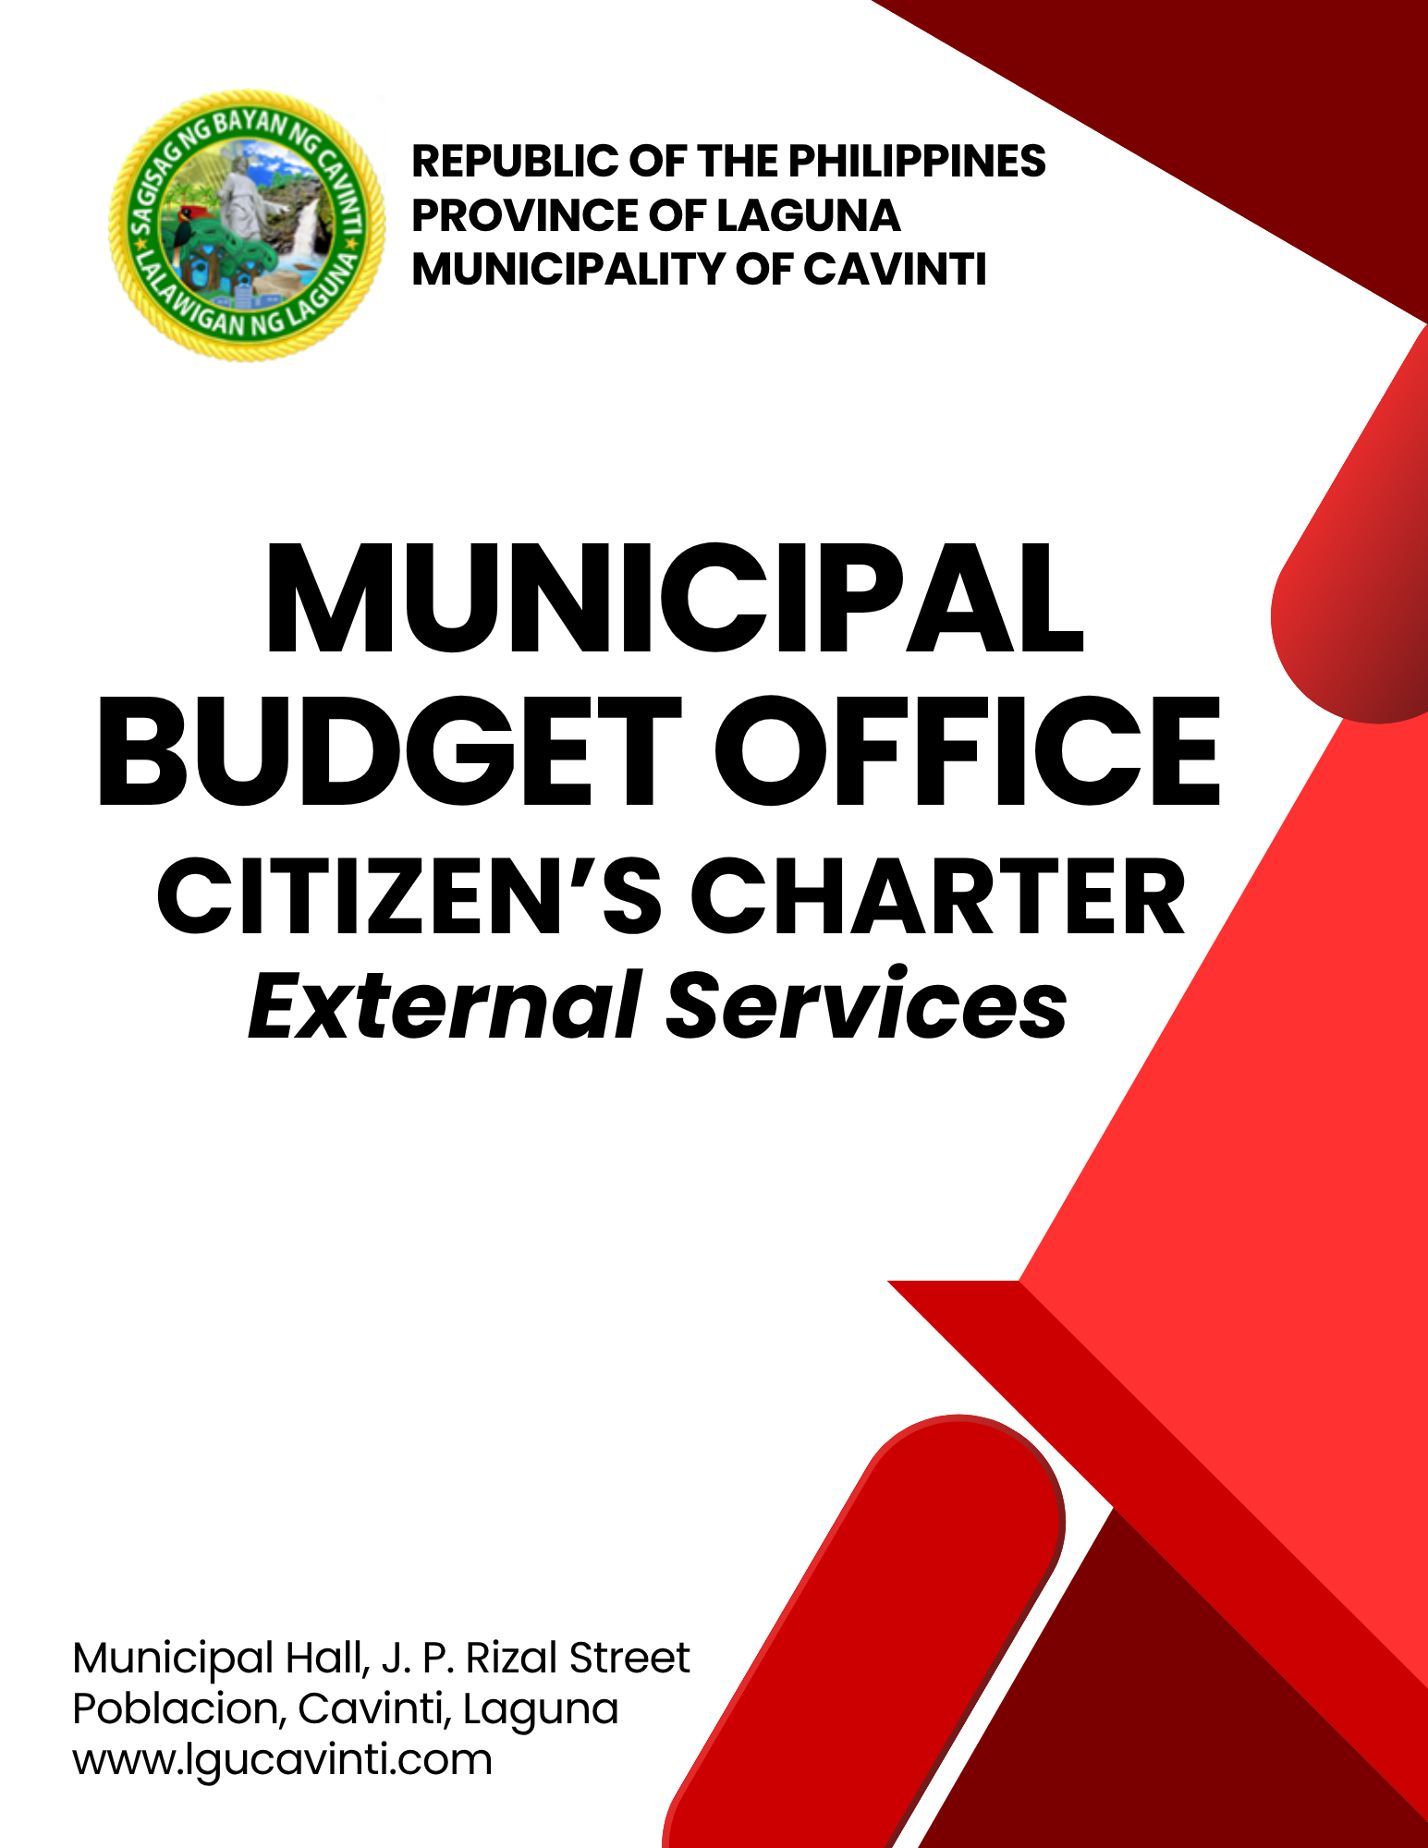

Municipal Budget Office

External Services

- Consultancy Services

To address the issues and concerns raised by the Sangguniang Barangay and formulate decisions and recommendations.

Office or Division: | Municipal Budget Office
Classification: | Simple
Type of Transaction: | G2G - Government to Government
Who may avail: | Barangay Secretaries, Barangay Treasurer and Punong Barangay
CHECKLIST OF REQUIREMENTS |  | WHERE TO SECURE
- Written request (1 original) |  | Sangguniang Barangay
CLIENT STEPS | AGENCY ACTIONS | FEES TO BE PAID | PROCESSING TIME | PERSON RESPONSIBLE
- Hand over the written request and/or coordinate with the Municipal Budget Office. | - Coordinate with client and/or receive the written request. | None | 1 Minute | Administrative Officer II  Administrative Officer IV  Municipal Budget Office
 | - Record the received document into the logbook. | None | 1 Minute | Administrative Officer II  Administrative Officer IV  Municipal Budget Office
 | - Give out copy of issuances, circulars, memo's if any to the client in response to their query. | None | 1 Minute | Administrative Officer II  Administrative Officer IV  Municipal Budget Office
 | - Make final recommendations. | None | 27 Minutes | Municipal Budget Officer  Municipal Budget Office
TOTAL: |  | None | 30 minutes
END OF TRANSACTION

- Barangay and Sangguniang Kabataan Annual Budget Review

The Municipal Budget Office undertakes preliminary review of the Appropriation Ordinance of barangays and makes recommendations for consideration of the Sangguniang Bayan (Section 475[b][7], R.A. No.7160). Assist the Sangguniang Bayan in the review and evaluation of the barangay budgets and recommend appropriate action thereon. The appropriation ordinance of barangays will be reviewed within 60 days upon receipt by the Sangguniang Bayan of copies of such ordinance.

Office or Division: | Municipal Budget Office
Classification: | Highly Technical
Type of Transaction: | G2G- Government to Government
Who may avail: | Barangay Secretaries, Barangay Treasurer, Committee on Appropriations, Punong Barangay, Sangguniang Kabataan Chairman
CHECKLIST OF REQUIREMENTS |  | WHERE TO SECURE
- Transmittal Letter |  | Barangay Secretary
- Appropriation Ordinance |  | Barangay Secretary
- Sanggunian - Approved Annual Investment Plan |  | Barangay Secretary, Punong Barangay
- List of Projects chargeable against the 20% Development Fund |  | Punong Barangay
- Plantilla of Personnel |  | Barangay Treasurer, Punong Barangay
- DILG-Endorsed Gender and Development Plan |  | Barangay Secretary, Punong Barangay
- Sangguniang Kabataan Resolution |  | Sangguniang Kabataan Secretary, Sangguniang Kabataan Chairman
CLIENT STEPS | AGENCY ACTIONS | FEES TO BE PAID | PROCESSING TIME | PERSON RESPONSIBLE
- Submit the Propose Barangay or Sangguniang Kabataan Annual Budget for Review with complete budgetary requirements. | - Receive annual budget and other attachments. | None | 1 Minute | Administrative Officer II  Administrative Officer IV  Municipal Budget Office
 | - Conduct a preliminary review of Barangay Budget. | None | 1 Day | Administrative Officer IV  Municipal Budget Office
 | - Conduct a technical review action of the submitted Barangay or Sangguniang Kabataan Annual Budget. | None | 15 Days | Municipal Budget Officer  Municipal Budget Office
 | - Prepare the endorsement letter with recommendations to the Sangguniang Bayan for their review and approval. | None | 15 Minutes | Administrative Officer IV  Municipal Budget Officer  Municipal Budget Office
TOTAL: |  | None | 16 Days and 16 Minutes
END OF TRANSACTION

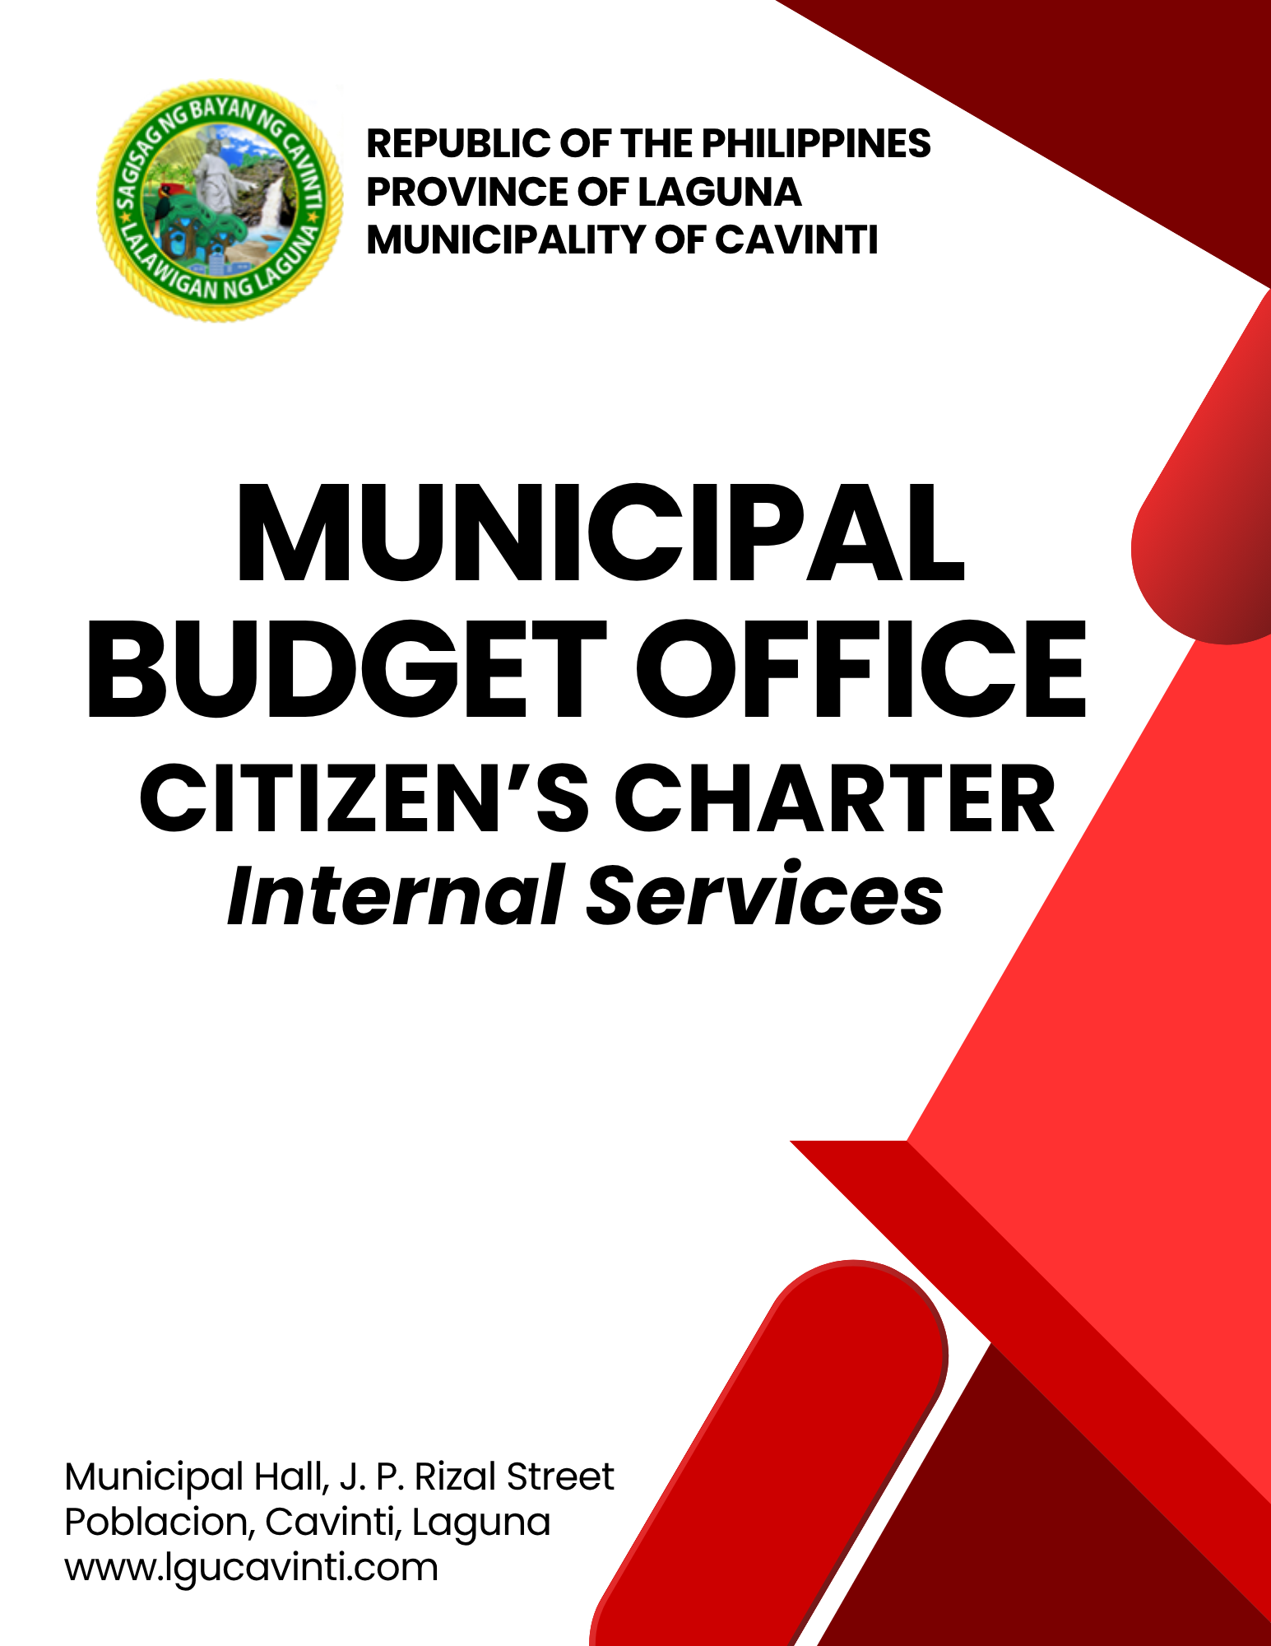
Municipal Budget Office

Internal Services

- Certification on the Availability of Appropriations for Obligation Requests

The use of appropriated funds pursuant to Section 336 of RA No. 7160 shall be exclusively for the specific purpose for which they have been appropriated. Before local funds are utilized, Section 344 of RA NO. 7160 provides that no money shall be disbursed unless the Municipal Budget Officer certifies to the existence of appropriation that has been made for the purpose.

Office or Division: |  | Municipal Budget Office
Classification: |  | Simple
Type of Transaction: |  | G2G- Government to Government
Who may avail: |  | All Offices
CHECKLIST OF REQUIREMENTS |  |  | WHERE TO SECURE
- For Personnel Services
- Payroll (4 original copies) |  |  | Human Resource Management Office
- For Travelling Expenses
- Travel Order (2 original copies) |  |  | Provided by their Office
- Itinerary of Travel  (2 original copies) |  |  | Provided by their Office
- Certificate of Appearance  (2 photocopies) |  |  | Provided by their Office
- Travel Completed/Tickets  (2 photocopies) |  |  | Provided by their Office
- For Infrastructure, Purchase & Service Charges
- Purchase Request  (5 original copies) |  |  | Provided by their Office
- Program of Works  (1 original copy) |  |  | Office of the Municipal Engineer
- Purchase Order/Job Order  (4 original copies) |  |  | Provided by their Office
- Abstract of Quotation and Request for Quotation  (4 original copies) |  |  | Bids And Awards Committee Secretary
- Notice of Award/Notice to Proceed (4 original copies) |  |  | Bids And Awards Committee Secretary
- Cash/Sales invoice/Official Receipts (1 original copy) |  |  | Supplier
- Acceptance and Inspection Reports (3 original copies) |  |  | Provided by their Office
- Bids And Awards Committee Resolution for the amount of Php 50, 000.00 above  (2 original copies) |  |  | Bids And Awards Committee Secretary
Contract |  |  | Bids And Awards Committee Secretary
- For Fixed Expenditures
- Billing Statement  (1 original copy,1 photocopy) |  |  | Office of the Municipal Accountant
- For Grants and Donations
- Letter Request  (1 original copy) |  |  | Person who requested
- Certificate of Eligibility  (1 original copy) |  |  | Municipal Social Welfare and Development Office
- Case Study (1 original copy) |  |  | Municipal Social Welfare and Development Office
CLIENT STEPS | AGENCY ACTIONS |  | FEES TO BE PAID | PROCESSING TIME | PERSON RESPONSIBLE
- Submit the obligation request form with complete attachments. | - Receive the complete set of requirements. |  | None | 1 Minute | Administrative Officer II  Administrative Officer IV  Municipal Budget Office
 | - Check consistency with submitted Project Procurement Management Plan (PPMP) and Annual Procurement Plan (APP), if applicable. |  | None | 3 Minutes | Administrative Officer II  Administrative Officer IV  Municipal Budget Office
 | - Check availability of appropriations with the registries. |  | None | 2 Minutes | Administrative Officer II  Administrative Officer IV  Municipal Budget Office
 | - Assign control number to the Obligation Request (OBR) and record the transaction in the logbook, then forward it to the Municipal Budget Officer for signing. |  | None | 3 Minutes | Administrative Officer II  Administrative Officer IV  Municipal Budget Office
 | - Conduct a final review and certify the existence of available appropriation. |  | None | 1 Minute | Municipal Budget Officer  Municipal Budget Office
 | - Record the transaction in the appropriation monitoring system and forward the obligation request to the accounting office or to other concerned offices for the next processing of documents. |  | None | 5 Minutes | Administrative Officer II  Administrative Officer IV  Municipal Budget Office
TOTAL: |  |  | None | 15 Minutes
END OF TRANSACTION

LIST OF OFFICES

OFFICE | ADDRESS | CONTACT INFORMATION
Office of the Mayor (OM) | 2nd Floor, Municipal Hall,  J. P. Rizal Street, Poblacion, Cavinti, Laguna | email: omcavinti@gmail.com  telephone no.: (049) 523-0012
Office of the Sangguniang Bayan (SB) | 2nd Floor, SB Hall, M. H. Del Pilar Street, Poblacion, Cavinti, Laguna | email: sbcavinti@gmail.com  telephone no.: (049) 523-4357
Office of the Municipal Administrator (OMAD) | 2nd Floor, Municipal Hall,  J. P. Rizal Street, Poblacion, Cavinti, Laguna | email: omadrecordslgucavinti@gmail.com  telephone no.: (049) 521-0147
Human Resource Management Office (HRMO) | 2nd Floor, Municipal Hall,  J. P. Rizal Street, Poblacion, Cavinti, Laguna | email: hrmocavintilaguna@gmail.com  telephone no.: (049) 523-1761
Municipal Budget Office (MBO) | 2nd Floor, Municipal Hall,  J. P. Rizal Street, Poblacion, Cavinti, Laguna | email: mbocavinti1071@gmail.com  telephone no.: (049) 523-1765
Office of the Municipal Accountant (OMACC) | 2nd Floor, Municipal Hall,  J. P. Rizal Street, Poblacion, Cavinti, Laguna | email: cavinti.omacc@gmail.com  telephone no.: (049) 503-7580
Municipal Civil Registrar Office (MCRO) | Municipal Hall, J. P. Rizal Street, Poblacion, Cavinti, Laguna | email: lcro_cavinti@gmail.com  telephone no.: (049) 523-1034
Office of the Municipal Treasurer | Municipal Hall, J. P. Rizal Street, Poblacion, Cavinti, Laguna | email: mtocavinti4013@gmail.com  telephone no.: (049) 502-4201
Municipal Planning and Development Office (MPDO) | 2nd Floor, Municipal Hall,  J. P. Rizal Street, Poblacion, Cavinti, Laguna | email: cavintimpdo@gmail.com  telephone no.: (049) 523-0366
Office of the Municipal Engineer (OME) | 2nd Floor, Municipal Hall,  J. P. Rizal Street, Poblacion, Cavinti, Laguna | email: ome.cavinti@gmail.com  telephone no.: (049) 521-8936
Municipal Disaster Risks Reduction and Management Office (MDRRMO) | National Highway, Barangay Poblacion, Cavinti, Laguna | email: mdrrmocavinti2022@gmail.com  Hotline Number: 0962-843-0781  Radio Frequency: 146.260
Office of the Municipal Social Welfare and Development (MSWDO) | Municipal Hall, J. P. Rizal Street, Poblacion, Cavinti, Laguna | email: omswdocavinti@yahoo.ocm  cavintisocialwelfare@gmail.com  telephone no.: (049) 523-0990
Municipal Environment and Natural Resources Office (MENRO) | Municipal Hall, J. P. Rizal Street, Poblacion, Cavinti, Laguna | email: menrocavinti@gmail.com  telephone no.: (049) 523-0967
Office of the Municipal Assessor (OMASS) | Municipal Hall, J. P. Rizal Street, Poblacion, Cavinti, Laguna | email: cavintiassessor@gmail.com  telephone no.: (049) 523-1023
Office of the Municipal Agriculture (OMAG) | SB Hall, M. H. Del Pilar Street, Poblacion, Cavinti, Laguna | email: maocavinti@gmail.com  telephone no.: (049) 544-2618
Cavinti Water Office (CWO) | 2nd Floor, Municipal Hall,  J. P. Rizal Street, Poblacion, Cavinti, Laguna | email: cavintiwater@gmail.com  telephone no.: (049) 523-0859
Cavinti Culture, History, Arts, Trade and Tourism Office (CCHATTO) | Ecopark, Barangay Tibatib, Cavinti, Laguna | email: tourismcavintilaguna@gmail.com  telephone no.: (049) 540-3924
Office of the Municipal Health Officer (OMHE) | Barangay Anglas, Cavinti, Laguna | email: cavintirhu@yahoo.com  telephone no.: (049) 523-0148
General Service Office (GSO) | Municipal Hall, J. P. Rizal Street, Poblacion, Cavinti, Laguna | email: gso.lgucavinti@gmail.com  telephone no.: (049) 523-1042
Public Employment Service Office (PESO) | Municipal Hall, J. P. Rizal Street, Poblacion, Cavinti, Laguna | email: @gmail.com  telephone no.: (049) 523-
Municipality of Cavinti | Municipal Hall, J. P. Rizal Street, Poblacion, Cavinti, Laguna | cavintimunicipalgovernment@gmail.com

FEEDBACK AND COMPLAINTS MECHANISMS
How to send feedback? | Answer the client feedback form and drop it at the designated drop boxes across the vicinity of the Municipal Building or you may contact us through the following to send in any suggestions, compliments and/or complaints.  cavintimunicipalgovernment@gmail.com Telephone No. 523-0129 local 100
How feedback is processed? | Every last working day of the week, the assigned personnel will open the drop box and compiles and records all the feedback submitted.  Feedbacks requiring answers will be forwarded to the relevant offices and they will be required to provide an answer within three (3) days upon receipt of the feedback.  The response will then be forwarded/relayed to the citizen if applicable.
How to file a complaint? | Answer the client complaint form and drop it at the designated drop boxes across the vicinity of the Municipal Building.  Make sure to provide the following information:  - Name of person being complained  - Incident  - Evidence
How complaints are processed? | The responsible/assigned personnel will open the complaint drop box on a daily basis and evaluate each complaint.  After thorough review of the complaint, an investigation will commence and require the personnel concerned for their explanation.  A report containing all the details of the incident and the findings shall be submitted to the head of agency for appropriate action.  Afterwards, feedback will be given to the client (complainant).
Contact Information of ARTA | email address: info@arta.gov.ph  contact nos.  PLDT - 1-ARTA (12782)  Smart  0920-925-3078  0998-856-8338

