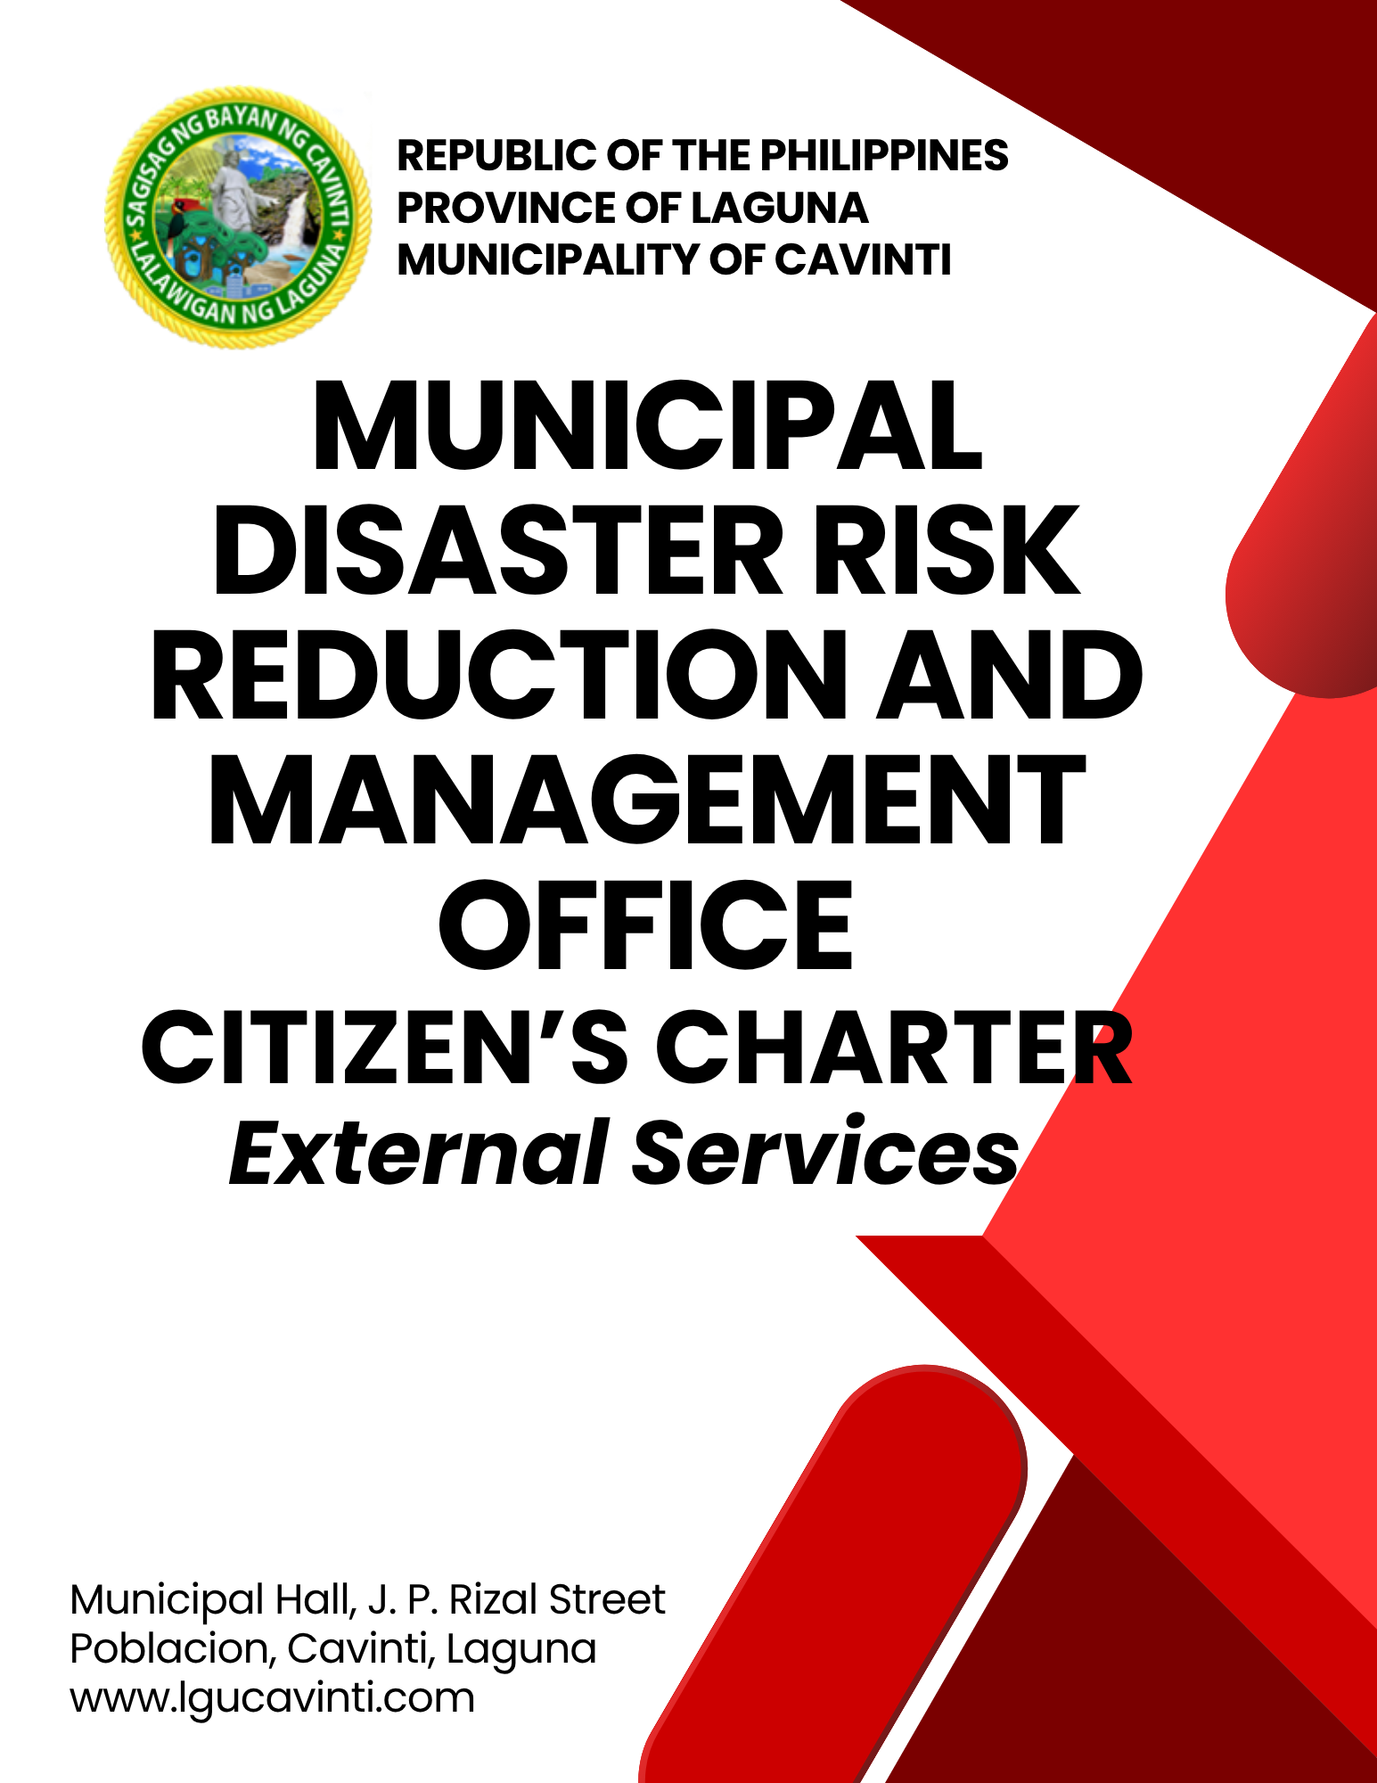

Municipal Disaster Risks Reduction
and Management Office

External Services

- Request for Information, Education and Campaign (IEC) Materials

Issuance of Request for Information, Education and Campaign (IEC) Materials ensures the requesting party are provided with valuable information relevant to Disaster Risk Reduction and Management.

Office or Division: | Municipal Disaster Risk Reduction and Management Office
Classification: | Simple
Type of Transaction: | G2C – Government to Citizens  G2G – Government to Government
Who may avail: | General Public
CHECKLIST OF REQUIREMENTS |  | WHERE TO SECURE
- Request letter from the Client addressed to the Mayor through LDRRMO indicating what type of Information, Education and Campaign (IEC) Materials are needed. |  | Client
CLIENT STEPS | AGENCY ACTION | FEES TO BE PAID | PROCESSING TIME | PERSON RESPONSIBLE
- Sign in the Client's Logbook at the information desk of the Municipal Disaster Risk Reduction and Management Office. | - Give the logbook to the client. | None | 2 minutes | Staff  Office of the Municipal Disaster Risk Reduction and Management
 | - Conduct an interview and gather information. | None | 5 minutes | Staff  Office of the Municipal Disaster Risk Reduction and Management
- Submit a letter of request. | - Identify the Information, Education and Campaign (IEC) material being requested and coordinate with the concerned division for the preparation of the requested IEC material. | None | 5 minutes | Staff  Office of the Municipal Disaster Risk Reduction and Management
- Receive the requested Information, Education and Campaign (IEC) materials. | - Issue the requested Information, Education and Campaign (IEC) materials | None | 5 minutes | Staff  Office of the Municipal Disaster Risk Reduction and Management
 | TOTAL: | None | 17 minutes
END OF TRANSACTION

- Municipal Disaster Risk Reduction and Management Relevant Trainings and Seminars

The service ensures that the trainings and seminars conducted will equip participants with the appropriate knowledge and skills that conforms with the standards set by governing agencies as mandated under the Republic Act 10121.

Office or Division: | Municipal Disaster Risk Reduction and Management Office
Classification: | Simple
Type of Transaction: | G2C – Government to Citizens  G2G – Government to Government
Who may avail: | All individuals
CHECKLIST OF REQUIREMENTS |  | WHERE TO SECURE
- Request letter addressed to the Mayor through LDRRMO indicating what type of training or seminar to be conducted |  | Client
CLIENT STEPS | AGENCY ACTION | FEES TO BE PAID | PROCESSING TIME | PERSON RESPONSIBLE
- Submit the request letter. | - Receive the request letter. | None | 2 minutes | Staff  Office of the Municipal Mayor
- Submit the request letter. | - Endorsement letter of the front desk to the Local Chief Executive or to the authorized official for the approval of the request | None | 1 day | Staff  Office of the Municipal Mayor
- Submit the request letter. | - Forward the letter to the Municipal Disaster Risks Reduction and Management Office (MDRRMO) | None | 10 minutes | Staff  Office of the Municipal Mayor
- Client will be advised to wait for the approval of the request through ph999one call or email. | - Assign the Training Team to accommodate and inform the client of the schedule and other details of the training or seminar. | None | 30 minutes | Training Section Chief  Office of the Municipal Disaster Risk Reduction and Management
 | - Prepare the modules and topic to include in the modules or seminar. | None | 1 day | Training Team  Office of the Municipal Disaster Risk Reduction and Management
 | TOTAL: | None | 2 days and 42 minutes
END OF TRANSACTION

- Emergency Response and other services for Emergencies and Disaster Management

Emergency response and disaster management services involve a coordinated effort to save lives, minimize health impacts, ensure public safety.

Office or Division: | Municipal Disaster Risk Reduction and Management Office
Classification: | Simple
Type of Transaction: | G2C – Government to Citizens  G2G – Government to Government
Who may avail: | General Public
CHECKLIST OF REQUIREMENTS |  | WHERE TO SECURE
- Emergency call through Operations Center Hotline Number or handheld radio |  | Municipal Disaster Risks Reduction and Management Office
- Provide necessary information (Name of caller, address, nature of emergency, location, and status of victims involved, etc. |  | Caller
CLIENT STEPS | AGENCY ACTION | FEES TO BE PAID | PROCESSING TIME | PERSON RESPONSIBLE
- Call Operations Center (OpCen) Hotline Number 0962-843-0781 or Municipal radio frequency 146.260 | - Receive and verify the emergency call, name of informant or caller, contact number and few details regarding the emergency or incident.  - Nature of Emergency / Type of Incident –  - Caller’s Information Location of the Incident  - Individuals affected and status | None | 2 minutes | Personnel on Duty  Office of the Municipal Disaster Risk Reduction and Management
 | - Forward the report to Operations Section Chief. | None | 2 minutes | Personnel on Duty  Office of the Municipal Disaster Risk Reduction and Management
 | - Mobilize the assigned Emergency Response team towards the identified location of the incident. | None | 5 minutes | Operations Section Chief  Office of the Municipal Disaster Risk Reduction and Management
 | - Arrive at the scene of the incident with each member of the emergency response team performing specific task (First Aiders, Documentation, Traffic Management, Crowd Control). | None | 3 minutes | Emergency Response Team  Office of the Municipal Disaster Risk Reduction and Management
 | - Ask the patient to sign the waiver indicating the reason if the patient refuse to transfer to the nearest hospital. | None | 1 minute | Emergency Response Team  Office of the Municipal Disaster Risk Reduction and Management
- If permitted, accompany patient to the hospital. | - Transport the patient to the nearest hospital. | None | 12 minutes | Emergency Response Team  Office of the Municipal Disaster Risk Reduction and Management
 | TOTAL: | None | 25 minutes
END OF TRANSACTION

LIST OF OFFICES

OFFICE | ADDRESS | CONTACT INFORMATION
Office of the Mayor (OM) | 2nd Floor, Municipal Hall,  J. P. Rizal Street, Poblacion, Cavinti, Laguna | email: omcavinti@gmail.com  telephone no.: (049) 523-0012
Office of the Sangguniang Bayan (SB) | 2nd Floor, SB Hall, M. H. Del Pilar Street, Poblacion, Cavinti, Laguna | email: sbcavinti@gmail.com  telephone no.: (049) 523-4357
Office of the Municipal Administrator (OMAD) | 2nd Floor, Municipal Hall,  J. P. Rizal Street, Poblacion, Cavinti, Laguna | email: omadrecordslgucavinti@gmail.com  telephone no.: (049) 521-0147
Human Resource Management Office (HRMO) | 2nd Floor, Municipal Hall,  J. P. Rizal Street, Poblacion, Cavinti, Laguna | email: hrmocavintilaguna@gmail.com  telephone no.: (049) 523-1761
Municipal Budget Office (MBO) | 2nd Floor, Municipal Hall,  J. P. Rizal Street, Poblacion, Cavinti, Laguna | email: mbocavinti1071@gmail.com  telephone no.: (049) 523-1765
Office of the Municipal Accountant (OMACC) | 2nd Floor, Municipal Hall,  J. P. Rizal Street, Poblacion, Cavinti, Laguna | email: cavinti.omacc@gmail.com  telephone no.: (049) 503-7580
Municipal Civil Registrar Office (MCRO) | Municipal Hall, J. P. Rizal Street, Poblacion, Cavinti, Laguna | email: lcro_cavinti@gmail.com  telephone no.: (049) 523-1034
Office of the Municipal Treasurer | Municipal Hall, J. P. Rizal Street, Poblacion, Cavinti, Laguna | email: mtocavinti4013@gmail.com  telephone no.: (049) 502-4201
Municipal Planning and Development Office (MPDO) | 2nd Floor, Municipal Hall,  J. P. Rizal Street, Poblacion, Cavinti, Laguna | email: cavintimpdo@gmail.com  telephone no.: (049) 523-0366
Office of the Municipal Engineer (OME) | 2nd Floor, Municipal Hall,  J. P. Rizal Street, Poblacion, Cavinti, Laguna | email: ome.cavinti@gmail.com  telephone no.: (049) 521-8936
Municipal Disaster Risks Reduction and Management Office (MDRRMO) | National Highway, Barangay Poblacion, Cavinti, Laguna | email: mdrrmocavinti2022@gmail.com  Hotline Number: 0962-843-0781  Radio Frequency: 146.260
Office of the Municipal Social Welfare and Development (MSWDO) | Municipal Hall, J. P. Rizal Street, Poblacion, Cavinti, Laguna | email: omswdocavinti@yahoo.ocm  cavintisocialwelfare@gmail.com  telephone no.: (049) 523-0990
Municipal Environment and Natural Resources Office (MENRO) | Municipal Hall, J. P. Rizal Street, Poblacion, Cavinti, Laguna | email: menrocavinti@gmail.com  telephone no.: (049) 523-0967
Office of the Municipal Assessor (OMASS) | Municipal Hall, J. P. Rizal Street, Poblacion, Cavinti, Laguna | email: cavintiassessor@gmail.com  telephone no.: (049) 523-1023
Office of the Municipal Agriculture (OMAG) | SB Hall, M. H. Del Pilar Street, Poblacion, Cavinti, Laguna | email: maocavinti@gmail.com  telephone no.: (049) 544-2618
Cavinti Water Office (CWO) | 2nd Floor, Municipal Hall,  J. P. Rizal Street, Poblacion, Cavinti, Laguna | email: cavintiwater@gmail.com  telephone no.: (049) 523-0859
Cavinti Culture, History, Arts, Trade and Tourism Office (CCHATTO) | Ecopark, Barangay Tibatib, Cavinti, Laguna | email: tourismcavintilaguna@gmail.com  telephone no.: (049) 540-3924
Office of the Municipal Health Officer (OMHE) | Barangay Anglas, Cavinti, Laguna | email: cavintirhu@yahoo.com  telephone no.: (049) 523-0148
General Service Office (GSO) | Municipal Hall, J. P. Rizal Street, Poblacion, Cavinti, Laguna | email: gso.lgucavinti@gmail.com  telephone no.: (049) 523-1042
Public Employment Service Office (PESO) | Municipal Hall, J. P. Rizal Street, Poblacion, Cavinti, Laguna | email: @gmail.com  telephone no.: (049) 523-
Municipality of Cavinti | Municipal Hall, J. P. Rizal Street, Poblacion, Cavinti, Laguna | cavintimunicipalgovernment@gmail.com

FEEDBACK AND COMPLAINTS MECHANISMS
How to send feedback? | Answer the client feedback form and drop it at the designated drop boxes across the vicinity of the Municipal Building or you may contact us through the following to send in any suggestions, compliments and/or complaints.  cavintimunicipalgovernment@gmail.com Telephone No. 523-0129 local 100
How feedback is processed? | Every last working day of the week, the assigned personnel will open the drop box and compiles and records all the feedback submitted.  Feedbacks requiring answers will be forwarded to the relevant offices and they will be required to provide an answer within three (3) days upon receipt of the feedback.  The response will then be forwarded/relayed to the citizen if applicable.
How to file a complaint? | Answer the client complaint form and drop it at the designated drop boxes across the vicinity of the Municipal Building.  Make sure to provide the following information:  - Name of person being complained  - Incident  - Evidence
How complaints are processed? | The responsible/assigned personnel will open the complaint drop box on a daily basis and evaluate each complaint.  After thorough review of the complaint, an investigation will commence and require the personnel concerned for their explanation.  A report containing all the details of the incident and the findings shall be submitted to the head of agency for appropriate action.  Afterwards, feedback will be given to the client (complainant).
Contact Information of ARTA | email address: info@arta.gov.ph  contact nos.  PLDT - 1-ARTA (12782)  Smart  0920-925-3078  0998-856-8338

