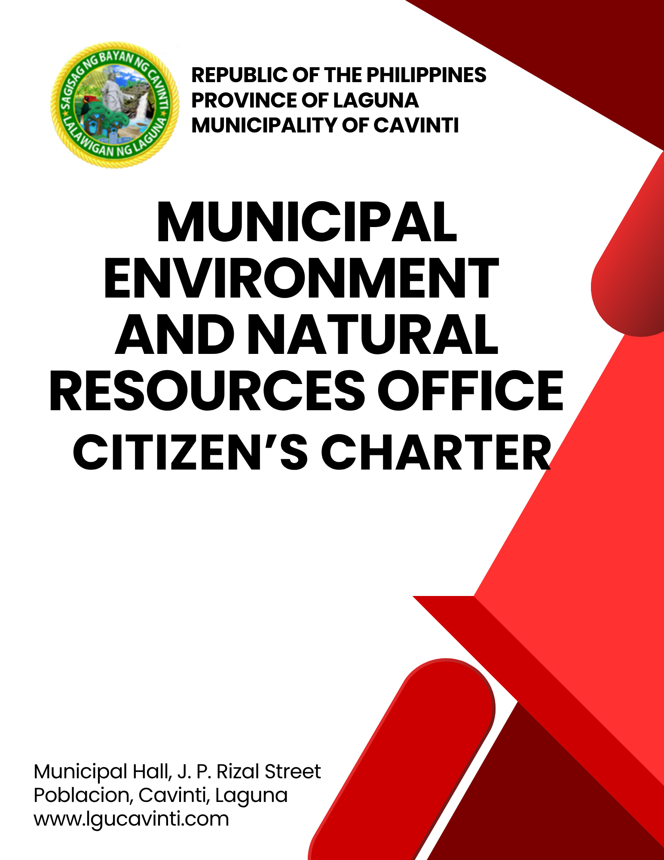

Municipal Environment and Natural Resources Office

External Services

- Resolution of Environmental Concern/Complaints

Clients may settle their complaints regarding issues on environmental exploitation and other environmental concerns at the office of the municipal environment and natural resources.

Office or Division: | Municipal Environment and Natural Resources Office/Solid Waste Management
Classification: | Complex
Type of Transactions: | G2C - Government to Citizen
Who may avail: | All
CHECKLIST OF REQUIREMENTS |  | WHERE TO SECURE
- Letter of complaint, if available  (1 original copy)  - Photo or Video evidences or any other documents that could support the complaint (1 copy of printed photos) |  | Letter of complaint along with the supporting documents must be provided by the client. Clients may report complaints to the office without the letter but the photo/video and other evidences must be present
CLIENT STEPS | AGENCY ACTION | FEES TO BE PAID | PROCESSING TIME | PERSON RESPONSIBLE
- Report to the office. Submit the letter of complaint | - Receive the letter. Ask the client to fill in their information in the log book. | None | 5 minutes | MENRO Clerk/Staff  Office of the Municipal Environment and Natural Resources
- Provide further important details about the concern/issue reported to the office | - Ask for an in-depth and detailed information about the concern/issue received from the client. | None | 1 hour | MENRO Head-of-Office  MENRO Clerk/Staff  Office of the Municipal Environment and Natural Resources
 | - Conduct a site inspection for verification and further data gathering. | None | 1 day | MENRO Head-of-Office  MENRO Staff  Office of the Municipal Environment and Natural Resources
 | - Issue a Notice of Violation, Cease and Desist Order, or Warning or whichever is applicable for the certain concern/issue received by the office. | None | 1 hour | MENRO Clerk/Staff  Office of the Municipal Environment and Natural Resources
 | - Monitor compliance of the person concerned after 3 days. | None | 3 days | MENRO Head-of-Office  MENRO Staff  Office of the Municipal Environment and Natural Resources
 | - For unresolved issues, endorse and coordinate with higher authorities for appropriate action. | None | 1 day | MENRO Head-of-Office  Office of the Municipal Environment and Natural Resources
Total |  | None | 5 days, 2 hours, and 5 minutes
END OF TRANSACTION

- Issuance of Municipal Environmental Certificate (MEC)

Municipal Environmental Certificate is necessary for all commercial, institutional, industrial, and green infrastructure projects as well as business and commercial buildings. The Municipal Environmental Permit to Operate shall be awarded to existing businesses with Municipal Environmental Certificate (MEC) provided that said facility has complied with the provisions set-forth under the issued MEC. New establishments must get MEC prior to their construction.

Office or Division: |  | Municipal Environment and Natural Resources Office/Solid Waste Management
Classification: |  | Simple
Type of Transactions: |  | G2C - Government to Citizen
Who may avail: |  | All business owners
CHECKLIST OF REQUIREMENTS |  |  |  | WHERE TO SECURE
- Zoning Clearance/ Locational Clearance  (1 photocopy) |  |  |  | Municipal Planning and Development Office
- Barangay Clearance (Interposing no objection to business) (1 photocopy) |  |  |  | Barangay Hall
- Other Certificates (Department of Trade and Industry, Security and Exchange Commission (1 photocopy) |  |  |  | Department of Trade and Industry, Security and Exchange Commission
- Orientation on relevant Solid Waste Management, Plastic |  |  |  | Municipal Environment Natural Resources Office
- Photo or any documents showing practice of waste segregation (1 photocopy) |  |  |  | Municipal Environment Natural Resources Office
*Additional requirements for large businesses
- Environmental Compliance Certificate or Certificate of Non-Compliant (DENR) with attachment (1 photocopy) |  |  |  | Department of Environment Natural Resources
- Discharge Permits from Department of Environment Natural Resources and Laguna Lake Development Authority (1 photocopy) |  |  |  | Department of Environment Natural Resources / Laguna Lake Development Authority
- Permit to Operate (Department of Environment Natural Resources - Environmental Management Bureau, Generator set, Rice Mill, etc.) (1 photocopy) |  |  |  | Department of Environment Natural Resources
- Hazardous Waste Generator ID No. (DENR-EMB) (1 photocopy) |  |  |  | Department of Environment Natural Resources  -Environmental Management Bureau
- National Water Resource Board Water Permit (1 photocopy) |  |  |  | National Water Resource Board
CLIENT STEPS | AGENCY ACTION |  | FEES TO BE PAID | PROCESSING TIME | PERSON RESPONSIBLE
- Sign in client logbook and submit all required documents. | - Assess the Application for Business Permit and other supporting documents. |  | None | 5 Minutes | MENRO Clerk/Staff  Office of the Municipal Environment and Natural Resources
 | - Conduct briefing / Orientation on Sanitation and Solid Waste Management. |  | None | 10 Minutes | MENRO Head-of-Office  MENRO Clerk/Staff  Office of the Municipal Environment and Natural Resources
 | - Sign the Application form and release the same to the Client. |  | None | 2 Minutes | MENRO Head-of-Office  MENRO Staff  Office of the Municipal Environment and Natural Resources
- Make the payment for the permit at Window 1 of the Office of the Municipal Treasurer. | - Accept and encode payment into the system. |  | Php 100.00 | 2 minutes | Maricris M. Ramos  Administrative Aide IV  Office of the Municipal Treasurer
Total |  |  | Php 100.00 | 19 minutes
END OF TRANSACTION
LIST OF OFFICES

OFFICE | ADDRESS | CONTACT INFORMATION
Office of the Mayor (OM) | 2nd Floor, Municipal Hall,  J. P. Rizal Street, Poblacion, Cavinti, Laguna | email: omcavinti@gmail.com  telephone no.: (049) 523-0012
Office of the Sangguniang Bayan (SB) | 2nd Floor, SB Hall, M. H. Del Pilar Street, Poblacion, Cavinti, Laguna | email: sbcavinti@gmail.com  telephone no.: (049) 523-4357
Office of the Municipal Administrator (OMAD) | 2nd Floor, Municipal Hall,  J. P. Rizal Street, Poblacion, Cavinti, Laguna | email: omadrecordslgucavinti@gmail.com  telephone no.: (049) 521-0147
Human Resource Management Office (HRMO) | 2nd Floor, Municipal Hall,  J. P. Rizal Street, Poblacion, Cavinti, Laguna | email: hrmocavintilaguna@gmail.com  telephone no.: (049) 523-1761
Municipal Budget Office (MBO) | 2nd Floor, Municipal Hall,  J. P. Rizal Street, Poblacion, Cavinti, Laguna | email: mbocavinti1071@gmail.com  telephone no.: (049) 523-1765
Office of the Municipal Accountant (OMACC) | 2nd Floor, Municipal Hall,  J. P. Rizal Street, Poblacion, Cavinti, Laguna | email: cavinti.omacc@gmail.com  telephone no.: (049) 503-7580
Municipal Civil Registrar Office (MCRO) | Municipal Hall, J. P. Rizal Street, Poblacion, Cavinti, Laguna | email: lcro_cavinti@gmail.com  telephone no.: (049) 523-1034
Office of the Municipal Treasurer | Municipal Hall, J. P. Rizal Street, Poblacion, Cavinti, Laguna | email: mtocavinti4013@gmail.com  telephone no.: (049) 502-4201
Municipal Planning and Development Office (MPDO) | 2nd Floor, Municipal Hall,  J. P. Rizal Street, Poblacion, Cavinti, Laguna | email: cavintimpdo@gmail.com  telephone no.: (049) 523-0366
Office of the Municipal Engineer (OME) | 2nd Floor, Municipal Hall,  J. P. Rizal Street, Poblacion, Cavinti, Laguna | email: ome.cavinti@gmail.com  telephone no.: (049) 521-8936
Municipal Disaster Risks Reduction and Management Office (MDRRMO) | National Highway, Barangay Poblacion, Cavinti, Laguna | email: mdrrmocavinti2022@gmail.com  Hotline Number: 0962-843-0781  Radio Frequency: 146.260
Office of the Municipal Social Welfare and Development (MSWDO) | Municipal Hall, J. P. Rizal Street, Poblacion, Cavinti, Laguna | email: omswdocavinti@yahoo.ocm  cavintisocialwelfare@gmail.com  telephone no.: (049) 523-0990
Municipal Environment and Natural Resources Office (MENRO) | Municipal Hall, J. P. Rizal Street, Poblacion, Cavinti, Laguna | email: menrocavinti@gmail.com  telephone no.: (049) 523-0967
Office of the Municipal Assessor (OMASS) | Municipal Hall, J. P. Rizal Street, Poblacion, Cavinti, Laguna | email: cavintiassessor@gmail.com  telephone no.: (049) 523-1023
Office of the Municipal Agriculture (OMAG) | SB Hall, M. H. Del Pilar Street, Poblacion, Cavinti, Laguna | email: maocavinti@gmail.com  telephone no.: (049) 544-2618
Cavinti Water Office (CWO) | 2nd Floor, Municipal Hall,  J. P. Rizal Street, Poblacion, Cavinti, Laguna | email: cavintiwater@gmail.com  telephone no.: (049) 523-0859
Cavinti Culture, History, Arts, Trade and Tourism Office (CCHATTO) | Ecopark, Barangay Tibatib, Cavinti, Laguna | email: tourismcavintilaguna@gmail.com  telephone no.: (049) 540-3924
Office of the Municipal Health Officer (OMHE) | Barangay Anglas, Cavinti, Laguna | email: cavintirhu@yahoo.com  telephone no.: (049) 523-0148
General Service Office (GSO) | Municipal Hall, J. P. Rizal Street, Poblacion, Cavinti, Laguna | email: gso.lgucavinti@gmail.com  telephone no.: (049) 523-1042
Public Employment Service Office (PESO) | Municipal Hall, J. P. Rizal Street, Poblacion, Cavinti, Laguna | email: @gmail.com  telephone no.: (049) 523-
Municipality of Cavinti | Municipal Hall, J. P. Rizal Street, Poblacion, Cavinti, Laguna | cavintimunicipalgovernment@gmail.com

FEEDBACK AND COMPLAINTS MECHANISMS
How to send feedback? | Answer the client feedback form and drop it at the designated drop boxes across the vicinity of the Municipal Building or you may contact us through the following to send in any suggestions, compliments and/or complaints.  cavintimunicipalgovernment@gmail.com Telephone No. 523-0129 local 100
How feedback is processed? | Every last working day of the week, the assigned personnel will open the drop box and compiles and records all the feedback submitted.  Feedbacks requiring answers will be forwarded to the relevant offices and they will be required to provide an answer within three (3) days upon receipt of the feedback.  The response will then be forwarded/relayed to the citizen if applicable.
How to file a complaint? | Answer the client complaint form and drop it at the designated drop boxes across the vicinity of the Municipal Building.  Make sure to provide the following information:  - Name of person being complained  - Incident  - Evidence
How complaints are processed? | The responsible/assigned personnel will open the complaint drop box on a daily basis and evaluate each complaint.  After thorough review of the complaint, an investigation will commence and require the personnel concerned for their explanation.  A report containing all the details of the incident and the findings shall be submitted to the head of agency for appropriate action.  Afterwards, feedback will be given to the client (complainant).
Contact Information of ARTA | email address: info@arta.gov.ph  contact nos.  PLDT - 1-ARTA (12782)  Smart  0920-925-3078  0998-856-8338

