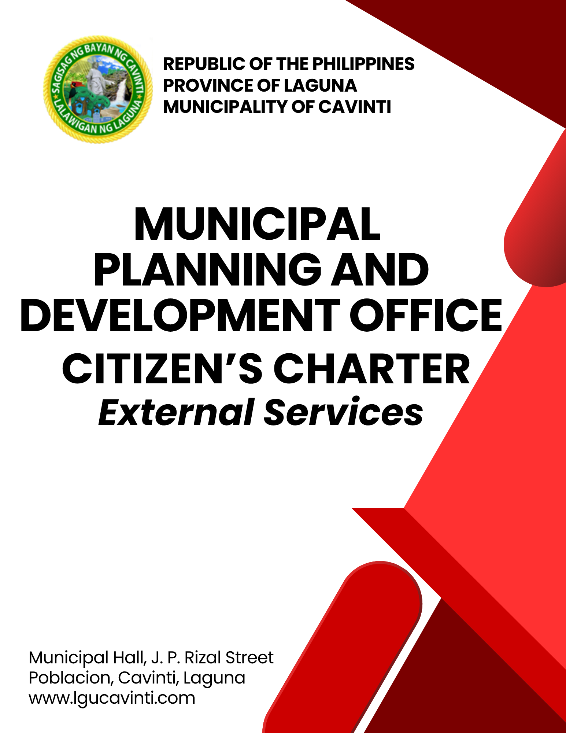

Municipal Planning and Development Office

Internal Services

- Securing Data from the Office of the Municipal Planning and Development Coordinator

The following data may be requested from the Office of the Municipal Planning and Development Coordinator:

- Annual Investment Plan (AIP)
- Comprehensive Land Use Plan (CLUP)
- Comprehensive Development Plan (CDP)
- Local Development Investment Plan (LDIP)
- Socio-Economic and Physical Profile (SEPP)
- Community-Based Monitoring System (CBMS) Data
- Other Municipal Plans

Office or Division: | Municipal Planning and Development Office
Classification: | Simple
Type of Transaction: | G2C – Government to Citizen  G2B – Government to Business  G2G – Government to Government
Who may avail: | All Individual
CHECKLIST OF REQUIREMENTS |  | WHERE TO SECURE
- Request Letter addressed to the Local Chief Executive (Municipal Mayor) signifying the intent, needed information, and purpose (2 original copies) |  | Client
- Official Receipt of Payment (1 original copy) |  | Office of the Municipal Treasurer
CLIENT STEPS | AGENCY ACTIONS | FEES TO BE PAID | PROCESSING TIME | PERSON RESPONSIBLE
- Inquire and hand over the request letter and log personal data on the logbook for recording purposes. | - Advise the client to prepare a letter addressed to the Local Chief Executive (Municipal Mayor) at the Office of the Mayor. | None | 5 minutes | Administrative Aide I  Municipal Planning and Development Office
- Forward the request letter to the Office of the Mayor for approval. | - Receive the request letter for the Mayor’s approval. | None | 5 minutes | Clerk  Office of the Mayor
 | - Once approved, forward the approved letter to the Office of the Municipal Planning and Development Coordinator. | None | 1 day | Clerk  Office of the Mayor
 | - Inform the client of the approval of the request letter. | None | 5 minutes | Administrative Aide I  Municipal Planning and Development Office
 | - Prepare the requested documents and order of payment. | None | 30 minutes | Administrative Aide I  Municipal Planning and Development Office
- Pay the corresponding fees for the document requested in Window 1 of the Office of the Municipal Treasurer. | - Receive the payment and advise the client to claim the official receipt in Window 3. | Php 120.00 per page  Free - for students conducting thesis preparation and research, and for national government agencies | 5 minutes | Administrative Aide IV  Office of the Municipal Treasurer
- Submit the order of payment and claim the official receipt in Window 3 of the Office of the Municipal Treasurer. | - Print and issue the official receipt of payment. | None | 2 minutes | Tax Mapping Aide  Office of the Municipal Treasurer
- Present the official receipt to the Office of Municipal Planning and Development and receive the documents requested. | - Release the requested documents and ask the client to sign the logbook. The requested document may also be in electronic format and sent via e-mail. | None | 5 minutes | Administrative Aide I  Municipal Planning and Development Office
TOTAL: |  | Php 120.00 per page  Free - for students conducting thesis preparation and research, and for national government agencies | 1 day, 57 minutes
END OF TRANSACTION

- Securing Zoning Certificate for Land Titling

A land title is a legal document that serves as proof of ownership of a piece of land, granting the holder the right to control, possess, and enjoy the property. It is evidenced by an Original Certificate of Title (OCT) for first-time registration or a Transfer Certificate of Title (TCT) when ownership is transferred. One of the requirements for this land title is the Zoning Certificate from the Office of the Municipal Planning and Development Coordinator, who also acts as the Zoning Authority.

Office or Division: | Municipal Planning and Development Office
Classification: | Simple
Type of Transaction: | G2C – Government to Citizen
Who may avail: | All Individual
CHECKLIST OF REQUIREMENTS |  | WHERE TO SECURE
- Request Letter from the Department of Environment and National Resources (DENR) for Zoning Certification  (1 original copy) |  | Community Environment and Natural Resources Office (CENRO) Sta. Cruz, Laguna
- Real Property Tax Declaration  (1 original or photocopy) |  | Client or Municipal Assessor’s Office
- Official Receipt of Payment  (1 original copy) |  | Office of the Municipal Treasurer
CLIENT STEPS | AGENCY ACTIONS | FEES TO BE PAID | PROCESSING TIME | PERSON RESPONSIBLE
- Submit/hand over the requirements. | - Assess and verify the requirements. | None | 5 minutes | Administrative Aide I  or  Planning Officer II  Municipal Planning and Development Office
- Submit/hand over the requirements. | - Issue the order of payment. | None | 2 Minutes | Administrative Aide I  or  Planning Officer II  Municipal Planning and Development Office
- Pay the corresponding fees for the document requested in Window 1 of the Office of the Municipal Treasurer. | - Receive the payment and advise the client to claim the official receipt in Window 3. | Php 120.00 | 10 minutes | Administrative Aide IV  Office of the Municipal Treasurer
- Submit the order of payment and claim the official receipt in Window 3 of the Office of the Municipal Treasurer. | - Print and issue the official receipt of payment. | None | 2 minutes | Tax Mapping Aide  Office of the Municipal Treasurer
- Hand over the proof of payment to the Municipal Planning and Development Office. | - Encode and print the Zoning Certificate. | None | 3 minutes | Administrative Aide I  or  Planning Officer II  Municipal Planning and Development Office
 | - Approve and sign the Zoning Certificate. | None | 2 minutes | Municipal Planning and Development Coordinator
- Receive the Zoning Certificate applied for and sign on the receiving logbook. | - Release the Zoning Certificate and ask the client to sign in the receiving logbook. | None | 2 minutes | Administrative Aide I  or  Planning Officer II  Municipal Planning and Development Office
TOTAL: |  | Php 120.00 | 26 minutes
END OF TRANSACTION

- Securing Zoning Certificate for Business Permit (New/Renewal during the Business One-Stop Shop Implementation)

To ensure that businesses comply with the municipality’s Zoning Ordinance, a Locational Clearance or Zoning Certificate is issued to business owners, serving as a prerequisite for the issuance of a Business Permit.

Office or Division: | Municipal Planning and Development Office
Classification: | Simple
Type of Transaction: | G2C – Government to Citizen
Who may avail: | All Individual
CHECKLIST OF REQUIREMENTS |  | WHERE TO SECURE
- Application for Business Permit  (1 original copy) |  | Business Permit and Licensing Section of the Municipal Treasurer’s Office
- Department of Trade and Industry Certificate of Business Registration; or Securities and Exchange Commission Registration Certificate  (1 original or photocopy) |  | Department of Trade and Industry Negosyo Center, Cavinti, Laguna  Securities and Exchange Commission  Quezon City
- Barangay Clearance for Business Permit (1 original or photocopy) |  | Barangay Government Center (Barangay Hall), where the business is located
- Official Receipt of Payment  (1 original copy) |  | Office of the Municipal Treasurer
CLIENT STEPS | AGENCY ACTIONS | FEES TO BE PAID | PROCESSING TIME | PERSON RESPONSIBLE
- Present the application form together with the required documents for initial assessment and verification at the Business Permit and Licensing Office (BPLO) under the Office of the Municipal Treasurer. | - Receive the required documents for encoding to the e-Business Permit and licensing System (eBPLS), then hand over the requirements to the next evaluator; | The fee of Php 120.00 is included in the final assessment of fees by the Municipal Treasurer’s Office | 5 minutes | Local Treasury Operations Officer I  Business Permit and Licensing Office
 | - Evaluate the business activity and location based on the Municipal Zoning Ordinance. | None | 5 minutes | Administrative Aide I  or  Planning Officer II  Municipal Planning and Development Office
 | - If the business activity and location are permitted, approve the Zoning Clearance in the e-BPLS, prepare the signed Zoning Clearance, and attach it to the required documents. However, if the application requires supplemental documents or is disapproved, it is reverted to the BPLO. | None | 2 minutes | Administrative Aide I  or  Planning Officer II  Municipal Planning and Development Office
 | - Hand over the application to the next evaluator. | None | 2 minutes | Administrative Aide I  or  Planning Officer II  Municipal Planning and Development Office
TOTAL: |  | Php 120.00 | 14 minutes
The transaction continues until the client pays the total fees assessed by the Municipal Treasurer’s Office, and the BPLO releases the Business Permit with the License plate several days after.
END OF TRANSACTION

- Securing Zoning Certificate for Business Permit (New/Renewal Without the Business One-Stop Shop)

To ensure that businesses comply with the municipality’s Zoning Ordinance, a Locational Clearance or Zoning Certificate is issued to business owners, serving as a prerequisite for the issuance of a business permit.

Office or Division: | Municipal Planning and Development Office
Classification: | Simple
Type of Transaction: | G2C – Government to Citizen
Who may avail: | All Individual
CHECKLIST OF REQUIREMENTS |  | WHERE TO SECURE
- Application for New Business Permit or Renewal of Business Permit  (1 original or photocopy) |  | Business Permit and Licensing Section of the Municipal Treasurer’s Office
- Department of Trade and Industry (DTI) Certificate of Business Registration; or  Securities and Exchange Commission (SEC) Registration Certificate  (1 original or photocopy) |  | Department of Trade and Industry (DTI) Negosyo Center, Cavinti, Laguna  Securities and Exchange Commission (SEC), Quezon City
- Barangay Clearance for Business Permit (1 original or photocopy) |  | Barangay Government Center (Barangay Hall), where the business is located
- Official Receipt of Payment  (1 original copy) |  | Office of the Municipal Treasurer
CLIENT STEPS | AGENCY ACTIONS | FEES TO BE PAID | PROCESSING TIME | PERSON RESPONSIBLE
- Present the application form together with the required documents for initial assessment and verification at the Business Permit and Licensing Office (BPLO) under the Office of the Municipal Treasurer. | - Receive the required documents for encoding to the e-Business Permit and licensing System (eBPLS). | None | 5 minutes | Local Treasury Operations Officer I  Business Permit and Licensing Office
 | - Hand over the required documents. | None |  | Local Treasury Operations Officer I  Business Permit and Licensing Office
- Proceed to the Municipal Planning and Development Office and hand over the requirements for Zoning Evaluation. | - Evaluate the business activity and location based on the Municipal Zoning Ordinance. | The fee of Php 120.00  is included in the final assessment of fees by the Municipal Treasurer’s Office | 5 minutes | Administrative Aide I  or  Planning Officer II  Municipal Planning and Development Office
 | - If the business activity and location are permitted, the evaluator approves the Zoning Clearance in the e-BPLS, prepares the signed Zoning Clearance and attaches it to the requirements; but if the application needs supplemental documents or disapproved, the application is handed back to the client for necessary action or completion. |  | 2 minutes | Administrative Aide I  or  Planning Officer II  Municipal Planning and Development Office
- Receive the requirements together with the signed Zoning Certificate and proceed to the Office of the Municipal Engineer for the next step. | - Hand back the requirements to the client together with the signed Zoning Certificate. |  | 2 minutes | Administrative Aide I  or  Planning Officer II  Municipal Planning and Development Office
TOTAL: |  | Php 120.00 | 14 minutes
END OF TRANSACTION

- Securing Zoning/Locational Clearance for Building Permit

All enterprises and private individuals constructing a new building or applying for expansion or renovation are required to secure a Zoning Clearance upon application for a Building Permit. This must be obtained before the start of construction to ensure that the proposed building or business complies with the municipality’s Comprehensive Land Use Plan.

Office or Division: | Municipal Planning and Development Office
Classification: | Simple
Type of Transaction: | G2C – Government to Citizen
Who may avail: | All Individual
CHECKLIST OF REQUIREMENTS |  | WHERE TO SECURE
- Plans (Vicinity Map, Site Development Plan, and others) duly signed by a registered professional (Civil engineer or Architect) (5 set blueprints for A2-sized and up or photocopies for A3-Sized) |  | Client’s chosen professionals
- Transfer Certificate of Title (TCT); or  Original Certificate of Title; or  Real Property Tax Declaration  (1 photocopy) |  | Client or  Municipal Assessor’s Office
- Authorization of Land Owner; or  Lease Contract (if not the owner)  (1 photocopy) |  | Client/Land Owner
- Deed of Sale (if TCT is not available yet) (1 photocopy) |  | Client to provide
- Certificate of Updated Real Property Tax Payment (1 photocopy) |  | Office of the Municipal Treasurer
- Technical Specifications (1 photocopy) |  | Client’s chosen professionals
- Bill of Materials/Quantity (1 photocopy) |  | Client’s chosen professionals
- Barangay Clearance for Building Permit Application (1 photocopy) |  | Barangay where the structure is to be constructed
- DENR-Environmental Compliance Certificate (ECC) / Certificate of Non-Coverage (CNC), (for Industrial, Agro-Industrial, and other related development)  - (1 photocopy) |  | Environmental Management Bureau  (online application)
- National Power Corporation (NPC) Clearance (if along Watershed Area)  - (1 photocopy) |  | National Power Corporation (NPC) Watershed Management Division
- LLDA Clearance (if structure is along riverbank) (1 photocopy) |  | Laguna Lake Development Authority (LLDA)
- For Communications Towers:
- CAAP Certification (1 photocopy) |  | Civil Aviation Authority of the Philippines
- National Telecommunications Commission (NTC) Clearance  (1 photocopy) |  | National Telecommunications Commission (NTC)
- Department of Health (DOH) Clearance  (1 photocopy) |  | Department of Health (DOH)
- Sworn Statement Declaring the true current and fair market value of real property (1 photocopy) |  | Client
- Development Permit from Sangguniang Bayan (for Subdivision Development)  (1 photocopy) |  | Sangguniang Bayan
- Land Conversion Certificate (for a land previously of agricultural use)  (1 photocopy) |  | Local Government Unit / Sangguniang Bayan
CLIENT STEPS | AGENCY ACTIONS | FEES TO BE PAID | PROCESSING TIME | PERSON RESPONSIBLE
- Submit/hand over the requirements. | - Assess and verify the completeness of requirements. | None | 5 minutes | Administrative Aide I  or  Planning Officer II  Municipal Planning and Development Office
- Submit/hand over the requirements. | - Issue the Order of Payment on the fees assessed. | None | 2 minutes | Administrative Aide I  or  Planning Officer II  Municipal Planning and Development Office
- Submit/hand over the requirements. | - Encode the necessary information in the Application form for Zoning Clearance and the Zoning Clearance. | None | 10 minutes | Administrative Aide I  or  Planning Officer II  Municipal Planning and Development Office
- Pay the corresponding fees for the document requested in Window 1 of the Office of the Municipal Treasurer. | - Receive the payment and advise the client to claim the official receipt in Window 3. | Please see Table 3 below. | 10 minutes | Administrative Aide IV  Office of the Municipal Treasurer
- Submit the order of payment and claim the official receipt in Window 3 of the Office of the Municipal Treasurer. | - Print and issue the official receipt of payment. | None | 2 minutes | Tax Mapping Aide  Office of the Municipal Treasurer
- Hand over the proof of payment and sign the printed Application Forms. | - Encode the payment details on the Zoning Clearance and print the Application Forms. | None | 10 minutes | Administrative Aide I  or  Planning Officer II  Municipal Planning and Development Office
- Wait while the evaluation is ongoing. | - Evaluate the submitted plans and documents as to their conformity to the existing Comprehensive Land Use Plan and Zoning Ordinance (CLUP-ZO). Once in conformity, print out the Zoning/Locational Clearance. If not, the client is advised to provide the necessary documents in conformity with the CLUP-ZO. | None | 10 minutes | Administrative Aide I  or  Planning Officer II  Municipal Planning and Development Office  Designated Inspector  Municipal Planning and Development Office  Municipal Planning and Development Coordinator  Municipal Planning and Development Office
- Accompany the designated inspector at the project location on the inspection date scheduled, if an actual inspection of the project location is required. | - If the project requires actual inspection, the designated inspector proceeds to the location of the proposed construction project. | None | 1 day  (if an actual inspection of the location is necessary) | Administrative Aide I  or  Planning Officer II  Municipal Planning and Development Office  Designated Inspector  Municipal Planning and Development Office  Municipal Planning and Development Coordinator  Municipal Planning and Development Office
 | - Sign the Zoning/Locational Clearance for Building Permit. | None | 2 minutes | Municipal Planning and Development Coordinator  Municipal Planning and Development Office
- Receive the approved Zoning Certification and sign in the Receiving Record Book. | - Release the approved Zoning Clearance, and ask the client to sign the Receiving Record Book. | None | 2 minutes | Administrative Aide I  or  Planning Officer II  Municipal Planning and Development Office
TOTAL: |  | Please see Table 3 below. | 1 day, 53 minutes
END OF TRANSACTION

Table 3. Schedule of Fees for Securing Zoning/Locational Clearance for Building Permit.

HOUSING AND LAND USE REGULATORY BOARD
Resolution No. 912 S. 2013 | 2013 Revised Schedule of Fees
1. ZONING CLEARANCE
A. Single residential structure attached or detached
PROJECT COST | FEES
- Php 100,000.00 below | Php 288.00
- Over Php 100,000.00 - Php 200,000.00 | Php 576.00
- Over Php 200,000.00 | Php 720 + (1/10 of 1% in excess of Php 200,000.00
B. Apartment/Townhouse
PROJECT COST | FEES
- Php 500,000.00 below | Php 1,440.00
- Over Php 100,000.00 - Php 200,000.00 | Php 2,160.00
- Over Php 200,000.00 | Php 3,600 + (1/10 of 1% in excess of Php 2M regardless of the number of floors
C. Dormitories
PROJECT COST | FEES
- Php 2 million and below | Php 3,600.00
- Over Php 2,000,000.00 | Php 3,600 + (1/10 of 1% in excess of Php 2M regardless of the number of floors
D. Institutional
PROJECT COST | FEES
- Below Php 2 million | Php 2,880.00
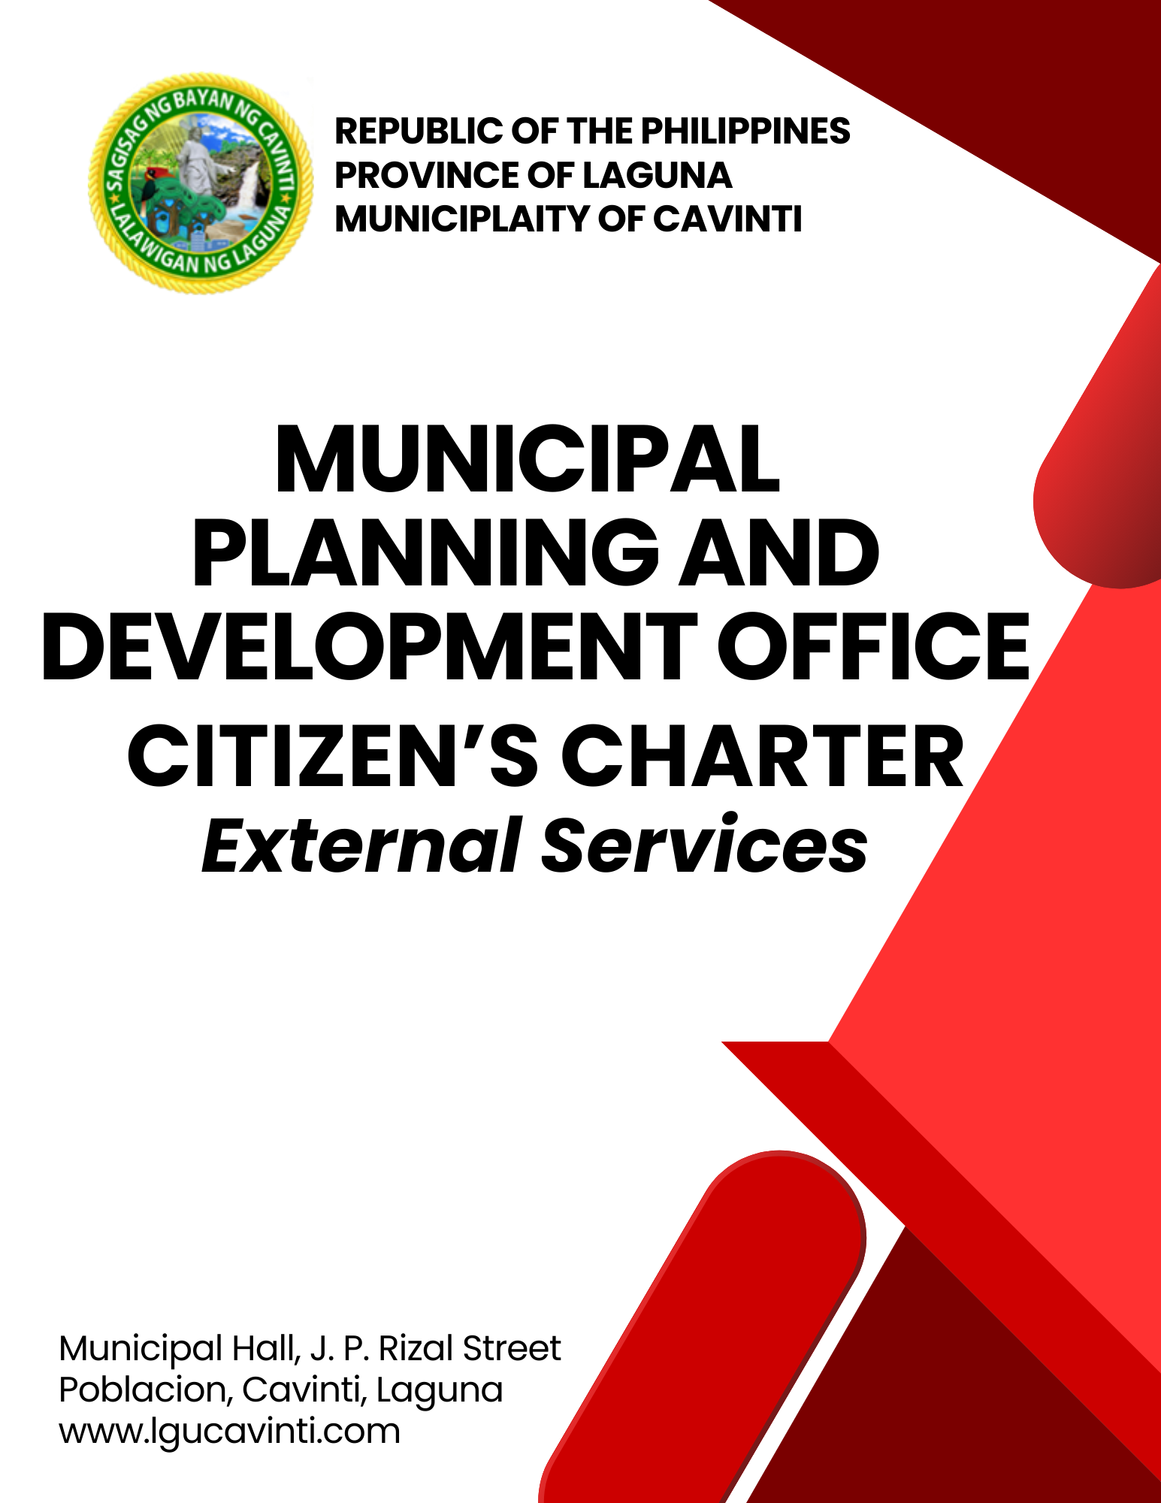  - Over Php 2 million | Php 2,880.00 + (1/10 of 1% in excess of Php 2 M)
E. Commercial, Industrial and Agro-Industrial Project Cost of Which is:
PROJECT COST | FEES
- Below Php 100,000.00 | Php 1,440.00
- Over Php100,000.00 - Php 500,000.00 | Php 2,160.00
- Over Php 500,000.00 | Php 2,880.00
- Over Php 1 million - Php 2 million | Php 4,320.00
- Over Php 2 million | Php 7,200.00 + (1/10 of 1% in excess of Php 2 M)
F. Special Uses/Special Projects (Gasoline Station, Cell Sites, Slaughter House,
Treatment Plants, etc.)
- Below Php 2 million | Php 7,200.00
- Over Php 2 million | Php 7,200.00 + (1/10 of 1% in excess of Php 2 M)
G. Alteration/expansion (affected area/const only)
Same as the original application
2. SUBDIVISION AND CONDOMINIUM PROJECTS (under P.D. 957)
- SUBDIVISION PROJECTS
- Approval of Subdivision Plans, including townhouses
- Preliminary Approval and Location Clearance (PALC)/Preliminary Subdivision Development Plan (PSDP)
- Processing Fee | Php 360.00 per hectare or a fraction thereof
- Inspection Fee | Php 1,500 per hectare regardless of density
- Final Approval and Development Permit
- Processing Fee | Php 2,800.00 per hectare regardless of density
- Additional Fee on Floor Area of housing component | Php 3.00 per square meter
- Inspection fee | Php 1,500 per hectare regardless of density
- Alteration of Plan (affected area only) | Same as final Approval and Development
- Certificate of Registration
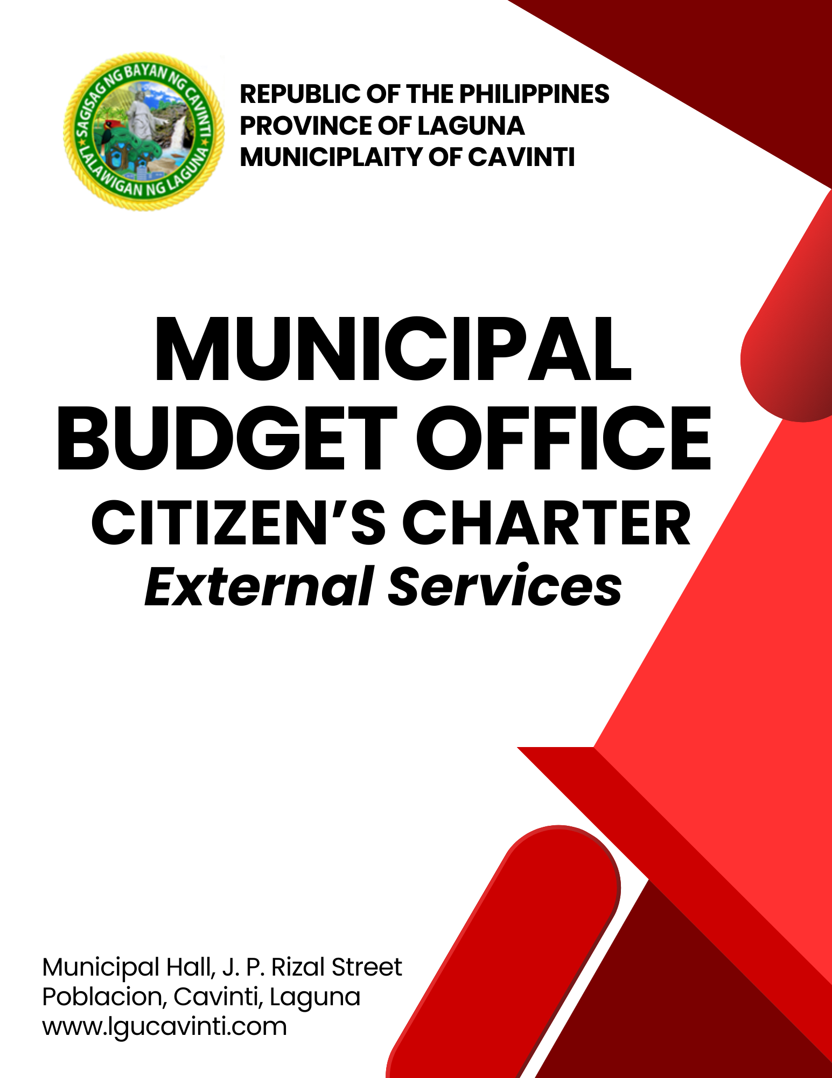  - Processing Fee | Php 2,880.00
- License to Sell
- Processing Fee | Php 216 per saleable lot
- Additional Fee for floor and housing component | Php14.4 per square meter
- Inspection fee | Php 1,500 per hectare regardless of density
- Certificate of Completion
- Certificate Fee | Php 216.00
  - Processing Fee
- Inspection fee | Php 1,500 per hectare regardless of density
- Extension of Time to Develop
- Certificate Fee | Php 504.00
- Additional Fee (unfinished area | Php 14.40 per square meter
- for development) | Php 1,500 per hectare regardless of density
- CONDOMINIUM PROJECT
- Approval of Condominium Plans
Final Approval and Development Permit
- Preliminary Approval and Locational Clearance
- Final Approval/Development Permit
- Processing Fee | Php 720.00
- Land Area | Php 7.20 per square meter
- No. of floors | Php 288 per floor
- Building Areas | Php 23.05 per square meter of the general floor area
- Inspection fee | Php 1,500 per hectare regardless of density
- Alteration of Plan (affected areas only) | Same as final approval and Development Permit
- Conversion (affected areas only) | Same as final approval and Development Permit
- Certificate of Registration Processing Fee
- Processing Fee | Php 2,880.00
- License to Sell
- Residential | Php 17.30 per square meter of saleable area
- Commercial | Php 36.00 per square meter of saleable area
- Inspection Fee | Php 1,500 per hectare
- Extension of Time to Develop
- Processing Fee | Php 504.00
- Additional Fee (unfinished area for  - development | Php 17.30 per square meter
- Inspection Fee | Php 1,500 per floor
- Certificate of Completion
- Certificate Fee | Php 216.00
  - Processing Fee
- Inspection Fee | Php 1,500 per floor
3. FARMLOT SUBDIVISION
- SUBDIVISION PROJECTS
- Approval of Farm lot subdivision
- Preliminary Approval and Location Clearance
- Processing Fee | Php 288.00 per hectare
- Inspection Fee | Php 1,500 per hectare
- Final Approval and Development Permit
- Processing Fee | Php 1,440 per hectare
- Inspection Fee | Php 1,500 per hectare
- Alteration of Plan (affected area only) | Same as final Approval and Development
- Certificate of Registration
- Processing Fee | Php 2,880.00
- License to Sell
- Processing Fee | Php 720 per lot
- Inspection Fee | Php 1,500 per hectare
- Certificate of Completion
- Certificate Fee | Php 216.00
  - Processing Fee
- Inspection Fee | Php 1,500 per hectare regardless of density
- Extension of Time to Develop
- Processing Fee | Php 504.00
- Additional Fee (unfinished area for development | Php 14.40 sqm
- Inspection Fee | Php 1,500 per hectare regardless of density
LIST OF OFFICES

OFFICE | ADDRESS | CONTACT INFORMATION
Office of the Mayor (OM) | 2nd Floor, Municipal Hall,  J. P. Rizal Street, Poblacion, Cavinti, Laguna | email: omcavinti@gmail.com  telephone no.: (049) 523-0012
Office of the Sangguniang Bayan (SB) | 2nd Floor, SB Hall, M. H. Del Pilar Street, Poblacion, Cavinti, Laguna | email: sbcavinti@gmail.com  telephone no.: (049) 523-4357
Office of the Municipal Administrator (OMAD) | 2nd Floor, Municipal Hall,  J. P. Rizal Street, Poblacion, Cavinti, Laguna | email: omadrecordslgucavinti@gmail.com  telephone no.: (049) 521-0147
Human Resource Management Office (HRMO) | 2nd Floor, Municipal Hall,  J. P. Rizal Street, Poblacion, Cavinti, Laguna | email: hrmocavintilaguna@gmail.com  telephone no.: (049) 523-1761
Municipal Budget Office (MBO) | 2nd Floor, Municipal Hall,  J. P. Rizal Street, Poblacion, Cavinti, Laguna | email: mbocavinti1071@gmail.com  telephone no.: (049) 523-1765
Office of the Municipal Accountant (OMACC) | 2nd Floor, Municipal Hall,  J. P. Rizal Street, Poblacion, Cavinti, Laguna | email: cavinti.omacc@gmail.com  telephone no.: (049) 503-7580
Municipal Civil Registrar Office (MCRO) | Municipal Hall, J. P. Rizal Street, Poblacion, Cavinti, Laguna | email: lcro_cavinti@gmail.com  telephone no.: (049) 523-1034
Office of the Municipal Treasurer | Municipal Hall, J. P. Rizal Street, Poblacion, Cavinti, Laguna | email: mtocavinti4013@gmail.com  telephone no.: (049) 502-4201
Municipal Planning and Development Office (MPDO) | 2nd Floor, Municipal Hall,  J. P. Rizal Street, Poblacion, Cavinti, Laguna | email: cavintimpdo@gmail.com  telephone no.: (049) 523-0366
Office of the Municipal Engineer (OME) | 2nd Floor, Municipal Hall,  J. P. Rizal Street, Poblacion, Cavinti, Laguna | email: ome.cavinti@gmail.com  telephone no.: (049) 521-8936
Municipal Disaster Risks Reduction and Management Office (MDRRMO) | National Highway, Barangay Poblacion, Cavinti, Laguna | email: mdrrmocavinti2022@gmail.com  Hotline Number: 0962-843-0781  Radio Frequency: 146.260
Office of the Municipal Social Welfare and Development (MSWDO) | Municipal Hall, J. P. Rizal Street, Poblacion, Cavinti, Laguna | email: omswdocavinti@yahoo.ocm  cavintisocialwelfare@gmail.com  telephone no.: (049) 523-0990
Municipal Environment and Natural Resources Office (MENRO) | Municipal Hall, J. P. Rizal Street, Poblacion, Cavinti, Laguna | email: menrocavinti@gmail.com  telephone no.: (049) 523-0967
Office of the Municipal Assessor (OMASS) | Municipal Hall, J. P. Rizal Street, Poblacion, Cavinti, Laguna | email: cavintiassessor@gmail.com  telephone no.: (049) 523-1023
Office of the Municipal Agriculture (OMAG) | SB Hall, M. H. Del Pilar Street, Poblacion, Cavinti, Laguna | email: maocavinti@gmail.com  telephone no.: (049) 544-2618
Cavinti Water Office (CWO) | 2nd Floor, Municipal Hall,  J. P. Rizal Street, Poblacion, Cavinti, Laguna | email: cavintiwater@gmail.com  telephone no.: (049) 523-0859
Cavinti Culture, History, Arts, Trade and Tourism Office (CCHATTO) | Ecopark, Barangay Tibatib, Cavinti, Laguna | email: tourismcavintilaguna@gmail.com  telephone no.: (049) 540-3924
Office of the Municipal Health Officer (OMHE) | Barangay Anglas, Cavinti, Laguna | email: cavintirhu@yahoo.com  telephone no.: (049) 523-0148
General Service Office (GSO) | Municipal Hall, J. P. Rizal Street, Poblacion, Cavinti, Laguna | email: gso.lgucavinti@gmail.com  telephone no.: (049) 523-1042
Public Employment Service Office (PESO) | Municipal Hall, J. P. Rizal Street, Poblacion, Cavinti, Laguna | email: @gmail.com  telephone no.: (049) 523-
Municipality of Cavinti | Municipal Hall, J. P. Rizal Street, Poblacion, Cavinti, Laguna | cavintimunicipalgovernment@gmail.com

FEEDBACK AND COMPLAINTS MECHANISMS
How to send feedback? | Answer the client feedback form and drop it at the designated drop boxes across the vicinity of the Municipal Building or you may contact us through the following to send in any suggestions, compliments and/or complaints.  cavintimunicipalgovernment@gmail.com Telephone No. 523-0129 local 100
How feedback is processed? | Every last working day of the week, the assigned personnel will open the drop box and compiles and records all the feedback submitted.  Feedbacks requiring answers will be forwarded to the relevant offices and they will be required to provide an answer within three (3) days upon receipt of the feedback.  The response will then be forwarded/relayed to the citizen if applicable.
How to file a complaint? | Answer the client complaint form and drop it at the designated drop boxes across the vicinity of the Municipal Building.  Make sure to provide the following information:  - Name of person being complained  - Incident  - Evidence
How complaints are processed? | The responsible/assigned personnel will open the complaint drop box on a daily basis and evaluate each complaint.  After thorough review of the complaint, an investigation will commence and require the personnel concerned for their explanation.  A report containing all the details of the incident and the findings shall be submitted to the head of agency for appropriate action.  Afterwards, feedback will be given to the client (complainant).
Contact Information of ARTA | email address: info@arta.gov.ph  contact nos.  PLDT - 1-ARTA (12782)  Smart  0920-925-3078  0998-856-8338

