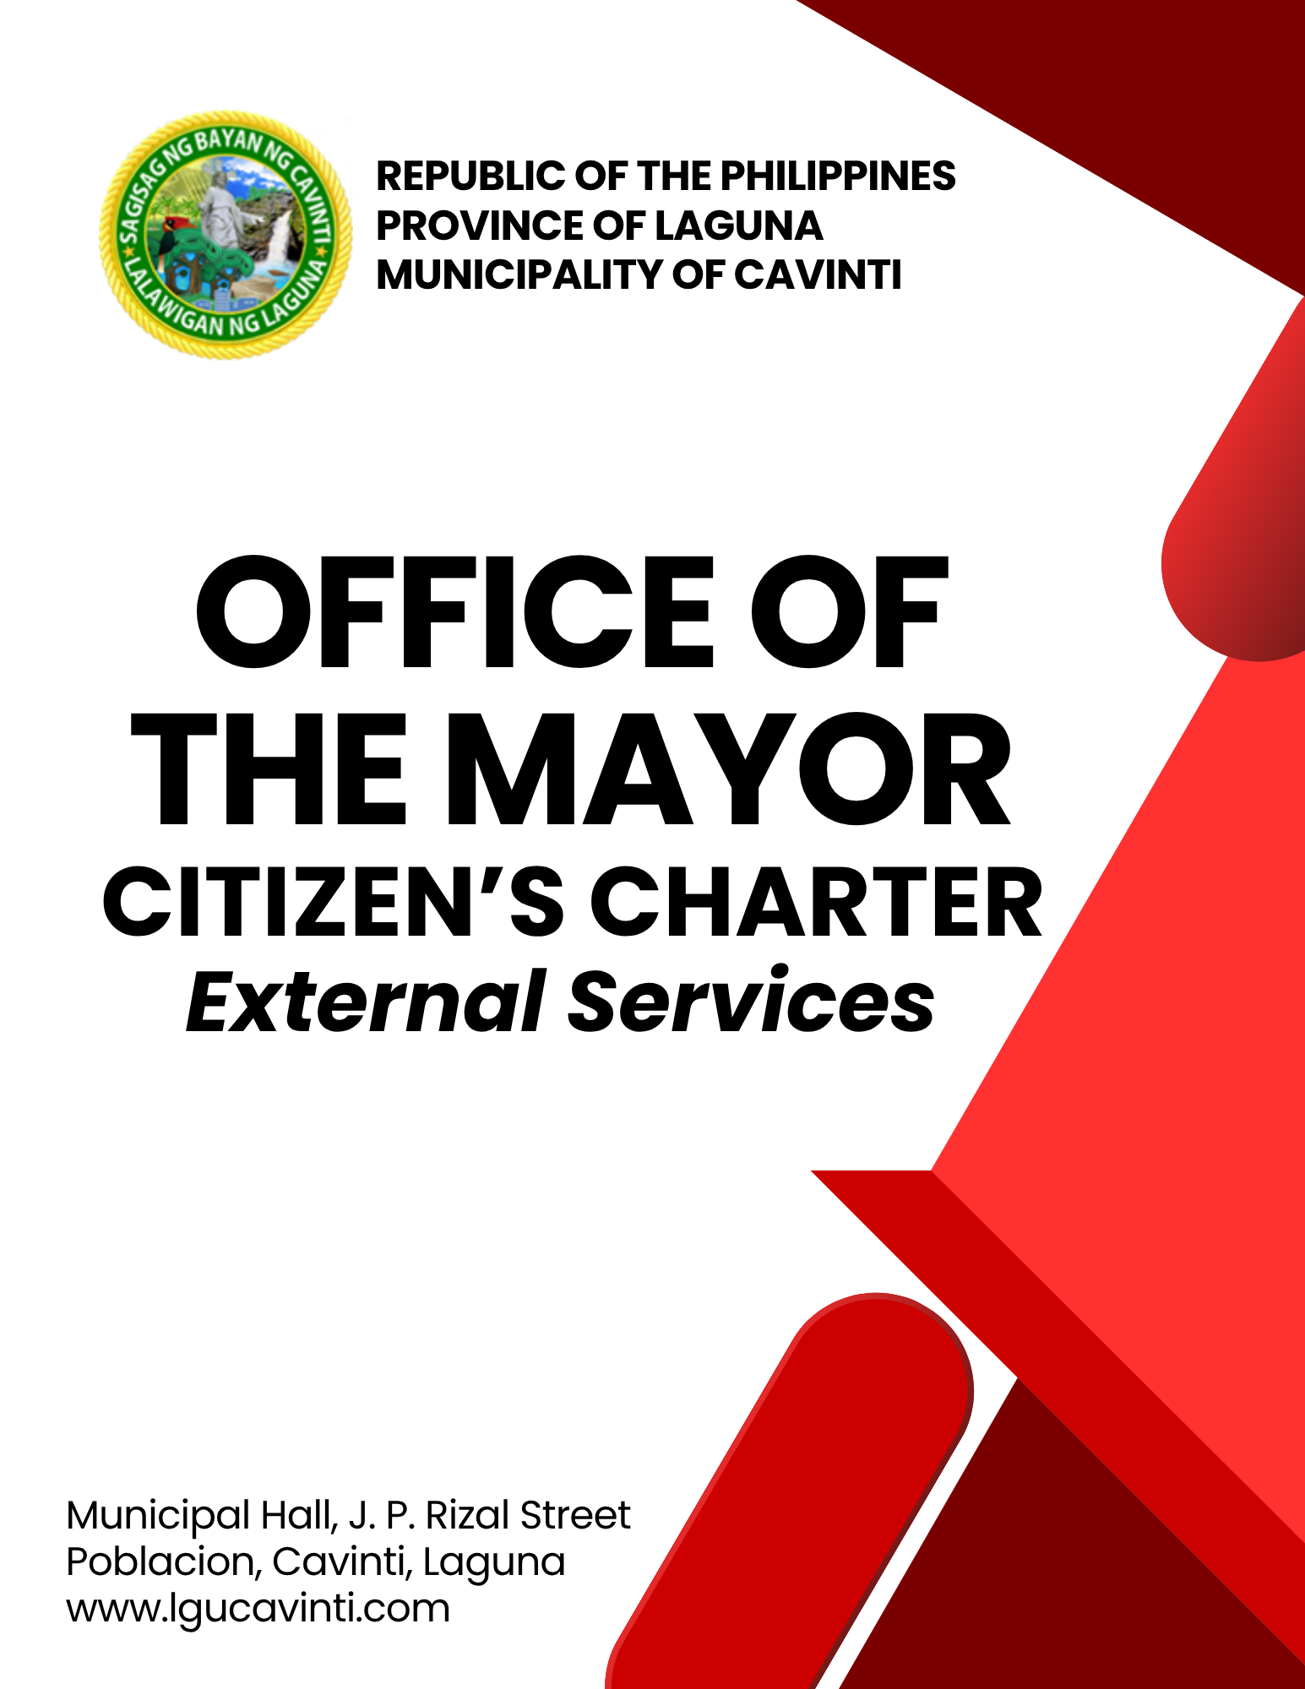

Office of the Mayor

External Services

- Issuance of Mayor's Clearance

The Mayor's Clearance is often used as a primary requirement for job applications. It is proof that the individual named therein is a true resident of the area or town and possesses good moral character within the jurisdiction of the Municipal Mayor who signed it.

Office or Division: | Office of the Mayor
Classification: | Simple
Type of Transaction: | G2C - Government to Citizen
Who may Avail: | Non-Government Personnel
CHECKLIST OF REQUIREMENTS |  | WHERE TO SECURE
- Official Receipt for payment of Clearance Fee (1 photocopy) |  | Office of the Municipal Treasurer
- Identification Card of Client (1 photocopy) |  | Client
- Request Form (1 of copy) |  | Office of the Mayor
CLIENT STEPS | AGENCY ACTIONS | FEES TO BE PAID | PROCESSING TIME | PERSON RESPONSIBLE
- Fill out the Request Form and present the requirements. | - Accept and verify the information in the submitted form and the Identification Card. | None | 2 minutes | Clerk  Office of the Mayor
- Fill out the Request Form and present the requirements. | - Advise the client to pay the appropriate fee. | None | 1 minute | Clerk  Office of the Mayor
- Pay the appropriate fee to Window 1 of the Office of the Municipal Treasurer. | - Accept payment and issue the official receipt. | ₱150.00 | 5 minutes | Cashier  Office of the Municipal Treasurer
- Submit a photocopy of the official receipt and a valid Identification Card. | - Receive and verify the submitted requirements. | None | 1 minute | Clerk  Office of the Mayor
 | - Prepare the Mayor's Clearance. | None | 3 minutes | Clerk  Office of the Mayor
 | - Advise the client to affix the signature and thumb mark in the Mayor's Clearance. | None | 1 minutes | Clerk  Office of the Mayor
 | - Forward the Mayor's Clearance to the Executive Secretary for review and endorsement to the Municipal Mayor. | None | 3 minutes | Clerk  Office of the Mayor
 | - Approve and sign the requested Mayor’s Clearance. | None | 1 minute | Municipal Mayor  Office of the Mayor
- Received the approved and signed Mayor's Clearance. | - Release the clearance to the client. | None | 1 minute | Clerk  Office of the Mayor
 | TOTAL: | Php 150.00 | 18 minutes
END OF TRANSACTION

- Application and Conduct of Civil Marriage Ceremony

Civil Marriage Ceremony is a legally recognized, government-officiated wedding ceremony that requires a marriage license from a Local Civil Registry Office

Office or Division: | Office of the Mayor
Classification: | Simple
Type of Transaction: | G2C - Government to Citizen
Who may Avail: | Individuals applying for a civil wedding
CHECKLIST OF REQUIREMENTS |  | WHERE TO SECURE
- Certificate of No Marriage (1 original copy) |  | Municipal Registrar's Office
- Wedding Rings (2 pieces for a couple) |  | Client
- All other needed documents (At least 1 copy each) |  | Municipal Registrar's Office
CLIENT STEPS | AGENCY ACTIONS | FEES TO BE PAID | PROCESSING TIME | PERSON RESPONSIBLE
- Inquire about the requirements and available schedule for the wedding. | - Check the Wedding Logbook and Mayor's Schedule on the proposed date. | None | 2 minutes | Clerk  Office of the Mayor
 | - Advise the client to complete the requirements before the wedding date. | None | 3 minutes | Clerk  Office of the Mayor
- Confirm the wedding schedule. | - Inform the client about the confirmed schedule or reschedule due to the conflicting schedule of the officiating person. | None | 2 minutes | Clerk  Office of the Mayor
 | - Inform the Registry Office about the final schedule of the wedding. | None | 3 minutes | Clerk  Office of the Mayor
- Personal appearance on the Wedding Day. | - Check the requirements before the ceremony. | None | 5 minutes | Clerk  Office of the Mayor
- Personal appearance on the Wedding Day. | - Prepare the venue. | None | 5 minutes | Clerk  Office of the Mayor
- Personal appearance on the Wedding Day. | - Officiate the civil wedding ceremony. | None | 30 minutes | Municipal Mayor  Office of the Mayor
- Personal appearance on the Wedding Day. | - Assist the Officiating Officer and witnesses to sign the Marriage Contract. | None | 10 minutes | Clerk  Office of the Mayor
 | TOTAL: | None | 1 hour
END OF TRANSACTION

- Request / Application of Assistance to Individual in Crisis Situation (AICS) / Social Case Study Report

Assistance to Individual in Crisis Situation (AICS) is one of the regular programs of the DSWD that provides food, transportation, medical, burial, education or financial assistance and other support services to individuals or families in need.

Office or Division: | Office of the Mayor
Classification: | Simple
Type of Transaction: | G2C - Government to Citizen
Who may Avail: | Non-Government Personnel
CHECKLIST OF REQUIREMENTS |  | WHERE TO SECURE
For Medical & Hospital Bill Assistance
- Medical Certificate (2 photocopies) |  | Client / Patient
- Medicine Prescription/Final Hospital Bill/ Laboratory Request/Price Quotation/Medical Abstract  (2 photocopies) |  | Client / Patient
- Barangay Certificate of Indigency  (2 photocopies) |  | Client / Patient
- Medical Certificate (2 photocopies) |  | Client / Patient
For Burial Assistance
- Death Certificate of the Deceased with Registry Number  (2 photocopies) |  | Client
- Funeral Contract stating the amount of the remaining balance  (2 photocopies) |  | Client
- Barangay Certificate of Indigency  (2 photocopies) |  | Client
- Photocopy of Client's ID  (2 photocopies) |  | Client
CLIENT STEPS | AGENCY ACTIONS | FEES TO BE PAID | PROCESSING TIME | PERSON RESPONSIBLE
- Present the needed requirements. | - Verify the authenticity of the requirements by checking the registry number, signatures, and date, etc. | None | 2 minutes | Clerk  Office of the Mayor
- Present the needed requirements. | - If the presented requirements are all original copies, advise the client to photocopy the requirements. | None | 5 minutes | Clerk  Office of the Mayor
- Report to the Office of the Municipal Social Welfare and Development for endorsement. | - Endorse the client to the Office of the Municipal Social Welfare and Development for a general intake interview and processing of the assistance. | None | 5 minutes | Clerk  Office of the Municipal Social Welfare and Development
 | - Encode the Request Letter and other documents which must be presented and checked by the client. | None | 2 minutes | Clerk  Office of the Municipal Social Welfare and Development
 | - The Request Letter and Certificate of Indigency must the sign by the client, Social Welfare Aide and the MSWD Officer. | None | 1 minute | Clerk  Office of the Municipal Social Welfare and Development
 | - Attach the Request Letter and Certificate of Indigency with the AICS requirements to be signed and approved by the Municipal Mayor. | None | 5 minutes | Clerk  Office of the Municipal Social Welfare and Development
- Receive the financial assistance. | - Release the financial assistance and/or the Social Case Study Report. | None | 5 minutes | Clerk  Office of the Mayor  or  Clerk  Office of the Municipal Social Welfare and Development
 | TOTAL: | None | 25 minutes
END OF TRANSACTION

- Coordination to Other Offices RE: Different Programs and Transactions

Linking information with other offices for clearer planning and implementation of Local Government programs.

Office or Division: | Office of the Mayor
Classification: | Simple
Type of Transaction: | G2C - Government to Citizen
Who may Avail: | Government Personnel/Non-Government Personnel
CHECKLIST OF REQUIREMENTS |  | WHERE TO SECURE
- Approved Request Letters (1 original copy) |  | Client
- All other possible documents (1 original copy) |  | Client
CLIENT STEPS | AGENCY ACTIONS | FEES TO BE PAID | PROCESSING TIME | PERSON RESPONSIBLE
- Submit the approved request letters, communication letters, or direct orders from the Municipal Mayor. | - Forward and coordinate to the right and concerned agency, office, or person about the content of the approved request letters or communication letters. | None | 5 minutes | Executive Secretary  Office of the Mayor  or  Clerk  Office of the Mayor
 | - Relay the feedback to the requestee, Head of Office, or the Municipal Mayor. | None | 5 minutes | Executive Secretary  Office of the Mayor  or  Clerk  Office of the Mayor
 | TOTAL: | None | 10 minutes
END OF TRANSACTION

LIST OF OFFICES

OFFICE | ADDRESS | CONTACT INFORMATION
Office of the Mayor (OM) | 2nd Floor, Municipal Hall,  J. P. Rizal Street, Poblacion, Cavinti, Laguna | email: omcavinti@gmail.com  telephone no.: (049) 523-0012
Office of the Sangguniang Bayan (SB) | 2nd Floor, SB Hall, M. H. Del Pilar Street, Poblacion, Cavinti, Laguna | email: sbcavinti@gmail.com  telephone no.: (049) 523-4357
Office of the Municipal Administrator (OMAD) | 2nd Floor, Municipal Hall,  J. P. Rizal Street, Poblacion, Cavinti, Laguna | email: omadrecordslgucavinti@gmail.com  telephone no.: (049) 521-0147
Human Resource Management Office (HRMO) | 2nd Floor, Municipal Hall,  J. P. Rizal Street, Poblacion, Cavinti, Laguna | email: hrmocavintilaguna@gmail.com  telephone no.: (049) 523-1761
Municipal Budget Office (MBO) | 2nd Floor, Municipal Hall,  J. P. Rizal Street, Poblacion, Cavinti, Laguna | email: mbocavinti1071@gmail.com  telephone no.: (049) 523-1765
Office of the Municipal Accountant (OMACC) | 2nd Floor, Municipal Hall,  J. P. Rizal Street, Poblacion, Cavinti, Laguna | email: cavinti.omacc@gmail.com  telephone no.: (049) 503-7580
Municipal Civil Registrar Office (MCRO) | Municipal Hall, J. P. Rizal Street, Poblacion, Cavinti, Laguna | email: lcro_cavinti@gmail.com  telephone no.: (049) 523-1034
Office of the Municipal Treasurer | Municipal Hall, J. P. Rizal Street, Poblacion, Cavinti, Laguna | email: mtocavinti4013@gmail.com  telephone no.: (049) 502-4201
Municipal Planning and Development Office (MPDO) | 2nd Floor, Municipal Hall,  J. P. Rizal Street, Poblacion, Cavinti, Laguna | email: cavintimpdo@gmail.com  telephone no.: (049) 523-0366
Office of the Municipal Engineer (OME) | 2nd Floor, Municipal Hall,  J. P. Rizal Street, Poblacion, Cavinti, Laguna | email: ome.cavinti@gmail.com  telephone no.: (049) 521-8936
Municipal Disaster Risks Reduction and Management Office (MDRRMO) | National Highway, Barangay Poblacion, Cavinti, Laguna | email: mdrrmocavinti2022@gmail.com  Hotline Number: 0962-843-0781  Radio Frequency: 146.260
Office of the Municipal Social Welfare and Development (MSWDO) | Municipal Hall, J. P. Rizal Street, Poblacion, Cavinti, Laguna | email: omswdocavinti@yahoo.ocm  cavintisocialwelfare@gmail.com  telephone no.: (049) 523-0990
Municipal Environment and Natural Resources Office (MENRO) | Municipal Hall, J. P. Rizal Street, Poblacion, Cavinti, Laguna | email: menrocavinti@gmail.com  telephone no.: (049) 523-0967
Office of the Municipal Assessor (OMASS) | Municipal Hall, J. P. Rizal Street, Poblacion, Cavinti, Laguna | email: cavintiassessor@gmail.com  telephone no.: (049) 523-1023
Office of the Municipal Agriculture (OMAG) | SB Hall, M. H. Del Pilar Street, Poblacion, Cavinti, Laguna | email: maocavinti@gmail.com  telephone no.: (049) 544-2618
Cavinti Water Office (CWO) | 2nd Floor, Municipal Hall,  J. P. Rizal Street, Poblacion, Cavinti, Laguna | email: cavintiwater@gmail.com  telephone no.: (049) 523-0859
Cavinti Culture, History, Arts, Trade and Tourism Office (CCHATTO) | Ecopark, Barangay Tibatib, Cavinti, Laguna | email: tourismcavintilaguna@gmail.com  telephone no.: (049) 540-3924
Office of the Municipal Health Officer (OMHE) | Barangay Anglas, Cavinti, Laguna | email: cavintirhu@yahoo.com  telephone no.: (049) 523-0148
General Service Office (GSO) | Municipal Hall, J. P. Rizal Street, Poblacion, Cavinti, Laguna | email: gso.lgucavinti@gmail.com  telephone no.: (049) 523-1042
Public Employment Service Office (PESO) | Municipal Hall, J. P. Rizal Street, Poblacion, Cavinti, Laguna | email: @gmail.com  telephone no.: (049) 523-
Municipality of Cavinti | Municipal Hall, J. P. Rizal Street, Poblacion, Cavinti, Laguna | cavintimunicipalgovernment@gmail.com

FEEDBACK AND COMPLAINTS MECHANISMS
How to send feedback? | Answer the client feedback form and drop it at the designated drop boxes across the vicinity of the Municipal Building or you may contact us through the following to send in any suggestions, compliments and/or complaints.  cavintimunicipalgovernment@gmail.com Telephone No. 523-0129 local 100
How feedback is processed? | Every last working day of the week, the assigned personnel will open the drop box and compiles and records all the feedback submitted.  Feedbacks requiring answers will be forwarded to the relevant offices and they will be required to provide an answer within three (3) days upon receipt of the feedback.  The response will then be forwarded/relayed to the citizen if applicable.
How to file a complaint? | Answer the client complaint form and drop it at the designated drop boxes across the vicinity of the Municipal Building.  Make sure to provide the following information:  - Name of person being complained  - Incident  - Evidence
How complaints are processed? | The responsible/assigned personnel will open the complaint drop box on a daily basis and evaluate each complaint.  After thorough review of the complaint, an investigation will commence and require the personnel concerned for their explanation.  A report containing all the details of the incident and the findings shall be submitted to the head of agency for appropriate action.  Afterwards, feedback will be given to the client (complainant).
Contact Information of ARTA | email address: info@arta.gov.ph  contact nos.  PLDT - 1-ARTA (12782)  Smart  0920-925-3078  0998-856-8338

