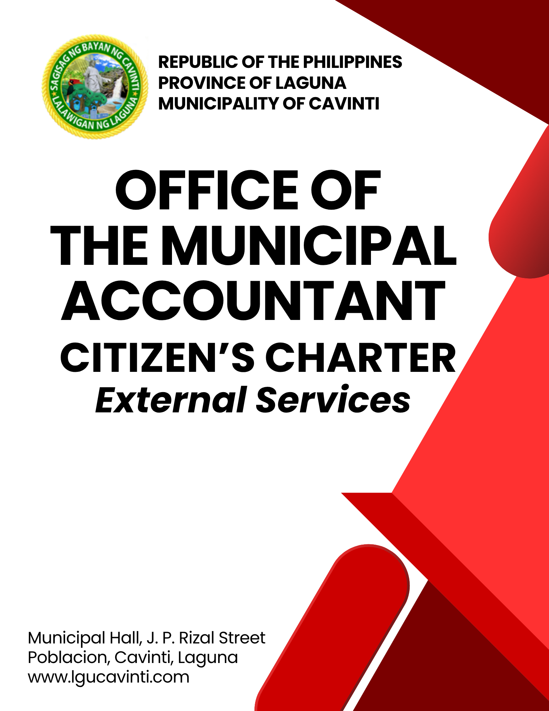

Office of the Municipal Accountant

External Services

- Procurement of Goods, Consultancy and Infrastructure Projects (Regardless of Mode of Procurement)

Procurement involves the process of acquiring goods, infrastructure, or consultancy services needed by the government. This includes competitive bidding, negotiated procurement, shopping, or other modes as provided under the procurement law (Republic Act 9184).

Office: | Office of the Municipal Accountant
Classification: | Simple
Type of Transaction: | G2B - Government to Business
Who may avail: | All Suppliers and Contractors/Bids and Awards Committee/Municipal General Services Office
CHECKLIST OF REQUIREMENTS |  | WHERE TO SECURE
- Disbursement Voucher (4 original copies) |  | Bids and Awards Office / Office of the Municipal Engineer
- Auditorial and Legal Review Checklist (2 original copies) |  | Bids and Awards Office
- Provincial Treasurer’s Office Certification for Sand and Gravel Fee (if necessary) (2 original copies) |  | Office of the Municipal Engineer
- Notice to Proceed (4 original copies) |  | Bids and Awards Office
- Statement of Work (4 original copies)  Accomplished/Accomplishment Report (4 original copies) |  | Office of the Municipal Engineer
- Certificate of Award (4 original copies) |  | Bids and Awards Office
- Inspection and Acceptance Report  (4 original copies) |  | Office of the Municipal Engineer
- Such other document peculiar to the contract and/ or to the mode of procurement and considered necessary in the auditorial review and in the technical evaluation  (2 original copies) |  | Bids and Awards Office/  Office of the Municipal Engineer
- Other requirements in compliance with Republic Act 9184 and Commission on Audit Circular No. 2012-001 (2 original copies) |  | Bids and Awards Office/  Office of the Municipal Engineer
- Obligation Request and Status (ORS) (4 original copies) |  | Office of the Municipal Budget
CLIENT STEPS | AGENCY ACTION | FEES TO BE PAID | PROCESSING TIME | PERSON RESPONSIBLE
- Submit the Disbursement Voucher and supporting documents. | - Receive and log the Disbursement Voucher together with the supporting documents. | None | 2 minutes | Accounting Clerk/Staff  Office of the Municipal Accountant
- Submit the Disbursement Voucher and supporting documents. | - Review the completeness of the submitted Disbursement Voucher and supporting documents. | None | 20 minutes | Accounting Clerk/Staff  Office of the Municipal Accountant
- Submit the Disbursement Voucher and supporting documents. | - Conduct final review, approval, and signing of the Disbursement Voucher. | None | 10 minutes | Municipal Accountant  Office of the Municipal Accountant
- Submit the Disbursement Voucher and supporting documents. | - Release the approved Disbursement Voucher to Office of Municipal Treasurer. | None | 2 minutes | Accounting Clerk/Staff  Office of the Municipal Accountant
TOTAL: |  | None | 34 minutes
END OF TRANSACTION

- Processing of Financial Assistance Voucher

This service provides financial assistance to eligible beneficiaries (individuals or families) based on approved requests under medical, educational, livelihood, or emergency categories.

Office: | Office of the Municipal Accountant
Classification: | Simple
Type of Transaction: | G2C - Government to Citizen
Who may avail: | All
CHECKLIST OF REQUIREMENTS |  | WHERE TO SECURE
- Disbursement Voucher (4 original copies) |  | Municipal Social Welfare and Development Office
- Case Study Report (2 original copies) |  | Municipal Social Welfare and Development Office
- Certificate of Indigency/Barangay Certificate (2 original copies) |  | Barangay
- Municipal Local Government Operations Officer Certificate - for Barangay Captains (2 original copies) |  | Municipal Local Government Operations Officer
- Medical Certificate - for confinement  (2 original copies) |  | From hospital/doctor
- Death Certificate - for burial assistance (2 original copies) |  | Office of the Civil Registrar
- Senior Citizen’s ID - for Senior Companion Program (2 original copies) |  | Municipal Social Welfare and Development Office
- Others (i.e. Doctor’s prescription)  (2 original copies) |  | Various regulating bodies
- Obligation Request and Statues (ORS) (2 original copies) |  | Office of the Municipal Budget
CLIENT STEPS | AGENCY ACTION | FEES TO BE PAID | PROCESSING TIME | PERSON RESPONSIBLE
- Submit the Disbursement Voucher and supporting documents. | - Receive and log the Disbursement Voucher together with the supporting documents. | None | 2 minutes | Accounting Clerk/Staff  Office of the Municipal Accountant
- Submit the Disbursement Voucher and supporting documents. | - Review the completeness of the submitted Disbursement Voucher and supporting documents. | None | 20 minutes | Accounting Clerk/Staff  Office of the Municipal Accountant
- Submit the Disbursement Voucher and supporting documents. | - Conduct final review, approval, and signing of the Disbursement Voucher. | None | 10 minutes | Municipal Accountant  Office of the Municipal Accountant
- Submit the Disbursement Voucher and supporting documents. | - Release the approved Disbursement Voucher to Office of Municipal Treasurer. | None | 2 minutes | Accounting Clerk/Staff  Office of the Municipal Accountant
TOTAL: |  | None | 34 minutes
END OF TRANSACTION

- Processing of other Miscellaneous Disbursement

This service covers the processing of payments for miscellaneous expenses.

Office: | Office of the Municipal Accountant
Classification: | Simple
Type of Transaction: | G2B - Government to Business
Who may avail: | All Suppliers and Contractors/Bids and Awards Committee/Municipal General Services Office.
CHECKLIST OF REQUIREMENTS |  | WHERE TO SECURE
- Disbursement Voucher (4 original copies) |  | Bids and Awards Office/  Municipal General Services Office
- Purchase Request (PR) (4 original copies) |  | Originating Department
- Request of Quotation (RFQ) (4 original copies) |  | Bids and Awards Office/  Municipal General Services Office
- Abstract of Quotation (4 original copies) |  | Bids and Awards Office/  Municipal General Services Office
- Certificate of Award (4 original copies) |  | Bids and Awards Office/  Municipal General Services Office
- Purchase Order (PO) (4 original copies) |  | Bids and Awards Office/  Municipal General Services Office
- Inspection and Acceptance Report  (4 original copies) |  | Bids and Awards Office/  Municipal General Services Office
- Such other document peculiar to the contract and/ or to the mode of procurement and considered necessary in the auditorial review and in the technical evaluation (2 original copies) |  | Bids and Awards Office/  Municipal General Services Office
- Other requirements in compliance with Republic Act 9184 and Commission on Audit Circular No. 2012-001 (2 original copies) |  | Bids and Awards Office/  Municipal General Services Office
- Obligation Request and Status (ORS)  (2 original copies) |  | Office of the Municipal Budget
CLIENT STEPS | AGENCY ACTION | FEES TO BE PAID | PROCESSING TIME | PERSON RESPONSIBLE
- Submit the Disbursement Voucher and supporting documents. | - Receive and log the Disbursement Voucher together with the supporting documents. | None | 2 minutes | Accounting Clerk/Staff  Office of the Municipal Accountant
- Submit the Disbursement Voucher and supporting documents. | - Review the completeness of the submitted Disbursement Voucher and supporting documents. | None | 20 minutes | Accounting Clerk/Staff  Office of the Municipal Accountant
- Submit the Disbursement Voucher and supporting documents. | - Conduct final review, approval, and signing of the Disbursement Voucher. | None | 10 minutes | Municipal Accountant  Office of the Municipal Accountant
- Submit the Disbursement Voucher and supporting documents. | - Release the approved Disbursement Voucher to Office of Municipal Treasurer. | None | 2 minutes | Accounting Clerk/Staff  Office of the Municipal Accountant
TOTAL: |  | None | 34 minutes
END OF TRANSACTION

- Accountant’s Advice for Check Issued

The Accountant’s Advice is issued to the Authorized Government Depository Bank as proof that all checks issued are complete with documentary requirements.

Office: | Office of the Municipal Accountant
Classification: | Simple
Type of Transaction: | G2C - Government to Citizen
Who may avail: | Government and Private Clients
CHECKLIST OF REQUIREMENTS |  | WHERE TO SECURE
- Approved Disbursement Voucher  (1 original copy) |  | Office of the Mayor
- Signed Check by Municipal Treasurer and the Mayor (1 original copy) |  | Office of the Municipal Treasurer and Office of the Mayor
CLIENT STEPS | AGENCY ACTION | FEES TO BE PAID | PROCESSING TIME | PERSON RESPONSIBLE
- Submit the Approved Disbursement Voucher with signed check. | - Receive and verify the name of Payee in the Disbursement Voucher with the name in the check. | None | 2 minutes | Accounting Clerk/Staff  Office of the Municipal Accountant
 | - Encode all check issue by the Office of Municipal Treasury to the Check Disbursement Journal (CDJ) | None | 5 minutes | Accounting Clerk/Staff  Office of the Municipal Accountant
 | - Prepare the Journal Entry Voucher. | None | 2 minutes | Accounting Clerk/Staff  Office of the Municipal Accountant
 | - Prepare the Advice of Checks Issued and assign number by using ACICDES version 2.1 and upload to WeAccess. When WeAccess is down, prepare manual copy of Accountant’s advice for check issued. | None | 5 minutes | Accounting Clerk/Staff  Office of the Municipal Accountant
 | - Review the accuracy of entry in the Accountant’s Advice and Approve the uploaded Checks Issued using WeAccess or sign the manual copy if WeAccess is down. | None | 5 minutes | Municipal Accountant  Office of the Municipal Accountant
 | - If WeAccess is down, deliver the Accountant’s Advice to Authorized Government. | None | 30 minutes | Accounting Clerk/Staff  Office of the Municipal Accountant
TOTAL: |  | None | 49 minutes
END OF TRANSACTION

- Certificate of Creditable Tax Withheld (BIR Tax Form 2307)

Certificate of Creditable Tax Withheld at Source, is a document issued by government agency to a payee (supplier, contractor, or professional) to certify the amount of income and tax withheld during a specific period.

Office: | Office of the Municipal Accountant
Classification: | Simple
Type of Transaction: | G2C - Government to Citizen
Who may avail: | Government and Private Clients
CHECKLIST OF REQUIREMENTS |  | WHERE TO SECURE
- Official Receipt or Certificate of Registration (1 original copy) |  | Requesting Office
CLIENT STEPS | AGENCY ACTION | FEES TO BE PAID | PROCESSING TIME | PERSON RESPONSIBLE
- Request for Bureau of Internal Revenue (BIR) Tax Withheld Certificate. | - Check the payment history and withholding details. | None | 2 minutes | Accounting Clerk/Staff  Office of the Municipal Accountant
 | - Encode the details of payments and tax withheld. | None | 5 minutes | Accounting Clerk/Staff  Office of the Municipal Accountant
 | - Review and sign the Certificate of Creditable Tax Withheld (BIR Tax Form 2307). | None | 5 minutes | Municipal Accountant  Office of the Municipal Accountant
 | - Release the signed Certificate of Creditable Tax Withheld (BIR Tax Form 2307). | None | 2 minutes | Accounting Clerk/Staff  Office of the Municipal Accountant
TOTAL: |  | None | 14 minutes
END OF TRANSACTION
- Receipts of Barangay Accounts and Reports

This service handles the official receiving and logging of barangay financial reports and supporting documents submitted on a periodic basis for compliance with government accounting and audit regulations.

Office: | Office of the Municipal Accountant
Classification: | Simple
Type of Transaction: | G2G - Government to Government
Who may avail: | All
CHECKLIST OF REQUIREMENTS |  | WHERE TO SECURE
- Disbursement Voucher and supporting documents different Barangay Treasurers (2 original copies) |  | Barangay Treasurer
- Official Receipt (Accountable Form No. 51) (2 original copies) |  | Barangay Treasurer
- Community Tax Certificate (CTC)  (2 copies) |  | Barangay Treasurer
- Monthly Reports (2 original copies) |  | Requesting Party
CLIENT STEPS | AGENCY ACTION | FEES TO BE PAID | PROCESSING TIME | PERSON RESPONSIBLE
- Submit the Disbursement Vouchers, Official Receipts (Ors), and Community Tax Certificate (CTC) monthly reports and other supporting documents. | For Disbursement Vouchers:  - Ensure the existence of the Punong Barangay Certification, Transmittal Letter, Supporting Documents and Schedule of Summary of Check issued | None | 30 minutes | Accounting Clerk/Staff  Office of the Municipal Accountant
 | For Community Tax Certificate (CTC):  - Check the existence of the Series of CTC Number, Official Receipt of remittance to MTO and Summary of Collection and Remittances | None | 30 minutes | Accounting Clerk/Staff  Office of the Municipal Accountant
 | For Accountable Form (AF) No. 51:  - Check the existence of the Series of AF 51 number, Deposit Slip and Summary of Collection and Deposits | None | 15 minutes | Accounting Clerk/Staff  Office of the Municipal Accountant
 | - Prepare the Journal Entry Voucher (JEV). | None | 1 hour | Accounting Clerk/Staff  Office of the Municipal Accountant
 | - Prepare the Bank Reconciliation. | None | 15 minutes | Accounting Clerk/Staff  Office of the Municipal Accountant
 | - Sign the transmittal letter. | None | 2 minutes | Municipal Accountant  Office of the Municipal Accountant
 | - Release the copy of transmittal letter to the barangay treasurer. | None | 2 minutes | Accounting Clerk/Staff  Office of the Municipal Accountant
TOTAL: |  | None | 2 hours and 19 minutes
END OF TRANSACTION

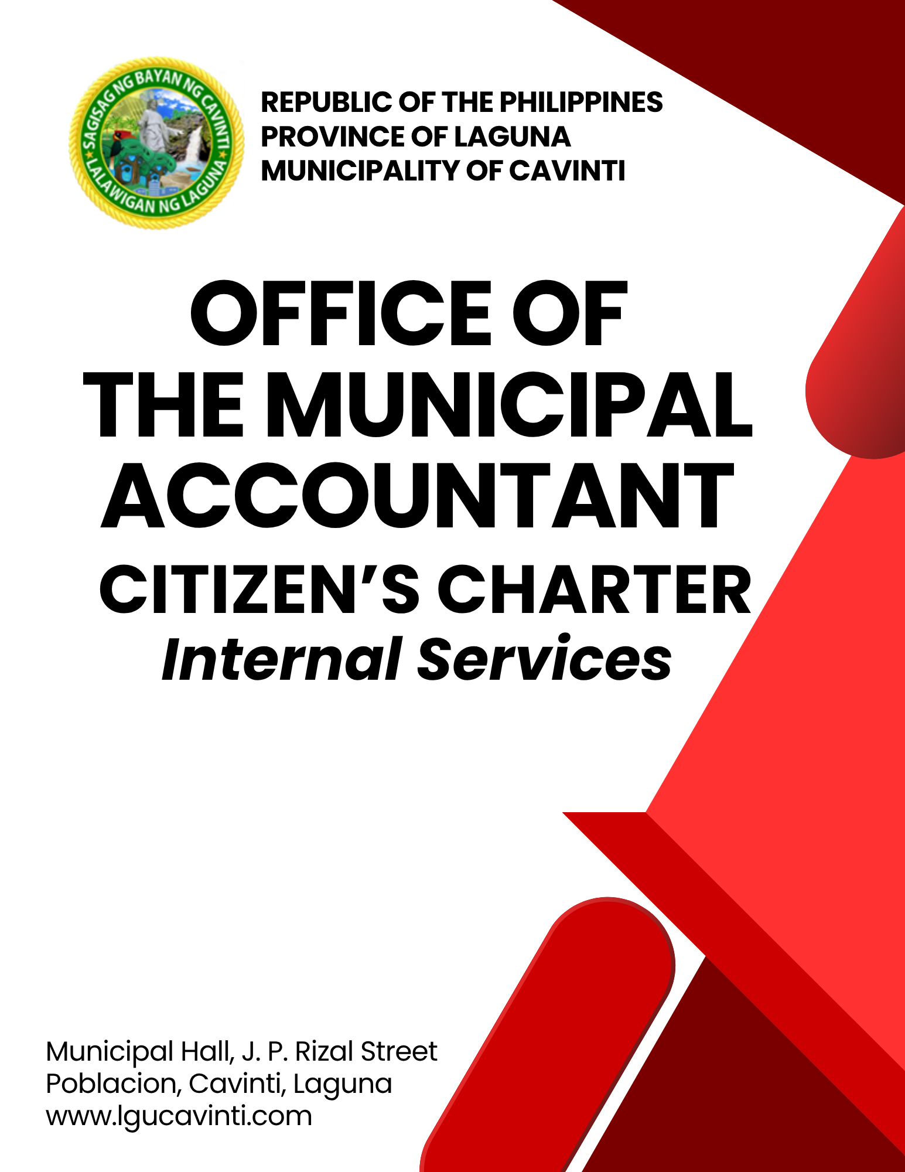

Office of the Municipal Accountant

Internal Services
- Processing of Cash Advances for Travel

This service processes the cash advance for travel and/or training.

Office: |  | Office of the Municipal Accountant
Classification: |  | Simple
Type of Transaction: |  | G2G - Government to Government
Who may avail: |  | All Municipal Officials and Employees
CHECKLIST OF REQUIREMENTS |  |  | WHERE TO SECURE
Disbursement Voucher (4 original copies) |  |  | Originating Department
- Travel Order (4 original copies) |  |  | Originating Department
- Itinerary of Travel (2 original copies) |  |  | Originating Department
- Letter of Invitation from the sponsoring agency (2 original copies) |  |  | Originating Department
- Project Proposal Design (for group travels) (2 original copies) |  |  | Originating Department
- Obligation Request and Status (4 original copies) |  |  | Office of the Municipal Budget
CLIENT STEPS | AGENCY ACTION |  | FEES TO BE PAID | PROCESSING TIME | PERSON RESPONSIBLE
Submit the Disbursement Voucher and other supporting documents. | - Receive and record the Disbursement Voucher together with the supporting documents from the requesting person. |  | None | 2 minutes | Accounting Clerk/Staff  Office of the Municipal Accountant
 | - Verify and issue certification whether the claimant has any outstanding cash advances. |  | None | 2 minutes | Municipal Accountant  Office of the Municipal Accountant
 | - Conduct a comprehensive review on the validity and completeness of the Disbursement Voucher and other supporting documents. |  | None | 5 minutes | Accounting Clerk/Staff  Office of the Municipal Accountant
 | - Conduct final review, approval, and signing of the Disbursement Voucher. |  | None | 8 minutes | Municipal Accountant  Office of the Municipal Accountant
 | - Release the approved Disbursement Voucher. |  | None | 2 minutes | Accounting Clerk/Staff  Office of the Municipal Accountant
TOTAL: |  |  | None | 19 minutes
END OF TRANSACTION

- Processing of Salaries/Payroll

Payrolls covering Personnel Services, Disbursement voucher/s and Maintenance and Other Operating Expenses (MOOE) (regular plantilla, salaries and other benefits; contract of service, consultant, job order) as remuneration for services rendered.

Office: | Office of the Municipal Accountant
Classification: | Simple
Type of Transaction: | G2G - Government to Government
Who may avail: | All Municipal Officials and Employees
CHECKLIST OF REQUIREMENTS |  | WHERE TO SECURE
Daily Time Record (DTR) (2 original copies) |  | Originating Department
- Accomplishment Report (for Job Orders/Contract of Service) (2 original copies) |  | Owner
- Appointment Paper (for Job Orders/Contract of Service) (2 original copies) |  | Human Resources and Management Office
- Employee’s Payrolls (2 original copies) |  | Office of the Municipal Accountant
- Copy of Circular/Issuance (for other benefits) (2 original copies) |  | Human Resources and Management Unit
- Project Proposal/Design/Program of Works (2 original copies) |  | Respective Departments
- Labor Payrolls (2 original copies) |  | Respective Departments
- Picture of the Project or Accomplishment (2 original copies) |  | Respective Departments
- Obligation Request and Status (ORS) (4 original copies) |  | Office of the Municipal Budget
CLIENT STEPS | AGENCY ACTION | FEES TO BE PAID | PROCESSING TIME | PERSON RESPONSIBLE
- Employee’s Payroll.
- Submit the documents marked. | - Receive and review all the documents marked for checking. | None | 30 minutes | Accounting Clerk/Staff  Office of the Municipal Accountant
- Submit the documents marked. | - Review the prepared payroll against the registry of obligation for personnel services. | None | 15 minutes | Accounting Clerk/Staff  Office of the Municipal Accountant
- Submit the documents marked. | - Sign the printed payroll. | None | 2 minutes | Municipal Accountant  Office of the Municipal Accountant
- Submit the documents marked. | - Forward the payroll and supporting documents to the Budget Office. | None | 2 minutes | Accounting Clerk/Staff  Office of the Municipal Accountant
- Receive payroll and supporting documents. | - Receive and log the Disbursement Voucher together with supporting documents and forward to the Journal Entry Voucher Preparer. | None | 2 minutes | Accounting Clerk/Staff  Office of the Municipal Accountant
- Receive payroll and supporting documents. | - Prepare the Journal Entry Voucher. | None | 2 minutes | Accounting Clerk/Staff  Office of the Municipal Accountant
- Receive payroll and supporting documents. | - Conduct final review and approval of the Journal Entry Voucher. | None | 6 minutes | Municipal Accountant  Office of the Municipal Accountant
- Receive payroll and supporting documents. | - File the Disbursement Voucher and Journal Entry Voucher. | None | 2 minutes | Accounting Clerk/Staff  Office of the Municipal Accountant
TOTAL: |  | None | 1 hour, 1 minute

- Labor Payroll.
- Receive the payroll and supporting documents. | - Receive and log the Disbursement Voucher together with supporting documents and forward to the Journal Entry Voucher Preparer. | None | 2 minutes | Accounting Clerk  Office of the Municipal Accountant
- Receive the payroll and supporting documents. | - Prepare the Journal Entry Voucher. | None | 2 minutes | Accounting Clerk  Office of the Municipal Accountant
- Receive the payroll and supporting documents. | - Conduct final review and approval of the Journal Entry Voucher. | None | 6 minutes | Municipal Accountant  Office of the Municipal Accountant
- Receive the payroll and supporting documents. | - File the Disbursement Voucher and Journal Entry Voucher. | None | 2 minutes | Accounting Clerk/Staff  Office of the Municipal Accountant
TOTAL: |  | None | 12 minutes
END OF TRANSACTION

- Issuance of Government Service Insurance System (GSIS), Home Development Mutual Fund (HDMF) and Philippine Health Insurance Corporation (PHIC) Remittance Statement Certificate/Loan Remittance

Upon request of the employee, the Office of the Municipal Accountant will release the Government Service Insurance System (GSIS), Home Development Mutual Fund (HDMF) and Philippine Health Insurance Corporation (PHIC) Remittance Statement Certificate/Loan Remittance.

Office: | Office of the Municipal Accountant
Classification: | Simple
Type of Transaction: | G2G - Government to Government
Who may avail: | All
CHECKLIST OF REQUIREMENTS |  | WHERE TO SECURE
- GSIS Disbursement Voucher  (1 original copy) |  | Human Resources and Management Office
- Supporting documents employees/official details (1 copy) |  | Human Resources and Management Office
- Payroll summary (1 original copy) |  | Human Resources and Management Office
CLIENT STEPS | AGENCY ACTION | FEES TO BE PAID | PROCESSING TIME | PERSON RESPONSIBLE
- Request of issuance of GSIS, HDMF and PHIC Remittance Statement Certificate/Loan Remittance. | - Log the name of requestor and purpose. | None | 2 minutes | Accounting Clerk/Staff  Office of the Municipal Accountant
 | - Prepare GSIS, HDMF and PHIC Remittance Statement Certificate/Loan Remittance as per request. | None | 20 minutes | Accounting Clerk/Staff  Office of the Municipal Accountant
 | - Review and sign the Remittance Statement Certificate/  Loan Remittances | None | 5 minutes | Municipal Accountant  Office of the Municipal Accountant
 | Release the signed Remittance Statement Certificate/  Loan Remittance. | None | 2 minutes | Accounting Clerk/Staff  Office of the Municipal Accountant
TOTAL: |  | None | 29 Minutes
END OF TRANSACTION

- Pre Audit Disbursement Voucher

To check the completeness of documents attached to Disbursement Voucher & Payrolls.

Office: | Office of the Municipal Accountant
Classification: | Simple
Type of Transaction: | G2G - Government to Government
Who may avail: | Employees
CHECKLIST OF REQUIREMENTS |  | WHERE TO SECURE
Obligation Request (4 original copies) |  | Requesting Office
- Disbursement Voucher (4 original copies) |  | Requesting Office
- Purchase Order (4 original copies) |  | Requesting Office
- Purchase Request (4 original copies) |  | Requesting Office
- Request for Quotation (RFQ) (4 original copies) |  | Requesting Office
- Inspection Report (4 original copies) |  | Requesting Office
- Payrolls (2 original copies) |  | Requesting Office
- Daily Time Record (DTR) (2 original copies) |  | Requesting Office
CLIENT STEPS | AGENCY ACTION | FEES TO BE PAID | PROCESSING TIME | PERSON RESPONSIBLE
- Receive Disbursement Vouchers/Payrolls from Requesting Office. | - Receive the Voucher from Requesting Office. | None | 2 minutes | Accounting Clerk/Staff  Office of the Municipal Accountant
 | - Conduct pre-audit on the completeness of Disbursement Vouchers/  Payroll. | None | 3 minutes | Municipal Accountant  Office of the Municipal Accountant
 | - Review/sign all the completed Disbursement Vouchers/  Payrolls. | None | 2 minutes | Municipal Accountant  Office of the Municipal Accountant
 | - Release all the completed and duly signed Disbursement Vouchers & Payrolls to the Office of the Municipal Mayor for approval. | None | 2 minutes | Accounting Clerk/Staff  Office of the Municipal Accountant
TOTAL: |  | None | 9 minutes
END OF TRANSACTION
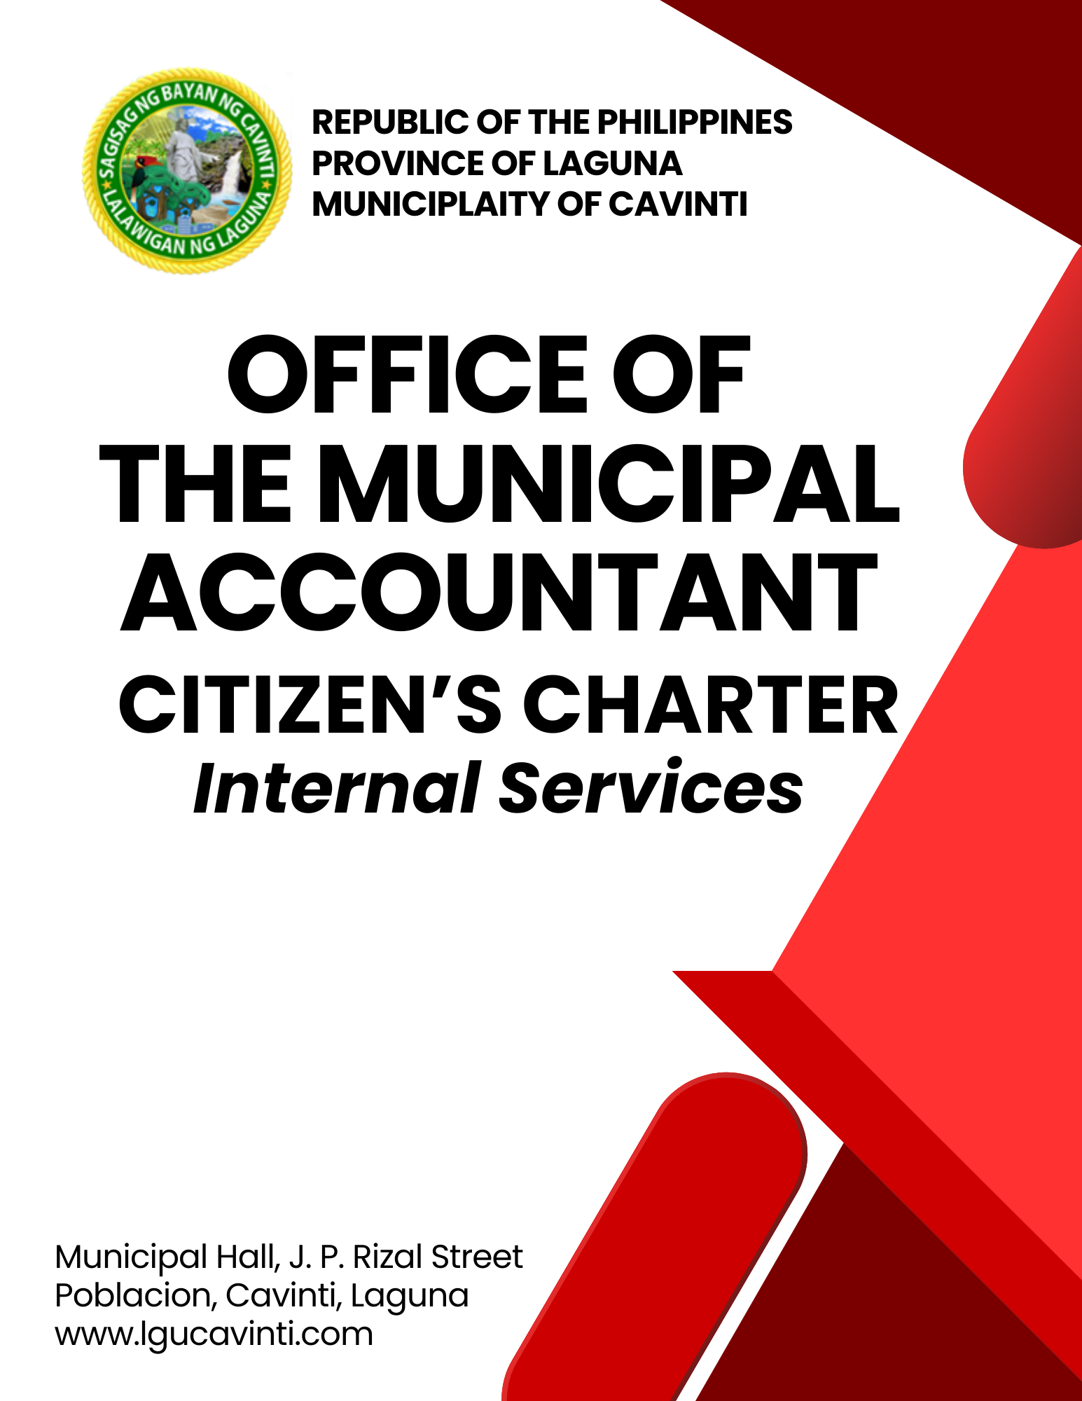

LIST OF OFFICES

OFFICE | ADDRESS | CONTACT INFORMATION
Office of the Mayor (OM) | 2nd Floor, Municipal Hall,  J. P. Rizal Street, Poblacion, Cavinti, Laguna | email: omcavinti@gmail.com  telephone no.: (049) 523-0012
Office of the Sangguniang Bayan (SB) | 2nd Floor, SB Hall, M. H. Del Pilar Street, Poblacion, Cavinti, Laguna | email: sbcavinti@gmail.com  telephone no.: (049) 523-4357
Office of the Municipal Administrator (OMAD) | 2nd Floor, Municipal Hall,  J. P. Rizal Street, Poblacion, Cavinti, Laguna | email: omadrecordslgucavinti@gmail.com  telephone no.: (049) 521-0147
Human Resource Management Office (HRMO) | 2nd Floor, Municipal Hall,  J. P. Rizal Street, Poblacion, Cavinti, Laguna | email: hrmocavintilaguna@gmail.com  telephone no.: (049) 523-1761
Municipal Budget Office (MBO) | 2nd Floor, Municipal Hall,  J. P. Rizal Street, Poblacion, Cavinti, Laguna | email: mbocavinti1071@gmail.com  telephone no.: (049) 523-1765
Office of the Municipal Accountant (OMACC) | 2nd Floor, Municipal Hall,  J. P. Rizal Street, Poblacion, Cavinti, Laguna | email: cavinti.omacc@gmail.com  telephone no.: (049) 503-7580
Municipal Civil Registrar Office (MCRO) | Municipal Hall, J. P. Rizal Street, Poblacion, Cavinti, Laguna | email: lcro_cavinti@gmail.com  telephone no.: (049) 523-1034
Office of the Municipal Treasurer | Municipal Hall, J. P. Rizal Street, Poblacion, Cavinti, Laguna | email: mtocavinti4013@gmail.com  telephone no.: (049) 502-4201
Municipal Planning and Development Office (MPDO) | 2nd Floor, Municipal Hall,  J. P. Rizal Street, Poblacion, Cavinti, Laguna | email: cavintimpdo@gmail.com  telephone no.: (049) 523-0366
Office of the Municipal Engineer (OME) | 2nd Floor, Municipal Hall,  J. P. Rizal Street, Poblacion, Cavinti, Laguna | email: ome.cavinti@gmail.com  telephone no.: (049) 521-8936
Municipal Disaster Risks Reduction and Management Office (MDRRMO) | National Highway, Barangay Poblacion, Cavinti, Laguna | email: mdrrmocavinti2022@gmail.com  Hotline Number: 0962-843-0781  Radio Frequency: 146.260
Office of the Municipal Social Welfare and Development (MSWDO) | Municipal Hall, J. P. Rizal Street, Poblacion, Cavinti, Laguna | email: omswdocavinti@yahoo.ocm  cavintisocialwelfare@gmail.com  telephone no.: (049) 523-0990
Municipal Environment and Natural Resources Office (MENRO) | Municipal Hall, J. P. Rizal Street, Poblacion, Cavinti, Laguna | email: menrocavinti@gmail.com  telephone no.: (049) 523-0967
Office of the Municipal Assessor (OMASS) | Municipal Hall, J. P. Rizal Street, Poblacion, Cavinti, Laguna | email: cavintiassessor@gmail.com  telephone no.: (049) 523-1023
Office of the Municipal Agriculture (OMAG) | SB Hall, M. H. Del Pilar Street, Poblacion, Cavinti, Laguna | email: maocavinti@gmail.com  telephone no.: (049) 544-2618
Cavinti Water Office (CWO) | 2nd Floor, Municipal Hall,  J. P. Rizal Street, Poblacion, Cavinti, Laguna | email: cavintiwater@gmail.com  telephone no.: (049) 523-0859
Cavinti Culture, History, Arts, Trade and Tourism Office (CCHATTO) | Ecopark, Barangay Tibatib, Cavinti, Laguna | email: tourismcavintilaguna@gmail.com  telephone no.: (049) 540-3924
Office of the Municipal Health Officer (OMHE) | Barangay Anglas, Cavinti, Laguna | email: cavintirhu@yahoo.com  telephone no.: (049) 523-0148
General Service Office (GSO) | Municipal Hall, J. P. Rizal Street, Poblacion, Cavinti, Laguna | email: gso.lgucavinti@gmail.com  telephone no.: (049) 523-1042
Public Employment Service Office (PESO) | Municipal Hall, J. P. Rizal Street, Poblacion, Cavinti, Laguna | email: @gmail.com  telephone no.: (049) 523-
Municipality of Cavinti | Municipal Hall, J. P. Rizal Street, Poblacion, Cavinti, Laguna | cavintimunicipalgovernment@gmail.com

FEEDBACK AND COMPLAINTS MECHANISMS
How to send feedback? | Answer the client feedback form and drop it at the designated drop boxes across the vicinity of the Municipal Building or you may contact us through the following to send in any suggestions, compliments and/or complaints.  cavintimunicipalgovernment@gmail.com Telephone No. 523-0129 local 100
How feedback is processed? | Every last working day of the week, the assigned personnel will open the drop box and compiles and records all the feedback submitted.  Feedbacks requiring answers will be forwarded to the relevant offices and they will be required to provide an answer within three (3) days upon receipt of the feedback.  The response will then be forwarded/relayed to the citizen if applicable.
How to file a complaint? | Answer the client complaint form and drop it at the designated drop boxes across the vicinity of the Municipal Building.  Make sure to provide the following information:  - Name of person being complained  - Incident  - Evidence
How complaints are processed? | The responsible/assigned personnel will open the complaint drop box on a daily basis and evaluate each complaint.  After thorough review of the complaint, an investigation will commence and require the personnel concerned for their explanation.  A report containing all the details of the incident and the findings shall be submitted to the head of agency for appropriate action.  Afterwards, feedback will be given to the client (complainant).
Contact Information of ARTA | email address: info@arta.gov.ph  contact nos.  PLDT - 1-ARTA (12782)  Smart  0920-925-3078  0998-856-8338

