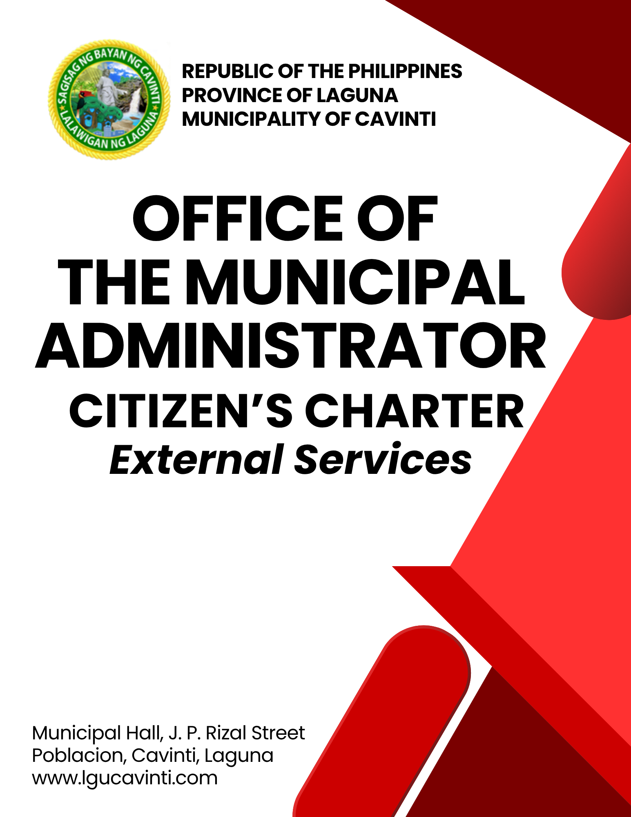

Office of the Municipal Administrator

External Services

- Issuance of Endorsement/ Recommendation

Recommendation/Endorsement is given to individuals and organizations to support their intentions for a purpose.

Office or Division: | Office of the Municipal Administrator
Classification: | Simple
Type of Transaction: | G2C – Government to Citizen  G2G – Government to Government  G2B – Government to Business
Who may avail: | All individuals
CHECKLIST OF REQUIREMENTS |  | WHERE TO SECURE
- Request Letter (1 original copy) |  | Client
- Resume (1 original copy) |  | Client
- Valid Government Identification  (1 photocopy) |  | Client
CLIENT STEPS | AGENCY ACTIONS | FEES TO BE PAID | PROCESSING TIME | PERSON  RESPONSIBLE
- Submit all the necessary requirements. | - Evaluate and assess the submitted requirements. | None | 1 minute | Office of the Municipal Administrator Staff  Office of the Municipal Administrator
- Submit all the necessary requirements. | - Prepare the document. | None | 5 minutes | Office of the Municipal Administrator Staff  Office of the Municipal Administrator
- Submit all the necessary requirements. | - Forward the document to the Municipal Administrator-affixing of initials/record the document in the logbook. | None | 2 minutes | Office of the Municipal Administrator Staff  Office of the Municipal Administrator
- Submit all the necessary requirements. | - Forward the document at the Mayor’s Office for the approval of the Municipal Mayor. | None | 1 minute | Office of the Municipal Administrator Staff  Office of the Municipal Administrator
- Submit all the necessary requirements. | - Sign the endorsement/  recommendation | None | 1 day | Municipal Mayor  Office of the Municipal Mayor
- Receive the endorsement/  recommendation. | - Release the endorsement/  recommendation. | None | 2 minutes | Office of the Municipal Administrator Staff  Office of the Municipal Administrator
TOTAL: |  | None | 1 day, 11 minutes
END OF TRANSACTION

- Issuance of Permit Slip for the Utilization of LGU's Amenities (Municipal Covered Plaza and Cavinti Sports Complex)

This service allows individuals, groups, or organizations to formally apply for permission to use the Local Government Unit’s facilities. Once the application is reviewed and approved, a permit slip is issued to authorize the use of the facilities for the specified dates and purposes.

Office or Division: | Office of the Municipal Administrator
Classification: | Simple
Type of Transaction: | G2C – Government to Citizen  G2G – Government to Government  G2B – Government to Business
Who may avail: | All individuals and Public/Private Organizations and Agencies
CHECKLIST OF REQUIREMENTS |  | WHERE TO SECURE
- Letter of request duly approved by the Local Chief Executive to utilize the LGU's amenities for any upcoming events and activities (1 photocopy) |  | Office of the Mayor
- Filled-out reservation form  (1 original copy) |  | Office of the Municipal Administrator
- Payment Receipt (1 original copy) |  | Office of the Municipal Treasurer
CLIENT STEPS | AGENCY ACTIONS | FEES TO BE PAID | PROCESSING TIME | PERSON RESPONSIBLE
- Hand over the duly approved request letter to the receiving personnel in the Office of the Municipal Administrator Staff. | - Receive the approved request letter and hand over the reservation form to the client. | None | 2 minutes | Staff  Office of the Municipal Administrator
 | - Check and determine the availability of the venue on the date of the event specified in the request letter. | None | 3 minutes | Staff  Office of the Municipal Administrator
 | - Issue reservation form to the client. | None | 5 minutes | Staff  Office of the Municipal Administrator
- Fill out the reservation form. | - Advise the client to pay the amount to the Office of the Municipal Treasurer. | None | 5 minutes | Staff  Office of the Municipal Administrator
- Pay the corresponding fees in Window 1 of the Office of the Municipal Treasurer. | - Receive the payment and prepare the order of payment. Advise the client to claim the official receipt in Window 3. | Please see Table 1 below. | 5 minutes | Cashier  Office of the Municipal Treasurer
- Submit the order of payment and claim the official receipt in Window 3 of the Office of the Municipal Treasurer. | - Print and issue the official receipt of payment. | None | 5 minutes | Staff  Office of the Municipal Treasurer
- Present the receipt and submit the reservation form to the Admin Staff. | - Record on the reservation log book the details of the event and issue the permit slip for the requested amenity. | none | 5 minutes | Staff  Office of the Municipal Administrator
TOTAL: |  | Please see Table 1 below. | 30 minutes
END OF TRANSACTION

Table 1: Schedule of Fees for the Utilization of LGU’s Amenities

LGU Amenities | Daytime | Nighttime
Municipal Plaza | Php 750.00 | Php 1,500.00
Cavinti Sports Complex | Php 1,000.00 | Php 2,000.00

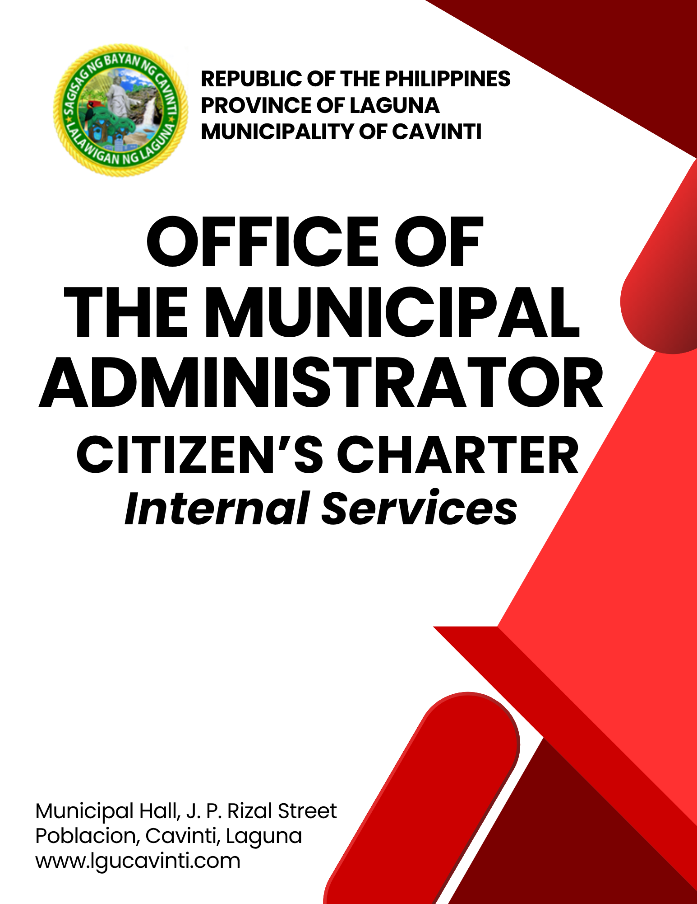

Office of the Municipal Administrator

Internal Services

- Approval of Leave Applications

The process allows employees to submit leave applications based on their specific needs. These applications are reviewed and, if deemed appropriate, approved by the designated authority (e.g., supervisor, Human Resource department). This service ensures proper documentation, tracking, and management of employee absences in line with organizational policies.

Office or Division: | Office of the Municipal Administrator
Classification: | Simple
Type of Transaction: | G2G – Government to Government
Who may avail: | Permanent Municipal Employees and Officials
CHECKLIST OF REQUIREMENTS |  | WHERE TO SECURE
- Leave Form (2 original copies) |  | Human Resource Management Office
CLIENT STEPS | AGENCY ACTIONS | FEES TO BE PAID | PROCESSING TIME | PERSON RESPONSIBLE
- Submit the filled-out Leave Form. | - Receive and review the documents. Forward to the Municipal Administrator for the signature. | None | 3 minutes | Office of the Municipal Administrator Staff  Admin’s Office
- Submit the filled-out Leave Form. | - Sign the leave form. | None | 2 minutes | Municipal Administrator  Office of the Municipal Administrator
- Receive the form and sign the logbook | - Record on the logbook and forward the leave applications to the Office of the Mayor for the Mayor’s signature. | None | 5 minutes | Office of the Municipal Administrator Staff Office of the Municipal Administrator
TOTAL: |  | None | 10 minutes
END OF TRANSACTION

- Approval of Travel Orders

This service facilitates the review and approval of travel orders for Local Government Unit (LGU) personnel who are required to travel for official business. It ensures that all travel requests are properly documented, justified, and compliant with government policies and budgetary guidelines.

Office or Division: | Office of the Municipal Administrator
Classification: | Simple
Type of Transaction: | G2G – Government to Government
Who may avail: | Municipal Employees and Officials
CHECKLIST OF REQUIREMENTS |  | WHERE TO SECURE
- Travel Order (3 original copies) |  | Office of the requestee
CLIENT STEPS | AGENCY ACTIONS | FEES TO BE PAID | PROCESSING TIME | PERSON RESPONSIBLE
- Submit the filled-out Travel Order. | - Receive and review the documents. | None | 2 minutes | Office of the Municipal Administrator Staff  Admin’s Office
- Submit the filled-out Travel Order. | - Put control number and forward to the Municipal Administrator for the signature. | None | 3 minutes | Office of the Municipal Administrator Staff  Admin’s Office
- Submit the filled-out Travel Order. | - Sign the Travel Order. | None | 2 minutes | Municipal Administrator  Office of the Municipal Administrator
- Receive the form and sign the logbook. | - Record on the logbook and forward the Travel Order to the Office of the Mayor for the Mayor’s signature. | None | 5 minutes | Office of the Municipal Administrator Staff Office of the Municipal Administrator
TOTAL: |  | None | 12 minutes
END OF TRANSACTION
- Vehicle Reservation

Vehicle reservation allows individuals or departments to request the use of government vehicles for official or authorized purposes. The reservation is processed based on availability and the intended use of the vehicle, with a permit issued once the request is approved.

Office or Division: | Office of the Municipal Administrator
Classification: | Simple
Type of Transaction: | G2C – Government to Citizen  G2G – Government to Government
Who may avail: | Government Personnel and Non-Governmental Organizations
CHECKLIST OF REQUIREMENTS |  | WHERE TO SECURE
- Travel Order (3 original copies) |  | Office of the requestee
- Pass Slip in case the travel is within the Municipality (2 original copies) |  | Office of the requestee
CLIENT STEPS | AGENCY ACTIONS | FEES TO BE PAID | PROCESSING  TIME | PERSON RESPONSIBLE
- Coordinate with the Admin’s Staff and hand over a copy of the travel order or pass slip. | - Check for the availability of the government vehicles. | None | 5 minutes | Office of the Municipal Administrator Staff  Office of the Municipal Administrator
 | - Record on to the reservation logbook the date of travel reflected in the Travel Order or Pass Slip. | None | 1 minute | Office of the Municipal Administrator Staff  Office of the Municipal Administrator
 | - Relay the schedule of travel to the respective drivers. | None | 2 minutes | Office of the Municipal Administrator Staff  Office of the Municipal Administrator
TOTAL: |  | None | 8 minutes
END OF TRANSACTION

LIST OF OFFICES

OFFICE | ADDRESS | CONTACT INFORMATION
Office of the Mayor (OM) | 2nd Floor, Municipal Hall,  J. P. Rizal Street, Poblacion, Cavinti, Laguna | email: omcavinti@gmail.com  telephone no.: (049) 523-0012
Office of the Sangguniang Bayan (SB) | 2nd Floor, SB Hall, M. H. Del Pilar Street, Poblacion, Cavinti, Laguna | email: sbcavinti@gmail.com  telephone no.: (049) 523-4357
Office of the Municipal Administrator (OMAD) | 2nd Floor, Municipal Hall,  J. P. Rizal Street, Poblacion, Cavinti, Laguna | email: omadrecordslgucavinti@gmail.com  telephone no.: (049) 521-0147
Human Resource Management Office (HRMO) | 2nd Floor, Municipal Hall,  J. P. Rizal Street, Poblacion, Cavinti, Laguna | email: hrmocavintilaguna@gmail.com  telephone no.: (049) 523-1761
Municipal Budget Office (MBO) | 2nd Floor, Municipal Hall,  J. P. Rizal Street, Poblacion, Cavinti, Laguna | email: mbocavinti1071@gmail.com  telephone no.: (049) 523-1765
Office of the Municipal Accountant (OMACC) | 2nd Floor, Municipal Hall,  J. P. Rizal Street, Poblacion, Cavinti, Laguna | email: cavinti.omacc@gmail.com  telephone no.: (049) 503-7580
Municipal Civil Registrar Office (MCRO) | Municipal Hall, J. P. Rizal Street, Poblacion, Cavinti, Laguna | email: lcro_cavinti@gmail.com  telephone no.: (049) 523-1034
Office of the Municipal Treasurer | Municipal Hall, J. P. Rizal Street, Poblacion, Cavinti, Laguna | email: mtocavinti4013@gmail.com  telephone no.: (049) 502-4201
Municipal Planning and Development Office (MPDO) | 2nd Floor, Municipal Hall,  J. P. Rizal Street, Poblacion, Cavinti, Laguna | email: cavintimpdo@gmail.com  telephone no.: (049) 523-0366
Office of the Municipal Engineer (OME) | 2nd Floor, Municipal Hall,  J. P. Rizal Street, Poblacion, Cavinti, Laguna | email: ome.cavinti@gmail.com  telephone no.: (049) 521-8936
Municipal Disaster Risks Reduction and Management Office (MDRRMO) | National Highway, Barangay Poblacion, Cavinti, Laguna | email: mdrrmocavinti2022@gmail.com  Hotline Number: 0962-843-0781  Radio Frequency: 146.260
Office of the Municipal Social Welfare and Development (MSWDO) | Municipal Hall, J. P. Rizal Street, Poblacion, Cavinti, Laguna | email: omswdocavinti@yahoo.ocm  cavintisocialwelfare@gmail.com  telephone no.: (049) 523-0990
Municipal Environment and Natural Resources Office (MENRO) | Municipal Hall, J. P. Rizal Street, Poblacion, Cavinti, Laguna | email: menrocavinti@gmail.com  telephone no.: (049) 523-0967
Office of the Municipal Assessor (OMASS) | Municipal Hall, J. P. Rizal Street, Poblacion, Cavinti, Laguna | email: cavintiassessor@gmail.com  telephone no.: (049) 523-1023
Office of the Municipal Agriculture (OMAG) | SB Hall, M. H. Del Pilar Street, Poblacion, Cavinti, Laguna | email: maocavinti@gmail.com  telephone no.: (049) 544-2618
Cavinti Water Office (CWO) | 2nd Floor, Municipal Hall,  J. P. Rizal Street, Poblacion, Cavinti, Laguna | email: cavintiwater@gmail.com  telephone no.: (049) 523-0859
Cavinti Culture, History, Arts, Trade and Tourism Office (CCHATTO) | Ecopark, Barangay Tibatib, Cavinti, Laguna | email: tourismcavintilaguna@gmail.com  telephone no.: (049) 540-3924
Office of the Municipal Health Officer (OMHE) | Barangay Anglas, Cavinti, Laguna | email: cavintirhu@yahoo.com  telephone no.: (049) 523-0148
General Service Office (GSO) | Municipal Hall, J. P. Rizal Street, Poblacion, Cavinti, Laguna | email: gso.lgucavinti@gmail.com  telephone no.: (049) 523-1042
Public Employment Service Office (PESO) | Municipal Hall, J. P. Rizal Street, Poblacion, Cavinti, Laguna | email: @gmail.com  telephone no.: (049) 523-
Municipality of Cavinti | Municipal Hall, J. P. Rizal Street, Poblacion, Cavinti, Laguna | cavintimunicipalgovernment@gmail.com

FEEDBACK AND COMPLAINTS MECHANISMS
How to send feedback? | Answer the client feedback form and drop it at the designated drop boxes across the vicinity of the Municipal Building or you may contact us through the following to send in any suggestions, compliments and/or complaints.  cavintimunicipalgovernment@gmail.com Telephone No. 523-0129 local 100
How feedback is processed? | Every last working day of the week, the assigned personnel will open the drop box and compiles and records all the feedback submitted.  Feedbacks requiring answers will be forwarded to the relevant offices and they will be required to provide an answer within three (3) days upon receipt of the feedback.  The response will then be forwarded/relayed to the citizen if applicable.
How to file a complaint? | Answer the client complaint form and drop it at the designated drop boxes across the vicinity of the Municipal Building.  Make sure to provide the following information:  - Name of person being complained  - Incident  - Evidence
How complaints are processed? | The responsible/assigned personnel will open the complaint drop box on a daily basis and evaluate each complaint.  After thorough review of the complaint, an investigation will commence and require the personnel concerned for their explanation.  A report containing all the details of the incident and the findings shall be submitted to the head of agency for appropriate action.  Afterwards, feedback will be given to the client (complainant).
Contact Information of ARTA | email address: info@arta.gov.ph  contact nos.  PLDT - 1-ARTA (12782)  Smart  0920-925-3078  0998-856-8338

