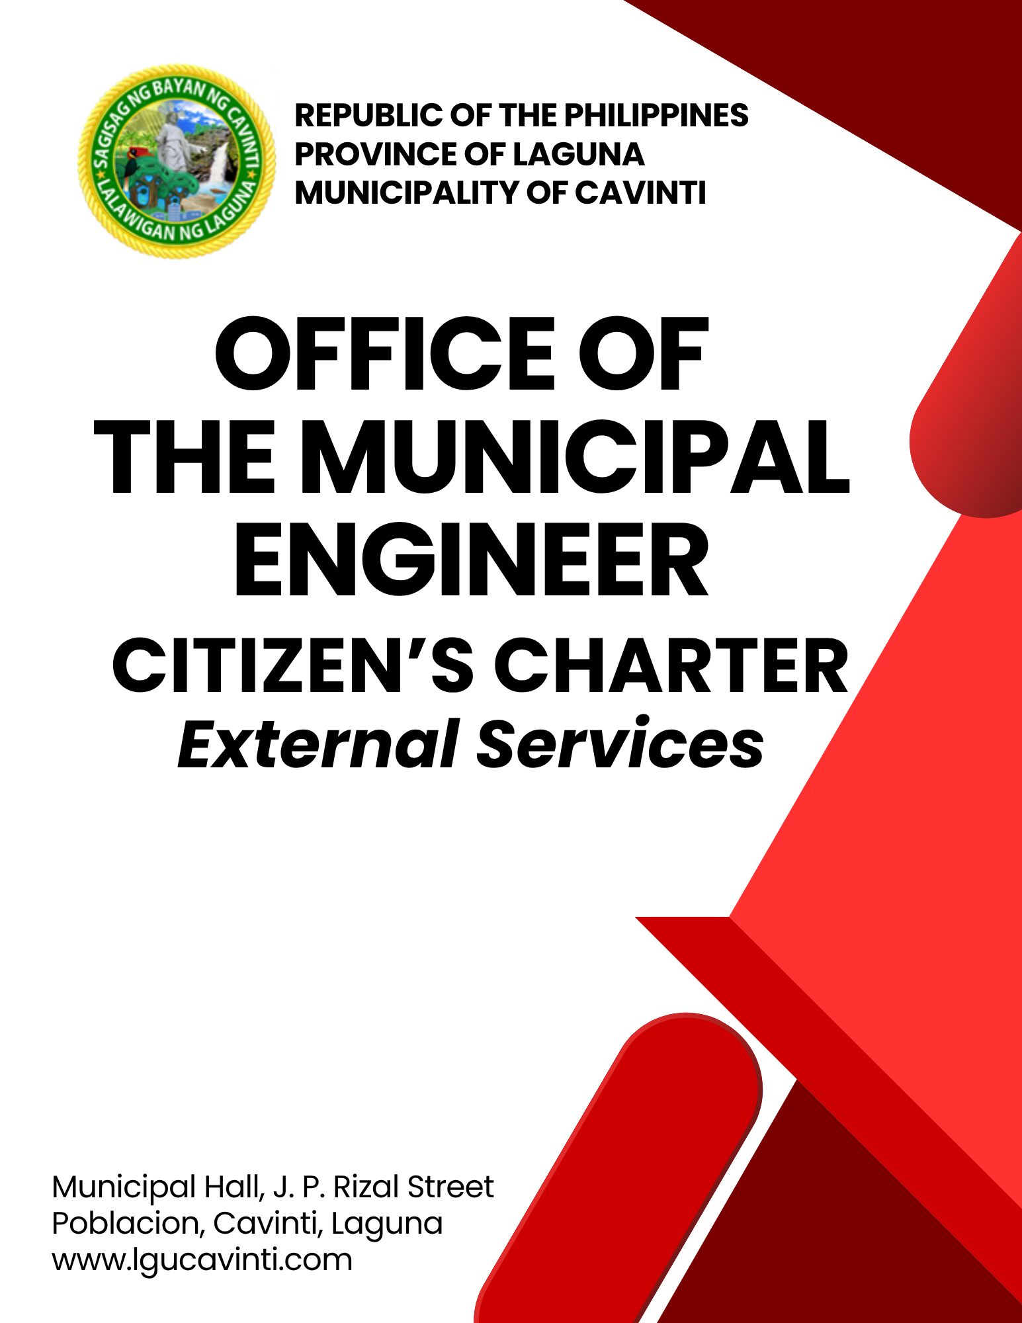

Office of the Municipal Engineer

- Issuance of Building Permit

The issuance of a building permit authorizes an applicant to proceed with the construction, erection, addition, alteration, renovation, conversion, or repair of a structure in accordance with the approved plans and specifications, as required under Presidential Decree No. 1096 (National Building Code of the Philippines).

Office or Division: | Office of the Municipal Engineer
Classification: | Simple
Type of Transaction: | G2B – Government to Business  G2C – Government to Citizen  G2G – Government to Government
Who may avail: | Applicants for Building Permit
CHECKLIST OF REQUIREMENTS |  | WHERE TO SECURE
- Unified Application Form for Building Permit (Notarized) Filled up completely, with signature of applicant, Building Owner and Lot Owner, Signed, and Sealed (Architect or Civil Engineer) (5 original copies) |  | Client
- Plumbing Permit Form filled up completely, with signature of Applicant, Building Owner and Lot Owner, Signed and Sealed (Sanitary Engineer or Master Plumber) (5 original copies) |  | Client
- Electrical Permit Form filled up completely, with signature of Applicant Building Owner, and Lot Owner, signed and sealed (Electrical Engineer) (5 original copies) |  | Client
- Civil/Structural Permit Form * Filled up completely, with signature of Applicant, Building Owner and Lot Owner, Signed and Sealed - Civil Engineer (5 original copies) |  | Client
- Architectural Permit Form * Filled up completely, with signature of Applicant, Building Owner and Lot Owner, Signed and Sealed – Architect (5 original copies) |  | Client
- Land Title / Tax Declaration (OHA) * registered in the name of the applicant (5 photocopies) |  | Client
- Deed of Sale / Extrajudicial Settlement / Contract of Sale / Contract of Lease * if not registered in the name of the applicant (5 photocopies) |  | Client
- Building Plans (5 sets)  Front page must contain:  - Perspective, Vicinity Map  - Site Development Plan (How is the parcel of land laid out; distance between building/s and property lines (front, left and right side, back) property lines (front, left and right side, back)  - Architectural, Structural, Sanitary/Plumbing  - Electrical Layout, Fire Protection Plan.  - Signed and sealed over the printed names of the duly licensed and Register professionals:  - Geodetic engineer, in case of lot survey plans;  - Architect, in case of architectural documents (in case of architectural interior/ interior design, documents, either an architect or interior designer may sign;  - Civil engineer, in case of civil/ structural documents;  - Professional Electrical engineer, in case of electrical documents  - Sanitary engineer, in case of plumbing documents  - Professional Mechanical engineer, in case of mechanical documents |  | Client
- Property Clearance/Certificate (1 original copy and 2 photocopies) |  | Client
- Barangay Clearance (1 original copy and 3 photocopies) |  | Client
- Community Tax Certificate (Cedula) (1 photocopy) |  | Client
- Bill of Materials with Notarized Cover Page (5 original copies) |  | Client
- Structural Design Analysis (if applicable) (1 copy) |  | Client
- Material and Technical Specification (5 original copies) |  | Client
- DPWH Clearance (if applicable) |  | Client
- Valid Professional Licenses (PRC I.D) and |  | Client
Professional Tax Receipt (PTR) of all involved professionals. (1 photocopy) |  | Client
NOTE: Special Power of Attorney shall be required if the owner is not the signatory to the application forms, plans and other documents.
CLIENT STEPS | AGENCY ACTIONS | FEES TO BE PAID | PROCESSING TIME | PERSON  RESPONSIBLE
- Submit the plans and required supporting documents and clearances. | - Receive, review, and evaluate submitted plans and documents for compliance with the National Building Code and related laws. | None | 1 hour | Engineer II  Office of the Municipal Engineer
 | - Inform the client of the status of the application or the return of plans and documents. | None | 25 minutes | Engineer II  Office of the Municipal Engineer
- Submit the lacking documents or corrected plans. | - Verify all the submitted lacking documents. | None | 5 minutes | Engineer II  Office of the Municipal Engineer
- Secure an Order of Payment and assessment once the application is found to be complete and in order. | - Compute applicable fees and issue an order of payment based on the project scope and applicable fees. | None | 10 minutes | Municipal Engineer  Office of the Municipal Engineer  Engineer II  Office of the Municipal Engineer
- Proceed to Window 1 of the Office of the Municipal Treasurer for payment of the required fees. | - Receive the payment and issue an official receipt. | Please Refer to Annex “A”  National Building Code of the Philippines (PD 1096) | 5 minutes | Administrative Aide IV  Office of the Municipal Treasurer
- Present the official receipt to the Engineering Office. | - Check the official receipt and advise the client to wait for 1 day for the processing of documents. | None | 5 minutes | Administrative Assistant  Office of the Municipal Engineer
- Present the official receipt to the Engineering Office. | - Process the permit and conduct ocular inspection of the site to verify site conditions and validate documents. | None | 1 day | Administrative Assistant  Office of the Municipal Engineer  Engineering Aide  Office of the Municipal Engineer
- Present the official receipt to the Engineering Office. | - Joint ocular inspection (Engineering, MPDC, Assessor, and Bureau of Fire Protection) | None | 1 day | Engineering Aide  Office of the Municipal Engineer
- Claim the approved permit. | - Issue and release the approved Building Permit to the applicant. | None | 5 minutes | Administrative Assistant  Office of the Municipal Engineer
TOTAL: |  | Please Refer to Annex “A”  National Building Code of the Philippines (PD 1096) | 2 days, 1 hour, 55 minutes
END OF TRANSACTION

- Issuance of Certificate of Occupancy

The Certificate of Occupancy is issued to confirm that a building or structure has been completed in accordance with the approved plans and specifications, and complies with the provisions of the National Building Code (PD 1096). It authorizes the use or occupancy of the structure after final inspection and clearance from the concerned technical personnel.

Office or Division: | Office of the Municipal Engineer
Classification: | Simple
Type of Transaction: | G2B – Government to Business  G2C – Government to Citizen  G2G – Government to Government
Who may avail: | Applicants for Certificate of Occupancy
CHECKLIST OF REQUIREMENTS |  | WHERE TO SECURE
- Certificate of Completion, duly notarized (3 original copies) |  | Client
- Constriction Logbook signed and sealed by the Owner's Architect or Civil Engineer who undertook full-time inspection and supervision. (3 original copies) |  | Client
- As-Plans signed and sealed by the Owner's Architect or Civil Engineer, who undertook full-time inspection and supervision. (3 original copies) |  | Client
- Valid licenses of all involved professionals (3 original copies) |  | Client
- Captioned Photographs of the Site and Completed Building/Structure showing front sides, and rear areas. (1 printed copy) |  | Client
- Unified Application Form for Certificate of Occupancy (3 original copies) |  | Client
CLIENT STEPS | AGENCY ACTIONS | FEES TO BE PAID | PROCESSING TIME | PERSON  RESPONSIBLE
- Submit the plans, requirements, and supporting clearances. | Receive and verify the completeness of required documents (e.g., as-built plans, clearances, certificates of completion, etc.). | None | 25 minutes | Administrative Assistant  Office of the Municipal Engineer
- Allow the Office of the Engineer to conduct an inspection of the building/structure and to check if the same is in accordance with the approved plans and specifications. | Conduct a joint final inspection of the completed structure by the Building Official and technical staff | None | 1 day | Municipal Engineer  Office of the Municipal Engineer  Engineering Aide  Office of the Municipal Engineer
- Obtain a copy of an inspection report with the list of the needed corrections and other required documents.  Make the necessary corrections and submit additional documents listed in the inspection report. Afterwards, inform the Office of the Engineer that the correction has been made. | Review and evaluate inspection findings to ensure compliance with the Building Code and approved plans. Advise the client to wait for one day for the processing of documents. | None | 30 minutes | Engineering Aide  Office of the Municipal Engineer
- Once all the requirements have been complied with, acquire an assessment/Order of Payment, then | Compute and issue an order of payment for the occupancy permit and related charges. | None | 10 minutes | Municipal Engineer  Office of the Municipal Engineer  Engineer II  Office of the Municipal Engineer
- Proceed to Window 1 of the Office of the Municipal Treasurer for payment of the required fees. | Receive the payment and issue an official receipt. | Please Refer to Annex “A”  National Building Code of the Philippines (PD 1096) | 5 minutes | Administrative Aide IV  Office of the Municipal Treasurer
- Present the official receipt to the Office of the Municipal Engineer. | Check the official receipt and advise the client to wait for 1 day for the processing of documents. | None | 5 minutes
 | Process plans and pertinent documents for approval. | None | 1 day | Administrative Assistant  Office of the Municipal Engineer
- Claim the approved certificate from the Office of the Municipal Engineer. | Release the Certificate of Occupancy to the applicant. | None | 5 minutes | Administrative Assistant  Office of the Municipal Engineer
TOTAL: |  | Please Refer to Annex “A”  National Building Code of the Philippines (PD 1096) | 2 days, 1 hour, 15 minutes
END OF TRANSACTION

- Issuance of Electrical Permit

The Electrical Permit is issued to authorize the installation, modification, or repair of electrical systems in accordance with the Philippine Electrical Code and the National Building Code (PD 1096). It ensures that all electrical works are designed, executed, and inspected by duly licensed professionals to guarantee safety and compliance with regulations before energization.

Office or Division: | Office of the Municipal Engineer
Classification: | Simple
Type of Transaction: | G2B – Government to Business  G2C – Government to Citizen  G2G – Government to Government
Who may avail: | Applicants for Certificate of Occupancy
CHECKLIST OF REQUIREMENTS |  | WHERE TO SECURE
- Certificate of Final Electrical Inspection (CFEI) duly signed by a registered professional. (3 original copies) |  | Client
- Electrical Permit Form duly signed by a registered professional. (3 original copies) |  | Client
- Declaration of Real Property (or permission from the Owner of the property land where the infrastructure is located) (3 original copies) |  | Client
- Barangay Clearance (for electrical permit) (3 original copies) |  | Client
- Electrical Layout duly signed by a registered professional. (3 original copies) |  | Client
- Pictures (front view, side view, rear view) of the structure or a photocopy of duly signed building permits (1 printed copy) |  | Client
NOTES:
1. Photocopies of PRC ID and PTR of professionals who sign the plans and application forms.

2. Show originals of photocopies for verification.
CLIENT STEPS | AGENCY ACTIONS | FEES TO BE PAID | PROCESSING TIME | PERSON  RESPONSIBLE
- Submit the plans, requirements and supporting clearances. | - Receive and verify the completeness of the electrical documents and the application form | None | 20 minutes | Engineer II  Office of the Municipal Engineer
- Allow the Office of the Engineer to conduct an inspection of the building or structure and to check if the same is in accordance with the approved plans specifications. | - Conduct an on-site electrical inspection. | None | 1 day | Engineering Aide  Office of the Municipal Engineer
- Obtain a copy of an inspection report with the list of the needed corrections and other required documents.  Make the necessary corrections and submit additional documents listed in the inspection report. Afterwards, inform the Office of the Engineer that the correction has been made | - Review electrical plans and documents for code compliance. | None | 30 minutes | Engineering Aide  Office of the Municipal Engineer
- Acquire an assessment or Order of Payment once all the requirements have been complied with. | - Assess and compute electrical permit fees | None | 10 minutes | Engineer II  Office of the Municipal Engineer
- Proceed to Window 1 of the Office of the Municipal Treasurer for payment of the required fees. | - Receive the payment and issue an official receipt. | Please Refer to Annex “A”  National Building Code of the Philippines (PD 1096) | 5 minutes | Administrative Aide IV  Office of the Municipal Treasurer
- Present the official receipt to the Office of the Municipal Engineer. | - Check the official receipt and advise the client to wait for 1 day for the processing of documents. | None | 5 minutes | Administrative Assistant  Office of the Municipal Engineer
 | - Recommend approval or disapproval based on evaluation and inspection results. | None | 1 day | Administrative Assistant  Office of the Municipal Engineer
- Claim the approved certificate from the Office of the Municipal Engineer. | - Release the Electrical Permit to the client. | None | 5 mins | Administrative Assistant  Office of the Municipal Engineer
TOTAL: |  | Please Refer to Annex “A”  National Building Code of the Philippines (PD 1096) | 2 days, 1 hour, 15 minutes
END OF TRANSACTION

LIST OF OFFICES

OFFICE | ADDRESS | CONTACT INFORMATION
Office of the Mayor (OM) | 2nd Floor, Municipal Hall,  J. P. Rizal Street, Poblacion, Cavinti, Laguna | email: omcavinti@gmail.com  telephone no.: (049) 523-0012
Office of the Sangguniang Bayan (SB) | 2nd Floor, SB Hall, M. H. Del Pilar Street, Poblacion, Cavinti, Laguna | email: sbcavinti@gmail.com  telephone no.: (049) 523-4357
Office of the Municipal Administrator (OMAD) | 2nd Floor, Municipal Hall,  J. P. Rizal Street, Poblacion, Cavinti, Laguna | email: omadrecordslgucavinti@gmail.com  telephone no.: (049) 521-0147
Human Resource Management Office (HRMO) | 2nd Floor, Municipal Hall,  J. P. Rizal Street, Poblacion, Cavinti, Laguna | email: hrmocavintilaguna@gmail.com  telephone no.: (049) 523-1761
Municipal Budget Office (MBO) | 2nd Floor, Municipal Hall,  J. P. Rizal Street, Poblacion, Cavinti, Laguna | email: mbocavinti1071@gmail.com  telephone no.: (049) 523-1765
Office of the Municipal Accountant (OMACC) | 2nd Floor, Municipal Hall,  J. P. Rizal Street, Poblacion, Cavinti, Laguna | email: cavinti.omacc@gmail.com  telephone no.: (049) 503-7580
Municipal Civil Registrar Office (MCRO) | Municipal Hall, J. P. Rizal Street, Poblacion, Cavinti, Laguna | email: lcro_cavinti@gmail.com  telephone no.: (049) 523-1034
Office of the Municipal Treasurer | Municipal Hall, J. P. Rizal Street, Poblacion, Cavinti, Laguna | email: mtocavinti4013@gmail.com  telephone no.: (049) 502-4201
Municipal Planning and Development Office (MPDO) | 2nd Floor, Municipal Hall,  J. P. Rizal Street, Poblacion, Cavinti, Laguna | email: cavintimpdo@gmail.com  telephone no.: (049) 523-0366
Office of the Municipal Engineer (OME) | 2nd Floor, Municipal Hall,  J. P. Rizal Street, Poblacion, Cavinti, Laguna | email: ome.cavinti@gmail.com  telephone no.: (049) 521-8936
Municipal Disaster Risks Reduction and Management Office (MDRRMO) | National Highway, Barangay Poblacion, Cavinti, Laguna | email: mdrrmocavinti2022@gmail.com  Hotline Number: 0962-843-0781  Radio Frequency: 146.260
Office of the Municipal Social Welfare and Development (MSWDO) | Municipal Hall, J. P. Rizal Street, Poblacion, Cavinti, Laguna | email: omswdocavinti@yahoo.ocm  cavintisocialwelfare@gmail.com  telephone no.: (049) 523-0990
Municipal Environment and Natural Resources Office (MENRO) | Municipal Hall, J. P. Rizal Street, Poblacion, Cavinti, Laguna | email: menrocavinti@gmail.com  telephone no.: (049) 523-0967
Office of the Municipal Assessor (OMASS) | Municipal Hall, J. P. Rizal Street, Poblacion, Cavinti, Laguna | email: cavintiassessor@gmail.com  telephone no.: (049) 523-1023
Office of the Municipal Agriculture (OMAG) | SB Hall, M. H. Del Pilar Street, Poblacion, Cavinti, Laguna | email: maocavinti@gmail.com  telephone no.: (049) 544-2618
Cavinti Water Office (CWO) | 2nd Floor, Municipal Hall,  J. P. Rizal Street, Poblacion, Cavinti, Laguna | email: cavintiwater@gmail.com  telephone no.: (049) 523-0859
Cavinti Culture, History, Arts, Trade and Tourism Office (CCHATTO) | Ecopark, Barangay Tibatib, Cavinti, Laguna | email: tourismcavintilaguna@gmail.com  telephone no.: (049) 540-3924
Office of the Municipal Health Officer (OMHE) | Barangay Anglas, Cavinti, Laguna | email: cavintirhu@yahoo.com  telephone no.: (049) 523-0148
General Service Office (GSO) | Municipal Hall, J. P. Rizal Street, Poblacion, Cavinti, Laguna | email: gso.lgucavinti@gmail.com  telephone no.: (049) 523-1042
Public Employment Service Office (PESO) | Municipal Hall, J. P. Rizal Street, Poblacion, Cavinti, Laguna | email: @gmail.com  telephone no.: (049) 523-
Municipality of Cavinti | Municipal Hall, J. P. Rizal Street, Poblacion, Cavinti, Laguna | cavintimunicipalgovernment@gmail.com

FEEDBACK AND COMPLAINTS MECHANISMS
How to send feedback? | Answer the client feedback form and drop it at the designated drop boxes across the vicinity of the Municipal Building or you may contact us through the following to send in any suggestions, compliments and/or complaints.  cavintimunicipalgovernment@gmail.com Telephone No. 523-0129 local 100
How feedback is processed? | Every last working day of the week, the assigned personnel will open the drop box and compiles and records all the feedback submitted.  Feedbacks requiring answers will be forwarded to the relevant offices and they will be required to provide an answer within three (3) days upon receipt of the feedback.  The response will then be forwarded/relayed to the citizen if applicable.
How to file a complaint? | Answer the client complaint form and drop it at the designated drop boxes across the vicinity of the Municipal Building.  Make sure to provide the following information:  - Name of person being complained  - Incident  - Evidence
How complaints are processed? | The responsible/assigned personnel will open the complaint drop box on a daily basis and evaluate each complaint.  After thorough review of the complaint, an investigation will commence and require the personnel concerned for their explanation.  A report containing all the details of the incident and the findings shall be submitted to the head of agency for appropriate action.  Afterwards, feedback will be given to the client (complainant).
Contact Information of ARTA | email address: info@arta.gov.ph  contact nos.  PLDT - 1-ARTA (12782)  Smart  0920-925-3078  0998-856-8338

