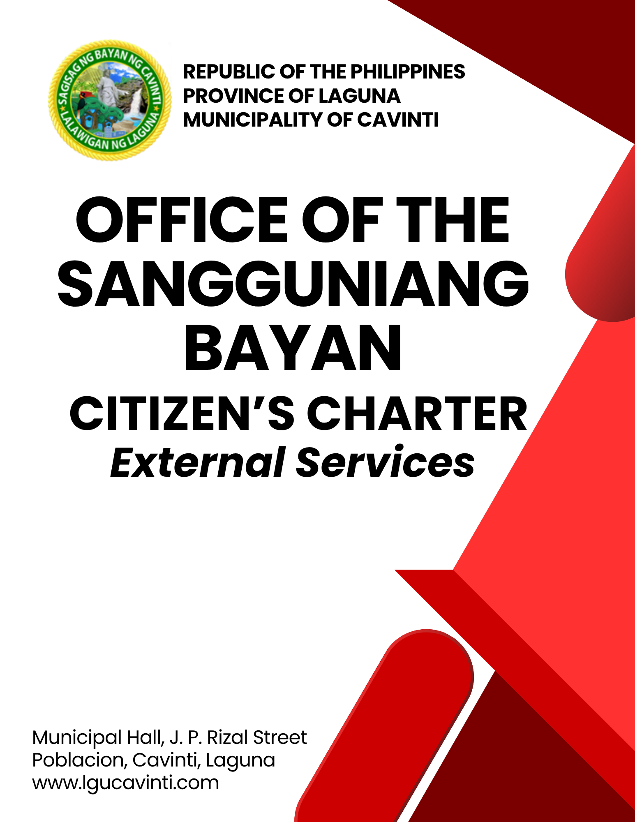
Office of the Sangguniang Bayan

- Accreditation of Non-Governmental Organizations, People's Organizations (POs) and Civil Society Organizations (CSOs)

This service facilitates the evaluation and accreditation of Non-Governmental Organizations, People's Organizations (POs) and Civil Society Organizations (CSOs) seeking recognition by the Local Government Unit (LGU). Accreditation allows organizations to participate in local governance, specifically in the Local Special Bodies (LSBs), development councils, committees, and consultative meetings.
The Sangguniang Bayan reviews applications to ensure that organizations are legitimate, active, community-oriented, and compliant with national and local guidelines before issuing the Accreditation Certificate.

Office or Division: | Office of the Sangguniang Bayan
Classification: | Highly Technical
Type of Transaction: | G2C – Government to Citizen  G2G – Government to Government
Who may avail: | Concerned Association
CHECKLIST OF REQUIREMENTS |  | WHERE TO SECURE
- Duly accomplished Application Form  (1 original and 3 photocopies) |  | Sangguniang Bayan's Office
- Board Resolution signifying the intention for accreditation  (1 original and 3 photocopies) |  | Concerned Association
- Certificate of Registration:  Securities and Exchange Commission (SEC), Department of Labor and Employment (DOLE), etc.  (1 original and 3 photocopies) |  | Securities and Exchange Commission (SEC),  Department of Labor and Employment (DOLE)
- List of current officers and members  (1 original and 3 photocopies) |  | Concerned Association
- Annual Accomplishment Report  (1 original and 3 photocopies) |  | Concerned Association
- Financial Statement (1 original and 3 photocopies) |  | Concerned Association
- Profile Indicating the purposes and objectives of the Organization  (1 original and 3 photocopies) |  | Sangguniang Bayan's Office
- Copy of the minutes of the meeting of the organization  (1 original and 3 photocopies) |  | Concerned Association
- Copy of Constitution and By-laws  (1 original and 3 photocopies) |  | Concerned Association
CLIENT STEPS | AGENCY ACTIONS | FEES TO BE PAID | PROCESSING TIME | PERSON RESPONSIBLE
- Inquire and secure the Application Form. | - Explain to the client the  requirements and give the application form. | None | 5 minutes | Bookbinder III  Office of the Sangguniang Bayan
- Submit the Application for Accreditation with attached complete requirements. | - Receive and ensure that all registration requirements are complete. | None | 5 minutes | Clerk  Office of the Sangguniang Bayan
 | - Once complete, it will be included in the Order of Business of the immediately succeeding Regular Session. | None | 5 days | Secretary to the Sangguniang Bayan  Office of the Sangguniang Bayan
 | - During the Regular Session, the approval is granted after the discussion. The validity and authenticity of the submitted application requirements will be verified. | None | 5 days | Chairman  Committee on Accreditation and Cooperatives
 | - During the Regular Session, if questions arise requiring the applicant’s appearance or the resubmission of additional requirements, the application will be referred to the Committee on Accreditation and Cooperatives. | None | 1 day | SB Members  Office of the Sangguniang Bayan
- Attend the Committee Hearing by officials of the concerned organization. | - Schedule or Hold a Committee Meeting or Hearing. | None | 1 day | Chairman  Committee on Accreditation and Committee on Rules
- Submit additional requirements. | - Conduct Committee Report or Approval. | None | 5 days | Chairman  Committee on Accreditation and Committee on Rules
- Submit additional requirements. | - Prepare the Resolution and Certificate approving accreditation. | None | 6 days | Secretary to the Sangguniang Bayan  Office of the Sangguniang Bayan  Bookbinder III  Office of the Sangguniang Bayan
- Submit additional requirements. | - Attach signatures in the Resolution and Certificate. | None | 1 day | Secretary to the Sangguniang Bayan  Office of the Sangguniang Bayan  Municipal Vice Mayor  Office of the Sangguniang Bayan  Municipal Mayor  Office of the Mayor
- Pay the accreditation fee at Window 1 of the Office of the Municipal Treasurer. | - Receive the payment and issue an official receipt. | P 350.00 | 5 minutes | Cashier  Office of the Municipal Treasurer
- Present the official receipt to the Office of the Sangguniang Bayan. | - Issue the Resolution and Certificate. Record and attach the seal. | None | 5 minutes | Staff  Office of the Sangguniang Bayan
- Receive the documents. | - Release the documents. | None | 5 minutes | Staff  Office of the Sangguniang Bayan
 | TOTAL | P 350.00 | 24 days, 25 minutes
END OF TRANSACTION

- Issuance of True Copy and Certified Photocopy of Sangguniang Bayan Documents

This service provides clients with an official True Copy or Certified Photocopy of Sangguniang Bayan (SB) documents such as ordinances, resolutions, minutes, and other records. The Sangguniang Bayan (SB) Secretariat verifies the authenticity of the requested document and issues a certified copy with proper stamps and signatures. This ensures that clients receive legitimate documents that may be used for legal, administrative, academic, or personal transactions.

Office or Division: | Office of the Sangguniang Bayan
Classification: | Simple
Type of Transaction: | G2C – Government to Citizen
Who may avail: | Concerned agencies, departments, and private individuals
CHECKLIST OF REQUIREMENTS |  |  | WHERE TO SECURE
- Request for Sangguniang Bayan Documents (4 original copies) |  |  | Office of the Sangguniang Bayan
- Written Request, which includes the Name, Address, Number of Copies, and Purpose (4 original copies) |  |  | Concerned Organization, Association, or Cooperative
CLIENT STEPS |  | AGENCY ACTIONS | FEES TO BE PAID | PROCESSING TIME | PERSON RESPONSIBLE
- Submit the request to the Office of the Sangguniang Bayan. |  | - Verify the availability of the document and approve the request. | None | 3 minutes | Secretary to the Sangguniang Bayan  Office of the Sangguniang Bayan  Local Legislative Staff I  Office of the Sangguniang Bayan
- Pay the corresponding fee in Window 1 of the Office of the Municipal Treasurer. |  | - Receive the payment and issue an official receipt. | Please see Table 2 below. | 5 minutes | Cashier  Office of the Municipal Treasurer
- Present the official receipt to the Office of Sangguniang Bayan. |  | - Verify the official receipt and print or photocopy the requested documents. Certify copies and attach the seal. | None | 5 minutes | Local Legislative Staff I  Office of the Sangguniang Bayan  Clerk  Office of the Sangguniang Bayan
- Receive the requested documents. |  | - Record and release the document | None | 2 minutes | Local Legislative Staff I  Office of the Sangguniang Bayan  Clerk  Office of the Sangguniang Bayan
 |  | TOTAL: | Please see Table2 below. | 15 minutes
END OF TRANSACTION

Table 2. Schedule of Fees for the Issuance of True Copy and Certified Photocopy of Sangguniang Bayan Documents

Description/Particulars | Amount
For every one hundred (100) words or fraction thereof, typewritten. | P 120.00
Where the copy is to be furnished in printed form, in whole or in part, for each page (double this fee if there are two pages in a sheet). | P 120.00
For each certificate of correctness (with seal of office) written on the copy or attached thereto | P 120.00
For certified copies of any paper, Record, Decree, Judgment, or entry of which any person is entitled to demand and receive a copy (In connection with Judicial proceedings), for each 100 words | P 120.00
For copy/s produced by copying machines, per page 5 pesos | P 120.00
Photocopy, per page. | P 6.00
For every one hundred (100) words or fraction thereof, typewritten  (not including the certificate and any notation) | P 120.00
Where the copy to be furnished is in printed form in whole or in part,  for each page (double this fee if there are two pages (in a sheet) | P 120.00
For each certification of correctness (with seal of office) written on the copy or attached thereto | P 120.00
For certifying the official act of a municipal judge or other judicial certificate with seal | P 120.00
For certified copies of any papers, records, decrees judgement or entry of which any persons is entitled to demand and received a copy (In connection with judicial proceedings) for each 100 words | P 120.00
Certified True Copy or any other copy produced by copying machine, per page | P 120.00
Softcopy in PDF (electronic copy) of other public documents for research and other purposes | P 120.00
All other Clearance/ Certifications not mentioned above | P 120.00

- Review and Approval of Barangay Ordinances and Resolutions

This service involves the evaluation, review, and confirmation of Barangay Ordinances and Resolutions submitted by the Sangguniang Barangay. The Sangguniang Bayan ensures that all measures are legally compliant, aligned with national laws, and consistent with the Municipal Comprehensive Land Use Plan (CLUP) and other local policies. The main goal is to ensure that barangay legislation is valid, implementable, and beneficial to the community before it is officially approved or returned for revision.

Office or Division: | Office of the Sangguniang Bayan
Classification: | Highly Technical
Type of Transaction: | G2G – Government to Government
Who may avail: | Sangguniang Barangay, Barangay Officials
CHECKLIST OF REQUIREMENTS |  | WHERE TO SECURE
- Request for the Approval of Ordinances and Resolutions (5 original copies) |  | Concerned Sangguniang Barangay
- Copy of Barangay Ordinance or Resolution with the following attachments: (4 original copies) |  | Concerned Sangguniang Barangay
For Barangay Ordinances:
- Cover Letter (5 original copies) |  | Concerned Sangguniang Barangay
- Minutes of the Public Hearing (4 original copies) |  | Concerned Sangguniang Barangay
For Appropriation Ordinances:
- Cover Letter (5 original copies) |  | Concerned Sangguniang Barangay
- Necessary Certification (5 original copies) |  | Concerned Sangguniang Barangay
- Annual Investment Plan (AIP)  (2 original and 3 photocopies) |  | Concerned Sangguniang Barangay
- Supplemental Annual Investment Program (SAIP)  (2 original and 3 photocopies) |  | Concerned Sangguniang Barangay
- Resolution Approving SAIP (# of copies) |  | Concerned Sangguniang Barangay
Additional Requirement for Annual Budget:
- Mandatory Council Resolutions (5 original copies) |  | Concerned Sangguniang Barangay
CLIENT STEPS | AGENCY ACTIONS | FEES TO BE PAID | PROCESSING TIME | PERSON RESPONSIBLE
- Submit the ordinance or resolution. | - Check and ensure that all required documents are duly attached. | None | 10 minutes | Clerk  Office of the Sangguniang Bayan
- Submit the ordinance or resolution. | - If complete - For inclusion in the Order of Business of the next Regular Session. | None | 2 days | Secretary to the Sangguniang Bayan  Office of the Sangguniang Bayan
- Submit the ordinance or resolution. | - For review and deliberation during Regular Session | None | 5 days | SB Members  Office of the Sangguniang Bayan
- Submit the ordinance or resolution. | - Approved - If all requirements are complete and no further questions. |  | 1 day | Chairman  Concerned Committee
- Submit the ordinance or resolution. | - If questions arise, further review is needed, or additional requirements are lacking, the matter shall be referred to the concerned committee. | None | 7 days | Chairman  Concerned Committee and Committee on Rules
- Attend the Committee Hearing | - Conduct Committee Meeting or Hearing. | None | 7 days | Chairman  Concerned Committee and Committee on Rules  Resource Persons  Concerned Barangay
- Attend the Committee Hearing | - Committee Report Approval/Disapproval | None | 1 day | Chairman Concerned Committee
- Attend the Committee Hearing | - Prepare the Resolution if it is approved.  - Prepare the endorsement if the application is disapproved, and notify the Punong Barangay or the concerned person of the necessary measures. | None | 1 day | Secretary to the Sangguniang Bayan  Office of the Sangguniang Bayan  Staff  Office of the Sangguniang Bayan
- Attend the Committee Hearing | - Attach the signatures. | None | 7 days | Secretary to the Sangguniang Bayan  Office of the Sangguniang Bayan  Presiding Officer  Office of the Sangguniang Bayan  Municipal Mayor  Office of the Mayor
- Receive the Resolution or Endorsement. | - Record and attach seal and release the document. | None | 5 minutes | Clerk  Office of the Sangguniang Bayan
TOTAL: |  | None | 30 days, 15 minutes - Brgy Resolution/Ordinances  Max 60 days – Annual Budget
- Issuance of Certification and Endorsement

This service covers the preparation and issuance of official Certifications and Endorsements requested by individuals, barangays, institutions, or agencies. These documents may be used for legal, administrative, academic, program-related, or inter-agency coordination purposes. The Sangguniang Bayan Secretariat verifies the purpose, checks supporting documents, and prepares the appropriate Certification or Endorsement for signature and release.

Office or Division: | Office of the Sangguniang Bayan
Classification: | Simple
Type of Transaction: | G2C – Government to Citizen
Who may avail: | Concerned agencies, departments, and private individuals
CHECKLIST OF REQUIREMENTS |  | WHERE TO SECURE
- Request for certification and endorsement (2 original copies) |  | Sangguniang Bayan's Office
CLIENT STEPS | AGENCY ACTIONS | FEES TO BE PAID | PROCESSING TIME | PERSON RESPONSIBLE
- Submit the Request for Certification or Endorsement. | - Prepare the requested certification or endorsement. | None | 10 minutes | Secretary to the Sangguniang Bayan  Office of the Sangguniang Bayan  Bookbinder III  Office of the Sangguniang Bayan
- Pay the corresponding fee in Window 1 of the Office of the Municipal Treasurer. | - Receive the payment and issue an official receipt. | P150.00 | 5 minutes | Cashier  Office of the Municipal Treasurer
- Receive the certification or endorsement. | - Check the official receipt, attach the seal, record, and release the certification or endorsement. | None | 3 minutes | Clerk  Office of the Sangguniang Bayan
TOTAL: |  | P150.00 | 18 minutes
END OF TRANSACTION

LIST OF OFFICES

OFFICE | ADDRESS | CONTACT INFORMATION
Office of the Mayor (OM) | 2nd Floor, Municipal Hall,  J. P. Rizal Street, Poblacion, Cavinti, Laguna | email: omcavinti@gmail.com  telephone no.: (049) 523-0012
Office of the Sangguniang Bayan (SB) | 2nd Floor, SB Hall, M. H. Del Pilar Street, Poblacion, Cavinti, Laguna | email: sbcavinti@gmail.com  telephone no.: (049) 523-4357
Office of the Municipal Administrator (OMAD) | 2nd Floor, Municipal Hall,  J. P. Rizal Street, Poblacion, Cavinti, Laguna | email: omadrecordslgucavinti@gmail.com  telephone no.: (049) 521-0147
Human Resource Management Office (HRMO) | 2nd Floor, Municipal Hall,  J. P. Rizal Street, Poblacion, Cavinti, Laguna | email: hrmocavintilaguna@gmail.com  telephone no.: (049) 523-1761
Municipal Budget Office (MBO) | 2nd Floor, Municipal Hall,  J. P. Rizal Street, Poblacion, Cavinti, Laguna | email: mbocavinti1071@gmail.com  telephone no.: (049) 523-1765
Office of the Municipal Accountant (OMACC) | 2nd Floor, Municipal Hall,  J. P. Rizal Street, Poblacion, Cavinti, Laguna | email: cavinti.omacc@gmail.com  telephone no.: (049) 503-7580
Municipal Civil Registrar Office (MCRO) | Municipal Hall, J. P. Rizal Street, Poblacion, Cavinti, Laguna | email: lcro_cavinti@gmail.com  telephone no.: (049) 523-1034
Office of the Municipal Treasurer | Municipal Hall, J. P. Rizal Street, Poblacion, Cavinti, Laguna | email: mtocavinti4013@gmail.com  telephone no.: (049) 502-4201
Municipal Planning and Development Office (MPDO) | 2nd Floor, Municipal Hall,  J. P. Rizal Street, Poblacion, Cavinti, Laguna | email: cavintimpdo@gmail.com  telephone no.: (049) 523-0366
Office of the Municipal Engineer (OME) | 2nd Floor, Municipal Hall,  J. P. Rizal Street, Poblacion, Cavinti, Laguna | email: ome.cavinti@gmail.com  telephone no.: (049) 521-8936
Municipal Disaster Risks Reduction and Management Office (MDRRMO) | National Highway, Barangay Poblacion, Cavinti, Laguna | email: mdrrmocavinti2022@gmail.com  Hotline Number: 0962-843-0781  Radio Frequency: 146.260
Office of the Municipal Social Welfare and Development (MSWDO) | Municipal Hall, J. P. Rizal Street, Poblacion, Cavinti, Laguna | email: omswdocavinti@yahoo.ocm  cavintisocialwelfare@gmail.com  telephone no.: (049) 523-0990
Municipal Environment and Natural Resources Office (MENRO) | Municipal Hall, J. P. Rizal Street, Poblacion, Cavinti, Laguna | email: menrocavinti@gmail.com  telephone no.: (049) 523-0967
Office of the Municipal Assessor (OMASS) | Municipal Hall, J. P. Rizal Street, Poblacion, Cavinti, Laguna | email: cavintiassessor@gmail.com  telephone no.: (049) 523-1023
Office of the Municipal Agriculture (OMAG) | SB Hall, M. H. Del Pilar Street, Poblacion, Cavinti, Laguna | email: maocavinti@gmail.com  telephone no.: (049) 544-2618
Cavinti Water Office (CWO) | 2nd Floor, Municipal Hall,  J. P. Rizal Street, Poblacion, Cavinti, Laguna | email: cavintiwater@gmail.com  telephone no.: (049) 523-0859
Cavinti Culture, History, Arts, Trade and Tourism Office (CCHATTO) | Ecopark, Barangay Tibatib, Cavinti, Laguna | email: tourismcavintilaguna@gmail.com  telephone no.: (049) 540-3924
Office of the Municipal Health Officer (OMHE) | Barangay Anglas, Cavinti, Laguna | email: cavintirhu@yahoo.com  telephone no.: (049) 523-0148
General Service Office (GSO) | Municipal Hall, J. P. Rizal Street, Poblacion, Cavinti, Laguna | email: gso.lgucavinti@gmail.com  telephone no.: (049) 523-1042
Public Employment Service Office (PESO) | Municipal Hall, J. P. Rizal Street, Poblacion, Cavinti, Laguna | email: @gmail.com  telephone no.: (049) 523-
Municipality of Cavinti | Municipal Hall, J. P. Rizal Street, Poblacion, Cavinti, Laguna | cavintimunicipalgovernment@gmail.com

FEEDBACK AND COMPLAINTS MECHANISMS
How to send feedback? | Answer the client feedback form and drop it at the designated drop boxes across the vicinity of the Municipal Building or you may contact us through the following to send in any suggestions, compliments and/or complaints.  cavintimunicipalgovernment@gmail.com Telephone No. 523-0129 local 100
How feedback is processed? | Every last working day of the week, the assigned personnel will open the drop box and compiles and records all the feedback submitted.  Feedbacks requiring answers will be forwarded to the relevant offices and they will be required to provide an answer within three (3) days upon receipt of the feedback.  The response will then be forwarded/relayed to the citizen if applicable.
How to file a complaint? | Answer the client complaint form and drop it at the designated drop boxes across the vicinity of the Municipal Building.  Make sure to provide the following information:  - Name of person being complained  - Incident  - Evidence
How complaints are processed? | The responsible/assigned personnel will open the complaint drop box on a daily basis and evaluate each complaint.  After thorough review of the complaint, an investigation will commence and require the personnel concerned for their explanation.  A report containing all the details of the incident and the findings shall be submitted to the head of agency for appropriate action.  Afterwards, feedback will be given to the client (complainant).
Contact Information of ARTA | email address: info@arta.gov.ph  contact nos.  PLDT - 1-ARTA (12782)  Smart  0920-925-3078  0998-856-8338

