Regular Expression to E-NFA

By Thompson's Construction in C

CAU Computer science & engineering

20134220 Jeong hyun, Woo

1. How to execute

In Windows,

1. Execute CMD

2. Go to 'Win' Directory

3. Usage : >Automata.exe [regexp] ex> Automata.exe ab(a+b)*cde*

In Linux(Unix),

1. Execute Terminal

2. Go to 'Unix' Directory

3. $make

4. $ls (Check 'Automata')

5. Usage : $./Automata [regexp] ex> ./Automata ab(a+b)*ab

2. Flow of program

* Get input(regular expression) from user (argv[1])
* Extract alphabets from input && Check that the regular expression is correct or not (regex_extract_alphabet, regex_input_validation)
  + If not correct, return
* Insert additional symbol that represents 'concatenation operator (.)' to original regular expression. (regex_insert_concat)
* Convert concat-added regular expression to postfix.(regex_to_postfix)
* Create an NFA with postfix expression.(postfix_to_nfa)& Print E-NFA
  + Function 'nfa_symbol' works as

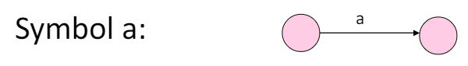

* + Function 'nfa_concat' works as

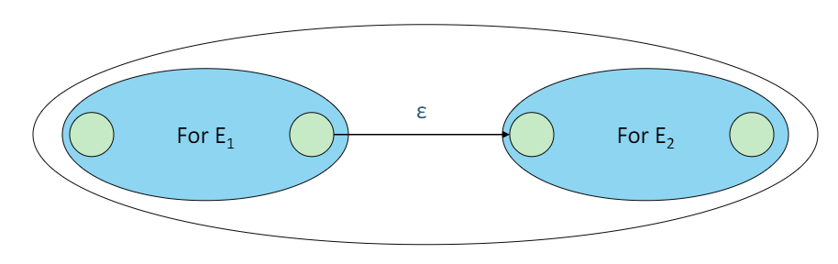

* + Function 'nfa_union' works as

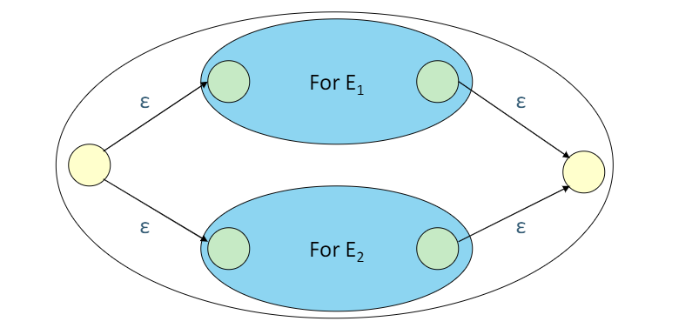

* + Function 'nfa_kleene' works as

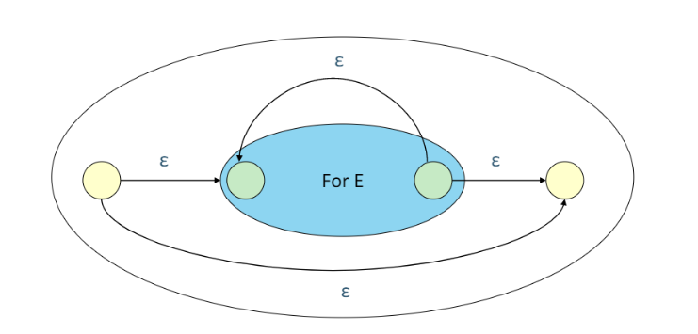

3. Result

※ 'E' in Delta means Epsilon ( Not a symbol! )

In Windows,

~Win>Automata.exe ab+b*(cdef)

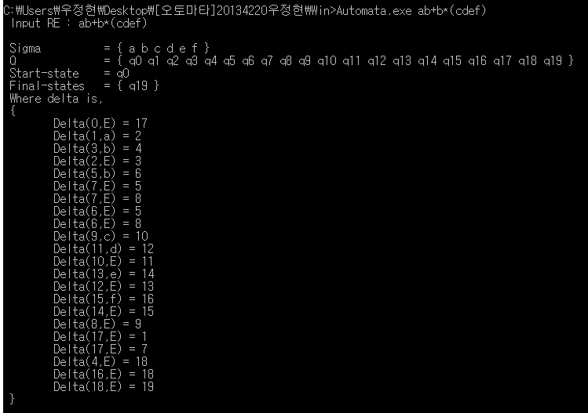

~Win>Automata.exe a(a+b)*

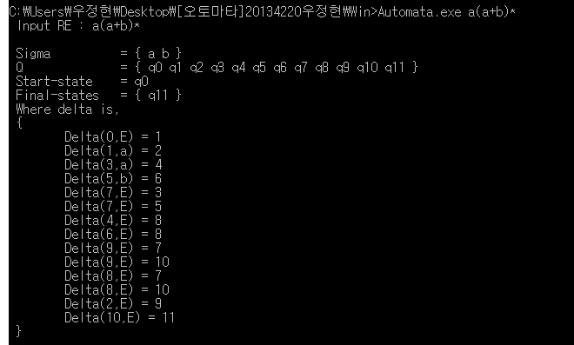

In Linux,

~Unix$ make

~Unix$ ./Automata a\(a+b\)* (== a(a+b)*)

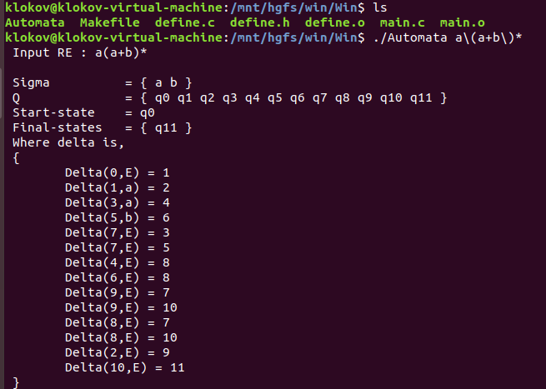

~Unix$ ./Automata (01)*110(0+1)*

