The name of my super cool degree project
Nicholas Snow Mattsson

Degree Project FSU24D
Medieinstitutet

Instructions

The point of this document is to plan your project in detail, before you start working on it. This is to ensure that you meet the requirements for the project.

Yes, the document must be written in English.

You should spend approximately a week of working time on breaking down your project into actionable items, so reserve enough time to go through the sections in this document. Don’t attempt to do it all at once, and not 10 minutes before the deadline.

Your planning must be approved by your instructor before you start the project.

The more detailed you are, the more likely you are to succeed with your degree project.

More effort and thought during the planning phase means less mistakes and redos during the project timeframe.

The degree project is six weeks, and those weeks should be spent doing, not planning. Thus, the ambition level of your project should match the work effort of six weeks full-time doing.

This document should be your tool to use as a checkpoint for you being on track, as well as a document to validate the outcome of your project and serve as a basis for your grade.

Planning is key.

Changes during the project are of course OK - unexpected things happen and the architecture changes, but ad-hoc changes should be the exception, not the rule.

You will use this same template to report the results of your degree project, so the extensive effort you put in now will be “saved” at the end of the project. Save this in an editable version!

Table of Contents

Project idea summary 3
Application flow 3
Purpose 3
Target audience 3
Goal 3
Activity and time plan 3
Site map/function analysis/technical breakdown 4
Database structure 4
User stories x 5 4
Persona 1: Experienced user (just an example) 5
Persona 2: Some other user type 5
Test plan 5
Tech stack 5
References 6
Final check before handing in your project description 6

Project idea summary
My project will be a music theory application on the web. It will consist of various games to expand and test the users knowledge on music theory. Users will also be able to log in in order to track their score.

Application flow
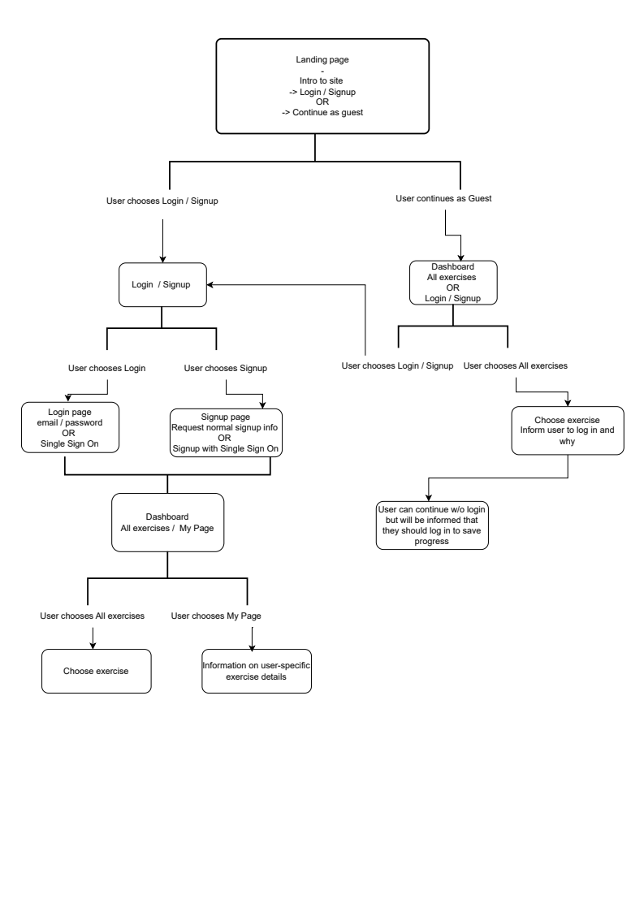

Purpose
I came up with this idea based on my own desire for a music theory application featuring the specific exercises I have designed. While there are numerous music theory websites and applications available, this project is relevant because it offers unique exercises not found in other platforms.

My project will provide value by giving users a practical and interactive way to learn and practice music theory. In addition to the exercises, it will supply resources for users to explore the specific theoretical concepts they are working on. The project will combine immediate feedback and a way to track progress, which will create a more effective learning environment which motivates the user to progress.

Target audience
My target audience consists mainly of musicians or anyone interested in learning music theory. Since the exercises build upon previous knowledge, users should have at least a basic grasp of music theory concepts. The application is valuable to this audience because it helps strengthen their theoretical skills and improves their ability to more quickly apply music theory.

Goal
During the six weeks my aim is to create at least five different exercises, an accessible and responsive website, a working database to store all the user data and an open API for music theory. Users will be able to create an account, see their progress/score and play the various exercises.

Activity and time plan

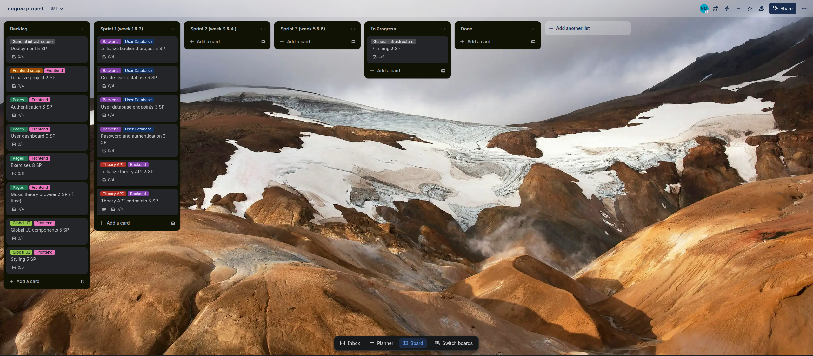
Week/sprints | Objective
1-2, sprint 1 | What is done / started  - Thorough planning for project, initialize backend, create user database, implement user database endpoints, implement password hashing and authentication  What is achieved  -Planning should be finished and I should have a working database and a server that can query to the DB
3-4, sprint 2 | What is done / started  -General UI, user dashboard page, create exercises, Login / signup pages, global UI components  What is achieved  I should be able to log in and signup and do the exercises, progress should be tracked and sent to DB, ability to view progress on dashboard, header and footer implemented
5-6, sprint 3 | What is done / started  -Responsiveness of whole page, start styling page according to design, deployment  What is achieved  -I can now use my page on mobile without responsiveness issues, page looks like design, page is deployed and live

Site map/function analysis/technical breakdown
In the frontend I will be using the functional programming language Elm. Elm manages state through its Model system and the routing will also be managed with Elms Browser.Navigation. The pages will be: Login, signup, user dashboard, exercises 1-5 (at least 5) and a user settings page.

In the backend I will be using Node.js + Express for the server and SQLite as the database technology. JWT authentication with access and refresh tokens will be implemented. I will create an open music theory API that stores basic information regarding music theory (notes in chords, notes in scales, etc). Users can access the information they need from the chords and scales through the API endpoints.

User without logging in (Guest User)
User clicks “Exercises” → Routed to Exercise Page → Frontend (Elm) generates exercises → User chooses which specific exercise → Frontend generates the exercise → Score is only saved in state since user is not signed in. Prompt to log in/sign up to save score → Render users updated score/progress on screen → if user answers wrong, prompt with relevant sources to learn about the corresponding theory

User when logged in (Authenticated User)
User clicks “Exercises” → Routed to Exercise Page → Frontend (Elm) generates exercises → User chooses which specific exercise → Frontend generates the exercise → Query to database to check user’s score/progress on specific exercise → Database updates depending on users answers → Render users updated score/progress on screen → if user answers wrong, prompt with relevant sources to learn about the corresponding theory

Database structure
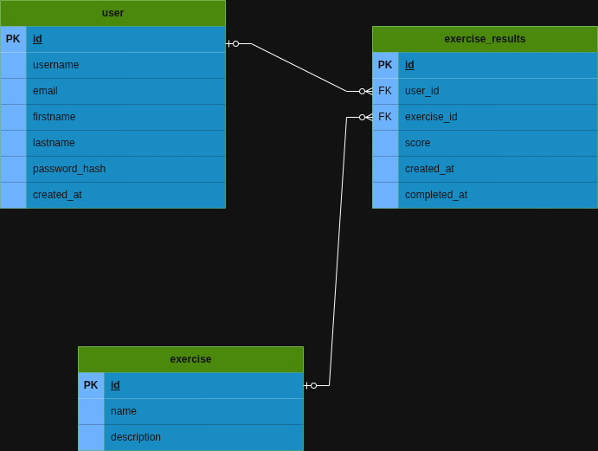

User stories x 5

Persona 1: Learner (Intermediate)
Person1, 23, is studying their first year at a music conservatory. They need to refine their music theory skills so they can apply it better in practice. They visit the site in order to find relevant exercises to become quicker at analyzing music theory.

Persona 2: Teacher (Experienced)
Person2, 56, knows programming and teaches music to high school students and will use the API to generate custom teaching material. They will also send their students to the website to complete exercises as homework. The students can show their progress to Person2 through the website dashboard and Person2 can see what they need to work on.

Persona 3: Learner (Advanced)
Person3, 29, is a professional pianist preparing for an entrance exam to a conservatory. They know music theory but need to become faster at identifying notes in various scales. They will use one specific exercise and track their speed to measure their progression.

Persona 4: Learner (Beginner)
Person4, 16, has just started learning to play the piano and uses guest mode on the website to quickly identify the notes in different chords. Since he uses the app very casually and is not interested in storing his progress he doesn’t need to create an account.

Persona 5: Developer (Experienced)
Person5, 42, is tasked with building a music theory app for a school who needs a specific type of exercise. They use the API instead of hard coding the necessary music theory data and finishes the task more effectively.

Test plan
I will test my project in the end when it is finished. I will send it to users who have prior understanding of music theory to try the various exercises in order to make sure they are functioning correctly.

Tech stack
I chose Elm for the frontend to strengthen my functional programming skills and because it is used at my internship. For the backend, I will use Node.js with SQLite since they offer a simple, lightweight setup suitable for my project. This stack allows fast development and matches my learning goals.

References
I have drawn inspiration from this site: https://www.musictheory.net/exercises. I used this site myself when learning music theory and wanted to create my own app with some exercise ideas I have had.

Final check before handing in your project description
- Ask someone else to read through it and give you feedback and comments on it
- Remove the example texts, i.e. these instructions as well as the descriptions under each heading.
- Run it through a spell-checker!
- Update the Table of contents
- Remove this section
- Save this document as a PDF and hand it in on itslearning

This is your chance to shine & an excellent opportunity to extend your portfolio with a case, so make it count. PS. The more time you spend on this now, the easier the summary and project report will be.

