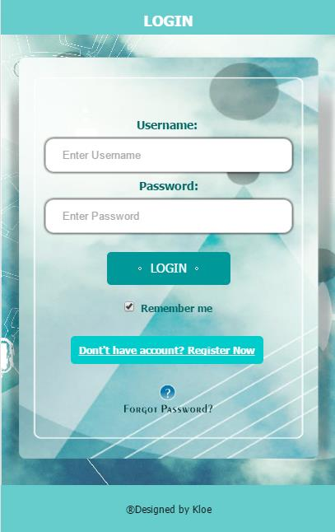

First, We could see it is a login page at the index.

We could login account after register a account.

So we have to register a account right now .

When we click a fresh green color button which show” Don’t have account? Register Now”

We could jump to register page.

Or we could use a finger and sweep the screen that use a jquery mobile function for jump to register page

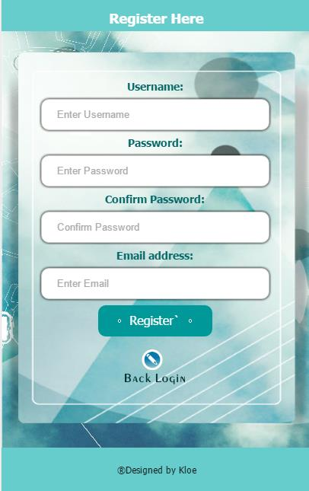

We could enter username/password in the box for register a new account.

We also need to type again password in “confirm password” box for reconfirm the password is correct.

If the password is wrong typing, when click a button of “ register”,it will show the password not match

Then you have to retype a correct password in the box.

After you success to register a new account, it will show: Successful -> and Account created.

And auto jump back to login page



When back to login page. If you forgot password, you can click a button of “ forgot password?”

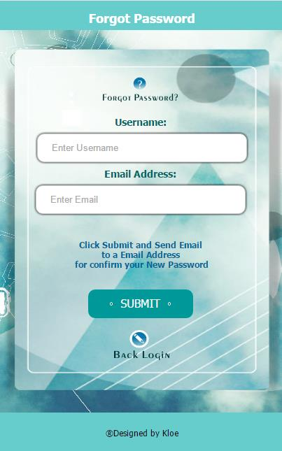

You can enter name and password for check your password and send to your mail

Ok, we try to login in first, so have to back the index ( click back login )

We enter username and password

If the password is not correct it will show” unsuccessful”

If the password is correct , it will show”Successful”

Also we could click a button “ remember me” for record the account information

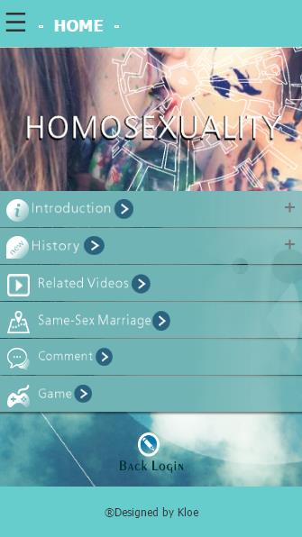

After login, we jump to a front page

We could see the topic for” Homosexually” and many different kind of information list

First, we can click a “+”button of introduction, it will slick down and show the introduction about the homosexuality.

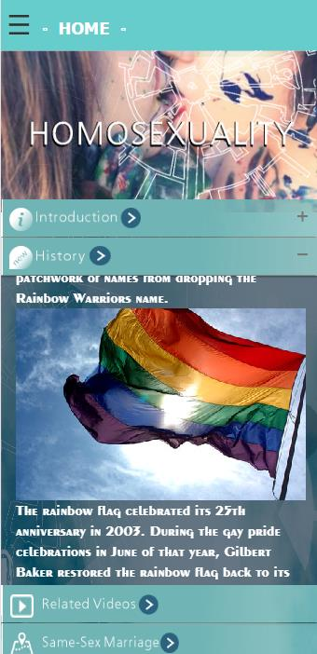

Same action for “history” button, it could show a information about the update history and event for the homosexual.

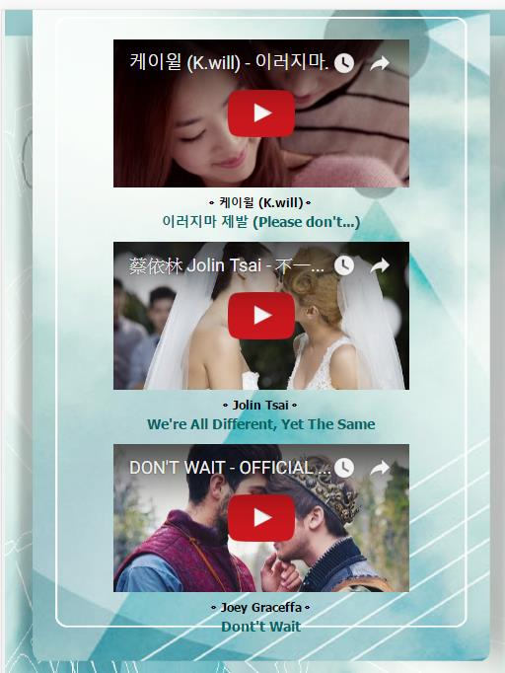

If we click a button for “related videos” we could view some video about homosexual by youtube.

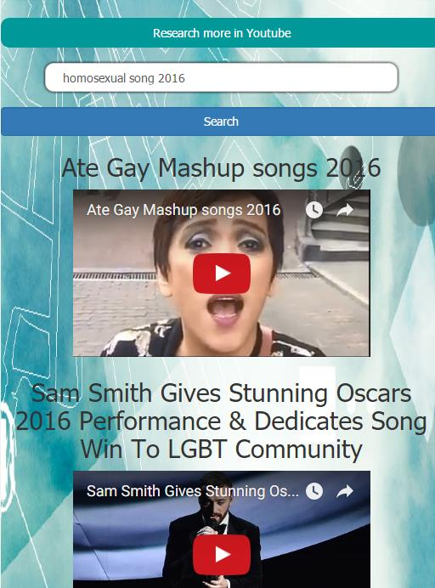

Also we can use a youtube API to search the related video from youtube too.

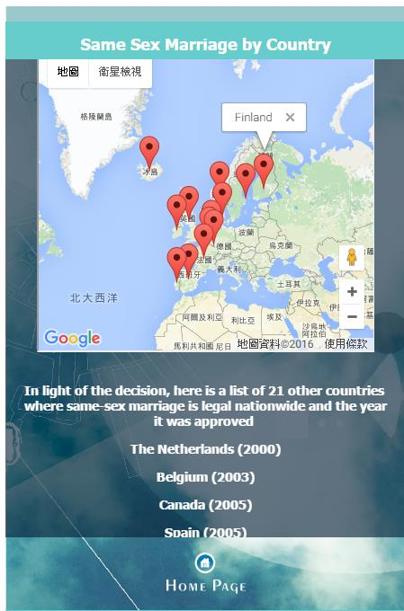

After that we back to the home page

The 4th point is “ same-sex marriage” , we click the button and we can check 21 country which could legally same sex marriage in the world.

We also could check it in google map it is create by google API.

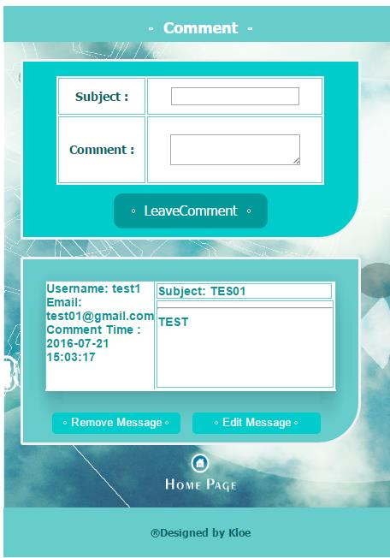

NEXT

We could leave the message in the website for share your comment.

Also we could delete and edit, update your comment after your leave message.

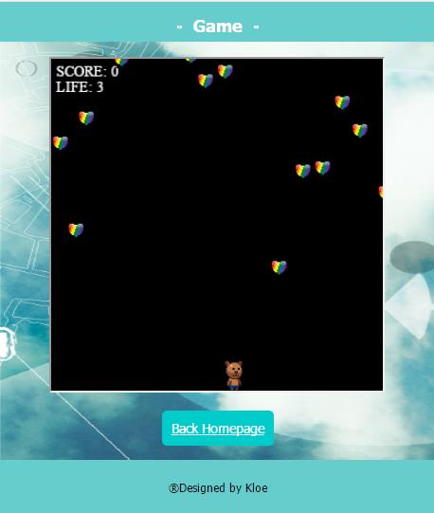

Last part at the list , we could play a little game

It can play in PC or mobile also.

It is a bear eat the heart which heart represents a logo of homosexual.

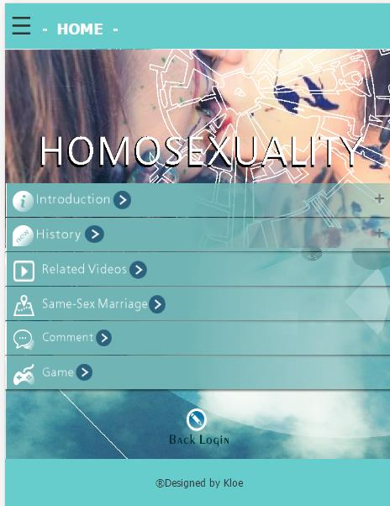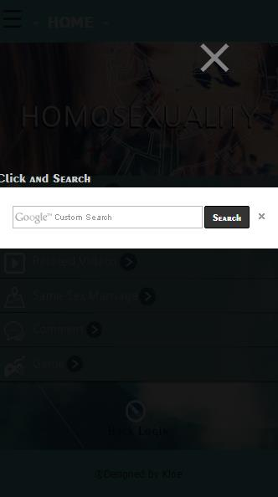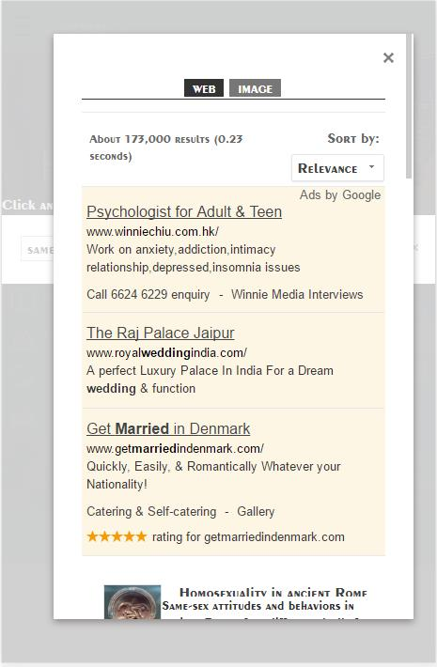

When we back to home page

At the top left concern we could click the button and it will show a google search for we to search the information about the topic.