Kyle K. Loewenhagen

Object Oriented Programming: 152-142-701

Lesson 1 – Installing Eclipse

1/23/2017

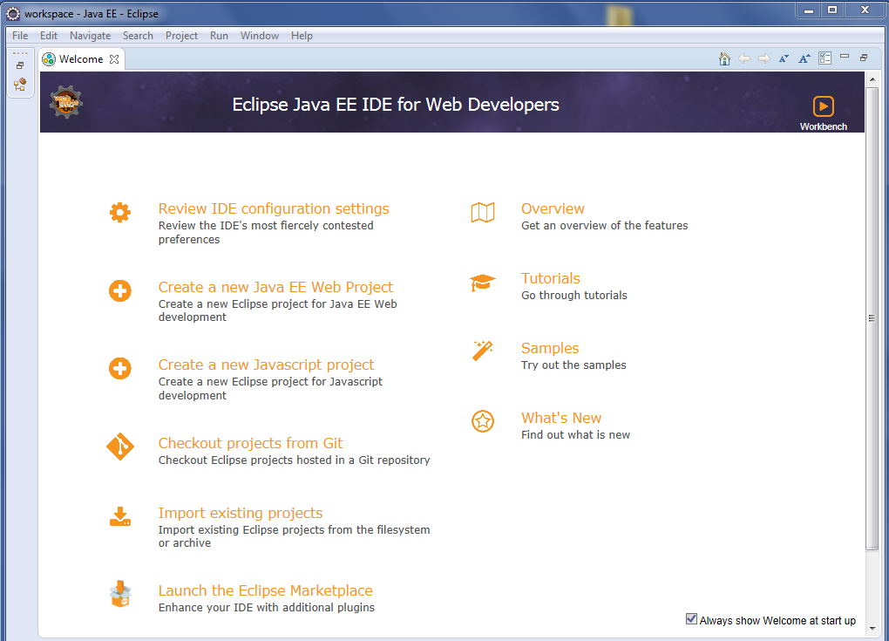

Downloaded Eclipse from <http://www.eclipse.org/downloads/eclipse-packages/>

Unzipped file on C: and ran eclipse.exe.

Selected c:\users\kloewenhagen\workspace as workspace.