What is EKS?

Amazon Elastic Kubernetes Service (Amazon EKS) is a managed service that you can use to run Kubernetes on AWS without needing to install, operate, and maintain your own Kubernetes control plane or nodes. ... Runs and scales the Kubernetes control plane across multiple AWS Availability Zones to ensure high availability.

Two type:

* Self managed
* Managed

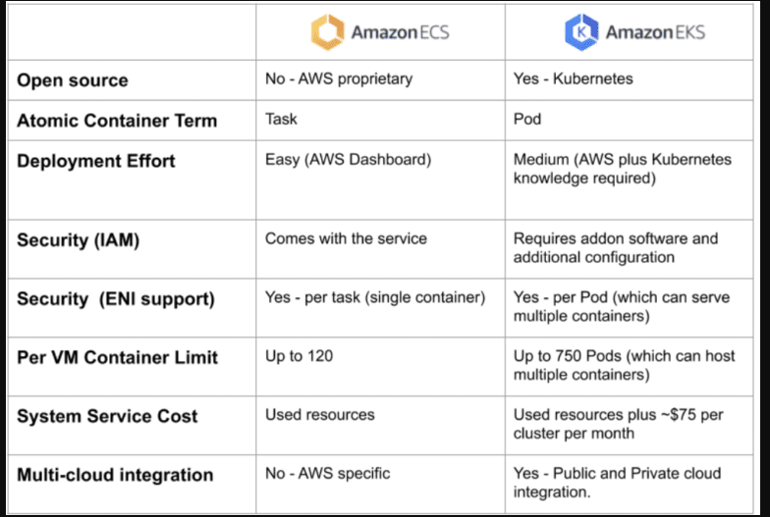

Self Managed control plane

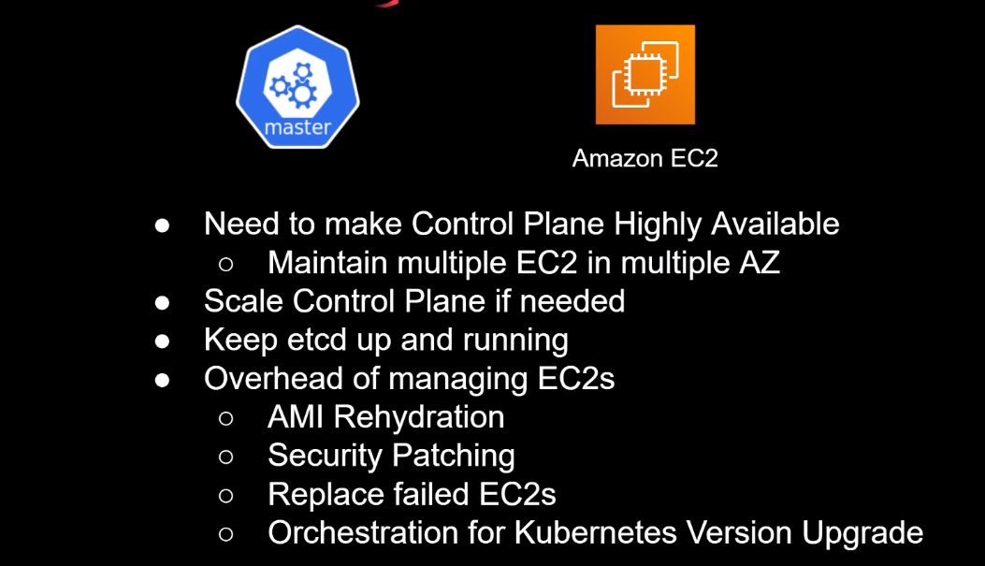

Manages control plane

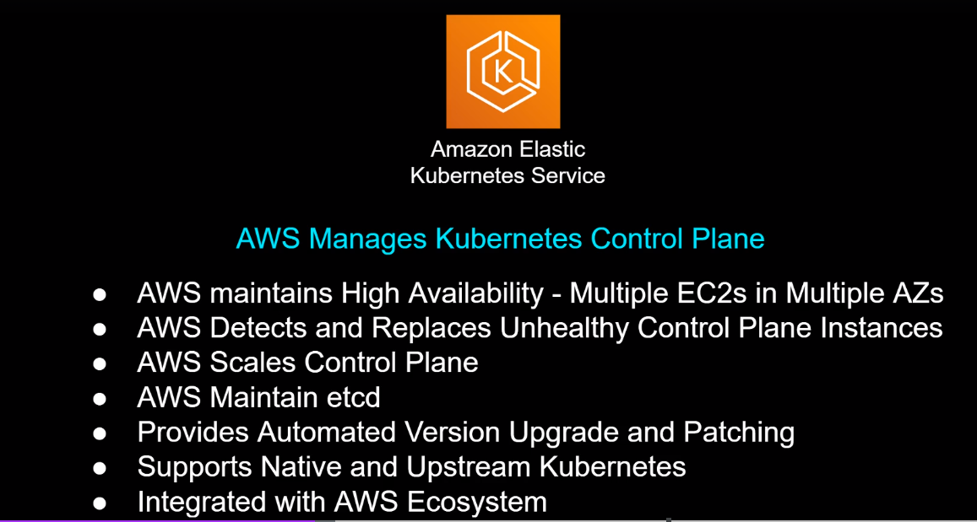

Data plane

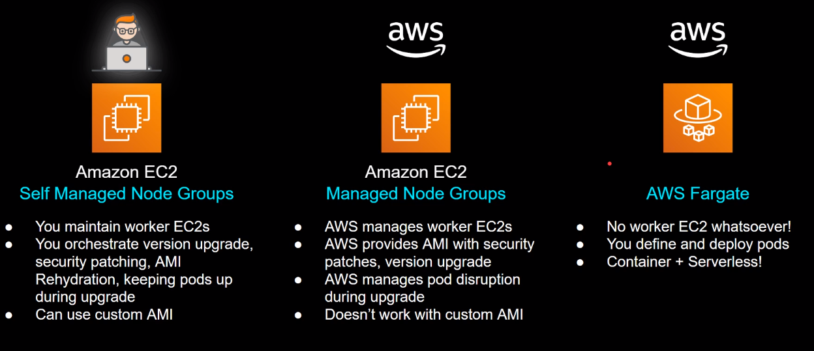

EKS Architecture

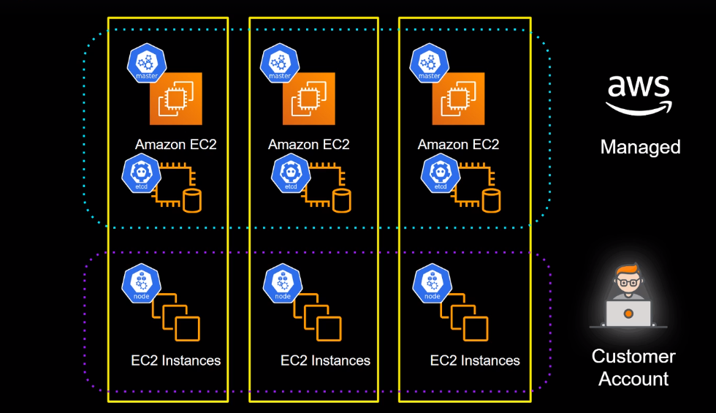

Cost of EKS

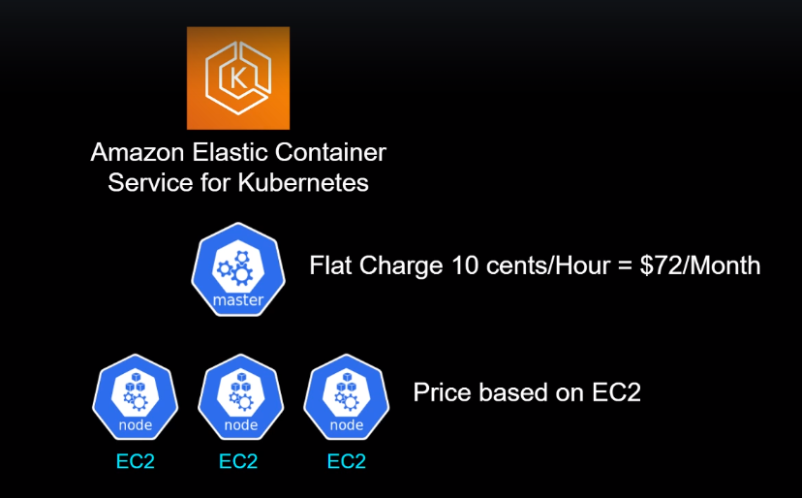

<https://calculator.aws/#/addService>

Ways to Spin Up Cluster

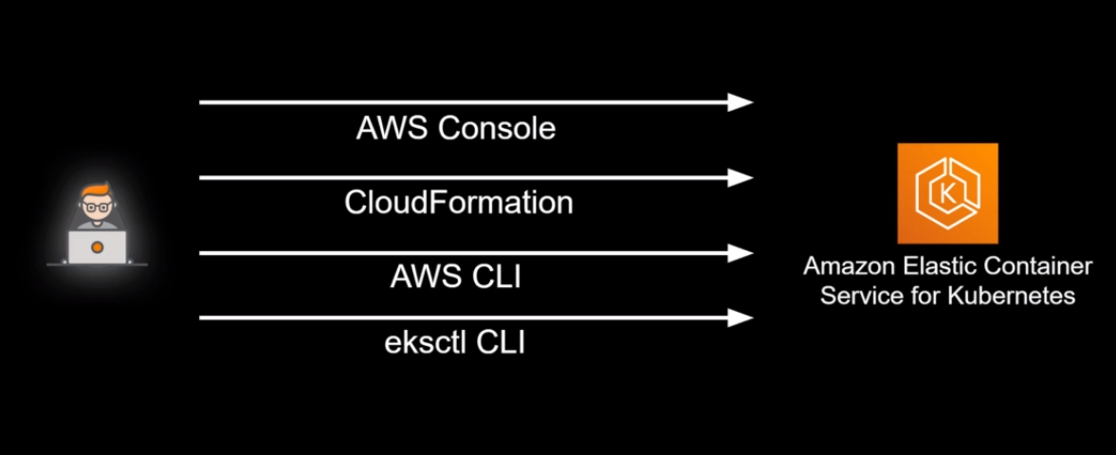

Intro to eksctl

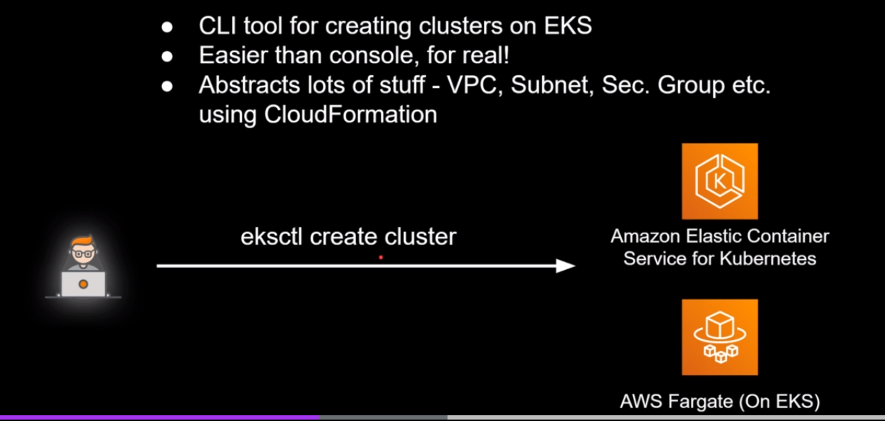

Commands:

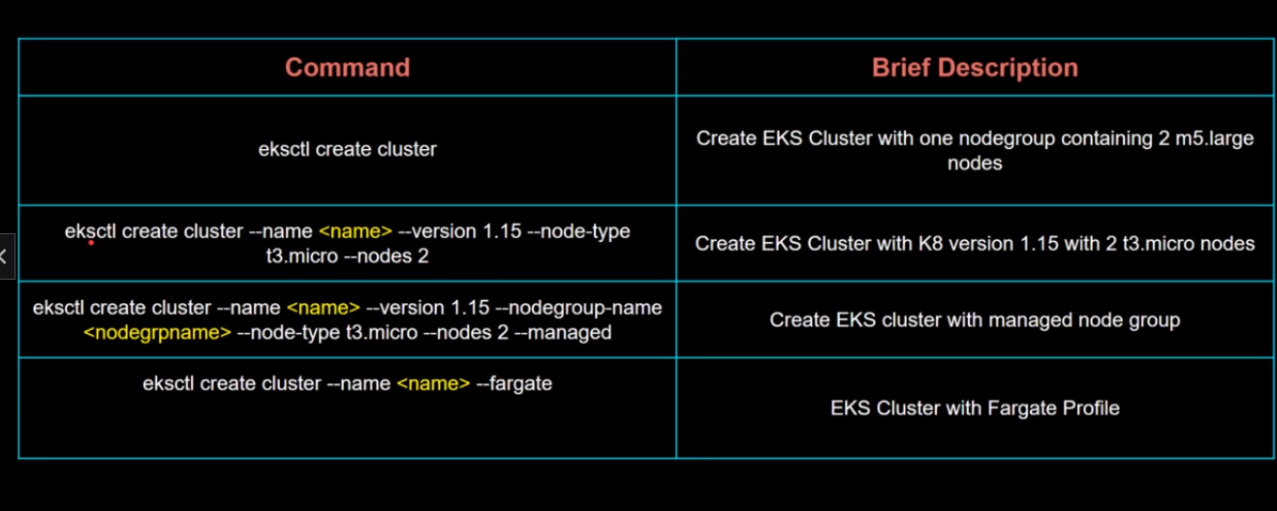

Feature:

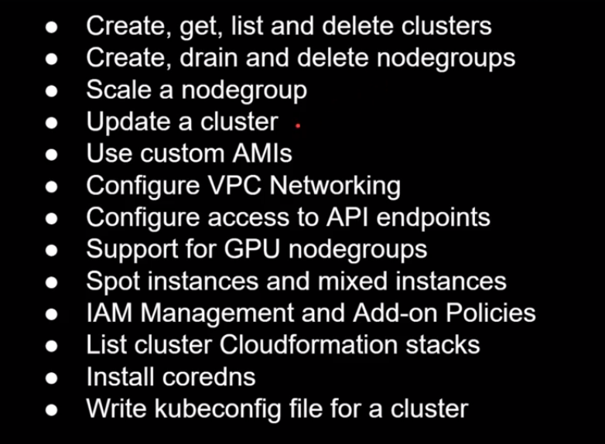

Intro to kubectl

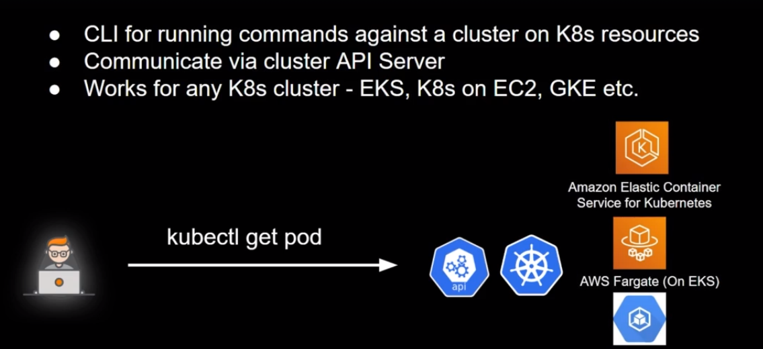

Install AWS CLI and Configure

<https://docs.aws.amazon.com/cli/latest/userguide/getting-started-install.html>

Install Kubectl

<https://docs.aws.amazon.com/eks/latest/userguide/install-kubectl.html>

Install Eksctl

<https://docs.aws.amazon.com/eks/latest/userguide/eksctl.html>