## Lacrosse WS2500/WS7000 Protocol

Signals are transmitted on 433MHz, AM (Amplitude Modulation), OOK (On/Off Keying):

On = signal 1

Off = signal 0

Bit0 encoding: length of each bit is #1200uS, #800uS On and #400uS Off:

Bit1 encoding: length of each bit is #1200uS, #400uS On and #800uS Off:

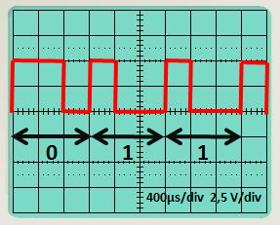

Messages are sent as nibbles (4 bits) with LSB sent first,

so we have to reverse the received bits of each nibble.

For example if we receive 1010, reversed it becomes 0101 = 5

## Message Layout



A frame is composed of a preamble followed by nibbles (4 bits) separated by a bit “1”.

Preamble: 10x bit “0”

Sensor Type: Value 0..9 determing the sensor type

0 = WS7000-27/28 Thermo sensor ( interval 177s - Adr * 0.5s )

1 = WS7000-22/25 Thermo/Humidity sensor ( interval 177s - Adr * 0.5s )

2 = WS7000-16 Rain sensor ( interval 173s - Adr * 0.5s )

3 = WS7000-15 Wind sensor ( interval 169s - Adr * 0.5s )

4 = WS7000-20 Thermo/Humidity/Barometer sensor ( interval 165s - Adr * 0.5s )

5 = WS2500-19 Brightness sensor ( interval 161s - Adr * 0.5s )

Address: Value 0..7 for the sensor address

In case of a negative temperature the MSB of the Address becomes “1”

Data: Nibbles with BCD encoded sensor data values.

XOR: Nibble holding XOR of the ST ^ A ^ DATA-Nibble’s

Checksum: Sum of all nibbles + 5 ( ST + A + NIBBLE(0) + .. + NiBBLE(n) + XOR + 5 ) & 0xF

**Example WS2500-19 brightness sensor**

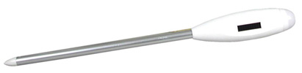

**Each frame is 66 bits long**

**Message**



The 1st bit of each nibble is in LSB, so we have to reverse the 4 bits of each nibble.

The active values of the sensor is coloured in green in the following tables:



|  |  |  |  |  |  |  |
| --- | --- | --- | --- | --- | --- | --- |
| BCD x1 Lux | x10 Lux | x100 Lux |  | Factor x1 Min | x10 Min | x100 Min |

Check Xor : (5 ^ 7 ^ 8 ^ 2 ^ 5 ^ 2 ^ 9 ^ 9 ^ 8 ) = 7  
Checksum : ((5 + 7 + 8 + 2 + 5 + 2 + 9 + 9 + 8 + 7) + 5 ) & 0xF = 9

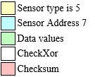

**Results:**

Brightness 528x102 lux

Exposition 899 minutes

**Lacrosse WS7000-20 meteo sensor**

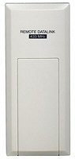

**Each frame is 81 bits long.**



**Message**



The 1st bit of each nibble is in LSB, so we have to reverse the 4 bits of each nibble.

The active values of the sensor is coloured in green in the following tables:



BCD +/-  oC 0.1 oC 1 oC 10 oC 0.1% 1% 10% 1hPa 10hPa 100hPa null

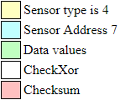

**Results:**

Temperature : **-**25.4 oC

Humidity: 47.9 %

Pressure 795 hPa (+ offset 200 hPa) = 995hPa

**Example WS7000-16 Rain Sensor**

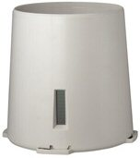

**Each frame is 46 bits long**



**Message**



The 1st bit of each nibble is in LSB, so we have to reverse the 4 bits of each nibble.



Nibble3 Nibble2 Nibble1

Check Xor : (2 ^ F ^ E ^ 2 ^ B ^ A) = 0  
Check Sum : (const5 + 2 + F + E + 2 + B + A) and F = B

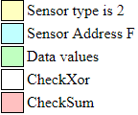

Rain =  MSN<<8 + MID<<4 + LSN = 0xB2E = 2862

This sensor sends a value of number the internal cup tilts between two transmissions.

Every time it increments 0.3mm rain

**Lacrosse WS7000-15 wind sensor**

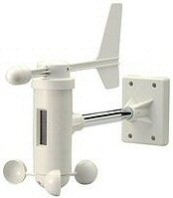

**Each frame is 61 bits long**



**Message**



The 1st bit of each nibble is in LSB, so we have to reverse the 4 bits of each nibble.

The active values of the sensor is coloured in green in the following tables:



sensor address x0.1kmh x1kmh x10kmh x1 o x10 o 8=1000

bit 3&4 = x100 o and bit 2&1=deviation (0=± 0 °, 1 = ± 22,5 °, 2 = ± 45 °, 3 = ± 67,5 °)

Check Xor : (3 ^ 7 ^ 5 ^ 2 ^ 1 ^ 0 ^ 0 ^ 8 ^ A) = 0  
Check Sum : (const5 + 3 + 7 + 5 + 2 + 1 + 0 + 0 + 8 + A) and F = 9

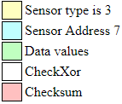

**Results in:**

Windspeed: 12.5 km/h

Direction: 200 deg ± 0.1 deg