**GH95 (AfcA)**

>AAQ72464.1 alpha-fucosidase [Bifidobacterium bifidum JCM 1254]   
MKHRAMSSRLMPLVASCATVGMLLAGLPVSAVAVGTTRAAASDASSSTTATITPSADTTLQTWTSEKNSS   
MASKPYIGTLQGPSQGVFGEKFESTDAADTTDLKTGLLTFDLSAYDHAPDSATFEMTYLGYRGNPTATDT   
DTIKVTPVDTTVCTNNATDCGANVATGATKPKFSINDSSFVAESKPFEYGTTVYTGDAITVVPANTKKVT   
VDVTEIVRQQFAEGKKVITLAVGETKKTEVRFASSEGTTSLNGATADMAPKLTVSVSTKDDLKPSADTTL   
QAWASEKNEKKNTAAYVGALQPEGDYGDFGEKFKSTDVHDVTDAKMGLMTFDLSDYTAAPEHSILTLTYL   
GYAGADKTATATDKVKVVAVDTSRCTGTAPCDTNNATWANRPDFEVTDTTKTATSHAFAYGSKKYSDGMT   
VESGNAKKVLLDVSDVIKAEFAKFSAGATEKKITLALGELNKSDMRFGSKEVTSLTGATEAMQPTLSVTK   
KPKAYTLSIEGPTKVKYQKGEAFDKAGLVVKATSTADGTVKTLTEGNGEDNYTIDTSAFDSASIGVYPVT   
VKYNKDPEIAASFNAYVIASVEDGGDGDTSKDDWLWYKQPASQTDATATAGGNYGNPDNNRWQQTTLPFG   
NGKIGGTVWGEVSRERVTFNEETLWTGGPGSSTSYNGGNNETKGQNGATLRALNKQLANGAETVNPGNLT   
GGENAAEQGNYLNWGDIYLDYGFNDTTVTEYRRDLNLSKGKADVTFKHDGVTYTREYFASNPDNVMVARL   
TASKAGKLNFNVSMPTNTNYSKTGETTTVKGDTLTVKGALGNNGLLYNSQIKVVLDNGEGTLSEGSDGAS   
LKVSDAKAVTLYIAAATDYKQKYPSYRTGETAAEVNTRVAKVVQDAANKGYTAVKKAHIDDHSAIYDRVK   
IDLGQSGHSSDGAVATDALLKAYQRGSATTAQKRELETLVYKYGRYLTIGSSRENSQLPSNLQGIWSVTA   
GDNAHGNTPWGSDFHMNVNLQMNYWPTYSANMGELAEPLIEYVEGLVKPGRVTAKVYAGAETTNPETTPI   
GEGEGYMAHTENTAYGWTAPGQSFSWGWSPAAVPWILQNVYEAYEYSGDPALLDRVYALLKEESHFYVNY   
MLHKAGSSSGDRLTTGVAYSPEQGPLGTDGNTYESSLVWQMLNDAIEAAKAKGDPDGLVGNTTDCSADNW   
AKNDSGNFTDANANRSWSCAKSLLKPIEVGDSGQIKEWYFEGALGKKKDGSTISGYQADNQHRHMSHLLG   
LFPGDLITIDNSEYMDAAKTSLRYRCFKGNVLQSNTGWAIGQRINSWARTGDGNTTYQLVELQLKNAMYA   
NLFDYHAPFQIDGNFGNTSGVDEMLLQSNSTFTDTAGKKYVNYTNILPALPDAWAGGSVSGLVARGNFTV   
GTTWKNGKATEVRLTSNKGKQAAVKITAGGAQNYEVKNGDTAVNAKVVTNADGASLLVFDTTAGTTYTIT   
KKASANVPVTGVTVTGANTATAGDTVTLTATVAPANATDKSVTWSTSDAAVATVNANGVVTTKKAGKVTI   
TATSNGDKTKFGSIEITVSAATVPVTSVTVAGDAAMTVDGEQTLTATVAPATATDKTVTWKSSDATVATV   
DANGKVVAKKAGEVTITATAGGVSGTLKITVSDKAPTVIPVQSVTVTGKQELVEGASTTLTATVAPADAT   
DKTVTWKSSDESVATVDKDGVVTAKKAGTVTITATAGGVSGTLHITVTAKPVETVPVTSVEVTVEAGTTV   
SVGKTLQATATVKPGNATNKKVTWKSSDESIATVDANGVITAKKAGKVVITATSTDGTDKSGSVEITVVD   
ETKPTPDHKSVKADTGDVTAGKTGTVTEPKDVAGWKSRSIIKQGKLGKAEIADGTLVYAAGDKTGDDSFV   
VQYTMADGTVIDVTYSVTVKAAETGKNDGDGKGDGVAKTGAAVGALAGLGLMLLAVGVSVVMIRRKHSA

**Estrutura da proteína**

**Terciária (PDB) :** [**https://www.rcsb.org/structure/2eab**](https://www.rcsb.org/structure/2eab)

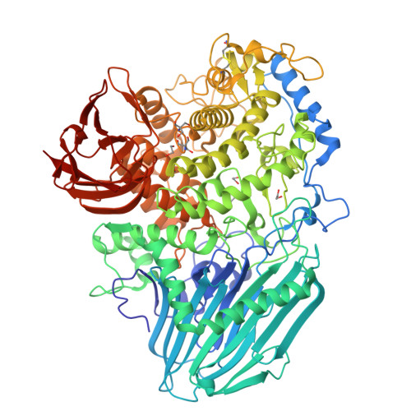

**Secundária: não consegui no [http://bioinf.cs.ucl.ac.uk/psipred/](http://bioinf.cs.ucl.ac.uk/psipred/" \t "_blank)** (sequencia é muito longa)

NetSurfP: [**https://services.healthtech.dtu.dk/cgi-bin/webface2.cgi?jobid=673E5EB7000B7D942790E1BB&wait=20**](https://services.healthtech.dtu.dk/cgi-bin/webface2.cgi?jobid=673E5EB7000B7D942790E1BB&wait=20)

**Relative Surface Accessibility:**  Red is exposed and blue is buried, thresholded at 25%.  
**Secondary Structure:**  Helix,  Strand,  Coil.  
**Disorder:**  Thickness of line equals probability of disordered residue.

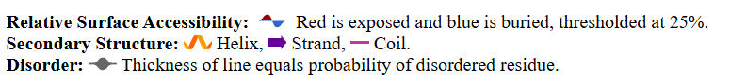

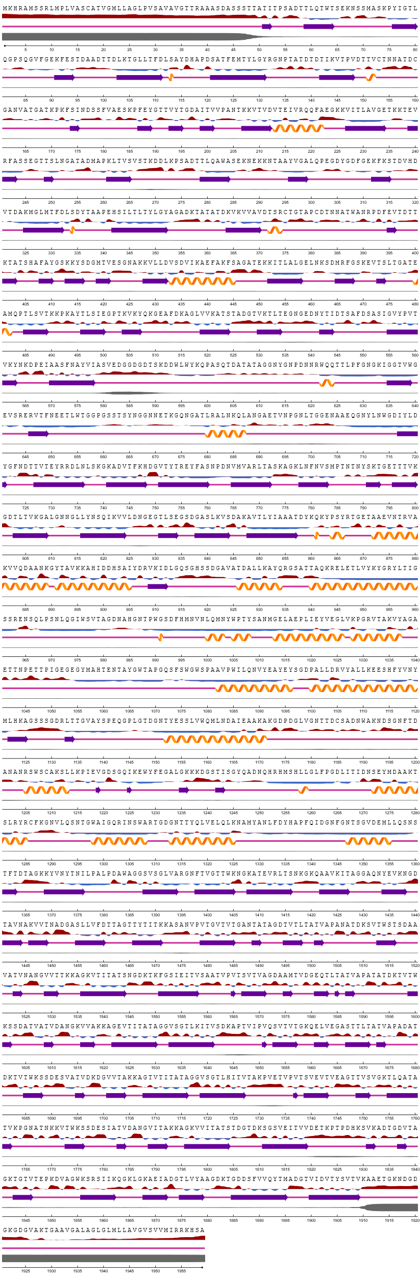

 Predict their theoretical molecular weight and isoelectric point: - ProtParam <https://web.expasy.org/protparam/>)

**Number of amino acids:** 1926

**Molecular weight:** 202159.02

**Theoretical pI:** 5.30

Top of Form

**Amino acid composition:**

Ala (A) 220 11.4%

Arg (R) 36 1.9%

Asn (N) 101 5.2%

Asp (D) 129 6.7%

Cys (C) 7 0.4%

Gln (Q) 46 2.4%

Glu (E) 86 4.5%

Gly (G) 185 9.6%

His (H) 20 1.0%

Ile (I) 56 2.9%

Leu (L) 107 5.6%

Lys (K) 145 7.5%

Met (M) 24 1.2%

Phe (F) 41 2.1%

Pro (P) 60 3.1%

Ser (S) 138 7.2%

Thr (T) 259 13.4%

Trp (W) 29 1.5%

Tyr (Y) 68 3.5%

Val (V) 169 8.8%

Pyl (O) 0 0.0%

Sec (U) 0 0.0%

(B) 0 0.0%

(Z) 0 0.0%

(X) 0 0.0%

Bottom of Form

**Total number of negatively charged residues (Asp + Glu):** 215

**Total number of positively charged residues (Arg + Lys):** 181

**Atomic composition:**

Carbon C 8830

Hydrogen H 13949

Nitrogen N 2395

Oxygen O 2969

Sulfur S 31

**Formula:** C8830H13949N2395O2969S31

**Total number of atoms:** 28174

**Extinction coefficients:**

Extinction coefficients are in units of M-1 cm-1, at 280 nm measured in water.

Ext. coefficient 261195

Abs 0.1% (=1 g/l) 1.292, assuming all pairs of Cys residues form cystines

Ext. coefficient 260820

Abs 0.1% (=1 g/l) 1.290, assuming all Cys residues are reduced

**Estimated half-life:**

The N-terminal of the sequence considered is V (Val).

The estimated half-life is: 100 hours (mammalian reticulocytes, in vitro).

>20 hours (yeast, in vivo).

>10 hours (Escherichia coli, in vivo).

**Instability index:**

The instability index (II) is computed to be 16.00

This classifies the protein as stable.

**Aliphatic index:** 69.88

**Grand average of hydropathicity (GRAVY):**-0.360

**Domínios Transmembranares**

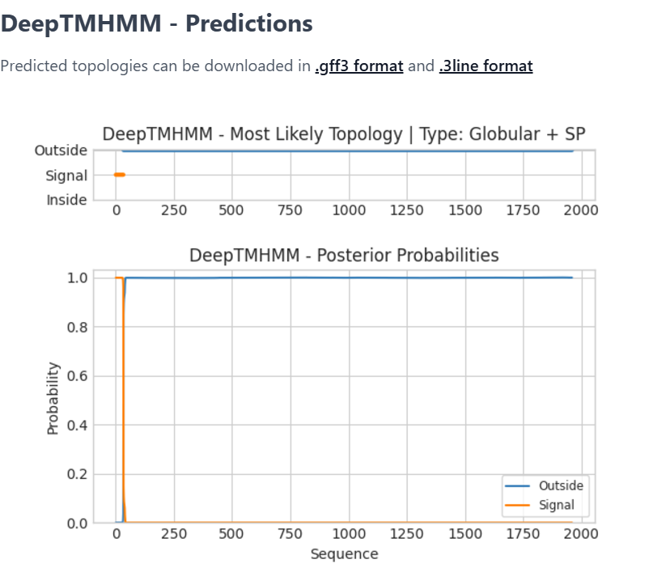

**Localização Subcelular:**

Target P: [https://services.healthtech.dtu.dk/cgi-bin/webface2.cgi?jobid=673E615E000B80149549A2DC&wait=20](https://services.healthtech.dtu.dk/cgi-bin/webface2.cgi?jobid=673E615E000B80149549A2DC&wait=20" \t "_blank)

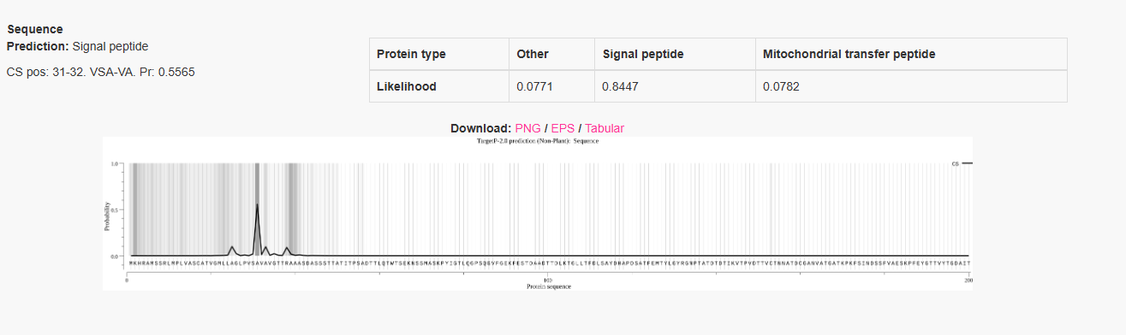

Cell-PLoc 2.0 : <http://www.csbio.sjtu.edu.cn/cgi-bin/GposmPLoc.cgi>

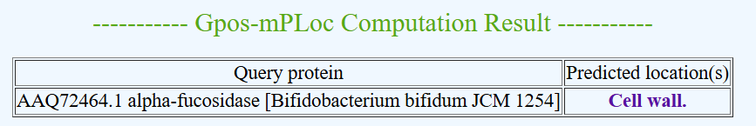

PSORTb – Unknown

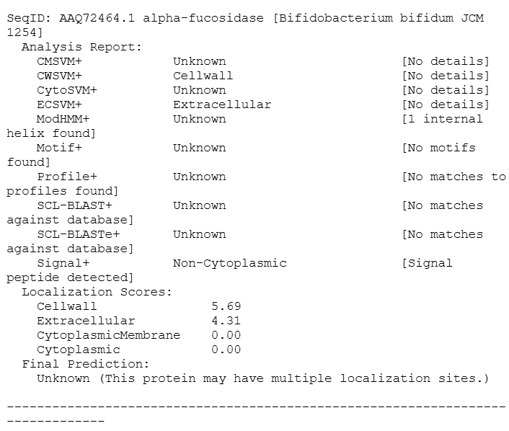

**Blastp**:

Usando UniProtKB/SwissProt

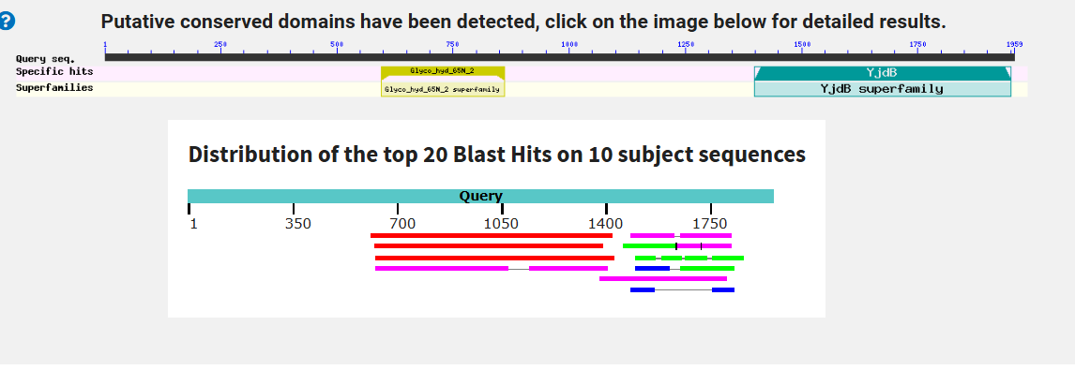

Non-redundant:

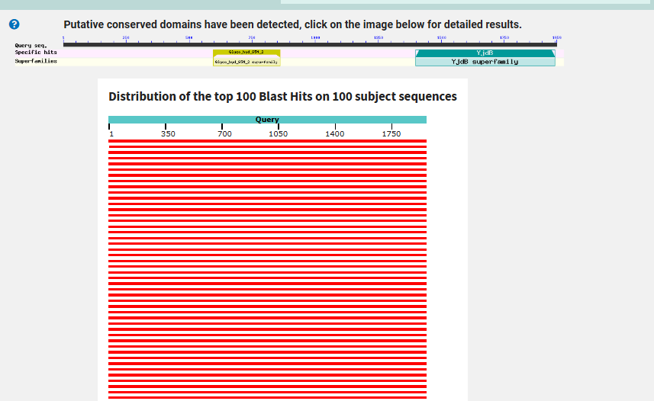

Domínios conservados:

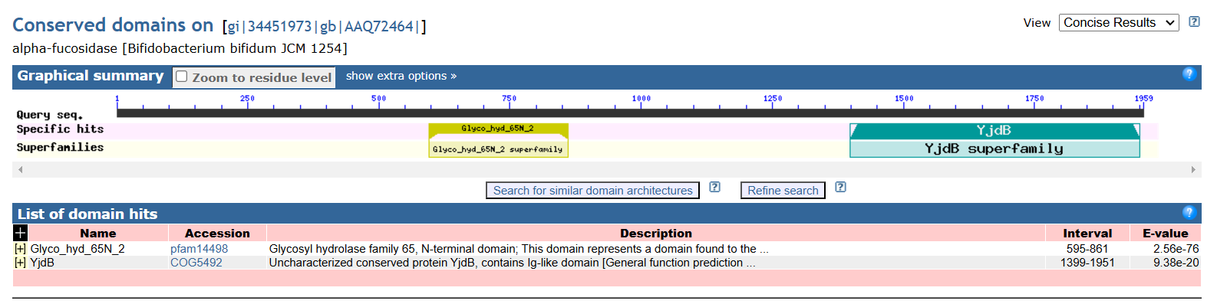

Alinhamento Múltiplo (COBALT)

<https://www.ncbi.nlm.nih.gov/tools/cobalt/cobalt.cgi>

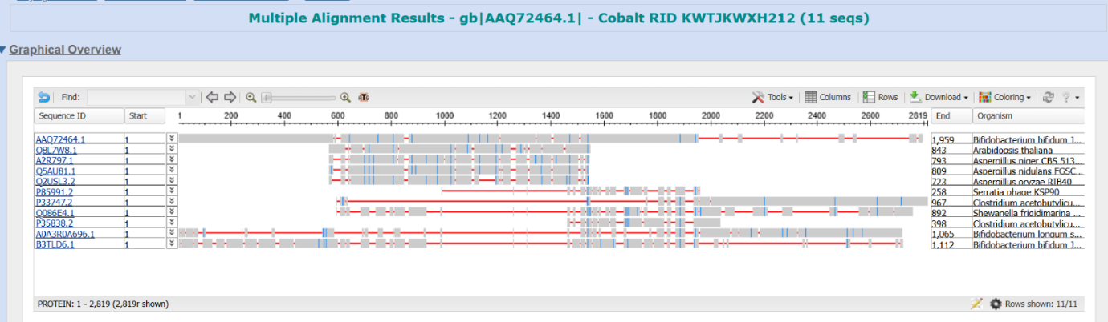

**Modificações pós- traducionais**

Glicosilação (NetNGlyc) : <https://services.healthtech.dtu.dk/cgi-bin/webface2.cgi?jobid=673E68E9000B8841C700DB9B&wait=20>

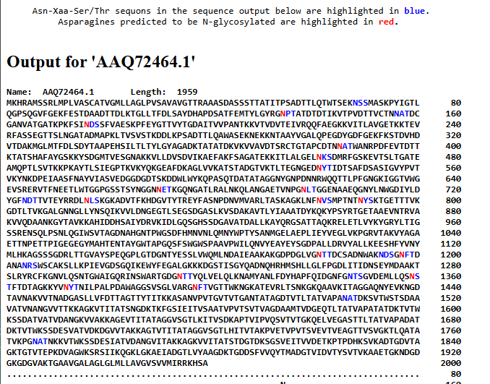

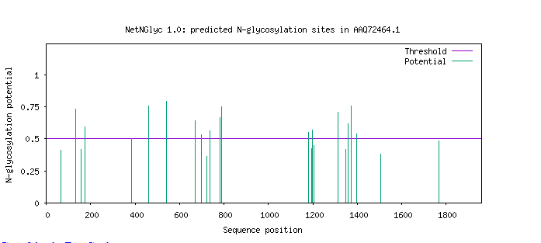

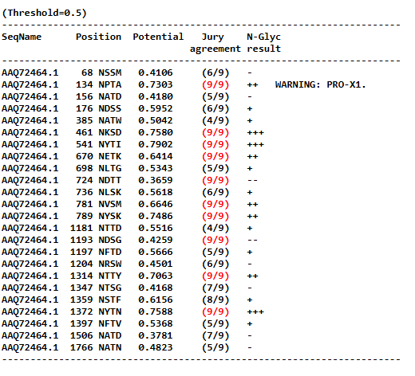

Fosforilação (NetPhos) - <https://services.healthtech.dtu.dk/cgi-bin/webface2.cgi?jobid=673E69FC000B8972E8AE67AD&wait=20>

