Display the information in one table (either table is fine).

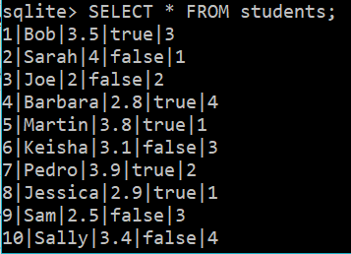

Update an item that meets some condition (you can choose a condition that makes sense).

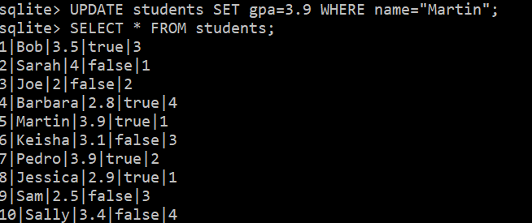

Display the information in both tables using one query.

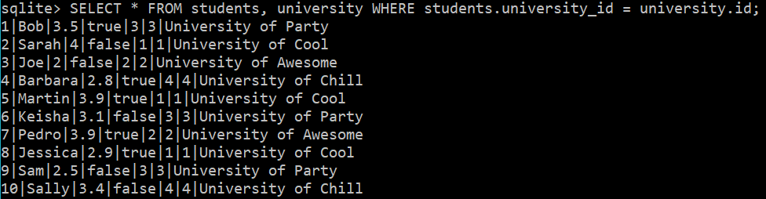

Display a narrower selection of columns (fewer columns than all of them, in other words) from both tables using one query.

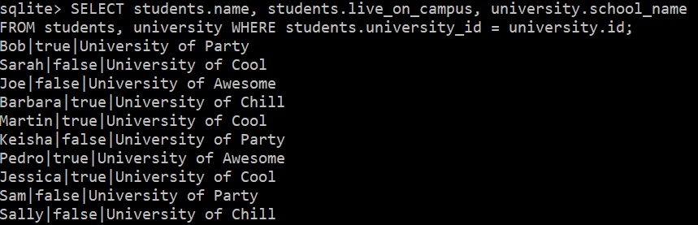

Delete an item that meets some condition (you can choose a condition that makes sense).

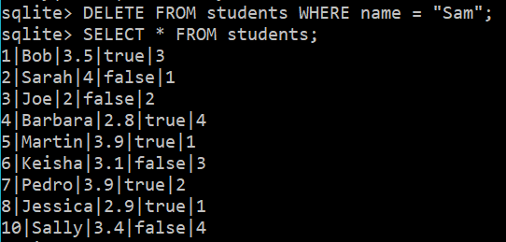

Release 3:

