Katharine LoScalzo

Professor Sigal

Intro to Web Development

12 December 2016

Final Project – “Contemplation”

**Links –**

Site link with my server: <http://sites.bxmc.poly.edu/~katloscalzo/Sounds/WebDev_Final/index.html>

Github link: <https://github.com/kloscalzo/WebDev_Final_Draft>

**Project Goal:** I am going to create a website for poets, artists, and people who are interested in poetry or visual art. This website will connect poets and artists from around the world, providing them with a space to share their work and inspire viewers.

**Purpose:** The purpose of this website is to reconnect our generation with poetry and visual art. Art was so significant in history and as technology advances, people are losing interest in it. I will bridge the gap between art and technology (and art and the people) by creating a website that supports artistry and creativity. Just as Instagram creates a platform for people to share photos, my website will provide a platform for users to share their poems and visual art. However, the website will focus on poetry.

**Audience:** The target audience for this website is teenagers, young adults, parents, and grandparents. I would like kids to submit and view poetry and art to explore their creativity sooner and for older people to reconnect or to discover their love of such.

**Competitive Analysis:** Sites like Instagram and Tumblr are similar to my website because users can submit their own art, view other pieces, and follow favorite accounts. However, my site will be different because its main focus is poetic content, whereas these popular apps/sites call for photographs or gifs. My website will be branded as largely a poetry site with an option to share personal art. It will be differentiated by the importance it plays on diversity of writing: simplicity, complexity, realism, fantasy, and much more. It will be a safe space for self-expression, with the choice of remaining anonymous or compiling a personal portfolio.

**Content Inventory:** My site will contain a lot of poetic, stylistic writing and images of self-made art. There will be 12 types of poems in the following categories: Love, Self, Loss, Jealousy, Fantasy, Fear, Nature, Religion, Culture, Family, Friendship, and Lust. Should a poem fit into multiple categories, it will appear in at most three, minimum of one. Initially I thought the poet’s words could speak for themselves, but I want to allow the user to feel limitless in their expression (although in actuality, restrictions will apply: videos will not be permitted). I will consider allowing the user to add images to their poems.

**Technical Requirements:** I will have a home page and 5 other main pages that a user can find through the main navigation bar. On the poem page, the poem categories will be circular buttons that when pressed, will take a user to that specific poem genre. Furthermore, I will have fun animations with key icons of my website – a quill pen and a candle. The clip art icons may run to the side or disappear and reappear.

**Creative Brief:** My site will not be crowded with words. It will be largely violet, ivory, beige/yellow, and black. There will be consistent black icons: a quill and a candle. Fonts will vary.

**Future Iterations:** Once the fundamentals of my website have been created and solidified, I will start to add more interesting updates. I will potentially allow for the user to add a photo that correlates to their poetry if they feel it will enhance their work or add meaning. Perhaps they can add music to match the tone of their poem as well, but that update will be one of the finishing touches, or “icing on the cake”.

**Risks:** I do not yet know how to code personal profiles for users, which is a major part of this site.

**Sitemap:**

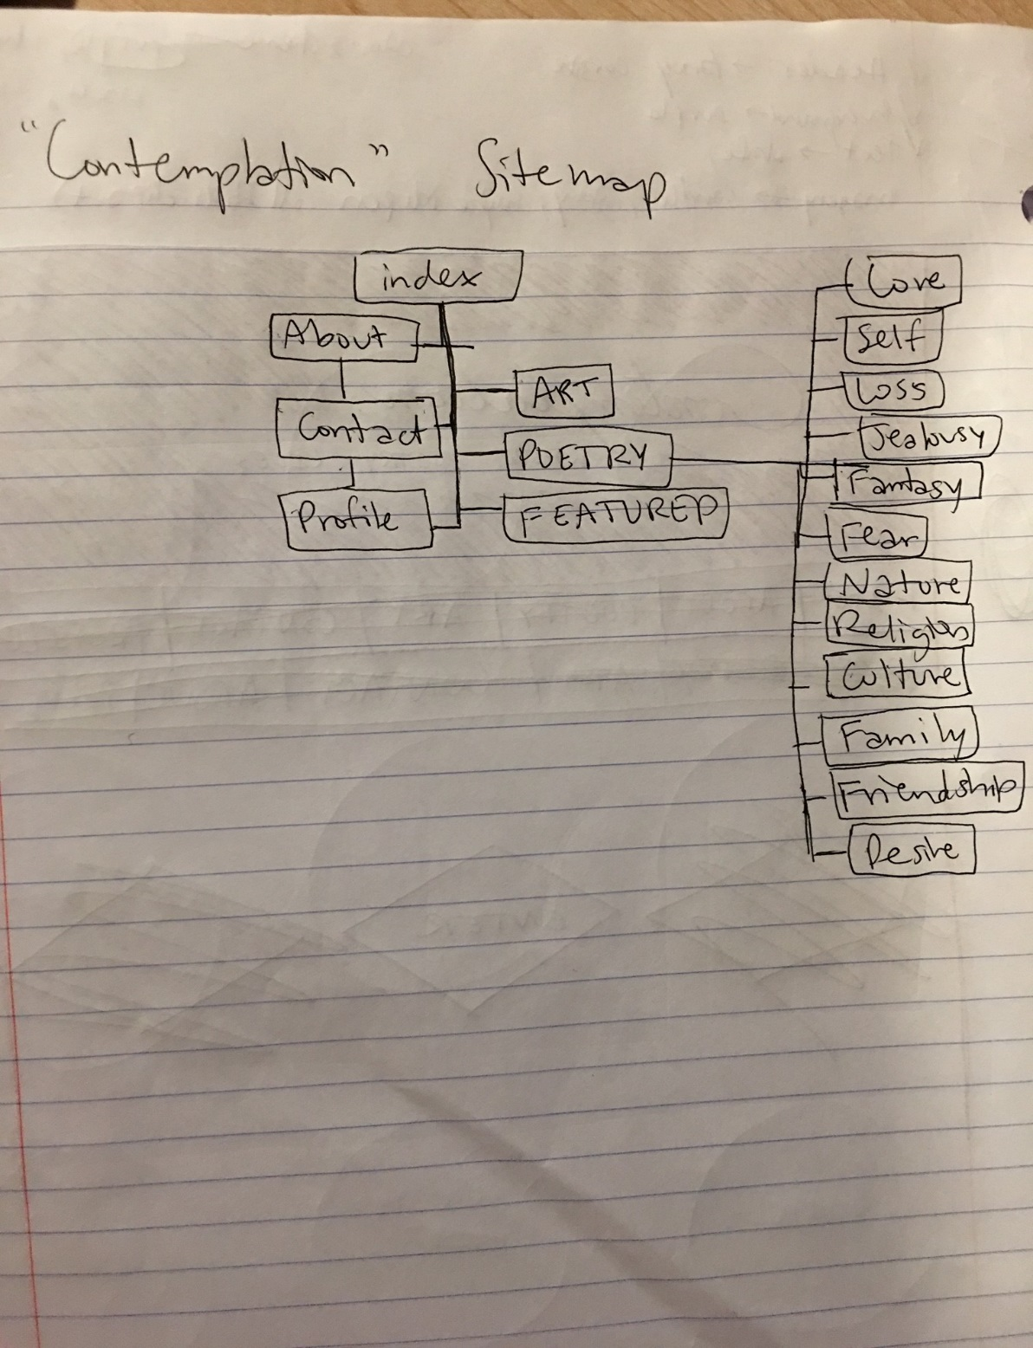

**Wireframe –**

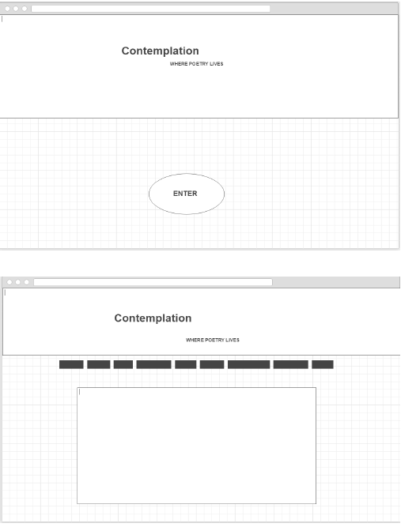

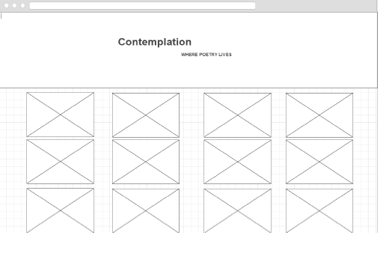

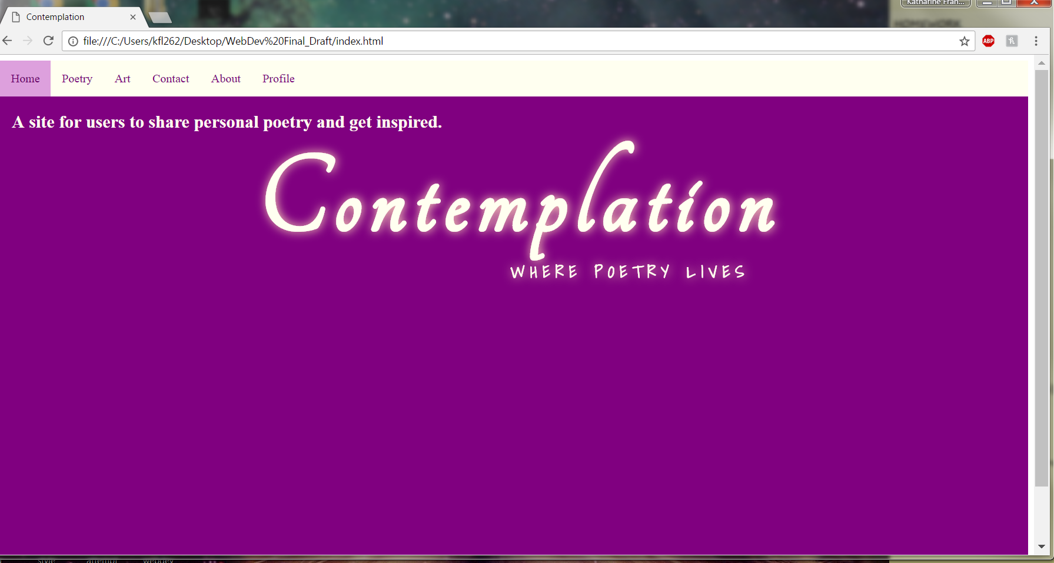

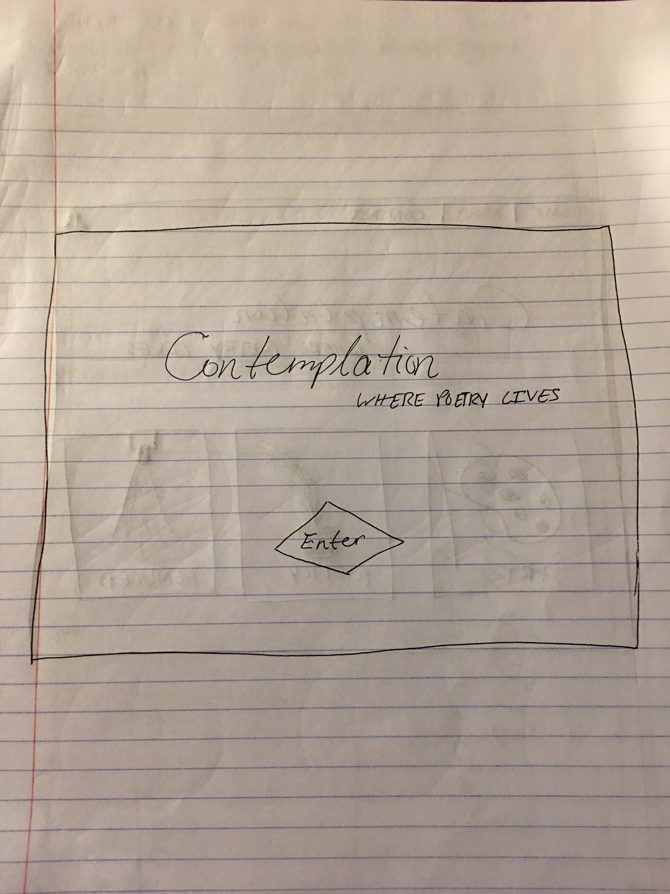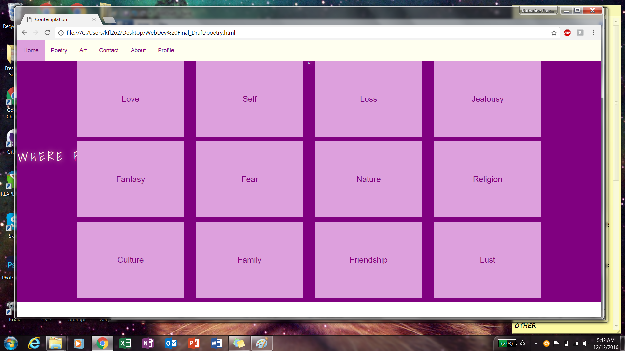

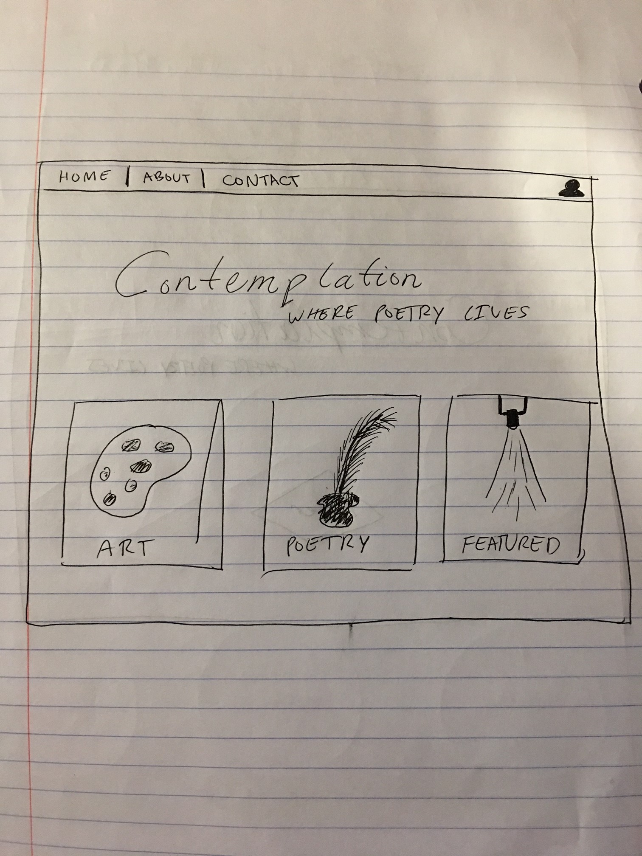

**Style Guide:**

Colors: Purple, Black, Ivory, Beige

Fonts: Tangerine, Shadows Into Light, Open Sans, Times New Roman

* From Google Fonts

Background -



Poetry Category Button –

