CS 452 Project -- Simulation: Token-Ring Communication

Monica Klosin

**Idea of how project will run:**

1. **run ./makeFile.exe**
2. **ask use for length of token ring, val word needs to go to, and word, and display users input and test values**
3. **Test that the values are valid**
4. **idea of output:**

PID 1111 – Process 1

I wrote: value

_____________

PID 1112 – Process 2

I Read: value

I write: value

_____________

PID 1113 – Process 3

I Read: value

I write: value

_____________

PID 1114 – Process 4

I Read: nothing

I write: nothing

_____________

Enter process ring length, process Word gets sent to, word:

1. **To exit, user types ^C, show that all PIDs get closed**

Enter process ring length, process Word gets sent to, word: ^C

PID 1111 shutting down

PID 1112 shutting down

PID 1113 shutting down

PID 1114 shutting down

How it works in my head:

In the program I parse user input to get the length of the token ring (X), where the message needs to get sent to, and the word.

After the program creates X amount of PIDs along with piping the previous write to the current read.

then loops from process to process.

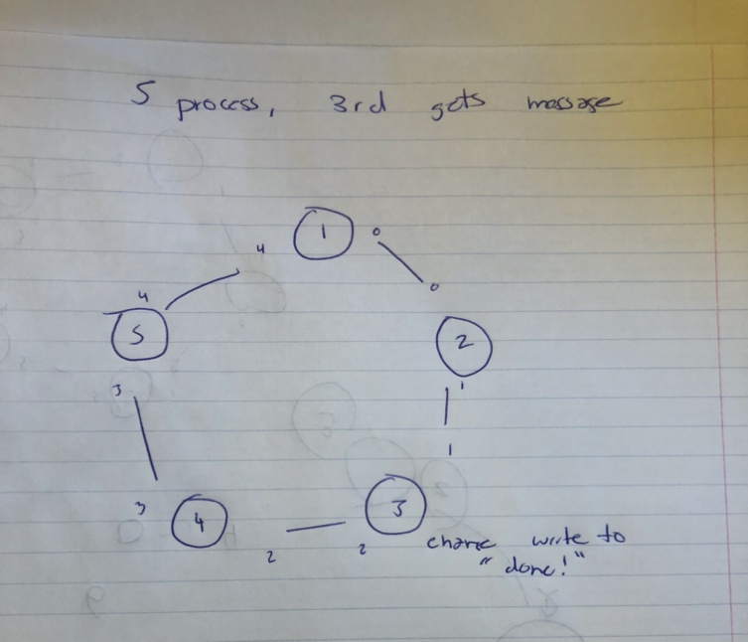

“make” command:

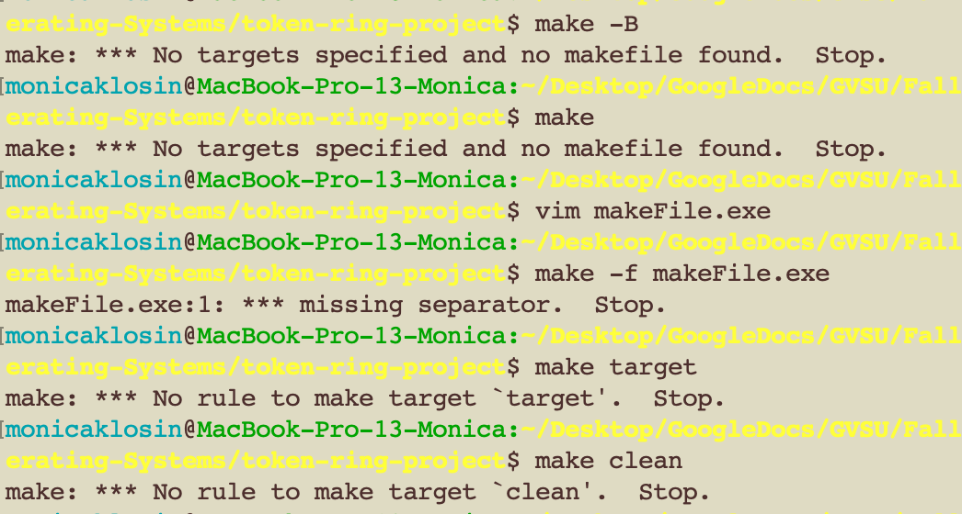

I was unsuccessful in making the “make” command run my makefile.exe.

To run my program, you must in the command line type, “./makefile.exe”

version 2:

I was able to correctly spawn the right number of children asked by user, but had issues making the pipes.

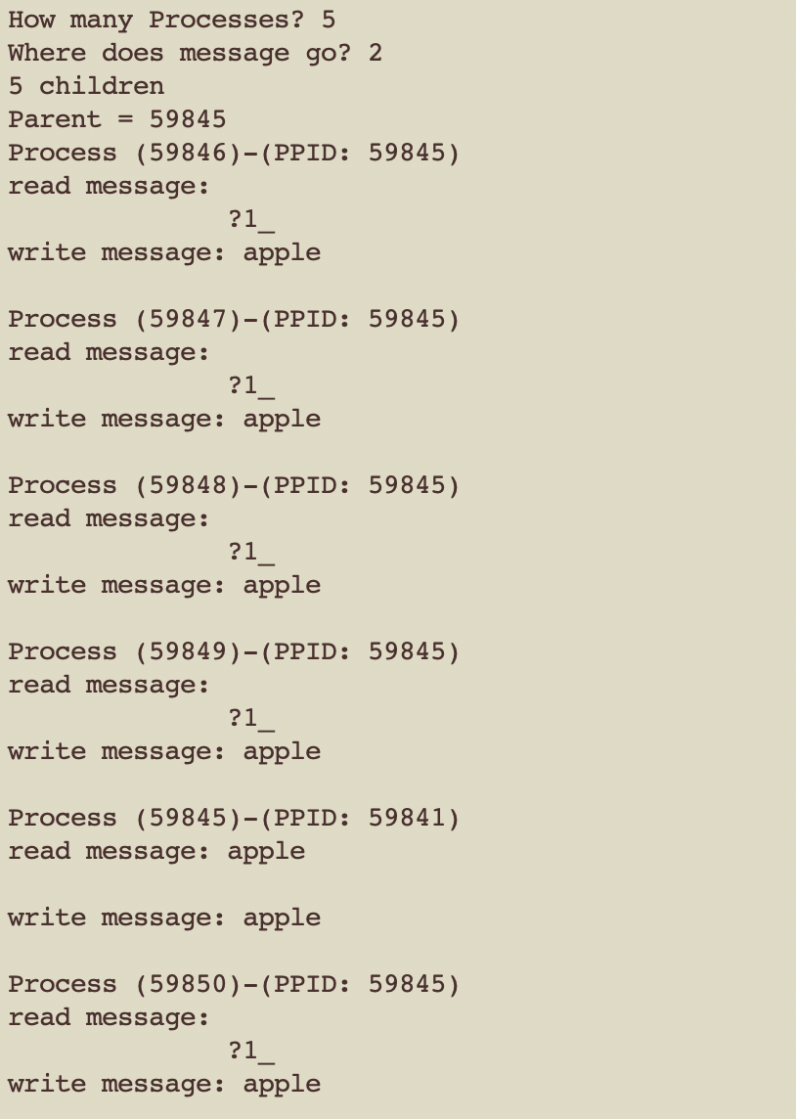

version 5: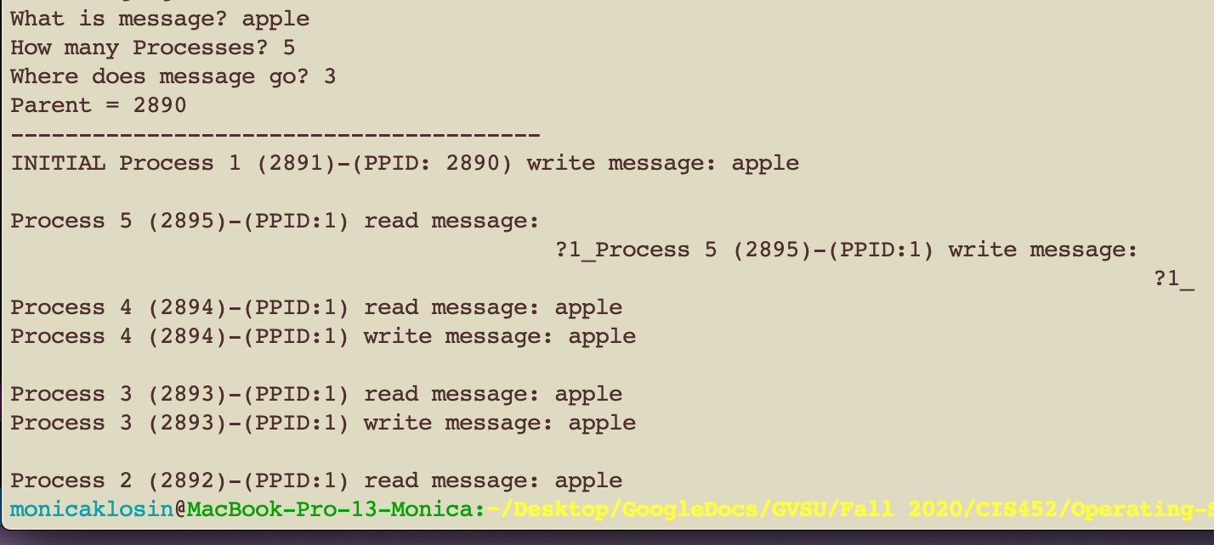

I had it reading backwards for some reason, I wasn’t able to retrieve how I did this version in time to submit this version (rip version).

version submitted:

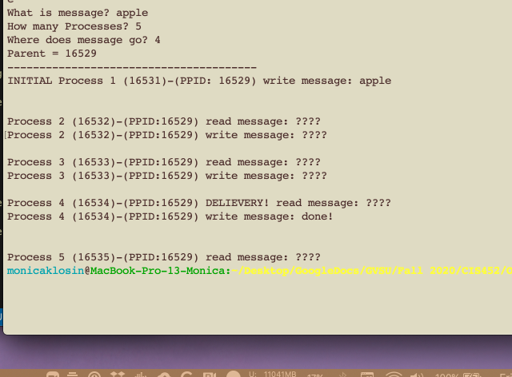

**edit : thank you Professor for letting me turn in my right version from last night, I appreciate it! Also thank you for helping me getting it to work – it makes a lot more sense conceptually now.**