

Terraform

IAC

kloudblogs.com

# Introduction :

Terraform is an infrastructure as code tool that lets you build, change and version infrastructure safely and efficiently. This includes low level components like compute instances, storage and networking; and high-level components like DNS entries and SaaS features.

# Installation:

1. To install terraform on your OS , please visit the official website. You can download the binaries required for your OS from

<https://developer.hashicorp.com/terraform/install>

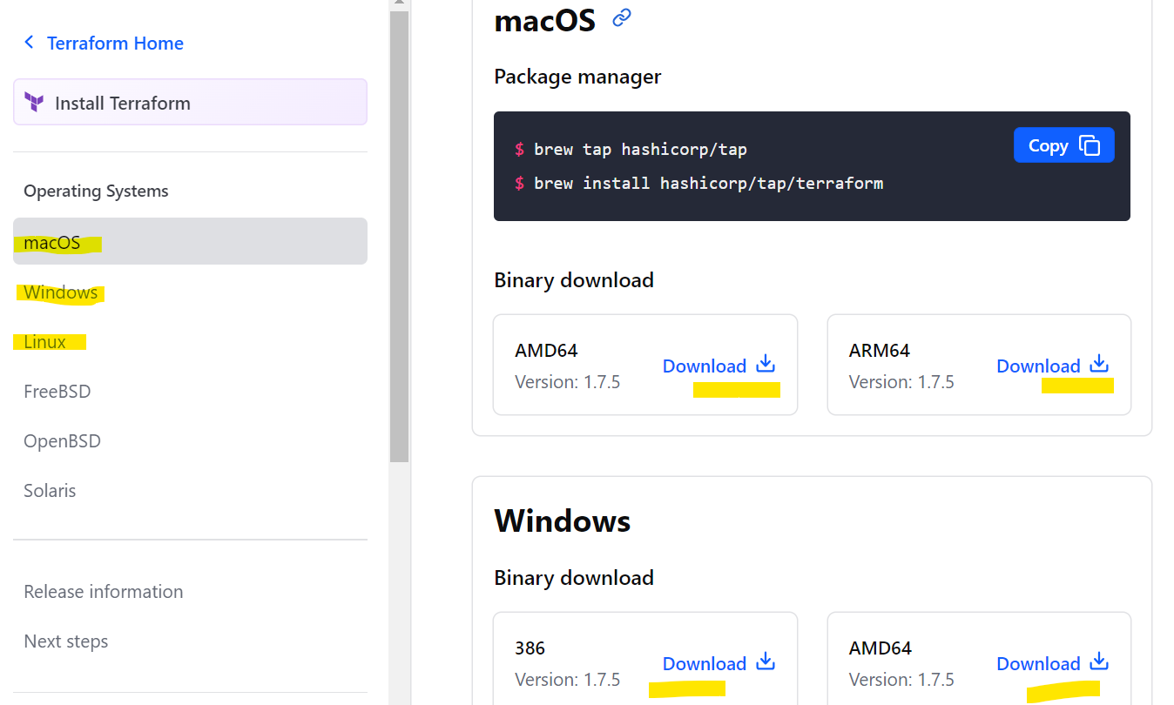

1. After downloading set the path so that you can access terraform from anywhere in your system.

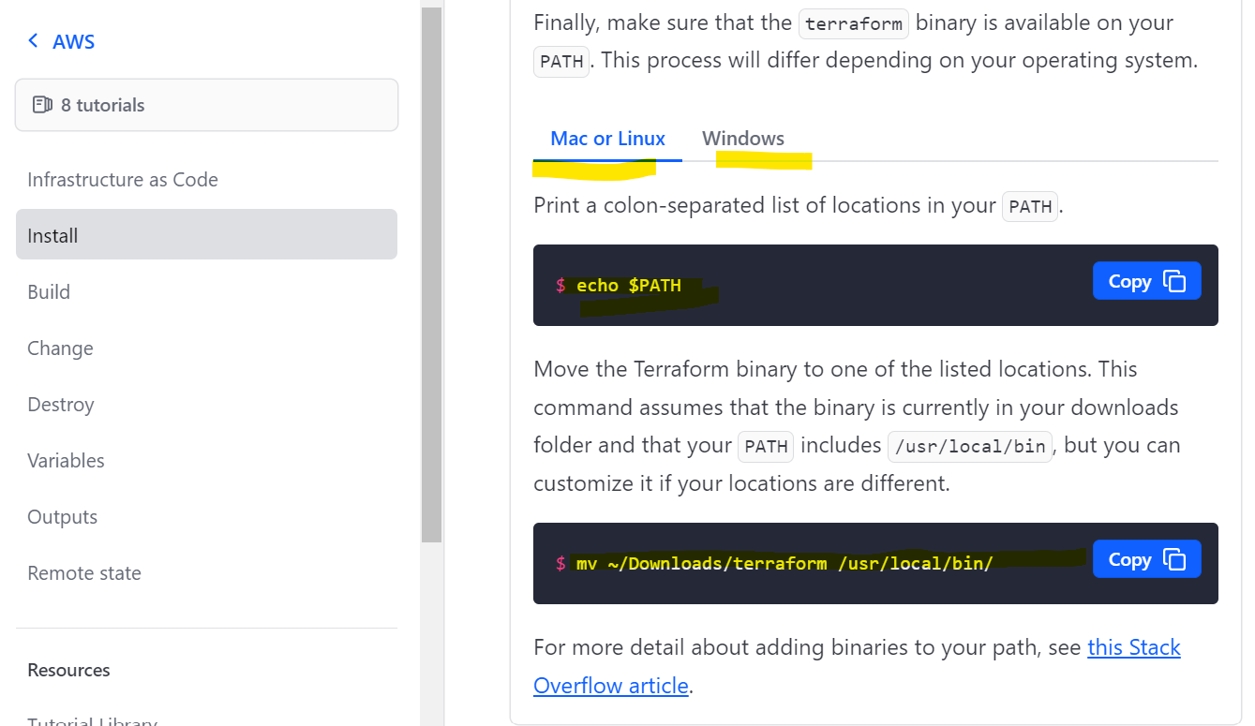

1. In windows operating system setting path is little different. Please follow below suggestions
2. Go to Control Panel -> System -> System settings -> Environment Variables.
3. Scroll down in system variables until you find PATH.
4. Click edit and change accordingly.
5. BE SURE to include a semicolon at the end of the previous as that is the delimiter, i.e. c:\path;c:\path2
6. Launch a new console for the settings to take effect.
7. Once installation is done, it can be verified by running

**terraform -help** from your cli.

