Business Requirement Document of GRC Green ERP

Date: 22/10/2019

Kloudrac Software Pvt. Ltd.

Author: Gaurav Saraswat

Document Version 1.0



1. Introduction 4

1.1 Purpose 4

1.1.1 Current vs. Future state of the business 4

1.2 Project Participants 5

1.3 Document Approvals and Sign off 5

GRC 5

Kloudrac 5

1.4 Organization Hierarchy 5

2. Project Modules 6

2.1 Organisation Management 7

2.1.1 Business Process Description 7

2.1.2 Business Process Flow 8

2.1.3 Requirement from “To Be System” 8

2.1.4 Open Points 8

2.1.5 Out of Scope 8

2.1.6 Suggested Fields of Campaigns 8

2.1.7 Prototype 1

2.2 Project Management 0

2.2.1 Business Process Description 0

2.2.2 Business Process Flow 2

2.2.3 Requirement from “To Be System” 2

2.2.4 Open Points 2

2.2.5 Prototype 3

2.3 Task Management 3

2.3.1 Business Process Description 3

2.3.2 Requirement from “To Be System” 4

2.3.3 Open Points 4

2.3.4 Prototype 5

2.4 User Management 5

2.4.1 Business Process Description 5

2.4.2 Role Hierarchy 6

2.4.3 Requirement from “To Be System” 6

2.4.4 Open Points 6

2.4.5 Prototype 7

2.5 Reports and Dashboards 7

2.5.1 Business Process Description 7

2.5.2 Requirement from “To Be System” 8

2.5.3 Open Points 8

2.5.4 Prototype 8

2.6 ERP Deployment Architecture 9

2.7 Technological Limitations and Constraints 9

2.1 Resolution Table 10

2.2 DB Schemass 10

2.3 Use Cases 16

[UC000] Registration 16

2.3.1 [UC001] Sign in 16

2.3.2 [UC002] Forgot Password 16

[UC003] Dashboard 17

[UC003.1] System Wide Settings 18

[UC004] Add New User 18

[UC005] Add Organisation 20

[UC006] Add Projects 22

[UC007] Add Task 23

# Introduction

## Purpose

The purpose of this Business Requirement Document (“BRD”) is to capture business requirements that are required to design a custom ERP application to handle the project management part of real estate industry projects(including architects, builders etc.), which include the tracking of compliances related to environment, CTE, CTO clearance processes defined by government. The implementation documented here would help GRC to streamline the process of EC, CTE, CTO and GB for their different customers. The document outlines all the aspects and functionalities required to understand processes of GRC’s Green ERP. It covers the major requirements that were discussed/shared by the client in detail.

### Current vs. Future state of the business

|  |  |
| --- | --- |
| **Current** | **Future** |
| **Challenges**   * Earlier there was no software to handle any project complacence part due to which there is a chance for builders to miss out some conditions which needs to be fulfilled as mentioned in the EC Clearance * These processes are being completed using Excel sheets. * Broken Processes * Entering information is more time consuming due to completing the conditions manually * More Manual Data Entry = More time consuming = Increased Data redundancy   **Focus on**   * Streamlining the whole EC, CTE and CTO complacence process. * Maintaining 360° view of the project with the help of reports and dashboards. * Simplified process for maintaining data. | **Solutions**   * Development of Green ERP to streamline the compliance process of the customers who need to have complete tracking of the same and to capture all the relevant details in a single system. * Our focus will be on making the system accurate for capturing all the relevant data as suggested by the client. * Making the system more dynamic according to the requirement of client * ERP ecosystem will be user friendly with a custom UI. * System will also deliver reliable data visibility and protection, ensuring that sensitive information is not lost or compromised. |

## Project Participants

The primary participants in the scoping and design of the ERP are listed in the table below:

## Document Approvals and Sign off

The primary participants in the design and implementation of Salesforce are:

Approvers

|  |  |  |  |  |
| --- | --- | --- | --- | --- |
| Company Name | Contact Names | Designation | Sign off | Sign off Comments |
| GRC | Mr Umang |  |  |  |
|  |  |  |  |
|  |  |  |  |
|  |  |  |  |
| Kloudrac | Anand Walimbe | Project Manager |  |  |
| Kushal Mishra | Customer Success Manager |  |  |
| Gaurav Saraswat | Business Consultant |  |  |
| Ashwini Kumar Raj | Sales and operation head |  |  |

## Organization Hierarchy

* To be given by GRC

# Project Modules

To automate and optimize all business processes below are the identified modules/components of custom ERP:

1. Organisation Management
2. Project Management
3. Task Management
4. Master Database Management
5. Reports and Dashboard
6. User Management

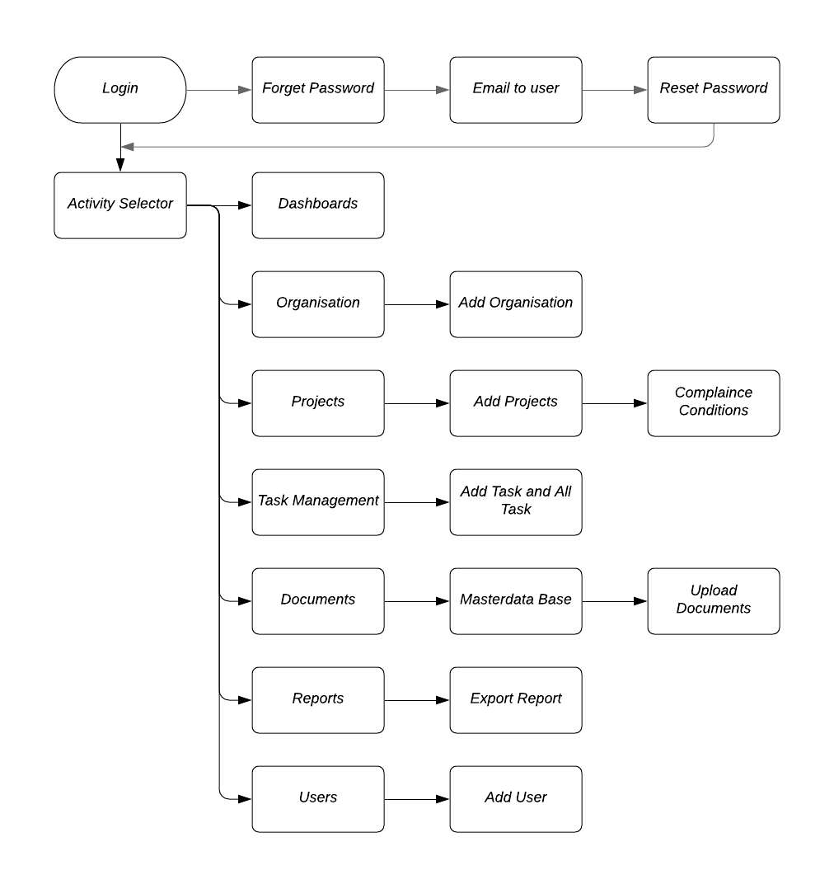

*Note: Module wise workflow diagram*

## Organisation Management

### Business Process Description

|  |  |  |
| --- | --- | --- |
| **S.No.** | **Description** | **Template**  **Document (If Any)** |
| 01 | Organisation management is the primary part of Green ERP, where the super Admin i.e. GRC will add the organisation for whom they have to do the compliance or adding those organisations where they are using this ERP as SAAS. |  |
| 02 | Organisation Management modules will consist of the below mentioned functionality:   * Add Organisation * Edit Organisation * Deactivate Organisation |
| 03 | Email alert need to be sent whenever any of the above mentioned action is being performed. |
| 04 | GRC as being a super admin will create the login access of the users (Admin user & normal user) of these organisation. |
| 05 | In terms of organisation data visibility, GRC will only have a viewing rights of the organisation data until any compliance related project is not being assigned to them. |
| 06 | Each organisation will get differentiated with a unique “Org ID”. |
| 07 | Number of running projects for an organisation can be easily tracked from its homepage. |
| 08 | GRC and the customer organisation admin only would have the rights to add projects in the Green ERP ecosystem. |

### https://documents.lucidchart.com/documents/8904c20c-4353-4592-8f82-be8791e7b18f/pages/0_0?a=430&x=309&y=14&w=682&h=583&store=1&accept=image%2F*&auth=LCA%202ac9a28fe74c2ab736869979b632a48766deeebb-ts%3D1571992654Business Process Flow

### Requirement from “To Be System”

* Capture all relevant information related to organisation.

### Open Points

* Email template need to be provided by GRC.
* Name of a person or a profile to whom the email need to be triggered whenever an organisation is created, edited or deactivated or its related data get manipulated.

### Out of Scope

* N/A

### Suggested Fields of Campaigns

* Need to discuss

### Prototype

## Project Management

### Business Process Description

|  |  |  |
| --- | --- | --- |
| **S.No.** | **Description** | **Template**  **Document (If Any)** |
| 01 | Green ERP is a compliance software which will be used as a project management tool for the compliance part of single or multiple projects of GRC or of its customers. |  |
| 02 | Projects of any organisation will be manually created in the system by the admin or super admin. |
| 03 | Project will consist of the details like “state” and “sector”, which will call the masterdata base to show the list of conditions of EC, CTE & CTO |
| 04 | A separate masterdata base (table) need to be created to save the statewise and sectorwise data of compliance. |
| 05 | Project Management modules will consist of the below mentioned functionality:   * Add Project * Delete Project * Edit Project * Deactivate Project |
| 06 | There would be different type or sector of projects:   * Commercial Project * Industrial Project * Residential Project |
| 07 | After the creation of single or multiple projects for any particular organisation, each project will have a unique “Project ID” for the reference purpose. |
| 08 | Functionality of project assignment should be there in the system, so that a project can be assigned to a project manager (user). Further to which a project manager can assign the task related to the compliances to his subordinate or to any other consulting partner (For e.g. GRC). |
| 09 | Green ERP will basically consist of three kind of compliances:   * EC * CTE * CTO * GB |
| 10 | **Environmental Clearance (Before Construction Stage):**   * Once after getting the environmental clearance, an organisation need to compliance the 75 to 80 conditions mentioned in the EC Letter. * List of the EC conditions is dependent on Stage and Sector of the project. * All the condition can be assigned in the form of task to multiple users or to a consulting partner depending upon the type of work. |
| 11 | **CTE (At the time of starting the construction):**   * Before starting the construction and in the phase of EC Compliances CTE Clearance is required, which also have the conditions to get fulfilled. * List of the CTE conditions is dependent on Stage and Sector of the project. * All the condition can be assigned in the form of task to multiple users or to a consulting partner depending upon the type of work. |
| 12 | **CTO (Before possession):**   * Before giving possession to the customers CTO Clearance is required by an organisation, which also have pre-defined conditions to get fulfilled. * List of the CTO conditions is also dependent on Stage and Sector of the project. * All the condition can be assigned in the form of task to multiple users or to a consulting partner depending upon the type of work. |
| 13 | **GB (Green Building Certification):**   * Green building certification is also the part of project compliance. * Certain condition need to be met for getting the green building certificate. * These conditions can also be assigned to any internal user or any consultant as a work order. |
| 13 | **6 Monthly Compliances (In the month of Jun & Dec):**   * This compliance is mandatory for every project within the duration on 6 months. * An option need to be provided for uploading the acknowledgement copy of 6 month compliance just like EC, CTE, CTO and GB. * This compliance can also be assigned to any consultant or compliance agency in the form of task. |

### Business Process Flow

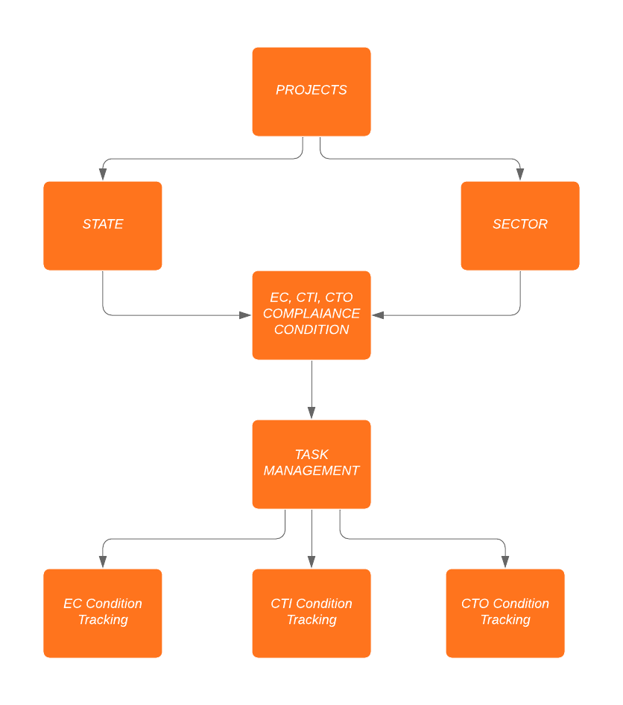

### Requirement from “To Be System”

* Easy to use Interface
* Capture relevant information

### Open Points

* Required fields of project module
* User Access Level to be defined by GRC Team and to be shared with Kloudrac Team
* Formats of Emails/Reminders to be set.
* Please suggest if there are few more types of project that need to be mentioned in the system.
* GRC need to give the statewise and sectorwise masterdata of EC, CTE and CTO condition to be uploaded in the system.

### C:\Users\Kloudrac Emp\Downloads\7.png Prototype

## Task Management

### Business Process Description

|  |  |  |
| --- | --- | --- |
| **S.No.** | **Description** | **Template**  **Document (If Any)** |
| 01 | Task management module consist of the list of task which has been assigned to the users for fulfilling the condition related to the compliance part. |  |
| 02 | Provision of notification will be there in the system whenever any task is being assign to them or when the task got completed (Both in mobile as well as in web portal) |
| 03 | An individual task will consist of the details of the task allotted to a user along with the optional deadline to complete the task, which has to be assigned by a project manager or admin. |
| 04 | There should be an option of status which need to be on task management detail page for keeping the exact tracking of the status of the task allotted to any user or consultant. |
| 05 | Initially there would be three values which needs to be updated within a task according to its progress.   * Working (Default Stage) * Condition Fulfilled * To be completed in future |
| 06 | A remark section need to be place, so that a user can enter his remarks while changing the stage of his task. |
| 07 | An Image and document upload option need to be given so that a user can attach a proof of completing the task. |
| 08 | At last the task will get completed after clicking on task completion button. |

### Requirement from “To Be System”

* Easy to use Interface.
* Capture relevant information
* User task visibility should be defined based on task ownership and role hierarchy.
* Tracking of activities related to the assigned task should be there in the system for creating the Dashboards.

### Open Points

* Pre-defined options which a user can select while completing his task for the remarks section.
* Shuffling of the conditions according to the EC clearance letter.

### C:\Users\Kloudrac Emp\Downloads\10.pngPrototype

## User Management

### Business Process Description

|  |  |  |
| --- | --- | --- |
| **SN** | **Description** | **Template**  **Document (If Any)** |
| 01 | In User Management, Roles will be created in the system and access will be defined based on user role.   * Super Admin * Master Admin * Admin * Users * Management * Customer Service |  |
| 02 | Organisation hierarchy to be mapped considering roles and levels of people related to different business groups (This hierarchy will be maintained throughout in the system). |
| 03 | Organization role structure and users will be created inside ERP considering the different team structures within teams and the overall reporting hierarchy. |
| 04 | Security settings (Profiles): Different profiles will be created to provide different levels of capabilities to users (e.g. Sales Head rights will differ from Sales User rights). |

### Role Hierarchy

* Will be provided by GRC

### Requirement from “To Be System”

* A role hierarchy should be made in the system according to the roles of business heads and their team members

### Open Points

* Discussion is required for the proper explanation of roles of each user in GRC

### C:\Users\Kloudrac Emp\Downloads\15.png Prototype

## Reports and Dashboards

### Business Process Description

|  |  |  |
| --- | --- | --- |
| **SN** | **Description** | **Template**  **Document (If Any)** |
| 01 | Analytical dashboards and reports as per the business requirements of GRC by using custom features and functionalities. |  |
| 02 | 6 month compliance reports need to be taken out from the GRC system along with their status in the form of PDF (along with Printout) and the attachment available in the system should get attached in the form of annexure in that report. |
| 03 | Dashboards and Reports should be scheduled on timely basis. |
| 04 | Suggested reports to be created in the system: 4 Reports & Dashboards on Marketing Process   * Project Wise Reports & Dashboards * Task Wise Reports & Dashboards * Stage Wise Reports & Dashboards * User Wise Reports & Dashboards |

### Requirement from “To Be System”

* Custom Reports and Dashboards to be configured for GRC
* System should have an option to export reports related to compliance condition in the PDF format along with the attached documents.

### Open Points

* Format of reports and dashboards need to be shared by the GRC Team. (If Any)

### Prototype

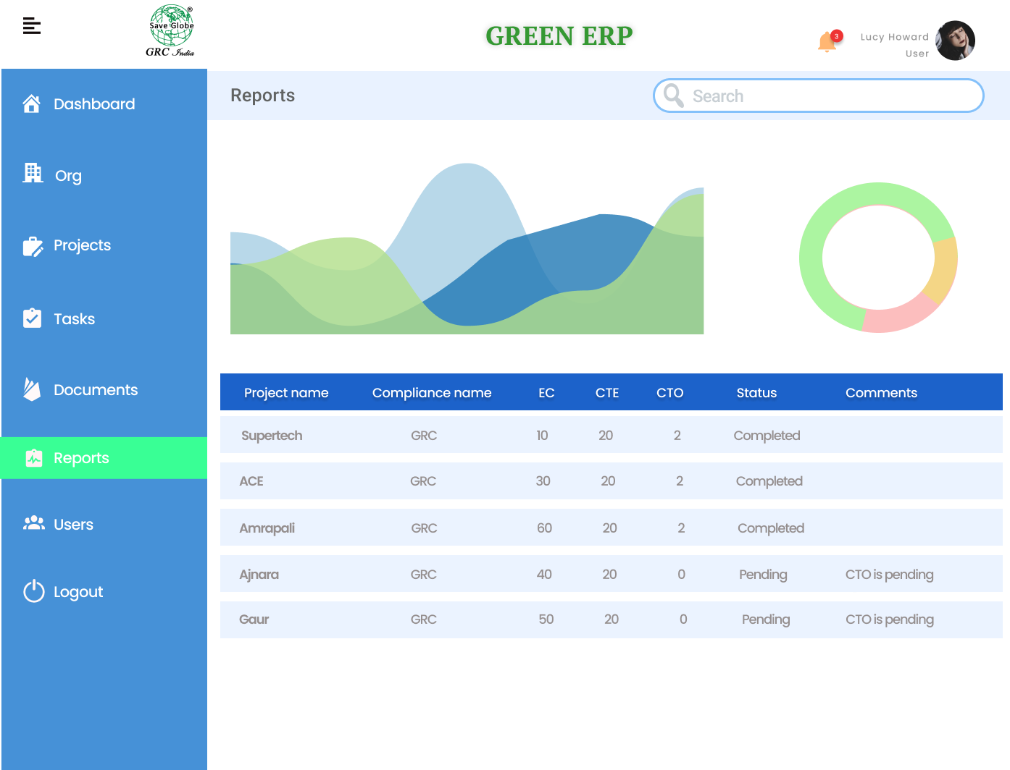

## ERP Deployment Architecture

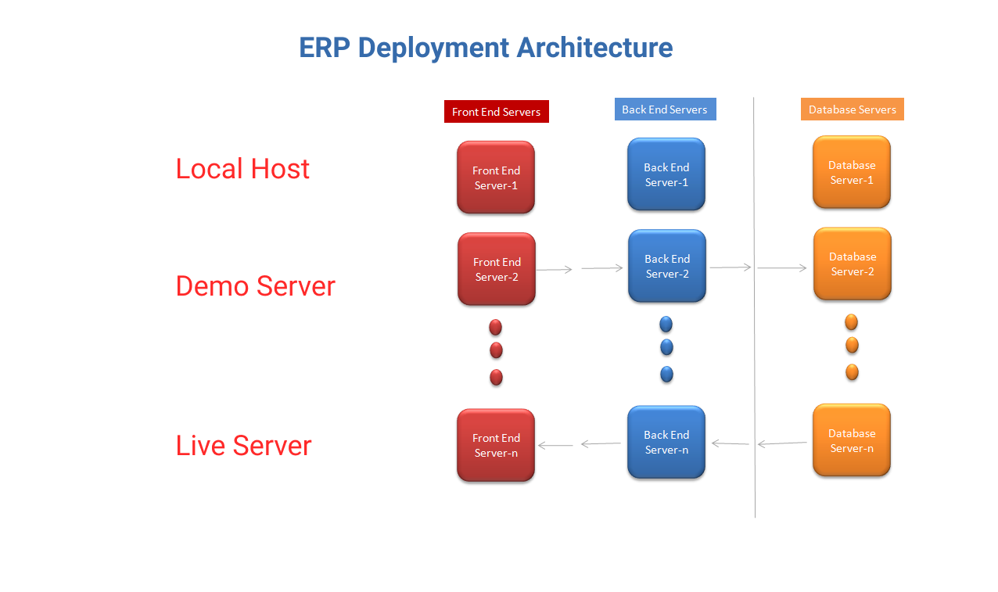

## Technological Limitations and Constraints

|  |  |  |
| --- | --- | --- |
| S.N. | Language/Hardware | Version |
| 1 | PHP version | 7.2 |
| 2 | Laravel version | 5.8 |
| 3 | Server Requirement | PHP >= 7.1.3  BCMath PHP Extension  Ctype PHP Extension  JSON PHP Extension  Mbstring PHP Extension  OpenSSL PHP Extension  PDO PHP Extension  Tokenizer PHP Extension  XML PHP Extension |
| 4 | HTML | 5 |
| 5 | CSS | 3 |
| 6 | Bootstrap | 4 |
| 7 | JQuery | 3.4.1 |
| 8 | Chart Js |  |
| 9 | Calender Js |  |

## Resolution Table

|  |  |  |
| --- | --- | --- |
| S.N. | Device | Resolution |
| 1 | Desktop | 1366X768 |
| 2 | IPad | 1024X768 |
| 3 | Tablet | 768X1024 |
| 4 | Mobile | 320X480 |

## DB Schemass

|  |  |
| --- | --- |
| S.N. | GRC DATABASE TABLES |
| 1 | grc_users |
| 2 | grc_gender |
| 3 | grc_usrs_summary |
| 4 | grc_emppersonaldetails |
| 5 | grc_organization |
| 6 | grc_project |
| 7 | grc_tasks |
| 8 | grc_project_task_document |
| 9 | grc_circular |
| 10 | grc_nationality |

|  |  |  |  |  |
| --- | --- | --- | --- | --- |
| S.N. | Table Name | Field Name | TYPE | Description |
| 1 | grc_users | id | INT (11) | Auto Increment (Primary Key) |
|  |  | employee_id | INT (11) |  |
|  |  | first_name | VARCHAR (20) |  |
|  |  | middle_name | VARCHAR (20) |  |
|  |  | last_name | VARCHAR (20) |  |
|  |  | user_name | VARCHAR (100) |  |
|  |  | email | VARCHAR (60) |  |
|  |  | password | VARCHAR (255) |  |
|  |  | role | VARCHAR (20) |  |
|  |  | pancardno | VARCHAR (100) |  |
|  |  | adhaarcard_no | VARCHAR (100) |  |
|  |  | uan_number | VARCHAR (100) |  |
|  |  | designation | VARCHAR (50) |  |
|  |  | dob | VARCHAR (50) |  |
|  |  | gender | INT (2) |  |
|  |  | mobile_no | INT (20) |  |
|  |  | phone_no | INT (20) |  |
|  |  | alternate_no | INT (20) |  |
|  |  | address | VARCHAR (200) |  |
|  |  | city | VARCHAR (50) |  |
|  |  | state | VARCHAR (50) |  |
|  |  | pincode | VARCHAR (50) |  |
|  |  | country | VARCHAR (50) |  |
|  |  | Profile_image | VARCHAR (255) |  |
|  |  | create_date | DATE |  |
|  |  | last_modified_date | DATE |  |
|  |  | token | VARCHAR (100) |  |
|  |  | status | tinyint(1) |  |

|  |  |  |  |  |
| --- | --- | --- | --- | --- |
| 2 | grc_gender | id | INT (11) | Auto Increment (Primary Key) |
|  |  | gendercode | varchar(50) |  |
|  |  | gendername | varchar(50) |  |
|  |  | createdby | INT (11) |  |
|  |  | modifiedby | INT (11) |  |
|  |  | createddate | DATE |  |
|  |  | last_modified_date | DATE |  |
|  |  | status | tinyint(1) |  |

|  |  |  |  |  |
| --- | --- | --- | --- | --- |
| 3 | grc_usrs_summary | id | INT (11) | Auto Increment (Primary Key) |
|  |  | user_id | INT (11) | foreign key |
|  |  | date_of_joining | DATE |  |
|  |  | date_of_leaving | DATE |  |
|  |  | reporting_manager | INT (11) |  |
|  |  | reporting_manager_name | VARCHAR (60) |  |
|  |  | emp_status | VARCHAR (20) |  |
|  |  | department_id | INT (11) |  |
|  |  | department_name | VARCHAR (20) |  |
|  |  | job_title_id | INT (11) |  |
|  |  | job_title | VARCHAR (20) |  |
|  |  | year_exp | VARCHAR (20) |  |
|  |  | mode_of_entry | VARCHAR (20) |  |
|  |  | create_by | INT (11) |  |
|  |  | create_by_name | VARCHAR (20) |  |
|  |  | last_modified_by | INT (11) |  |
|  |  | create_date | DATE |  |
|  |  | last_modified_date | DATE |  |
|  |  | status | tinyint(1) |  |

|  |  |  |  |  |
| --- | --- | --- | --- | --- |
| 4 | grc_emppersonaldetails | id | INT (11) | Auto Increment (Primary Key) |
|  |  | user_id | INT (11) | foreign key |
|  |  | Gender_id | INT (11) |  |
|  |  | maritalstatusid | INT (11) |  |
|  |  | nationalityid | INT (11) |  |
|  |  | languageid | INT (11) |  |
|  |  | dob | DATE |  |
|  |  | bloodgroup | VARCHAR (100) |  |
|  |  | identity_documents | longtext |  |
|  |  | createdby | INT (11) |  |
|  |  | last_modified_by | INT (11) |  |
|  |  | createddate | DATE |  |
|  |  | last_modified_date | DATE |  |
|  |  | status | tinyint(1) |  |

|  |  |  |  |  |
| --- | --- | --- | --- | --- |
| 5 | grc_organization | id | INT (11) | Auto Increment (Primary Key) |
|  |  | org_unique_id | INT (11) |  |
|  |  | org_name | VARCHAR (200) |  |
|  |  | org_email | INT (11) |  |
|  |  | user_name | VARCHAR (100) |  |
|  |  | email | VARCHAR (60) |  |
|  |  | password | VARCHAR (255) |  |
|  |  | mobile_no | INT (20) |  |
|  |  | phone_no | INT (20) |  |
|  |  | alternate_no | INT (20) |  |
|  |  | address | VARCHAR (200) |  |
|  |  | city | VARCHAR (50) |  |
|  |  | state | VARCHAR (50) |  |
|  |  | pincode | VARCHAR (50) |  |
|  |  | country | VARCHAR (50) |  |
|  |  | logo | VARCHAR (255) |  |
|  |  | create_date | DATE |  |
|  |  | last_modified_date | DATE |  |
|  |  | token | VARCHAR (100) | Backend |
|  |  | status | tinyint(1) |  |

|  |  |  |  |  |
| --- | --- | --- | --- | --- |
| 6 | grc_project | id | INT (11) | Auto Increment (Primary Key) |
|  |  | project_name | VARCHAR (255) |  |
|  |  | project_type | INT (11) |  |
|  |  | project_stage | INT (11) |  |
|  |  | state_id | INT (11) |  |
|  |  | pincode | INT (11) |  |
|  |  | landmark | VARCHAR (255) |  |
|  |  | description | VARCHAR (255) |  |
|  |  | state_id | INT (11) |  |
|  |  | currency_id | INT (11) |  |
|  |  | estimated_hrs | VARCHAR (10) |  |
|  |  | start_date | DATE |  |
|  |  | end_date | DATE |  |
|  |  | created_by | INT (11) |  |
|  |  | modified_by | INT (11) |  |
|  |  | create_date | DATE |  |
|  |  | last_modified_date | DATE |  |
|  |  | project_status | tinyint(1) |  |

|  |  |  |  |  |
| --- | --- | --- | --- | --- |
| 7 | grc_tasks | id | INT (11) | Auto Increment (Primary Key) |
|  |  | org_id | INT (11) |  |
|  |  | project_id | INT (11) |  |
|  |  | task_name | VARCHAR (255) |  |
|  |  | state_id | INT (11) |  |
|  |  | Category | INT (11) |  |
|  |  | Sector | VARCHAR (10) |  |
|  |  | condition_no | VARCHAR (255) |  |
|  |  | user_id | INT (11) |  |
|  |  | Type | VARCHAR (255) |  |
|  |  | Description | VARCHAR (255) |  |
|  |  | estimated_hrs | VARCHAR (10) |  |
|  |  | start_date | DATE |  |
|  |  | end_date | DATE |  |
|  |  | created_by | INT (11) |  |
|  |  | modified_by | INT (11) |  |
|  |  | create_date | DATE |  |
|  |  | last_modified_date | DATE |  |
|  |  | task_status | tinyint(1) |  |

|  |  |  |  |  |
| --- | --- | --- | --- | --- |
| 8 | grc_project_task_document | Id | INT (11) | Auto Increment (Primary Key) |
|  |  | org_id | INT (11) |  |
|  |  | project_id | INT (11) |  |
|  |  | task_id | INT (11) |  |
|  |  | document_name | INT (11) |  |
|  |  | Remarks | VARCHAR (255) |  |
|  |  | time_frame |  |  |
|  |  | created_by | INT (11) |  |
|  |  | modified_by | INT (11) |  |
|  |  | create_date | DATE |  |
|  |  | last_modified_date | DATE |  |
|  |  | Status | tinyint(1) |  |

|  |  |  |  |  |
| --- | --- | --- | --- | --- |
| 9 | grc_circular | Id | INT (11) | Auto Increment (Primary Key) |
|  |  | circular_name | VARCHAR (255) |  |
|  |  | Remarks | VARCHAR (255) |  |
|  |  | time_frame | VARCHAR (255) |  |
|  |  | show_type | INT (11) |  |
|  |  | created_by | INT (11) |  |
|  |  | modified_by | INT (11) |  |
|  |  | create_date | DATE |  |
|  |  | last_modified_date | DATE |  |
|  |  | task_status | tinyint(1) |  |

|  |  |  |  |  |
| --- | --- | --- | --- | --- |
| 10 | grc_nationality | Id | INT (11) | Auto Increment (Primary Key) |
|  |  | Nationality | VARCHAR (100) |  |
|  |  | Createdby | INT (11) |  |
|  |  | Modifiedby | INT (11) |  |
|  |  | Createddate | DATE |  |
|  |  | last_modified_by | DATE |  |
|  |  | Status | tinyint(1) |  |

## Use Cases

### [UC000] Registration

### [UC001] Sign in

|  |  |
| --- | --- |
| Use Case ID | UC001 |
| Use Case Name | Sign in |
| Primary Actor | Users |
| Description | User fill up the required details to login. |
| Pre-Condition | User does exist in the System |
| Post-Condition | User is logged in. |
| Normal Flow | 1. User visits the Website. 2. User fill in the **Employee ID** & **Password** fields. 3. Users click on Submit button. |
| Validations | Employee ID & Password fields are mandatory. |
| Website Actions | User is logged in successfully. |

### [UC002] Forgot Password

|  |  |
| --- | --- |
| Use Case ID | UC002 |
| Use Case Name | Forgot Password |
| Primary Actor | Users |
| Description | Users fill up the required details to login. |
| Pre-Condition | User does exist in the System |
| Post-Condition | A verification code is sent on registered email id for authentication from which a new Password can be reset |
| Normal Flow | 1. User visits the Website. 2. Clicks on Forget Password. 3. User fill in the **registered Email ID**. 4. User click on Submit button. 5. 6 digit code received on email 6. Code entered on the login page 7. Click on submit button 8. Enter and Re-enter the new password 9. Click on save button |
| Validations | All fields are mandatory. |
| Website Action | Website reloads to Login Page. |

### [UC003] Dashboard

|  |  |
| --- | --- |
| Use Case ID | UC003 |
| Use Case Name | Dashboard |
| Primary Actor | Users |
| Description | Multiple graphs to be shown here. TBD with GRC. |
| Pre-Condition | User does exist in the System & is logged in & on the first screen after login. |
| Post-Condition | NA |
| Normal Flow | 1. Member visits the Website. 2. Member logs in. 3. Dashboard opens. |
| Validations | NA |
| Website Actions | NA |

### [UC003.1] System Wide Settings

|  |  |
| --- | --- |
| Use Case ID | UC003.1 |
| Use Case Name | System Wide Settings [SWS]. |
| Primary Actor | Super Admin |
| Description | Super Admin of ERP can set Company Defaults here. |
| Pre-Condition | Login with Super Admin Login Details. |
| Post-Condition | NA |
| Normal Flow | 1. User visits the Website. 2. User logs in. 3. Clicks on SWS on Sidebar. 4. Chooses Currency as INR, Language as English, Emp Code – Input Field, Company Name, Logo, Admin Name, Address, City, Pin Code, Work Hours – From & To in 24hr Format. Clicks Next. 5. Department & Role Management – Here Super Admin can add Department Names & Role Names. Once Done, Click Next. 6. On Next Screen – Super Admin Manages Organization. **Organization Management.** |
| Validations | All Fields are mandatory. |
| Website Actions | Reload to Dashboard. |

### [UC004] Add New User

|  |  |
| --- | --- |
| Use Case ID | UC004 |
| Use Case Name | Add New User – Official Tab |
| Primary Actor | Super Admin |
| Description | Super Admin of ERP or Admin of customer organisation will be able to add New user details to the system. |
| Fields | Official Tab – User_id, Employee_id, first_name, middle_name, last_name, user_name, email, password, role, pancardno, adhaarcard_no, designation, dob, gender, mobile_no, phone_no, alternate_no, address, city, state, pincode, country, Profile_image, create_date, status |
| Pre-Condition | User does not exist in the System but is an Employee of GRC or any other customer organisation. Super Admin & Admin is logged in & on Dashboard. |
| Post-Condition | All required fields in this tab are filled in. |
| Normal Flow | 1. Super Admin Clicks on Users on Sidebar and then Add User or on All User Screen, clicks on Big Plus sign on bottom right. 2. Add new user Screen opens up. 3. Super Admin fills in all tab-wise details for tabs – Clicks save button |
| Validations | **Field wise Validation:**  **User id*:** Format need to be shared by GRC  **Employee id:** Need to discuss  **First name*:** First letter capital followed by the first name  **Middle Name:** First letter capital followed by the middle name (optional Field)  **Last Name*:** First letter capital followed by the last name  **User Name*:** Format need to be given by GRC  **Email*:** abc@domainname  **Password*:** Minimum 8 characters, (A upper case, A lower case, A number)  **Role:** Drop down (Dynamic Field: Value need to be given by GRC**)**  **PAN Card No:** Alphanumeric (10 character)  **Adhaar Card No:** Numeric Field (12 digits)  **Designation:** Drop Down (Dynamic Field: Value need to be given by GRC)  **Dob*:** DD/MM/YYYY  **Gender*:** Male, Female & Others  **Mobile No*:** +91 (By Default) follow by 10 numerical digit number (input)  **Alternate No:** +91 (By Default) follow by 10 numerical digit number (input)  **Address:** First letter capital then followed by full address  **City:** Drop down (Dependent on state)  **State:** Drop down (All State of Country India)  **Pin code:** 6 numeric digits  **Country:** India (By Default)  **Profile*:** Initially 4 Profiles will be maintained ( Dynamic Value: Super Admin, Admin, Project Manager, Normal User**)**  **Profile Image:** PNG, JPG, GIF  **Create Date*:** DD/MM/YYYY (Auto Populated By System)  **Status*:** Active or Inactive |
| Website Actions | Reload to Dashboard. |

### [UC005] Add Organisation

|  |  |
| --- | --- |
| Use Case ID | UC005 |
| Use Case Name | Add New Organisation – Official Tab |
| Primary Actor | Super Admin |
| Description | Super Admin of ERP will be able to add New organisation details into the system. |
| Fields | Official Tab – id, org_unique_id, org_name, org_email, user_name, email, password, mobile_no, phone_no, alternate_no, address, city, state, pincode, country, logo, create_date, last_modified_date, token, status |
| Pre-Condition | Organisation does not exist in the System but is a customer of GRC. Super Admin is logged in & on Organisation Tab. |
| Post-Condition | All required fields in this tab are filled in. |
| Normal Flow | 1. Super Admin Clicks on organisation on Sidebar and then Add Organisation or on all organisation Screen, clicks on Big Plus sign on bottom right. 2. Add new organisation Screen opens up. 3. Super Admin fills in all tab-wise details for tabs – Clicks save on end of each tab. |
| Validations | **Field wise Validation:**  **Org unique id**: Format need to be shared by GRC  **Org name\***: First Letter Capital then followed by full name  **Alias\***: 10 character (Alphanumeric)  **Org email*:** abc@domainname  **Username*:** Format need to be given by GRC  **Password\***: Minimum 8 characters, (A upper case, A lower case, A number)  **Mobile no\***: +91 (By Default) follow by 10 numerical digit number (input)  **Alternate no**: +91 (By Default) follow by 10 numerical digit number (input)  **Address:** First letter capital then followed by full address  **City:** Drop down (Dependent on state)  **State:** Drop down (All State of Country India)  **Pin code:** 6 numeric digits  **Country:** India (By Default)  **Logo:** PNG, JPG, GIF  **create date*:** DD/MM/YYYY (Auto populated by system)  **Last modified date*:** DD/MM/YYYY (Auto populated by system)  **Token:** 6 numeric digit token (Received over email)  **Status*:** Active & Inactive |
| Website Actions | Reload to All Organisation Page. |

### [UC006] Add Projects

|  |  |
| --- | --- |
| Use Case ID | UC006 |
| Use Case Name | Add New Project – Official Tab |
| Primary Actor | Super Admin or Admin |
| Description | Super Admin of ERP or Admin of customer organisation will be able to add New Project details into the system. |
| Fields | Official Tab – id, project_name, project_type, project_stage, state_id, pincode, landmark, description, state_id, currency_id, estimated_hrs, start_date, end_date, created_by, modified_by, create_date, last_modified_date, project_status |
| Pre-Condition | Project does not exist in the System but is a project of customer of GRC. Super Admin & Admin is logged in & on Projects Tab. |
| Post-Condition | All required fields in this tab are filled in. |
| Normal Flow | 1. Super Admin & Admin will Clicks on projects on Sidebar and then Add Projects or on all Project Screen, clicks on Big Plus sign on bottom right. 2. Add new Project Screen opens up. 3. Super Admin & Admin fills in all tab-wise details for tabs – Clicks save on end of each tab. |
| Validations | **Field wise Validation:**  **Project id\***: Auto Populated (Format need to be shared by GRC)  **Project name*:** First letter capital then followed by full name of project  **Project type*:** Drop down (Dynamic Values: Industrial, Commercial, Residential, Housing Society, Others)  **Project stage\***: Drop down (Dynamic values: EC, CTE, CTO, GB)  **State:** Drop down (dependent on country)  **Pin code:** 6 numeric digit  **Landmark:** Text Area  **Description:** Text Area  **Currency id:** INR (Dynamic field)  **Estimated hrs:** HH/MM  **Start date*:** DD/MM/YYYY  **End date*:** DD/MM/YYYY  **Created by\***: Logged In User’s name who has created (Auto populated by system)  **Modified by*:** Logged In User’s name who has modified (Auto populated by system)  **Create date*:** DD/MM/YYYY (Auto populated by system)  **Last modified date:** DD/MM/YYYY (Auto populated by system)  **Project status:** Drop down (Dynamic Values: New, Running, Completed, On Hold) |
| Website Actions | Reload to All Project Page. |

### [UC007] Add Task

|  |  |
| --- | --- |
| Use Case ID | UC007 |
| Use Case Name | Add New Task – Official Tab |
| Primary Actor | Super Admin or Admin |
| Description | Super Admin of ERP or Admin of customer organisation will be able to add New task details into the system. |
| Fields | Official Tab – org_id, project_id, task_name, state_id, category, sector, condition_no, user_id, type, description, estimated_hrs, start_date, end_date, created_by, last_modified_by, create_date, last_modified_date, task_status, task completion (%) |
| Pre-Condition | Task does not exist in the System but is a Task related to the project of customer of GRC. Super Admin & Admin is logged in & on Tasks Tab. |
| Post-Condition | All required fields in this tab are filled in. |
| Normal Flow | 1. Super Admin & Admin will Clicks on tasks on Sidebar and then Add task or on all tasks Screen, clicks on Big Plus sign on bottom right. 2. Add new task Screen opens up. 3. Super Admin & Admin fills in all tab-wise details for tabs – Clicks save on end of each tab. |
| Validations | **Field wise Validation**:  **Org id*:** Auto Generated (Format need to be shared by GRC)  **Project id*:** Auto Generated **(**Format need to be shared by GRC)  **Task name*:** Auto Populated  **State*:** Dependent on country (By Default Country: India)  **Category*:** Drop down (Dynamic values: EC, CTE, CTO, GB)  **Sector*:** Drop down (Dynamic Values: Industrial, Commercial, Residential, Housing Society)  **Condition no*:** Same as EC,CTE,CTO and GB letter condition number  **User*:** Lookup with existing user  **Type*:** Drop down (Dynamic values: EC, CTE, CTO, GB)  **Description:** Text Area  **Estimated rs:** HH/MM  **Start date:** DD/MM/YYYY  **End date:** DD/MM/YYYY  **Created by*:** Logged In User’s name who has created (Auto populated by system)  **Last Modified by\***: Logged In User’s name who has created (Auto populated by system)  **Create date*:** DD/MM/YYYY (Auto populated by system)  **Last modified date*:** DD/MM/YYYY (Auto populated by system)  **Task status*:** Drop down (Dynamic values: New, Working, Completed, To be done in Future)  **Task Completion(%)*:** Numeric Value (10,20,30,40,50,60,70,80,90,100) % |
| Website Actions | Reload to All Tasks Page. |

END OF DOCUMENT