File Name: Design.doc

Name: Kristopher Lowell

Functions:

unsigned send_file_client_to_server(FILE* outFile, int socketFD, char* buffer, unsigned buffer_size, struct sockaddr_in socketAddress, socklen_t addressLength)

unsigned receive_file_server_from_client(FILE* inFile, int socketFD, char* buffer, unsigned buffer_size, struct sockaddr_in socketAddress, socklen_t addressLength)

Synchronization:
In order to send a file from the client to the server, we first assume that the server is going to be listening already. If the server is listening, then the client can send a request. Once the request is sent by the client, the client will start listening for a reply by the server. The server sends a reply and immediately starts listening, this time for file data. Since the client was listening, the server’s reply signals the client to start processing the file to send.

Packet Transmission:
So, the client starts putting data from the file into the buffer, and then sends it out to a listening server. Once the client sends out the data, it goes back into listening. Since it takes time to process the information the server has received, we institute a bit of error checking to re-synchronize the client and server. Since the client is listening, the server processes the buffer and will send the client how many bits it has received and immediately start listening again. The client sees how much bytes the server received and compares that amount to the size of the last packet it sent, if there’s a mismatch, it will resend the previous packet. Assuming they match, the client will start the packet transmission process all over again.

Packet Size Mismatch:
In the case of a mismatch in sizes of sent and received packets, the server will be listening and the client will process the mismatch. The client will then rewind its file one packet’s worth of data, and send a packet signaling the server that it’s going to repeat the previous packet so the server can rewind its file. Once the client sends that signal, it goes into listening to wait for the server to be ready to re-receive the previous packet. It takes some time for the server process to rewind its file back, thus it sends a signal back to the client letting it know that the server is ready for the packet. Once the server sends this signal, it goes straight back into listening and getting back onto the packet transmission process with the client process.

End of File:
Once the client has reached the end of file, it will send that last bit of the file through one final packet transmission. After that process, the client sends a “End of File” packet which signals the server to stop expecting any more packets after it.

Return Value:
These two functions return the minimum amount of packets it takes to send and receive the file. This means that it does not include the packets needed for synchronization, packet size mismatch checking, and end of file detection. It is the theoretical minimum amount of packets needed to send the file.

Functions (cont.):

unsigned send_file_server_to_client(FILE* outFile, int socketFD, char* buffer, unsigned buffer_size, struct sockaddr_in socketAddress, socklen_t addressLength)

unsigned receive_file_client_from_server(FILE* inFile, int socketFD, char* buffer, unsigned buffer_size, struct sockaddr_in socketAddress, socklen_t addressLength)

Synchronization:
In order to send a file from the server to the client, we first assume that the server needs to hear a request, therefore, the server starts off listening. The client will then sends a request and immediately starts listening for a reply. The server sends a reply and starts putting data from the file into the buffer. The client receives the reply and immediately goes back into listening for the packet transmission process.

Packet Transmission:
So, the server starts putting data from the file into the buffer, and then sends it out to a listening client. Once the server sends out the data, it goes back into listening. Since it takes time to process the information the client has received, we institute a bit of error checking to re-synchronize the server and client. Since the server is listening, the client processes the buffer and will send the server how many bits it has received and immediately start listening again. The server sees how much bytes the client received and compares that amount to the size of the last packet it sent, if there’s a mismatch, it will resend the previous packet. Assuming they match, the server will start the packet transmission process all over again.

Packet Size Mismatch:
In the case of a mismatch in sizes of sent and received packets, the client will be listening and the server will process the mismatch. The server will then rewind its file one packet’s worth of data, and send a packet signaling the client that it’s going to repeat the previous packet so the client can rewind its file. Once the server sends that signal, it goes into listening to wait for the client to be ready to re-receive the previous packet. It takes some time for the client process to rewind its file back, thus it sends a signal back to the server letting it know that the client is ready for the packet. Once the client sends this signal, it goes straight back into listening and getting back onto the packet transmission process with the server process.

End of File:
Once the server has reached the end of file, it will send that last bit of the file through one final packet transmission. After that process, the server sends a “End of File” packet which signals the client to stop expecting any more packets after it.

Return Value:
These two functions return the minimum amount of packets it takes to send and receive the file. This means that it does not include the packets needed for synchronization, packet size mismatch checking, and end of file detection. It is the theoretical minimum amount of packets needed to send the file.

Functions (cont.):

clear_buffer(char* buffer, unsigned buffer_size)

String classes/data types do not technically exist in the C language. A string in C is actually an array of characters terminated with the null character (null-terminated). Clearing the buffer will eliminate any data within the buffer to reduce the chance of data corruption. Filling the buffer array back up with null characters essentially ensures that the next bit of data to be entered into will be a null-terminated string.

Sample Execution:

Pre-Execution:

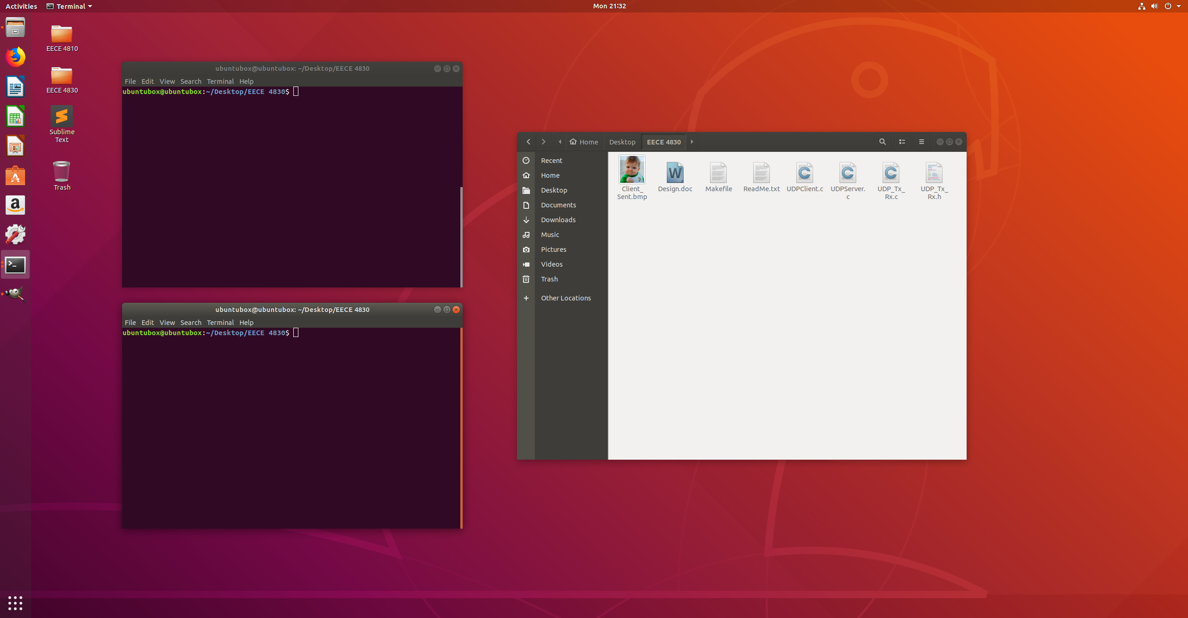
File Compilation:

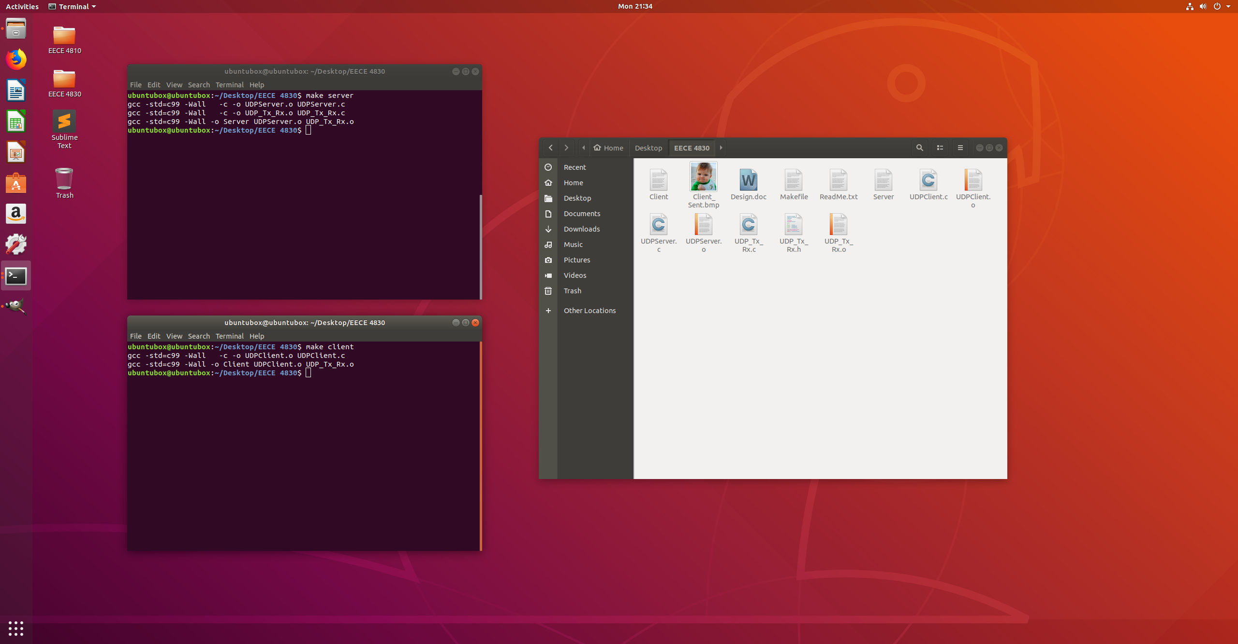

Sample Execution (cont.):

Server Execution:

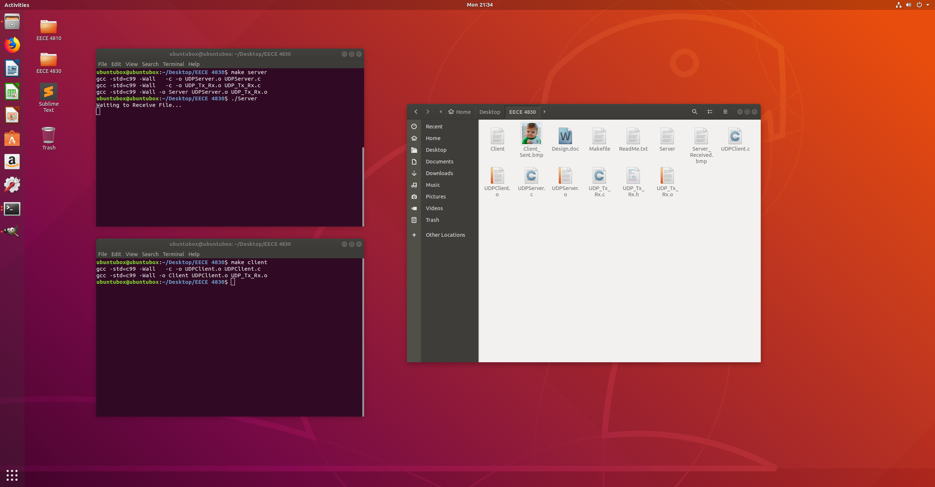
Client Execution

