**STEPS TO CONNECT OT CLI-MODE IN JBOSS AND VIEW QUEUE COUNT: - (FOR RTRA)**

* Navigate to "/apps/notif/jboss-eap-7.4/bin" on "10.45.16.80"
* Execute " jboss-cli.sh"
* Execute connect 10.45.16.80:10380
* We would have entered the CLI-mode
* run the below command, post entering CLI-mode

/subsystem=messaging-activemq/server=default/jms-queue=P4AGGRFEEDQUE:read-attribute(name=message-count

**Sample output-generated: -**

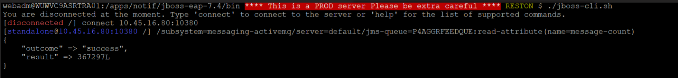

NOTE:-

Please check the jboss-cli.sh, to check the Java-home-path, configured

Queue-name, should be altered if we need to check queue-depth for a different queue