**RTRA**

Traffic Movement:-

***************

Traffic movement will take care by Network team.

Servers List:-

**********

**Reston:-**

Reston Node1: 10.45.16.80

Reston Node2: 10.45.16.81

Reston Node3: 10.45.16.82

Reston Node4: 10.45.16.86

Reston Node5: 10.45.16.87

Reston Node6: 10.45.16.120

**Chicago:-**

Chicago Node1: 10.47.16.162

Chicago Node2: 10.47.16.163

Chicago Node3: 10.47.16.164

Chicago Node4: 10.47.16.165

Chicago Node5: 10.47.16.81

Chicago Node6: 10.47.16.82

Chicago Node7: 10.47.16.83

**Implementation:-**

**Note:- RTRA Application team will confirm with us the sequence of steps that need to execute.**

* RTRA has multiple instances running like (RTRA, RTRA Batch, RTRA Notification, RTRA AddressService, RTRA Agent Screening(AGS), entity_clearing_tool,Csmart, addrsvc, notif…)
* Implementation plan separate for reach data center.
* Select RTRA-StackUpgrade as per change plan

RTRA_MASTER_RELEASE for all deploy jobs

(or)

RTRA_FIXES_RELEASE for all deploy jobs

* Select the build number as per change plan.

**RTRA Servers Plan Start:-**

---------------------------------------------------

-- Chicago Node1: 10.47.16.162

---------------------------------------------------

Step 1:Execute config_rtra on Chicago Node1

Step 2: Execute deploy_rtra build 9900 on Chicago node1

Step 3: Check the status of deployment clicking on Log Out tab.

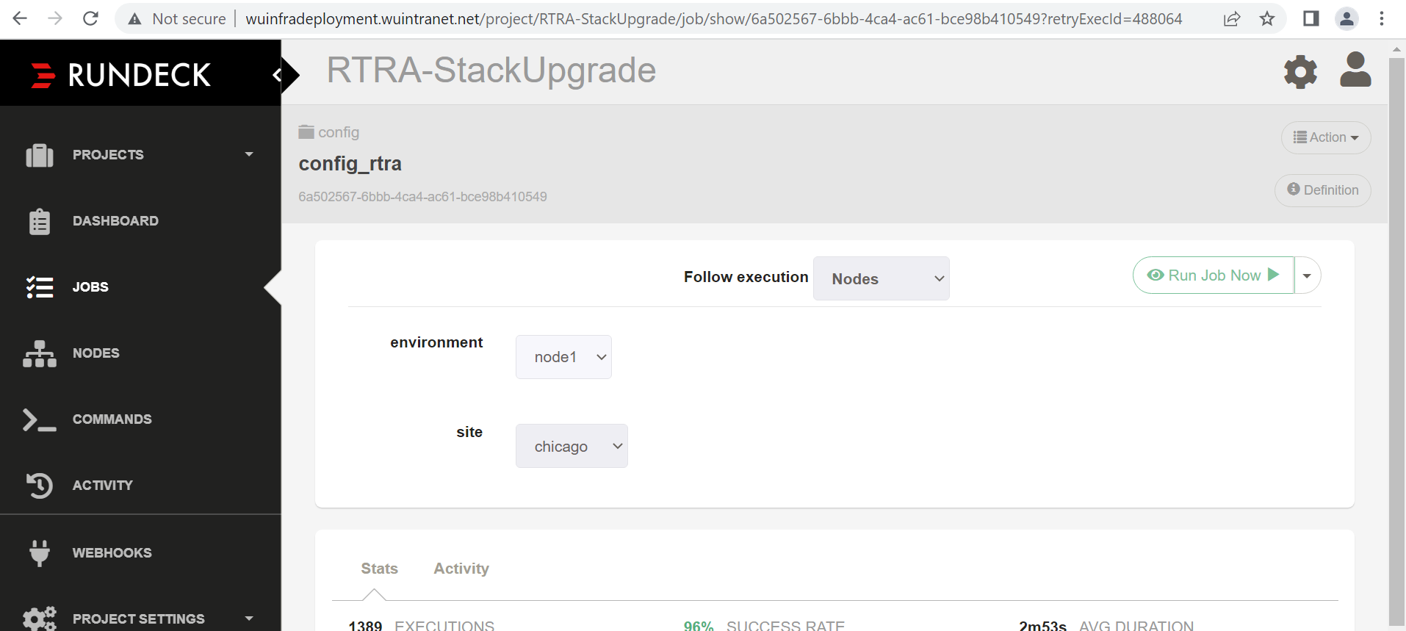

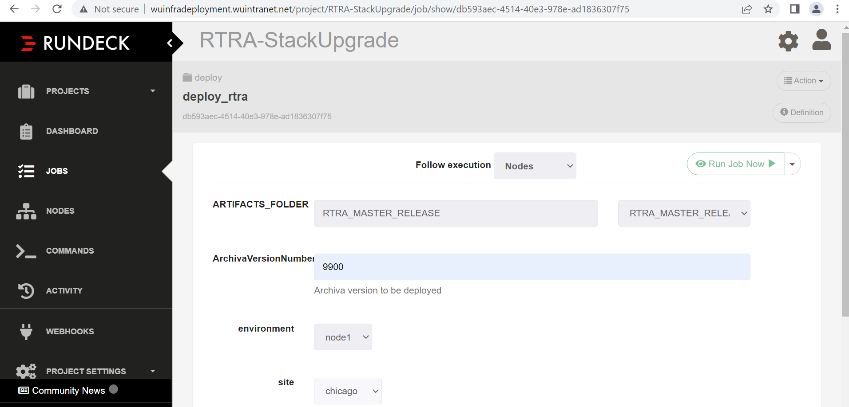

Similarly, execute for below RTRA steps for remaining nodes,

---------------------------------------------------

-- Chicago Node2: 10.47.16.163

---------------------------------------------------

Step 1:Execute config_rtra on Chicago node2

Step 2: Execute deploy_rtra build 9900 on Chicago node2

Step 3: Check the status of deployment clicking on Log Out tab.

---------------------------------------------------

-- Chicago Node3: 10.47.16.164

---------------------------------------------------

Step 1:Execute config_rtra on Chicago node3

Step 2: Execute deploy_rtra build 9900 on Chicago node3

Step 3: Check the status of deployment clicking on Log Out tab.

---------------------------------------------------

-- Chicago Node4: 10.47.16.165

---------------------------------------------------

Step 1:Execute config_rtra on Chicago node4

Step 2: Execute deploy_rtra build 9900 on Chicago node4

Step 3: Check the status of deployment clicking on Log Out tab.

---------------------------------------------------

-- Chicago Node5: 10.47.16.81

---------------------------------------------------

Step 1:Execute config_rtra on Chicago node5

Step 2: Execute deploy_rtra build 9900 on Chicago node5

Step 3: Check the status of deployment clicking on Log Out tab.

---------------------------------------------------

--Chicago Node6: 10.47.16.82

---------------------------------------------------

Step 1: Execute config_rtra on Chicago Node6

Step 2: Execute deploy_rtra build 9900 on Chicago Node 6

Step 2: Check the status of deployment clicking on Log Out tab.

---------------------------------------------------

-- Chicago Node7: 10.47.16.83

---------------------------------------------------

Step 1: Execute config_rtra on Chicago Node7

Step 2: Execute deploy_rtra build 9900 on Chicago Node7

Step 2: Check the status of deployment clicking on Log Out tab.

***************************************************************************** Restart steps

******************************************************************************

Restart Csmart : Chicago

-------------------------

Step 1: Select project - RTRA_StackUpgrade

Step 2: execute restart_csmart [please execute STOP and START operation]

step 3: Check the status of deployment clicking on Log Out tab.

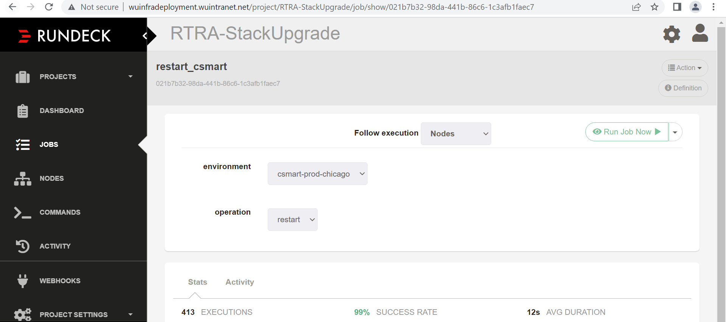

========================================================================

Restart Notif: Chicago

-----------------------

Step 1: Select project - RTRA_StackUpgrade

Step 2: execute restart_notif [please execute STOP and START operation]

step 3: Check the status of deployment clicking on Log Out tab.

Nodes : Node 1,Node 2

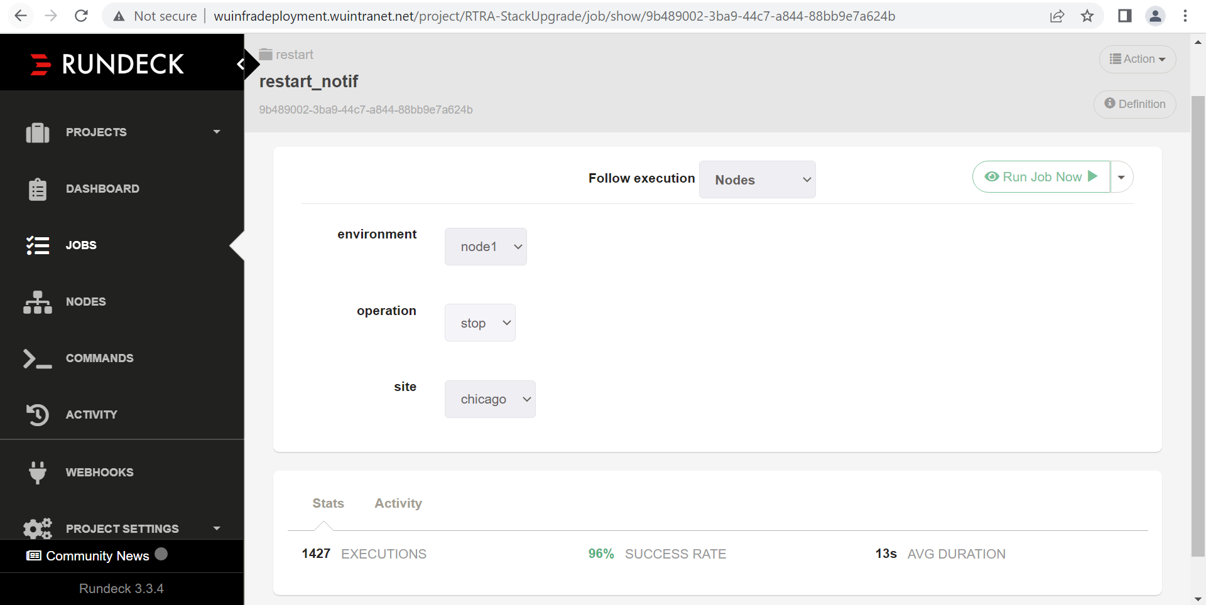

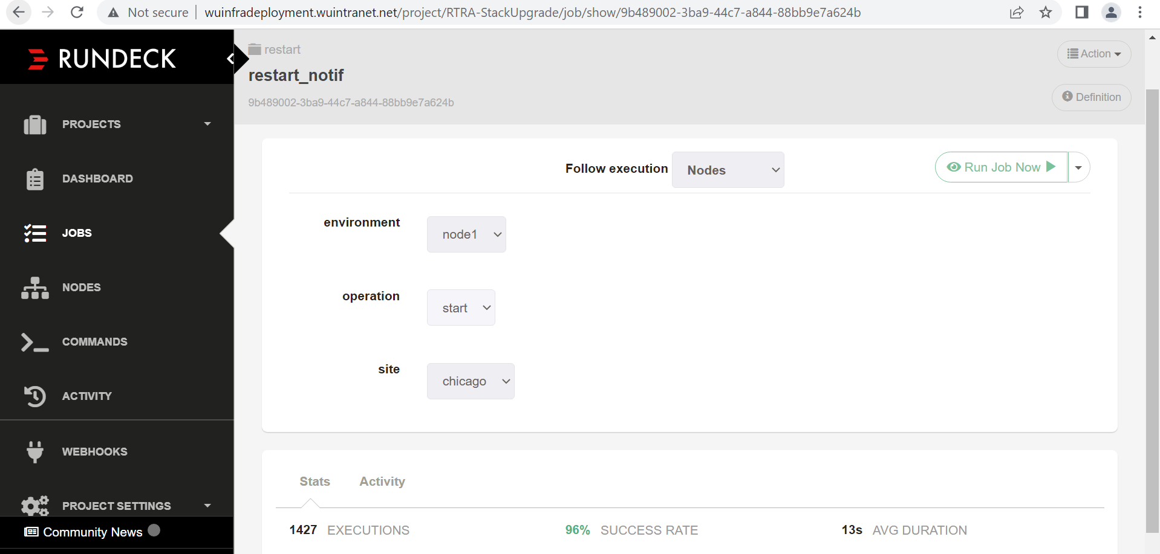

Similarly, execute for node2.

========================================================================

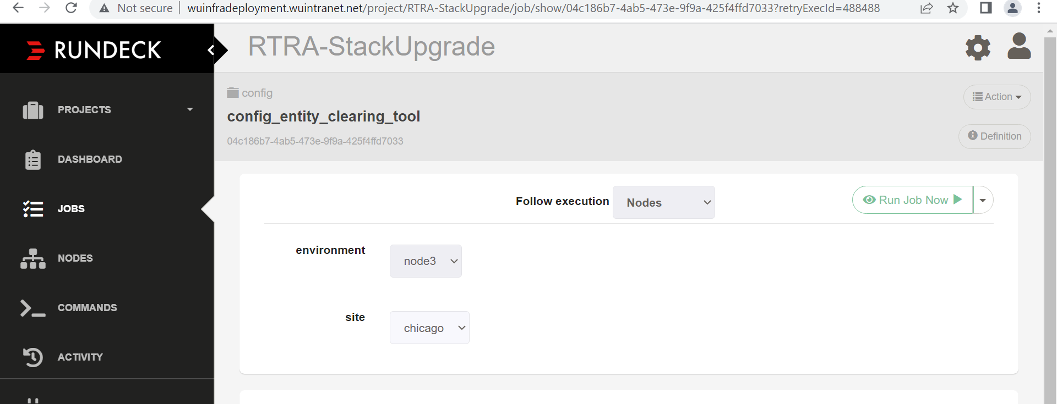

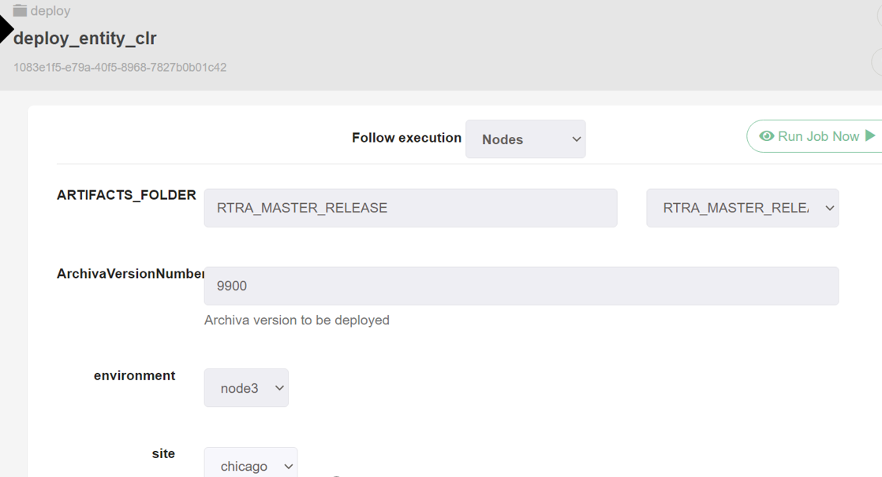

* **EAS RESTART: Chicago**

-------------------------

Server ips: 10.46.32.190 ,10.46.32.191 ,10.46.32.192

Login to above servers as easadmin user

cd /opt/ibm/ISII/bin

./restartEASClearDB.sh > restartEASClearDB.log &





**IWRA**

Traffic Movement:-

***************

No Traffic movement for IWRA

Servers List:-

**********

**Chicago:-**

**\*\*\*\*\*\***

10.47.16.167

10.47.16.168

10.47.16.169

**Reston:-**

**\*\*\*\*\*\*\*\***

10.45.16.96

10.45.16.97

10.45.16.98

**Implementation:-**

**Note:-IWRA Application team will confirm with us the sequence of steps that need to execute.**

Implementation plan separate for reach data center.

* Select RTRA-StackUpgrade as per change plan

IWRA_PROD for all deploy jobs

(or)

IWRA_FIXES_RELEASE for all deploy jobs

* Select the build number as per change plan.

==============================================================================

DEPLOY BUILD NO : <#999>

SELECT : IWRA_PROD

*****************************************************************************

IDEA SIDE Jboss Changes - CHICAGO (10.47.16.166) PLAN 1

******************************************************************************

For Instance idea

Step 1: Login to Rundeck using below URL

http://wuinfradeployment.wuintranet.net/menu/home

Step 2: Select RTRA-StackUpgrade

Step 3: Execute deploy_idea [ provide build number, node_number, instance_name and site]

Deploy Build No : Mentioned at the top of the plan

Step 4: Execute config_idea_batch

Step 5: Check the status of deployment clicking on Log Out tab

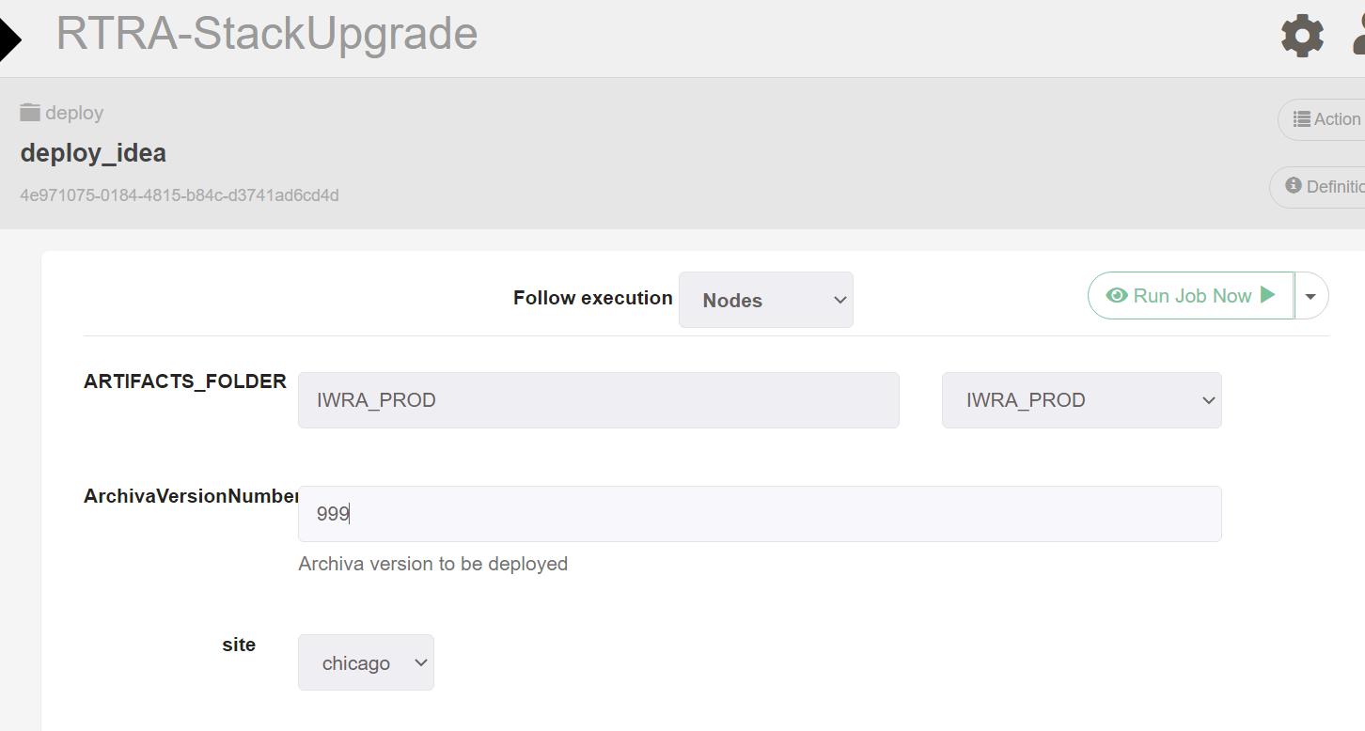

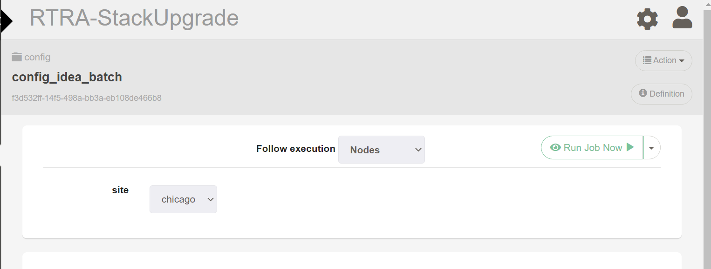

Execute the remaining steps as per implementation plan.

============================================================================

Jboss Changes - Chicago (10.47.16.167, 10.47.16.168 & 10.47.16.169) PLAN 2

============================================================================

* In Chicago we have 3 IWRA Nodes/Boxes and each node is having 4 IWRA instances [IWRA1,IWRA2,IWRA3,IWRA4]
* For Instances IWRA1,IWRA2,IWRA3 and IWRA4

Step 1: Login to Rundeck using below URL

http://wuinfradeployment.wuintranet.net/menu/home

Step 2. Select RTRA-StackUpgrade

Step 3: Execute restart_iwra [ provide node, instance name, operation, site] [please execute STOP and START operation]

Step 4: Check the status of deployment clicking on Log Out tab

Execute Step 3 on below [please execute STOP and START operation]

-- **Node1, IWRA1, Chicago**

--if it is not restarted from Rundeck, please restart manually

**************************************************

* 10.47.16.167, 10.47.16.168 & 10.47.16.169
* Login as webadm user
* Restart iwra1 instance

**----------------------Deploy Job on Rest nodes-----------------------------------------------------**

Step 2: Select RTRA-StackUpgrade

Step 3: Execute deploy_iwra [ provide build number, node_number, instance_name and site]

Deploy Build No : Mentioned at the top of the plan

Step 4: Execute config_iwra_batch [ provide build number, node_number, instance_name and site] Deploy Build No : Mentioned at the top of the plan

Step 5: Execute deploy_iwra_batches [ provide build number, node_number, instance_name and site] Deploy Build No : Mentioned at the top of the plan

Step 6: Check the status of deployment clicking on Log Out tab

Execute above Steps on below

-- Node1, IWRA2, Chicago

-- Node1, IWRA3, Chicago

-- Node1, IWRA4, Chicago

-- Node2, IWRA1, Chicago

-- Node2, IWRA2, Chicago

-- Node2, IWRA3, Chicago

-- Node2, IWRA4, Chicago

-- Node3, IWRA1, Chicago

-- Node3, IWRA2, Chicago

-- Node3, IWRA3, Chicago

-- Node3, IWRA4, Chicago