# SOP for BROKER Restart

This document outlays the operating procedure to be followed for broker restart. The steps mentioned are applicable for all the Gateway lower environments i.e., QA, PI, UAT, UAT_Lab. This script/process helps us to reduce the manual process and to avoid any manual mistakes.

## **Points to remember:**

* Do not use **mqsistop** command to **stop** the Broker.
* Do not use **mqsistart** command to **start** the broker.
* Replace the <env_name> with environment name on which deployment is being performed.

For Example: If deployment is being done in PI, use pi as

/apps/wubsg/config/<env_name> /mqsipolicy

/apps/wubsg/config/qa/mqsipolicy

* We don’t have NRT in UAT and UAT_LAB. Therefore, we do not need to execute below command for UAT, UAT_LAB and QA2.

**Command**: mqsistartmsgflow <env name> -e NRT_EG -k NRT_Notification_Service

* Once broker gets started, we must check if the cache is reloaded or not.

## **SOP STEPS:**

**The steps for SOP are as following:**

Step 1: Broker/Integration Stop:

* Go to the below mentioned file path.

**File/Path**: /apps/wubsg/config/<env_name>/mqsipolicy

**Example**: /apps/wubsg/config/qa/mqsipolicy

* Run the **ACE-BrokerStop.sh** shell script using below command.

Command: ./ **ACE-BrokerStop.sh**

* After the above-mentioned script is executed. At first message flows (DASCloudOkta , NRT_Notification_Serviceflows and Auth_Token_APP) will stop and then Broker will get stop.

#### Step 2: Broker/Integration Start

* Go to the below mentioned file path.

**File/Path**: /apps/wubsg/config/<env_name>/mqsipolicy

**Example**: /apps/wubsg/config/qa/mqsipolicy

* Run the **ACE-BrokerStart.sh** shell script using below command.

**Command:** ./ **ACE-BrokerStart.sh**

* Broker will start after the above-mentioned script is executed.
* Once broker gets started, we must verify if the cache is reloaded or not in below path.

**Cache Path** : /apps/wubsg/config/<env_name>/mqsioutput/Global_cache_status.xml

* Execute the below commands once cache gets refreshed.

**Commands**:

mqsistartmsgflow <Broker Name> -e BIS_EG -k BIS_Quotation_APP -m DASCloudOkta

mqsistartmsgflow < Broker Name > -e NRT_EG -k NRT_Notification_Service

mqsistartmsgflow < Broker Name > -e default_EG -k Auth_Token_APP

* Run below commands and verify the map is loaded or not after starting of **Auth_Token_APP**
* **mqsicacheadmin < Broker Name >** **-c showMapSizes|grep -E 'ES.EventToken|MOP.EventToken'** Refer below sample screenshot from DEV

**mqsicacheadmin ACENDQA2** **-c showMapSizes|grep -E 'ES.EventToken|MOP.EventToken'**

* 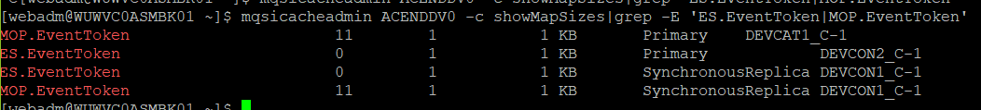

**Note : Below lines are commented in BrokerStart.sh file as currently Kafka Ohio traffic is disabled. NRT _DR service should be started only when kafka traffic is active in Ohio region. App team will confirm when NRT_DR to be started.**

## Don't start the below service without App Team confirmation  
#mqsistartmsgflow ESBBKPI0 -e NRT_DR -k NRT_Notification_Service

#### **Step 3: Verify Splunk log**

* Verify the splunk logs that is OKTA flow got logged successfully?

**Query**: index = “wugateway” “BIS“ “OKTA“

**Query**: index = “wugateway” “Auth_Token_APP “

