Minimax Searching In Checkers

Submitted To Dr. Moonis Ali
CS 5346 Spring 2008

Kris Pickrell
April 21, 2008

Table of Contents

1. Introduction
1.1 Team Considerations
1.2 Problem Description and Project Goals
1.3 Document Layout
2. Checkers Software Design
2.1 Section Goals
2.2 Checkers Representation in Software
2.3 Major Software Components
2.3.1 GUI Layout and Design
2.3.2 Board Validation
2.3.3 Analysis Engine
3. Minimax Algorithms
3.1 Rich and Knight - Minimax
3.2 Russell and Norvig - Alpha-Beta Search
4. Heuristic Functions
4.1 Evaluation Functions
4.2 Deep-Enough
4.3 Move-Gen
5. Program Output - Example Positions With Program Analysis
5.1 Position 1 - Initial Position
5.1.1 Rich and Knight - Depth 5 ply
5.1.2 Russell and Norvig - Depth 5 ply
5.1.3 Rich and Knight - Depth 10 ply
5.1.4 Rich and Knight - Depth 10 ply
5.2 Position 2 - Middlegame Position
5.2.1 Rich and Knight - Depth 5 ply
5.2.2 Russell and Norvig - Depth 5 ply
5.2.3 Rich and Knight - Depth 10 ply
5.2.4 Russell and Norvig - Depth 10 ply
6. Complexity Analysis and Performance
6.1 Rich and Knight
6.1.1 Time Complexity
6.1.2 Space Complexity
6.2 Russell and Norvig
6.2.1 Time Complexity
6.2.2 Space Complexity
6.3 Side-by-Side Comparison

7. Summary

Appendix: Code Listings
a. engine.cc, engine.h
b. board.cc, board.h
c. mainwindow.cc, mainwindow.h
d. mainframe.cc, mainframe.h
e. boardwidget.cc

References
1. Introduction

1.1 Team Considerations
In the previous project, I worked with Shachin Maharjan and Alan Niu. For this project, it was clear that each of us would need to do some significant software development. Since their C++ programming background is quite limited, it would have been too difficult to coordinate all of my development with them in order to let them use my GUI and checkers validation code. Additionally, because I am working full time and have a family, meeting with them is very difficult and often unproductive. Since no one else was available, I elected to do this project on my own.

1.2 Problem Description and Project Goals
The goal of this project is to develop the software necessary in order to evaluate the minimax algorithm applied to the checkers game domain. This requires development of a good heuristic for the static evaluation function, a successor function that generates a subset (possibly improper) of the legal moves in a position, a method that determines when the goal state or maximum search depth has been reached, and all of the checkers rules logic, user interface code, and anything else required to allow the minimax algorithm to run. The engine is required to keep track of the number of nodes expanded at 1. each iteration, and 2. for the complete game. It should also keep track of positions it encounters that it evaluates as a win. A side goal of this project is to implement two versions of the minimax algorithm using alpha-beta cutoffs and compare their performance and complexity. The remainder of this document describes the methodologies I have used in order to satisfy these requirements.

1.3 Document Layout
Section 1 introduces the problem domain and project goals. Section 2 deals with the software that I have written in order to provide a platform for analyzing the minimax algorithm. It's intention is to give a high-level view of the major components of the software and how they function together. Each of the major software pieces can be found in the appendix of code listings. Section 3 gives my implementation of two minimax algorithms: alpha-beta-search from [Russell, 2003] and minimax from [Rich, 1990]. Section 4 focuses on the static evaluation, deep-enough, and move generation routines. Section 5 gives several examples and trial runs in order to demonstrate the run-time behavior of the algorithms. Section 6 analyzes the complexity of the algorithms with statistics taken from trial runs. Section 7 gives concluding remarks.

2. Checkers Software Design

2.1 Section Goals
This section intends to lay the groundwork for the minimax algorithms by describing the software environment in which their execution takes place. In the next section, I describe some of the design decisions I made in order to ease the development of the checkers interface and engine. I discuss how I represent the squares on the board and how I describe moves when translated for display. Understanding this section is critical for understanding the remainder of the analysis in this document. Section 2.3 describes, at a high level, how the software is laid out, the overall GUI design, and how the checkers engine and move verification fit together. Section 2.3.2 is of particular importance since it discusses the Board class which is used in the move-gen routine. This class is also responsible for validating moves made within the GUI and, in general, houses the rules for how the game of checkers is played.

2.2 Checkers Representation in Software
In order to make it possible to have a computer analyze a checkers position, it is necessary to have some way to represent and describe the board's squares. This is accomplished by assigning numbers to each of the dark squares. I have selected the common method of numbering the squares from the top down. I begin numbering with 0 and end with 31 as follows:

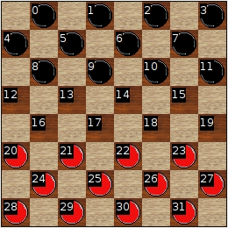

Figure 1: Board Numbering

This is the way the squares are presented to the user in analysis lines and user input through clicking. It is, however, cumbersome to keep squares like this internally since it is not clear how to go from a square to one at it's lower right, for example, in a quick numerical way. On some squares you add 4 and on others, 5. What would be nice is to trade off some space for the time we could save by computing the numerically adjacent squares. We can do this by spreading out the squares in a larger space (54 vs. 32), and assigning them numbers that make the movement computation simpler:

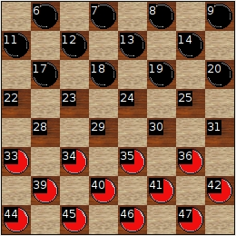

Figure 2: Internal Numbering

Notice now that in order to move to a square at any square's lower left, you always subtract 5, to move to the lower right you always add 6, etc. This greatly simplifies and speeds up the computation of adjacent squares and is how the board is represented internally. I distinguish between an int index or the 0-31 version, and a board index or the 0-53 version. Extra space is used in the board index array so that lower left and right of an edge square does not run across the array bounds. Moves using this numbering are indicated with either source - destination, indicating a normal move, source x destination, indicating a capture, or source x square1 x square 2 x destination, indicating a multi-hop capture where squareN is the Nth square visit on the sequence. Some examples should help clarify:
18-24: move from square 18 to square 24
18x30: capture the piece at square 24 landing on square 30
18x30x40: capture pieces at squares 24 and 35 landing on square 40
Moves are ordered by move number followed by the first player's move followed by the second. e.g.:
1. 10-14 23-18
2. 14x23 27x18
... etc
When referring to the first players 5th move, I write 5. 10-14. When referring to the second players 5th move, I write 5...10-14, the ellipses indicating the second player.

2.3 Major Software Components
This section focuses on the major software components surrounding the minimax algorithms: the GUI, the Board class, and the Analysis Engine.

2.3.1 GUI Layout and Design
I have written this project in C++ using the QT development library. QT provides several features that make it possible to develop applications quickly which I felt were key to completing this project in the given 4 week schedule. I created a checkers board widget which provides the ability to draw a checkers board with pieces on it as well as click on squares and have that information available to be presented to the engine. QT provides the ability to quickly assemble widgets using a conglomeration of existing widgets and base classes. QT also supports a mechanism called signals and slots. This is essentially a thread-safe publish-subscribe mechanism where a signal gets routed to one or many slots that are equipped to handle the signal. This mechanism is key in routing analysis updates from the engine to the main application in a simplified manner. The GUI is laid out in four main parts, the main menu and toolbar, the board widget, a text entry showing the moves played, and an analysis window which shows the output from the engine. This is shown in detail in the following figure:

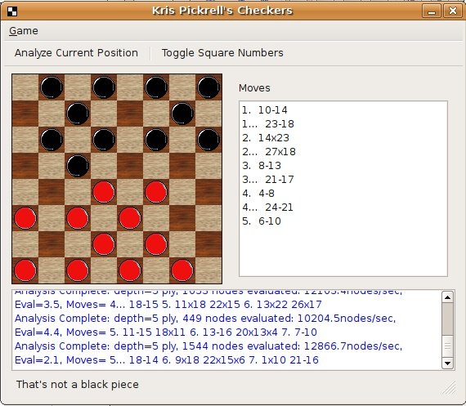
Figure 3: The checkers application

The bottom of the window shows the engine analysis including depth, number of nodes evaluated, and the evaluation and moves contained in the best line. The status bar at the very bottom gives information about any illegal moves attempted and other general rules verification.

2.3.2 Board Validation
One of the most significant pieces of software that needed to be developed houses the rule validation, generation, and position information. This is contained in the Board class. The Board class is used by the minimax algorithm and GUI code to store position information, validate user moves, and generate legal moves in a position. Significant methods contained in this class include getLegalMoves, getAdjacentSquares, moveWhite, moveBlack, isLegalMove, whiteCaptureExists, blackCaptureExists, isSingleJumpCapture, isMultiJumpCapture, as well as methods which determine whether a square is at the upper left, upper right, lower left or lower right of another square.

2.3.3 Analysis Engine
The analysis engine is implemented by the Engine class. This class is responsible for beginning a minimax thread and passing the current position to the thread. It starts either the Rich and Knight minimax or the Russel and Norvig minimax depending on the options given to the think method. Engine is also responsible for receiving analysis update and completion signals from the minimax threads and relaying this information to the user interface (UI) in a user friendly way. It retains control over its thread and can stop it when needed. The next section talks in detail about the design of the minimax thread classes and how the apply the minimax algorithms.
3. Minimax Algorithms

3.1 Rich and Knight - Minimax

Both Rich and Knight and Russel and Norvig, hereafter referred to as R&K and R&N respectively, algorithms are implemented as derived classes of an abstract base class MinimaxThread. MinimaxThread provides interfaces for stopping/starting the thread, storing the initial position, alpha-beta cutoffs, statistical and timing info, storing the best path, and calling the heuristic functions. There are currently three types of heuristic function abstract base classes passed to the MinimaxThread constructor. These are:

DepthStrategy: the logic for determining if deep enough on a position
bool deep_enough( const Board& position ) const;

EvaluationStrategy: the static evaluation function
float evaluate( const Board& position ) const; // returns eval between min and max
float minimum() const; // the minimum possible value
float maximum() const; // the maximum possible value

MovegenStrategy: the successor function and move generator
Path generate_moves( const Board& position ) const;
// returns possible moves from the given position

These are all abstract base classes. In order to implement one of them, it is necessary to derive a class and implement the appropriate virtual method. For example, I have created two different evaluation strategies: BasicEvaluationStrategy, and WeightBasedEvaluationStrategy. The basic strategy merely computes the quantity of pieces remaining on the board assigning 1 to men and 4 to kings. The weight based strategy computes a weighted sum of 3 factors: material value, piece mobility, and piece control. Having MinimaxThread operate on abstract strategies makes it easy to create, test, and compare different depth measures, evaluation functions, and move generation algorithms. Construction of a MinimaxThread is straightforward:

new RichAndKnightMinimax( engine,
initial_position,
new BasicDepthStrategy( max_depth ),
new WeightBasedEvaluationStrategy
( 1, .7, .7 ) ,
new BasicMovegenStrategy,
true ) // output analysis=true

The engine parameter is the engine this thread is running on behalf of. initial_position is the initial position the thread is assigned, the next three parameters construct the strategies used by the algorithm. The last parameter indicates that the thread should emit analysisUpdate signals. This significantly slows the performance of the algorithm, however.

The R&K minimax is implemented through the method:

MinimaxResult RichAndKnightMinimax::minimax_ab( const Board& position,
float use_thresh,
float pass_thresh )

You may immediately be wondering where the current depth and current player are stored. They are kept within the Board class and can be modified and accessed through the methods:

void Board::setDepth( int newdepth ) and
void Board::switchTurns() and
Board::Color Board::getTurn() const

Here is my implementation of R&K minimax for reference. The entire Engine class can be found in the code listings in the appendix:

MinimaxResult RichAndKnightMinimax::minimax_ab( const Board& position,
float use_thresh,
float pass_thresh )
{

// if paused, sleep until resumed
while( paused() ) {
_is_paused = true;
msleep( 10 );
}

_is_paused = false;

// if stopped, return immediately with empty result
if( stopped() ) {
return MinimaxResult( 0, Path() );
}

_nodes_evaluated++;

/***************************************************************
deep_enough( position ) executes the depth strategy that
we have been assigned on construction. If true, it returns with
an empty path and the static evaluation of the current position
****************************************************************/
if( deep_enough( position ) ) {
float evaluation = evaluate( position );
return MinimaxResult( evaluation, Path() );
}

/***************************************************************
generate_moves( position ) executes the move generation
strategy. It returns a Path which is a list of possible moves
in the current position.
****************************************************************/
Path moves = generate_moves( position );

// if there are no more moves, evaluate the current position
// and return same structure when deep-enough returns true
if( moves.empty() ) {
float evaluation = evaluate( position );
return MinimaxResult( evaluation, Path() );
}

/***************************************************************
This is the main loop of the algorithm. It loops through each
of the moves returned by generate_moves and evaluates them
updating the new best path if their result is greater than
pass_thresh.
****************************************************************/
Path current_best_path = Path();
for( Path::iterator path = moves.begin();
path != moves.end();
++path ) {

// This generates the next position by making a move from the current
// position. The current move must be converted to a BoardMove and then
// applied by calling Board::move( from, to )

Board next_position = position;
Board::BoardMove next_move = next_position.convertToBoardMove( (*path) );

// make the move. It shouldn't fail since the move should be legal, but
// debug code is there just in case

if( !next_position.move( next_move.from, next_move.to ) ) {
qDebug( "Move failure in minimax_ab, generate_moves"
" generated an invalid move" );
}

/***********************************************************************
This part takes a little explaining. What I am doing is checking if
the current move is a capture and whether there are any captures
after that. If there are, we want to perform the moves that result,
but we don't want to switch turns. This effectively handles scenarios
where a single jump is made, and then two possible captures exist after
that. Since captures will be the only thing in moves if a capture exists,
since they must be performed, minimax_ab will evaluate which of the
two particular captures is better
************************************************************************/
MinimaxResult result( 0, Path() );
if( position.isMultiJumpCapture( next_move ) ) {

// the next move is a capture too, don't switch
// turns, but perform minimax
// on the resulting position which will perform and evaluate any
// subsequent multi-hop captures

result = minimax_ab( next_position,
use_thresh,
pass_thresh );
} else {

// otherwise, switch turns and evaluate from the other players perspective

next_position.switchTurns();

// go down one in depth
next_position.setDepth( position.depth() + 1 );
result = minimax_ab( next_position,
-pass_thresh,
-use_thresh );
}

// if the new value is greater than the pass threshold, assign the new value
// to pass_thresh, and make note of which path the evaluation occurred on

float new_value = result.value;
if( new_value > pass_thresh ) {
pass_thresh = new_value;
current_best_path.assign( result.path.begin(), result.path.end() );
current_best_path.push_front( (*path) );

if( _outputAnalysis ) {
emit analysisUpdate( position, current_best_path, pass_thresh );
}
}

// no need to search the rest of the moves
if( pass_thresh >= use_thresh ) {
return MinimaxResult( pass_thresh, current_best_path );
}
}

_best_evaluation = pass_thresh;
_best_path = current_best_path;

return MinimaxResult( pass_thresh, current_best_path );
}

Performance and trials of this algorithm are shown in sections 5 and 6.

3.2 Russell and Norvig - Alpha-Beta Search
R&N Alpha-Beta search is implemented in the class RussellAndNorvigMinimax through the functions:

MinimaxResult alpha_beta_search( const Board& position );
MinimaxResult max_value( const Board& position,
float alpha, float beta );
MinimaxResult min_value( const Board& position,
float alpha, float beta );

alpha_beta_search simply calls max_value with the minimum and maximum values on the initial position:

MinimaxResult alpha_beta_search( const Board& position )
{
return max_value( position,
_evaluation_strategy->minimum(),
_evaluation_strategy->maximum() );
}

The max_value and min_value functions are given here for convenience with explanatory comments, but may be found in their entirety in the code listings in the appendix.

MinimaxResult RussellAndNorvigMinimax::max_value( const Board& position,
float alpha,
float beta )
{

// if paused, sleep until resumed
while( paused() ) {
_is_paused = true;
msleep( 10 );
}

_is_paused = false;

// if stopped return immediately with result
if( stopped() ) {
return MinimaxResult( 0, Path() );
}

_nodes_evaluated++; // tally one more node evaluated

/***************************************************************
deep_enough( position ) executes the depth strategy that
we have been assigned on construction. If true, it returns with
an empty path and the static evaluation of the current position
****************************************************************/
if( deep_enough( position ) ) {
float evaluation = evaluate( position );
return MinimaxResult( evaluation, Path() );
}

/***************************************************************
generate_moves( position ) executes the move generation
strategy. It returns a Path which is a list of possible moves
in the current position.
****************************************************************/
Path moves = generate_moves( position );

// if there are no more moves, evaluate the current position
// and return same structure when deep-enough returns true

if( moves.empty() ) {
float evaluation = evaluate( position );
return MinimaxResult( evaluation, Path() );
}

/***************************************************************
This is the main loop of the algorithm. It loops through each
of the moves returned by generate_moves and evaluates them
from the MAX perspective updating the new best path if their
result is GREATER than each of the other moves.
****************************************************************/

Path current_best_path = Path();
float v = _evaluation_strategy->minimum();
for( Path::iterator path = moves.begin();
path != moves.end();
++path ) {

// This generates the next position by making a move from the current
// position. The current move must be converted to a BoardMove and then
// applied by calling Board::move( from, to )

Board next_position = position;
Board::BoardMove next_move = next_position.convertToBoardMove( (*path) );

if( !next_position.move( next_move.from, next_move.to ) ) {
qDebug( "Move failure in max_value, generate_moves"
" generated an invalid move" );
}

// See the note in the minimax_ab code for an explanation about how
// multi-hop captures are handled here. Basically, don't switch turns if
// we can make a multi-hop capture until the last capture

MinimaxResult result( 0, Path() );
if( position.isMultiJumpCapture( next_move ) ) {

// the next move is a capture too, don't switch turns, but perform minimax
// on the resulting position which will perform and evaluate any subsequent
// captures

result = max_value( next_position,
alpha,
beta );
} else {

// switch turns and evaluate the next position from the perspective of
// the opposite player

next_position.switchTurns();

next_position.setDepth( position.depth() + 1 );
result = min_value( next_position,
alpha,
beta );
}

// if we've found a value greater than our current best (v), keep track of the
// new value and the path that got us there

if( result.value > v ) {
v = result.value;
current_best_path.assign( result.path.begin(), result.path.end() );
current_best_path.push_front( (*path) );

if( _outputAnalysis ) {
emit analysisUpdate( position, current_best_path, result.value );
}
}

// we've gone over our current beta value, return with the best path
if( v >= beta ) {

return MinimaxResult( v, current_best_path );
}

// set alpha to the best between alpha and v
alpha = max( alpha, v );
}

_best_evaluation = v;
_best_path = current_best_path;

return MinimaxResult( v, current_best_path );
}

/************************************************************************************
The min_value recursive function
************************************************************************************/
MinimaxResult RussellAndNorvigMinimax::min_value( const Board& position, float alpha, float beta )
{
while( paused() ) {
_is_paused = true;
msleep( 10 );
}

_is_paused = false;

if( stopped() ) {
return MinimaxResult( 0, Path() );
}

_nodes_evaluated++;

/***************************************************************
deep_enough( position ) executes the depth strategy that
we have been assigned on construction. If true, it returns with
an empty path and the static evaluation of the current position
****************************************************************/

if( deep_enough( position ) ) {
float evaluation = evaluate( position );
return MinimaxResult( evaluation, Path() );
}

/***************************************************************
generate_moves( position ) executes the move generation
strategy. It returns a Path which is a list of possible moves
in the current position.
****************************************************************/

Path moves = generate_moves( position );

// if there are no more moves, evaluate the current position
if( moves.empty() ) {
float evaluation = evaluate( position );
return MinimaxResult( evaluation, Path() );
}

/***************************************************************
This is the main loop of the algorithm. It loops through each
of the moves returned by generate_moves and evaluates them
from the MIN perspective updating the new best path if their
result is LESS than each of the other moves.
****************************************************************/
Path current_best_path = Path();
float v = _evaluation_strategy->maximum(); // keep track of current best
for( Path::iterator path = moves.begin();
path != moves.end();
++path ) {

// This generates the next position by making a move from the current
// position. The current move must be converted to a BoardMove and then
// applied by calling Board::move( from, to )

Board next_position = position;
Board::BoardMove next_move = next_position.convertToBoardMove( (*path) );

if( !next_position.move( next_move.from, next_move.to ) ) {
qDebug( "Move failure in max_value, generate_moves"
" generated an invalid move" );
}

// see the note in the minimax_ab code for a description of
// how multi-hop captures
// are handled

MinimaxResult result( 0, Path() );
if( position.isMultiJumpCapture( next_move ) ) {

// the next move is a capture too, don't switch turns, but perform minimax
// on the resulting position which will perform and evaluate any subsequent
// captures

result = min_value( next_position,
alpha,
beta );
} else {

// switch turns and evaluate the position from the perspective of max
next_position.switchTurns();

// go one level deeper
next_position.setDepth( position.depth() + 1 );
result = max_value( next_position,
alpha,
beta );
}

// if we've found a new minimum value, update our v
if( result.value < v ) {
v = result.value;
current_best_path.assign( result.path.begin(), result.path.end() );
current_best_path.push_front( (*path) );

if( _outputAnalysis ) {
emit analysisUpdate( position, current_best_path, result.value );
}
}

// if we've crossed the alpha threshold, return the current best path
if( v <= alpha ) {
return MinimaxResult( v, current_best_path );
}

// update beta to reflect the global minimum best
beta = min( beta, v );
}

_best_evaluation = v;
_best_path = current_best_path;

return MinimaxResult( v, current_best_path );
}

The entirety of the algorithm in context can be found in the Appendix.

4. Heuristic Functions

4.1 Evaluation Functions

My first attempt at an evaluation function considered only piece values on a particular board. This is implemented by the BasicEvaluationStrategy class. This heuristic assigns a value of 1 to any 'Man' (non-king) and a value of 4 to any king. The color of the piece determines whether 1 or 4 is added or subtracted from the evaluation. So given an equal number and same types of pieces by both sides, the evaluation should always come out to 0. For this analysis, I assign a positive value to a red-player advantage (or the human) and a negative value to a white player advantage (or the computer). It is not critical which player maximizes his evaluation or which player minimizes his evaluation. What matters is that the evaluation is consistently moving toward the appropriate bound assigned to the player, whether max or min.
Here is an example of the evaluation given by this strategy:

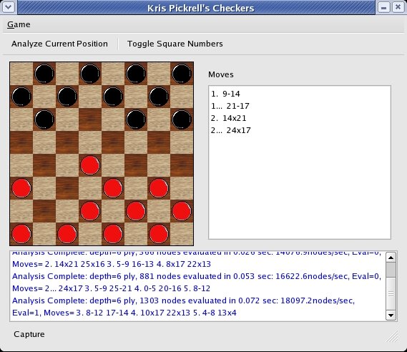

In this position, it gives an evaluation of 1, meaning at the end of the line 3. 8-12 17-14 4. 10x17 22x13 5. 4-8 13x4, red will be ahead by a single piece. This line is shown in this diagram:

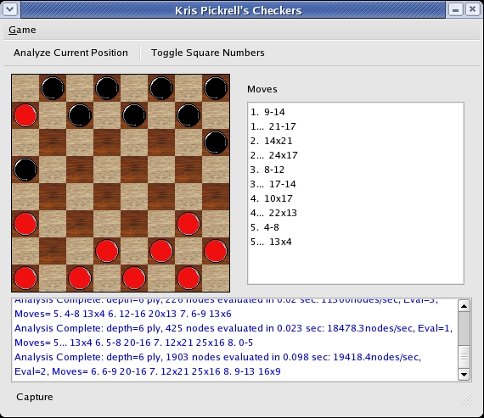

Where we count that red has 10 pieces and black has 9 giving an evaluation of +1 to red.
Notice, however, that at the top of the analysis window (5. 4-8 13x4) black plays a move that has immediately lost a piece. This is because the search depth is only 6 ply and it has not seen far enough ahead to realize that this is a loss for it. At greater search depth, it sees these types of errors. Search depth is compared below.
This heuristic is, in general quite poor. For example, it chooses to play the move 3. 8-12. In general, apart from a tactical win, moving a piece from a square where it controls two squares to one on the edge where it only controls one limits piece mobility and control. Also, this heuristic tends to keep moving the same pieces over and over until they get captured. What would be better is to move several pieces in a coordinated fashion so that maximal board control can be obtained.
The second evaluation strategy I developed to begin to address some of these issues is called WeightBasedEvaluationStrategy. It implements a weighted evaluation of 3 different factors:
1. material - who has the most pieces
2. number of squares controlled - pieces controlling more squares are
evaluated higher
3. original square displacement - pieces remaining on their original squares are evaluated lower
The first is the same heuristic as before and should be weighted the most heavily. The second encourages stronger movement and the third encourages total-army movement. That is, it encourages the movement of more than just a single piece. These 3 factors are combined with weights in the following evaluation function:

float WeightBasedEvaluationStrategy::evaluate( const Board& position ) const
{
float eval =
pieceCountWeight() * calculatePieceCountDifference( position ) +
squaresControlledWeight() * calculateSquaresControlledDifference( position ) +
displacementWeight() * calculateDisplacementDifference( position );

return eval;
}

Each of the *Weight() methods returns the current weight assigned to the particular factor it is multiplied by. The multiplicands calculatePieceCountDifference(), calculateSquaresControlledDifference(), and calculateDisplacementDifference() take the current position and compute a value for each of the three factors. This heuristic performs much more intelligently than the original piece weight heuristic. Here is the following evaluation using this weight-based approach on the previous example for comparison:

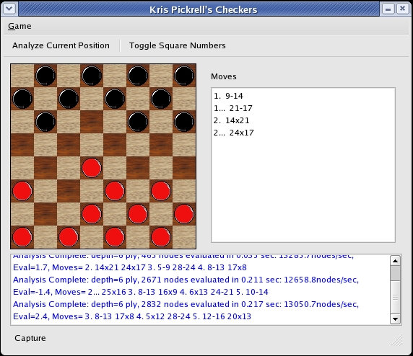

Notice at the end of this line, the move preference has changed from 3. 8-12 to 3. 8-13. This more central square gives black more control and is a better move. When playing through the line, the engine falls prey to the 6 ply depth, though. Here is the final position evaluated by the second heuristic at a depth of 6 ply:

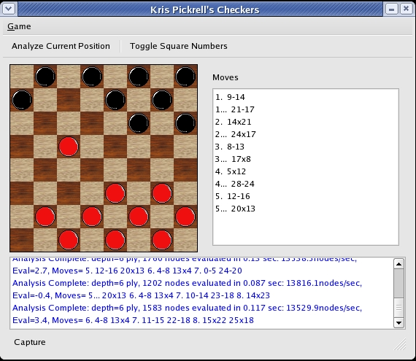

At a depth of 10 ply, the heuristic prefers this position at move 3:

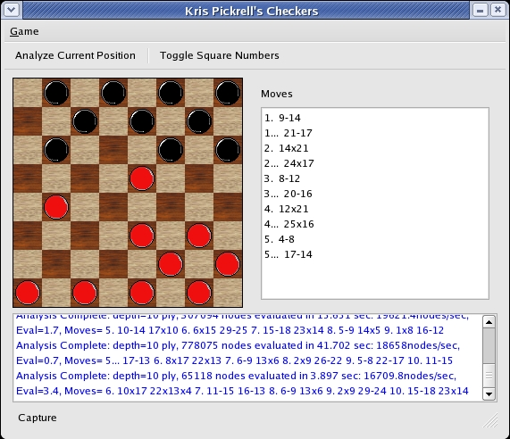
Where it's original evaluation of 2.4 changed to 3.4 since it is now able to see that it can win a piece by 5...17-14 forcing capture and setting up a double jump. Notice that the move 3. 8-12 appeared again because it thinks red is going to play 20-16 allowing the piece on the edge to be traded off. In this sense, black is giving up one of it's pieces in order to remove a strong red piece. Much more indicative of stronger play. The weights for this function have been chosen somewhat arbitrarily. A better solution would be to train the weights from a set of trial runs that would give more optimized weights and discourage over or under-evaluation.

4.2 Deep-Enough

The deep-enough algorithm is the simplest of the three. It checks whether the current depth is above the maximum search depth and whether the position is a terminal state with one side winning. It is implemented in the BasicDepthStrategy::deep_enough method:

bool BasicDepthStrategy::deep_enough( const Board& position ) const
{
return position.depth() >= max_depth() || position.isGameOver();
}

This makes use of the Board class method isGameOver which takes a current position and tests whether one side or the other has one. This method is also quite simple:

bool Board::isGameOver() const
{
if( getTurn() == WHITE ) {
vector< Move > moves = getAllCurrentlyLegalWhiteMoves();
return moves.empty();
} else {
vector< Move > moves = getAllCurrentlyLegalBlackMoves();
return moves.empty();
}
}

That is, it merely returns whether or not there are any legal white moves, if white's turn, or legal black moves, if black's turn. These functions are given within context in the appendix. An example of the winning situation encounter that terminates the analysis can be seen in the following position:

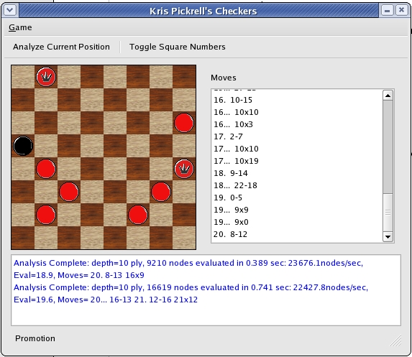

In this position, it is red to move. Here, any legal move wins, but the engine chooses to move 20...16-13 allowing 21 12-16 and the capture 21x12 winning all the pieces. Notice that the analysis line is shorter. It has determined that the second clause of the depth test, namely isGameOver is true and has terminated the seacrh. This is shown in this position:

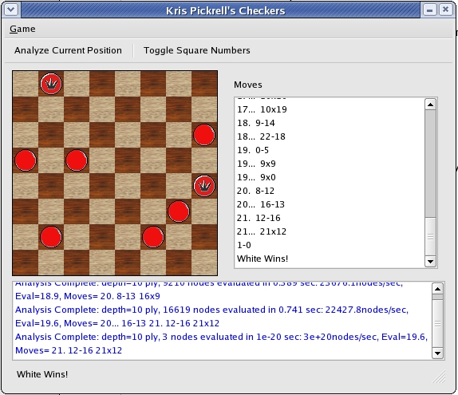
Figure: the terminal state encountered

Here it terminates the evaluation at 3 nodes and determines that the resulting position is a goal state position.

4.3 Move-Gen

The move-gen function is implemented by the BasicMovegenStrategy class. This class has a method, generate_moves which takes a board position and, from it, generates all possible moves in that position for the current player. It returns a Path, which is a list of possible moves that the minimax algorithms can iterate through. As an example of it's output, from the initial position:

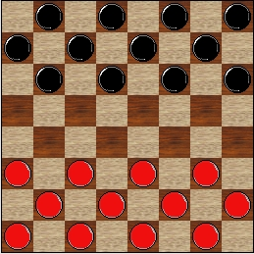

With black to move, generate_moves would return the list: (8-12, 8-13, 9-13, 9-14, 10-14, 10-15, 11-15) for each of the first row black pieces possible moves. If a capture is available, it only includes captures in the list, since I have developed without the huffing rule and any possible captures must be made under the current international checkers rules. The generate_moves routine is given here for reference and in its entirety in the appendix:

// Get all currently legal moves and prune them based on whether they are
// not captures if necessary
Path BasicMovegenStrategy::generate_moves( const Board& position ) const
{
Path path;
vector< Board::Move > vmoves = position.getAllCurrentlyLegalMoves( position.getTurn() );

Path moves;
moves.assign( vmoves.begin(), vmoves.end() );

// for each of the moves, if it is a capture, add it to path, otherwise skip it

for( Path::iterator move = moves.begin();
move != moves.end();
++move ) {

Board::BoardMove bmove = position.convertToBoardMove( (*move) );

if( bmove.type == Board::PIECE_CAPTURE ||
bmove.type == Board::KING_CAPTURE ) {

path.push_back( (*move) );
}
}

// path will be empty when there were no captures. In this case, we want
// to use the moves vector

if( path.empty() ) {
path = moves;
}

return path;
}
5. Program Output - Example Positions With Program Analysis

Program output and analysis is given in the engine output pane at the bottom of the window. This has been seen before, but a more detailed evaluation and explanation is shown here. An example of program analysis is shown here in blue for the initial position:

Eval=-1.4, Moves= 3. 7-10
Eval=-1.4, Moves= 2... 16-12 3. 7-10
Eval=0, Moves= 3. 10x19
Eval=0, Moves= 2... 22x15 3. 10x19
Eval=-0.7, Moves= 3. 9x18
Eval=-0.7, Moves= 2... 23x14 3. 9x18
Eval=-0.7, Moves= 2. 15-18 23x14 3. 9x18
Eval=-1.4, Moves= 3. 7-11
Eval=-1.4, Moves= 2... 16-12 3. 7-11
Eval=-0.7, Moves= 1... 20-16 2. 15-18 23x14 3. 9x18
Analysis Complete: depth=5 ply, 926 nodes evaluated in 0.129 sec: 7178.29nodes/sec, Eval=-0.7, Moves= 1. 9-14 20-16 2. 14-17 22x13 3. 8x17

This gives the final evaluation as well as moves considered on separate branches of the evaluation tree.

5.1 Position 1 - Initial Position

5.1.1 Rich and Knight - Depth 5 ply

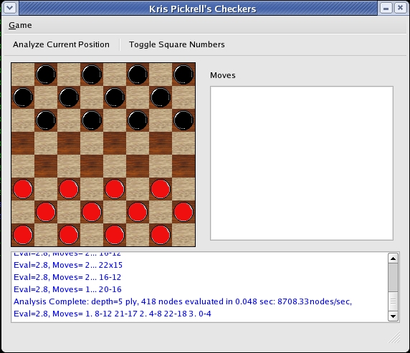

From the analysis window at a depth of 5 ply, this algorithm evaluates 418 nodes with the best line at 2.8.

5.1.2 Russell and Norvig - Depth 5 ply

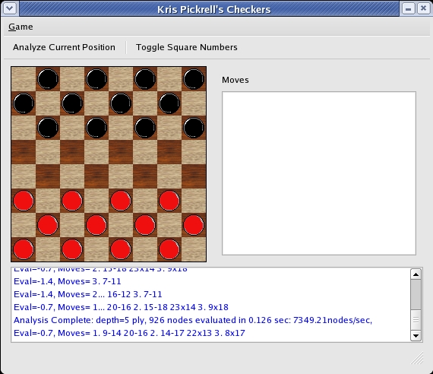

At a depth of 5 ply this algorithm evaluates 926 nodes at a slight advantage for black. This is probably more accurate as black has the first move. But at this depth, it is likely that this is just coincidence. The initial position should evaluate fairly close to 0.

5.1.3 Rich and Knight - Depth 10 ply

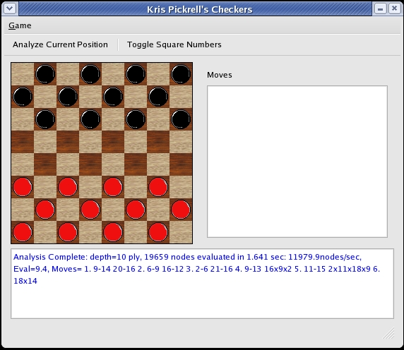

At 10 ply, because of the fewer nodes encountered, the evaluation is much less accurate than one would think.

5.1.4 Russell and Norvig - Depth 10 ply

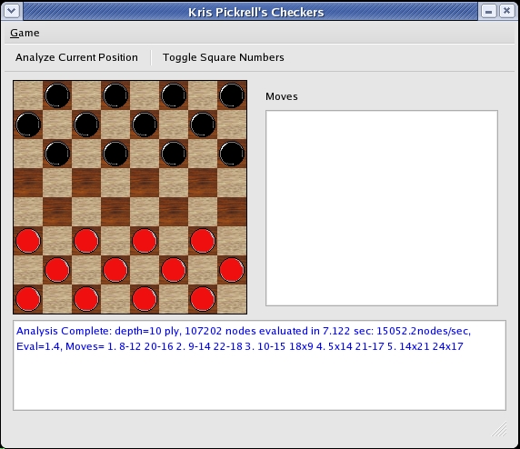

This evaluation seems to be more reasonable as it is closer to 0.

5.2 Position 2 - Middlegame Position

Here, I run some sample trials using the following middlegame position with both the R&K and R&N algorithms:

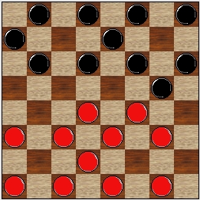

I run trials at a depth of 5 ply as well as a depth of 10 ply.

5.2.1 Rich and Knight - Depth 5 ply
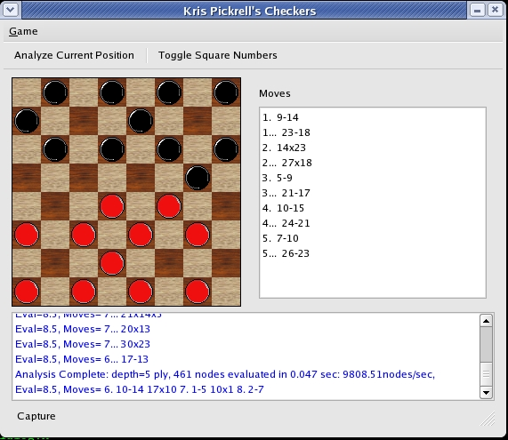

5.2.2 Russell and Norvig - Depth 5 ply

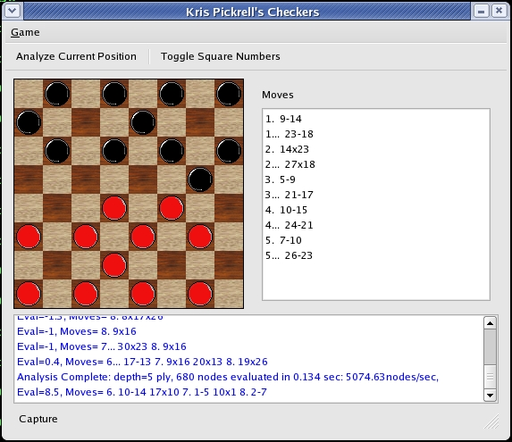

5.2.3 Rich and Knight - Depth 10 ply

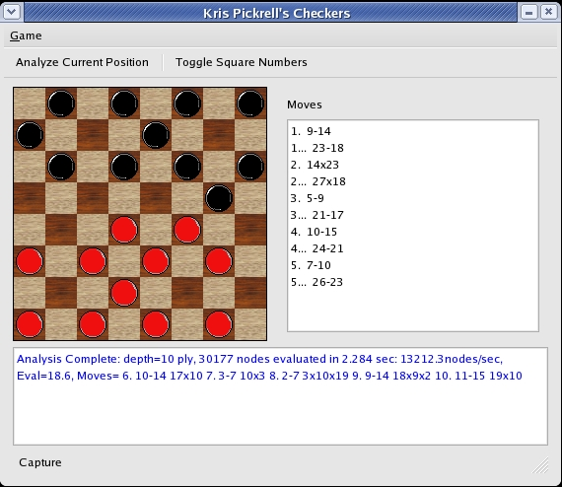

5.2.4 Russell and Norvig - Depth 10 ply

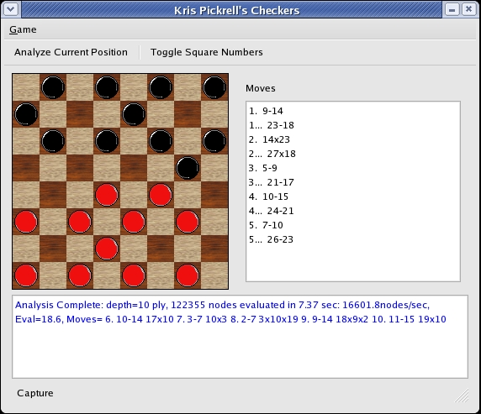

6. Complexity Analysis and Performance

Both algorithms were analyzed by comparing performance analyzing the initial position from between 1 to 12 ply.

6.1 Rich and Knight

6.1.1 Time Complexity

Rich and Knight time vs. depth
Depth | Time(s) - R&K
1 | >0.001
2 | 0.002
3 | 0.014
4 | 0.017
5 | 0.04
6 | 0.084
7 | 0.187
8 | 0.396
9 | 0.771
10 | 1.642
11 | 3.312
12 | 5.755

6.1.2 Space Complexity

Rich and Knight nodes expanded vs. depth
Depth | Nodes - R&K
1 | 8
2 | 21
3 | 68
4 | 157
5 | 418
6 | 952
7 | 2183
8 | 4433
9 | 8292
10 | 19659
11 | 36358
12 | 95246

6.2 Russell and Norvig

6.2.1 Time Complexity

Russell and Norvig time vs. depth
Depth | Time(s) - R&N
1 | 0.001
2 | 0.003
3 | 0.016
4 | 0.046
5 | 0.087
6 | 0.237
7 | 0.478
8 | 1.16
9 | 3.196
10 | 6.764
11 | 14.199
12 | 31.917

6.2.2 Space Complexity

Russell and Norvig nodes expanded vs. depth
Depth | Nodes (R&N)
1 | 8
2 | 21
3 | 146
4 | 457
5 | 926
6 | 2664
7 | 5130
8 | 12898
9 | 34486
10 | 107202
11 | 214642
12 | 567902

6.3 Side-by-Side Comparison

Here are side-by-side comparisons of the visited nodes and time complexity of the algorithms. Rich and Knight is shown in red, while Russell and Norvig is shown in blue.

Both algorithms appear to have the expected O(b^m) time complexity. What is not seen is the O(bm) expected space complexity. This is because I am accumulating a count of nodes visited which mirrors time complexity.

7. Summary

Checkers provides an interesting problem domain for analyzing the minimax algorithms. Additional challenges exist when attempting to define accurate heuristic functions. In this analysis, it is clear that having an appropriate evaluation function is perhaps the most important factor in determining the quality of moves and the ultimate performance of the checkers playing program.

Appendix: Code Listings

a. engine.cc, engine.h

These files house the Engine class, as well as both Minimax algorithms and all heuristic functions.

Listing: engine.cc

#include <QDebug>
#include <QApplication>
#include <QEvent>
#include <QMetaType>

#include <sstream>
#include <algorithm>

#include <unistd.h>

#include "engine.h"

using namespace std;

Engine::Engine( int max_depth,
Engine::Algorithm algorithm,
bool outputAnalysis ) :
_algorithm( algorithm ),
_outputAnalysis( outputAnalysis )
{
_move_number = 0;
_max_depth = max_depth;

qRegisterMetaType< Board >( "Board" );
qRegisterMetaType< Path >( "Path" );
}

Engine::~Engine()
{
stop();
wait();

if( _thread ) {
disconnect( _thread.get() );
}
}

void Engine::think( const Board& position, int move_number )
{
stop();
wait();

if( _thread ) {
disconnect( _thread.get() );
}

if( _algorithm == Engine::RICH_AND_KNIGHT ) {

_thread.reset( new RichAndKnightMinimax( this,
position,
boost::shared_ptr< DepthStrategy >( new BasicDepthStrategy( _max_depth ) ),
//boost::shared_ptr< EvaluationStrategy >( new BasicEvaluationStrategy ),
boost::shared_ptr< EvaluationStrategy >( new WeightBasedEvaluationStrategy( 1, .7, .7 ) ),
boost::shared_ptr< MovegenStrategy >( new BasicMovegenStrategy ),
_outputAnalysis ) );
connect( _thread.get(), SIGNAL( analysisUpdate( const Board&, const Path&, float ) ),
this, SLOT( threadAnalysisUpdateSlot( const Board&, const Path&, float ) ) );

connect( _thread.get(), SIGNAL( analysisComplete( const Board&, const Path&, float ) ),
this, SLOT( threadAnalysisCompleteSlot( const Board&, const Path&, float ) ) );

} else if( _algorithm == Engine::RUSSELL_AND_NORVIG ) {

_thread.reset( new RussellAndNorvigMinimax( this,
position,
boost::shared_ptr< DepthStrategy >( new BasicDepthStrategy( _max_depth ) ),
//boost::shared_ptr< EvaluationStrategy >( new BasicEvaluationStrategy ),
boost::shared_ptr< EvaluationStrategy >( new WeightBasedEvaluationStrategy( 1, .7, .7 ) ),
boost::shared_ptr< MovegenStrategy >( new BasicMovegenStrategy ),
_outputAnalysis ) );

connect( _thread.get(), SIGNAL( analysisUpdate( const Board&, const Path&, float ) ),
this, SLOT( threadAnalysisUpdateSlot( const Board&, const Path&, float ) ) );

connect( _thread.get(), SIGNAL( analysisComplete( const Board&, const Path&, float ) ),
this, SLOT( threadAnalysisCompleteSlot( const Board&, const Path&, float ) ) );
} else {
qDebug("Engine::think received invalid algorithm type");
return;
}

_move_number = move_number;
_thread->start();
}

void Engine::stop()
{
if( _thread ) {
_thread->stop();
}
}

void Engine::pause()
{
if( _thread ) {
_thread->pause();
}
}

void Engine::resume()
{
if( _thread ) {
_thread->resume();
}
}

void Engine::wait( unsigned int millis )
{
if( _thread ) {
if( _thread->wait( millis ) ) {
qDebug( "thread returned from run in Engine::wait" );
} else {
ostringstream os;
os << "timeout after " << millis << " milliseconds waiting on thread in Engine::wait";
qDebug( os.str().c_str() );
}
}
}

void Engine::threadAnalysisUpdateSlot(const Board& position,
const Path& path,
float eval)
{
string linestring = generateLineString( position,
path,
eval,
_move_number+position.depth() );

if( linestring != _last_update ) {

_last_update = linestring;
emit engineUpdate( linestring.c_str() );
}
}

void Engine::threadAnalysisCompleteSlot(const Board& position,
const Path& path,
float eval)
{
stop();
wait();

if( !path.empty() ) {
// grab the evaluation and path from the thread
string linestring = generateLineString( position,
path,
eval,
_move_number+position.depth() );

ostringstream os;
int nodes = _thread->nodes_evaluated();
float time = static_cast< float >( _thread->time_elapsed() );

if( time <= 0 ) {
time = 1e-17;
}

os << "depth=" << _max_depth << " ply, " << nodes << " nodes evaluated in " << time/1e3 << " sec: " << 1e3*(nodes/time) << "nodes/sec, " << linestring;

emit analysisDone( os.str().c_str() );
}

disconnect( _thread.get() );
_thread.reset();
}

string Engine::generateLineString( const Board& initial_position,
const Path& path,
double evaluation,
int mnum )
{
ostringstream line;
line << "Eval=" << evaluation << ", Moves= ";

int move_number = mnum;

if( move_number % 2 == 0 ) {
line << Board::moveNumberToString( move_number );
}

#ifdef PATH_DEBUG_PRINT
Board print_board = initial_position;
for( Path::const_iterator it = path.begin();
it != path.end();
++it ) {

Board::BoardMove move = print_board.convertToBoardMove( (*it) );

ostringstream debug;
debug << "generateLineString path contents: " << move.from << "-" << move.to;
qDebug( debug.str().c_str() );

print_board.move( move.from, move.to );
}
#endif

Board current_board = initial_position;

for( Path::const_iterator it = path.begin();
it != path.end();
++it, move_number++ ) {

if( move_number % 2 ) {
line << Board::moveNumberToString( move_number );
}

Board::BoardMove move = current_board.convertToBoardMove( (*it) );

if( current_board.isMultiJumpCapture( move ) ) {

line << Board::toString( move.from, move.to, current_board[ move.from ] );

// make the first jump
if( !current_board.move( move.from, move.to ) ) {
ostringstream err;
err << "Engine::generateLineString detected invalid move in Path: " << Board::toString( move.from, move.to, current_board[ move.from ] ) << endl;
qDebug( err.str().c_str() );
}

Board::BoardMove realmove = move;

for( Path::const_iterator next_i = ++it; next_i != path.end(); ++next_i ) {

Board::BoardMove next_move = current_board.convertToBoardMove( (*next_i) );
if( !current_board.move( next_move.from, next_move.to ) ) {
ostringstream err;
err << "Engine::generateLineString detected invalid move in Path: " << Board::toString( move.from, move.to, current_board[ move.from ] ) << endl;
qDebug( err.str().c_str() );
break;
}

// this happens when a multi-jump capture is included
if( next_move.from == realmove.to ) {

realmove.to = next_move.to;
line << "x" << next_move.to;

} else {
break;
}
}

} else {

line << Board::toString( move.from, move.to, current_board[ move.from ] );
if( !current_board.move( move.from, move.to ) ) {
ostringstream err;
err << "Engine::generateLineString detected invalid move in Path: " << Board::toString( move.from, move.to, current_board[ move.from ] ) << endl;
qDebug( err.str().c_str() );
continue;
}
}

line << " ";
current_board.switchTurns();
}

return line.str();
}

void RichAndKnightMinimax::run()
{
qDebug("RichAndKnightMinimax::run");

timer.start();
MinimaxResult result = minimax_ab( _initial_position,
_evaluation_strategy->maximum(),
_evaluation_strategy->minimum() );
_time_elapsed = timer.elapsed();

_best_evaluation = result.value;
_best_path = result.path;

qDebug("RichAndKnightMinimax completed");
emit analysisComplete( _initial_position,
_best_path,
_best_evaluation );

while( !stopped() ) {
msleep( 10 );
// someone tried to pause while we were busy sleeping
if( paused() ) {
_is_paused = true;
}
}
}

MinimaxResult RichAndKnightMinimax::minimax_ab( const Board& position,
float use_thresh,
float pass_thresh )
{
while( paused() ) {
_is_paused = true;
msleep( 10 );
}

_is_paused = false;

if( stopped() ) {
return MinimaxResult( 0, Path() );
}

_nodes_evaluated++;

if( deep_enough( position ) ) {
float evaluation = evaluate( position );
return MinimaxResult( evaluation, Path() );
}

Path moves = generate_moves( position );

if( moves.empty() ) {
float evaluation = evaluate( position );
return MinimaxResult( evaluation, Path() );
}

Path current_best_path = Path();
for( Path::iterator path = moves.begin();
path != moves.end();
++path ) {

Board next_position = position;
Board::BoardMove next_move = next_position.convertToBoardMove( (*path) );

if( !next_position.move( next_move.from, next_move.to ) ) {
qDebug( "Move failure in minimax_ab, generate_moves generated an invalid move" );
}

MinimaxResult result( 0, Path() );
if( position.isMultiJumpCapture( next_move ) ) {

// the next move is a capture too, don't switch turns, but perform minimax
// on the resulting position which will perform and evaluate any subsequent
// captures

result = minimax_ab( next_position,
use_thresh,
pass_thresh );
} else {

next_position.switchTurns();

next_position.setDepth( position.depth() + 1 );
result = minimax_ab( next_position,
-pass_thresh,
-use_thresh );
}

float new_value = result.value;
if( new_value > pass_thresh ) {
pass_thresh = new_value;
current_best_path.assign( result.path.begin(), result.path.end() );
current_best_path.push_front( (*path) );

if( _outputAnalysis ) {
emit analysisUpdate( position, current_best_path, pass_thresh );
}
}

if( pass_thresh >= use_thresh ) {
return MinimaxResult( pass_thresh, current_best_path );
}
}

_best_evaluation = pass_thresh;
_best_path = current_best_path;

return MinimaxResult( pass_thresh, current_best_path );
}

void RussellAndNorvigMinimax::run()
{
qDebug("RussellAndNorvigMinimax::run");

timer.start();
MinimaxResult result = alpha_beta_search( _initial_position );

_time_elapsed = timer.elapsed();

_best_evaluation = result.value;
_best_path = result.path;

qDebug("RussellAndNorvigMinimax completed");

emit analysisComplete( _initial_position,
_best_path,
_best_evaluation );

while( !stopped() ) {
msleep( 10 );
// someone tried to pause while we were busy sleeping
if( paused() ) {
_is_paused = true;
}
}
}

MinimaxResult RussellAndNorvigMinimax::max_value( const Board& position, float alpha, float beta )
{
while( paused() ) {
_is_paused = true;
msleep( 10 );
}

_is_paused = false;

if( stopped() ) {
return MinimaxResult( 0, Path() );
}

_nodes_evaluated++;

if( deep_enough( position ) ) {
float evaluation = evaluate( position );
return MinimaxResult( evaluation, Path() );
}

Path moves = generate_moves( position );

if( moves.empty() ) {
float evaluation = evaluate( position );
return MinimaxResult( evaluation, Path() );
}

Path current_best_path = Path();
float v = _evaluation_strategy->minimum();
for( Path::iterator path = moves.begin();
path != moves.end();
++path ) {

Board next_position = position;
Board::BoardMove next_move = next_position.convertToBoardMove( (*path) );

if( !next_position.move( next_move.from, next_move.to ) ) {
qDebug( "Move failure in max_value, generate_moves generated an invalid move" );
}

MinimaxResult result( 0, Path() );
if( position.isMultiJumpCapture( next_move ) ) {

// the next move is a capture too, don't switch turns, but perform minimax
// on the resulting position which will perform and evaluate any subsequent
// captures

result = max_value( next_position,
alpha,
beta );
} else {

next_position.switchTurns();

next_position.setDepth( position.depth() + 1 );
result = min_value( next_position,
alpha,
beta );
}

if( result.value > v ) {
v = result.value;
current_best_path.assign( result.path.begin(), result.path.end() );
current_best_path.push_front( (*path) );

if( _outputAnalysis ) {
emit analysisUpdate( position, current_best_path, result.value );
}
}

if( v >= beta ) {

return MinimaxResult( v, current_best_path );
}

alpha = max( alpha, v );
}

_best_evaluation = v;
_best_path = current_best_path;

return MinimaxResult( v, current_best_path );
}

MinimaxResult RussellAndNorvigMinimax::min_value( const Board& position, float alpha, float beta )
{
while( paused() ) {
_is_paused = true;
msleep( 10 );
}

_is_paused = false;

if( stopped() ) {
return MinimaxResult( 0, Path() );
}

_nodes_evaluated++;

if( deep_enough( position ) ) {
float evaluation = evaluate( position );
return MinimaxResult( evaluation, Path() );
}

Path moves = generate_moves( position );

if( moves.empty() ) {
float evaluation = evaluate( position );
return MinimaxResult( evaluation, Path() );
}

Path current_best_path = Path();
float v = _evaluation_strategy->maximum();
for( Path::iterator path = moves.begin();
path != moves.end();
++path ) {

Board next_position = position;
Board::BoardMove next_move = next_position.convertToBoardMove( (*path) );

if( !next_position.move( next_move.from, next_move.to ) ) {
qDebug( "Move failure in max_value, generate_moves generated an invalid move" );
}

MinimaxResult result( 0, Path() );
if( position.isMultiJumpCapture( next_move ) ) {

// the next move is a capture too, don't switch turns, but perform minimax
// on the resulting position which will perform and evaluate any subsequent
// captures

result = min_value( next_position,
alpha,
beta );
} else {

next_position.switchTurns();

next_position.setDepth( position.depth() + 1 );
result = max_value( next_position,
alpha,
beta );
}

if( result.value < v ) {
v = result.value;
current_best_path.assign( result.path.begin(), result.path.end() );
current_best_path.push_front( (*path) );

if( _outputAnalysis ) {
emit analysisUpdate( position, current_best_path, result.value );
}
}

if( v <= alpha ) {
return MinimaxResult( v, current_best_path );
}

beta = min( beta, v );
}

_best_evaluation = v;
_best_path = current_best_path;

return MinimaxResult( v, current_best_path );
}

bool BasicDepthStrategy::deep_enough( const Board& position ) const
{
return position.depth() >= max_depth() || position.isGameOver();
}

float BasicEvaluationStrategy::evaluate( const Board& position ) const
{
float eval = 0.0;
for( int i = 0; i < position.size(); i++ ) {

if( position[i] == Board::WHITE_PIECE ) {
eval += 1;
} else if( position[i] == Board::WHITE_KING ) {
eval += 4;
} else if( position[i] == Board::BLACK_PIECE ) {
eval -= 1;
} else if( position[i] == Board::BLACK_KING ) {
eval -= 4;
}
}

return eval;
}

float WeightBasedEvaluationStrategy::evaluate( const Board& position ) const
{
float eval =
pieceCountWeight() * calculatePieceCountDifference( position ) +
squaresControlledWeight() * calculateSquaresControlledDifference( position ) +
displacementWeight() * calculateDisplacementDifference( position );

return eval;
}

// This calculates a simple differential of piece weights. Equal numbers
// of pieces and kings should come out to 0.
int WeightBasedEvaluationStrategy::
calculatePieceCountDifference( const Board& position ) const
{
int count = 0;
for( int i = 0; i < position.size(); i++ ) {

if( position[i] == Board::WHITE_PIECE ) {
count += 1;
} else if( position[i] == Board::WHITE_KING ) {
count += 4;
} else if( position[i] == Board::BLACK_PIECE ) {
count -= 1;
} else if( position[i] == Board::BLACK_KING ) {
count -= 4;
}
}

return count;
}

// This gives bonuses to each side for having more pieces with free squares
// in front of them. This encourages central control.
int WeightBasedEvaluationStrategy::
calculateSquaresControlledDifference( const Board& position ) const
{
int count = 0;
for( int i = 0; i < position.size(); i++ ) {

vector< Board::BoardIndex > adjacents =
position.getAdjacentSquares( Board::board_index( i ), position[i] );

if( adjacents.empty() ) {
continue;
}

if( position[i] == Board::WHITE_PIECE ||
position[i] == Board::WHITE_KING ) {

// give +1 to every free square in front of a piece or king
for( vector< Board::BoardIndex >::iterator current = adjacents.begin();
current != adjacents.end();
++current ) {

if( position.isFree( (*current ) ) ) {
count += 1;
}
}

} else if( position[i] == Board::BLACK_PIECE ||
position[i] == Board::BLACK_KING ) {

for( vector< Board::BoardIndex >::iterator current = adjacents.begin();
current != adjacents.end();
++current ) {

if( position.isFree( (*current ) ) ) {
count -= 1;
}

}
}
}

return count;
}

// This gives penalties to each side for number of pieces remaining
// on the original square side. It encourages movement.
int WeightBasedEvaluationStrategy::
calculateDisplacementDifference( const Board& position ) const
{
int displacement = 0;
// these should all be black pieces in the initial position
for( int i=0; i<12; i++ ) {

if( position[i] == Board::BLACK_PIECE )
displacement += 1;
}

// these should all be white pieces in the initial position
for( int i=20; i<32; i++ ) {
if( position[i] == Board::WHITE_PIECE ) {
displacement -= 1;
}
}

return displacement;
}

Path BasicMovegenStrategy::generate_moves( const Board& position ) const
{
Path path;
vector< Board::Move > vmoves = position.getAllCurrentlyLegalMoves( position.getTurn() );

Path moves;
moves.assign( vmoves.begin(), vmoves.end() );

for( Path::iterator move = moves.begin();
move != moves.end();
++move ) {

Board::BoardMove bmove = position.convertToBoardMove( (*move) );

// if( position.isCapture( bmove.from, bmove.to ) ) {
if( bmove.type == Board::PIECE_CAPTURE ||
bmove.type == Board::KING_CAPTURE ) {

path.push_back( (*move) );
}
}

if( path.empty() ) {
path = moves;
}

return path;
}

Listing: engine.h

#ifndef ENGINE_H
#define ENGINE_H

#include <QThread>
#include <QEvent>
#include <QTime>
#include <QQueue>

#include "boost/shared_ptr.hpp"

#include "board.h"

class MinimaxThread;
typedef std::list< Board::Move > Path;
class MinimaxResult
{
public:
MinimaxResult( float v, const Path& p )
{
value = v;
path = p;
}

float value;
Path path;
};

class Engine : public QObject
{
Q_OBJECT

public:

typedef enum {
RICH_AND_KNIGHT,
RUSSELL_AND_NORVIG,
} Algorithm;

Engine( int depth, Engine::Algorithm algorithm, bool outputanalysis = false );
~Engine();

virtual void stop();
virtual void pause();
virtual void resume();

virtual void think( const Board& position, int move_number );

// generates a string for the move sequence applied to the initial position
static std::string generateLineString( const Board& initial_position,
const Path& path,
double evaluation,
int movenum );

void wait( unsigned int millis = ULONG_MAX );

public slots:

void threadAnalysisUpdateSlot(const Board& position, const Path& path, float eval);
void threadAnalysisCompleteSlot(const Board& position, const Path& path, float eval);

signals:

void engineUpdate(const QString&);
void analysisDone(const QString&);

protected:

boost::shared_ptr< MinimaxThread > _thread;
int _move_number;
Engine::Algorithm _algorithm;
bool _outputAnalysis;

private:

int _max_depth;
std::string _last_update;
};

// implements the deep-enough algorithm
class DepthStrategy
{
public:
virtual bool deep_enough( const Board& position ) const = 0;
};

// implements the static evaluation function
class EvaluationStrategy
{
public:
// the static evaluation function, to be implemented in derived classes
virtual float evaluate( const Board& position ) const = 0;
// the minimum possible evaluation
virtual float minimum() const = 0;
// the maximum possible evaluation
virtual float maximum() const = 0;
};

// implements the move generation strategy
class MovegenStrategy
{
public:
virtual Path generate_moves( const Board& position ) const = 0;
};

class BasicDepthStrategy : public DepthStrategy
{
public:
BasicDepthStrategy( int max_depth ) :
_max_depth( max_depth )
{}

bool deep_enough( const Board& position ) const;

int max_depth() const { return _max_depth; }

private:
int _max_depth;
};

class BasicEvaluationStrategy : public EvaluationStrategy
{
public:
BasicEvaluationStrategy()
{}

float evaluate( const Board& position ) const;

float minimum() const { return -255; }
float maximum() const { return 255; }
};

class WeightBasedEvaluationStrategy : public EvaluationStrategy
{
public:
WeightBasedEvaluationStrategy( float piece_count_weight_p = 1,
float squares_controlled_weight_p = 1,
float displacement_weight_p = 1 )
{
_piece_count_weight = piece_count_weight_p;
_squares_controlled_weight = squares_controlled_weight_p;
_displacement_weight = displacement_weight_p;
}

float evaluate( const Board& position ) const;

float minimum() const { return -255; }
float maximum() const { return 255; }

int calculatePieceCountDifference( const Board& position ) const;

float pieceCountWeight() const {
return _piece_count_weight;
}

int calculateSquaresControlledDifference( const Board& position ) const;

float squaresControlledWeight() const {
return _squares_controlled_weight;
}

int calculateDisplacementDifference( const Board& position ) const;

float displacementWeight() const {
return _displacement_weight;
}

private:

float _piece_count_weight;
float _squares_controlled_weight;
float _displacement_weight;

};

class BasicMovegenStrategy : public MovegenStrategy
{
public:
BasicMovegenStrategy()
{}

Path generate_moves( const Board& position ) const;
};

class MinimaxThread : public QThread {

Q_OBJECT

public:
MinimaxThread( Engine* e,
const Board& pos,
boost::shared_ptr< DepthStrategy > depth_strategy,
boost::shared_ptr< EvaluationStrategy > eval_strategy,
boost::shared_ptr< MovegenStrategy > movegen_strategy )

: _engine(e),
_depth_strategy( depth_strategy ),
_evaluation_strategy( eval_strategy ),
_movegen_strategy( movegen_strategy ),
_initial_position( pos )
{
_stopped = false;
_pause = false;
_is_paused = false;
_nodes_evaluated = 0;
_time_elapsed = 0;
}

virtual void run() = 0;

void stop() { qDebug("MinimaxThread::stop called"); _stopped = true; }
void pause() { _pause = true; }
void resume() { _pause = false; }

bool stopped() const { return _stopped; }
bool paused() const { return _pause; }
bool ispaused() const { return _is_paused; }

virtual bool deep_enough( const Board& position ) const
{
return _depth_strategy->deep_enough( position );
}

virtual float evaluate( const Board& position ) const
{
return _evaluation_strategy->evaluate( position );
}

virtual Path generate_moves( const Board& position ) const
{
return _movegen_strategy->generate_moves( position );
}

float alpha_cutoff() const { return _alpha_cutoff; }
void set_alpha_cutoff( float newv ) { _alpha_cutoff = newv; }

float beta_cutoff() const { return _beta_cutoff; }
void set_beta_cutoff( float newv ) { _beta_cutoff = newv; }

std::list< Board::Move > best_path() const { return _best_path; }
float best_evaluation() const { return _best_evaluation; }

Board initial_position() const { return _initial_position; }

int nodes_evaluated() const { return _nodes_evaluated; }
int time_elapsed() const { return _time_elapsed; }

signals:

void analysisUpdate(const Board& position, const Path& path, float eval);
void analysisComplete(const Board& position, const Path& path, float eval);

protected:

Engine* _engine;
boost::shared_ptr< DepthStrategy > _depth_strategy;
boost::shared_ptr< EvaluationStrategy > _evaluation_strategy;
boost::shared_ptr< MovegenStrategy > _movegen_strategy;

Board _initial_position;

Path _best_path;
float _best_evaluation;
float _alpha_cutoff;
float _beta_cutoff;

bool _stopped;
bool _pause;
bool _is_paused;

// members for managing statistics

int _nodes_evaluated;
int _time_elapsed;
QTime timer;
};

class RichAndKnightMinimax : public MinimaxThread
{
public:

RichAndKnightMinimax( Engine* engine,
const Board& position,
boost::shared_ptr< DepthStrategy > depth_strategy,
boost::shared_ptr< EvaluationStrategy > eval_strategy,
boost::shared_ptr< MovegenStrategy > movegen_strategy,
bool outputAnalysis ) :

MinimaxThread( engine, position, depth_strategy, eval_strategy, movegen_strategy )
{
_outputAnalysis = outputAnalysis;
}

void run();

MinimaxResult minimax_ab( const Board& position,
float use_threshold,
float pass_threshold );

private:

bool _outputAnalysis;
};

class RussellAndNorvigMinimax : public MinimaxThread
{
public:
RussellAndNorvigMinimax( Engine* engine,
const Board& position,
boost::shared_ptr< DepthStrategy > depth_strategy,
boost::shared_ptr< EvaluationStrategy > eval_strategy,
boost::shared_ptr< MovegenStrategy > movegen_strategy,
bool outputAnalysis ) :
MinimaxThread( engine, position, depth_strategy, eval_strategy, movegen_strategy )
{
_outputAnalysis = outputAnalysis;
}

void run();

MinimaxResult alpha_beta_search( const Board& position )
{
return max_value( position,
_evaluation_strategy->minimum(),
_evaluation_strategy->maximum() );
}

MinimaxResult max_value( const Board& position, float alpha, float beta );
MinimaxResult min_value( const Board& position, float alpha, float beta );

private:

bool _outputAnalysis;
};

#endif

b. board.cc, board.h

These files implement the Board class which contains the move validation/verification code.

Listing: board.cc

// This is the Board class which houses the rules verification
// code and move validation

#include "board.h"
#include <string.h>
#include <sstream>

using namespace std;

//
// Internal Representation External Representation
//
// Board = 54 Fields: Board = 32 Fields:
// ------------------ ------------------
// | 06 07 08 09| Black | 00 01 02 03|
// |11 12 13 14 | |04 05 06 07 |
// | 17 18 19 20| | 08 09 10 11|
// |22 23 24 25 | |12 13 14 15 |
// | 28 29 30 31| | 16 17 18 19|
// |33 34 35 36 | |20 21 22 23 |
// | 39 40 41 42| | 24 25 26 27|
// |44 45 46 47 | White |28 29 30 31 |
// ------------------ ------------------

Board::PieceType Board::_board_validator[ INTERNAL_BOARD_SIZE ];

Board::Board()
{
reset();
}

Board::Board( const Board& rhs )
{
_to_move = rhs._to_move;
_depth = rhs._depth;
memcpy( _board, rhs._board, INTERNAL_BOARD_SIZE*sizeof( PieceType ) );
}

Board& Board::operator=( const Board& rhs )
{
_to_move = rhs._to_move;
_depth = rhs._depth;
memcpy( _board, rhs._board, INTERNAL_BOARD_SIZE*sizeof( PieceType ) );

return *this;
}

void Board::reset()
{
// initialize the board verifier
// the board verifier is used as a quick test to see whether a square is
// on the board or within the sparse region

for( int i = 0; i < INTERNAL_BOARD_SIZE; i++ ) {
_board_validator[i] = Board::NONE;
_board[i] = Board::NONE;
}

for( int i = 0; i < size(); i++ ) {
_board_validator[ board_index( i ).to_int() ] = FREE_SPACE;
}

// initialize the boards valid indices
for( int i=0; i<12; i++ )
(*this)[ i ] = BLACK_PIECE;
for( int i=12; i<20; i++ )
(*this)[ i ] = FREE_SPACE;
for( int i=20; i<32; i++ )
(*this)[ i ] = WHITE_PIECE;

_to_move = BLACK;
_depth = 0;
}

// retrieves adjacent squares to a given index
// prunes the adjacent squares based on whether a piece is on the rim, or is a king or
// man
vector< Board::BoardIndex > Board::getAdjacentSquares( const BoardIndex& i, PieceType ptype )
{
vector< BoardIndex > adjacent;

if( ptype == WHITE_KING ||
ptype == BLACK_KING ) {

BoardIndex ul = upper_left( i );
BoardIndex ur = upper_right( i );
BoardIndex ll = lower_left( i );
BoardIndex lr = lower_right( i );

if( _board_validator[ ul.to_int() ] == FREE_SPACE )
adjacent.push_back( ul );
if( _board_validator[ ur.to_int() ] == FREE_SPACE )
adjacent.push_back( ur );
if( _board_validator[ ll.to_int() ] == FREE_SPACE )
adjacent.push_back( ll );
if( _board_validator[ lr.to_int() ] == FREE_SPACE )
adjacent.push_back( lr );
} else if( ptype == WHITE_PIECE ) {

BoardIndex ul = upper_left( i );
BoardIndex ur = upper_right( i );

if( _board_validator[ ul.to_int() ] == FREE_SPACE )
adjacent.push_back( ul );
if( _board_validator[ ur.to_int() ] == FREE_SPACE )
adjacent.push_back( ur );
} else if( ptype == BLACK_PIECE ) {

BoardIndex ll = lower_left( i );
BoardIndex lr = lower_right( i );

if( _board_validator[ ll.to_int() ] == FREE_SPACE )
adjacent.push_back( ll );
if( _board_validator[ lr.to_int() ] == FREE_SPACE )
adjacent.push_back( lr );
}

return adjacent;
}

// returns true if a is an adjacent square to b
bool Board::isAdjacentSquare( const BoardIndex& a, const BoardIndex& b, PieceType ptype )
{
vector< BoardIndex > adjacents = getAdjacentSquares( b, ptype );
return find( adjacents.begin(), adjacents.end(), a ) != adjacents.end();
}

// returns true if the square is on the board
bool Board::onBoard( int square )
{
if( square > 31 || square < 0 ) {
return false;
} else {
return true;
}
}
bool Board::onBoard( const BoardIndex& square )
{
if( square.to_int() > 53 || square.to_int() < 0 ) {
return false;
} else {
return _board_validator[ square.to_int() ] != Board::NONE;
}
}

// returns true if a square is on the back rank
bool Board::isBackRank( const BoardIndex& square, Color color )
{
bool is = false;
switch( color )
{
case WHITE:
if( square == board_index( 0 ) ||
square == board_index( 1 ) ||
square == board_index( 2 ) ||
square == board_index( 3 ) ) {

is = true;
}

break;
case BLACK:
if( square == board_index( 28 ) ||
square == board_index( 29 ) ||
square == board_index( 30 ) ||
square == board_index( 31 ) ) {

is = true;
}
break;
}

return is;
}

// returns true if a white capture exists
bool Board::whiteCaptureExists() const
{
bool found = false;
for( int i = 0; i < size(); i++ ) {
if( getColor( board_index( i ) ) == WHITE ) {
if( itemAtSquareCanCapture( i ) ) {
found = true;
break;
}
}
}

return found;
}

// returns true if a black capture exists
bool Board::blackCaptureExists() const
{
bool found = false;
for( int i = 0; i < size(); i++ ) {
if( getColor( board_index( i ) ) == BLACK ) {
if( itemAtSquareCanCapture( i ) ) {
found = true;
break;
}
}
}

return found;
}

// returns true if the item at square 'square' can capture anything
bool Board::itemAtSquareCanCapture( const BoardIndex& square ) const
{
if( isFree( square ) ) {
return false;
}

vector< BoardIndex > adjacents = getAdjacentSquares( square, (*this)[ square ] );

for( vector< BoardIndex >::iterator it = adjacents.begin();
it != adjacents.end();
++it ) {

if( isSingleJumpCapture( square, (*it) ) ) {
return true;
}
}

return false;
}

// checks to see if the move from-to is a capture
bool Board::isCapture( int from, int to ) const
{
MoveType move = getMoveType( from, to );
return (move == PIECE_CAPTURE || move == KING_CAPTURE );
}

// checks to see if the given move is a multi-jump capture
bool Board::isMultiJumpCapture( const BoardMove& move ) const
{
bool is = false;

if( canPromote( board_index( move.from ) ) || !onBoard( move.to ) || !onBoard( move.from ) ) {
return false;
}

if( move.type == PIECE_CAPTURE ||
move.type == KING_CAPTURE ) {

Board testboard = (*this);
if( testboard.move( move.from, move.to ) ) {
is = testboard.itemAtSquareCanCapture( move.to );
}
}

return is;
}

// retrieves all legal moves in the position and returns them in a vector
vector< Board::Move > Board::getLegalMoves( const BoardIndex& square ) const
{
vector< Move > legals;

vector< BoardIndex > adjacents = getAdjacentSquares( square, (*this)[square] );
for( vector< BoardIndex >::const_iterator it = adjacents.begin();
it != adjacents.end();
++it ) {

Move m( square, (*it) );
if( isFree( (*it) ) ) {
m.from = square;
m.to = (*it);

if( isPiece( square ) ) {
m.type = PIECE_MOVE;
} else if( isKing( square ) ) {
m.type = KING_MOVE;
}

legals.push_back( m );
} else if( isSingleJumpCapture( square, (*it) ) ) {
m.from = square;
m.to = (*it);

if( isPiece( square ) ) {
m.type = PIECE_CAPTURE;
} else if( isKing( square ) ) {
m.type = KING_CAPTURE;
}

legals.push_back( m );
}
}

return legals;
}

// this gets all currently legal moves for the indicated color
vector< Board::Move > Board::getAllCurrentlyLegalMoves( Color color ) const
{
vector< Move > legals;
for( int i = 0; i < size(); i++ ) {
if( getColor( board_index( i ) ) == color ) {

vector< BoardIndex > adjacents = getAdjacentSquares( i, (*this)[i] );
for( vector< BoardIndex >::iterator it = adjacents.begin();
it != adjacents.end();
++it ) {

BoardIndex square( board_index( i ) );
Move m( square, (*it) );
if( isFree( (*it) ) ) {
m.from = square;
m.to = (*it);

if( isPiece( square ) ) {
m.type = PIECE_MOVE;
} else if( isKing( square ) ) {
m.type = KING_MOVE;
}

legals.push_back( m );
} else if( isSingleJumpCapture( square, (*it) ) ) {
m.from = square;
m.to = (*it);

if( isPiece( square ) ) {
m.type = PIECE_CAPTURE;
} else if( isKing( square ) ) {
m.type = KING_CAPTURE;
}

legals.push_back( m );
}

}
}
}

return legals;
}

// this checks to see if the game is over, i.e. no more legal moves
bool Board::isGameOver() const
{
if( getTurn() == WHITE ) {
vector< Move > moves = getAllCurrentlyLegalWhiteMoves();
return moves.empty();
} else {
vector< Move > moves = getAllCurrentlyLegalBlackMoves();
return moves.empty();
}
}

// returns true if the item at 'square' can promote
bool Board::canPromote( const BoardIndex& square ) const
{
if( (*this)[ square ] == WHITE_KING ||
(*this)[ square ] == BLACK_KING ) {

return false;
}

vector< Board::Move > moves = getLegalMoves( square );
if( moves.empty() ) {

return false;
}

Color color = getColor( square );

for( vector< Board::Move >::iterator it = moves.begin();
it != moves.end();
++it ) {

switch( color ) {

case WHITE:
if( isBackRank( it->to, WHITE ) ||
( isSingleJumpCapture( it->from, it->to ) &&
isBackRank( upper_left( it->to ), WHITE ) ) ) {

return true;
}
break;
case BLACK:
if( isBackRank( it->to, BLACK ) ||
( isSingleJumpCapture( it->from, it->to ) &&
isBackRank( upper_left( it->to ), BLACK ) ) ) {

return true;
}
break;
}

}

return false;
}

// returns the move type from-to: PIECE_MOVE, PIECE_CAPTURE, KING_MOVE, KING_CAPTURE
Board::MoveType Board::getMoveType( int from, int to ) const
{
if( !onBoard( from ) || !onBoard( to ) ) {
_last_error = "Those squares aren't on the board";
return ILLEGAL;
}

if( getTurn() == WHITE ) {
return getWhiteMoveType( from, to );
} else {
return getBlackMoveType( from, to );
}
}

// same as above but for white only
Board::MoveType Board::getWhiteMoveType( int from, int to ) const
{

MoveType _result = ILLEGAL;
if( getColor( from ) != WHITE ) {
_last_error = "That's not a white piece";
return _result;
}

if( !isFree( to ) ) {
_last_error = "That space isn't free";
return _result;
}

if( (*this)[ from ] == WHITE_PIECE ) {
// its a piece move

// first check single square moves, then check captures
if( board_index( to ) == upper_left( from ) ||
board_index( to ) == upper_right( from ) ) {

// this is the single square move case
_result = PIECE_MOVE;
return _result;

} else {

// check captures

if( board_index( to ) == upper_left( upper_left( from ) ) &&
isSingleJumpCapture( board_index( from ), upper_left( from ) ) ) {
_result = PIECE_CAPTURE;
return _result;
} else if( board_index( to ) == upper_right( upper_right( from ) ) &&
isSingleJumpCapture( board_index( from ), upper_right( from ) ) ) {
_result = PIECE_CAPTURE;
return _result;
} else {
_last_error = "Can't jump there";
return _result;
}
}

} else {
// its a king move
return getKingMoveType( from, to );
}

_last_error = "Invalid move";
return _result;
}

// same as above but for black only
Board::MoveType Board::getBlackMoveType( int from, int to ) const
{

MoveType _result = ILLEGAL;
if( getColor( from ) != BLACK ) {
_last_error = "That's not a black piece";
return _result;
}

if( !isFree( to ) ) {
_last_error = "That space isn't free";
return _result;
}

if( (*this)[ from ] == BLACK_PIECE ) {
// its a piece move

// first check single square moves, then check captures
if( board_index( to ) == lower_left( from ) ||
board_index( to ) == lower_right( from ) ) {

// this is the single square move case
_result = PIECE_MOVE;
return _result;

} else {

// check captures

if( board_index( to ) == lower_left( lower_left( from ) ) &&
isSingleJumpCapture( board_index( from ), lower_left( from ) ) ) {
_result = PIECE_CAPTURE;
return _result;
} else if( board_index( to ) == lower_right( lower_right( from ) ) &&
isSingleJumpCapture( board_index( from ), lower_right( from ) ) ) {
_result = PIECE_CAPTURE;
return _result;
} else {
_last_error = "Can't jump there";
return _result;
}
}

} else {
// its a king move
return getKingMoveType( from, to );
}

_last_error = "Invalid move";
return _result;
}

Board::MoveType Board::getKingMoveType( const BoardIndex& from, const BoardIndex& to ) const
{
MoveType _result = ILLEGAL;
// first check single square moves, then check captures
if( to == upper_left( from ) ||
to == upper_right( from ) ||
to == lower_left( from ) ||
to == lower_right( from ) ) {

// this is the single square move case
_result = KING_MOVE;
return _result;

} else {

// it must be a king capture

// check captures

if( to == upper_left( upper_left( from ) ) &&
isSingleJumpCapture( from, upper_left( from ) ) ) {
_result = KING_CAPTURE;
return _result;
} else if( to == upper_right( upper_right( from ) ) &&
isSingleJumpCapture( from, upper_right( from ) ) ) {
_result = KING_CAPTURE;
return _result;
} else if( to == lower_left( lower_left( from ) ) &&
isSingleJumpCapture( from, lower_left( from ) ) ) {
_result = KING_CAPTURE;
return _result;
} else if( to == lower_right( lower_right( from ) ) &&
isSingleJumpCapture( from, lower_right( from ) ) ) {
_result = KING_CAPTURE;
return _result;
} else {
_last_error = "Can't jump there";
}
}

return _result;
}

// returns true if the checker at from can jump over the checker at 'over'
bool Board::isSingleJumpCapture( const BoardIndex& from, const BoardIndex& over ) const
{
if( isFree( from ) || isEdgeSquare( over ) || isFree( over ) ) {
return false;
}

// check colors for optimization to allow check for single piece directions first

if( getColor( from ) == WHITE ) {
if( over == upper_left( from ) ) {

return ( isFree( upper_left( over ) ) &&
getColor( from ) != getColor( over ) );

} else if( over == upper_right( from ) ) {

return ( isFree( upper_right( over ) ) &&
getColor( from ) != getColor( over ) );

} else if( over == lower_left( from ) ) {

return ( isFree( lower_left( over ) ) &&
getColor( from ) != getColor( over ) );

} else if( over == lower_right( from ) ) {

return ( isFree( lower_right( over ) ) &&
getColor( from ) != getColor( over ) );

}
} else {
if( over == lower_left( from ) ) {

return ( isFree( lower_left( over ) ) &&
getColor( from ) != getColor( over ) );

} else if( over == lower_right( from ) ) {

return ( isFree( lower_right( over ) ) &&
getColor( from ) != getColor( over ) );

} else if( over == upper_left( from ) ) {

return ( isFree( upper_left( over ) ) &&
getColor( from ) != getColor( over ) );

} else if( over == upper_right( from ) ) {

return ( isFree( upper_right( over ) ) &&
getColor( from ) != getColor( over ) );

}
}

return false;
}

// returns the color of the square
Board::Color Board::getColor( const BoardIndex& square ) const
{
if( isFree( square ) )
return EMPTY;

if( (*this)[ square ] == WHITE_PIECE ||
(*this)[ square ] == WHITE_KING ) {
return WHITE;
} else {
return BLACK;
}
}

// returns true if the square is free
bool Board::isFree( int square ) const
{
return (*this)[ square ] == FREE_SPACE;
}

bool Board::isFree( const BoardIndex& square ) const
{
return (*this)[ square ] == FREE_SPACE;
}

// returns true if the square is on the edge
bool Board::isEdgeSquare( int square ) const
{
return isEdgeSquare( board_index( square ) );
}
bool Board::isEdgeSquare( const BoardIndex& square ) const
{
if( square.to_int() <= 11 ||
square.to_int() >= 42 ||
square.to_int() == 22 ||
square.to_int() == 33 ||
square.to_int() == 20 ||
square.to_int() == 31 ) {
return true;
} else {
return false;
}
}

// performs a single jump capture
bool Board::makeSingleJumpCapture( const BoardIndex& from, const BoardIndex& over )
{
bool captured = false;

if( isFree( from ) || isEdgeSquare( over ) || isFree( over ) ) {
return false;
}

// check colors for optimization to allow check for single piece directions first

if( getColor( from ) == WHITE ) {
if( over == upper_left( from ) &&
isFree( upper_left( over ) ) ) {

(*this)[ upper_left( over ) ] = (*this)[ from ];
captured = true;

} else if( over == upper_right( from ) &&
isFree( upper_right( over ) ) ) {

(*this)[ upper_right( over ) ] = (*this)[ from ];
captured = true;

} else if( over == lower_left( from ) &&
isFree( lower_left( over ) ) ) {

(*this)[ lower_left( over ) ] = (*this)[ from ];
captured = true;

} else if( over == lower_right( from ) &&
isFree( lower_right( over ) ) ) {

(*this) [ lower_right( over ) ] = (*this)[ from ];
captured = true;

}
} else {
if( over == lower_left( from ) &&
isFree( lower_left( over ) ) ) {

(*this)[ lower_left( over ) ] = (*this)[ from ];
captured = true;

} else if( over == lower_right( from ) &&
isFree( lower_right( over ) ) ) {

(*this) [ lower_right( over ) ] = (*this)[ from ];
captured = true;

} else if( over == upper_left( from ) &&
isFree( upper_left( over ) ) ) {

(*this)[ upper_left( over ) ] = (*this)[ from ];
captured = true;

} else if( over == upper_right( from ) &&
isFree( upper_right( over ) ) ) {

(*this)[ upper_right( over ) ] = (*this)[ from ];
captured = true;

}
}

if( captured ) {
(*this)[ over ] = FREE_SPACE;
(*this)[ from ] = FREE_SPACE;
}

return captured;
}

// makes the move from-to
bool Board::move( int from, int to )
{
// perform the move
bool moved = false;
if( getTurn() == WHITE ) {
moved = moveWhite( from, to );
} else {
moved = moveBlack( from, to );
}

if( moved ) {
promoteKings();
}

return moved;
}

// makes the white move from-to
bool Board::moveWhite( int from, int to )
{
if( !onBoard( from ) || !onBoard( to ) ) {
return false;
}

if( getColor( from ) != WHITE ) {
return false;
}

if( !isFree( to ) ) {
return false;
}

if( (*this)[ from ] == WHITE_PIECE ) {
// its a piece move

// first check single square moves, then check captures
if( board_index( to ) == upper_left( from ) ||
board_index( to ) == upper_right( from ) ) {

// this is the single square move case

(*this)[ to ] = (*this)[ from ];
(*this)[ from ] = FREE_SPACE;

return true;

} else {

// check captures

if( board_index( to ) == upper_left( upper_left( from ) ) &&
isSingleJumpCapture( board_index( from ), upper_left( from ) ) ) {

return makeSingleJumpCapture( board_index( from ), upper_left( from ) );

} else if( board_index( to ) == upper_right( upper_right( from ) ) &&
isSingleJumpCapture( board_index( from), upper_right( from ) ) ) {

return makeSingleJumpCapture( board_index( from ), upper_right( from ) );
} else {

_last_error = "Can't jump there";
return false;
}
}

} else {
return makeKingMove( from, to );
}

return false;
}

// makes the black move from-to
bool Board::moveBlack( int from, int to )
{
if( !onBoard( from ) || !onBoard( to ) ) {
return false;
}

if( getColor( from ) != BLACK ) {
return false;
}

if( !isFree( to ) ) {
return false;
}

if( (*this)[ from ] == BLACK_PIECE ) {
// its a piece move

// first check single square moves, then check captures
if( board_index( to ) == lower_left( from ) ||
board_index( to ) == lower_right( from ) ) {

// this is the single square move case

(*this)[ to ] = (*this)[ from ];
(*this)[ from ] = FREE_SPACE;

return true;

} else {

// check captures

if( board_index( to ) == lower_left( lower_left( from ) ) &&
isSingleJumpCapture( board_index( from ), lower_left( from ) ) ) {

return makeSingleJumpCapture( board_index( from ), lower_left( from ) );

} else if( board_index( to ) == lower_right( lower_right( from ) ) &&
isSingleJumpCapture( board_index( from), lower_right( from ) ) ) {

return makeSingleJumpCapture( board_index( from ), lower_right( from ) );
} else {
_last_error = "Can't jump there";
return false;
}
}

} else {

return makeKingMove( from, to );
}

return false;
}

// makes the king move from-to
bool Board::makeKingMove( int from, int to )
{
// its a king move

// first check single square moves, then check captures
if( board_index( to ) == upper_left( from ) ||
board_index( to ) == upper_right( from ) ||
board_index( to ) == lower_left( from ) ||
board_index( to ) == lower_right( from ) ) {

// this is the single square move case

(*this)[ to ] = (*this)[ from ];
(*this)[ from ] = FREE_SPACE;

return true;

} else {

// it must be a king capture

// check captures

if( board_index( to ) == upper_left( upper_left( from ) ) &&
isSingleJumpCapture( board_index( from ), upper_left( from ) ) ) {
return makeSingleJumpCapture( board_index( from ), upper_left( from ) );
} else if( board_index( to ) == upper_right( upper_right( from ) ) &&
isSingleJumpCapture( board_index( from ), upper_right( from ) ) ) {
return makeSingleJumpCapture( board_index( from ), upper_right( from ) );
} else if( board_index( to ) == lower_left( lower_left( from ) ) &&
isSingleJumpCapture( board_index( from ), lower_left( from ) ) ) {
return makeSingleJumpCapture( board_index( from ), lower_left( from ) );
} else if( board_index( to ) == lower_right( lower_right( from ) ) &&
isSingleJumpCapture( board_index( from ), lower_right( from ) ) ) {
return makeSingleJumpCapture( board_index( from ), lower_right( from ) );
} else {
_last_error = "Can't jump there";
}

}

return false;
}

// make every piece sitting on its furthest row a king
void Board::promoteKings()
{
if( (*this)[ 0 ] == WHITE_PIECE ) {
(*this)[ 0 ] = WHITE_KING;
}

if( (*this)[ 1 ] == WHITE_PIECE ) {
(*this)[ 1 ] = WHITE_KING;
}

if( (*this)[ 2 ] == WHITE_PIECE ) {
(*this)[ 2 ] = WHITE_KING;
}

if( (*this)[ 3 ] == WHITE_PIECE ) {
(*this)[ 3 ] = WHITE_KING;
}

if( (*this)[ 28 ] == BLACK_PIECE ) {
(*this)[ 28 ] = BLACK_KING;
}

if( (*this)[ 29 ] == BLACK_PIECE ) {
(*this)[ 29 ] = BLACK_KING;
}

if( (*this)[ 30 ] == BLACK_PIECE ) {
(*this)[ 30 ] = BLACK_KING;
}

if( (*this)[ 31 ] == BLACK_PIECE ) {
(*this)[ 31 ] = BLACK_KING;
}
}

// converts a Move (board indices) to a BoardMove (int indices) or the one you
// would play over the board and see in the analysis window
Board::BoardMove Board::convertToBoardMove( const Board::Move& move ) const
{
Move result = move;
if( Board::isAdjacentSquare( move.to, move.from ) ) {
if( isSingleJumpCapture( move.from, move.to ) ) {
if( move.to == upper_left( move.from ) ) {
result.to = upper_left( move.to );
} else if( move.to == upper_right( move.from ) ) {
result.to = upper_right( move.to );
} else if( move.to == lower_left( move.from ) ) {
result.to = lower_left( move.to );
} else if( move.to == lower_right( move.from ) ) {
result.to = lower_right( move.to );
}
}
}

BoardMove bm( int_index( result.from ), int_index( result.to ) );
bm.type = getMoveType( bm.from, bm.to );

return bm;
}

string Board::toString( int from, int to, Board::PieceType type )
{
ostringstream os;
os << from;

if( !Board::isAdjacentSquare( to, from, type ) ) {
os << "x";
} else {
os << "-";
}

os << to;
return os.str();
}

string Board::moveNumberToString( int move_number )
{

int normalized = (move_number+1)/2;
std::ostringstream os;
os << normalized << ".";
if( move_number % 2 == 0 ) {
os << "..";
}

os << " ";
return os.str();
}

Listing: board.h

#ifndef BOARD__H
#define BOARD__H

#include <stdexcept>
#include <vector>

class BoardException : public std::exception
{
public:
BoardException( const std::string& m ) :
_msg( m ){}

~BoardException() throw() {}

const char* what() const throw() { return _msg.c_str(); }

private:

std::string _msg;
};

const int INTERNAL_BOARD_SIZE = 54;
const int BOARD_SIZE = 32;

class Board
{
public:

typedef enum { WHITE, BLACK, EMPTY } Color;

typedef enum { FREE_SPACE = -1,
WHITE_PIECE = 1,
WHITE_KING,
BLACK_PIECE,
BLACK_KING,
NONE } PieceType;

typedef enum { ILLEGAL = 0,
PIECE_MOVE = 1,
KING_MOVE = 2,
PIECE_CAPTURE = 3,
KING_CAPTURE = 4 } MoveType;

static const int UPPER_LEFT = -6;
static const int UPPER_RIGHT = -5;
static const int LOWER_LEFT = 5;
static const int LOWER_RIGHT = 6;

class BoardIndex {
public:
explicit BoardIndex( int idx ) :
_idx( idx ){}

public:

int to_int() const { return _idx; }

BoardIndex operator+( int where ) const { int idx = _idx + where; return BoardIndex( idx ); }
BoardIndex operator+( const BoardIndex& where ) const { int idx = _idx + where._idx; return BoardIndex( idx ); }
BoardIndex& operator=( int where ) { _idx = where; return *this; }
BoardIndex& operator=( const BoardIndex& rhs ) { _idx = rhs._idx; return *this; }
bool operator==( const BoardIndex& rhs ) const { return _idx == rhs._idx; }
bool operator!=( const BoardIndex& rhs ) const { return !( *this == rhs ); }

private:
int _idx;
};

class IndexProxy {
public:
IndexProxy( Board& b, int idx ) :
_board_ref( b ),
_idx( idx ){}

IndexProxy& operator=( const IndexProxy& rhs ) {
_board_ref._board[ _board_ref.board_index( _idx ).to_int() ] = rhs._board_ref._board[ rhs._board_ref.board_index( rhs._idx ).to_int() ];
return *this;
}

IndexProxy& operator=( PieceType p ) {
_board_ref._board[ _board_ref.board_index( _idx ).to_int() ] = p;
return *this;
}

operator PieceType() const {
return _board_ref._board[ _board_ref.board_index( _idx ).to_int() ];
}

private:
Board& _board_ref;
int _idx;
};

class BoardIndexProxy {
public:
BoardIndexProxy( Board& b, int idx ) :
_board_ref( b ),
_idx( idx ){}

BoardIndexProxy& operator=( const BoardIndexProxy& rhs ) {
_board_ref._board[ _idx ] = rhs._board_ref._board[ rhs._idx ];
return *this;
}

BoardIndexProxy& operator=( PieceType p ) {
_board_ref._board[ _idx ] = p;
return *this;
}

operator PieceType() const {
return _board_ref._board[ _idx ];
}

private:
Board& _board_ref;
int _idx;
};

class Move
{
public:
Move( const BoardIndex& f,
const BoardIndex& t,
Board::MoveType tp = ILLEGAL ) :
from( f ),
to( t ),
type( tp )
{}

Board::BoardIndex from;
Board::BoardIndex to;
Board::MoveType type;
};

class BoardMove
{
public:
BoardMove( int f,
int t,
Board::MoveType tp = ILLEGAL ) :
from( f ),
to( t ),
type( tp )
{}

int from;
int to;
Board::MoveType type;
};

class CaptureSequence
{
public:
~CaptureSequence(){}

bool empty() const { return _indices.empty(); }
BoardIndex first() const {
if( empty() ) {
throw BoardException( "CaptureSequence::first called on empty sequence" );
}

return *(_indices.begin());
}
BoardIndex last() const {
if( empty() ) {
throw BoardException( "CaptureSequence::last called on empty sequence" );
}

return *(_indices.end()-1);
}

std::vector< BoardIndex >::const_iterator begin() const {
return _indices.begin();
}

std::vector< BoardIndex >::const_iterator end() const {
return _indices.end();
}

private:

CaptureSequence(){}

void push_back( const BoardIndex& square ) {
_indices.push_back( square );
}

friend class Board;

private:

std::vector< BoardIndex > _indices;
};

public:

Board();
Board( const Board& rhs );
Board& operator=( const Board& rhs );

std::string last_error() const { return _last_error; }

public:

static BoardIndex upper_left( int idx ) { return BoardIndex( board_index( idx ) + UPPER_LEFT ); }
static BoardIndex upper_right( int idx ) { return BoardIndex( board_index( idx ) + UPPER_RIGHT ); }
static BoardIndex lower_left( int idx ) { return BoardIndex( board_index( idx ) + LOWER_LEFT ); }
static BoardIndex lower_right( int idx ) { return BoardIndex( board_index( idx ) + LOWER_RIGHT ); }

static BoardIndex upper_left( const BoardIndex& idx ) { return BoardIndex( idx + UPPER_LEFT ); }
static BoardIndex upper_right( const BoardIndex& idx ) { return BoardIndex( idx + UPPER_RIGHT ); }
static BoardIndex lower_left( const BoardIndex& idx ) { return BoardIndex( idx + LOWER_LEFT ); }
static BoardIndex lower_right( const BoardIndex& idx ) { return BoardIndex( idx + LOWER_RIGHT ); }

void reset();
int size() const { return BOARD_SIZE; }

void setTurn( Color t ) { _to_move = t; }
Color getTurn() const { return _to_move; }
void switchTurns() {
if( _to_move == WHITE ) {
_to_move = BLACK;
} else {
_to_move = WHITE;
}
}

static std::vector< BoardIndex > getAdjacentSquares( int i, PieceType ptype = WHITE_KING )
{
return getAdjacentSquares( board_index( i ), ptype );
}
static std::vector< BoardIndex > getAdjacentSquares( const BoardIndex& i, PieceType ptype = WHITE_KING );

static bool isAdjacentSquare( int a, int b, PieceType ptype = WHITE_KING )
{
return isAdjacentSquare( board_index( a ), board_index( b ), ptype );
}

static bool isAdjacentSquare( const BoardIndex& a, const BoardIndex& b, PieceType ptype = WHITE_KING );

// legality tests
MoveType getMoveType( int from, int to ) const;
MoveType getWhiteMoveType( int from, int to ) const;
MoveType getBlackMoveType( int from, int to ) const;

MoveType getKingMoveType( int from, int to ) const
{
return getKingMoveType( board_index( from ), board_index( to ) );
}
MoveType getKingMoveType( const BoardIndex& from, const BoardIndex& to ) const;

bool isSingleJumpCapture( const BoardIndex& from, const BoardIndex& over ) const;

bool isMultiJumpCapture( int from, int to, MoveType type ) const
{
return isMultiJumpCapture( BoardMove( from, to, type ) );
}
bool isMultiJumpCapture( const Board::BoardMove& move ) const;

bool canPromote( int square ) const
{
return canPromote( board_index( square ) );
}
bool canPromote( const BoardIndex& square ) const;

bool whiteCaptureExists() const;
bool blackCaptureExists() const;

// return true if this item can capture anything adjacent
bool itemAtSquareCanCapture( int square ) const
{
return itemAtSquareCanCapture( board_index( square ) );
}
bool itemAtSquareCanCapture( const BoardIndex& square ) const;

// return true if the requested move is a capture
bool isCapture( int from, int to ) const;
bool isCapture( const BoardMove& move )
{
return isCapture( move.from, move.to );
}

Color getColor( int square ) const
{
return getColor( board_index( square ) );
}
Color getColor( const BoardIndex& square ) const;

bool isFree( int square ) const;
bool isFree( const BoardIndex& square ) const;

bool isEdgeSquare( int square ) const;
bool isEdgeSquare( const BoardIndex& square ) const;

bool isKing( int square ) const
{
return isKing( board_index( square ) );
}
bool isKing( const BoardIndex& square ) const
{
return ( (*this)[square] == WHITE_KING ||
(*this)[square] == BLACK_KING );
}
bool isPiece( int square ) const
{
return isPiece( board_index( square ) );
}
bool isPiece( const BoardIndex& square ) const
{
return ( (*this)[square] == WHITE_PIECE ||
(*this)[square] == BLACK_PIECE );
}

// moving the pieces
bool move( int from, int to );
bool move( const Move& move );

static bool onBoard( int square );
static bool onBoard( const BoardIndex& square );

static bool isBackRank( int square, Color color )
{
return isBackRank( board_index( square ), color );
}
static bool isBackRank( const BoardIndex& square, Color color );

bool isGameOver() const;

std::vector< Move > getLegalMoves( int square ) const
{
return getLegalMoves( board_index( square ) );
}
std::vector< Move > getLegalMoves( const BoardIndex& square ) const;

std::vector< Move > getAllCurrentlyLegalMoves( Color which ) const;
std::vector< Move > getAllCurrentlyLegalWhiteMoves() const { return getAllCurrentlyLegalMoves( WHITE ); }
std::vector< Move > getAllCurrentlyLegalBlackMoves() const { return getAllCurrentlyLegalMoves( BLACK ); }

int depth() const { return _depth; }
void setDepth( int newdepth ) { _depth = newdepth; }

// convert adjacent captures to from-square to-square format
BoardMove convertToBoardMove( const Move& move ) const;

static std::string toString( int from, int to, Board::PieceType type = WHITE_KING );
static std::string moveNumberToString( int movenum );

private:

bool moveWhite( int from, int to );
bool moveBlack( int from, int to );

bool makeKingMove( int from, int to );
bool makeSingleJumpCapture( const BoardIndex& from, const BoardIndex& to );

void promoteKings();

public:

const IndexProxy operator[]( int idx ) const throw( BoardException ) {
if( !onBoard( idx ) ) {
throw BoardException( "index out of range" );
}

return IndexProxy( const_cast< Board& >( *this ), idx );
}

IndexProxy operator[]( int idx ) throw( BoardException ) {
if( !onBoard( idx ) ) {
throw BoardException( "index out of range" );
}

return IndexProxy( *this, idx );
}

const BoardIndexProxy operator[]( BoardIndex b ) const throw( BoardException ) {
if( !onBoard( b ) ) {
throw BoardException( "index out of range" );
}

return BoardIndexProxy( const_cast< Board& >( *this ), b.to_int() );
}

BoardIndexProxy operator[]( BoardIndex b ) throw( BoardException ) {
if( !onBoard( b ) ) {
throw BoardException( "index out of range" );
}

return BoardIndexProxy( *this, b.to_int() );
}

friend class IndexProxy;
friend class BoardIndexProxy;

public:

static BoardIndex board_index( int idx ) throw( BoardException ) {
static const int i[]={6,7,8,9,11,12,13,14,17,18,19,20,22,23,24,25,
28,29,30,31,33,34,35,36,39,40,41,42,44,45,46,47};

if( idx > 31 || idx < 0 ) {
throw BoardException( "index out of range in board_index" );
}

return BoardIndex( i[ idx ] );
}

static int int_index( const BoardIndex& idx ) throw( BoardException ) {

static const int i[]={
-1,-1,-1,-1,-1,-1,0,1,2,3, // 0-9 internal
-1,4,5,6,7,-1,-1,8,9,10, // 10-19
11,-1,12,13,14,15,-1,-1,16,17, // 20-29
18,19,-1,20,21,22,23,-1,-1,24, // 30-39
25,26,27,-1,28,29,30,31,-1,-1, // 40-49
-1,-1,-1,-1}; // 50-53

if( idx.to_int() > 53 || idx.to_int() < 0 ) {
throw BoardException( "index out of range in int_index" );
}

if( i[ idx.to_int() ] < 0 ) {
throw BoardException( "invalid BoardIndex passed to int_index" );
}

return i[ idx.to_int() ];
}

private:

Color _to_move;
PieceType _board[ INTERNAL_BOARD_SIZE ];
mutable std::string _last_error;
int _depth;

static PieceType _board_validator[ INTERNAL_BOARD_SIZE ];
};

#endif

c. mainwindow.cc, mainwindow.h

These files contain the toplevel window of the application.

Listing: mainwindow.cc

#include <QLayout>
#include <QApplication>
#include <QMenuBar>
#include <QToolBar>
#include <QDir>
#include <QMessageBox>
#include <QFileDialog>
#include <QCloseEvent>
#include <QFontDialog>
#include <QDebug>
#include <QPushButton>

#include "mainwindow.h"
#include "mainframe.h"

MainWindow::MainWindow()
{
setWindowTitle( "Kris Pickrell's Checkers" );
setWindowIcon(QIcon("./icons/biglogo.png"));

newGameDialog = new NewGameDialog( this );

make_mainframe();
make_menu();

QAction* thinkAction = new QAction( "Analyze Current Position", this );

connect( thinkAction,
SIGNAL(triggered()),
this,
SLOT( analyzeButtonClickedSlot() ));

QAction* toggleAction = new QAction( "Toggle Square Numbers", this );

connect( toggleAction,
SIGNAL(triggered()),
this,
SLOT( toggleNumbersButtonClickedSlot() ));

QToolBar* tb = addToolBar(tr("&Toolbar"));
tb->setMovable( false );
tb->addAction( thinkAction );
tb->addSeparator();
tb->addAction( toggleAction );

initialize_board();
_mainframe->setNotation( false,
false );

_mainframe->newGame( 5, ( newGameDialog->isRusselAndNorvig() ?
Engine::RUSSELL_AND_NORVIG :
Engine::RICH_AND_KNIGHT ) );

if(layout())
layout()->setSizeConstraint(QLayout::SetFixedSize);

_showNotation = false;
}

void MainWindow::make_menu()
{
gameNew = new QAction(QIcon("./icons/logo.png"), tr("&New"), this);
gameNew->setShortcut(tr("CTRL+N", "File|New"));
connect(gameNew, SIGNAL(triggered()), this, SLOT(fileNewSlot()));

QAction* gameQuit = new QAction(QIcon("./icons/exit.png"), tr("&Quit"),
this);
gameQuit->setShortcut(tr("CTRL+Q", "File|Quit"));
connect(gameQuit, SIGNAL(triggered()),
this, SLOT(close()));

QMenu* gameMenu = menuBar()->addMenu(tr("&Game"));
gameMenu->addAction(gameNew);
gameMenu->addAction(gameQuit);

}

void MainWindow::make_mainframe()
{
_mainframe = new MainFrame(this);

connect(_mainframe, SIGNAL(working(bool)),
this, SLOT(workingSlot(bool)));

setCentralWidget( _mainframe );
}

void MainWindow::warning(const QString& text)
{
QMessageBox::warning(this, tr("Error")+" - Checkers", text);
}

void MainWindow::information(const QString& caption, const QString& text)
{
QDialog* dlg = new QDialog(this);
dlg->setModal(true);
dlg->setWindowTitle(caption+" - Checkers");

// logo left
QLabel* logo = new QLabel(dlg);
logo->setPixmap(QPixmap("./icons/dialog.png"));

// text editor
QTextEdit* te = new QTextEdit(text, dlg);
te->setReadOnly(true);
te->setMinimumWidth(_mainframe->width()-100);
te->setMinimumHeight(_mainframe->height()-200);

// close button
QPushButton* button = new QPushButton(tr("&Close"), dlg);
connect(button, SIGNAL(clicked()), dlg, SLOT(accept()));

// Layout.
QHBoxLayout* hb = new QHBoxLayout();
hb->addWidget(logo, 0, Qt::AlignTop);
hb->addWidget(te, 1);

QHBoxLayout* hb_button = new QHBoxLayout();
hb_button->addStretch();
hb_button->addWidget(button);

QVBoxLayout* vb = new QVBoxLayout(dlg);
vb->addLayout(hb, 1);
vb->addSpacing(5);
vb->addLayout(hb_button);

// go
dlg->exec();
delete dlg;
}

void MainWindow::closeEvent(QCloseEvent* e)
{
e->accept();
}

void MainWindow::initialize_board()
{
_mainframe->initialize_board( true );
}

void MainWindow::fileNewSlot()
{
if( newGameDialog->exec() == QDialog::Accepted ) {
_mainframe->newGame( newGameDialog->engineThinkDepth(),
( newGameDialog->isRusselAndNorvig() ?
Engine::RUSSELL_AND_NORVIG :
Engine::RICH_AND_KNIGHT ),
newGameDialog->outputUpdateAnalysis(),
newGameDialog->editPosition(),
newGameDialog->switchColors() );
}
}

void MainWindow::analyzeButtonClickedSlot()
{
_mainframe->analyzeCurrentPosition();
}

void MainWindow::toggleNumbersButtonClickedSlot()
{
if( _showNotation ) {
_mainframe->setNotation( false, false );
_showNotation = false;
} else {
_mainframe->setNotation( true, true );
_showNotation = true;
}
}

void MainWindow::workingSlot(bool working)
{
bool disable = !working;

gameNew->setEnabled(disable);

_mainframe->setEnabled(disable);
}

Listing: mainwindow.h

#ifndef MAIN_WINDOW__H
#define MAIN_WINDOW__H

#include <qmainwindow.h>
#include <qaction.h>
#include <qmap.h>
#include "newgamedialog.h"

class MainFrame;

class MainWindow : public QMainWindow
{
Q_OBJECT

public:
MainWindow();

protected:

void closeEvent(QCloseEvent*);

private slots:

void fileNewSlot();
void analyzeButtonClickedSlot();
void toggleNumbersButtonClickedSlot();

void workingSlot(bool);

void warning(const QString& text);

private:

void make_menu();
void make_mainframe();

void information(const QString& caption, const QString& text);

void initialize_board();

private:
QMenu* viewMenu;
QAction* gameNew;
NewGameDialog* newGameDialog;

MainFrame* _mainframe;
bool _showNotation;
};

#endif

d. mainframe.cc, mainframe.h

These files contain the central frame which houses the board widget and analysis and move logs.

Listing: mainframe.cc

#include <QLayout>
#include <QDate>
#include <QDebug>
#include <QTimer>
#include <QApplication>
#include <sstream>

#include "mainframe.h"
#include "engine.h"

using namespace std;

#define MAX_CMD_LEN 80
#define MOVE_PAUSE 1000

// this class is used to note differencies between moves.
class myDiff {
public:
myDiff(int pos, int from, int to)
: m_pos(pos), m_from(from), m_to(to) {}
int m_pos;
int m_from;
int m_to;
};

MainFrame::MainFrame(QWidget* parent)
: QFrame(parent)
{
_selected_square = -1;

QFrame* rightpanel = new QFrame( this );
movesLog = new QTextEdit( rightpanel );
movesLog->setReadOnly( true );

QVBoxLayout* logvb = new QVBoxLayout( rightpanel );
logvb->addWidget( new QLabel( "Moves", rightpanel ) );
logvb->addWidget( movesLog );

boardWidget = new BoardWidget( this );

connect(boardWidget, SIGNAL(squareClicked(int)),
this, SLOT(squareClickedSlot(int)));

QHBoxLayout* toplayout = new QHBoxLayout();
toplayout->addWidget( boardWidget );
toplayout->addSpacing( 5 );
toplayout->addWidget( rightpanel );

analysisLog = new QTextEdit( this );
analysisLog->setFixedHeight(100);
analysisLog->setReadOnly(true);

statusBar = new QStatusBar( this );

QVBoxLayout* layout = new QVBoxLayout( this );
layout->addLayout( toplayout );
layout->addWidget( analysisLog );
layout->addWidget( statusBar );
layout->setSizeConstraint( QLayout::SetFixedSize );

_whitePiecePixmap = 0;
_whiteKingPixmap = 0;
_blackPiecePixmap = 0;
_blackKingPixmap = 0;
_engine = 0;

_edit_position = false;
}

MainFrame::~MainFrame()
{
reset_pixmaps();
reset_engine();
QApplication::restoreOverrideCursor();
}

void MainFrame::reset_engine()
{
if( _engine ) {
_engine->stop();
_engine->wait();
delete _engine;
_engine = 0;
}
}

void MainFrame::allocate_engine( int depth,
Engine::Algorithm algorithm,
bool outputAnalysis )
{
if( _engine )
return;

_engine = new Engine( depth, algorithm, outputAnalysis );

connect( _engine, SIGNAL( engineUpdate(const QString&) ),
this, SLOT( engineUpdateSlot(const QString&) ) );

connect( _engine, SIGNAL( analysisDone(const QString&) ),
this, SLOT( analysisDoneSlot(const QString&) ) );
}

void MainFrame::setEnabled(bool b)
{
boardWidget->setEnabled(b);
if(b)
setCursor(Qt::ArrowCursor); // should be boardWidget bound.
else
setCursor(Qt::WaitCursor);
}

void MainFrame::newGame( int thinkdepth,
Engine::Algorithm algorithm,
bool outputAnalysis,
bool editposition,
bool switchcolors )
{
clear_analysis_log();
clear_move_log();

_selected_square = -1;

// emit working(true);
boardWidget->reset();

reset_engine();
allocate_engine( thinkdepth, algorithm, outputAnalysis );

_game_over = false;
_move_number = 1;
_edit_position = editposition;
}

void MainFrame::analyzeCurrentPosition()
{
if( !_engine ) {
return;
}

Board current_board = boardWidget->getCurrentBoard();
_engine->think( current_board, _move_number );
}

void MainFrame::squareClickedSlot(int field_num)
{
if( _game_over ) {
return;
}

if( _selected_square == -1 ) {

Board current_board = boardWidget->getCurrentBoard();

if( !current_board.isFree( field_num ) ) {
// take the selected piece off the board until it is moved
_selected_square = field_num;
_selected_piece = current_board[ _selected_square ];
current_board[ _selected_square ] = Board::FREE_SPACE;

switch( _selected_piece )
{
case Board::WHITE_PIECE:
QApplication::setOverrideCursor( QCursor( *_whitePiecePixmap ) );
break;
case Board::WHITE_KING:
QApplication::setOverrideCursor( QCursor( *_whiteKingPixmap ) );
break;
case Board::BLACK_PIECE:
QApplication::setOverrideCursor( QCursor( *_blackPiecePixmap ) );
break;
case Board::BLACK_KING:
QApplication::setOverrideCursor( QCursor( *_blackKingPixmap ) );
break;
}

boardWidget->setCurrentBoard( current_board );
}
} else if( _selected_square != field_num ) {

// put the selected piece back onto the board

Board current_board = boardWidget->getCurrentBoard();
current_board[ _selected_square ] = _selected_piece;

Board::MoveType current_move_type = current_board.getMoveType( _selected_square, field_num );
if( current_move_type != Board::ILLEGAL ) {

// its legal, see if its a capture
bool switchTurns = true;
bool is_capture = (current_move_type == Board::PIECE_CAPTURE ||
current_move_type == Board::KING_CAPTURE );
if( !is_capture ) {

if( ( current_board.getTurn() == Board::WHITE &&
current_board.whiteCaptureExists() ) ||
( current_board.getTurn() == Board::BLACK ) &&
current_board.blackCaptureExists() ) {

statusBar->showMessage( "You must capture" );
current_board[ _selected_square ] = Board::FREE_SPACE;
boardWidget->setCurrentBoard( current_board );
boardWidget->drawBoard();
return;
}
}

if( current_board.isMultiJumpCapture( Board::BoardMove( _selected_square, field_num, current_move_type ) ) ) {
statusBar->showMessage( "Multi-jump capture" );
} else if( is_capture ) {
statusBar->showMessage( "Capture" );
}

bool was_promote = current_board.canPromote( _selected_square );
if( !current_board.move( _selected_square, field_num ) ) {
add_move_log( MainFrame::Warning, "Inconsistency in Board::move and Board::isLegalMove, there's a bug" );
}

if( was_promote ) {
statusBar->showMessage( "Promotion" );
}

// if we can still capture
if( is_capture && !was_promote ) {

if( current_board.itemAtSquareCanCapture( field_num ) ) {

_selected_square = field_num;

_selected_piece = current_board[ _selected_square ];
current_board[ _selected_square ] = Board::FREE_SPACE;

switchTurns = false;

statusBar->showMessage( "Keep Jumping!" );
}
}

ostringstream os;
os << Board::moveNumberToString( _move_number ) << current_board.toString( _selected_square, field_num );
add_move_log( MainFrame::None, os.str().c_str() );

if( switchTurns ) {

current_board.switchTurns();
_move_number++;

if( !_edit_position ) {
_engine->think( current_board, _move_number );
}

QApplication::restoreOverrideCursor();
_selected_square = -1;

if( current_board.isGameOver() ) {
if( current_board.getTurn() == Board::WHITE ) {
add_move_log( MainFrame::None, "0-1" );
add_move_log( MainFrame::None, "Black Wins!" );
statusBar->showMessage( "Black Wins!" );
} else {
add_move_log( MainFrame::None, "1-0" );
add_move_log( MainFrame::None, "White Wins!" );
statusBar->showMessage( "White Wins!" );
}

_game_over = true;
}
}

} else {

current_board[ _selected_square ] = Board::FREE_SPACE;

statusBar->showMessage( current_board.last_error().c_str() );
}

boardWidget->setCurrentBoard( current_board );

} else {
// same square was clicked twice

Board current_board = boardWidget->getCurrentBoard();
current_board[ _selected_square ] = _selected_piece;
boardWidget->setCurrentBoard( current_board );

_selected_square = -1;
// boardWidget->selectSquare( 0, false );
QApplication::restoreOverrideCursor();
}

boardWidget->drawBoard();
}

void MainFrame::engineUpdateSlot( const QString& board_str )
{
// clear_log();
add_analysis_log( MainFrame::System, board_str );
}

void MainFrame::analysisDoneSlot( const QString& board_str )
{
// clear_log();
QString str = "Analysis Complete: " + board_str;
add_analysis_log( MainFrame::System, str );
}

void MainFrame::add_analysis_log(enum LogType type, const QString& text)
{
QString str = text;
str = str.replace('<', "&lt;");
str = str.replace('>', "&gt;");

QString tag_b, tag_e;
switch(type) {
case Error: tag_b="<ul><pre>"; tag_e="</pre></ul>"; break;
case Warning: tag_b="<font color=\"red\"><b>"; tag_e="</b></font>"; break;
case System: tag_b="<font color=\"blue\">"; tag_e="</font>"; break;
default: break;
}

analysisLog->append(tag_b + str + tag_e);
analysisLog->ensureCursorVisible();
}

void MainFrame::add_move_log(enum LogType type, const QString& text)
{
QString str = text;
str = str.replace('<', "&lt;");
str = str.replace('>', "&gt;");

QString tag_b, tag_e;
switch(type) {
case Error: tag_b="<ul><pre>"; tag_e="</pre></ul>"; break;
case Warning: tag_b="<font color=\"red\"><b>"; tag_e="</b></font>"; break;
case System: tag_b="<font color=\"blue\">"; tag_e="</font>"; break;
default: break;
}

movesLog->append(tag_b + str + tag_e);
movesLog->ensureCursorVisible();
}

void MainFrame::clear_analysis_log()
{
analysisLog->clear();
}

void MainFrame::clear_move_log()
{
movesLog->clear();
}

void MainFrame::setNotation(bool enabled, bool show_above)
{
boardWidget->setNotation(enabled, show_above);
}

Listing: mainframe.h

#ifndef MAIN_FRAME__H
#define MAIN_FRAME__H

#include <QFrame>
#include <QTextEdit>
#include <QLineEdit>
#include <QLabel>
#include <QStatusBar>

#include <sstream>

#include "boardwidget.h"
#include "engine.h"

class Player;

class MainFrame : public QFrame
{
Q_OBJECT

public:

MainFrame(QWidget* parent);
~MainFrame();

void newGame( int thinkdepth,
Engine::Algorithm algorithm,
bool outputAnaylysis = false,
bool editposition = false,
bool switchcolors = false );

void setTheme();

void setNotation(bool enabled, bool show_above);

void initialize_board( bool reverse = false )
{
boardWidget->load_icons( reverse );
reset_pixmaps();

_whitePiecePixmap = new QPixmap( boardWidget->getWhitePieceIconPath().c_str() );
_whiteKingPixmap = new QPixmap( boardWidget->getWhiteKingIconPath().c_str() );
_blackPiecePixmap = new QPixmap( boardWidget->getBlackPieceIconPath().c_str() );
_blackKingPixmap = new QPixmap( boardWidget->getBlackKingIconPath().c_str() );
}

void reset_engine();

void allocate_engine( int depth, Engine::Algorithm, bool outputAnalysis );
void analyzeCurrentPosition();

public slots:
virtual void setEnabled(bool);

signals:
void working(bool);

private slots:

void squareClickedSlot(int);
void engineUpdateSlot(const QString& board_str);
void analysisDoneSlot(const QString& board_str);

private:

enum LogType {
None,
Error,
Warning,
System,
User,
Opponent,
};

void clear_move_log();
void clear_analysis_log();

void add_move_log( enum LogType type, const QString& text );
void add_analysis_log( enum LogType type, const QString& text );

void reset_pixmaps() {
if( _whitePiecePixmap )
delete _whitePiecePixmap;
if( _whiteKingPixmap )
delete _whiteKingPixmap;
if( _blackPiecePixmap )
delete _blackPiecePixmap;
if( _blackKingPixmap )
delete _blackKingPixmap;

_whitePiecePixmap = 0;
_whiteKingPixmap = 0;
_blackPiecePixmap = 0;
_blackKingPixmap = 0;
}

private:

BoardWidget* boardWidget;
QStatusBar* statusBar;

int _selected_square;
Board::PieceType _selected_piece;
bool _game_over;
int _move_number;

bool _edit_position;

QTextEdit* analysisLog;
QTextEdit* movesLog;

QPixmap* _whitePiecePixmap;
QPixmap* _whiteKingPixmap;
QPixmap* _blackPiecePixmap;
QPixmap* _blackKingPixmap;

Engine* _engine;
};

#endif

e. boardwidget.cc

This is the board widget. It makes use of a TileWidget (not shown) which simply loads an image into a square. BoardWidget organizes tiles into a grid and assigns the pictures the tiles use for display.

#include <QLayout>
#include <QDebug>

#include "boardwidget.h"

BoardWidget::BoardWidget(QWidget* parent)
: QFrame(parent)
{
setFrameStyle(QFrame::Box|QFrame::Plain);
for(int i=0; i<64; i++)
_squares[i] = new TileWidget(this, i);

QGridLayout* grid = new QGridLayout(this);
grid->setSpacing(0);
grid->setMargin(0);
for(int i=0; i<4; i++) {
for(int k=0; k<4; k++) {
grid->addWidget(_squares[i*8+k+32], i*2, k*2 );
grid->addWidget(_squares[i*8+k ], i*2, k*2+1);
grid->addWidget(_squares[i*8+k+4 ], i*2+1,k*2 );
grid->addWidget(_squares[i*8+k+36], i*2+1,k*2+1);
}
}

for(int i=0; i<32; i++)
connect(_squares[i], SIGNAL(click(int)),
this, SIGNAL(squareClicked(int)));

_pattern1 = 0;
_pattern2 = 0;
_frame= 0;
_black_single = 0;
_white_single = 0;
_black_king= 0;
_white_king= 0;

_white_piece_icon_path = "./themes/selected/manwhite.png";
_black_piece_icon_path = "./themes/selected/manblack.png";
_white_king_icon_path = "./themes/selected/kingwhite.png";
_black_king_icon_path = "./themes/selected/kingblack.png";

setSquareText( true );
}

BoardWidget::~BoardWidget()
{
reset_icons();
}

void BoardWidget::load_icons( bool reverse )
{
reset_icons();

_pattern1 = new QPixmap("./themes/selected/tile1.png");
_pattern2 = new QPixmap("./themes/selected/tile2.png");
_frame= new QPixmap("./themes/selected/frame.png");
_black_single = new QPixmap( _black_piece_icon_path.c_str() );
_white_single = new QPixmap( _white_piece_icon_path.c_str() );
_black_king= new QPixmap( _black_king_icon_path.c_str() );
_white_king= new QPixmap( _white_king_icon_path.c_str() );

if( reverse )
reverseColors();

for(int i=0; i<32; i++)
_squares[i]->setPattern(_pattern2);
for(int i=32; i<64; i++)
_squares[i]->setPattern(_pattern1);
for(int i=0; i<32; i++)
_squares[i]->setFrame(_frame);

setFixedSize(_active_player1->width()*8 + 2*frameWidth(),
_active_player1->height()*8 + 2*frameWidth());

drawBoard();
}

void BoardWidget::reset_icons()
{
if( _white_single ) {
delete _white_single;
}
if( _black_single ) {
delete _black_single;
}
if( _white_king ) {
delete _white_king;
}
if( _black_king ) {
delete _black_king;
}
if( _pattern1 ) {
delete _pattern1;
}
if( _pattern2 ) {
delete _pattern2;
}
if( _frame ) {
delete _frame;
}
}

void BoardWidget::reset()
{
_current_board = Board();
drawBoard();
}

void BoardWidget::setSquareText( bool whiteOnBottom )
{
if( whiteOnBottom ) {

for(int i=0; i<32; i++) {

QString label;
label.setNum( i );
_squares[i]->setLabel( label );
}

} else {

for(int i=0; i<32; i++) {

QString label;
label.setNum( 31-i );
_squares[i]->setLabel( label );
}
}
}

void BoardWidget::drawBoard()
{
for( int i = 0; i < _current_board.size(); i++ ) {
switch( _current_board[i] ) {
case Board::WHITE_PIECE:
_squares[i]->setPicture(_active_player1);
break;
case Board::BLACK_PIECE:
_squares[i]->setPicture(_active_player2);
break;
case Board::WHITE_KING:
_squares[i]->setPicture(_active_king1);
break;
case Board::BLACK_KING:
_squares[i]->setPicture(_active_king2);
break;
default:
_squares[i]->setPicture( 0 );
}
}
}

void BoardWidget::reverseColors()
{
if( _active_player1 != _white_single ) {
_active_player1 = _white_single;
_active_player2 = _black_single;
_active_king1= _white_king;
_active_king2= _black_king;
} else {
_active_player1 = _black_single;
_active_player2 = _white_single;
_active_king1= _black_king;
_active_king2= _white_king;
}
}

void BoardWidget::setNotation(bool s, bool above)
{
for(int i=0; i<32; i++)
_squares[i]->showLabel(s, above);
}

// called when a square is clicked
void BoardWidget::selectSquare(int square_num, bool is_on)
{
for(int i=0; i<32; i++) {
if(i==square_num)
_squares[i]->showFrame(is_on);
else
_squares[i]->showFrame(false);
}
}

References

[Russell, 2003] Artificial Intelligence: A Modern Approach, Stuart Russell, Peter Norvig, Prentice Hall, 2003, Second Edition.

[Rich, 1990] Artificial Intelligence, Elaine Rich, Kevin Knight, McGraw-Hill Higher Education, 1990.

