Software Requirements Specification

for

Basic Math Learning System
Version 1.3 approved
Prepared by Michael Anderson
Billy Eatman
Tom Ecord
Keungsik Kim
Paul Meyer
Kris Pickrell
Khalil Souabni
Amudha Subramanian
November 1, 2006
Table of Contents

Table of Contents ii
Revision History v
1. Introduction 1
1.1 Purpose 1
1.2 Document Conventions 1
1.3 Intended Audience and Reading Suggestions 1
1.4 Project Scope 1
1.5 References 1
2. Overall Description 2
2.1 Product Perspective 2
2.2 Product Features 2
2.3 User Classes and Characteristics 2
2.4 Operating Environment 2
2.5 Design and Implementation Constraints 2
2.6 User Documentation 3
2.7 Assumptions and Dependencies 3
3. System Feature Groups and Sub-Features 4
3.1 Present Arithmetic and Counting Problems 4
3.1.1 Description 4
3.1.2 Stimulus/Response Sequences 4
3.1.3 Feature: Answer entry 4
3.1.3.1 Description 4
3.1.4 Feature: Organize Problems into Lessons 5
3.1.4.1 Description 5
3.1.5 Feature: Organize Lessons into Topics 5
3.1.5.1 Description 5
3.1.6 Functional Requirements 5
3.2 Provide Introductions and On-line Help 6
3.2.1 Description 6
3.2.2 Feature: BMLS System Introduction 6
3.2.2.1 Description 6
3.2.2.2 Stimulus/Response Sequences 6
3.2.3 Feature: Topic Introductions 6
3.2.3.1 Description 6
3.2.4 Feature: Lesson Introductions 6
3.2.4.1 Description 6
3.2.5 Feature: On-line Help 6
3.2.5.1 Description 6
3.2.6 Feature: Present context-sensitive multi-media 7
3.2.6.1 Description 7
3.2.7 Functional Requirements 7
3.3 Evaluation of Mastery 7
3.3.1 Description 7
3.3.2 Stimulus/Response Sequences 7
3.3.3 Feature: Topic Tests 7
3.3.3.1 Description 7
3.3.4 Feature: Final Exam 8
3.3.4.1 Description 8
3.3.5 Feature: Dynamic mastery evaluation 8
3.3.5.1 Description 8
3.3.6 Functional Requirements 8
3.4 Saving Progress 8
3.4.1 Description 8
3.4.2 Functional Requirements 8
3.5 Administrative features 9
3.5.1 Description 9
3.5.2 Stimulus/Response Sequences 9
3.5.3 Functional Requirements 9
4. External Interface Requirements 10
4.1 User Interfaces 10
4.1.1 Input Buttons 10
4.1.2 Interface Workspaces 10
4.1.2.1 System Output: 10
4.1.2.2 User Input: 10
4.1.2.3 User Progress meter: 10
4.1.3 Screens 10
4.1.3.1 Splash Screen 10
4.1.3.2 Counting screens 11
4.1.3.3 Basic arithmetic screens 11
4.2 Hardware Interfaces 12
4.3 Software Interfaces 12
4.4 Communications Interfaces 13
5. Other Nonfunctional Requirements 14
5.1 Performance Requirements 14
5.2 Software Quality Attributes 14
5.2.1 Adaptability 14
5.2.2 Correctness 14
5.2.3 Robustness 14
5.2.4 Usability 14
5.2.5 Portability 14
6. Other Requirements 15
Appendix A: Glossary 16
Appendix B: Analysis Models 18
Appendix C: Issues List 26
Revision History
Name | Date | Reason For Changes | Version
All | 9-27-06 | Initial | 1.0
Billy Eatman, Kris Pickrell | 10-21-06 | Rewrite of section 3 | 1.1
Kris Pickrell | 10-22-06 | Clarified GUI Screenshots | 1.1
Michael Anderson, Tom Ecord, Kahlil Souabni | 10-24-06 | Initial Analysis Models | 1.2
Tom Ecord, Kris Pickrell | 10-26-06 | Expanded Control Flow Diagrams | 1.3

Introduction

Purpose
The purpose of this document is to specify the software requirements for the Basic Math Learning System (BMLS). The scope includes the description of the BMLS software, system features, external interfaces, and other functional and nonfunctional requirements.

Document Conventions
The entire document is written in Times New Roman font. Hyperlinks are underlined and are highlighted in blue. Captions for images are located above the image in italics.

Intended Audience and Reading Suggestions
The SRS is intended for the clients and future developers of the BMLS. The SRS contains the following sections:
- Section 1 contains the description of the SRS.
- Section 2 contains the overall description of BMLS.
- Section 3 contains the system features of BMLS.
- Section 4 contains the external interface details.
- Section 5 contains the nonfunctional requirements.
- Section 6 contains other requirements not previously specified.

Project Scope
BMLS is an interactive software tool designed to teach the basic math concepts of counting and arithmetic. BMLS will give a student practice with basic math concepts by combining multimedia instruction with interactive questions and answers. BMLS identifies the student’s progress by showing the math topics the student has completed successfully.

References
- Dr. Deborah East, Professor of Computer Science, Texas State University San Marcos
- SRS template: http://www.cs.txstate.edu/~de14/CLASSES/CS5391/srs_template.doc

Overall Description

Product Perspective
BMLS is a new self-contained tool that will teach the basic math concepts of counting and arithmetic. BMLS is a standalone application developed using the java programming language. BMLS will support only one user at a time.

Product Features
The BMLS tool will teach counting and arithmetic by combining multimedia instruction with interactive questions and answers. The student will use the mouse to communicate with BMLS. BMLS will identify the student’s progress by identifying the math topics the student has mastered. BMLS will save the student’s progress so that the student can continue from where they left off when BMLS is restarted.

User Classes and Characteristics
BMLS is primarily designed for a student class requiring instruction in basic counting and arithmetic. The student must have basic computer knowledge including starting and stopping applications and the use of the mouse. BMLS will also provide minimal administrative capabilities intended for use by a proctor. The proctor may start and stop the application for the student as needed.

Operating Environment
This application is developed to work under the RedHat Enterprise Linux Version 4 Update 4 operating system. The hardware platform must be a Pentium 3 class computer or higher. The operating system must have the Java Runtime Environment JRE 1.4.2 installed.

Design and Implementation Constraints
Hardware Requirement:
- Operating system : RedHat Enterprise Linux Version 4 Update 4
- Processor: 1GHz or higher.
- Hard drive space: minimum 100MB hard drive
- Memory space: minimum 256MB ram
- Sound card supported by Java Sound
- Speakers/Headphones
- 16 bit color display adapter
- Color display supporting a minimum resolution of 640X480
- language: English

Implementation Constraints:
- Timing requirements: Application must be developed within 16 weeks.
- The java programming language will be used to implement the application.

User Documentation
The following documentation will be available for the BMLS:
- The Software Requirements Specification (SRS) for Basic Math Learning System includes the description of the BMLS software, system features, external interfaces, and other functional and nonfunctional requirements.
- Multimedia tutorials and hints will be delivered with BMLS and will be available to the student as needed.

Assumptions and Dependencies
The student must have access to a Linux computer with the RedHat Enterprise Linux Version 4 Update 4 operating system.
The student must be familiar with the use of a mouse. The proctor must be familiar with how to start and stop applications on a Linux computer. The proctor must be familiar with how to issue command line commands in a terminal window.

System Feature Groups and Sub-Features
This section is divided into higher level feature-groups, each of which contains one or more features that are all related in some way. These relationships were chosen fairly arbitrarily and exist for the purpose of making the feature-set understandable. Some features may apply to more than one category. This is indicated where needed. Each feature-group concludes with a list of the requirements satisfied by the features in the group.

Present Arithmetic and Counting Problems

Description
This feature group deals with the general problem presentation capabilities BMLS must support. This section includes a general stimulus/response sequence that applies to the feature groups in which problem presentation is the main theme. For this reason, stimulus/response sequences are left out of some sections. The general function of BMLS is problem presentation. Problems are presented to the user and the user is prompted to enter the correct answer. Problems will be organized into lessons and lessons will be organized into topics. In this way, the user can tackle a consistent set of problems which incorporate a small set of new arithmetic concepts. The problems will gradually increase in difficulty within a lesson where applicable. Topics will also increase in difficulty as new material is presented.

Stimulus/Response Sequences
At the start of the program, BMLS first determines whether the user is leaving off from a previous session, or is starting a new session. Assuming the user is starting fresh, the following sequence describes the general operation of problem presentation features:
- Introduce BMLS general operations and screen layout through audio/visual material. Show basic problem/answer capabilities and walk the user through some example problems.
- Introduce the current topic and topic-specific screen layout and buttons.
- Introduce the current lesson.
- Display the current problem and wait for user input. If a hint is requested, present the hint information for a problem.
- When input is received by pressing one or more number buttons followed by the submit button, compare the answer provided against the correct answer. If it is correct, proceed to the next problem and repeat from 4. If it is incorrect, allow the user a second and third attempt if needed. At the end of this problem, whether correct or not, display the correct answer and proceed to the next problem. If it is the last problem in the lesson proceed to the next lesson and repeat from 3. If it is the last lesson in the topic, a test is presented for the topic and this sequence repeats from 2.
- At the last topic, the user is rewarded for completing the program.

Feature: Answer entry

Description
The user will be given 3 chances to enter the correct answer to the current problem. These will be entered through the use of number buttons followed by a submit button. When the user clicks a number button, the corresponding number will appear onscreen near the problem. When all numbers have been entered, the user should click the submit button. At this point, BMLS will determine whether the answer is correct or not. The user may also click on the back arrow to erase the most recently entered number. Scoring is discussed in the Evaluation of Mastery section.

Feature: Organize Problems into Lessons

Description
Lessons are used to organize groups of similar problems. Lessons will contain somewhere between 5 and 15 problems. Problems will be randomly selected from a pre-defined collection of problems. The collection will be sufficiently large that, given a small number (1-3) of repeats of the lesson, the user will not encounter the same problem an inordinate amount of times. Subsequent lessons within a topic will expound upon the concept that a particular topic is trying to convey. For example, in a topic that seeks to drill addition, the first lesson may contain addition of numbers that sum to a single digit, while a subsequent lesson may contain numbers that sum to double digits. While both lessons deal with addition, the latter lesson is more difficult as it deals with a more complicated version of addition.

Feature: Organize Lessons into Topics

Description
Topics are used to organize a set of lessons. Each topic will present a new arithmetic or counting concept that the lessons will then seek to employ. The topics that BMLS must implement (not necessarily in this particular order) are:
- Arabic numeral recognition
- Value relation
- Place value
- Basic addition
- Basic subtraction
- Basic multiplication
- Basic division
Arabic numeral recognition deals with the recognition that the symbols representing numbers refer to a quantity of something. For example, the user will be presented 5 objects and taught that the corresponding symbol for the quantity is “5”. Value relation teaches that 5 is greater than 1. These two concepts are similar and may be subsumed into a single topic. Place value teaches the concept of forming numbers greater than 9 and gives a basic introduction to the concept of number bases. The remaining topics deal with basic arithmetic: addition, subtraction, multiplication, and division.

Functional Requirements
REQ-1: Topics increase in difficulty based on mastery of previous topic
REQ-5: Topic mastery will be drilled with exercises
REQ-6: Exercises will gradually increase in difficulty within a topic
REQ-7: Questions provided by the application should be dynamically generated as appropriate.
REQ-8: Present arithmetic and counting problems

Provide Introductions and On-line Help

Description
This feature group deals with general user guidance features.

Feature: BMLS System Introduction

Description
BMLS will run a brief introduction when started up for the first time, or when it determines that there is no previous save point. This can happen when it has been reset, discussed in the section on administrative features. The purpose of this introduction is to give the user an idea of how problems and answers are presented and entered in BMLS. The user will be given an overview of the general screen layout of BMLS as well as how to get help within the application. The introduction will show screens from selected topics and walk the user through solving some examples of these lessons. This will include instruction such as highlighting a particular button and playing audio instructing the user to click on the highlighted button. Before the introduction begins, the user will be given the option to skip to the topics and lessons. At various points in the introduction the user will also be given this option.

Stimulus/Response Sequences
Audio will welcome and introduce the user to BMLS. The user will be instructed to use only the mouse for entering answers to BMLS. The user will first be presented with a screen in which he/she must click on an icon to continue the intro, or skip to the topics. This determines that the user has the capability to move and click with the mouse. The next screen presented in the introduction is a blank problem screen. The three panels representing the BMLS GUI layout will be highlighted and described with audio. These panels are discussed in section 4. The user will then be asked whether to continue or skip the intro. If the user continues, he/she will be presented with a few example problems from some of the topics. He/she will be told the answer and instructed to click the appropriate number icon followed by the submit button. The user will also be instructed to enter an incorrect answer and use the back arrow to erase it. When this has finished the first topic will be presented.

Feature: Topic Introductions

Description
Topics may contain a brief introduction to the material to be presented. This may be as simple as a single screen, or a small multi-media presentation. Topic introductions will contain material relevant for the current topic. They may also contain reminders of material given in the general introduction.

Feature: Lesson Introductions

Description
Lessons will also contain introductions. These will likely be a simple screen indicating that the lesson has started.

Feature: On-line Help

Description
On-line help is available for the user anytime a problem is displayed. There will be a hint mechanism that will give the user direction about the answer. How exactly this occurs is TBD. The user will either be able to click on the answer area to receive a hint or there will be some sort of hint button. The user will also be able to click on an icon to repeat the audio instruction for the problem. This does not yet exist in the sample screens.

Feature: Present context-sensitive multi-media

Description
Multi-media will occur in the form of audio as well as visual guidance in the BMLS system introduction. Panels and buttons will be highlighted during this phase in order to direct the user's attention to a particular part of the screen. During the problem answering screens, audio will be associated with a particular problem, lesson, and topic. There will also be general audio. For example, when a correct entry is submitted, the user will be given audio feedback from a set of encouraging audio clips such as “Good” or “Great Job”.

Functional Requirements
REQ-3: Application will provide hints at the user’s request
REQ-9: Application will use graphics/audio as appropriate to topic

Evaluation of Mastery

Description
This feature group deals with material mastery. Mastery will be evaluated both statically and dynamically. Static evaluation occurs in the form of a topic test. Tests will be presented at the end of each topic and will consist of material from the topic. A final, comprehensive test will be presented at the end of the arithmetic topics of the program. This test will not include information from the counting section.
Dynamic evaluation occurs on a per-problem basis. In order for the user to progress to the next lesson, he or she must exhibit lesson mastery at 70%. Dynamic evaluation of master is discussed below.

Stimulus/Response Sequences
BMLS will automatically evaluate mastery of a lesson when the user correctly or incorrectly answers the questions. If the user’s score for a lesson is less than 70%, the user will be required to repeat the lesson.
A test will automatically be given for a topic after all of the topic’s lessons have been completed with a score of 70% or better. If the user’s score on the test is less than 70%, the user will be required to repeat the test and possibly repeat the lessons corresponding to the areas missed on the exam.

Feature: Topic Tests

Description
Topic tests will be administered when the user has successfully completed the lessons in the topic. The topic will consist of material encountered in the lessons. Topic tests are considered complete when the user passes with a score of 70% or better. Topic tests are presented in the same way as lessons are presented with two exceptions, the user may not request hints during the test, and the user is given more time for a test. That is, taking longer on a test does not penalize the user as much as it does during the lessons. At the end of the test, the user is given his or her score.

Feature: Final Exam

Description
A final exam will be presented at the completion of the last topic. The format will be identical to the topic test format, but it will include material from each of the arithmetic topics. Counting will not be drilled during this test, as it can be reasonably assumed that the user recognizes numbers well enough after successfully completing the arithmetic section.

Feature: Dynamic mastery evaluation

Description
Dynamic mastery evaluation occurs during problem presentation. 3 factors determine the weight of a correct answer:
- The user is given 3 attempts at a problem before the solution is revealed. 1 incorrect answer deducts 10% from the problem solution, so that the user can be awarded at most 90%. 2 incorrect answers deduct a total of 40% from the problem solution. Incorrect answers are awarded 0%. The second wrong answer deducts more from the quality because we assume that the user is probably guessing at this point.
- The time a user takes on a problem determines the quality of the answer. This varies by topic, as it can conceivably take someone with adequate mastery more time on arithmetic problems than it does on counting problems. Thus, in counting for example, a correct answer within 10 seconds is awarded 100%, within 20 seconds is awarded 80%. In arithmetic, these numbers will be higher, such that something like 20 seconds is given for simple problems before deductions are taken.
- Hints reduce the quality of the answer. The user can have 1 hint and the answer will be reduced by 5%. Two hints will reduce the answer by 10%. At most 2 hints will be given. Hints are not penalized as much as incorrect answers or long completion times.

Functional Requirements
REQ-2: Topic mastery will be determined by testing
REQ-4: Time will be a factor in determining mastery of a subject
REQ-5: Topic mastery will be drilled with exercises
REQ-11: Application will direct user to review previous topics as needed

Saving Progress

Description
BMLS will save the user's progress at the start of each lesson. Material within the lesson that the user has not completed will not be saved. Thus, a user beginning where he or she left off will be taken to the start of the last lesson visited. BMLS will save the current topic and lesson as well as the scores on previous lessons and exams.

Functional Requirements
REQ-12: Application will save user progress

Administrative features

Description
Administrative functions will be performed by starting the program with option parameters. These optional parameters will allow the resetting of the student progress to the beginning.

Stimulus/Response Sequences
The proctor will use the command line to start BMLS. BMLS will reset the user’s progress to the beginning when an argument of --reset or -r is passed.

Functional Requirements
REQ-10: Reset user progress

External Interface Requirements

User Interfaces
This section details the characteristics of the user interface including layout, hardware and software interactions.

Input Buttons
Standardized input buttons will be displayed on every screen. The input buttons are further divided with the following characteristics:
- Answer input is selected from a collection of buttons
- Answer input is reset/cleared by one button
- Answer input is submitted by one button
- Hints to a problem are requested through one button

Interface Workspaces
All the displays, with the exception of the Splash Screen, are organized into the following categories. The layout and format pertaining to these areas will remain constant throughout the application.

System Output:
This is the display area for questions, introductions and error statements.

User Input:
This is the display area where multiple buttons are presented to the user which can be selected by the mouse.

User Progress meter:
This is the display area where the user progress level will be displayed.

Screens

Splash Screen
The splash screen shown in Figure 1 will be displayed temporarily on boot-up and will include the system name, details and version.
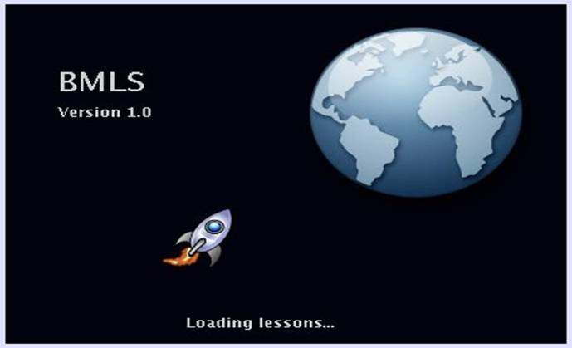
Figure 1 Splash Screen

The rocket/earth motif will be used later to indicate progress to the student. The student will be given instructions in the introduction that will encourage them to guide the rocket, which is far away from earth, back home.

Counting screens
The counting screen shown in Figure 2 follows a template that persists for the remainder of the application. The application screen is divided into 3 panels: the upper left panel is the problem presentation panel, the lower left panel is the user input panel, and the rightmost panel is the progress panel. The user may receive a hint by clicking on the question mark in the problem presentation panel. How a hint is presented is determined by the context in which the hint is given. For counting screens, a button may be removed from the user input panel to give the user a better idea of the correct answer. In counting screens, the primary educational purpose is to instruct the student in relating quantities of items. In the example shown in Figure 2, the student selects the numeral that matches the quantity of flowers shown in the problem presentation panel.
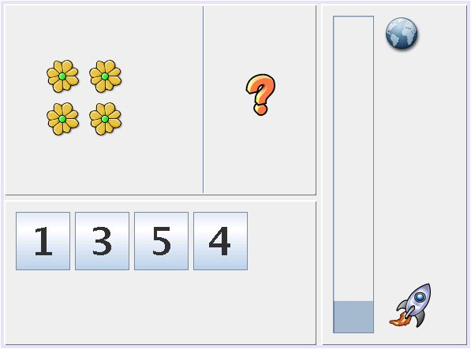
Figure 2 Counting Screen

Basic arithmetic screens
In the basic arithmetic screen shown in Figure 3, the student is presented with a problem which he or she must solve in a reasonable time frame. Clicking the question mark provides a hint as in the counting screen. When the answer is submitted, the question mark changes to the correct answer. The two buttons to the right of the numbers are backspace and calculate. Backspace is used to take an entry back in the event that an incorrect number is entered before the user has submitted the answer. The button marked 'E' represents the answer submission button. Clicking this button causes the problem to be evaluated against the user's answer.
Figure 3 Arithmetic Screen
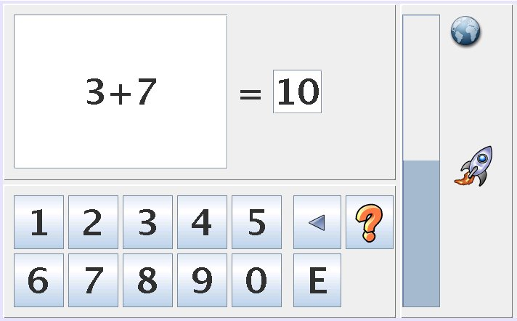

Hardware Interfaces
The user will communicate with the application through the use of the mouse which is a required component of the hardware system.
The application will utilize Java 2 Runtime Environment (JRE) classes in order to communicate with persistent storage. The application is, therefore, dependent on the JRE implementation for storing data to disk as well as for other hardware interaction.
The application will use the Java Sound API bundled with the JRE. The system must contain a sound card that is supported by the Java Sound API as well as a connected set of speakers or headphones.
Since the application will be using the JRE, minimum system requirements are loosely based on JRE specs. The multi-media components of the application, however, require additional system resources. A minimum of 256 MB of RAM and 100 MB of free hard drive space is required. A 16-bit color display adapter and comparable display is also required. The application will be optimized for a display resolution of 1024x768, but will run acceptably at a minimum resolution of 640x480.

Software Interfaces
The application will be written in the Java programming language and will require J2SE 1.4.2 or greater. This version includes the Java Swing components and Java Sound API that are required for the application.
The application will utilize Java Swing and Java AWT for implementing the user interface. These components handle the display of panels, buttons, labels, icons, etc. and will provide an event-driven mechanism for interacting with application specific code.
The application will, at a minimum, support the playback of .wav format audio files. Audio will be presented through the use of the Java Sound API.
Application state will be saved through the use of the Java Serialization API. This provides a mechanism to write and read class instances to and from persistent storage for the preservation of runtime state and configuration when the application is shut down.
The application will also utilize standard Java packages for the reading and parsing of XML configuration files.
Documentation for Swing, AWT, Java Sound, as well as the Java Serialization API may be found at http://java.sun.com.

Communications Interfaces
The application will not require networking services, protocols, or other communications infrastructures.

Other Nonfunctional Requirements

Performance Requirements
BMLS is a stand alone application and will operate properly as long as the local machine meets the minimum hardware requirements.

Software Quality Attributes

Adaptability
The math questions that BMLS uses are contained in text files. New questions can be added and old questions can be removed by editing the text files with a text editor.

Correctness
BMLS must correctly evaluate each question after the student enters an answer. The software must satisfy all functional requirements herein.

Robustness
The software must behave reasonably even upon entry of incorrect input. BMLS must also correctly detect errors in the text files containing the questions.

Usability
The GUI for BMLS must be user-friendly. The GUI must support the use of a mouse.

Portability
BMLS was developed using the Java programming language in order to support multiple computing platforms. BMLS must function correctly on a computer with the RedHat Enterprise Linux Version 4 Update 4 operating system, however, BMLS will also function correctly on a computer with the Windows operating system if that operating system has Java JRE 1.4.2 installed.

Other Requirements
TBD
Appendix A: Glossary
A
API – Application Programming Interface
B
BMLS - Basic Math Learning System
C
Class - A class is the blueprint from which individual objects are created.
Class Diagram - A class diagram is a type of static structure diagram that describes the structure of a system by showing the system's classes their attributes, and the relationships between the classes.
Control Flow Diagram - Control flow diagrams (or “flowcharts”) break a process down to a finite number of steps that get executed one at a time
CPU - Central Processing Unit
G
GUI - Graphical User Interface
I
IDE - An integrated development environment (IDE), also known as integrated design environment and integrated debugging environment, is a type of computer software that assists computer programmers to develop software
J
Java - Programming language used to develop BMLS
Java AWT - Java Abstract Window Toolkit
Java Serialization - This is the mechanism you use in Java when you want to store a Java object in a persistent form on disk
Java Swing - Swing is a GUI toolkit for Java
JRE - Java Runtime Environment
L
Linux - Linux is a computer operating system and is one of the most prominent examples of open source development
N
N/A - Not applicable
S
State Diagram - A state diagram is a labeled directed graph together with state information that can be used to indicate that certain paths in a system may be traversed only in a certain way
SRS - Software Requirements Specification
T
TBD - To Be Determined. Work yet to be completed in this project.
X
XML – Extended Markup Language
Appendix B: Analysis Models

Figure 4 Use Case Diagram
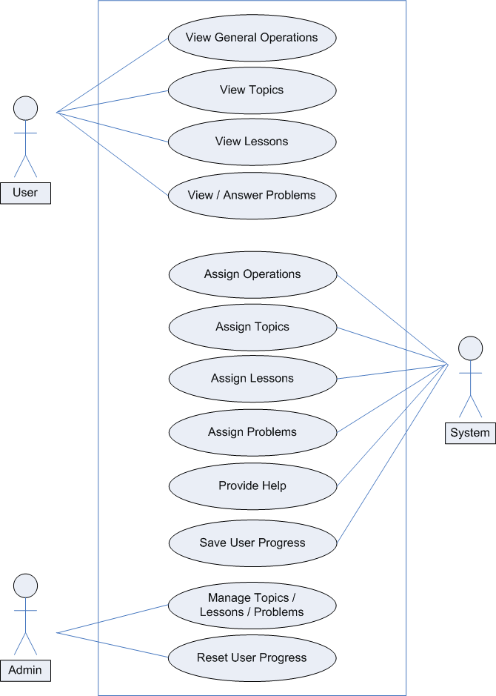

Figure 5 Class Diagram
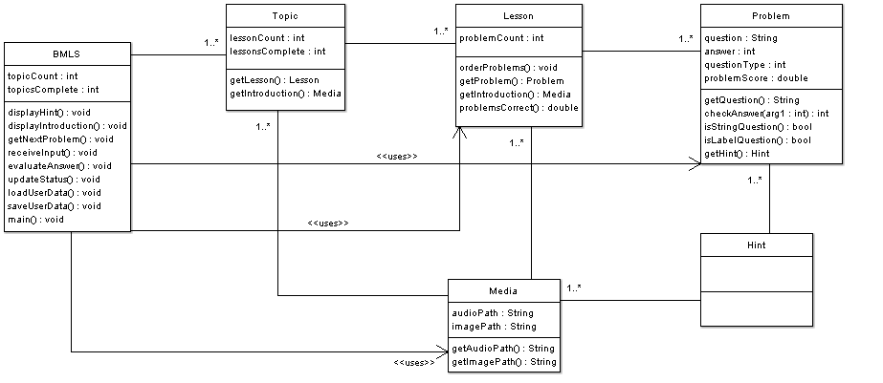

Figure 6: BMLS Top Level Control Flow Diagram - Level 1

The following series of diagrams show the general flow of control through BMLS. The series begins with a top level diagram (Level 1). In this diagram, each of the boxes, with the exception of the Splash Screen, represents a more complex system. At level 2, we break these boxes into more detail. The relevant boxes and exit points in the Level 1 diagram are labeled with lower-case letters. These are used in the Level 2 diagrams as aids to conceptualizing the control connections of these, more complicated, sub-systems. The Level 2 diagrams begin at the arrow labeled Entry Point. This represents the likely implementation of a single entry point for a sub-system. In the diagrams, however, many boxes contain several arrows pointing to them independently. This is simply for clarity.

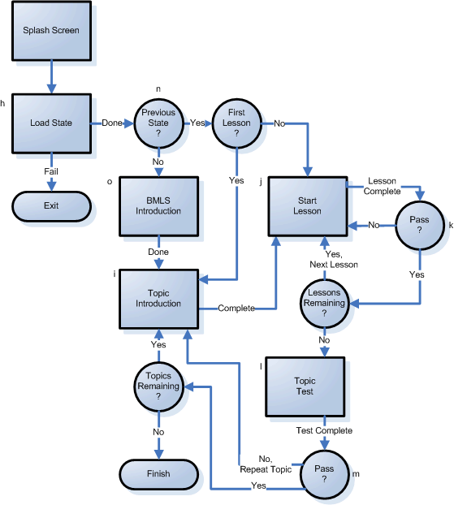
Figure 7: Topic Introduction Control Flow Diagram (i)

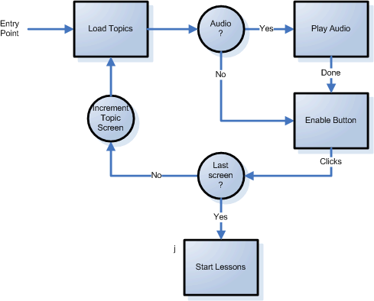
Figure 8: Start Lesson Control Flow Diagram (j)
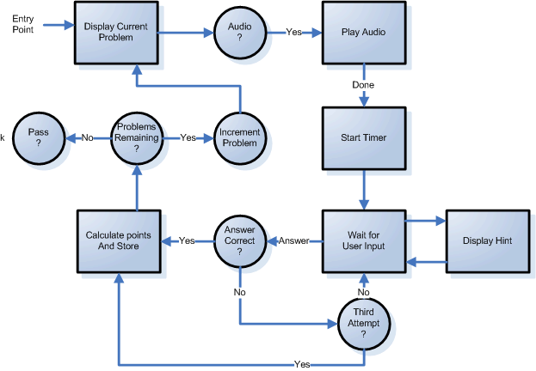
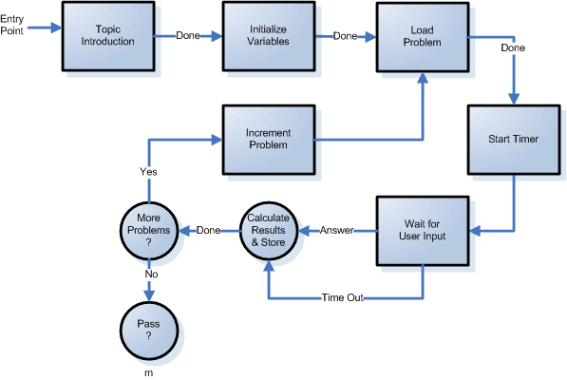
Figure 9: Topic Test Control Flow Diagram (l)

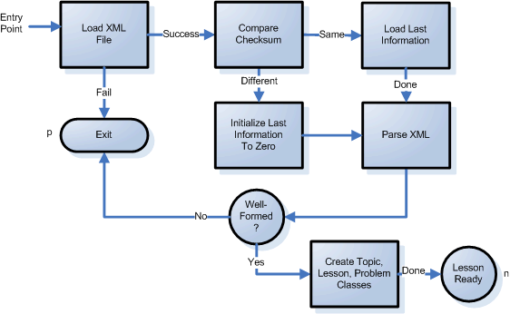
Figure 10: Load State and Initialization Control Flow Diagram (h)

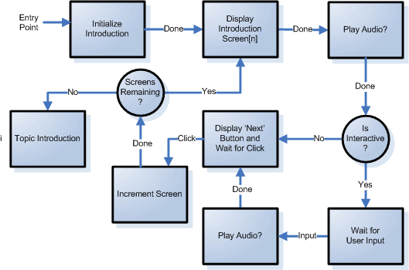
Figure 11 BMLS Introduction Control Flow Diagram (o)

Appendix C: Issues List
None

