# **Coffee Shop App and Customer APP services**

**3 Microservices**

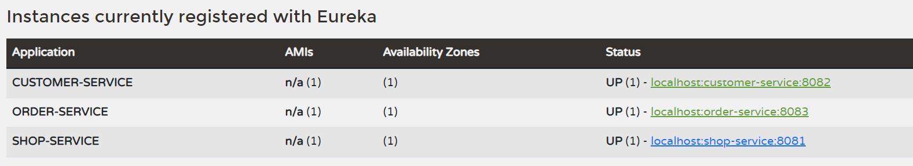

**Discovery server:**

[**http://localhost:8761/**](http://localhost:8761/)

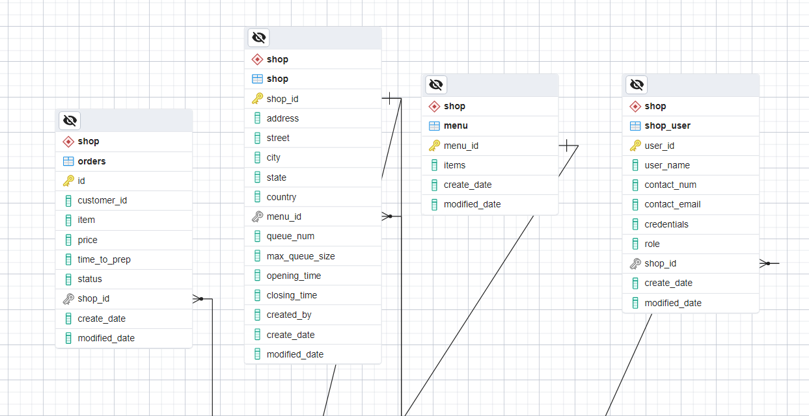

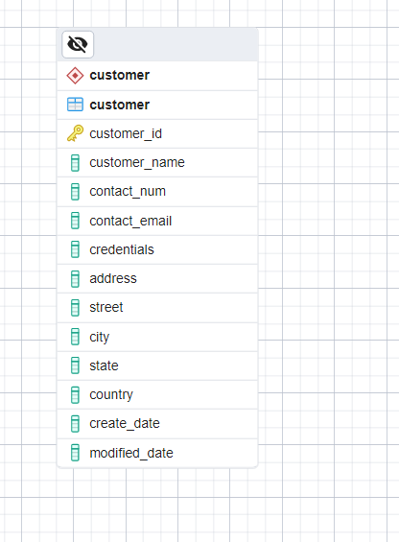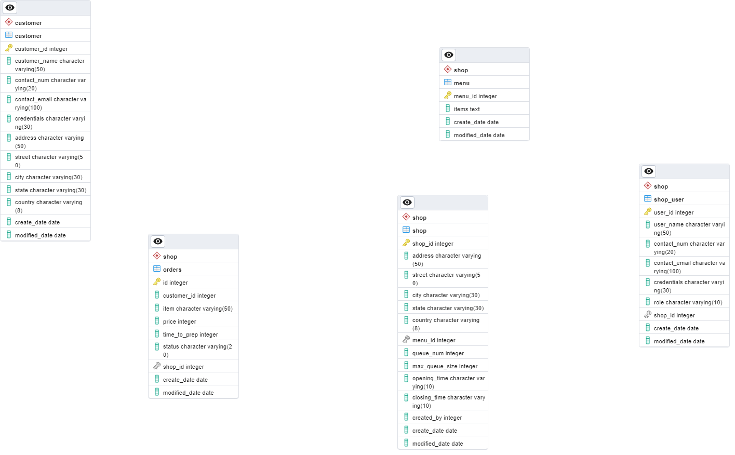

**Sequence Diagram:**

