Configuring DHCP, DNS servers
and dynamic routing using OSPF protocol

1. Use already created internal-network for three VMs (VM1-VM3). VM1 has NAT and internal, VM2, VM3 – internal only interfaces.
VM1
#nat
auto eth0
iface eth0 inet dhcp
#internal
auto eth1
iface eth1 inet static
address 10.10.10.1
netmask 255.255.255.0
broadcast 10.10.10.255

VM2 and VM3
sudo nano /etc/network/interfaces
#internal
auto eth0
iface etho inet dhcp

2. Install and configure DHCP server on VM1.
(3 ways: using VBoxManage, DNSMASQ and ISC-DHSPSERVER).
You should use at least 2 of them.
sudo apt update
sudo apt-get install dnsmasq
sudo nano /etc/dnsmasq.conf

edit srtings with
interface=eth1
dhcp-range=10.10.10.10,10.10.10.20,12h

3. Check VM2 and VM3 for obtaining network addresses from DHCP server.
VM2
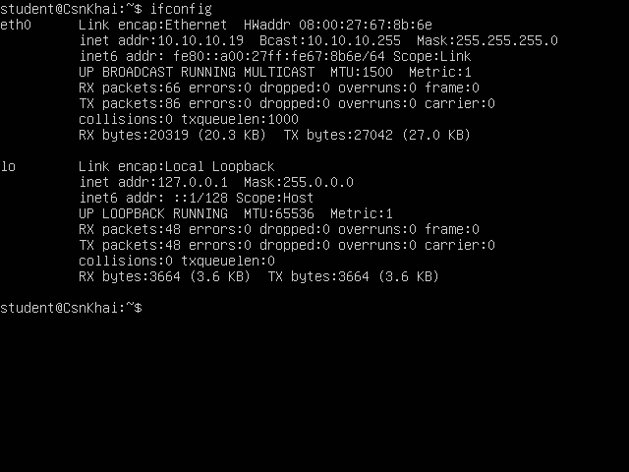
VM3
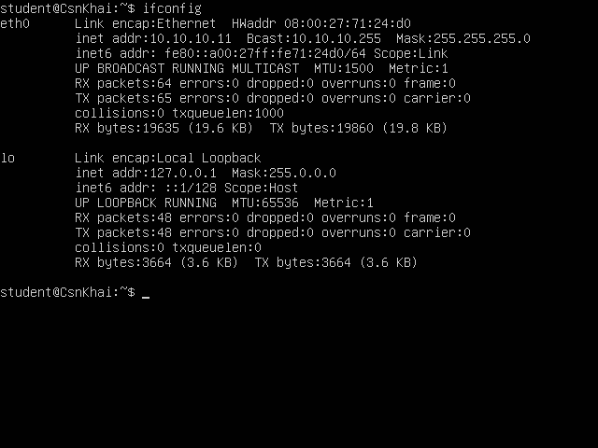
4. Using existed network for three VMs (from p.1) install and configure DNS server on VM1. (You can use DNSMASQ, BIND9 or something else).

sudo nano /etc/resolv.conf
nameserver 127.0.0.1

sudo nano /etc/dhcp/dhclient.conf
prepend domain-name-servers 127.0.0.1;

5. Check VM2 and VM3 for gaining access to DNS server (naming services).
VM2
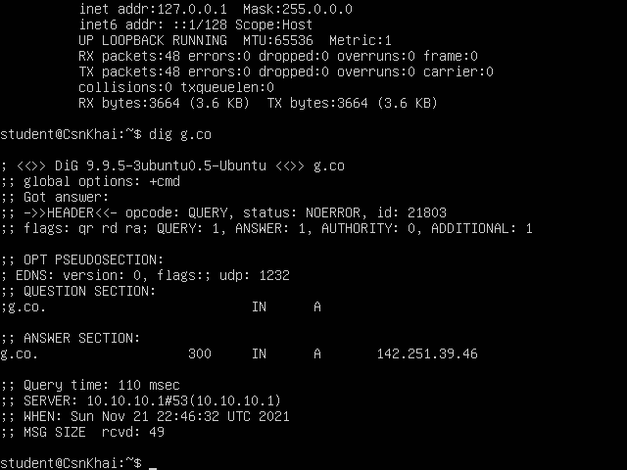

VM3
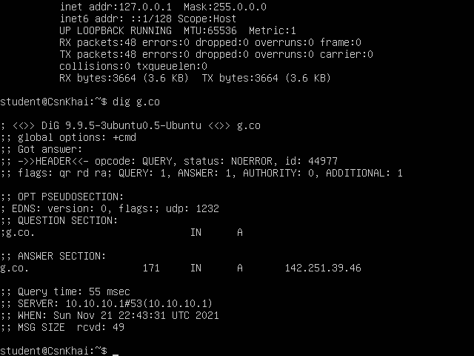

6. ***Using the scheme which follows, configure dynamic routing using OSPF protocol.

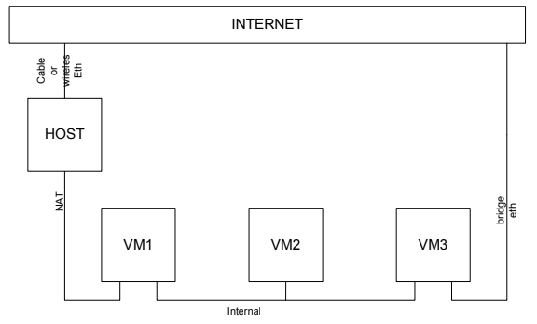
7.Check results.

