Task1.Part1
1) Log in to the system as root.
sudo passwd root
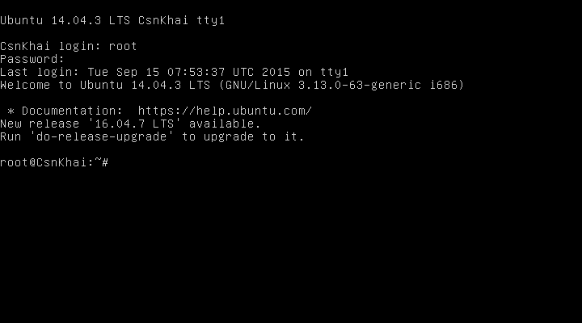
2) Use the passwd command to change the password. Examine the basic parameters of the command. What system file does it change *?
etc/shadow user file
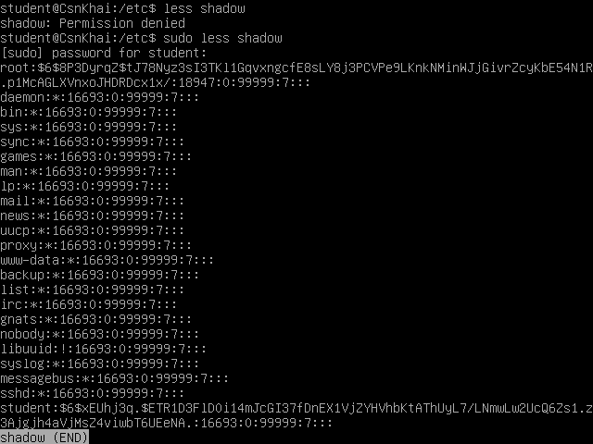
3) Determine the users registered in the system, as well as what commands they execute. What additional information can be gleaned from the command execution?
w display name of terminal, from for remote session, time login, what doing
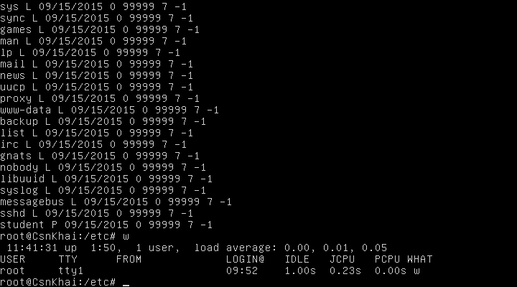
4) Change personal information about yourself.
chfn user
5) Become familiar with the Linux help system and the man and info commands. Get help on the previously discussed commands, define and describe any two keys for these commands. Give examples.
man chfn
with option -f change user’s full name
with option -w change user’s work phone number
man w
with option - h don’t show the header
with option -s display short format
info passwd
with option -a show status for all user only with -S option
with option -d delete a password for the user for login without it
passwd -e user expire a password, prompts to change the next login

6) Explore the more and less commands using the help system. View the contents of files .bash* using commands.
ls -la |grep ‘.bash*’
more bash.bashrc
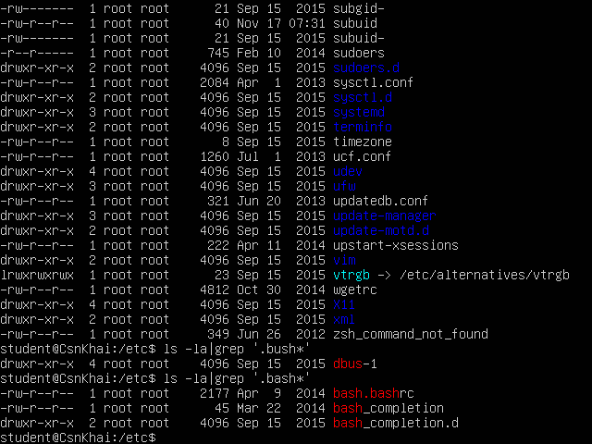

less bash.bashrc
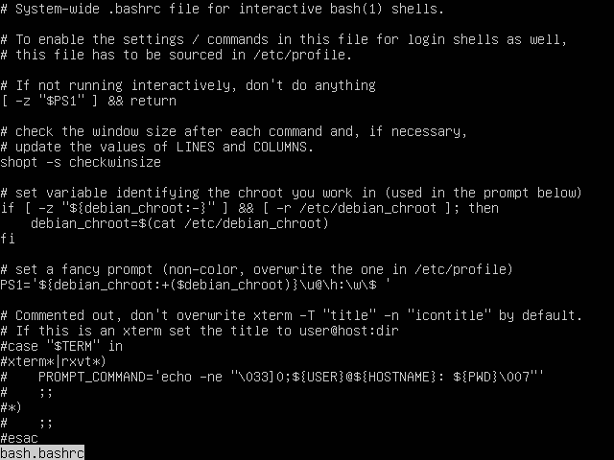

7) * Describe in plans that you are working on laboratory work 1. Tip: You should read the documentation for the finger command.
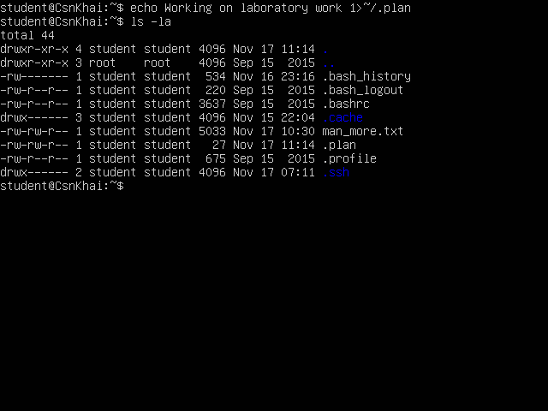
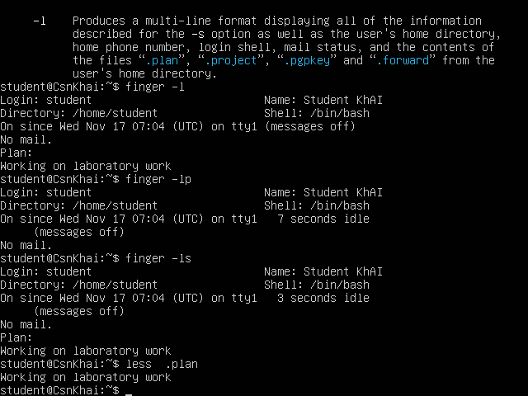
8) * List the contents of the home directory using the ls command, define its files and directories. Hint: Use the help system to familiarize yourself with the ls command.
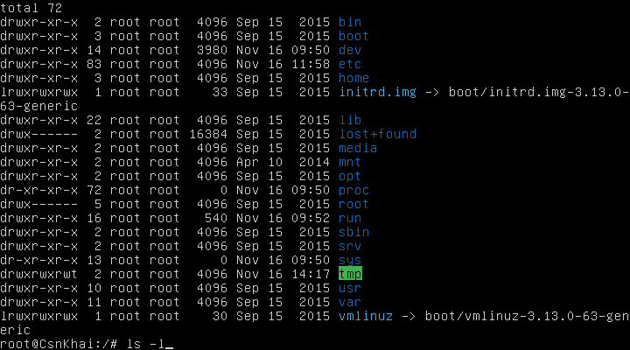

Task1.Part2
1) Examine the tree command. Master the technique of applying a template, for example, display all files that contain a character c, or files that contain a specific sequence of characters. List subdirectories of the root directory up to and including the second nesting level.
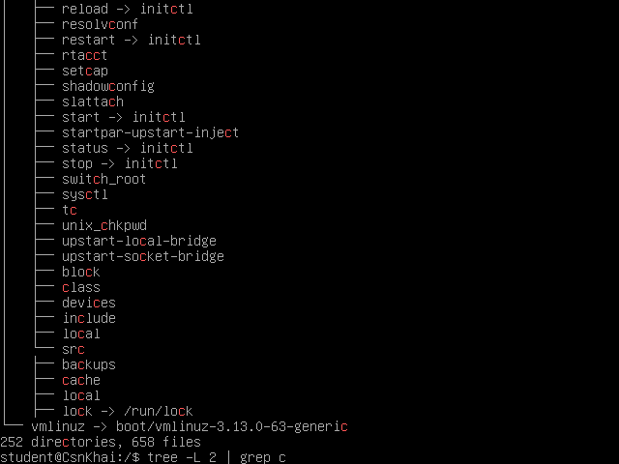
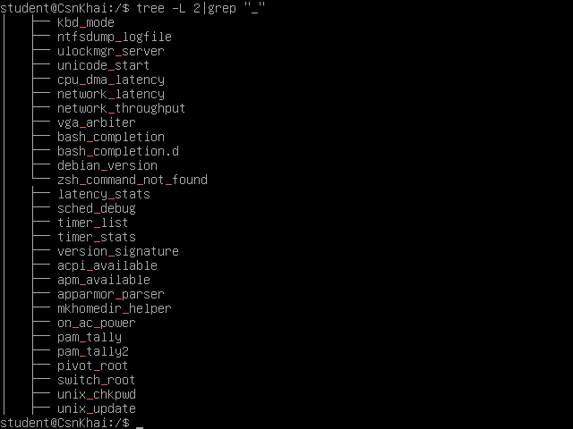
2) What command can be used to determine the type of file (for example, text or binary)? Give an example.
file initrd.img
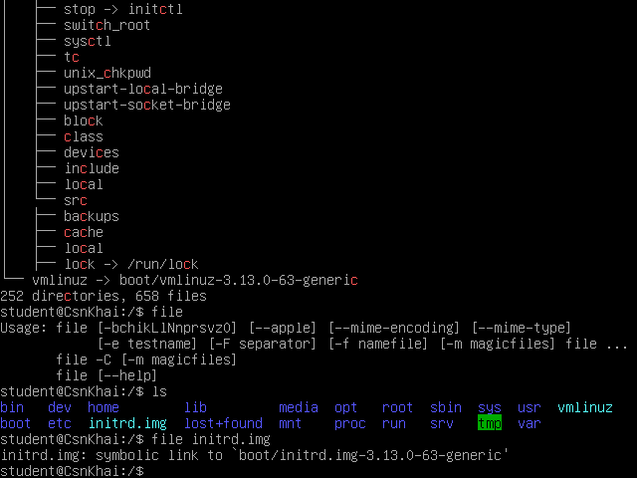

3) Master the skills of navigating the file system using relative and absolute paths. How can you go back to your home directory from anywhere in the filesystem?

cd ~
4) Become familiar with the various options for the ls command. Give examples of listing directories using different keys. Explain the information displayed on the terminal using the -l and -a switches.
ls -l information about files in a long listing format
ls -la no ignore information about files starting with .

5) Perform the following sequence of operations:
- create a subdirectory in the home directory;
mkdir task1
- in this subdirectory create a file containing information about directories located in the root directory (using I/O redirection operations);
cd task1
dir -la / > info_root_dir
- view the created file;
less info_root_dir
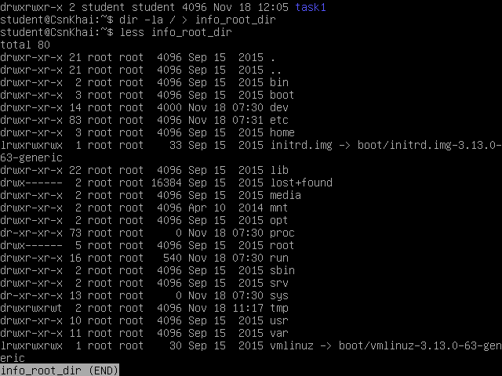
- copy the created file to your home directory using relative and absolute addressing.
cd task1
cp info_root_dir ../root_dir_copy using relative path
cd /
cp /home/student/info_root_dir /home/root_dir_copy2 using absolute path
- delete the previously created subdirectory with the file requesting removal;
rm -ri task1
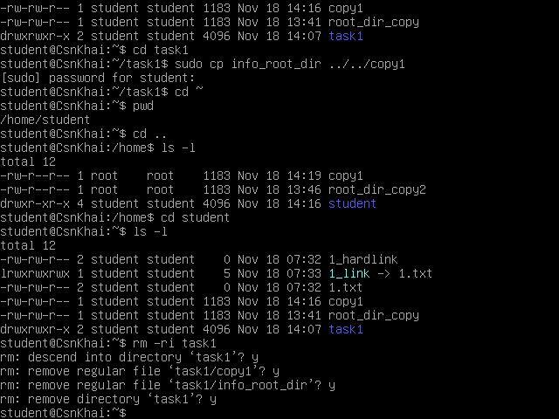
- delete the file copied to the home directory.

sudo rm -i ../copy1 using relative path from the directory student
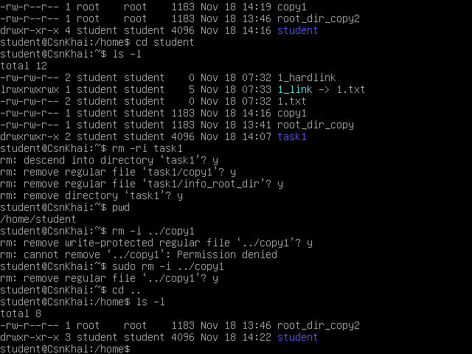
6) Perform the following sequence of operations:
- create a subdirectory test in the home directory;
mkdir test

- copy the .bash_history file to this directory while changing its name to labwork2;
cp .bash_history test/labwork2
- create a hard and soft link to the labwork2 file in the test subdirectory;
cd test
ln -s labwork2 slink_lab2
ln labwork2 hlink_lab2

- how to define soft and hard link, what do these
concepts;
ls -li
hard link and original file have similar inode and permission,
soft link determine by the letter ‘l’ and has different permission and inode with original file

- change the data by opening a symbolic link. What changes will happen and why
nano slink_lab2
nano hlink_lab2
editing symbolic link change data in original file, they are point to the file

- rename the hard link file to hard_lnk_labwork2;
mv hlink_lab2 hard_lnk_labwork2
- rename the soft link file to symb_lnk_labwork2 file;
mv slink_lab2 symb_lnk_labwork2
- then delete the labwork2. What changes have occurred and why?
rm labwork2
soft link became suspended
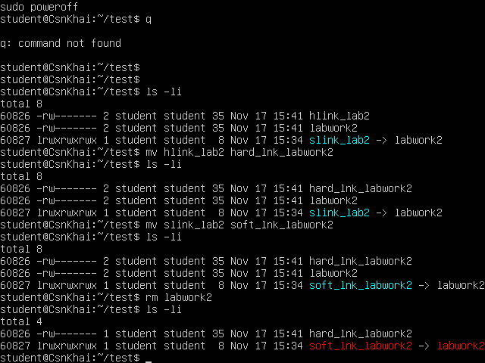
7) Using the locate utility, find all files that contain the squid and traceroute sequence.
sudo updatedb
locate squid
locate traceroute
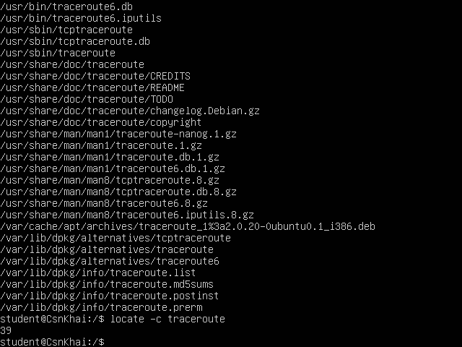
8) Determine which partitions are mounted in the system, as well as the types of these partitions.
df -Th
mount -l

9) Count the number of lines containing a given sequence of characters in a given file.
grep -c “a” hard_lnk_labwork2
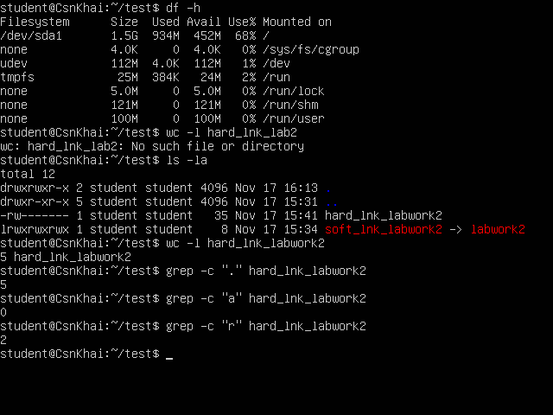

10) Using the find command, find all files in the /etc directory containing the host character sequence.
find -name “*host*”
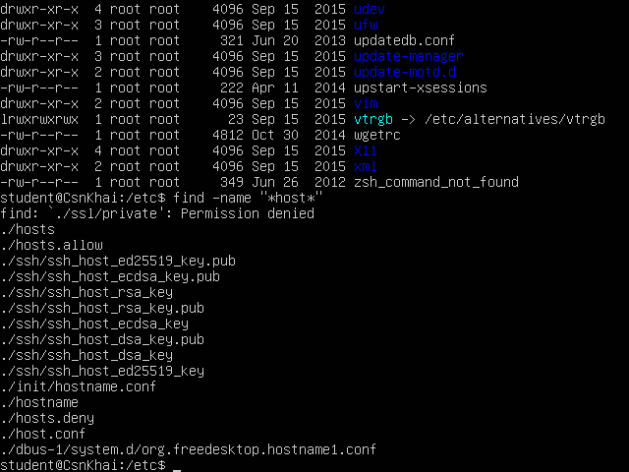
11) List all objects in /etc that contain the ss character sequence. How can I duplicate a similar command using a bunch of grep?
ls -la /etc | grep “ss”
12) Organize a screen-by-screen print of the contents of the /etc directory. Hint: You must use stream redirection operations.
ls -la /etc 2>&1
13) What are the types of devices and how to determine the type of device? Give examples.
lsblk -a

14) How to determine the type of file in the system, what types of files are there?
find where -type type of file
15) * List the first 5 directory files that were recently accessed in the /etc directory.
ls -ula --sort=time | head -6

