Software Requirement
Specification (SRS) Report
━━━━━━━━━━━━━━━━━━━━━━━━━━━━━━━━━━━━━━━━━━━━━━━━━━━━━━━━━
BECS 21213 – SOFTWARE ENGINEERING
EC/2023/051
W.D.V.Y.RANSITH

1. Introduction

The ABC Parking Management System is a console-based Java application built to bring structure and reliability to everyday parking operations. Rather than relying on manual processes that are slow and prone to error, this system automates the core tasks involved in managing a parking facility.

In many smaller parking areas across the country, attendants still handle everything by hand. Writing down vehicle numbers, estimating fees, and tracking available spaces all introduce opportunities for mistakes. Over time, these small errors add up and create real frustration, both for the staff managing the facility and for the drivers using it. This project was started with exactly that problem in mind, and the goal was to create something practical enough to actually help.

The system was built around Object-Oriented Programming principles throughout its development. Encapsulation, inheritance, polymorphism, and abstraction all played a role in shaping how the code was organized. Keeping each responsibility in its own class made the whole project easier to follow and much simpler to test as features were added. When something needed to be changed in one part of the system, it rarely required touching anything else, which kept the development process from becoming unnecessarily complicated.

Purpose
The purpose of this Software Requirements Specification document is to clearly describe what the ABC Parking Management System does and how it is expected to behave. Both functional and non-functional requirements are covered so that any reader, whether technical or not, can understand the scope and behavior of the system.

During development, this document served as a useful reference for keeping track of what had been implemented and what still needed attention. It can also be consulted during evaluation or used as a starting point if the system is extended in the future.

Intended Audience
This document is written for the following readers:
- Lecturers and examiners reviewing the project for assessment purposes
- Students exploring software development and OOP-based system design
- Developers who may wish to extend or improve the system at a later stage

The language used throughout this document is kept as clear and approachable as possible, so that even someone without a deep technical background can follow along without difficulty.

Scope
The system is designed to handle the basic day-to-day operations of a parking facility in a controlled and organized way. The features that have been built into the system include:
- Registering vehicles along with the details of the driver
- Automatically creating unique reference numbers for each entry
- Assigning parking slots based on what type of vehicle is being parked
- Generating a parking ticket when a vehicle is allocated a slot
- Calculating how much is owed when a vehicle leaves, based on how long it was parked
- Displaying current vehicle and slot information on demand

What the system does not include, at least in this version, are things like a graphical interface, any kind of database storage, or online payment support. The focus here was on demonstrating solid programming fundamentals rather than building a feature-complete commercial product.

Definitions, Acronyms, and Abbreviations
Term | Description
OOP | Object-Oriented Programming
Ref No | Unique reference number assigned to a vehicle
Slot | Parking space assigned to a vehicle
Ticket | Record containing parking information
Console | Text-based user interface
Table 1: Definitions of terms

2. Overall Description

Product Perspective
The ABC Parking Management System is a self-contained Java application. It does not communicate with any external systems, databases, or network services. All the information it works with during a session is kept in memory using arrays, and that data is cleared once the program is closed.

The design follows a modular approach where different classes are each responsible for a distinct piece of functionality. One class might handle the logic for parking a vehicle, while another takes care of storing driver information. This kind of separation keeps things clean and easy to follow, which was especially helpful while the system was being built and tested. It also means that if someone wanted to add features later, they could do so without having to restructure everything from scratch.

Product Functions
The main things the system is capable of doing are listed below:
- Taking in vehicle and driver details and storing them for the session
- Creating a unique reference number for every vehicle that is registered
- Matching vehicles to appropriate parking slots based on their category
- Issuing a parking ticket when a vehicle is successfully assigned to a slot
- Working out the total fee when a vehicle checks out, factoring in both time and vehicle type
- Showing a live view of which slots are occupied and which vehicles are currently parked

These functions are designed to work together smoothly to deliver a complete parking management experience from entry to exit.

User Classes and Characteristics
User Type | Description
General User | Can park and remove vehicles
Admin User | Can view system details using passkey
Table 2: Users and Characteristics

General users interact with the system through a straightforward menu and can perform the main parking operations. Admin users get access to additional information about the system, such as vehicle lists and slot status, but only after entering the correct passkey.

Operating Environment
The system runs in the following environment:
- Programming Language: Java
- Platform: Any machine with a working Java installation
- Interface: Command-line / console
- Hardware: A standard computer with a keyboard and display

Constraints
There are a few built-in limitations worth noting:
- The system supports a maximum of 20 parking slots
- Data storage relies on fixed-size arrays
- All data is lost when the program is closed, since there is no persistent storage
- Interaction is entirely through the console

Assumptions and Dependencies
The following assumptions were made while building the system:
- Users will enter valid and correctly formatted data
- Parking rates remain fixed for each vehicle type
- Parking duration is calculated using the system clock
- At least one appropriate slot will be free when a vehicle attempts to park

3. Functional Requirements

FR-01: Vehicle Registration
When a vehicle arrives, the system prompts the user to enter the driver's name, contact number, and vehicle registration number. Once all the details have been entered, the information is saved and a reference number is automatically created for that vehicle. Having this reference number makes it straightforward to look up any vehicle later, and it ensures that no two entries are ever confused with each other.

Driver Name: verosha
Vehicle Number: ABC 0000
Driver Contact: 077624656
Reference and driver details registered.
Image 1: Vehicle registration

FR-02: Reference Number Generation
Every vehicle that is registered receives a unique reference number, and the format of that number is tied to the type of vehicle. This makes it immediately obvious, just from looking at the reference, what kind of vehicle it belongs to.

Vehicle Type | Format
Car | C1001, C1002
Motorcycle | M2001, M2002
Heavy Vehicle | H3001, H3002
Table 3: Vehicle type and used format

Select Vehicle Type: 1. Car 2. Motorcycle 3. Heavy Vehicle 2
Generated Reference Number: M2001
Image 2: Reference number generation according to vehicle type

FR-03: Parking Slot Allocation
Slots are divided into groups based on vehicle type. Cars, motorcycles, and heavy vehicles each have their own designated range of slots, which helps keep the parking area organised and prevents any mismatches between vehicle size and available space.

Vehicle Type | Slot Range
Car | 1 – 10
Motorcycle | 11 – 15
Heavy Vehicle | 16 – 20
Table 4: Slot range

FR-04: Parking a Vehicle
Once a reference number has been assigned, the user can proceed to park the vehicle by choosing from the list of available slots. Before a slot is confirmed, the system checks that it is both unoccupied and appropriate for the vehicle type in question. If everything checks out, the slot is marked as taken. This step directly addresses one of the biggest problems with manual parking systems, where two vehicles could end up assigned to the same spot simply because no one had updated the records.

Available MOTORCYCLE Slots: [11] [12] [13] [14] [15]
Enter Slot Number to park: 14
Vehicle Parked Successfully! Reference: M2001
Image 3: Slot allocation and parking a vehicle

FR-05: Leaving a Vehicle
When it is time for a vehicle to leave, the user enters its reference number. The system pulls up the relevant record, frees the slot, and moves straight into the billing process. Once payment has been handled, the slot is immediately made available for the next vehicle to use.

FR-06: Billing System
Fees are worked out based on two things: how long the vehicle was parked, and what type of vehicle it is. A base fee applies to every vehicle regardless of duration, and additional charges are layered on top depending on the time spent. The billing logic was tested against multiple scenarios during development to make sure the calculations came out correctly across all three vehicle categories.

Vehicle Type | Base Fee
Car | Rs. 100
Motorcycle | Rs. 50
Heavy Vehicle | Rs. 150
Table 5: Base fee

The entry time recorded when the vehicle is parked and the exit time captured at checkout are used together to calculate the total duration, which then feeds directly into the fee calculation.

======== BILL ========
Reference No : M2001 Driver : verosha
Contact : 0123456789 Vehicle No: ABC 0000
Slot No : 12 Time Parked: 2 minutes
Base Fee : Rs.50.00 Total Amount: Rs.60.00
========================== Thank You! Have a nice day.
Image 5: Billing and leaving a vehicle

FR-07: Display Vehicle Details
At any point, the system can produce a list of all vehicles currently parked, showing the reference number, vehicle type, slot number, driver name, and vehicle registration for each one. This gives whoever is managing the facility a quick and complete snapshot of what is currently in the lot.

FR-08: Display Slot Details
The full list of parking slots can be shown on screen at any time, along with whether each one is free or occupied. This makes it easy to quickly spot where space is available without having to walk the lot or rely on guesswork.

Available MOTORCYCLE Slots: [11] [12] [13] [14] [15]
Image 4: Slot availability

4. Non-Functional Requirements

Performance
Because the number of records the system handles is small and fixed, it is expected to respond to any user action almost instantly. There are no complex queries or heavy computations involved, so performance should not be a concern under normal usage.

Security
Access to the administrative section of the system is protected by a simple passkey, which is set to 1234. While this is not a sophisticated security mechanism, it does provide a basic layer of protection that keeps casual users from accessing information they should not be seeing.

===== ABC Parking System Management =====
1. Parking System 2. Main Menu 3. Exit
Enter Option: 2
Enter the PassKey to access to the System: 1234
Access Granted to Main Menu
Image 6: Security through a passkey

Usability
The system was designed to be easy to use from the very first interaction. Everything is menu-driven, so users can navigate step by step without needing to remember commands or syntax. During testing, it was clear that people who had never used the system before could figure it out quickly, which was one of the things the design was aiming for.

Reliability
The system is built to handle unexpected input without crashing or producing incorrect results. If a user tries to park a vehicle in a slot that is already taken, the system will catch that and prevent it from happening. Consistent and predictable behavior across different inputs was a priority throughout development.

Availability
The system is available as long as the program is running. It has no dependencies on network connectivity or external services, which means it can operate reliably in any environment where Java is installed.

5. External Interface Requirements

User Interface
===== ABC Parking System Management =====
1. Parking System
2. Main Menu
3. Exit
Enter Option:
Image 7: User Interface

Hardware Interface
- Keyboard for entering all user input
- Monitor or display screen for viewing output

Software Interface
- Java Development Kit (JDK)
- Java Runtime Environment (JRE)

6. System Constraints

The current version of the system comes with a few notable limitations that are worth understanding before using or evaluating it:
- There is no graphical interface; everything runs in the console
- No database is connected, so data does not survive between sessions
- The parking lot is capped at 20 slots, which is sufficient for this demonstration but would need to be expanded for real-world use
- All input must be entered manually; there is no automated or barcode-based entry

These constraints exist primarily because the system was designed as an educational project. The goal was to illustrate key programming concepts clearly, not to replicate the full complexity of a production parking system.

7. Appendices

Use Case Diagram
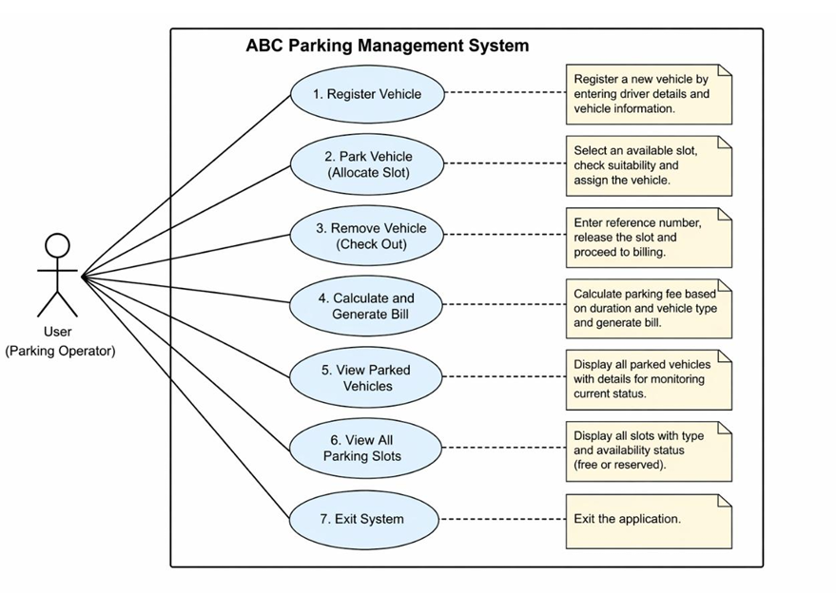
The use case diagram below illustrates the interactions available to the parking operator within the system:

Use Case | Actor | Description
1. Register Vehicle | User (Parking Operator) | Register a new vehicle by entering driver details and vehicle information.
2. Park Vehicle (Allocate Slot) | User (Parking Operator) | Select an available slot, check suitability and assign the vehicle.
3. Remove Vehicle (Check Out) | User (Parking Operator) | Enter reference number, release the slot and proceed to billing.
4. Calculate and Generate Bill | User (Parking Operator) | Calculate parking fee based on duration and vehicle type and generate bill.
5. View Parked Vehicles | User (Parking Operator) | Display all parked vehicles with details for monitoring current status.
6. View All Parking Slots | User (Parking Operator) | Display all slots with type and availability status (free or reserved).
7. Exit System | User (Parking Operator) | Exit the application.

System Workflow

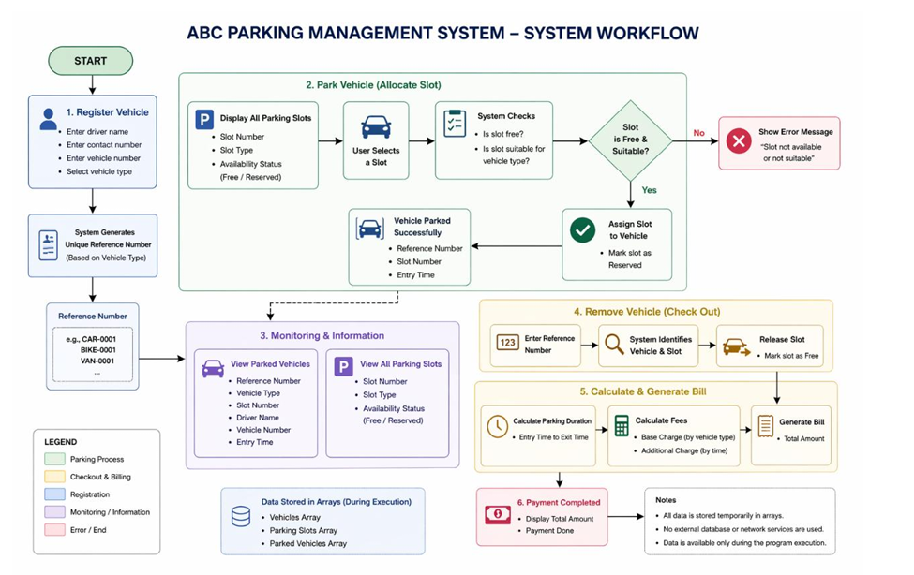

The system follows a clear sequence of steps from the moment a vehicle arrives to the moment it departs. The driver's information is first recorded and a reference number generated. The vehicle is then assigned to an appropriate free slot, which is marked as reserved. While parked, the vehicle details are available for viewing at any time. When the driver is ready to leave, the reference number is used to trigger checkout, calculate the fee based on elapsed time, display the bill, and release the slot back into the available pool.

All data during this flow is kept in three main arrays: a vehicles array, a parking slots array, and a parked vehicles array. No external database or network service is involved at any stage.

Class Description Table
Class | Description
Vehicle | Abstract base class for all vehicles
Car | Represents car vehicles
Motorcycle | Represents motorcycles
HeavyVehicle | Represents heavy vehicles
Driver | Stores driver information
ParkingSlot | Manages parking slots
ParkingTicket | Stores parking details
BillingService | Calculates parking fees
ParkingManager | Controls system operations
ParkingApp | Main application class
Table 6: Define classes

8. Conclusion

One thing that I really like about the ABC Parking Management System is that it shows a clear example of how Java and OOP principles can help design a fully functional program solving an actual problem. By isolating responsibilities into their classes and ensuring clean communication between them, the end result becomes much more readable and maintainable in comparison to if all the actions were coded in one huge block.

There are several things to criticize about the system – namely, there are no databases involved, no graphical interface, and no persistence of data outside of the program itself. Nevertheless, the system does its job pretty well – it allows to register vehicles, allocate spots, calculate costs, and perform all other tasks involved without manual actions at all. Furthermore, it can easily accommodate for adding extra functionality in the future.

When reflecting on the process of designing the product, the most important thing about the entire experience has been not only the fact that we managed to get the code running, but realizing why some of the architectural choices were helpful or unhelpful during the course of development. There have been several small issues that appeared throughout the course of development, solving which provided a very realistic understanding of how everything works in real life.

