IP Address Computation Exercise No. 2

Based on the topology shown below, compute for the IP Addressing scheme using 10.0.0.0/8 as the base IP by way of VLSM:

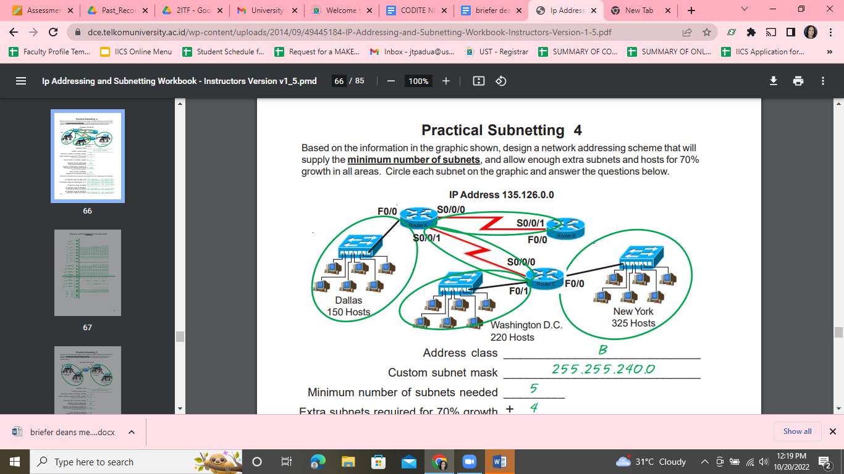

Answer the following questions:

1. Address class - **Class A**
2. Default subnet mask - **255.0.0.0**
3. Minimum number of subnets need - **5**
4. Extra subnets - **3**
5. Total number subnets needed - **8**
6. Number of host addresses in the largest subnet - **325**
7. IP Range for Dallas - **10.0.0.0 to 10.31.255.255**
8. IP Range for Washington D.C. - **10.32.0.0 to 10.63.255.255**
9. IP Range for New York - **10.64.0.0 to 10.95.255.255**
10. Show your complete solution below:

