I created 1.000 records can the process is quited.
Load all grip data, dari Cash Entry Postings dipakai
Saya punya dua versi Create Analyze. Yang pakai di page ini pakai semua GRIP buffer

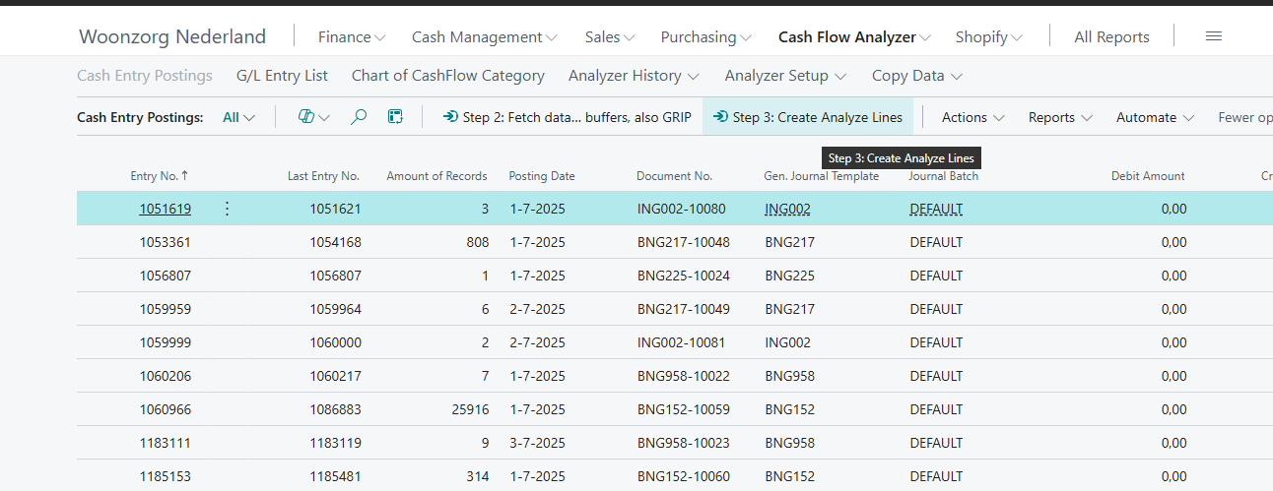

First Step 2: load all buffers, include grip buffer
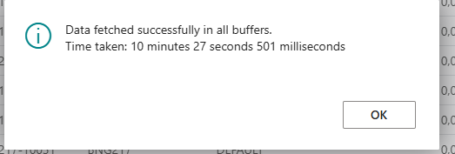
Then Step 3: process all postings for satu record
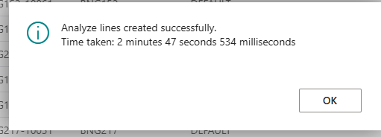

When run this same process for 1.000 records, without the gripbuffer, it takes about 10 minutes including the time for fill the buffers (about 2 minutes). So when we have 26.000 records it must be much faster when use the gripbuffer.

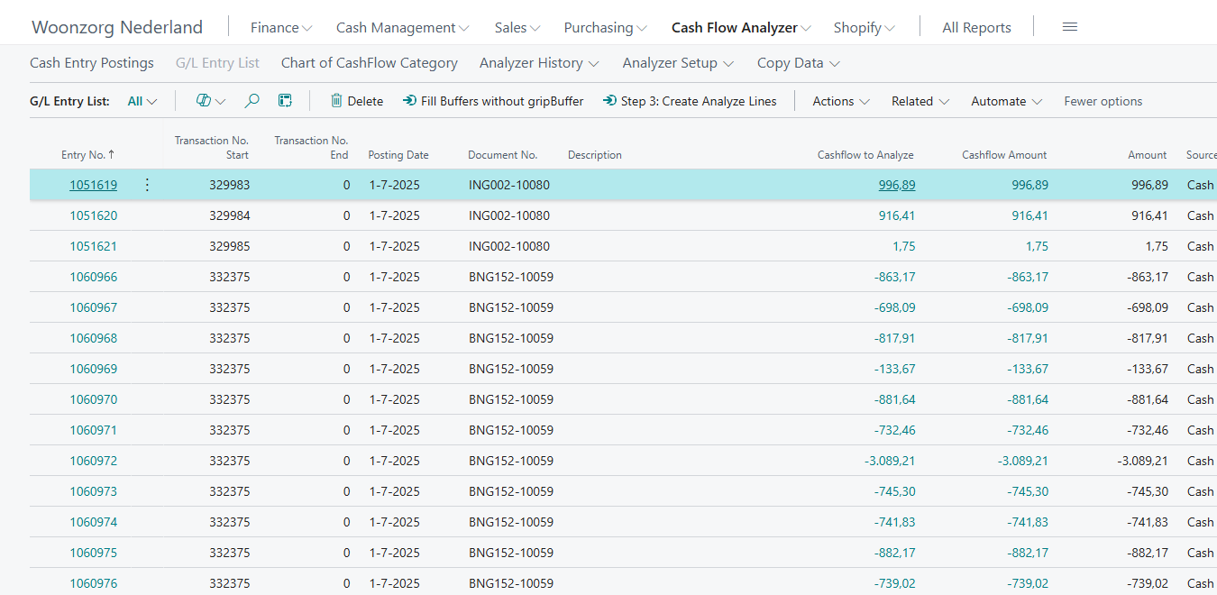
For testing this page is very suitable.
First fill buffers… (now without GRIP buffer)

Second: The for each line you can start Create analyze lines

