How to do the Project Invoicing.
Technical Design for Programmer - Release 1 with Release 2 Direction
Purpose: explain how realized Day Planning is posted to standard Business Central project/job ledger entries, and then summarized into standard Project Planning Lines for invoicing, and linked back to the detailed usage lines for reporting and auditability.

1. Design Goal
The planning engine or users creates Day Planning lines independently from standard Business Central Project Planning Lines. After realization of the Day Planning Lines, the system must return to the standard BC flow by posting the day planning lines to Job Ledger Entries. Then creating billable Project Planning Lines that can be transferred to sales invoices so that we are back to default BC.
The commercial invoice preparation must be held a summarized set group by on the invoice resource no of records of the job ledger entry (created by the day planning lines) in the table Job Planning Line. The customer still request a separate detailed hours specification by real resource number like we had in the day planning lines. Therefore the system needs a lean one-to-many link between the generated invoice summary line (job planning line) and the posted usage entries.
Concept | Meaning in this design
Skill | Operational demand category from Day Planning. In release 1, invoice summaries are grouped by this code.  The Invoice Resource No. used on the billable Project Planning Line is stored on this table.
Project Planning Line / Job Planning Line | Standard BC invoice summary line used by Get Project Planning Lines / standard invoice flow.
Job Ledger Invoice Link | Small companion table linking many posted usage entries to one invoice summary planning line.

2. The Scope of Release 1
Release 1 only supports invoicing by grouping posted usage by Skill Code. Installments are explicitly out of scope for release 1.
Included in Release 1
Post realized Day Planning usage to Job Ledger Entries.
Create billable Project Planning Lines using Skill.Invoice Resource No.
Store link records from Job Ledger Entry when generated Project Planning Line.
Print/detail report of real resource hours behind each invoice summary line.

3. Release 1 Functional Flow
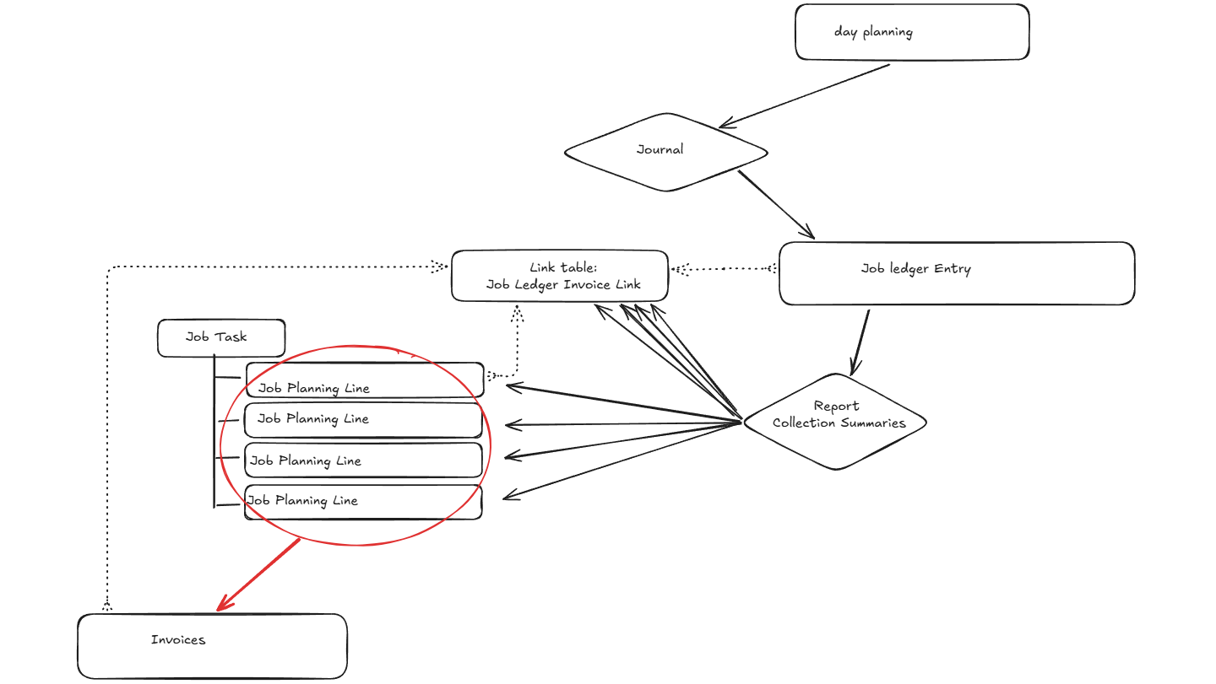
1) After realization, usage is posted to standard BC Job Ledger Entries with the actual Resource No.
2. The invoice preparation process selects posted usage entries that are not yet linked in Job Ledger Invoice Link.
4. The process determines the Skill Code for each usage entry and reads Skill.Invoice Resource No.
5. The process groups entries by Job No., Job Task No., Skill Code, Invoice Resource No., Unit of Measure, and optionally Unit Price.
6. For each group, the process creates one billable Project Planning Line.
7. For every included Job Ledger Entry, the process inserts one Job Ledger Invoice Link record that points to the created Project Planning Line.
8. Standard BC invoice creation is then used from the billable Project Planning Lines.
9. The customer hour detail report uses the link table to show which real usage entries belong to the summary invoice line.

4. Minimal Data Model

4.1 Skill Table Extension
Add one field to the Skill table.
field(50xxx; "Invoice Resource No."; Code[20])
{
Caption = 'Invoice Resource No.';
TableRelation = Resource."No.";
}

4.2 New Table: Job Ledger Invoice Link
This table is intentionally small. It is not a batch table. It exists for performance, indexing, anti-double-invoicing, and drilldown from invoice summary line to usage details.
table 50xxx "Job Ledger Invoice Link"
{
Caption = 'Job Ledger Invoice Link';
fields
{
field(1; "Job Ledger Entry No."; Integer)
{
Caption = 'Job Ledger Entry No.';
TableRelation = "Job Ledger Entry"."Entry No.";
}
field(2; "Job No."; Code[20])
{
Caption = 'Project No.';
TableRelation = Job."No.";
}
field(3; "Job Task No."; Code[20])
{
Caption = 'Project Task No.';
}
field(4; "Invoice Job Planning Line No."; Integer)
{
Caption = 'Invoice Project Planning Line No.';
}
// Optional for reporting/performance. Not mandatory for release 1.
field(5; "Skill Code"; Code[20])
{
Caption = 'Skill Code';
}
}
keys
{
key(PK; "Job Ledger Entry No.")
{
Clustered = true;
}
key(PlanningLine; "Job No.", "Job Task No.", "Invoice Job Planning Line No.")
{
}
}
}

4.3 Why This Table Exists
Reason | Explanation
Performance | Lookup from Project Planning Line to many Job Ledger Entries must use a proper key.
No custom index on large standard ledger table | Avoid adding custom keys directly to Job Ledger Entry.
Anti-double-invoicing | PK on Job Ledger Entry No. means one usage entry can only be linked once.
Drilldown/reporting | The customer detail report can reliably find the exact usage lines behind a summary line.
Lean design | No batch table is required; the generated Project Planning Line is the summary identity.

5. Invoice Preparation Process

5.1 Selection of Usage Entries when want create new summary lines
In the job planning lines we must add summary records. Select posted Job Ledger Entries for the project/job task that represent usage and are not already linked in Job Ledger Invoice Link.
Pseudo filter:
Job Ledger Entry where:
Job No. = selected project
Entry Type = Usage
Type = Resource // if only resource usage is in scope
Entry No. not in Job Ledger Invoice Link."Job Ledger Entry No."

5.2 Grouping Rule
Release 1 groups only by Skill Code and its related invoice resource. The Skill Code must be determined from the Day Planning/realization origin of the Job Ledger Entry.
Grouping Field | Comment
Job No. | Required because planning lines belong to a project.
Job Task No. | Required because Job Planning Line identity includes Job Task No.
Skill.Invoice Resource No. | Resource No. used on the generated billable planning line.
Unit of Measure Code | Usually HOURS. Include in grouping if multiple UOMs are possible.
Unit Price | Include if different sales prices can occur within the same skill. If not, read from resource/standard price setup.

5.3 Create Billable Project Planning Line
// Conceptual AL only - adjust to project codebase standards
JobPlanningLine.Init();
JobPlanningLine.Validate("Job No.", JobNo);
JobPlanningLine.Validate("Job Task No.", JobTaskNo);
JobPlanningLine.Validate("Line No.", NextLineNo);
JobPlanningLine.Validate("Line Type", JobPlanningLine."Line Type"::Billable);
JobPlanningLine.Validate(Type, JobPlanningLine.Type::Resource);
JobPlanningLine.Validate("No.", Skill."Invoice Resource No.");
JobPlanningLine.Validate("Planning Date", WorkDateOrInvoiceDate);
JobPlanningLine.Validate(Quantity, TotalHours);
// Unit Price is from standard resource price logic or explicit setup.
JobPlanningLine.Insert(true);

5.4 Insert Link Records
foreach included JobLedgerEntry do begin
Link.Init();
Link.Validate("Job Ledger Entry No.", JobLedgerEntry."Entry No.");
Link.Validate("Job No.", JobLedgerEntry."Job No.");
Link.Validate("Job Task No.", JobLedgerEntry."Job Task No.");
Link.Validate("Invoice Job Planning Line No.", JobPlanningLine."Line No.");
Link.Validate("Skill Code", SkillCode); // optional
Link.Insert(true);
end;

6. Customer Detail Hours Report
The invoice can remain summarized, while the detail report shows the posted usage entries behind each invoice planning line.
From a Job Planning Line:
Filter Job Ledger Invoice Link by:
Job No. = JobPlanningLine."Job No."
Job Task No. = JobPlanningLine."Job Task No."
Invoice Job Planning Line No. = JobPlanningLine."Line No."
For each link record:
Get Job Ledger Entry by Entry No.
Print Posting Date, Resource No., Description, Quantity, UOM.
Optional summary:
Group by Resource No. and total Quantity.
Invoice Summary Line | Detail Source
INV-INSTALL, 240 hours | All Job Ledger Entries linked to this Job Planning Line through Job Ledger Invoice Link.
INV-ENGINEER, 80 hours | All Job Ledger Entries linked to this Job Planning Line through Job Ledger Invoice Link.

7. Deletion Behavior
The design relies on standard BC behavior to decide whether a Project Planning Line can be deleted. If BC allows the line to be deleted, the extension follows that result and deletes the related link records. If BC blocks the deletion, the link records remain.
[EventSubscriber(ObjectType::Table, Database::"Job Planning Line", 'OnAfterDeleteEvent', '', false, false)]
local procedure JobPlanningLine_OnAfterDelete(var Rec: Record "Job Planning Line"; RunTrigger: Boolean)
var
Link: Record "Job Ledger Invoice Link";
begin
if Rec.IsTemporary then
exit;
Link.SetRange("Job No.", Rec."Job No.");
Link.SetRange("Job Task No.", Rec."Job Task No.");
Link.SetRange("Invoice Job Planning Line No.", Rec."Line No.");
Link.DeleteAll(true);
end;
Consequence: when a generated planning line is deleted, the linked usage entries become available again for invoice preparation because their link records no longer exist.

8. Standard BC Invoice Flow
After the generated billable Project Planning Lines exist, the user continues with the standard BC project invoice flow. The custom link table does not replace BC invoice posting. It only preserves the relation between summarized invoice planning lines and detailed posted usage.
Our extension:
Posted usage -> summarized billable Project Planning Lines -> link records
Standard BC:
Project Planning Lines -> Sales Invoice -> Posted Sales Invoice

9. Rules and Safeguards
We do not know of and how to post the invoice summary resource. Job Ledger Entries must keep the real actual Resource No. for usage. For the profit part we need also job ledgers. How are they created? By posting the invoice it is using the job plannnig lines or the sales lines?
The invoice resource comes from Skill.Invoice Resource No. in release 1.
A Job Ledger Entry may only have one link record. This prevents duplicate invoicing.
Line No. alone is not enough to identify a Job Planning Line. Always use Job No. + Job Task No. + Line No.
If a Skill has no Invoice Resource No., invoice preparation must stop with a clear error.
If a Project Planning Line is deleted by standard BC, remove the related custom link records in OnAfterDelete.
Do not reconstruct invoice details later using only date filters. Use the link table as the frozen relationship.

10. Implementation Notes / Open Decisions
Topic | Decision / Note
Skill source on Job Ledger Entry | Programmer must define how to retrieve Skill Code from the posted entry. Preferred source is the Day Planning realization origin.
Unit Price source | Decide whether to use standard Resource price logic, Job Planning Line defaulting, or a custom price from Skill/resource setup.
UOM handling | If all usage is HOURS, keep simple. If not, include UOM in grouping.
Reversal/corrections | Later design may need to handle negative usage entries and credit/correction flows.
Installments | Release 2 can reuse the same link table and keys.

