ACTIVITY-1

Problem Definition: identify variance python IDE and identify difference between them.

IDE:

An integrated development environment (IDE) is **a software application that helps programmers develop software code efficiently**. It increases developer productivity by combining capabilities such as software editing, building, testing, and packaging in an easy-to-use application.

Types of IDE:

1.Spyder

2.Pycharm

3.Atom

4.IDLE

5.Thonny

6.Eclipse

1.Spyder:

Spyder is an open-source cross-platform IDE. The Python Spyder IDE is written completely in Python. It is designed by scientists and is exclusively for scientists, data analysts, and engineers. It is also known as the Scientific Python Development IDE and has a huge set of remarkable features which are discussed below.  The Python Spyder IDE has been created for the same purpose.

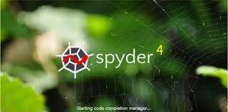

2.Pycharm:

PyCharm is an IDE developed by JetBrains specifically for Python. It is best known for smart code completion, code inspections, on-the-fly error highlighting, and very quick fixes. It helps us to write neat and maintainable code. It also offers great support for using frameworks like Django, Flask, Google App Engine, etc. It integrates with the IPython Notebook and we can also use scientific packages like Numpy and Matplotlib. PyCharm IDE is free to use. The OS supports for this IDE are Windows, macOS, and Linux.

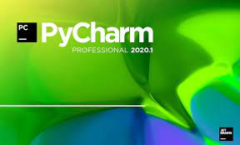

3.Atom:

Atom is mainly used for web development. It is developed by GitHub. Atom is founded by GitHub’s founder Chris Wanstrath. It is a hundred percent free and open source. It is cross-platform and used for Windows, Linux, and macOS. It is highly customizable and has many useful plugins. The main advantage with Atom is that it has an attractive interface, good color-coded syntax. But the disadvantage is that it suffers from high start-up time.



4.IDLE:

**IDLE** is Python’s **Integrated Development and Learning Environment.** It allows programmers to easily write Python code. Just like Python Shell, IDLE can be used to execute a single statement and create, modify, and execute Python scripts.

IDLE provides a fully-featured text editor to create Python scripts that include features like syntax highlighting, autocompletion, and smart indent. It also has a debugger with stepping and breakpoints features. This makes debugging easier.

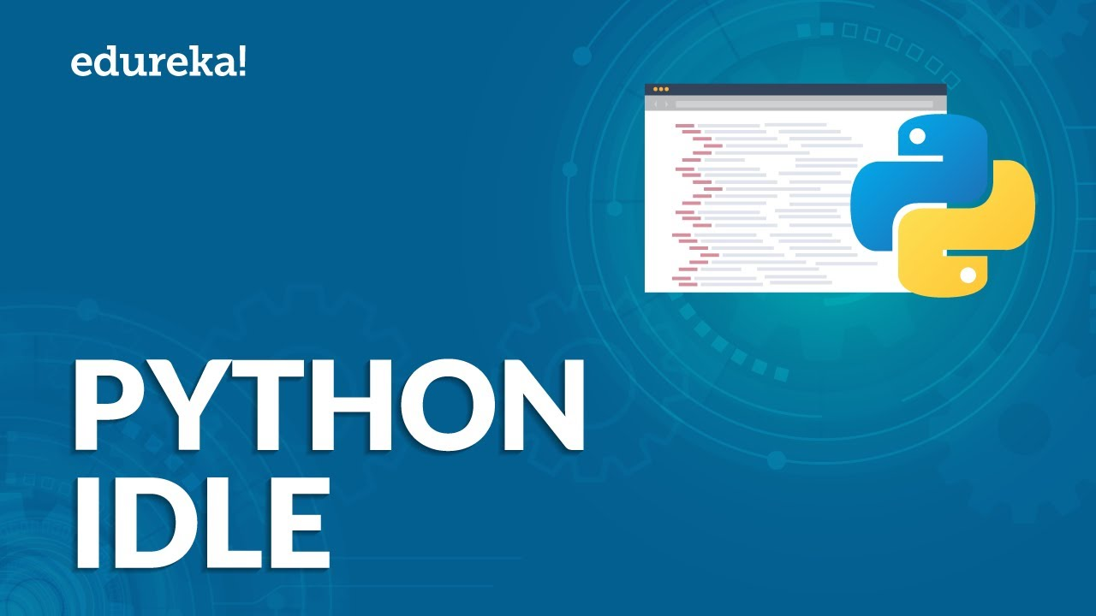

5.Thonny:

**Thonny** is a free [development](https://en.softonic.com/windows/development) program for PC that was made by an independent dev who goes by the same name. It is an open-source **integrated development environment**(IDE) that can be used to create various applications using the [Python](https://en.softonic.com/downloads/python) programming language.

Just like [Microsoft Visual Studio](https://microsoft-visual-studio.en.softonic.com/) or [NetBeans IDE](https://netbeans-ide.en.softonic.com/" \t "_blank), Thonny makes it easier for programmers to code as it already comes with the essential **tools, libraries, and dependencies** that they need to get started. This particular IDE was made to focus on Python and to cater to beginners who want to **learn to code** and make programs with it.

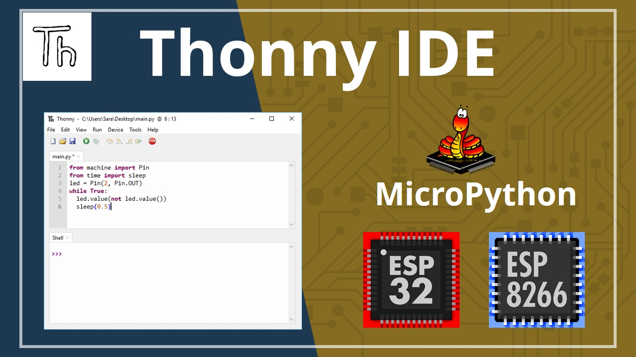

6.Eclipse:

It is developed by the Eclipse Foundation. It functions by having a base workspace and an extensible plugin environment where we can download and customize the workspace available. It supports debugging and profiling. It has a drag and drop functionality and allows us to analyze the code using static analysis. If you are comfortable in eclipse IDE, you can code in any famous language like Python, Java, and C++. The OS supports for this IDE are Windows, Linux, and macOS. Eclipse is available for free to use.



