1)How would you define Virtual Machine?

Answer:-

* A virtual machine (VM) is an operating system (OS) or application environment that is installed on software, which imitates dedicated hardware.
* The end user has the same experience on a VM as they would on dedicated hardware.

2) How would you express working of VM with diagram?

Answer:-

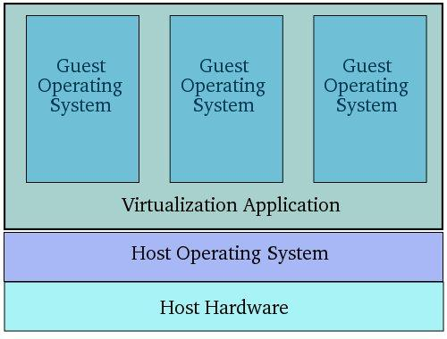

3) How would you state the need of hypervisor?

Answr:-

* A computer that hosts VMs requires specialized software called a ***hypervisor*.**
* The hypervisor emulates(imitate/copy) the computer's CPU, memory, hard disk, network and other hardware resources, creating a pool of resources that can be allocated to the individual VMs according to their specific requirements.
* The hypervisor can support multiple virtual hardware platforms that are isolated from each other, enabling VMs to run Linux and Windows Server OSes on the same physical host.
* The hypervisor manages resources and allocates them to VMs. It also schedules and adjusts how resources are distributed based on how the hypervisor

4) How can you describe Type1 and Type2 hypervisors?

Answer:-

* Type 1. Also referred to as a **bare-metal hypervisor**, this type of hypervisor runs directly on the physical host machine and has direct access to its hardware. Type 1 hypervisors typically run-on server computers and are considered more efficient and better-performing than Type 2 hypervisors, making them well suited to server, desktop and application virtualization. Examples of Type 1 hypervisors include Microsoft Hyper-V and VMware ESXi.
* Type 2. Sometimes called a [**hosted hypervisor**](https://searchservervirtualization.techtarget.com/definition/hosted-hypervisor-Type-2-hypervisor), a Type 2 hypervisor is installed on top of the host machine's OS, which manages calls to the hardware resources. Type 2 hypervisors are generally deployed on end-user systems for specific use cases. For example, a developer might use a Type 2 hypervisor to create a specific environment for building an application, or a data analyst might use it to test an application in an isolated environment. Examples of Type 2 hypervisors include VMware Workstation and Oracle VirtualBox.

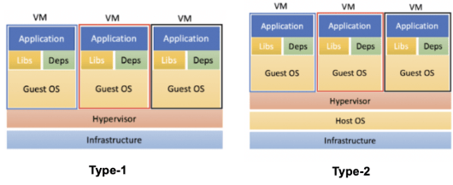

5) Oracle VirtualBox is what type of hypervisor? Explain.?

Answer:-

6) How do you compare Virtual Machine and Container?

.