1 在gatt_uuid128.h 自定义UUID，使用宏定义UUID128（服务名/特征名，128位uuid）

UUID128(uuid_service_adcTst,0x01,0x03,0x07,0x09,0x0b,0x0d,0x0f,0x02,0x03,0x01,0x04,0x43,0x23,0x32,0x33,0x78)

UUID128(uuid_characteristic_adcTst,0x01,0x03,0x07,0x0a,0x0b,0x0d,0x0f,0x02,0x04,0x01,0x04,0x93,0x23,0x32,0x33,0x79)

名字+16字节uuid

2 gatt_db.h定义服务

PRIMARY_SERVICE_UUID128(service_device_adc, uuid_service_adcTst)

CHARACTERISTIC_UUID128(char_adc_value,uuid_characteristic_adcTst,(gGattCharPropRead_c | gGattCharPropNotify_c | gGattCharPropWrite_c))

VALUE_UUID128(value_adc_value, uuid_characteristic_adcTst, gPermissionFlagReadable_c | gPermissionFlagWritable_c ,1, 0x00)

CCCD(cccd_adc)

3 在profiles下创建一个新文件夹，放自定义服务，在文件夹下放两个文件，xxx_interface.h和xxx_services.c

4 在interface.h自定义数据结构，类似

typedef struct psConfig_tag  
{  
    uint16_t    serviceHandle;                 /*!<Service handle */  
    uint8_t     potentiometerValue;            /*!<Input report field */  
} psConfig_t;

声明两个开启服务的函数，类似

bleResult_t Ps_Start(psConfig_t *pServiceConfig);  
bleResult_t Ps_Stop(psConfig_t *pServiceConfig);

两个注册客户端注册服务，类似

bleResult_t Ps_Subscribe(deviceId_t clientDeviceId);  
bleResult_t Ps_Unsubscribe();

用于读写更新特征的函数，类似

bleResult_t Ps_RecordPotentiometerMeasurement (uint16_t serviceHandle, uint8_t newPotentiometerValue);

5 service.c要实现

一个静态变量用于存储ID

static deviceId_t mPs_SubscribedClientId;

实现以上函数

bleResult_t Ps_Start (psConfig_t *pServiceConfig)  
{      
    /* Clear subscibed clien ID (if any) */  
    mPs_SubscribedClientId = gInvalidDeviceId_c;  
      
    /* Set the initial value defined in pServiceConfig to the characteristic values */  
    return Ps_RecordPotentiometerMeasurement (pServiceConfig->serviceHandle,   
                                             pServiceConfig->potentiometerValue);  
}  
  
bleResult_t Ps_Stop (psConfig_t *pServiceConfig)  
{  
  /* Unsubscribe current client */  
    return Ps_Unsubscribe();  
}  
  
bleResult_t Ps_Subscribe(deviceId_t deviceId)  
{  
   /* Subscribe a new client to this service */  
    mPs_SubscribedClientId = deviceId;  
  
    return gBleSuccess_c;  
}  
  
bleResult_t Ps_Unsubscribe()  
{  
   /* Clear current subscribed client ID */  
    mPs_SubscribedClientId = gInvalidDeviceId_c;  
    return gBleSuccess_c;  
}

这函数的 特征uuid变量是定义在uuid128里的，但是我实验时候发现，直接填进函数里会报未定义错误，后来使用了extern解决了问题

bleResult_t Ps_RecordPotentiometerMeasurement (uint16_t serviceHandle, uint8_t newPotentiometerValue)  
{  
    uint16_t  handle;  
    bleResult_t result;  
  
    /* Get handle of Potentiometer characteristic */  
    result = GattDb_FindCharValueHandleInService(serviceHandle,  
        gBleUuidType128_c, (bleUuid_t*)&potentiometerCharacteristicUuid128, &handle);  
  
    if (result != gBleSuccess_c)  
        return result;  
  
    /* Update characteristic value */  
    result = GattDb_WriteAttribute(handle, sizeof(uint8_t), (uint8_t*)&newPotentiometerValue);  
  
    if (result != gBleSuccess_c)  
        return result;  
  
    Ps_SendPotentiometerMeasurementNotification(handle);  
  
    return gBleSuccess_c;  
}

实现发送提醒的函数

static void Ps_SendPotentiometerMeasurementNotification  
(  
  uint16_t handle  
)  
{  
    uint16_t  hCccd;  
    bool_t isNotificationActive;  
  
    /* Get handle of CCCD */  
    if (GattDb_FindCccdHandleForCharValueHandle(handle, &hCccd) != gBleSuccess_c)  
        return;  
  
    if (gBleSuccess_c == Gap_CheckNotificationStatus  
        (mPs_SubscribedClientId, hCccd, &isNotificationActive) &&  
        TRUE == isNotificationActive)  
    {  
        GattServer_SendNotification(mPs_SubscribedClientId, handle);  
    }  
}

6 在文件里，放置服务数据的地方，定义自定义的数据，类似

Static psConfig_t psServiceConfig = {service_potentiometer,0};

这个service_potentiometer就是UUID定义的主服务

7 在BleApp_Config() 里开启服务

Ps_Start(&psServiceConfig);

8 在BleApp_ConnectionCallback, 在gConnEvtConnected_c这个状态下，调用

Ps_Subscribe(peerDeviceId); 注册ID，开启对应服务定时器，实现定时器回调函数

# 9 如果需要处理，Notifications和写请求

在BleApp_GattServerCallback里的ccd写情况下，开启定时器，定时发送数据

写请求则要先用GattServer_RegisterHandlesForWriteNotifications来注册函数

uint16_t notifiableHandleArray[] = {value_led_control, value_buzzer, value_accelerometer_scale, value_controller_command, value_controller_configuration};  
    uint8_t notifiableHandleCount = sizeof(notifiableHandleArray)/2;  
    bleResult_t initializationResult = GattServer_RegisterHandlesForWriteNotifications(notifiableHandleCount, (uint16_t*)&notifiableHandleArray[0]);

在BleApp_GattServerCallback里的属性写情况下，

同时要用GattServer_RegisterHandlesForWriteNotifications来注册句柄，cpHandles放了VALUE值的句柄，需要在里面添加VALUE对应的第一个名字

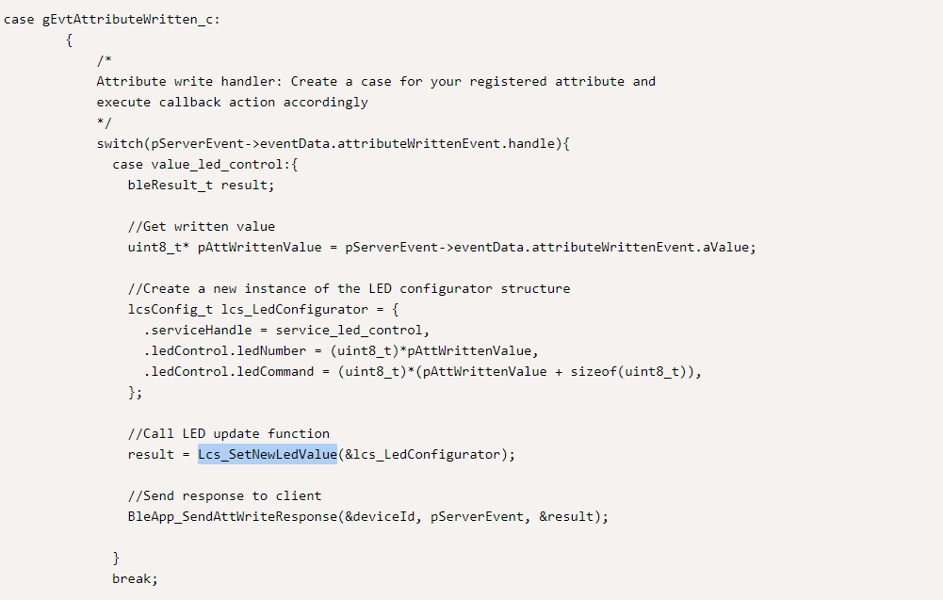

实现sendAttWrite…

static void BleApp_SendAttWriteResponse (deviceId_t* pDeviceId, gattServerEvent_t* pGattServerEvent, bleResult_t* pResult){  
  attErrorCode_t attErrorCode;  
    
  // Determine response to send (OK or Error)  
  if(*pResult == gBleSuccess_c)  
    attErrorCode = gAttErrCodeNoError_c;  
  else{  
    attErrorCode = (attErrorCode_t)(*pResult & 0x00FF);  
  }  
  // Send response to client    
  GattServer_SendAttributeWrittenStatus(*pDeviceId, pGattServerEvent->eventData.attributeWrittenEvent.handle, attErrorCode);  
}

按下app里的notify按钮则会触发cccd写事件 gEvtCharacteristicCccdWritten_c

启用配对验证在app_preinclude.h定义为1

/*! Enable/disable use of bonding capability */

#define gAppUseBonding_d 1

/*! Enable/disable use of pairing procedure */

#define gAppUsePairing_d 1

密钥定义

#define gPasskeyValue_c 999999