How to test the backdoor key?

I use the pflash example to show you how to set the backdoor. The board I use is frdm-k82.

The IDE is Keil.

1 configure the flash configuration to set the backdoor key. I set the key like the picture.

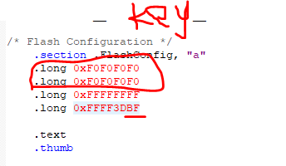

2 We need to configure the last byte of the flash configuration as BF. ‘B’ means that we enable the backdoor. ‘F’ means that we set the mcu as security state.

3 In main function, go to line 257. Modify the code like the picture.

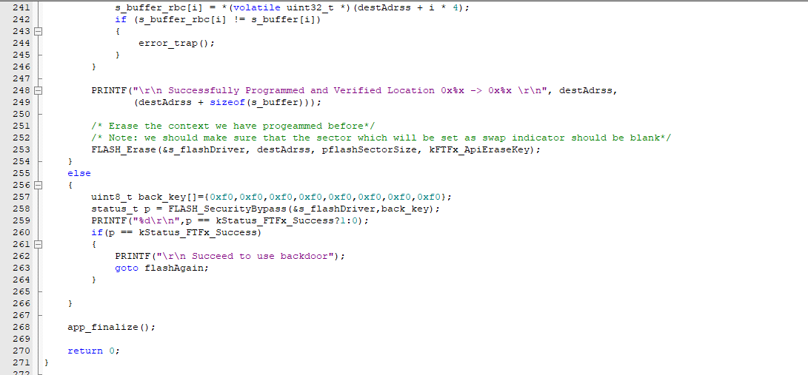

The ‘flashAgain’ is here.

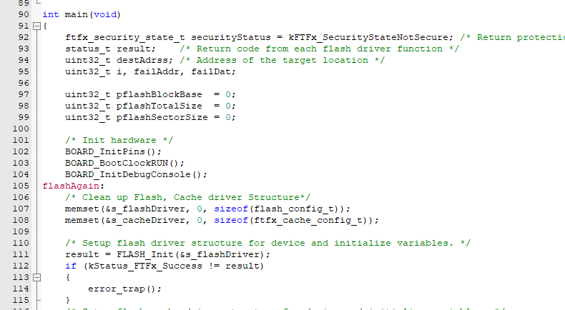

Here is the result.

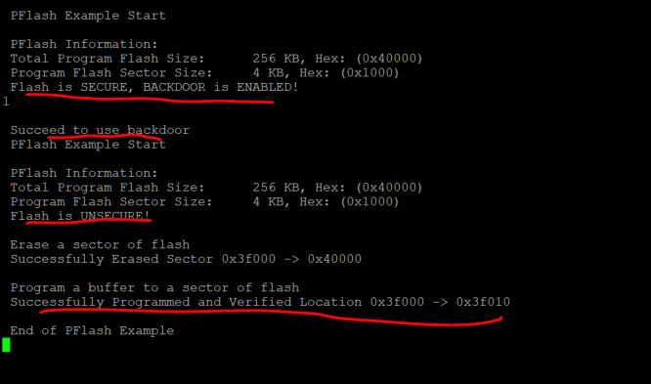

Now I explain what happened.

I set the mcu as security mode and enable the backdoor. So the console prints ‘the Flash is secure, backdoor is enabled’.

Then it will run my code in line 256. Function ‘FLASH_SecurityBypass’ is used to set the mcu as unsecurity state by using the backdoor. I use the command ‘goto’ to run this flash example again. Because the flash is unsecure, it will run normally.